Restrictive Practices and Me: Icon Set

Version 1.1 July 2026

About these Icons
The NDIS Commission created these icons to help people talk about restrictive practices. They can be used to start conversations, share information or develop resources, subject to the licensing terms.
A person-centred approach must be used to ensure that any visual supports meet the person’s communication needs and preferences. For example, some icons, such those representing rights, may be too abstract for some people. They may need to be replaced with photographs, or custom symbol sets developed in collaboration with the person.
 This material is licenced under a Creative Commons Attribution – Non-commercial 4.0 International Licence, except for the Commonwealth Coat of Arms. More information is available on the Creative Commons website: http://www.creativecommons.org/licenses/by-nc/4.0/legalcode
  NDIS Participant |   NDIS Participant (worried) |   Rights
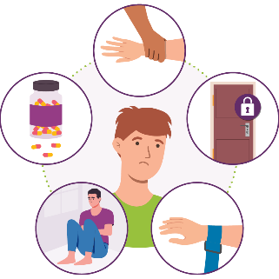  Regulated Restrictive Practices |   Chemical Restraint | 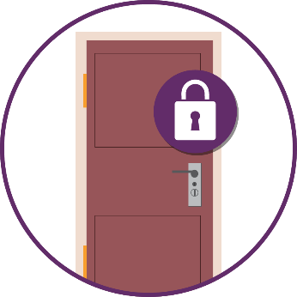  Environmental Restraint
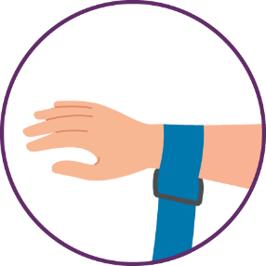  Mechanical Restraint | 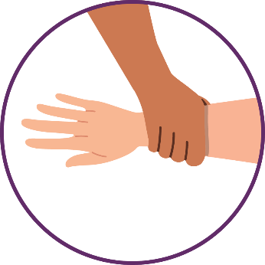  Physical Restraint |   Seclusion
  Collaboration /  Support People |   Collaboration / Conversation |   Behaviour support practitioner
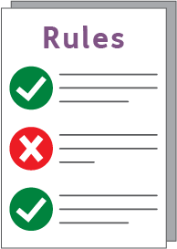  Rules | 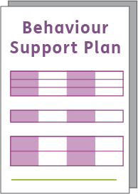  Behaviour Support Plan |   Keep Safe
  Risk |   Side effects |   Questions / Discussion
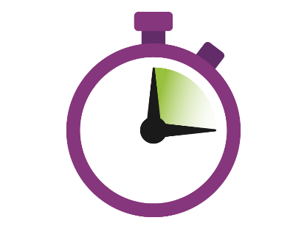  Shortest time | Reduce |   Stop

