
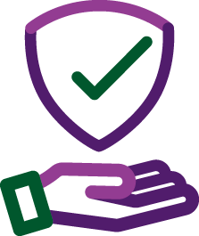


Improve safety and quality of supports and uphold NDIS participant rights

Trial of two-way information sharing has expanded from NSW Ageing and Disability Commissioner (Official Community Visitors) (OCV) to other States and Territories.
The CVS Project – May Update 2026






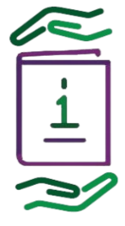
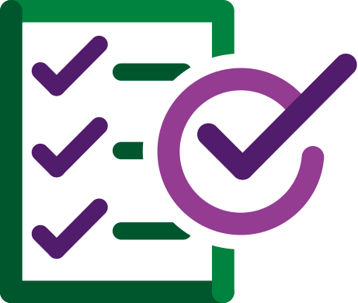
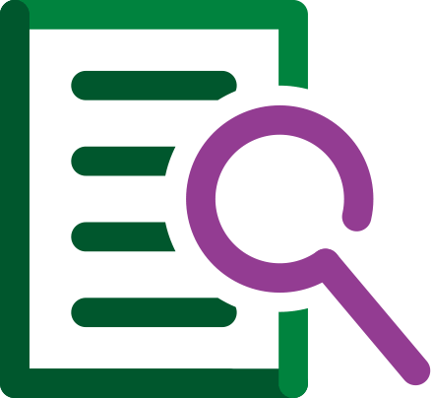
$1.7 million for Strengthening Information Sharing with Community Visitors Schemes (CVS) project
Throughout March and April 2026, the CVS project ran workshops with CVS and state and territory government officers from:
- ACT – Official Community Visitors
- Victoria – Public Advocate
- Northern Territory - Principal Community Visitors
- Queensland – Public Guardian
- South Australia – Principal Community Visitor
The project formally concludes in June 2026 with a full evaluation and published project report to follow.
Three tranches of NDIS data have been shared as part of the information sharing trial with NSW OCV. Data shared includes information about supported independent living (SIL) providers and de-identified information including the number of participants and level of SIL supports received.

All states and territories with CVS have formally agreed to participate in the trial: New South Wales, Northern Territory, South Australia, Queensland, Victoria and Australian Capital Territory.

The project team is following through on actions arising from the workshops held, including for relevant jurisdictions –
- Standardising information sharing
- Setting out what a well-functioning approach could look like in all jurisdictions
- Recommendations on best practice
A project evaluation plan is currently being developed for these outcomes:
the development of model NDIS data sets to test applicability before the sharing of live data is trialled in June 2026.

