Information about the Community Visitor Scheme project
(Report 2)

How to use this information
The NDIS Quality and Safeguards Commission wrote this information.
We will say NDIS Commission for short.

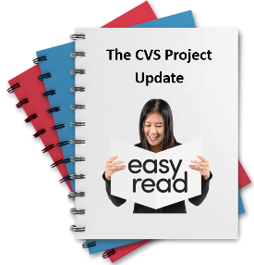 | This information is a summary of a big report.
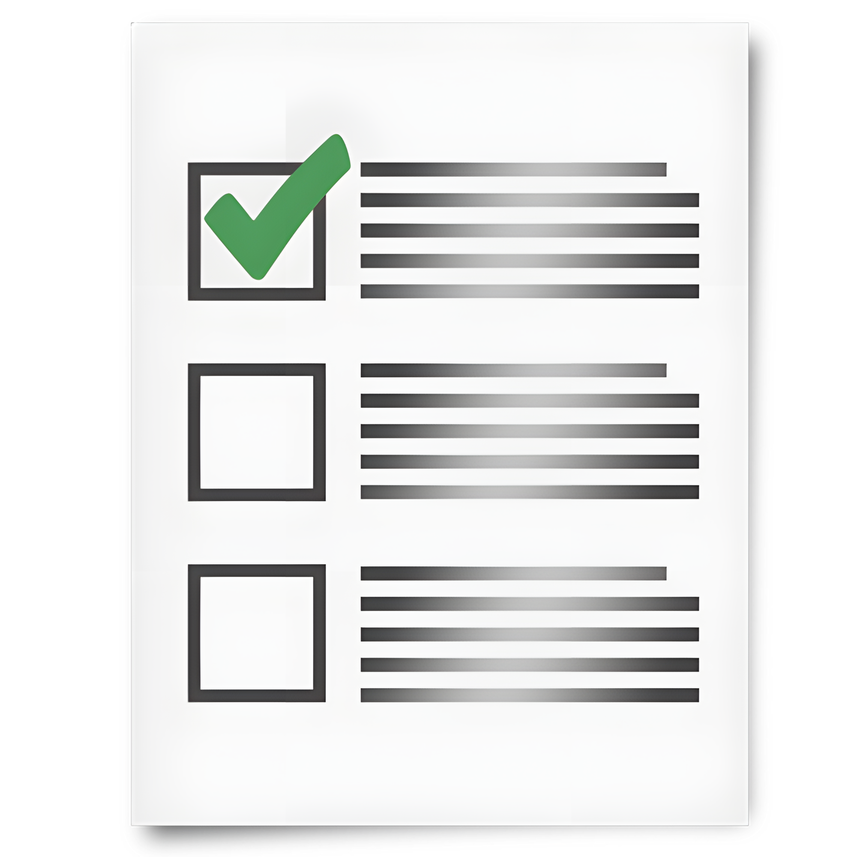 | Summary means we only talk about the most important things from the big report.
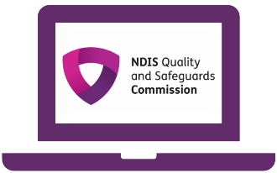 | To read the big report go to our website at CVS Project progress report 2- May 2026.
Bold  Not Bold | We wrote some important words in bold.  Bold means the letters are thicker and darker.
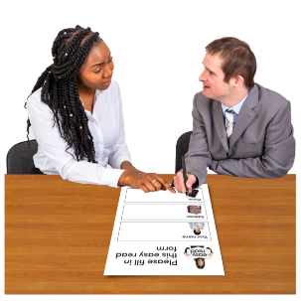 | You can ask for support to read this information.
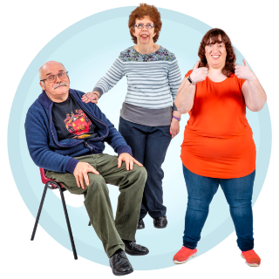 | You could ask  - A friend  - A family member  - A support person.
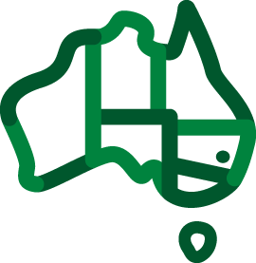 | We respect all Aboriginal and Torres Strait Islander peoples from the land we live on.
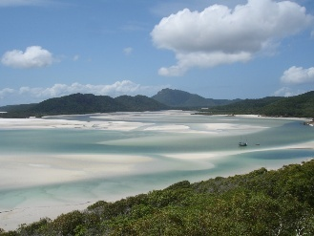 | They were the first people to live on and use the  - Land  - Waters.

About our project
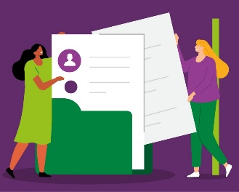 | This information is about our Community Visitor Schemes project.  We will say CVS project for short.  When you see this picture, you will know it is the CVS project.
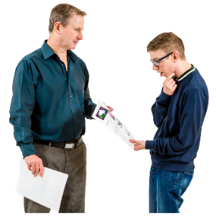 | The CVS project is trying a new way for us to share information with community visitors.
 | Community visitors are people who go into homes where many people with disability live.
 | They go there to make sure the people with disability are safe.
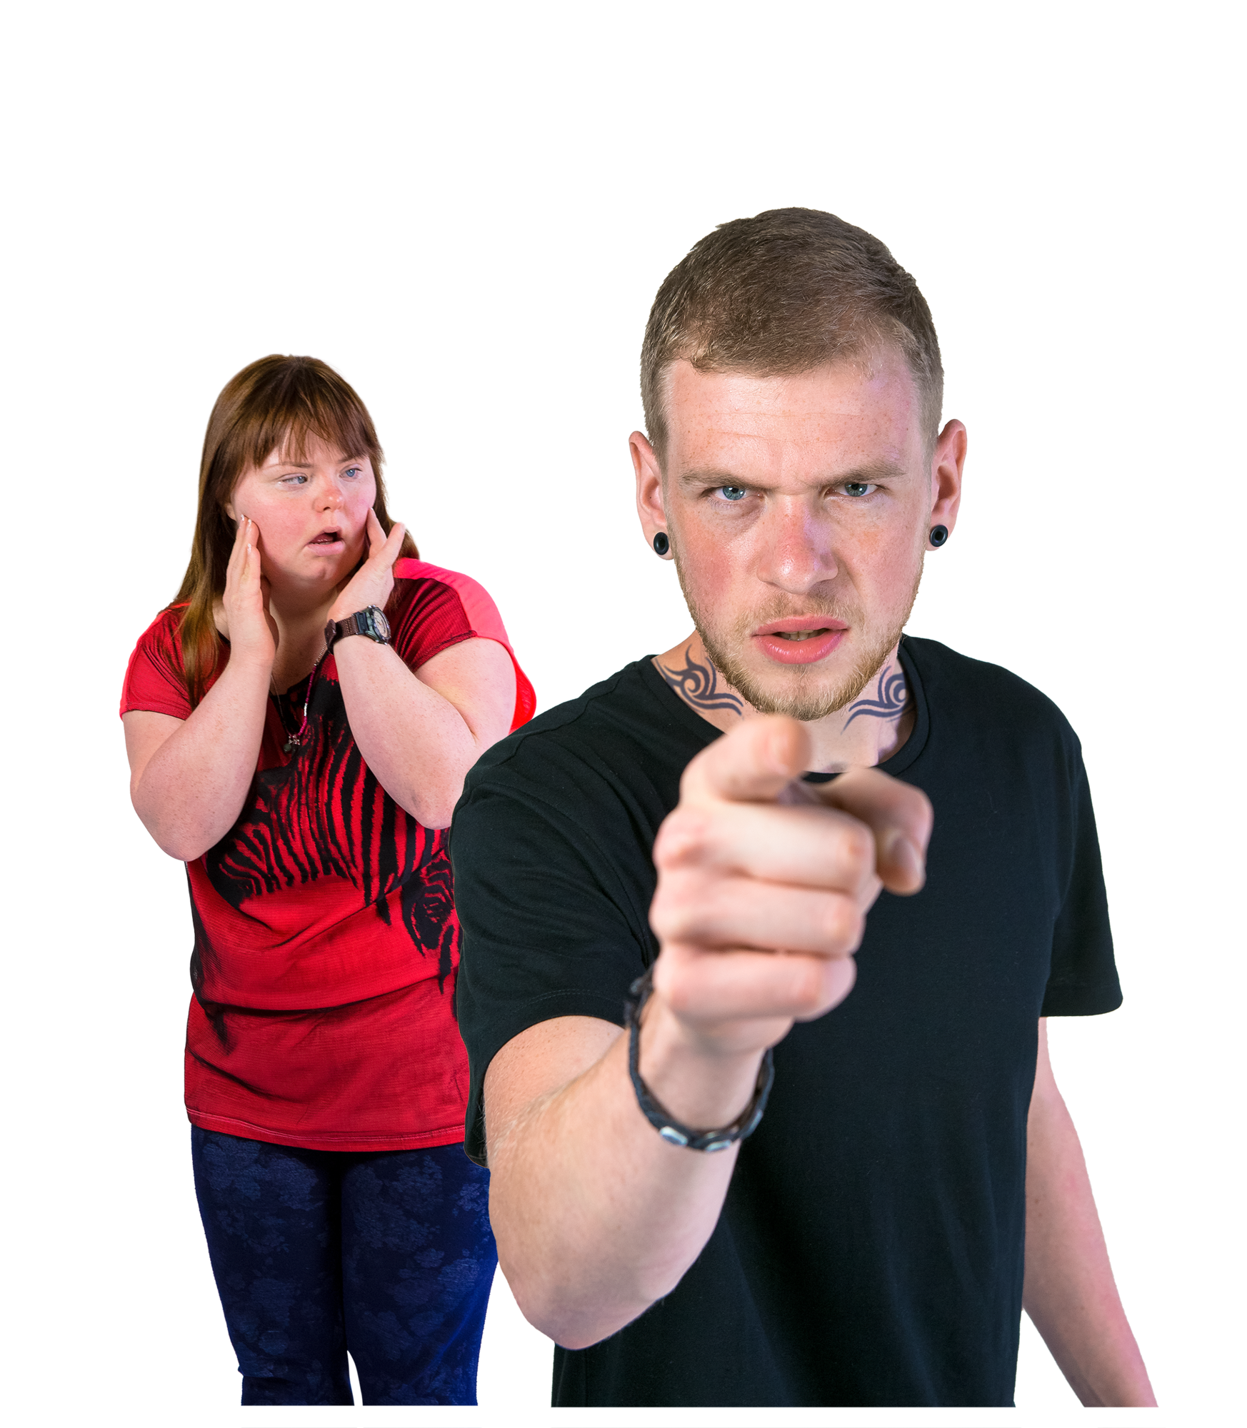  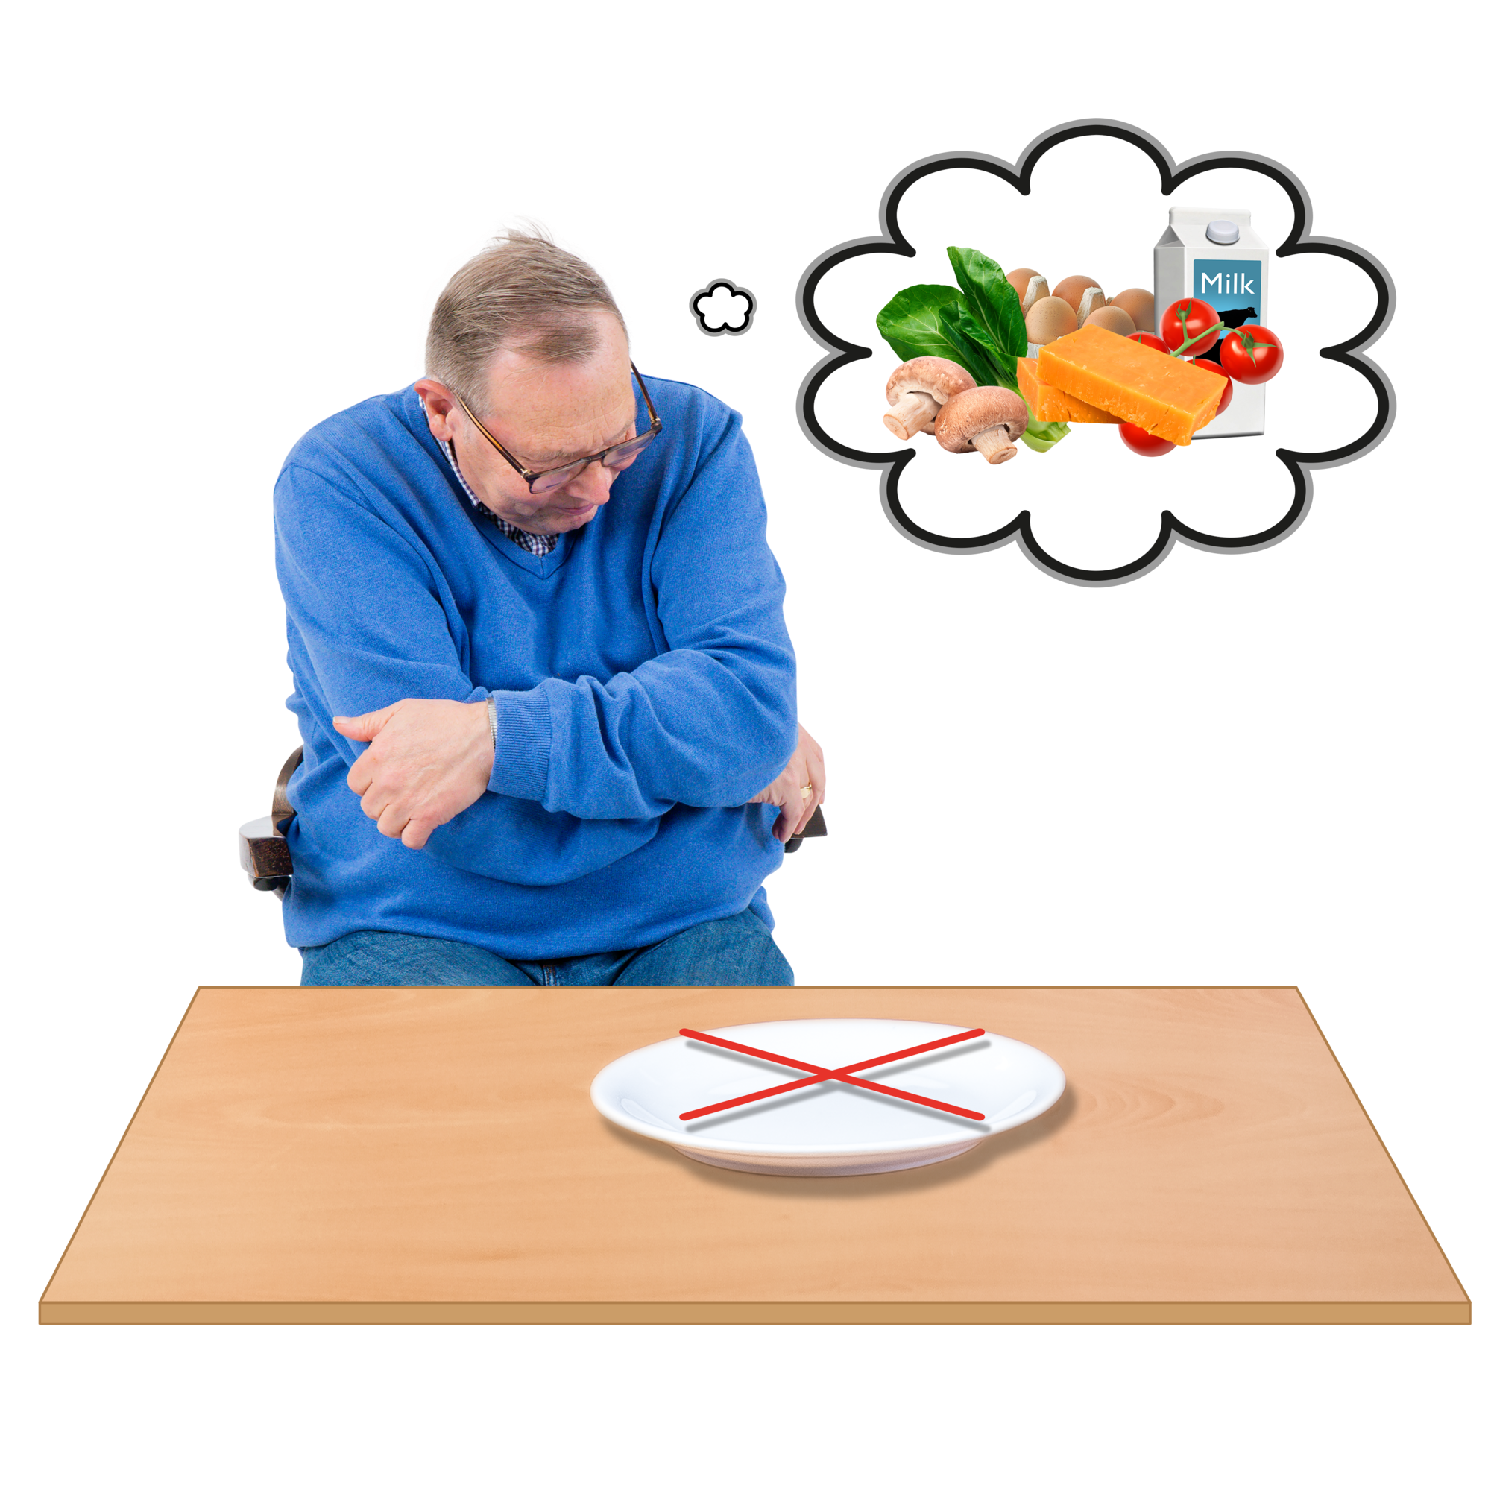 | The community visitors want to make sure the people with disability are safe from  - Abuse  - Neglect.
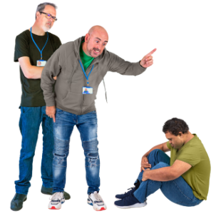 | Abuse is when someone treats you badly.
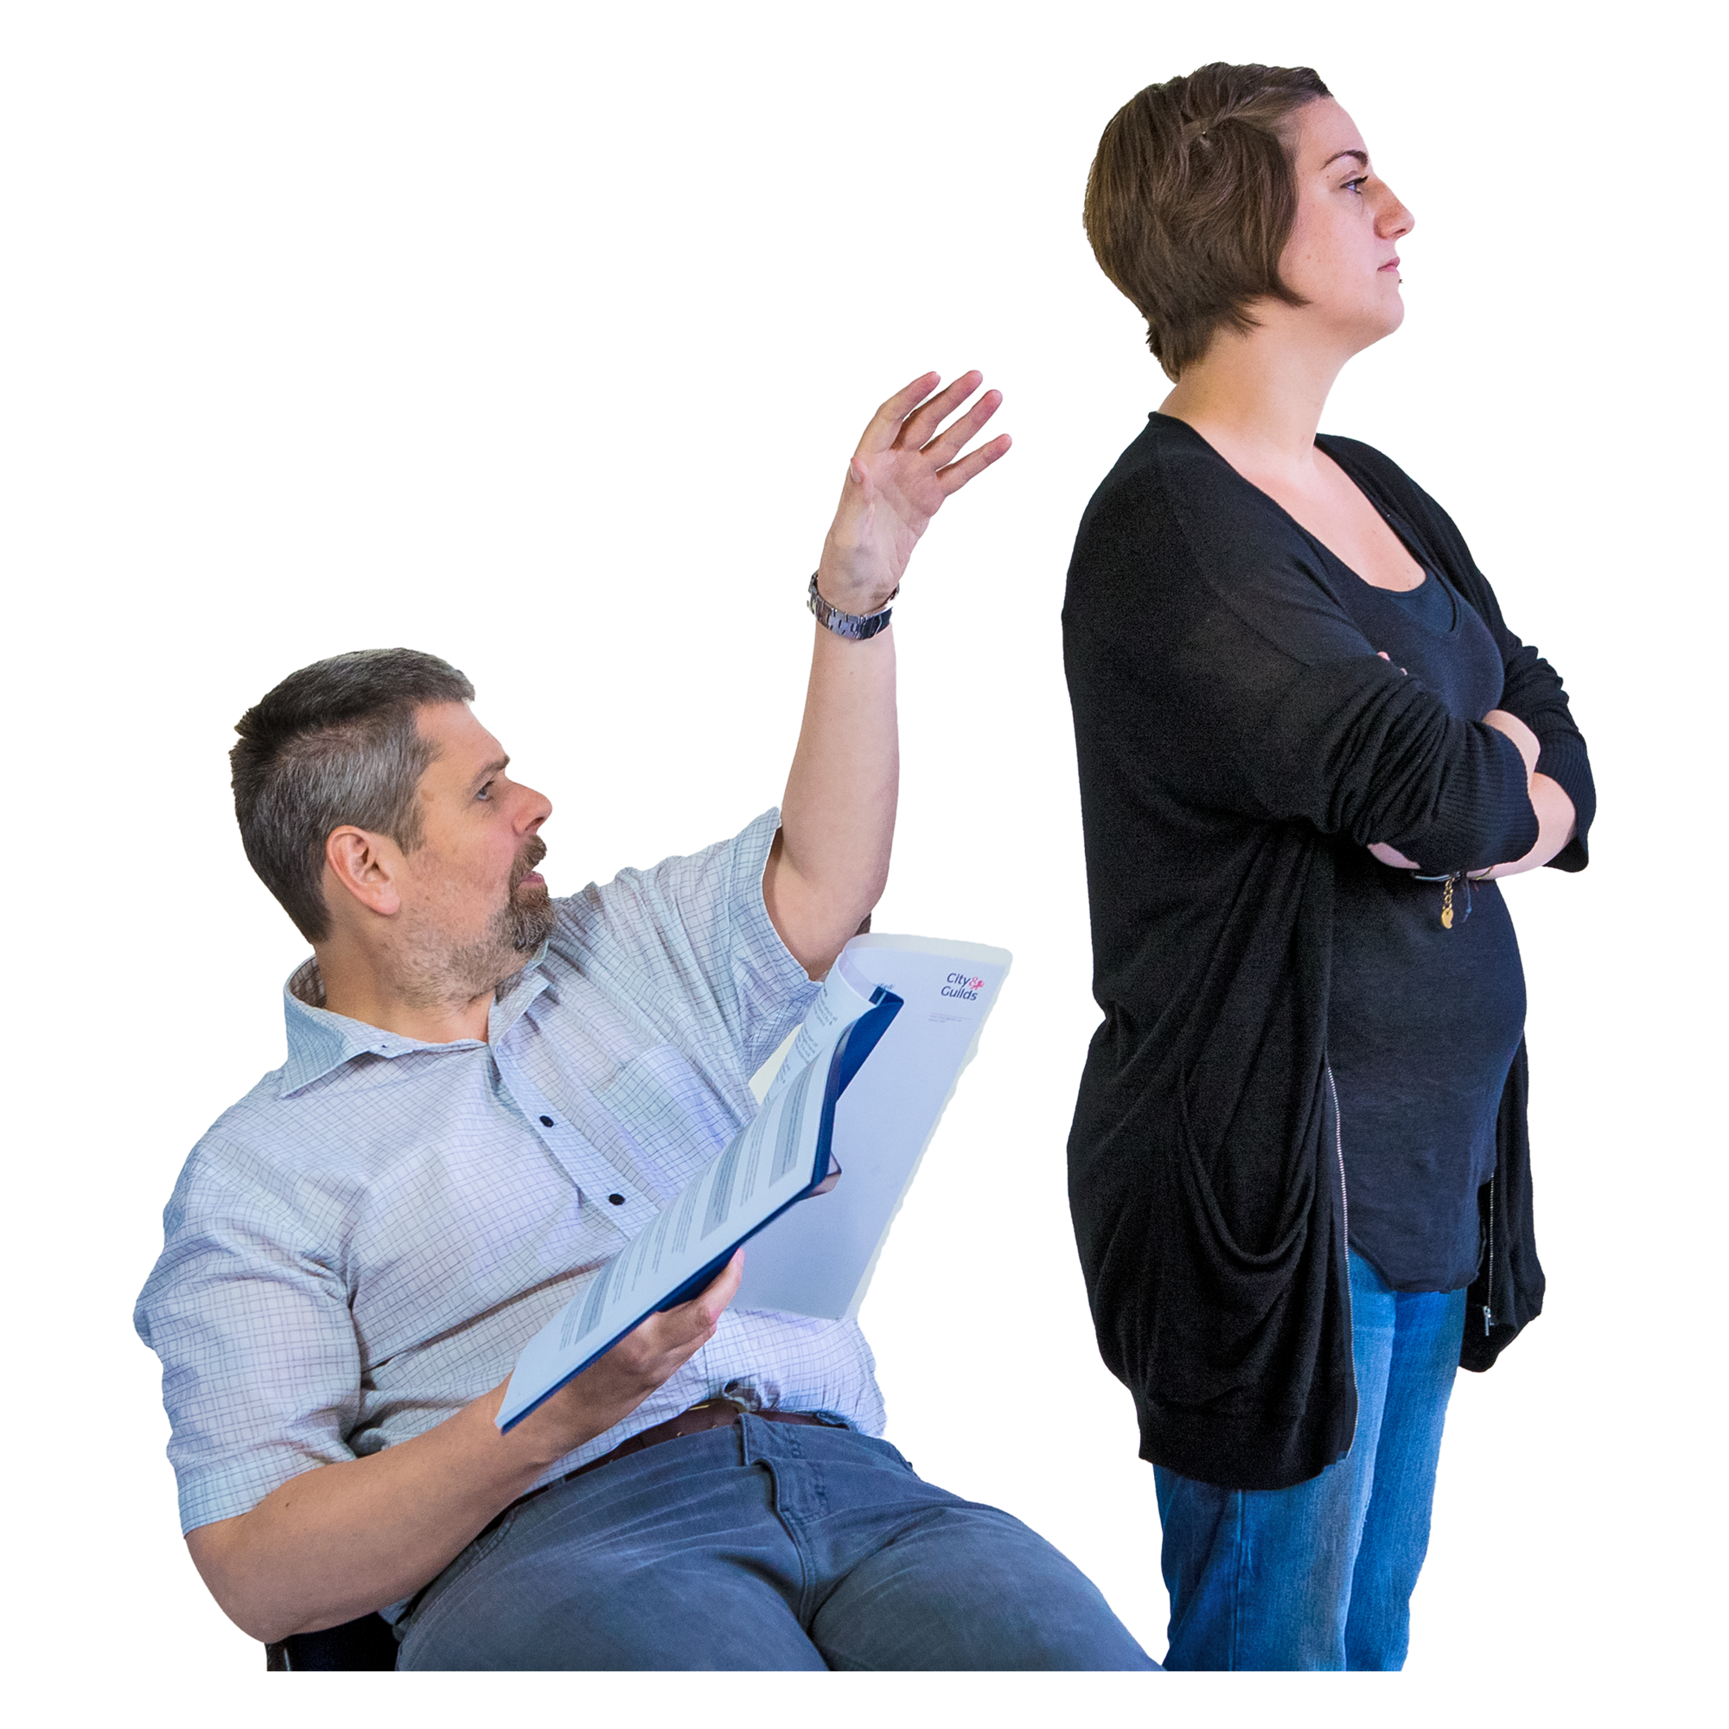 | Neglect is when someone does not support you how they are meant to.
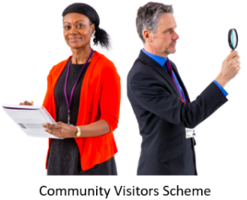 | Community visitors also help make sure people with disability get their rights.
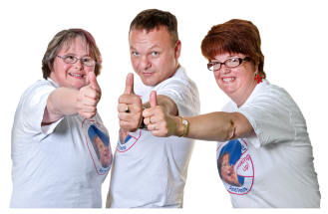 | Rights are rules about treating everyone fair and the same way.
 | We share information with the community visitors.
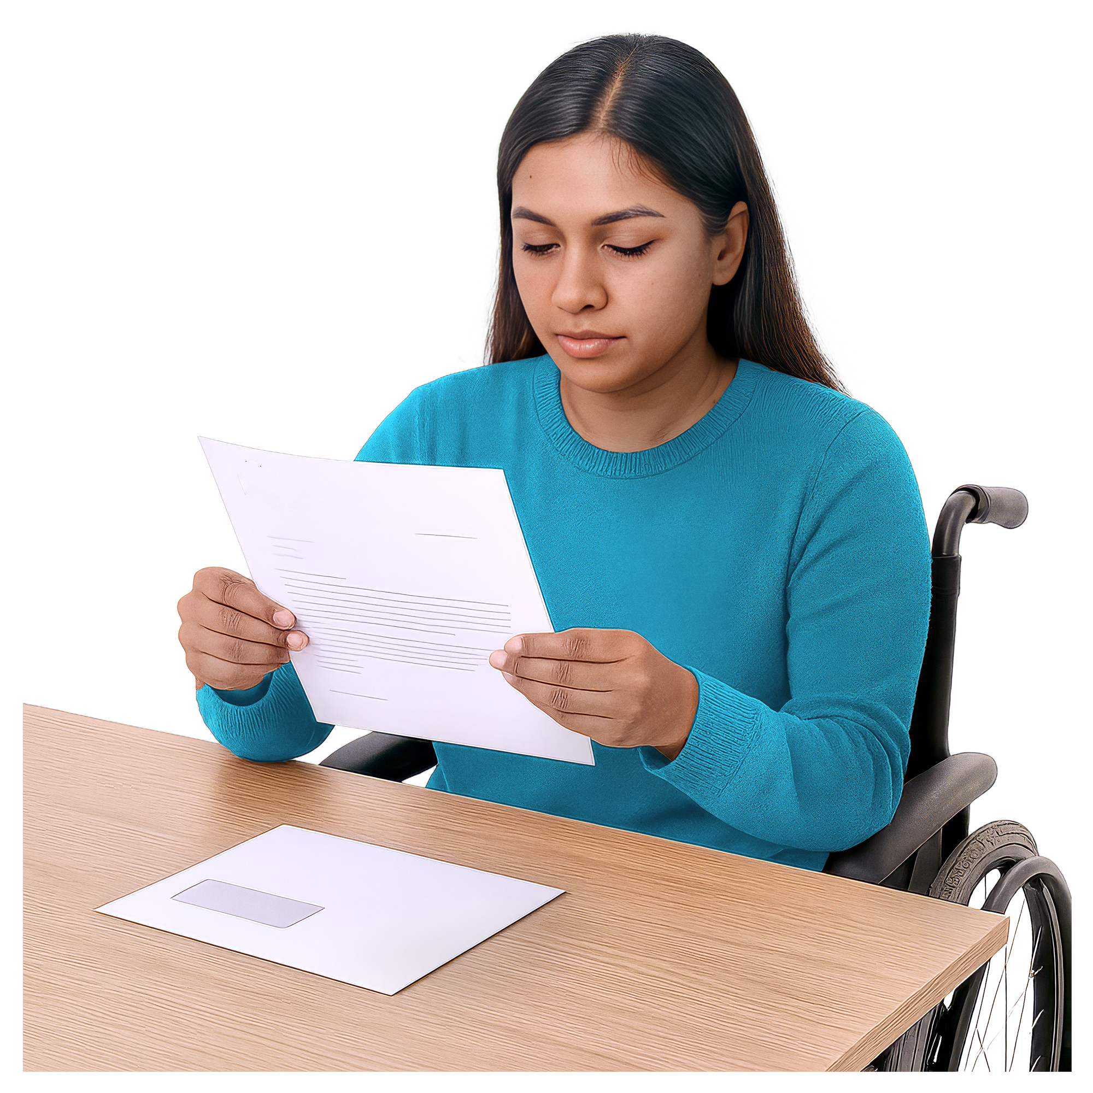 | This information helps them know  - Who to visit  - About any issues in the home.

Why are we doing the CVS project
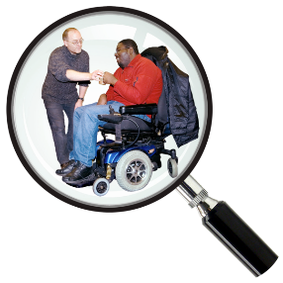 | The Disability Royal Commission looked at how people with disability are treated.  We will say DRC for short.
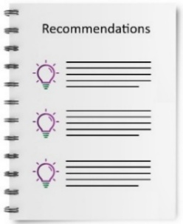 | DRC wrote a report with recommendations.
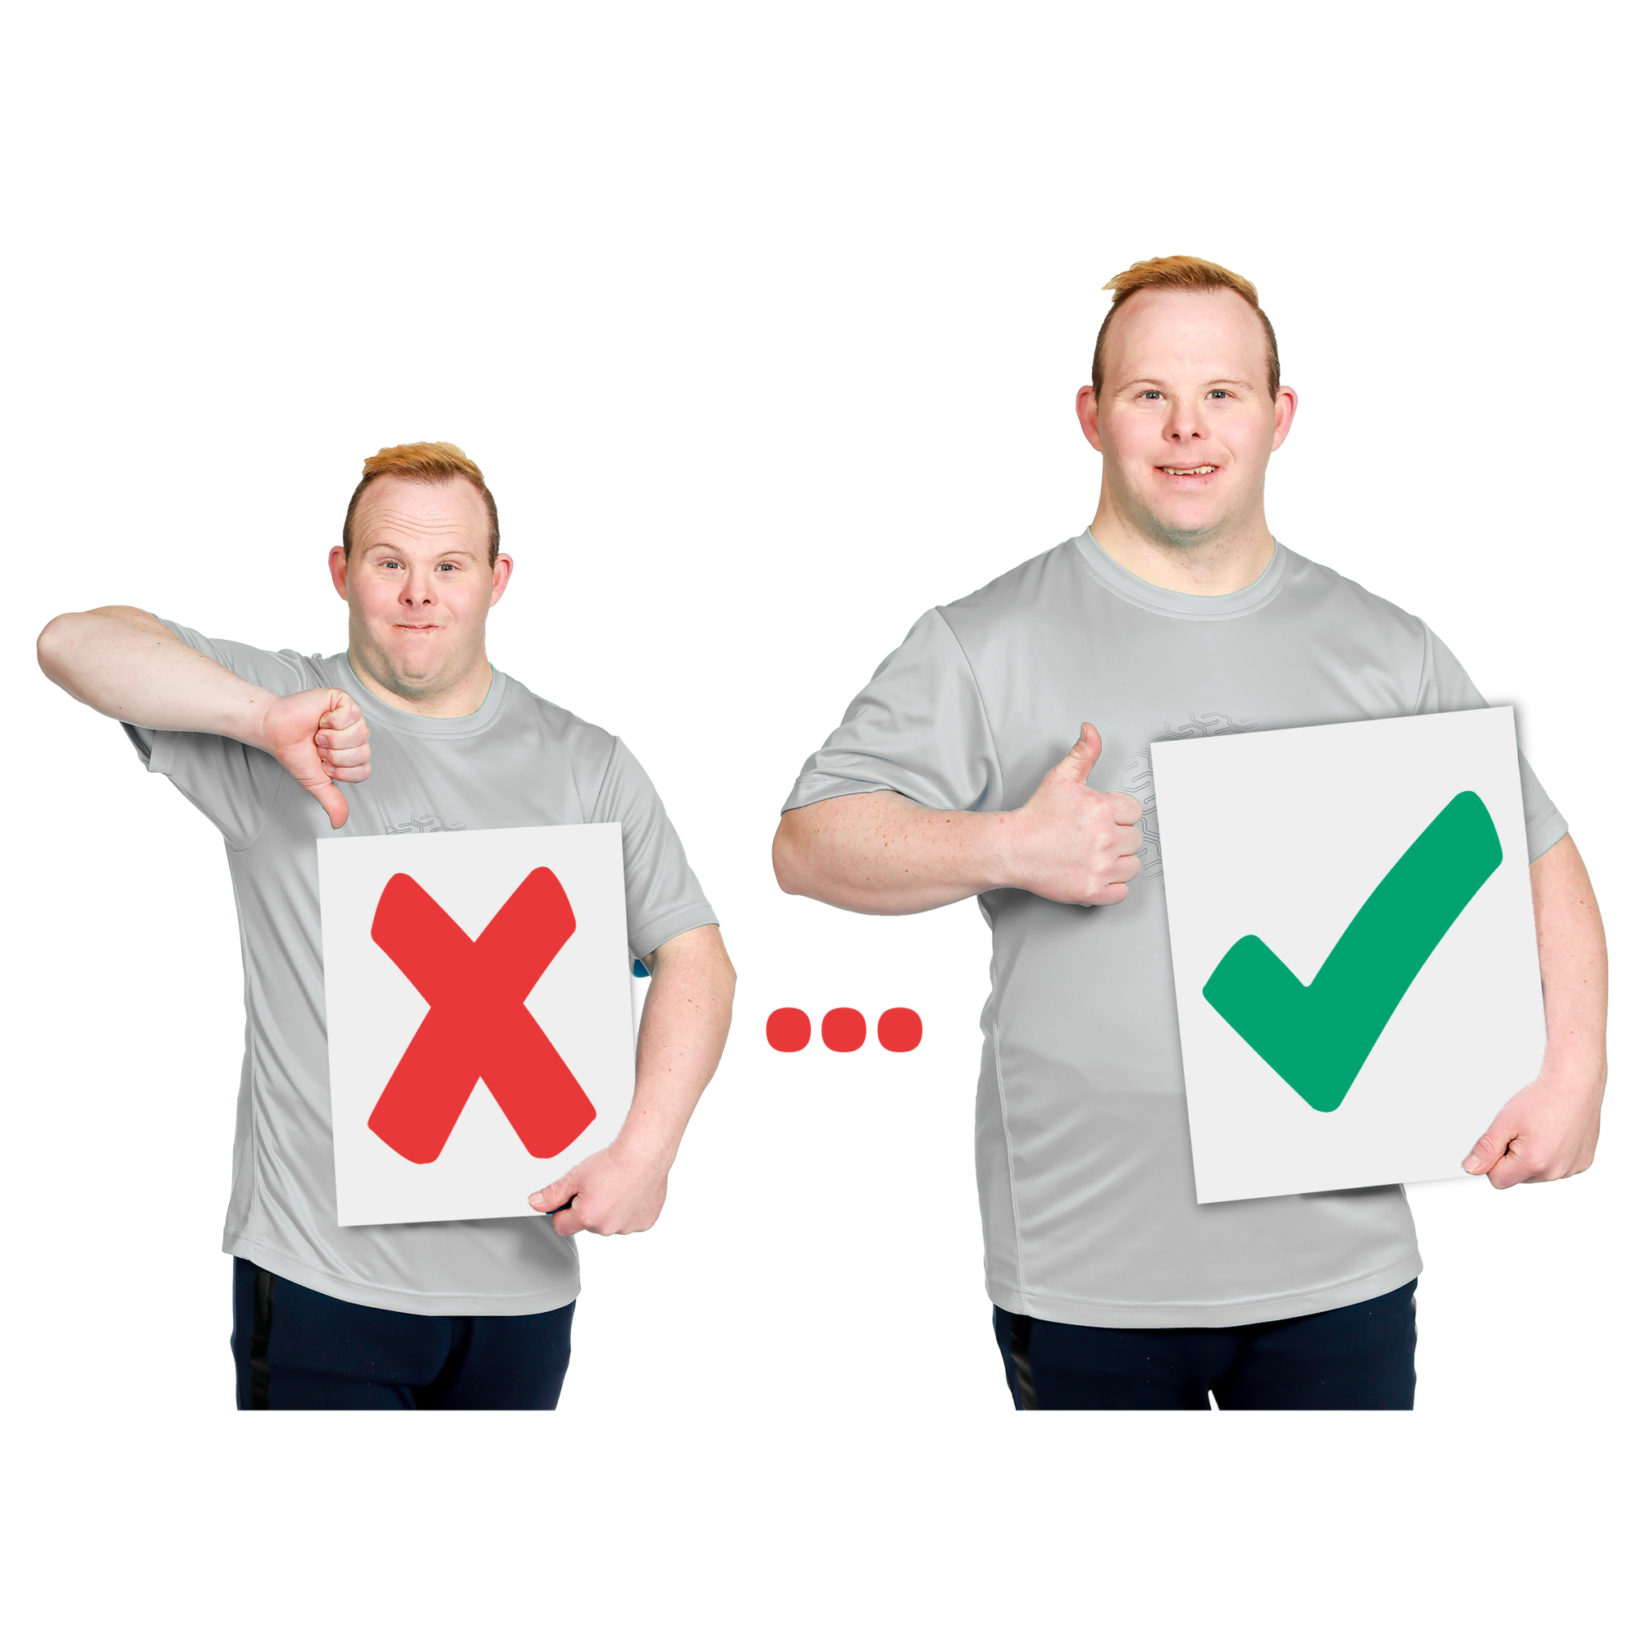 | Recommendations are ideas to do things better.
 | 1 DRC recommendation is to share more information with community visitors.
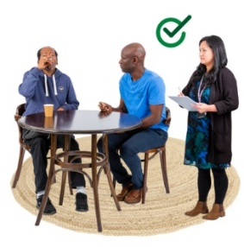 | The information will help them  - Check that people with disability are safe when they use services
 | - Help people with complaints.
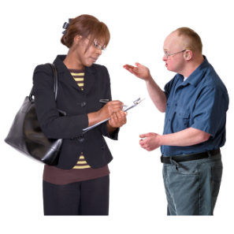 | A complaint is when you speak up if you are not happy about something.
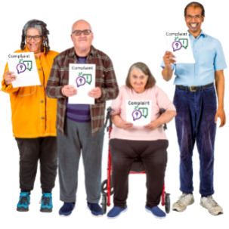 | Everyone has a right to make a complaint.
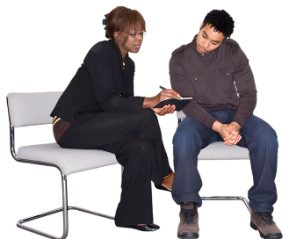 | Community visitors know who to talk to if you have a complaint.
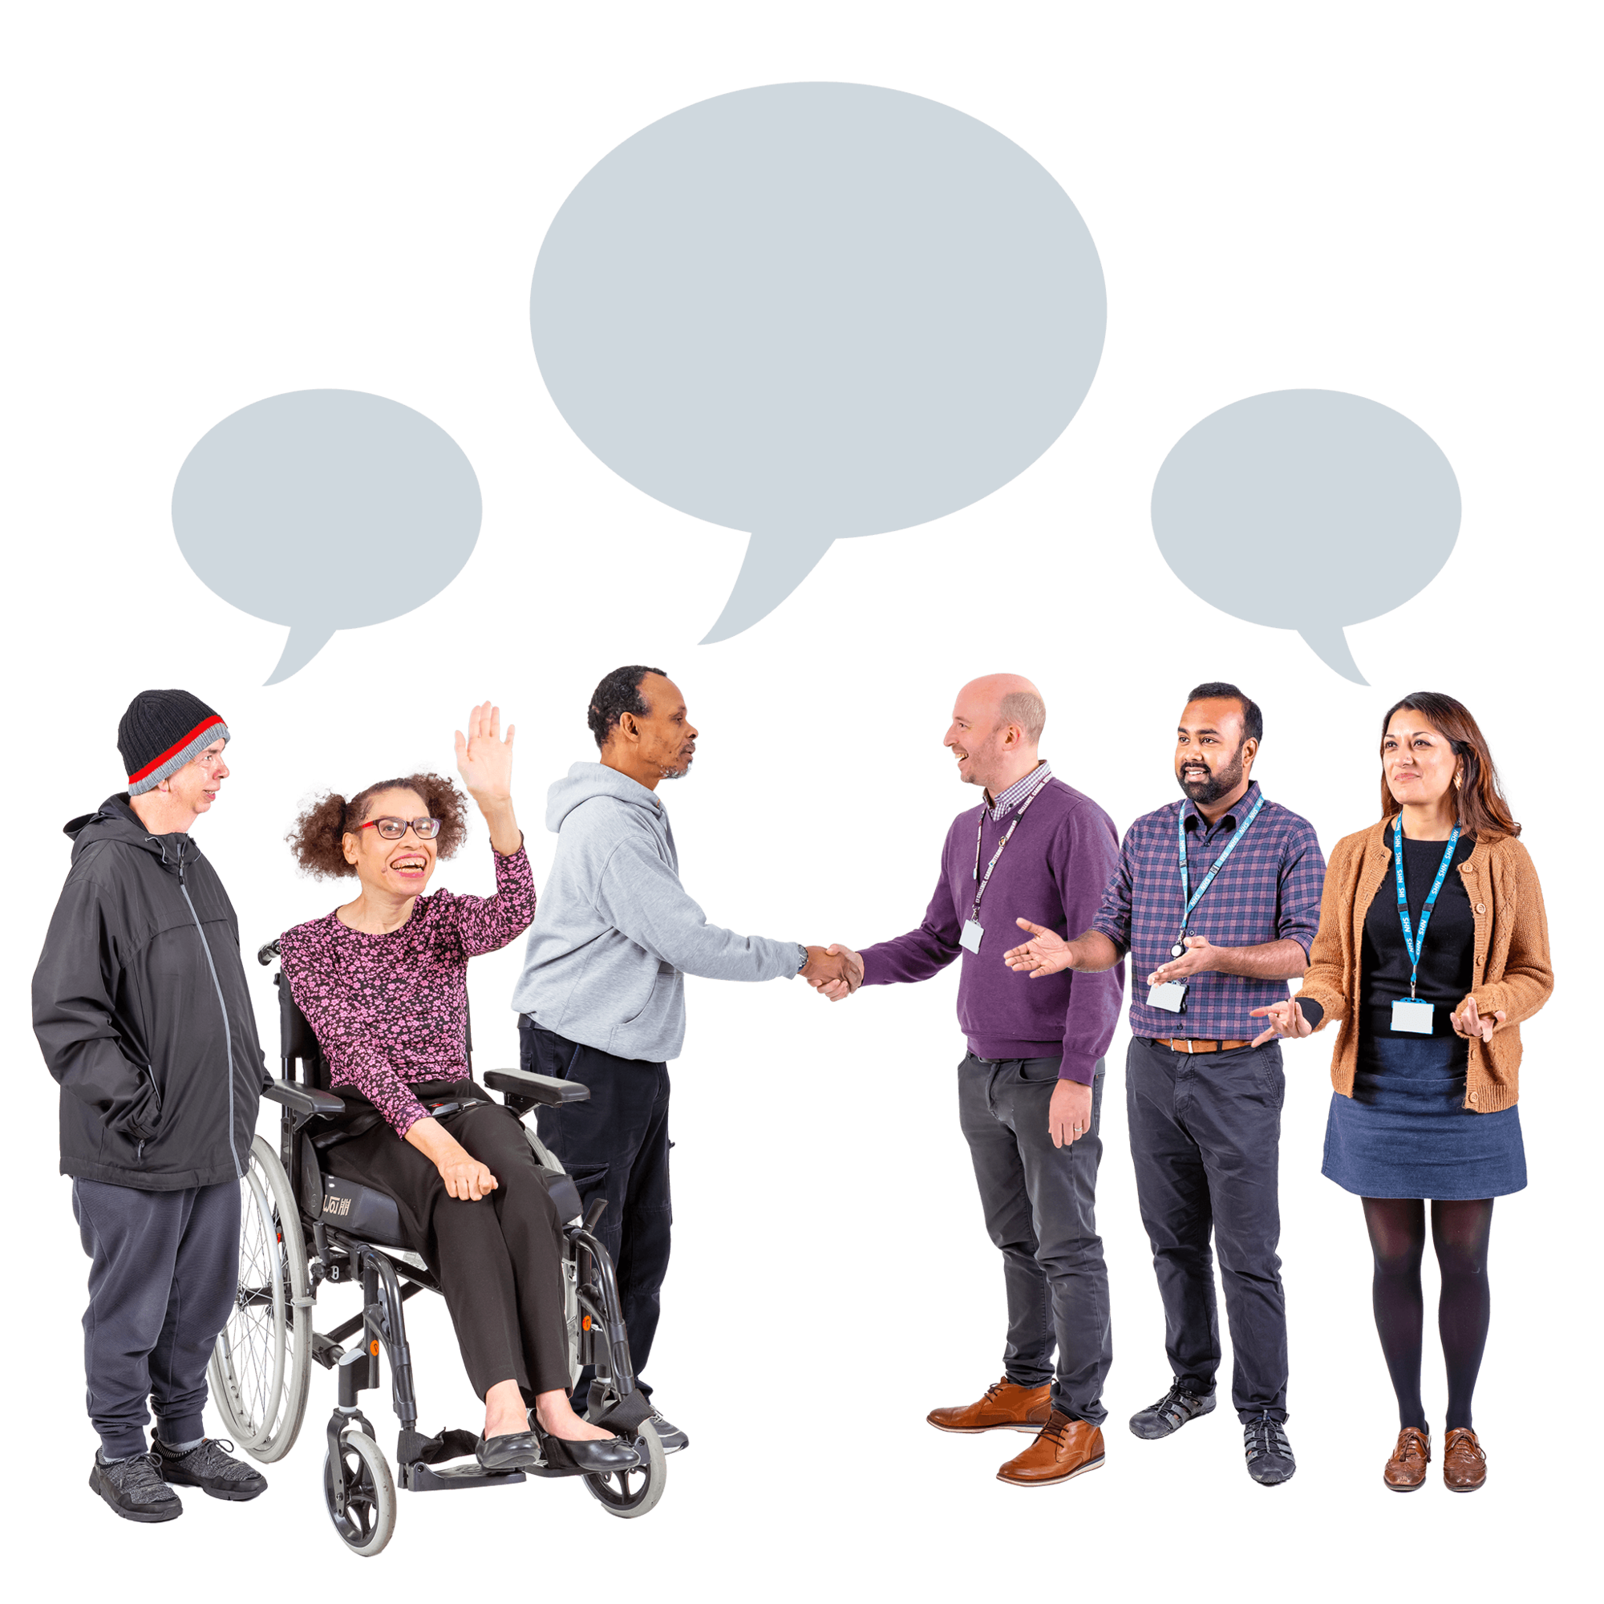 | They can ask us to help fix the problem.
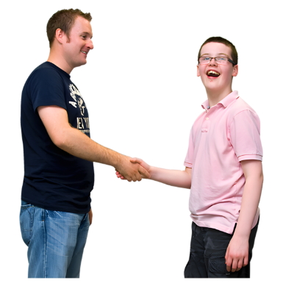 | We want to support community visitors to support you to make a complaint.
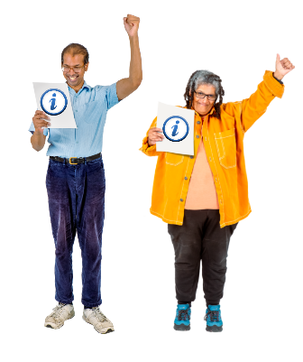 | We can support community visitors by sharing good information.
 | The CVS project looks at what information we can share with the community visitors.
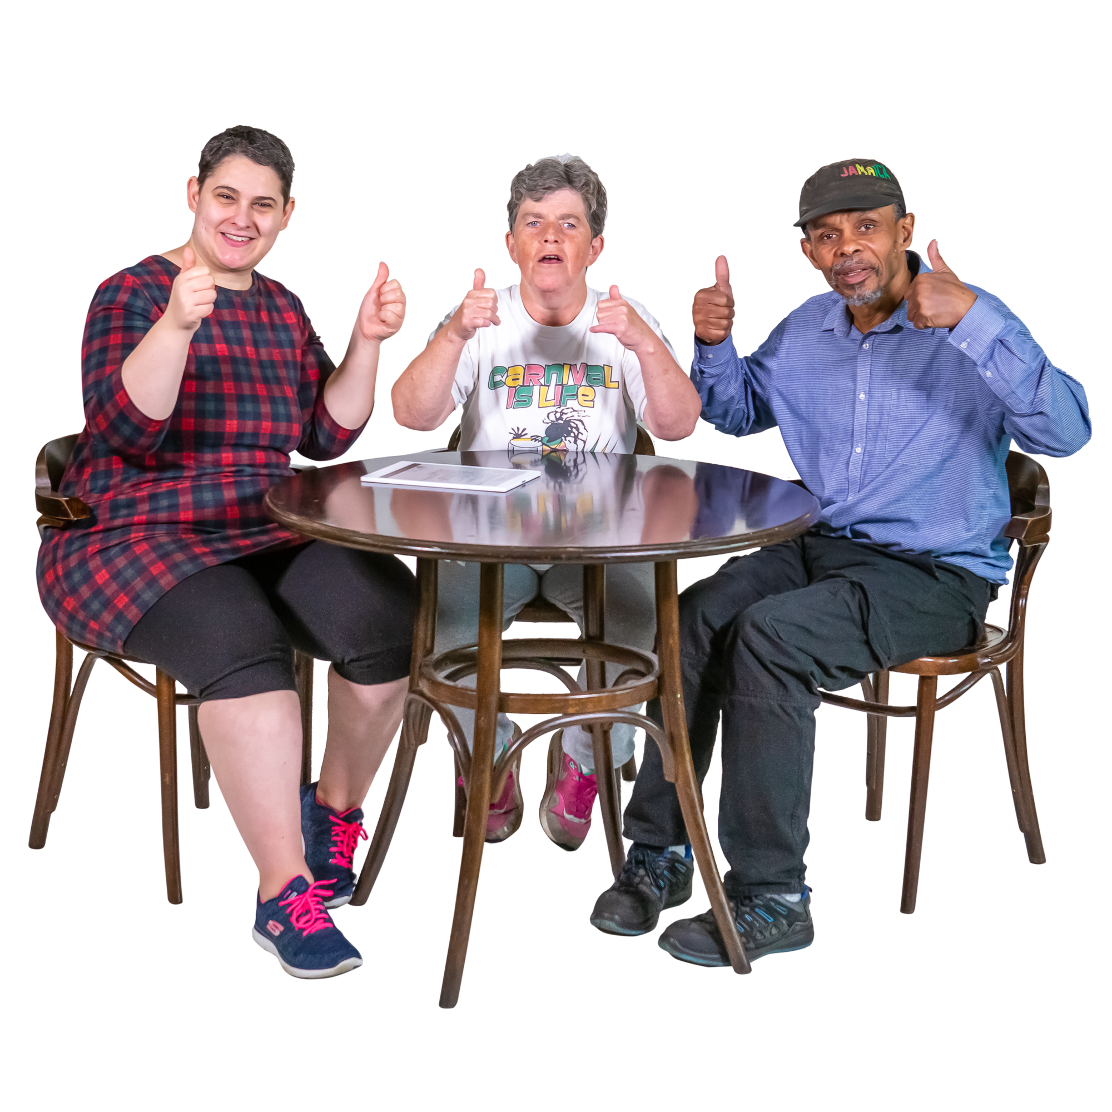 | We want to make sure we share the right information that will help them keep people safe.

Who we work with
 | The CVS project works with the NSW Government Ageing and Disability Commission, the ACT Government Official Community Visitors, the NT Government Principal Community Visitor, the QLD Government Public Guardian, the SA Government Principal Community Visitor and the VIC Government Public Advocate.
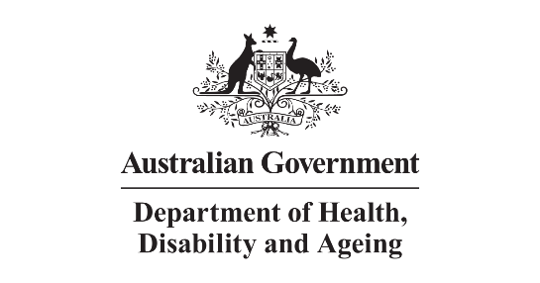 | The National CVS project is being run by the Department of Health, Disability and Ageing.
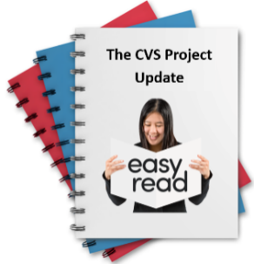 | We will share a project report after the project has been evaluated.

What we are doing now
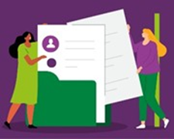 | We have sent services information about the CVS project.
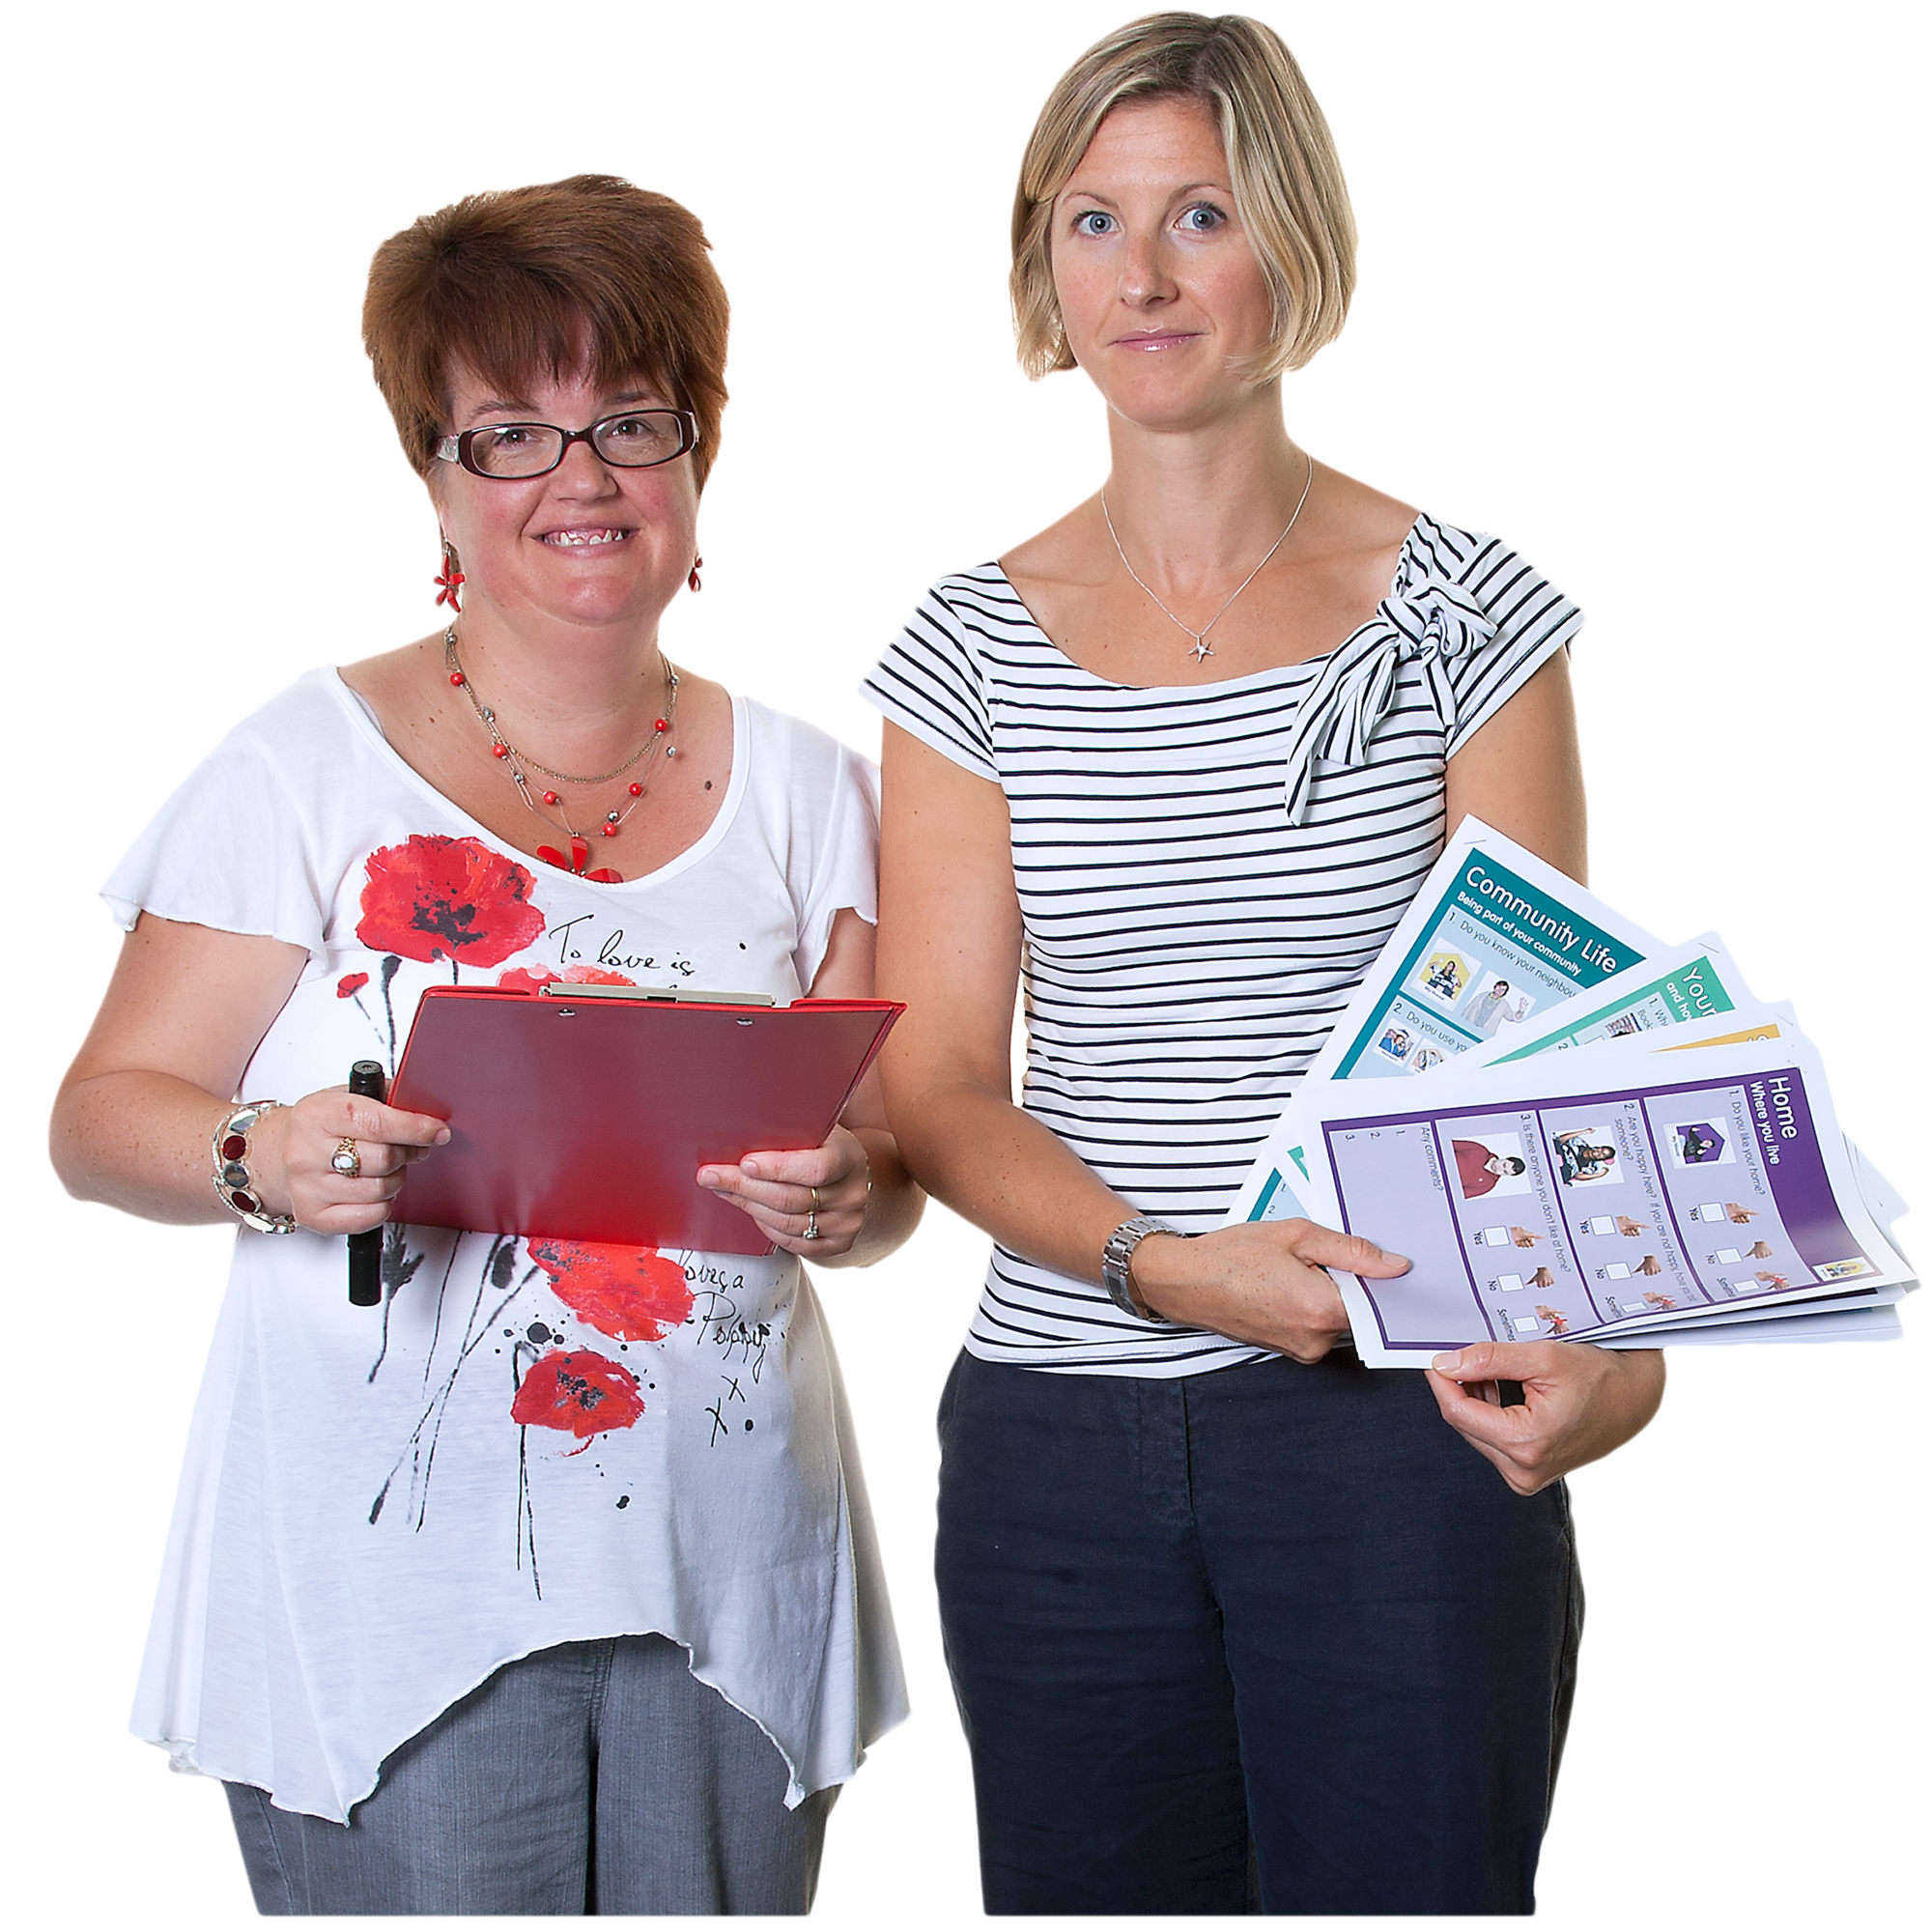 | We will share information about NDIS services with the ACT Official Community Visitors, the NT Principal Community Visitor, the QLD Public Guardian, the SA Principal Community Visitor and the VIC Public Advocate.
 | We will share information about 2 kinds of services for people with disability.
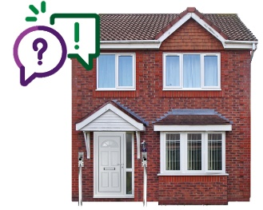 | The information we will share is about  - Specialist Disability Accommodation or SDA  - Supported Independent Living or SIL.
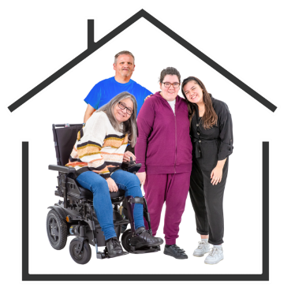 | SDA means homes where people with disability can live and get support.
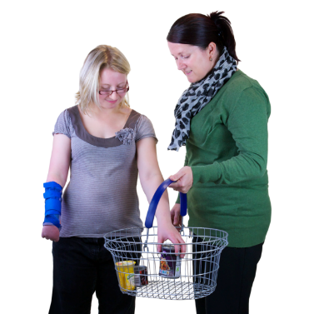 | SIL is support for your daily things like going shopping.
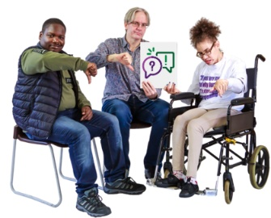 | We will share the information to make it easier  for community visitors to  - Know who to visit and when
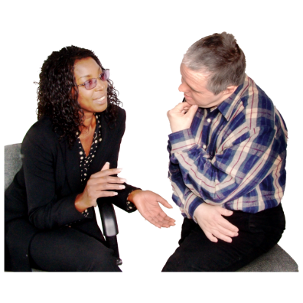 | - Talk with staff
 | - Make sure people are safe
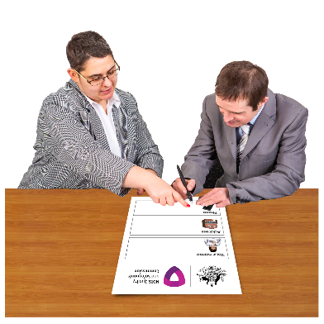 | - To help people if they have a complaint.
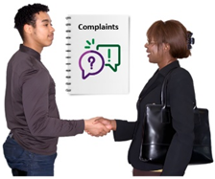 | Community visitors send us complaints that we want to know about.
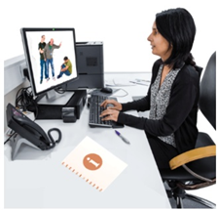 | Good information from community visitors helps  us to know about abuse and neglect.

What we have done so far
 | We have collected information about what community visitors do all over Australia.
 | We have asked the NSW Ageing and Disability Commission, the ACT Official Community Visitors, the NT Principal Community Visitor, the QLD Public Guardian, the SA Principal Community Visitor and the VIC Public Advocate what information helps them when they visit people.
 | We have shared information with the NSW Ageing and Disability Commission about new services.

What we will do next
 | We will share information with the ACT Official Community Visitors, the NT Principal Community Visitor, the QLD Public Guardian, the SA Principal Community Visitor and the VIC Public Advocate.
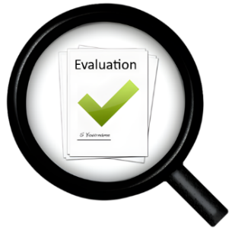 | We will do an evaluation on the CVS Project.
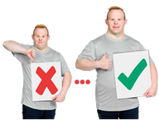 | Evaluation means we look at what  - Went well  - We could do better.
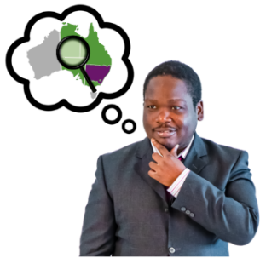 | This will help us know how we can keep supporting other community visitors in different parts of Australia.

More information
 | You can contact the NDIS Commission for more information about the CVS project.
 | You can  - Call us on 1800 035 544
 | - Email us at contactcentre@ndiscommission.gov.au
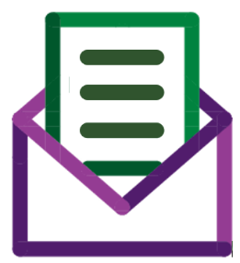 | - Send us a letter to  NDIS Quality and Safeguards Commission  PO Box 210  Penrith NSW 2751.

You can go to our
- Website at www.ndiscommission.gov.au
 | - Facebook page at www.facebook.com/NDISCommission
 | - LinkedIn page at au.linkedin.com/company/ndiscommission

 | The NDIS Commission made this Easy Read information.  You must not use any of the images without asking us first.

