NDIS behaviour support practitioners
  - Quick reference guide – How to apply for New Entry-Level practitioner suitability reconsideration
‘New entry-level practitioners’ are practitioners that were considered suitable through the New Entry-Level pathway (alternative pathway) when they applied to be an NDIS behaviour support practitioner.
New Entry-Level practitioners are required to have their suitability reconsidered by the NDIS Commission 12 months after being considered suitable as a NDIS behaviour support practitioner. A letter will be sent via email to the practitioner outlining the requirements and timeframes for the reconsideration process.

Reconsideration process
New entry-level practitioners should only submit a self-assessment once they are formally invited to do so from the NDIS Commission.
If the self-assessment process is not completed within the timeframes identified in the letter, suitability as a NDIS behaviour support practitioner may be revoked.
During the reconsideration process, the new entry-level practitioner can continue working as a NDIS behaviour support practitioner unless advised otherwise.

How to complete a new entry-level reconsideration application

1. Prepare for your application
The following resources will support you with the application.
Positive Behaviour Support Capability Framework
This resource describes:
- The capabilities you need to have, to provide specialist behaviour support under the NDIS
- The standards your new entry-level suitability reconsideration application will be assessed against.
Self-assessment Resource Guide for the Positive Behaviour Support Capability Framework
This resource:
- Describes how new entry-level practitioners can assess their own capabilities against the Capability Framework
- Provides an example of the self-assessment questions you will need to answer.
Note: You can use the Self-assessment Tool to understand the requirements and prepare for your application. You are required to complete the self-assessment questions in your online application.

2. Discuss your self-assessment with your supervisor
You will need to discuss your self-assessment with your supervisor and document the outcome of your discussion in the New Entry-Level Behaviour Support Practitioner Endorsement Tool. This tool:
- Examines your self-assessment against the Capability Framework
- Validates your self-assessment and portfolio of evidence
- Must be completed and signed by you and your supervisor
You must upload the completed tool in your online application.
When a behaviour support practitioner is considered suitable, their portal access moves from the applications portal to the NDIS provider portal.
Important note: An auto-generated verification email is sent when the application is approved. This can end up in you spam or junk email folder. You must click on the link in the auto-generated verification email in order to complete your practitioner profile access. If you are unable to access your practitioner profile via the link, please contact us using the NDIS Commission Portal technical help form.
This Quick Reference Guide explains the step-by-step process of lodging a suitability application for the reconsideration of new-entry practitioners.

In this guide
- Logging into the NDIS Commission Provider Portal
- Lodging a new entry-level reconsideration application
- Completing the practitioner Self-Assessment
- Accessing your outcome letter
- About Digital ID and myID app

Logging into the NDIS Commission portal
- On the NDIS Commission homepage, select the Portal dropdown at the top right of the page and select Registered NDIS providers.
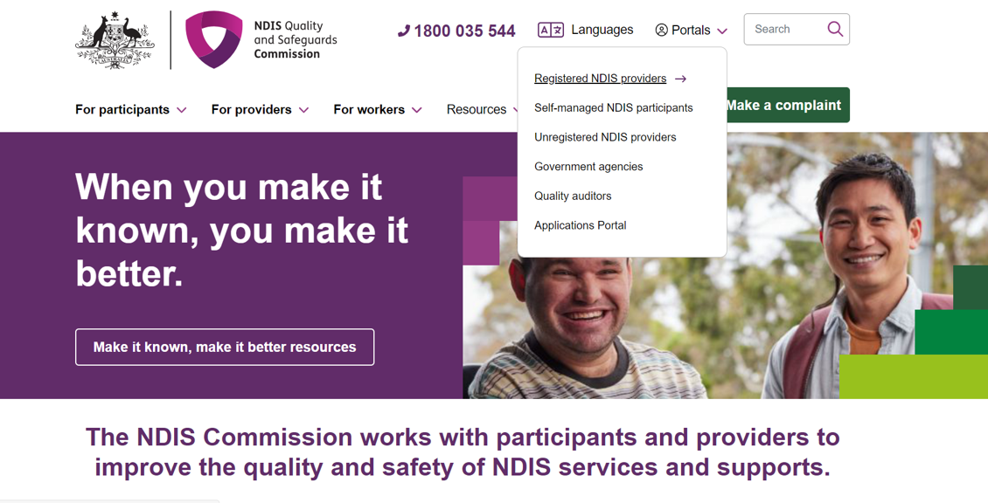
- Select Log in.
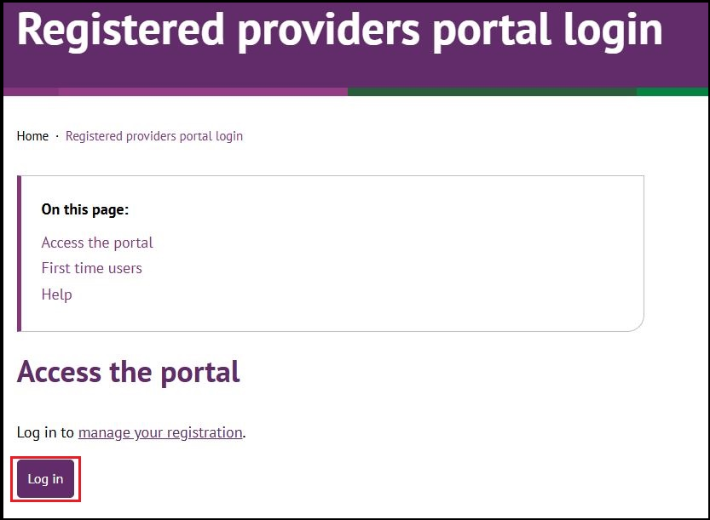
- Select Continue with Digital ID

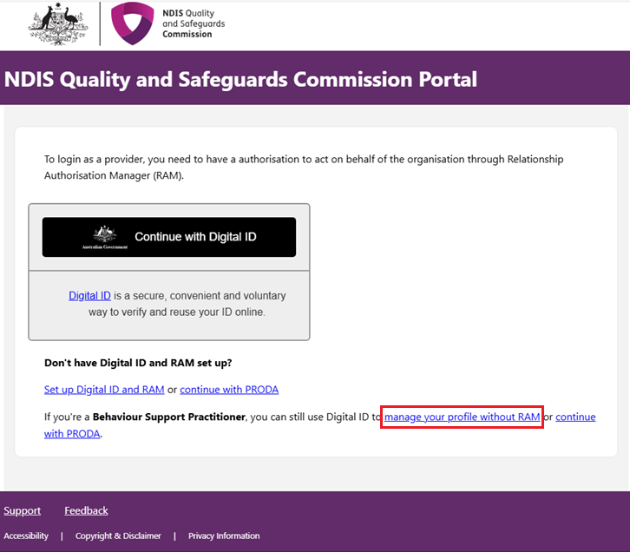

- Select Select myID
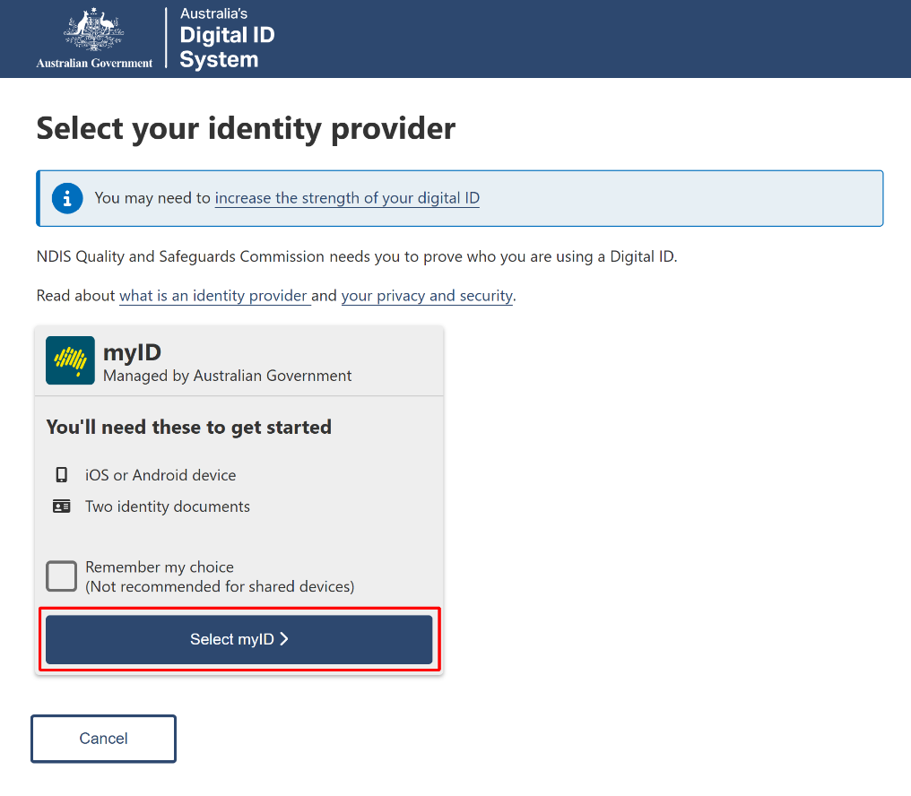

- Enter your myID email and select Get code. If you don’t have an account, you can register for a Digital ID (myID).
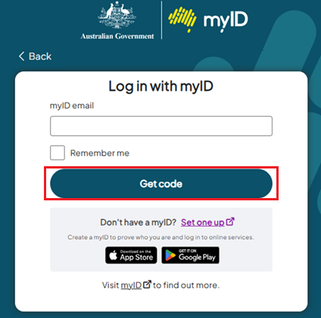

- A code will be generated.
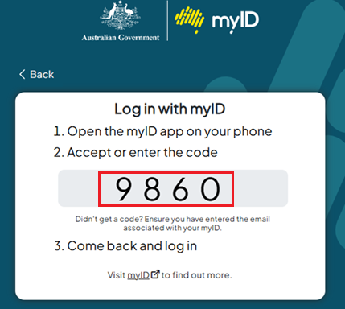
- Open the myID app on your phone and either accept the request or enter the code.
- Select Your account and the Role to log on and then select Continue

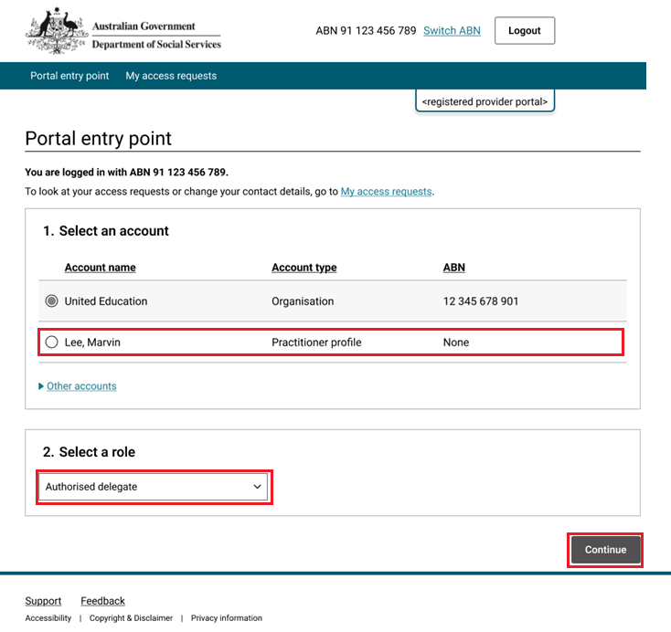

- Select I agree.
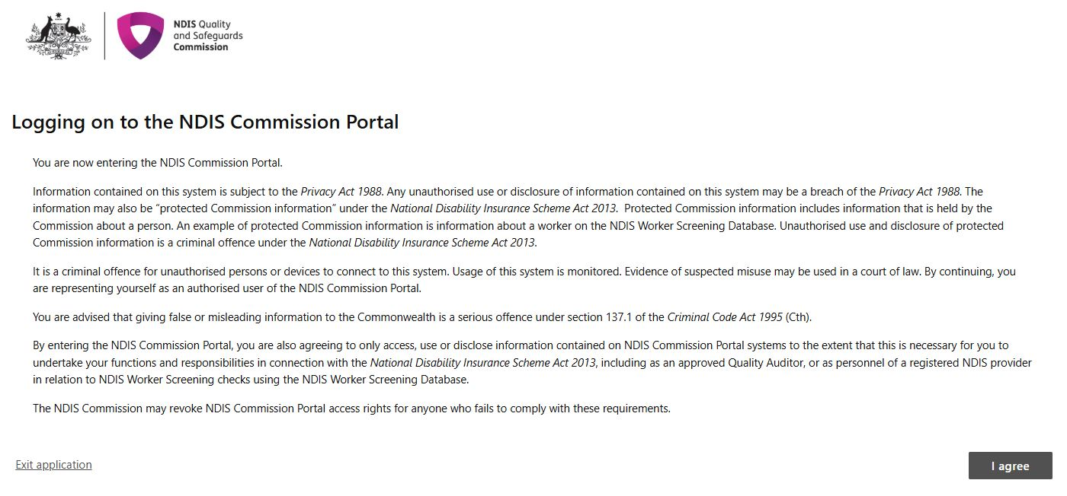
This should successfully log you on to the Portal.

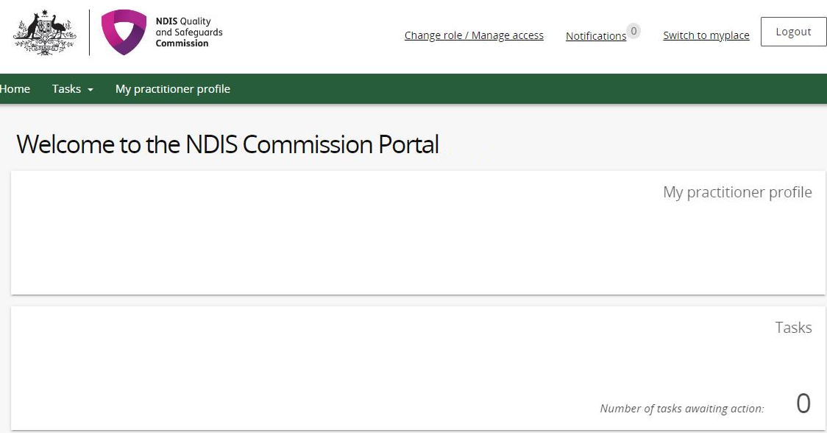
- On the Welcome to the NDIS Commission Portal select My Practitioner Profile.

Lodging a new entry-level reconsideration application
- On the left navigation menu bar, select ‘Applications’.
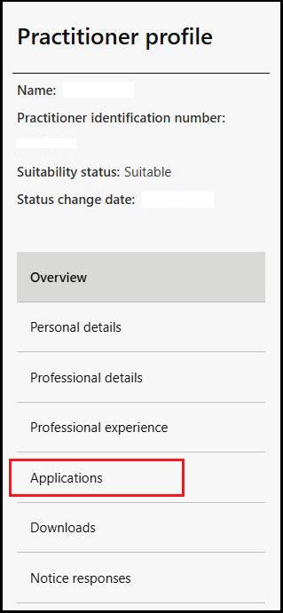
- Select ‘Start an application’.
  - Note: You will not be able to start a new application if you have any outstanding with a status of ‘Draft’, ‘Submitted’, ‘Information Request’ or ‘Assessment’.
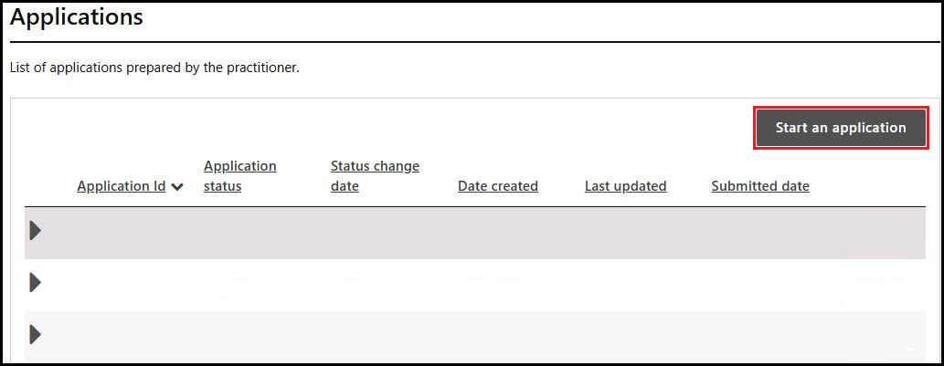
- On the Overview page read the information under the heading “Preparing to apply” and “How to complete this application”.
- Select Personal details on the left navigation menu.
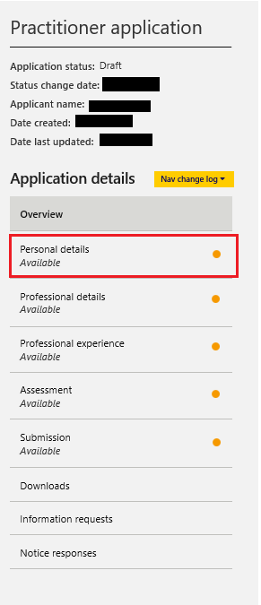
- If any “Personal details” are missing or incorrect, select Update and enter the required information.
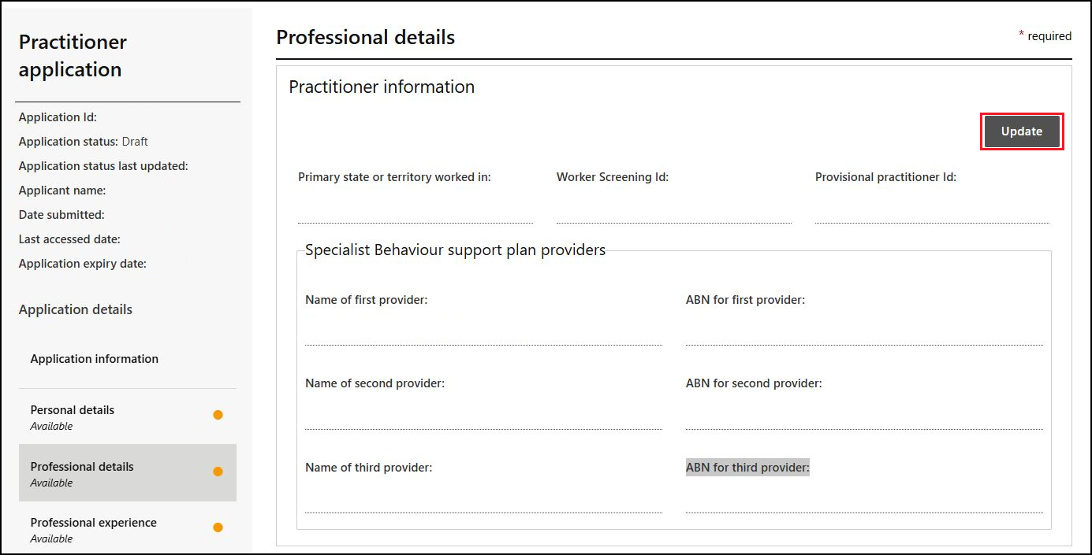
- On the Professional details page, select Update under “Practitioner information” and enter the required information.
- Under “Primary state and territory worked in,” choose your respective state or territory from the drop-down menu.
- Under “Worker Screening Id,” enter in your NDIS Worker Screening number.
- Practitioners considered suitable are encouraged to have their name and contact details published on the NDIS Commission website. If you consent to your name and contact details being published on the NDIS Commission website, select Update and enter the details that you wish to be published. Then select Mark as complete and continue to progress through the application.
- If you do not consent to publishing your contact details on the NDIS Commission website when considered suitable, click Mark as complete and continue.
- Under “Employment history” select Add and enter any information relevant to behaviour support.
- Under “Behaviour support experience,” select Update and enter the required information.
- Under “Qualifications and training,” select Add and enter the required information relevant to your role as a behaviour support practitioner.
- Under “Professional registrations and associations,” select Add and enter any relevant information.
- Under “Attachments,” select Add attachment and attach a copy of your current resume and certified copies of any qualifications stated. Your current resume should include details of all positions held since you were first considered suitable as an NDIS behaviour support practitioner, including your current employer and start date in this role.
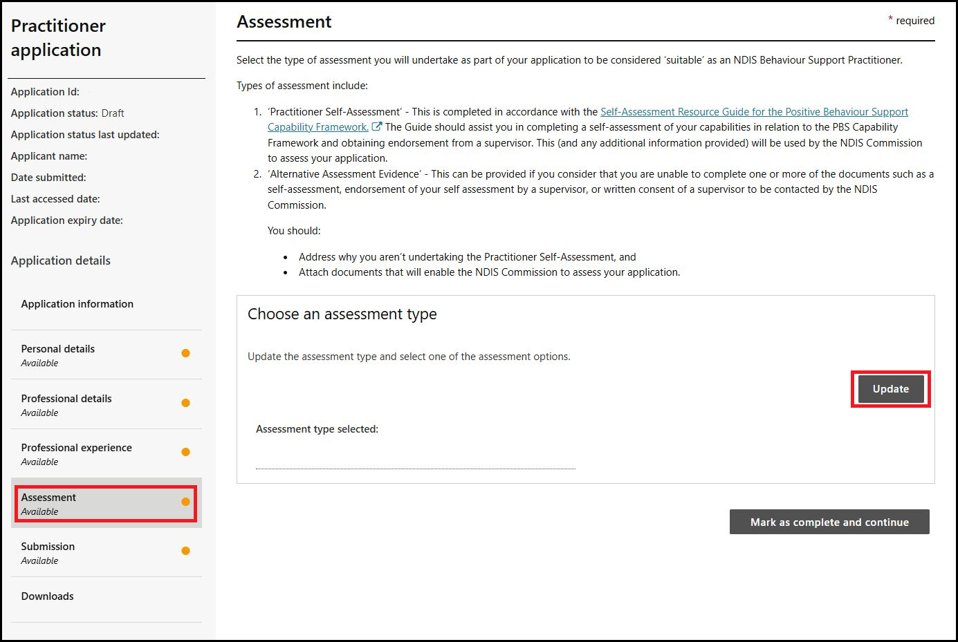

Completing the Practitioner Self-Assessment
- Navigate to the Assessment page on the left navigation menu and select Update under “Choose an assessment type”.
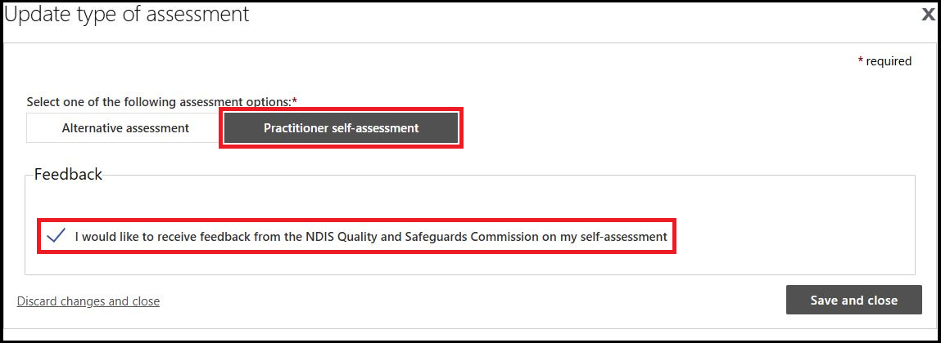
- Select Practitioner self-assessment under “Select one of the following assessment options:”
- Select the box under Feedback, to provide you with an opportunity to receive feedback from the NDIS Quality and Safeguards Commission on your self-assessment.
- Select Save and close to progress through the application.
- If Practitioner Self-Assessment is selected, the Practitioner self-assessment page will appear.
- Read or listen to the relevant information on the page regarding the requirements of using the “Practitioner self-assessment” tool.
- Start from the Core Practitioner Level under the “Self-assessments” title. Select Actions and click Update.
Select Action and select Update for each Capability domain. Please ensure all items have been responded to as either Met, Developing or Not met. Once items are completed, enter the relevant information for “Sources of evidence”.
- Select Save and return when a capability domain is completed.
- Once all capability domains are completed, select Back to the “Practitioner self-assessment” page.
- Once the Core Practitioner Level is completed, the Proficient Level will become available. Work through each practitioner level up to the level that you have self-assessed at. Please note that if the Proficient level is met, both Advanced and Specialist levels will become available. You can self-assess at either an Advanced level or a Specialist level (or both) if you have met the capability for the Proficient level.
- Under “Supervisor details,” select Update, this will activate a pop-up screen. Enter the relevant information to identify your supervisor. Select Save and close once that is completed.
- Under “Postal address,” select Add and enter the relevant information.
- Under “Supervisor’s endorsement and consent,” select Update and select answers from the drop-down menu. Select Save and close once that is completed.
- Under “Attachments,” select Add attachment, add a copy of your supervisor’s endorsement using the completed New-Entry Level Behaviour Support Practitioner Endorsement Tool.
- Once attached select Mark as complete and continue.
- Read the “Declarations” and select Agree and submit.
- Your application is now complete.
- If the submit button is greyed out, please review the application to ensure all aspects have been completed.

Help with accessing your Practitioner Suitability Outcome Letter.
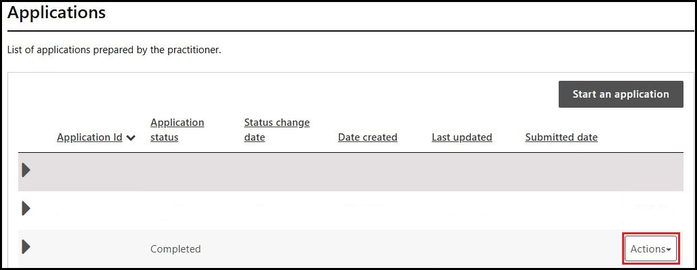
- Login to the NDIS Commission Provider Portal.

- Select on Applications in the left navigation menu under the title Practitioner profile.
- From the drop-down list, select Actions on your completed application and select View.
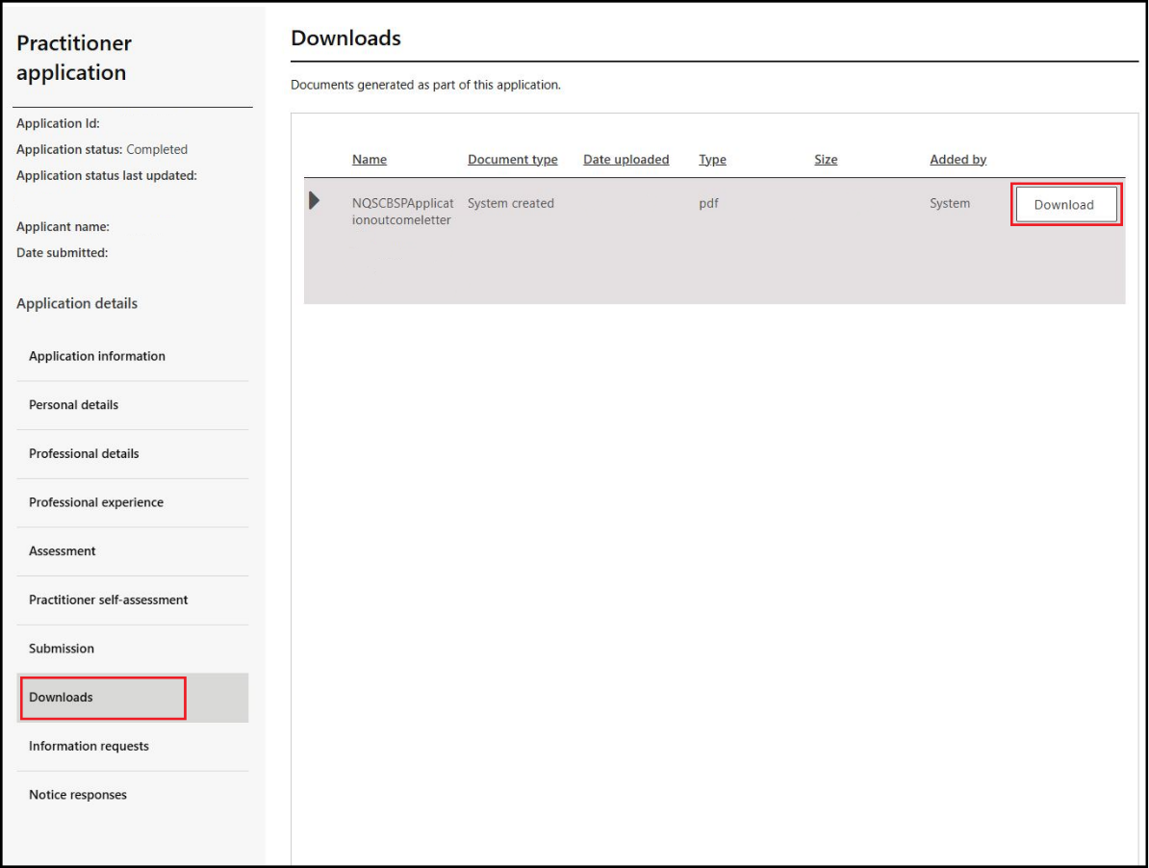
- Select Downloads on the left navigation menu then download the latest Application Outcome Letter from the list.

About Digital ID and myID app

Digital ID is a whole-of-government digital identity solution which can be used by Australians to prove who they are online and provide an identity that can be used to access participating government online services.
To gain access to the NQSC Application Portal, you will need to have set up your Digital identity in myID app.
Using Digital ID to log into the NQSC portals provides a high level of assurance that only the appropriately identified and authorised people are accessing NQSC systems.

To learn more about Digital ID, visit What is Digital ID? | Digital ID System website.

The Australian Government's Digital ID app is called myID. To access government services using a Digital ID, you need to set up a myID account. please visit the Help section on the myID website.

Further information or support
Contact the NDIS Quality and Safeguards Commission
Email: ndispractitioners@ndiscommission.gov.au

