Log in to the database once your access has been finalised
- Go to the Homepage | NDIS Quality and Safeguards Commission
Once you have access to the Worker Screening Database you will select the below login option
Go to Portal Login > select Self-managed participants login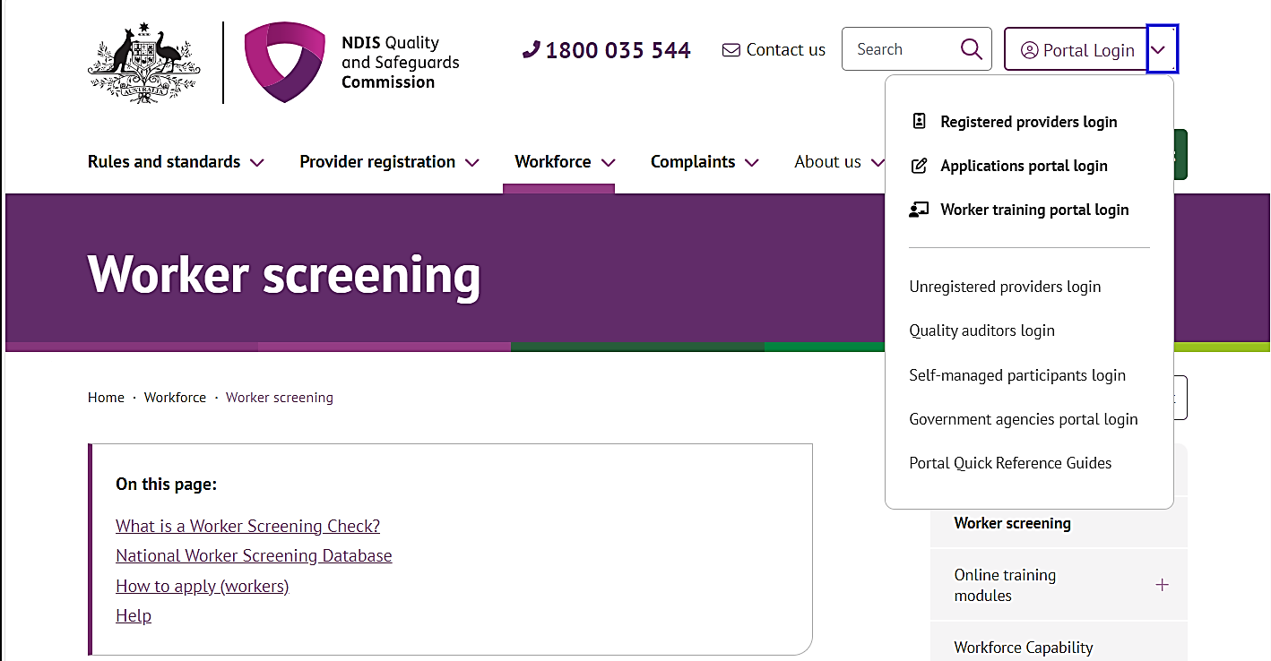
- Once you get to the Self-managed participants portal login webpage, click Login
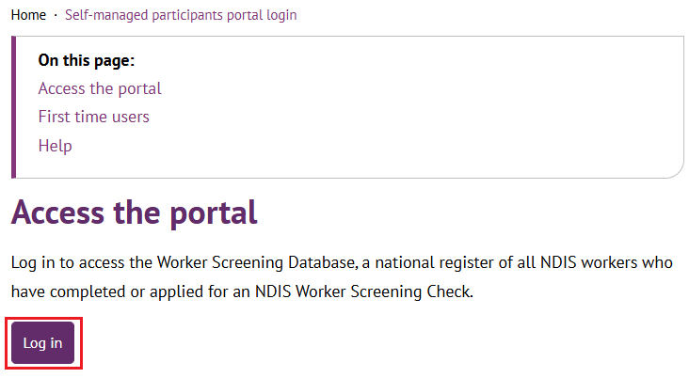
- You can log in to the Applications Portal by clicking either Login to PRODA or Continue with Digital ID.

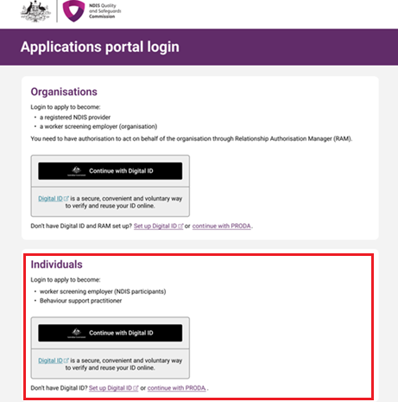

- Select your Name, use the dropdown and select Worker Screening for NDIS Participants OR Authorised Access Delegate role > Continue.

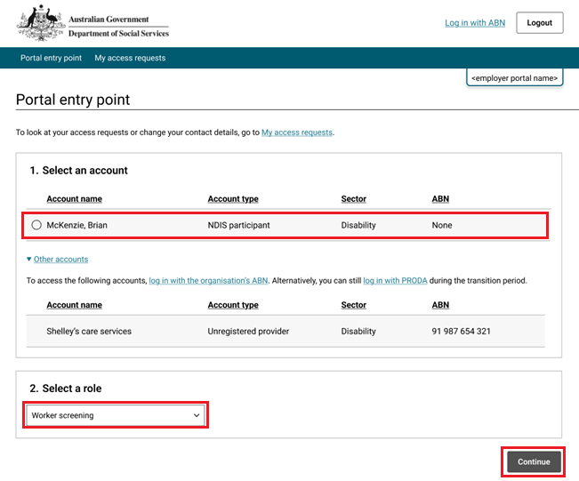
- Read the declaration and click I Agree. 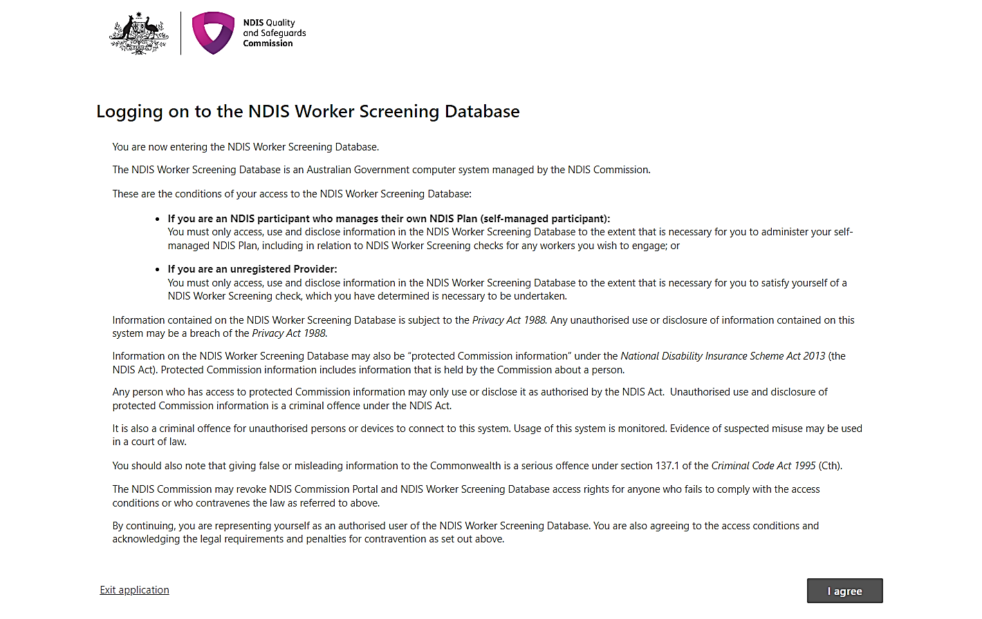

- You are now in the NDIS Worker Screening Database.
