Finalise access to the NWSD once your application has been approved: Participants
You will receive an email with a link to continue the finalisation of access, if your link expires or is not working, please follow the below steps.
- Go to the Homepage | NDIS Quality and Safeguards Commission
- Go to Portal Login > Self-managed participants login.
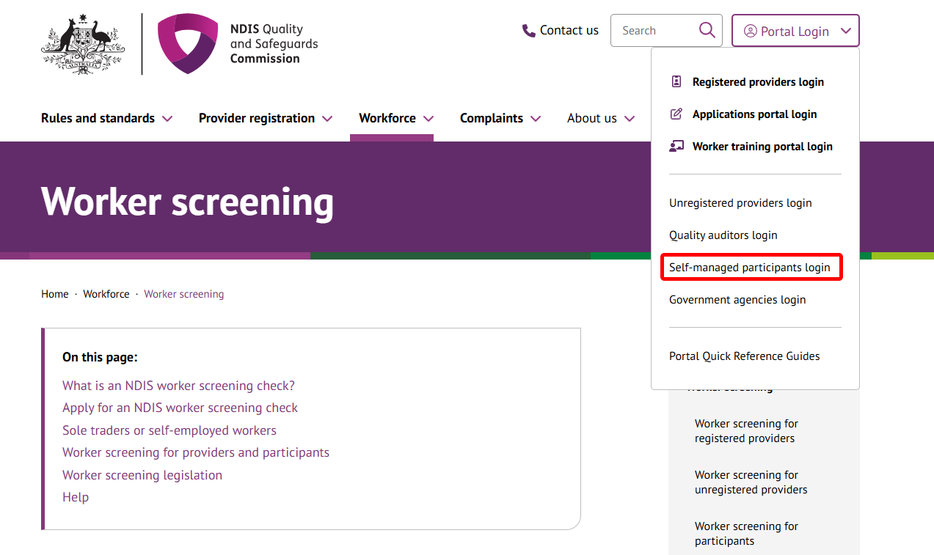
- Once you get to the Self-managed participants portal login webpage, click Login
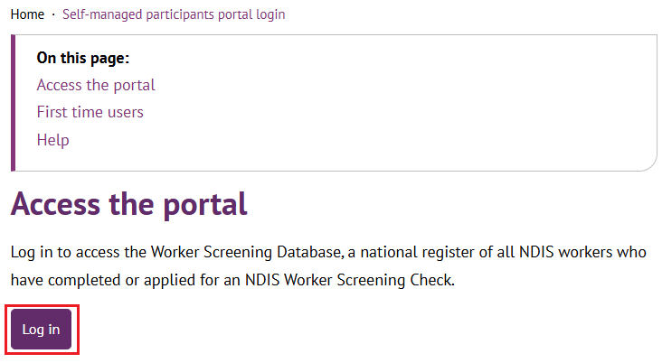
- You can log in to the Applications Portal by clicking either Login to PRODA or Continue with Digital ID.
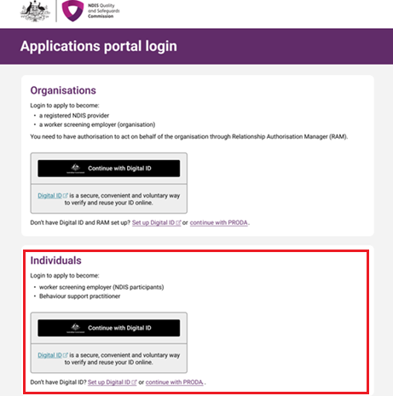

- Click Create a new request.
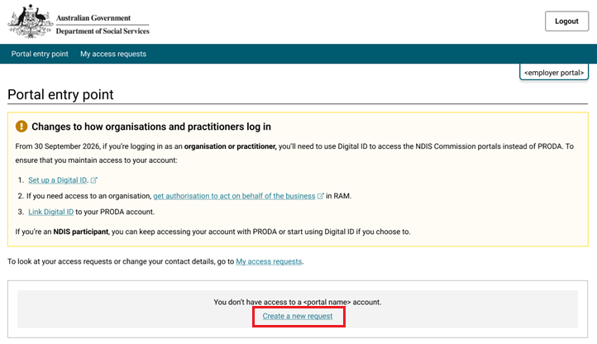
- Click I am ready to request access. 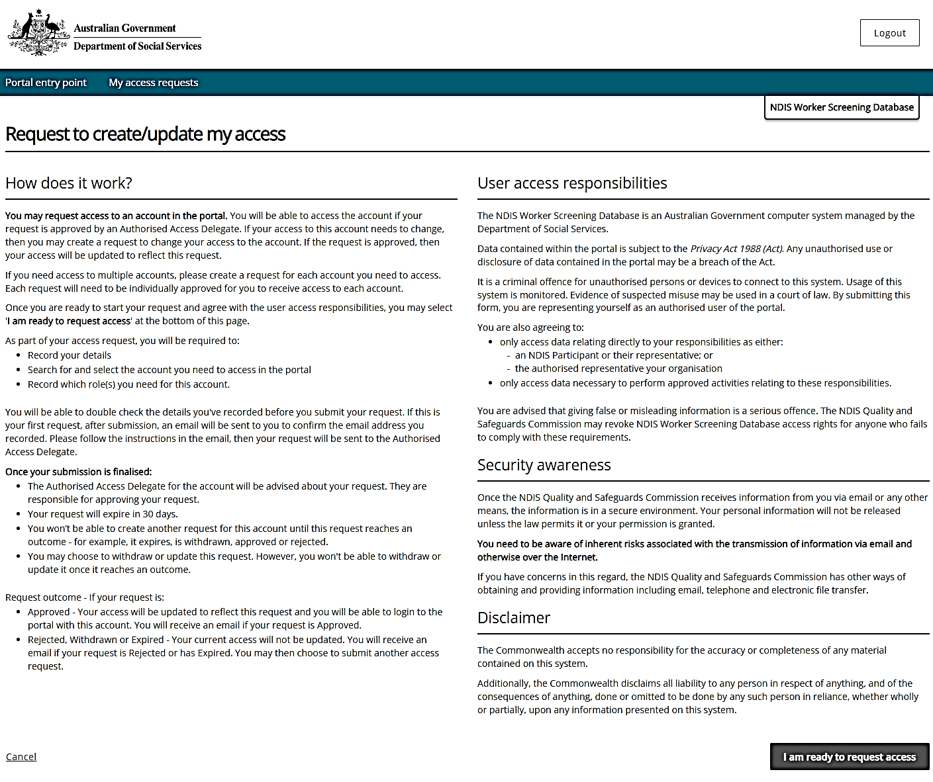
- Click Organisation for Worker Screening employer > Next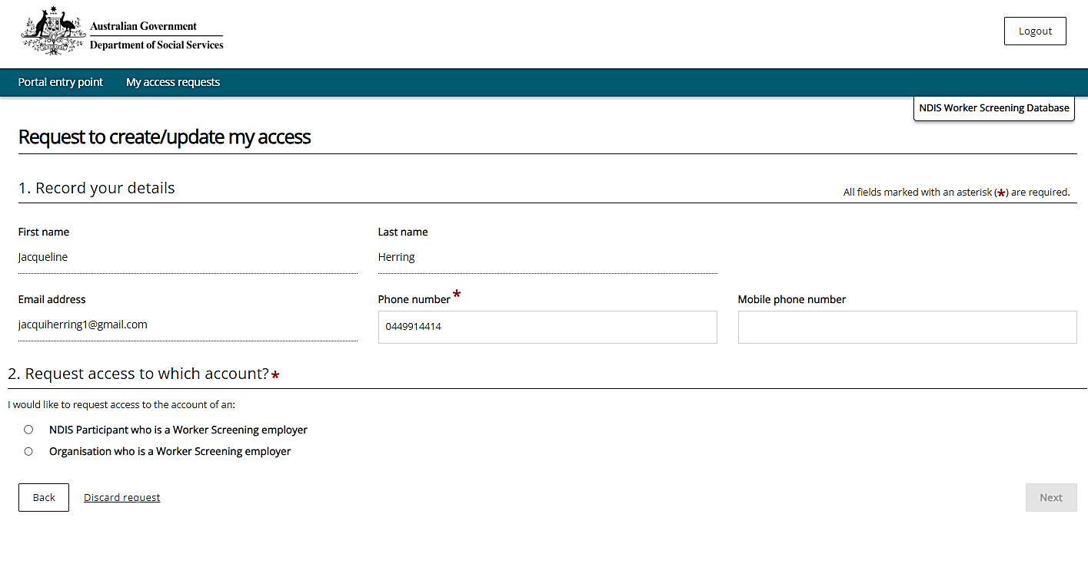
- Enter your Participant WS ID and Last Name > Run search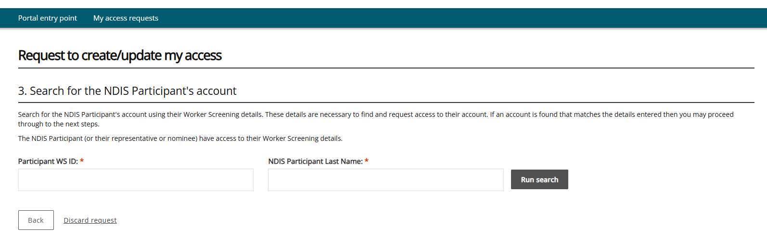
- Confirm these are your participant details and click Next. 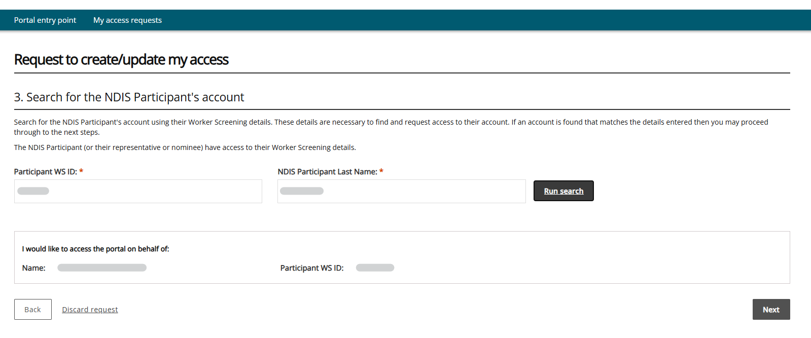
- Select Worker Screening for NDIS Participants and Authorised Access Delegate as the roles > click next. 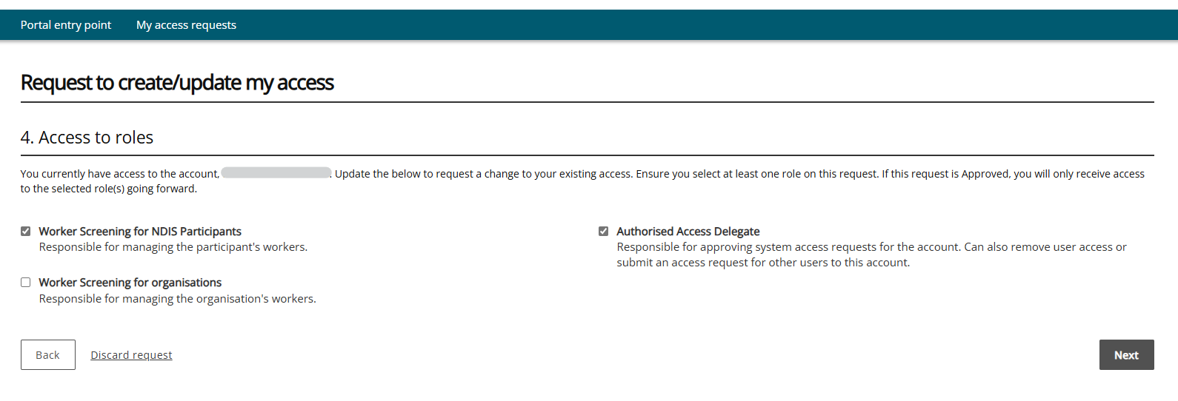
- Tick - I confirm the above details are correct > click submit.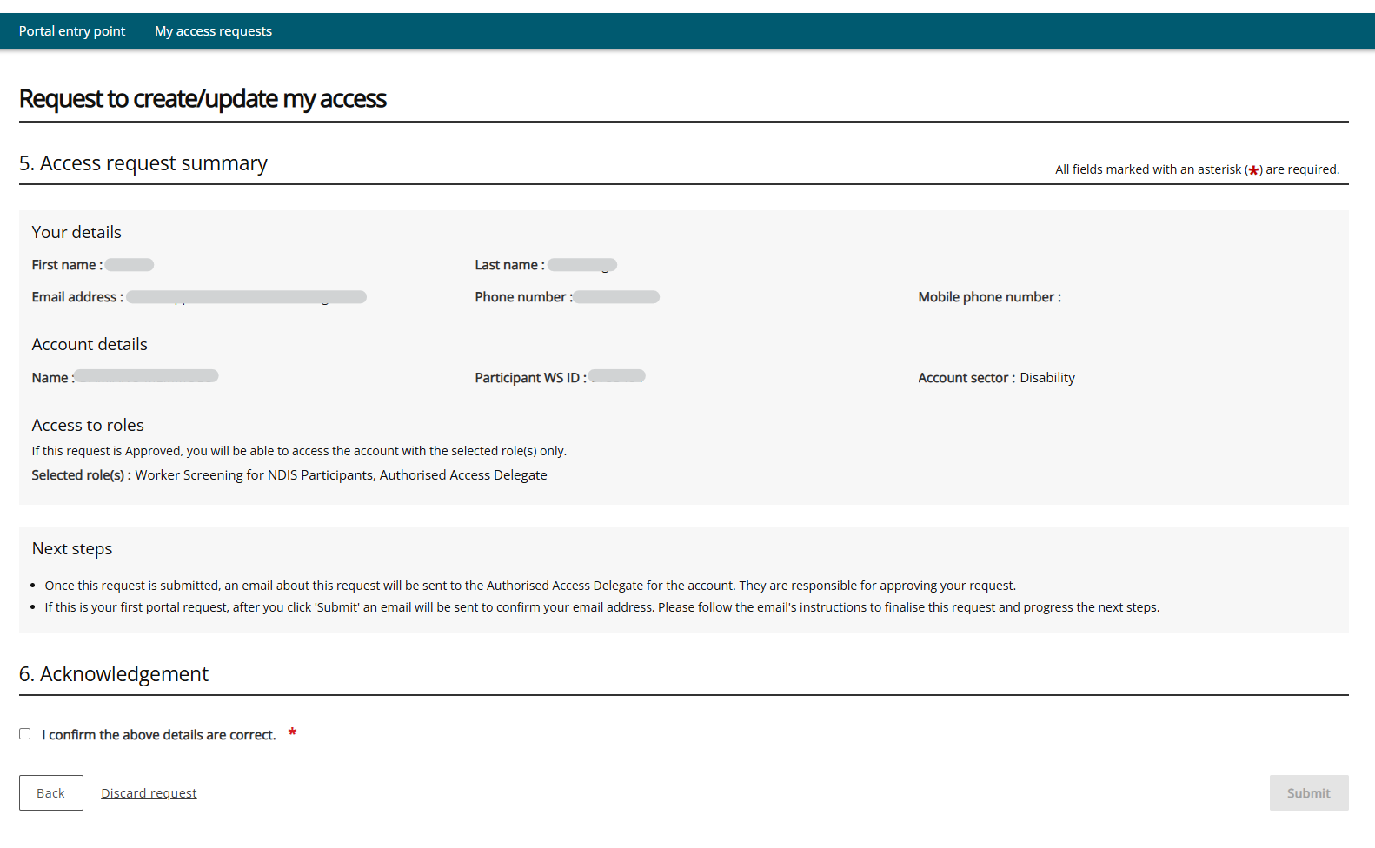
Click Finish. You will receive an email once your access has been finalised. This access request will generally take 24-48 hours to be updated in the database.

