Getting access to the NDIS Commission Portal
  - Quick reference guide – Providers registration

Only NDIS Providers registered with the NDIS Commission can access the NDIS Commission Portal. This part of the Quick Reference Guide explains the step-by-step process of successfully logging in to the NDIS Commission Portal.

In this guide
- Logging in to the NDIS Commission Portal
- Request new user roles
- About Digital ID, myID app and RAM
- Help with accessing the NDIS Commission Portal

Logging in to the NDIS Commission portal
- Click Portal. Select Registered NDIS providers
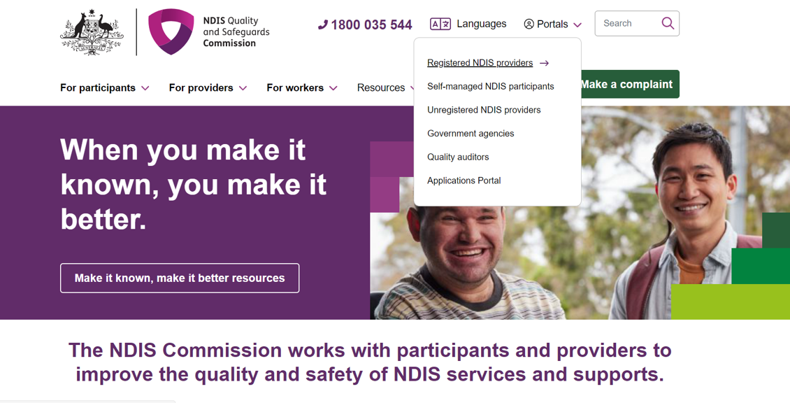
- Once you get to the Registered providers portal webpage, click Login
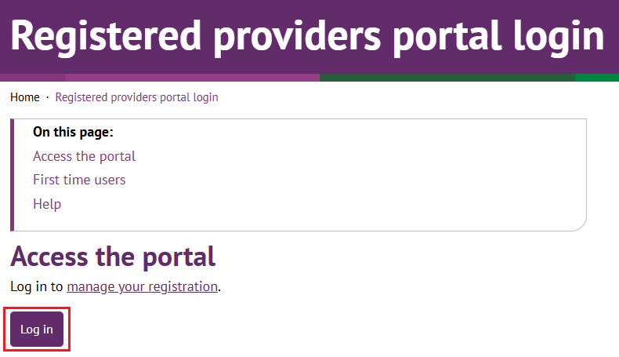

- Click Continue with Digital ID

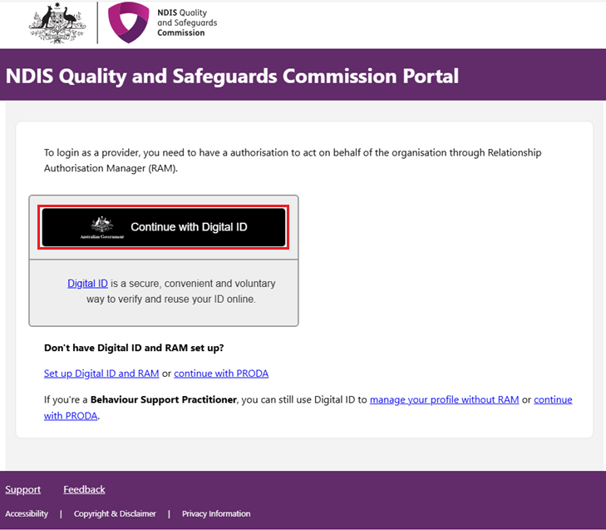

- Click Select myID
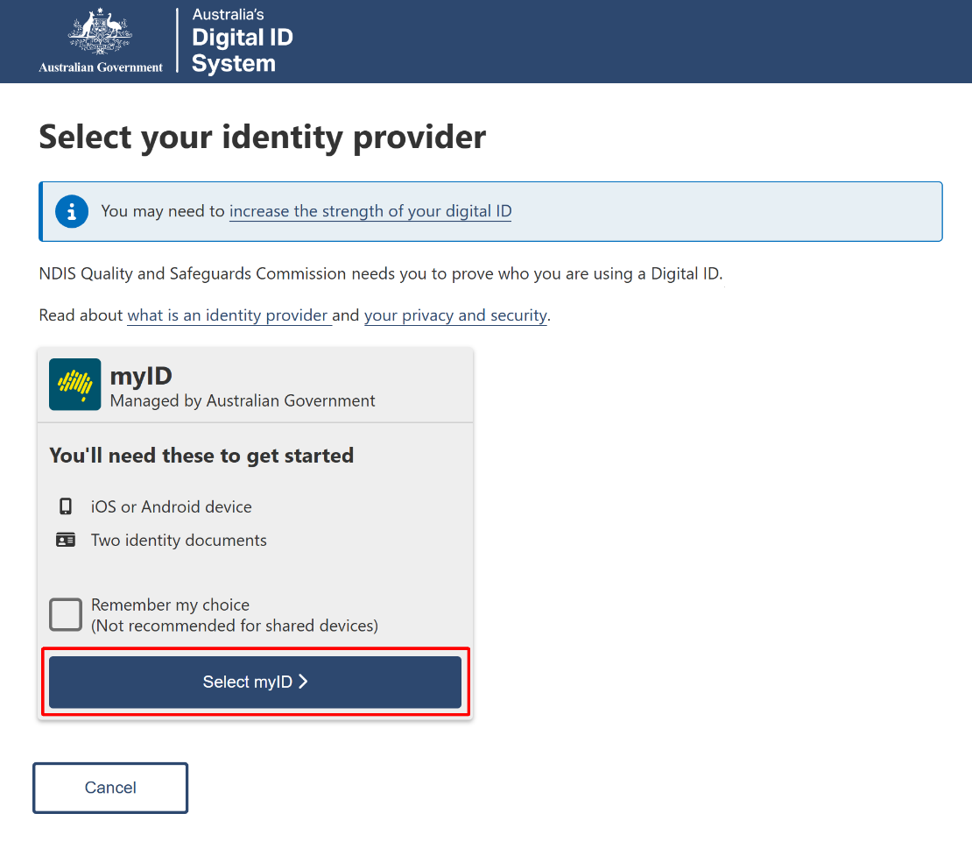

- Enter your myID email and click Get code. If you don’t have an account, you can register for a Digital ID (myID).
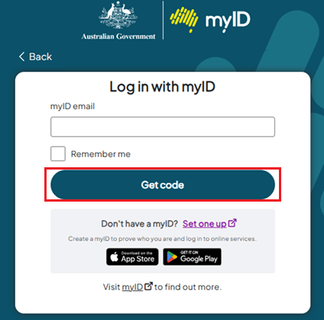

- A code will be generated.
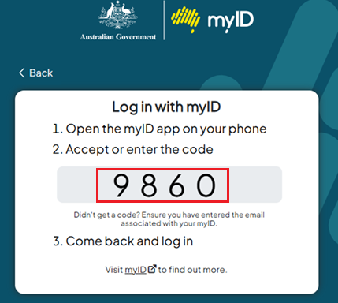

- Open the myID app on your phone and either accept the request or enter the code.
- If you have authority for multiple provider organisations, you will be directed to the RAM Australian Business Number (ABN) selection page, where you must choose the organisation, you wish to represent in the NDIS Commission portals. If you only have authority for one provider organisation, you will bypass this selection page.
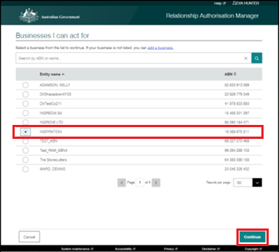

- Select the Provider and the Role to logon and then click Continue

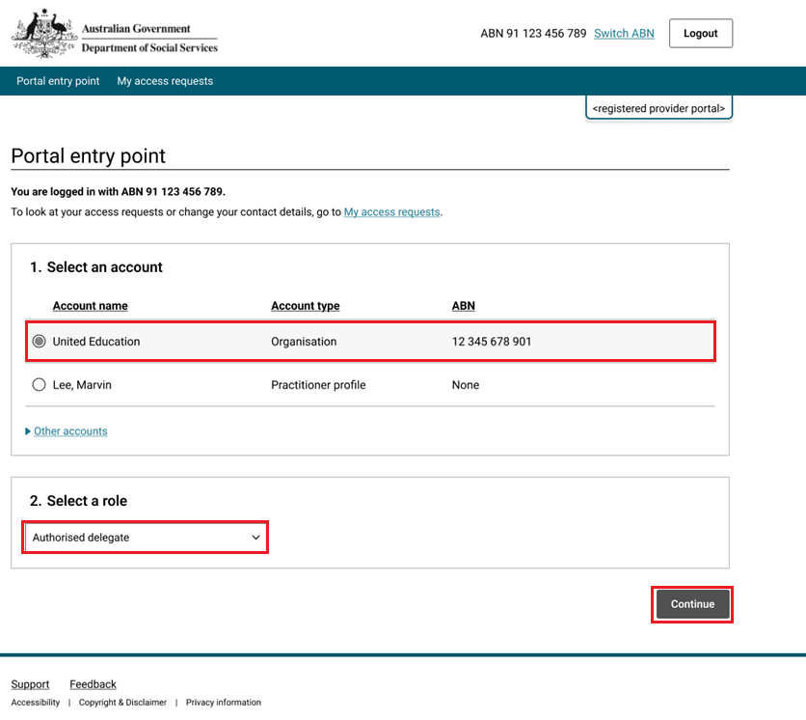

- Click I agree
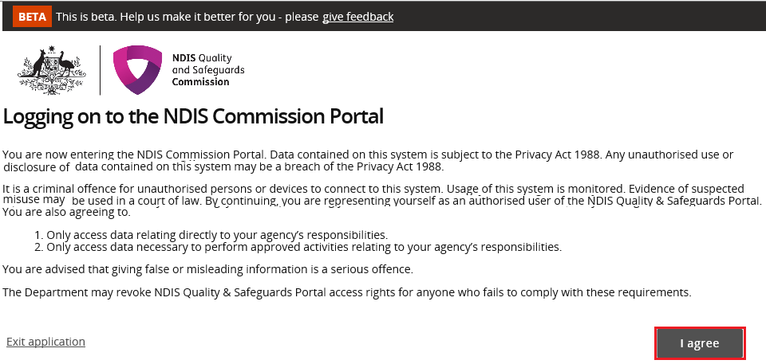
This should successfully log you on to the Portal.

Request new user roles
A staff member can request a new user role using the Commission Portal, for this the user first needs to successfully login to Digital ID and RAM.
- After logging in to Digital ID and RAM, at Portal entry point, click My access requests

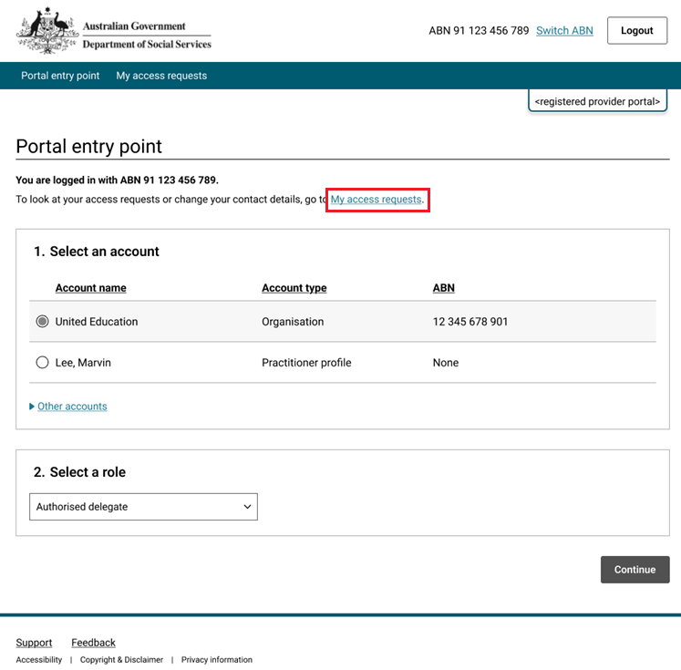
- Click Create a new request
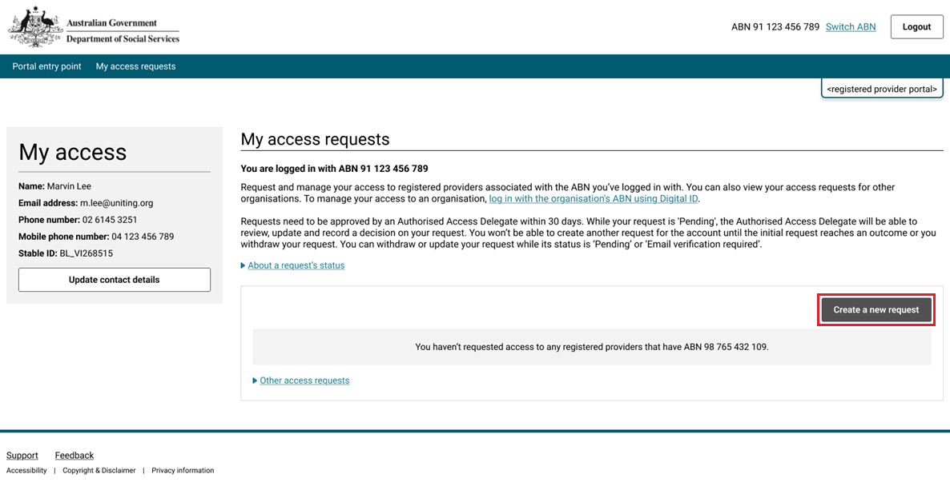

- Click I’m ready to request access
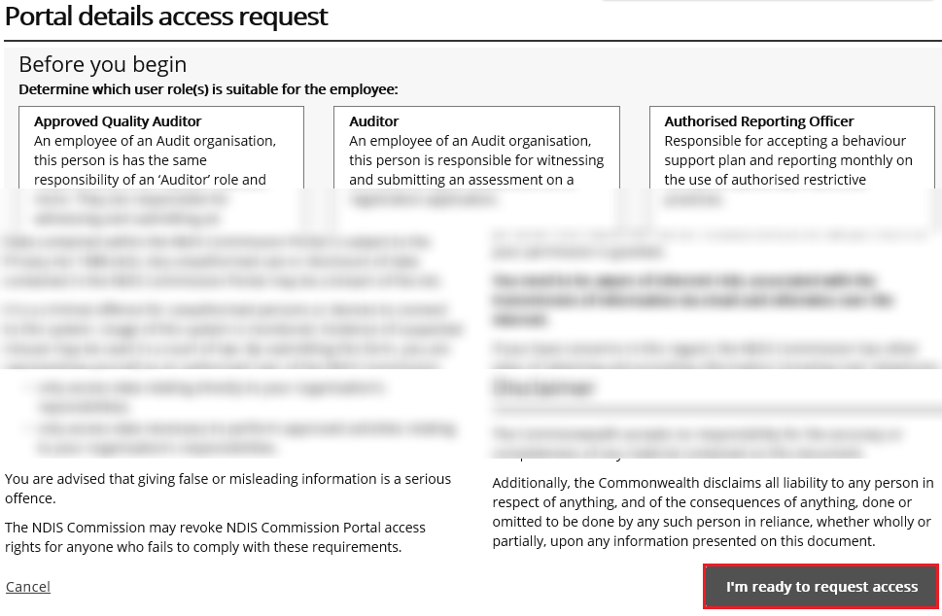

- Record your email and phone details and click Next
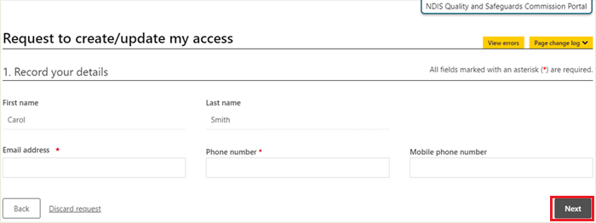

- To request the creation of a user role access, confirm the organisation’s account by clicking Select
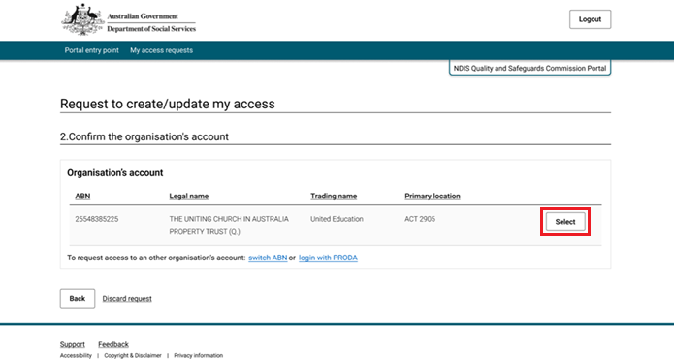

- Select the user roles that are required and click Next
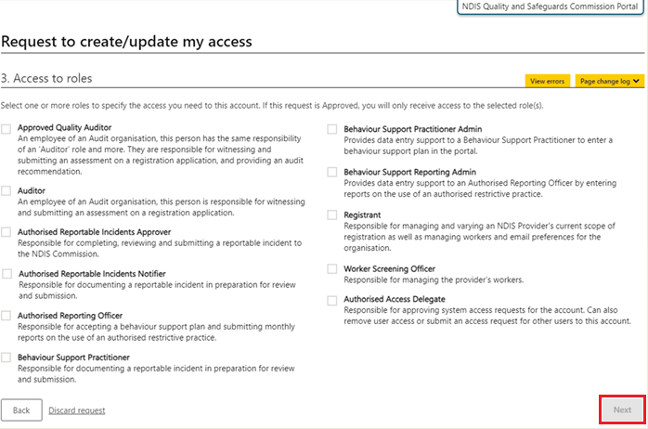

- Review the Summary access request and click the checkbox labelled ‘I confirm the above details are correct’, then click Submit.
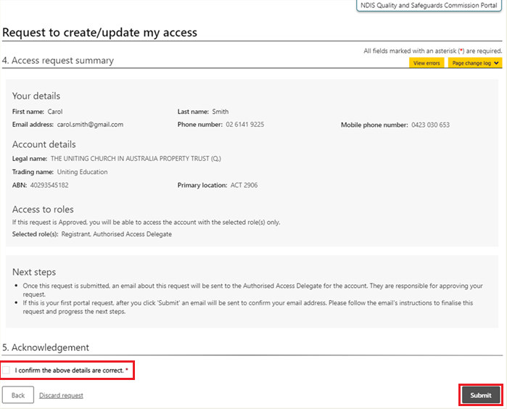

About Digital ID, myID app and RAM

Digital ID is a whole-of-government digital identity solution which can be used by Australians to prove who they are online and provide an identity that can be used to access participating government online services.
Relationship Authorisation Manager (RAM) is an authorisation service that allows you to access government online services on behalf of a business.
To gain access to the NQSC Provider Portal, you will need to have set up your Digital identity in myID app and authorisation(s) in RAM.
Using Digital ID to log into the NQSC portals provides a high level of assurance that only the appropriately identified and authorised people are accessing NQSC systems.

To learn more about Digital ID, visit What is Digital ID? | Digital ID System website.

The Australian Government's Digital ID app is called myID. To access government services using a Digital ID, you need to set up a myID account. please visit the Help section on the myID website.

For information about RAM (Relationship Authorisation Manager), go to the "Home" page on the RAM website. To find out how to link your myID to a business using RAM, visit Accessing online services with Digital ID and RAM on the Australian Taxation Office website.

