Getting access to the NDIS Commission Applications Portal
  - Quick reference guide – Applicants
The Quick Reference Guide explains the step-by-step process of successfully logging in to the Applications Portal through Digital ID for the first time.
The Applications Portal has two functions it gives you the ability to:
- apply to register as a provider
- be considered suitable as an NDIS behaviour support practitioner

To access the Applications Portal, you need a Digital ID account.

In this guide
Getting access to the NDIS Commission Applications Portal 1
Logging in to the Applications Portal through Digital ID for the first time 2
Logging in to the Applications Portal through Digital ID using an existing Digital ID account 10
About Digital ID and myID app 13

Logging in to the Applications Portal through Digital ID for the first time
- Go to the NDIS Commission website. Click Portals select Applications Portal
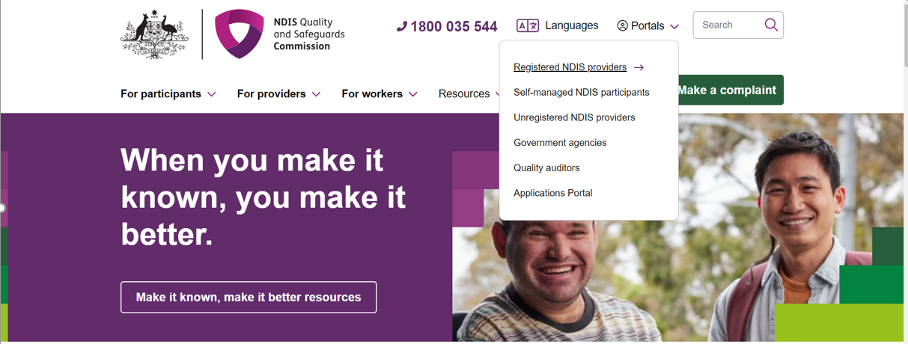

- Once you get to the Applications Portal webpage, click Login
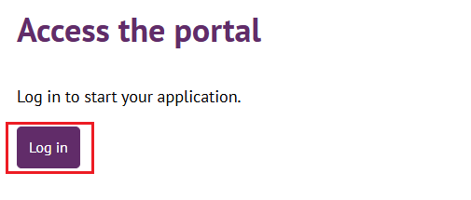

- Click Continue with Digital ID

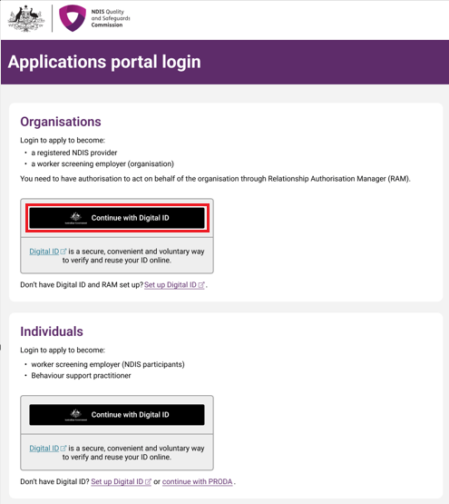
- Click Select myID
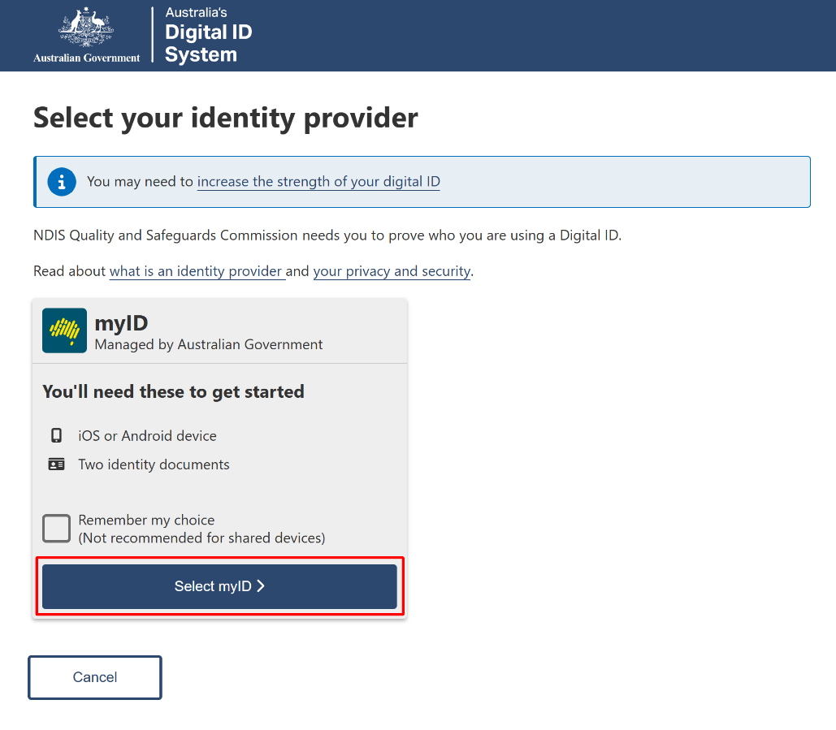
- Enter your myID email and click Get code. If you don’t have an account, you can register for a Digital ID (myID).
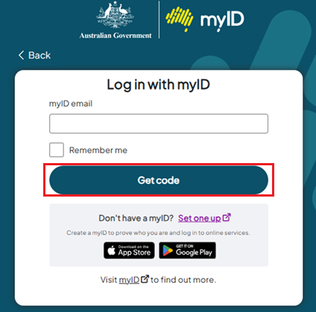
- A code will be generated.
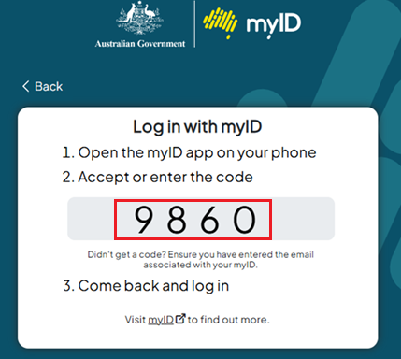

- Open the myID app on your phone and either accept the request or enter the code.
- If you have authority for multiple provider organisations, you will be directed to the RAM Australian Business Number (ABN) selection page, where you must choose the organisation, you wish to represent in the NDIS Commission portals. If you only have authority for one provider organisation, you will bypass this selection page.
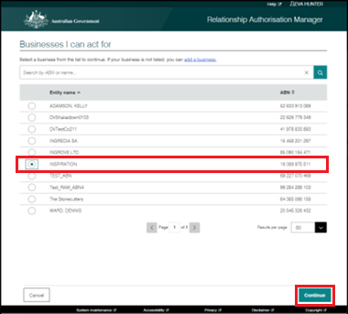

- Login again with your Digital ID details if requested. You will be taken to the New portal access page. After you have read the information, select Begin
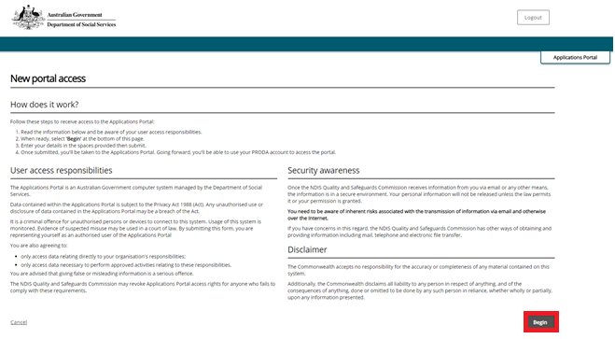
- Fill out your details and click Next
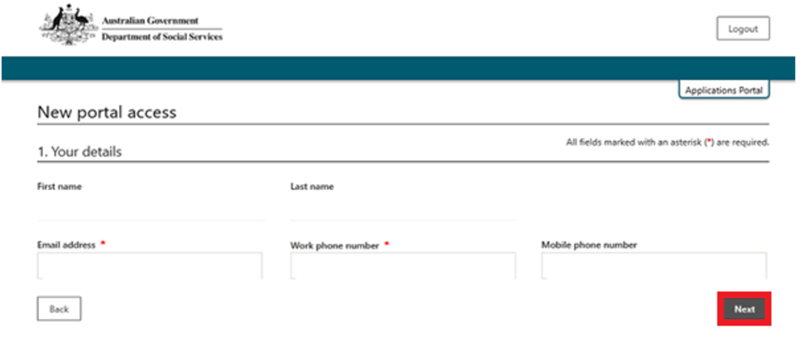
- Check if your details are correct. If correct, tick the confirm button and click submit. If incorrect, select the Back button to correct your details, then repeat this step.
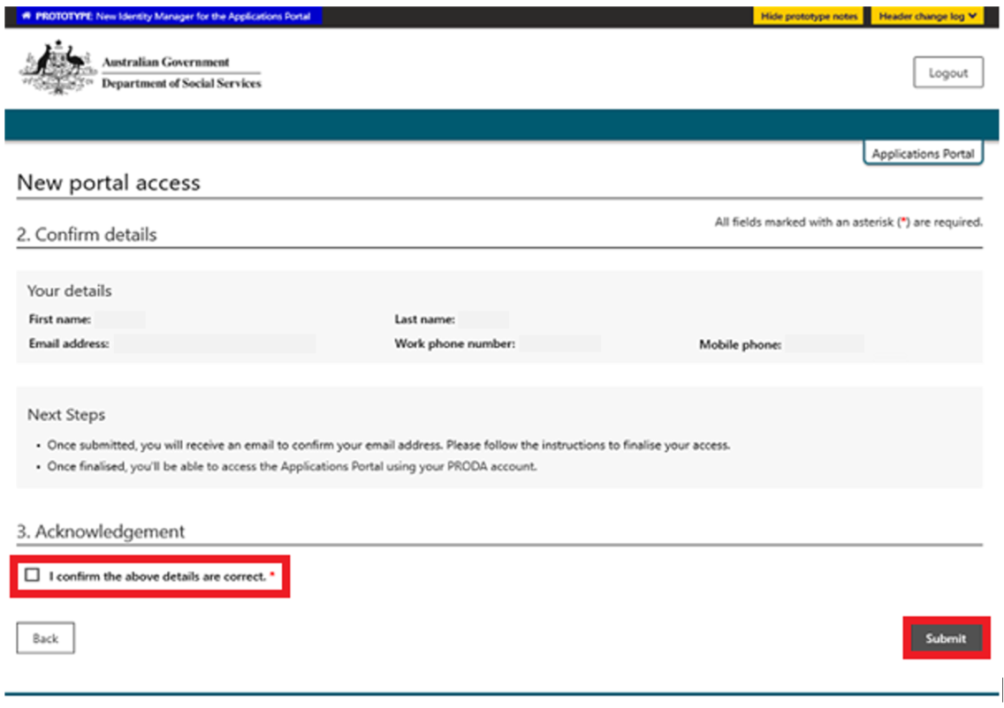

- If all details are correct, select Finish. You will receive an email to the email address you have entered. Access this email in your inbox and click Confirm my email address.
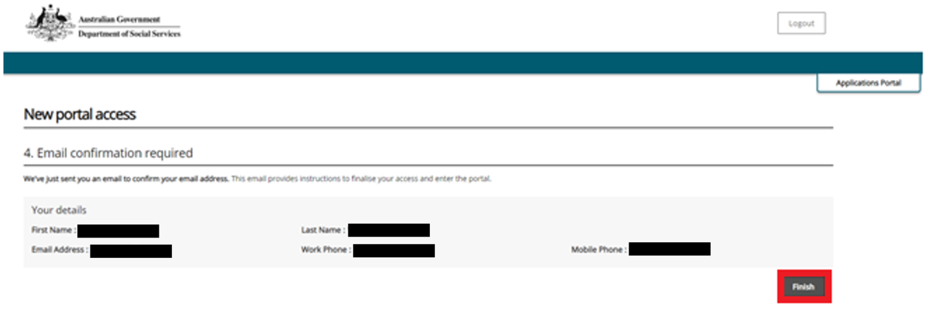
- Once you have confirmed your email address you will take you to the Applications Portal login screen, select I agree.
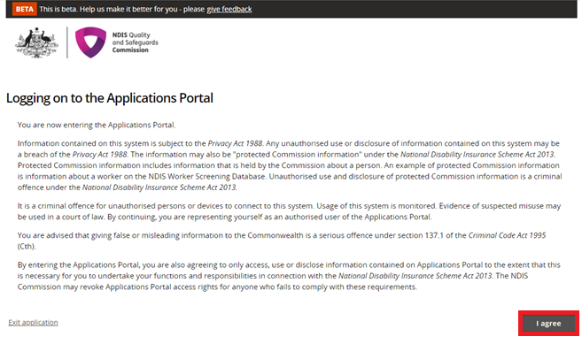
- If you are applying to be a registered Provider, select New application to be registered as an NDIS provider
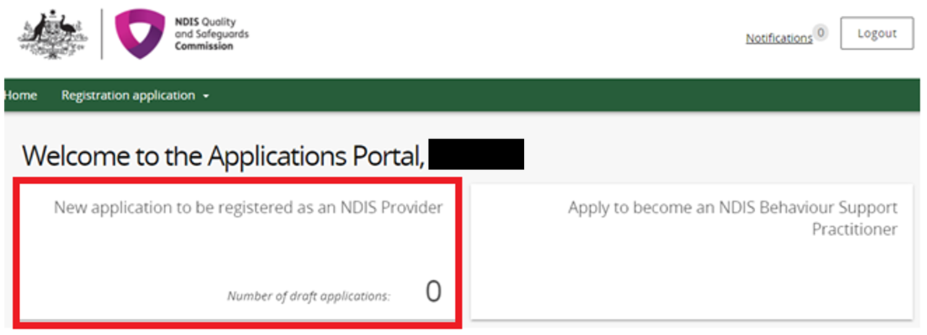
- Click Start new application
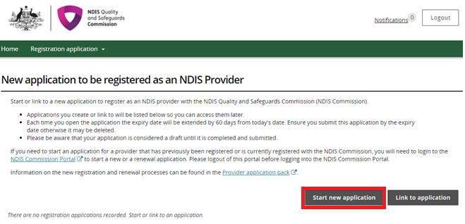
- If you are applying to be considered suitable as an NDIS behaviour support practitioner select Apply to become an NDIS behaviour support practitioner
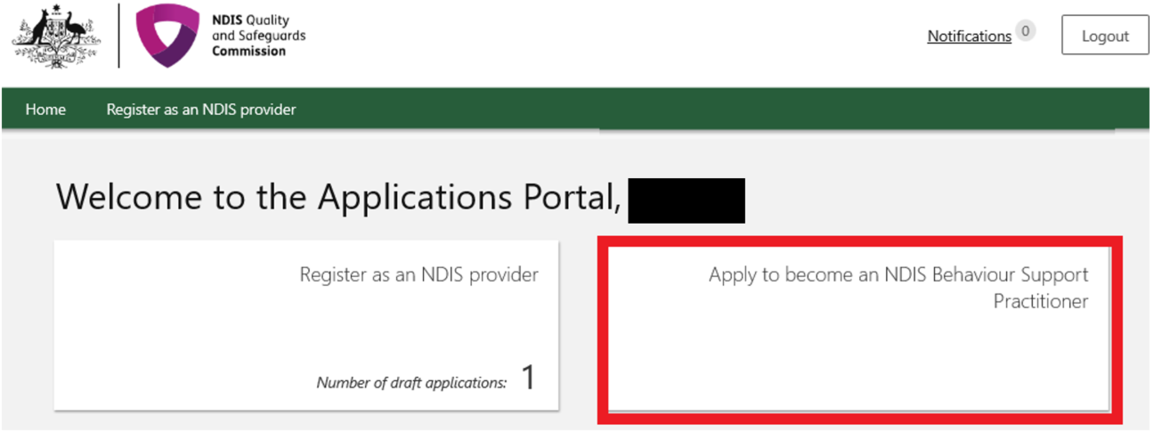

For practitioner applications refer to the quick reference guide: Applying to be considered suitable as an NDIS behaviour support practitioner

Logging in to the Applications Portal through Digital ID using an existing Digital ID account

- Go to the NDIS Commission website. Click Portals select Applications Portal
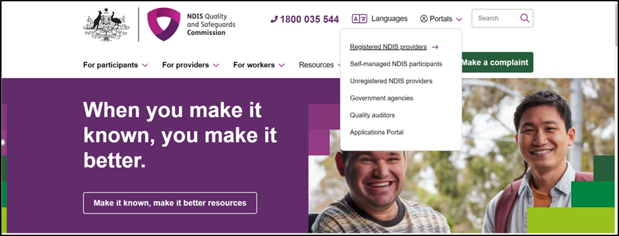

- Once you get to the Applications Portal webpage, click Login

- Click Continue with Digital ID
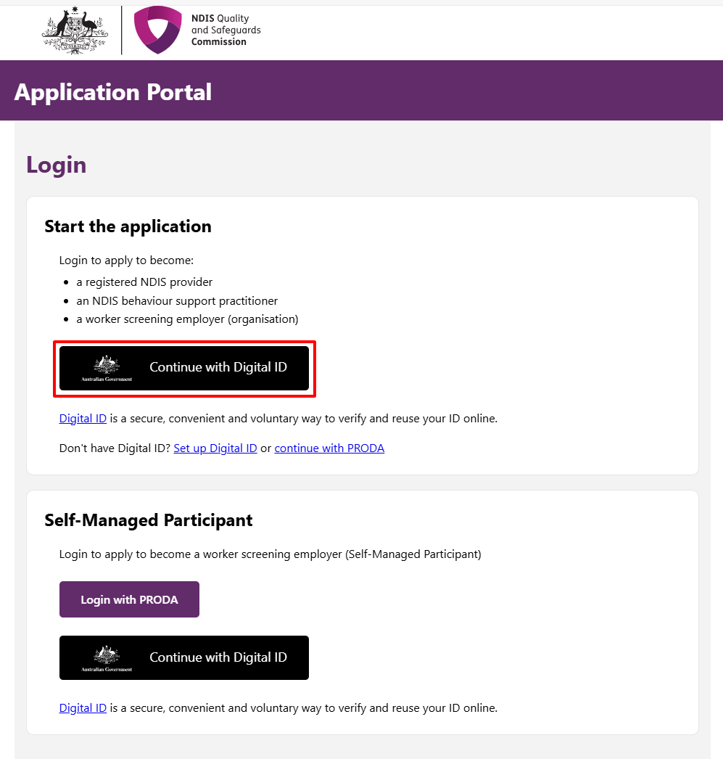
- Click Select myID
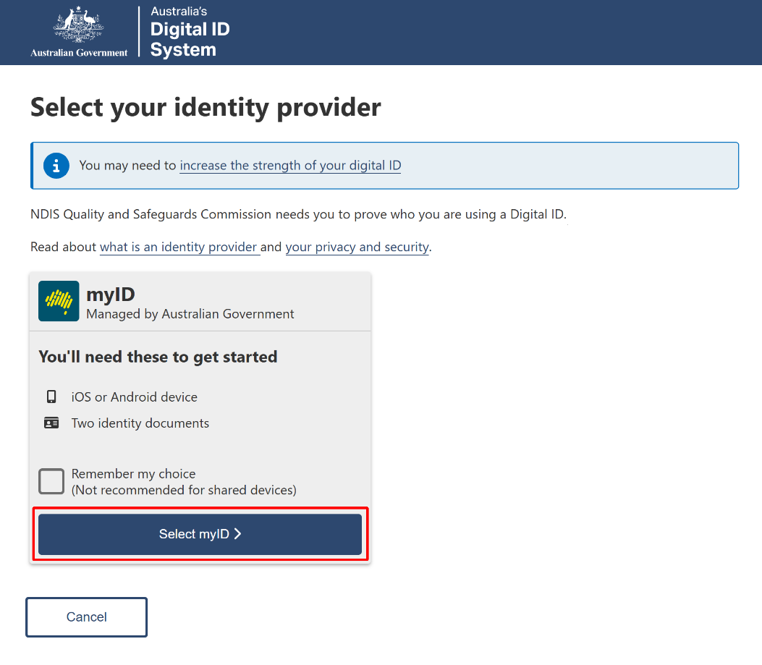
- Enter your myID email and click Get code. If you don’t have an account, you can register for a Digital ID (myID).
- A code will be generated.

- Open the myID app on your phone and either accept the request or enter the code.

Then follow steps 12 through to 15 in this Quick Reference Guide.

About Digital ID and myID app
Digital ID is a whole-of-government digital identity solution which can be used by Australians to prove who they are online and provide an identity that can be used to access participating government online services.
To gain access to the NQSC Application Portal, you will need to have set up your Digital identity in myID app.
Using Digital ID to log into the NQSC portals provides a high level of assurance that only the appropriately identified and authorised people are accessing NQSC systems.

To learn more about Digital ID, visit What is Digital ID? | Digital ID System website.

The Australian Government's Digital ID app is called myID. To access government services using a Digital ID, you need to set up a myID account. please visit the Help section on the myID website.

