Information about the Community Visitor Scheme project
(Report 1)

How to use this information
The NDIS Quality and Safeguards Commission wrote this information.
We will say NDIS Commission for short.

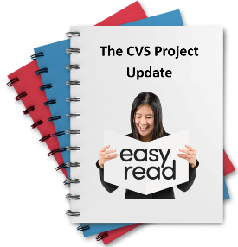 | This information is a summary of a big report.
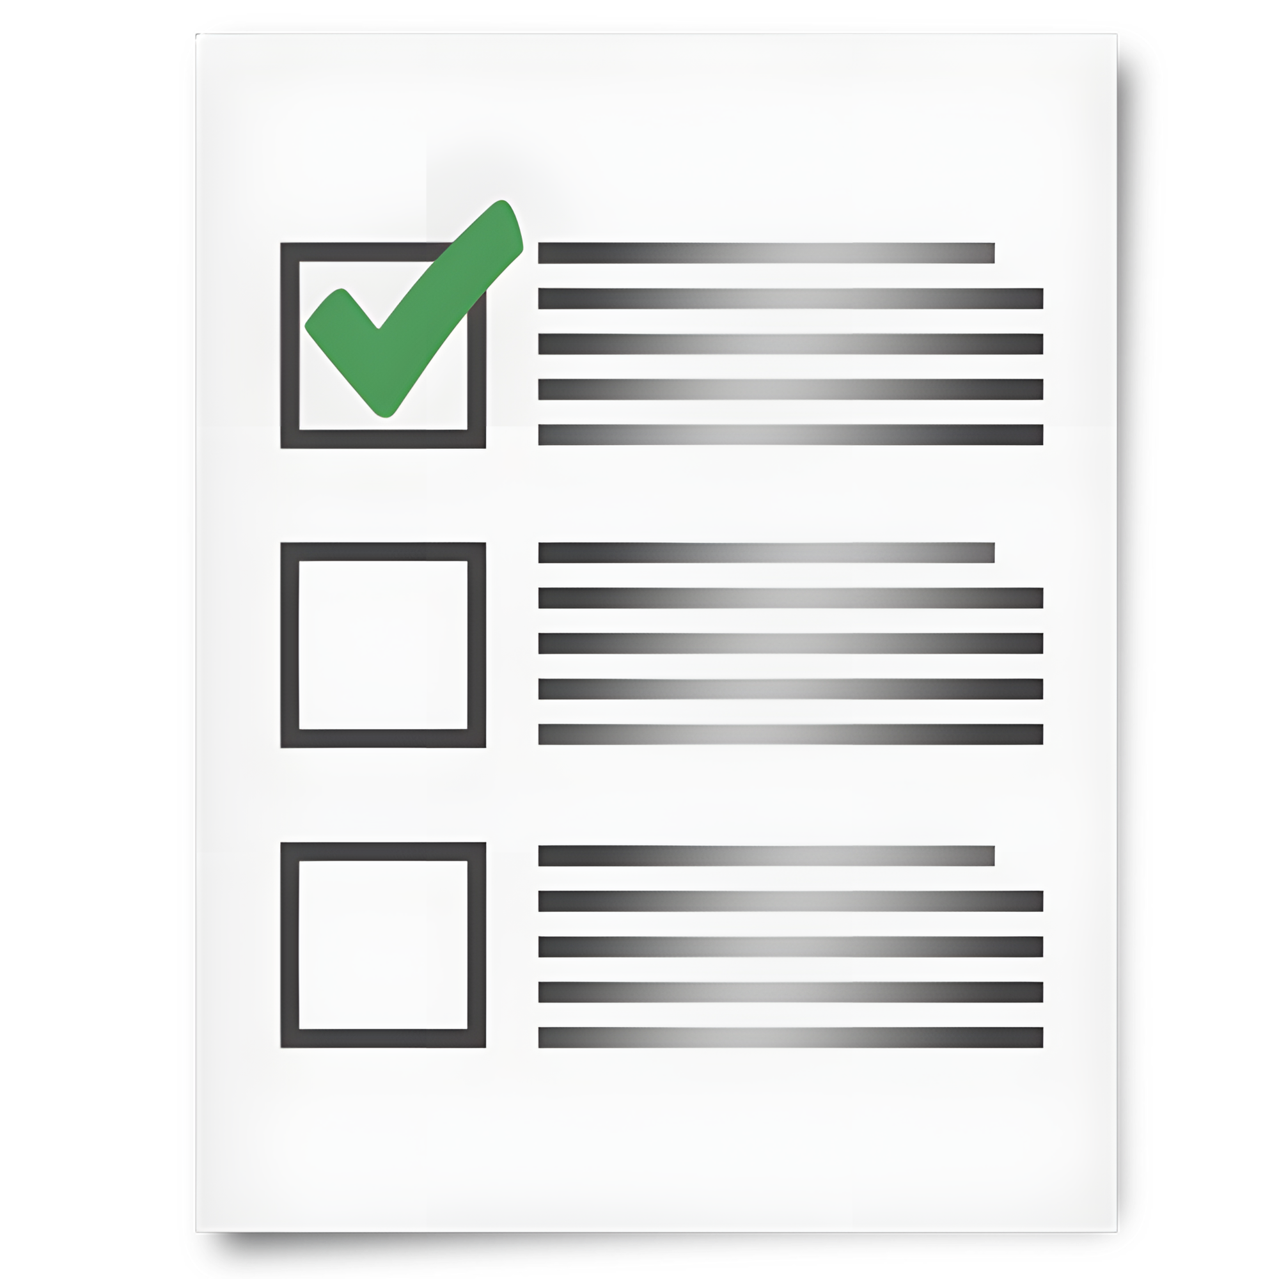 | Summary means we only talk about the most important things from the big report.
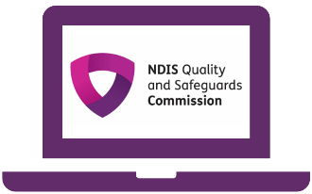 | To read the big report go to our website at CVS-Progress-Report-2025-PDF.pdf.
Bold  Not Bold | We wrote some important words in bold.  Bold means the letters are thicker and darker.
 | You can ask for support to read this information.
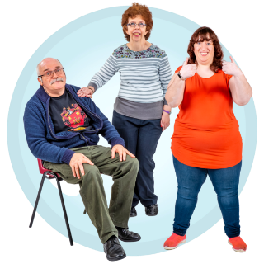 | You could ask  - A friend  - A family member  - A support person.
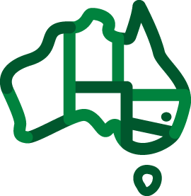 | We respect all Aboriginal and Torres Strait Islander peoples from the land we live on.
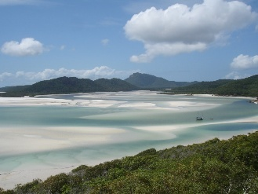 | They were the first people to live on and use the  - Land  - Waters.

About our project
 | This information is about our Community Visitor Schemes project.  We will say CVS project for short.  When you see this picture, you will know it is the CVS project.
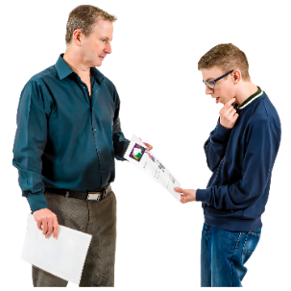 | The CVS project is trying a new way for us to share information with community visitors.
 | Community visitors are people who go into homes where many people with disability live.
 | They go there to make sure the people with disability are safe.
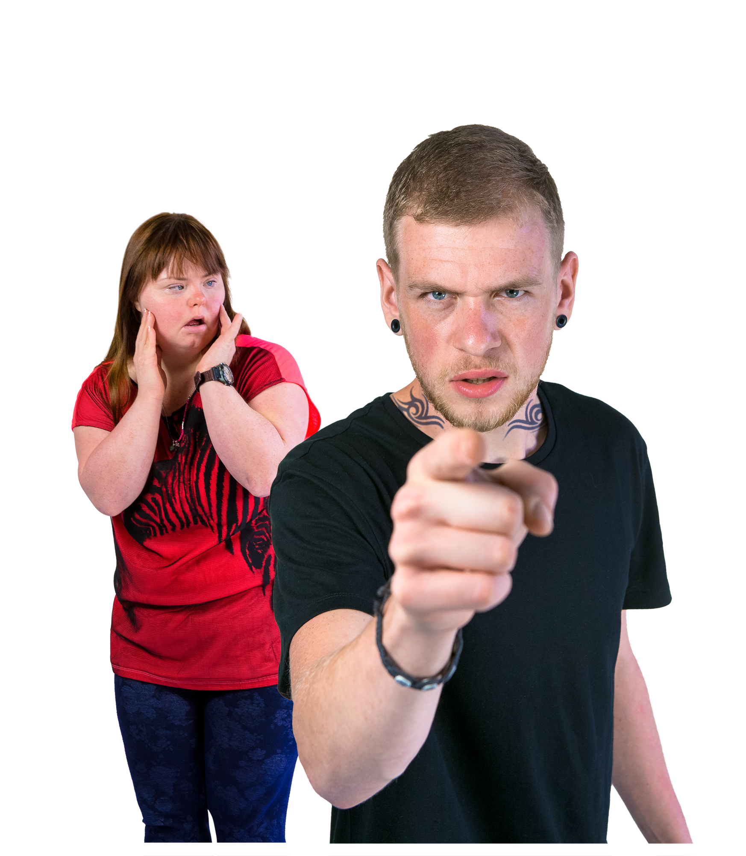  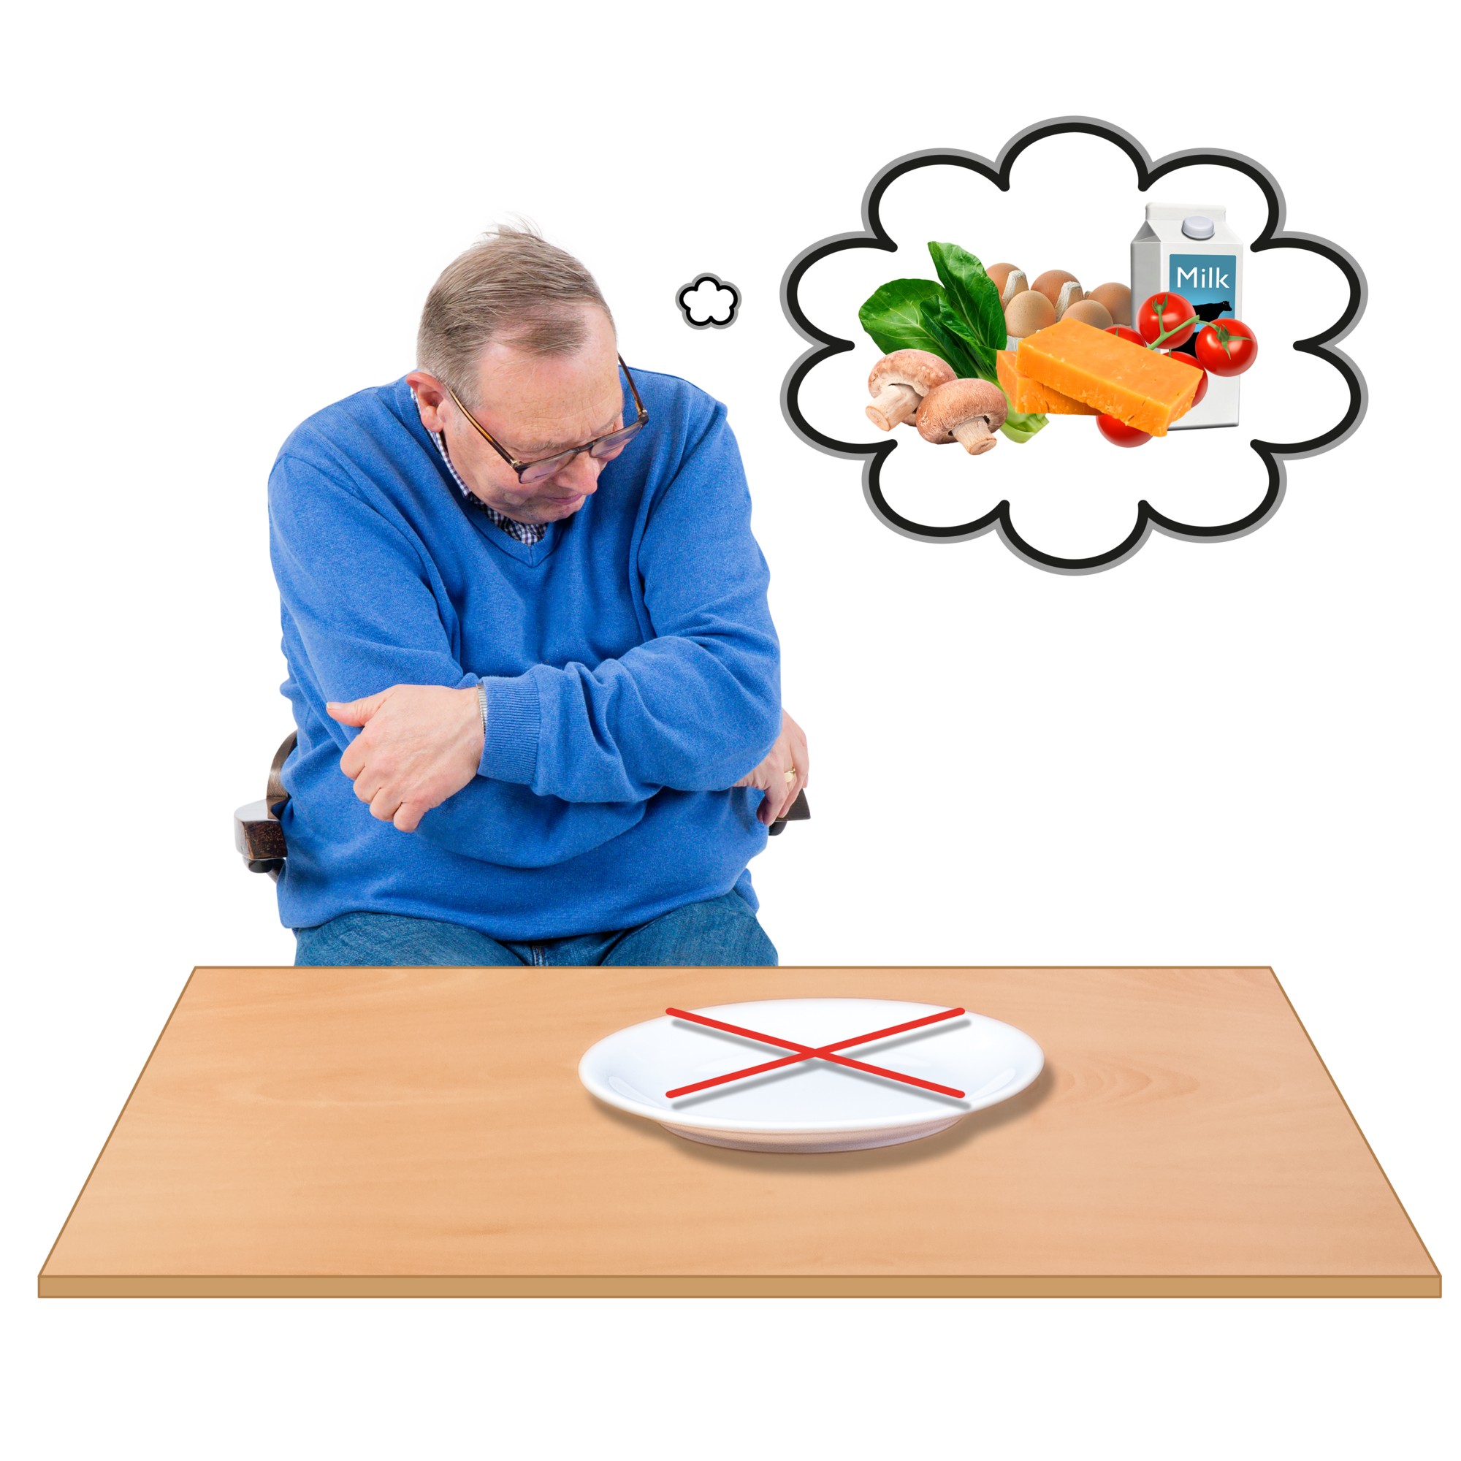 | The community visitors want to make sure the people with disability are safe from  - Abuse  - Neglect.
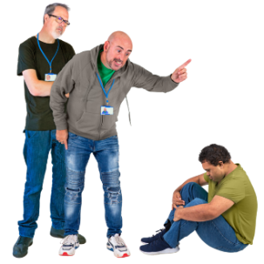 | Abuse is when someone treats you badly.
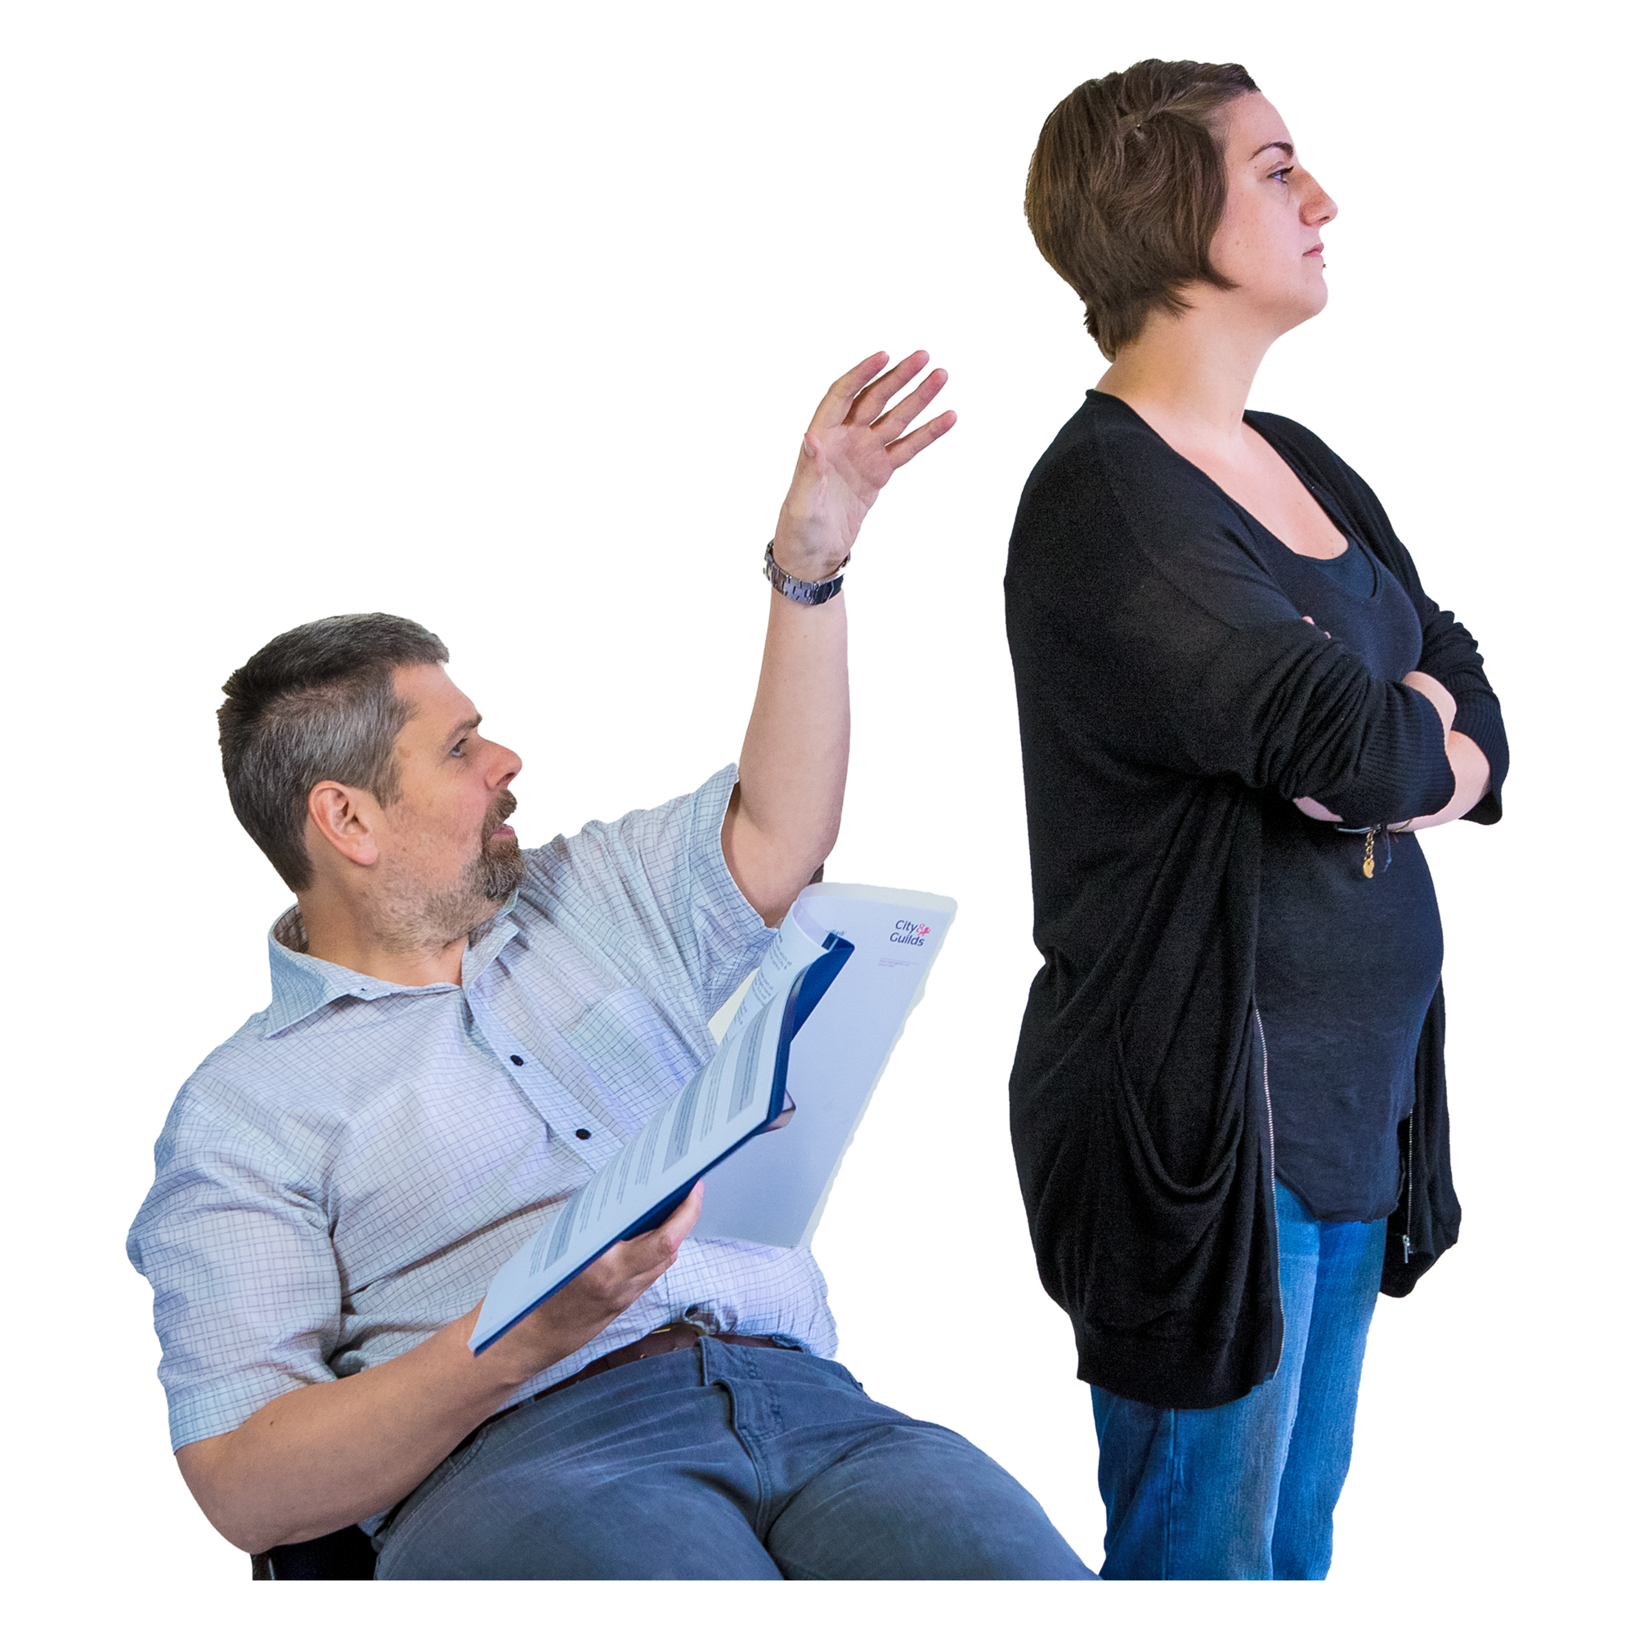 | Neglect is when someone does not support you how they are meant to.
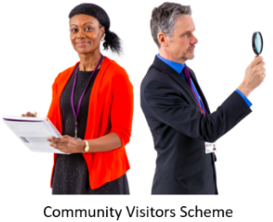 | Community visitors also help make sure people with disability get their rights.
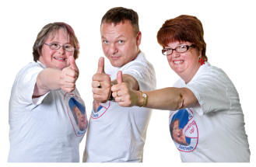 | Rights are rules about treating everyone fair and the same way.
 | We share information with the community visitors.
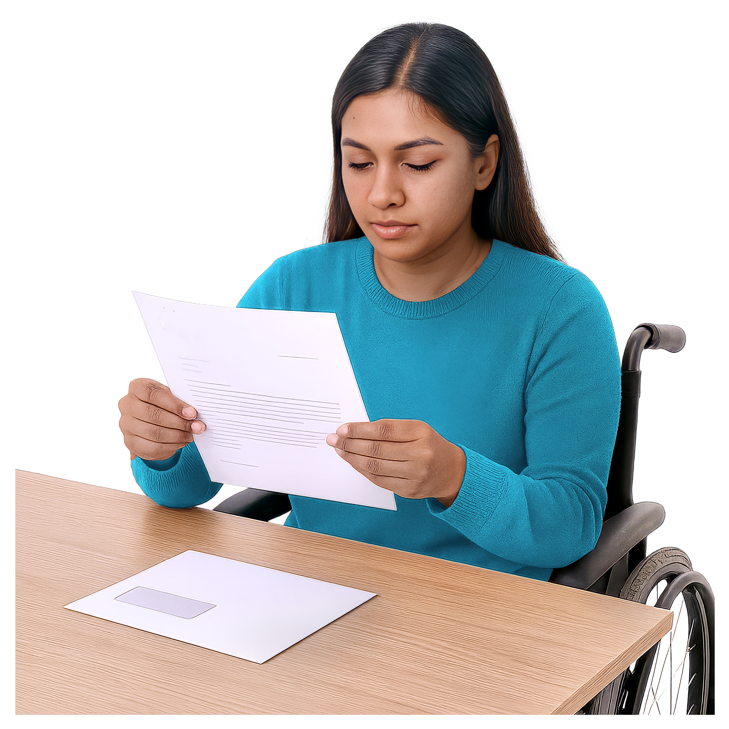 | This information helps them know  - Who to visit  - About any issues in the home.

Why are we doing the CVS project
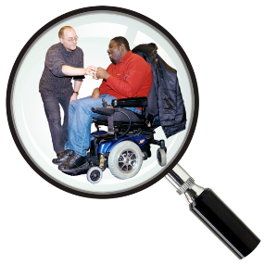 | The Disability Royal Commission looked at how people with disability are treated.  We will say DRC for short.
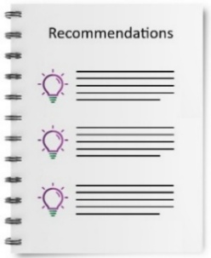 | DRC wrote a report with recommendations.
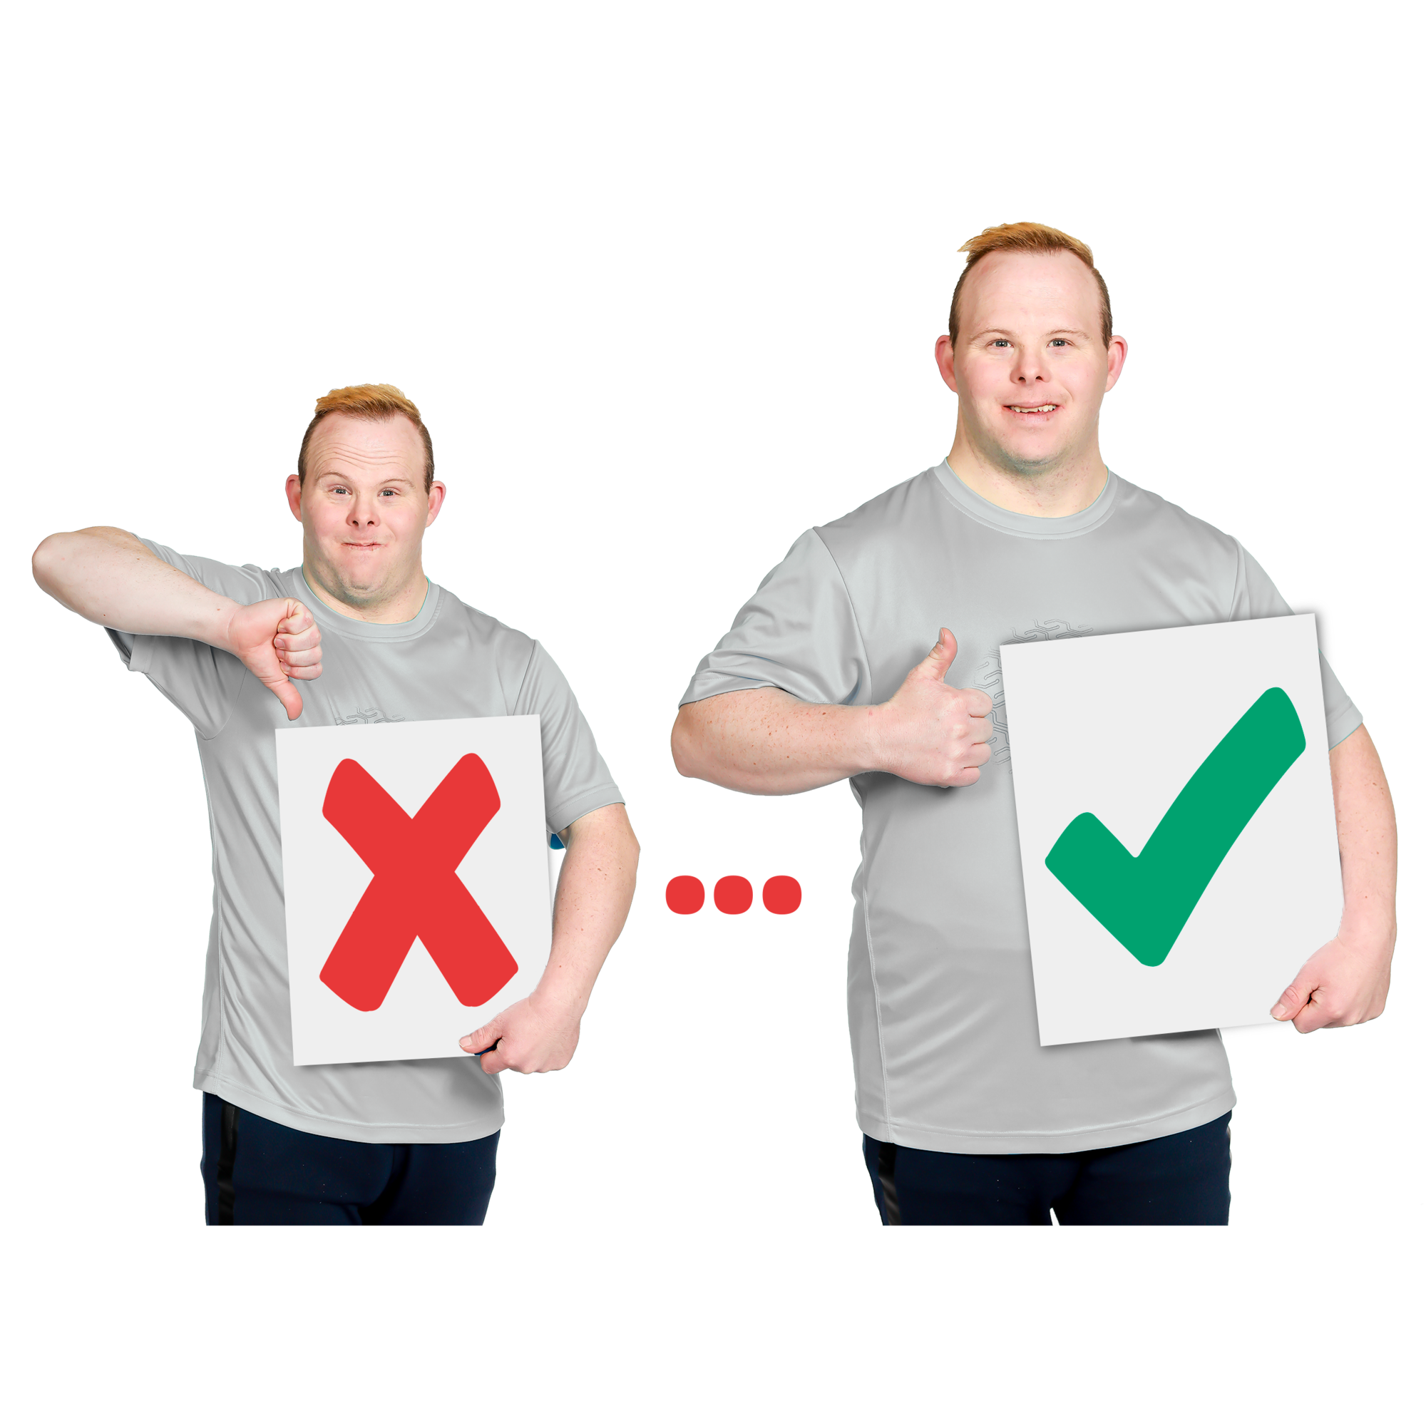 | Recommendations are ideas to do things better.
 | 1 DRC recommendation is to share more information with community visitors.
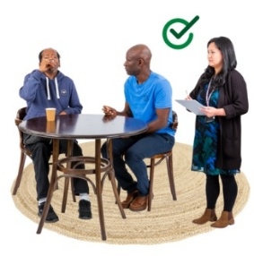 | The information will help them  - Check that people with disability are safe when they use services
 | - Help people with complaints.
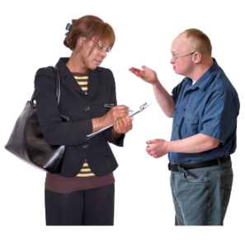 | A complaint is when you speak up if you are not happy about something.
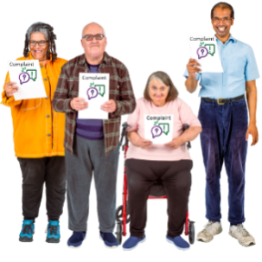 | Everyone has a right to make a complaint.
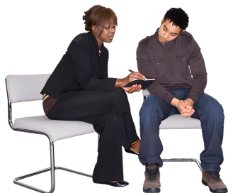 | Community visitors know who to talk to if you have a complaint.
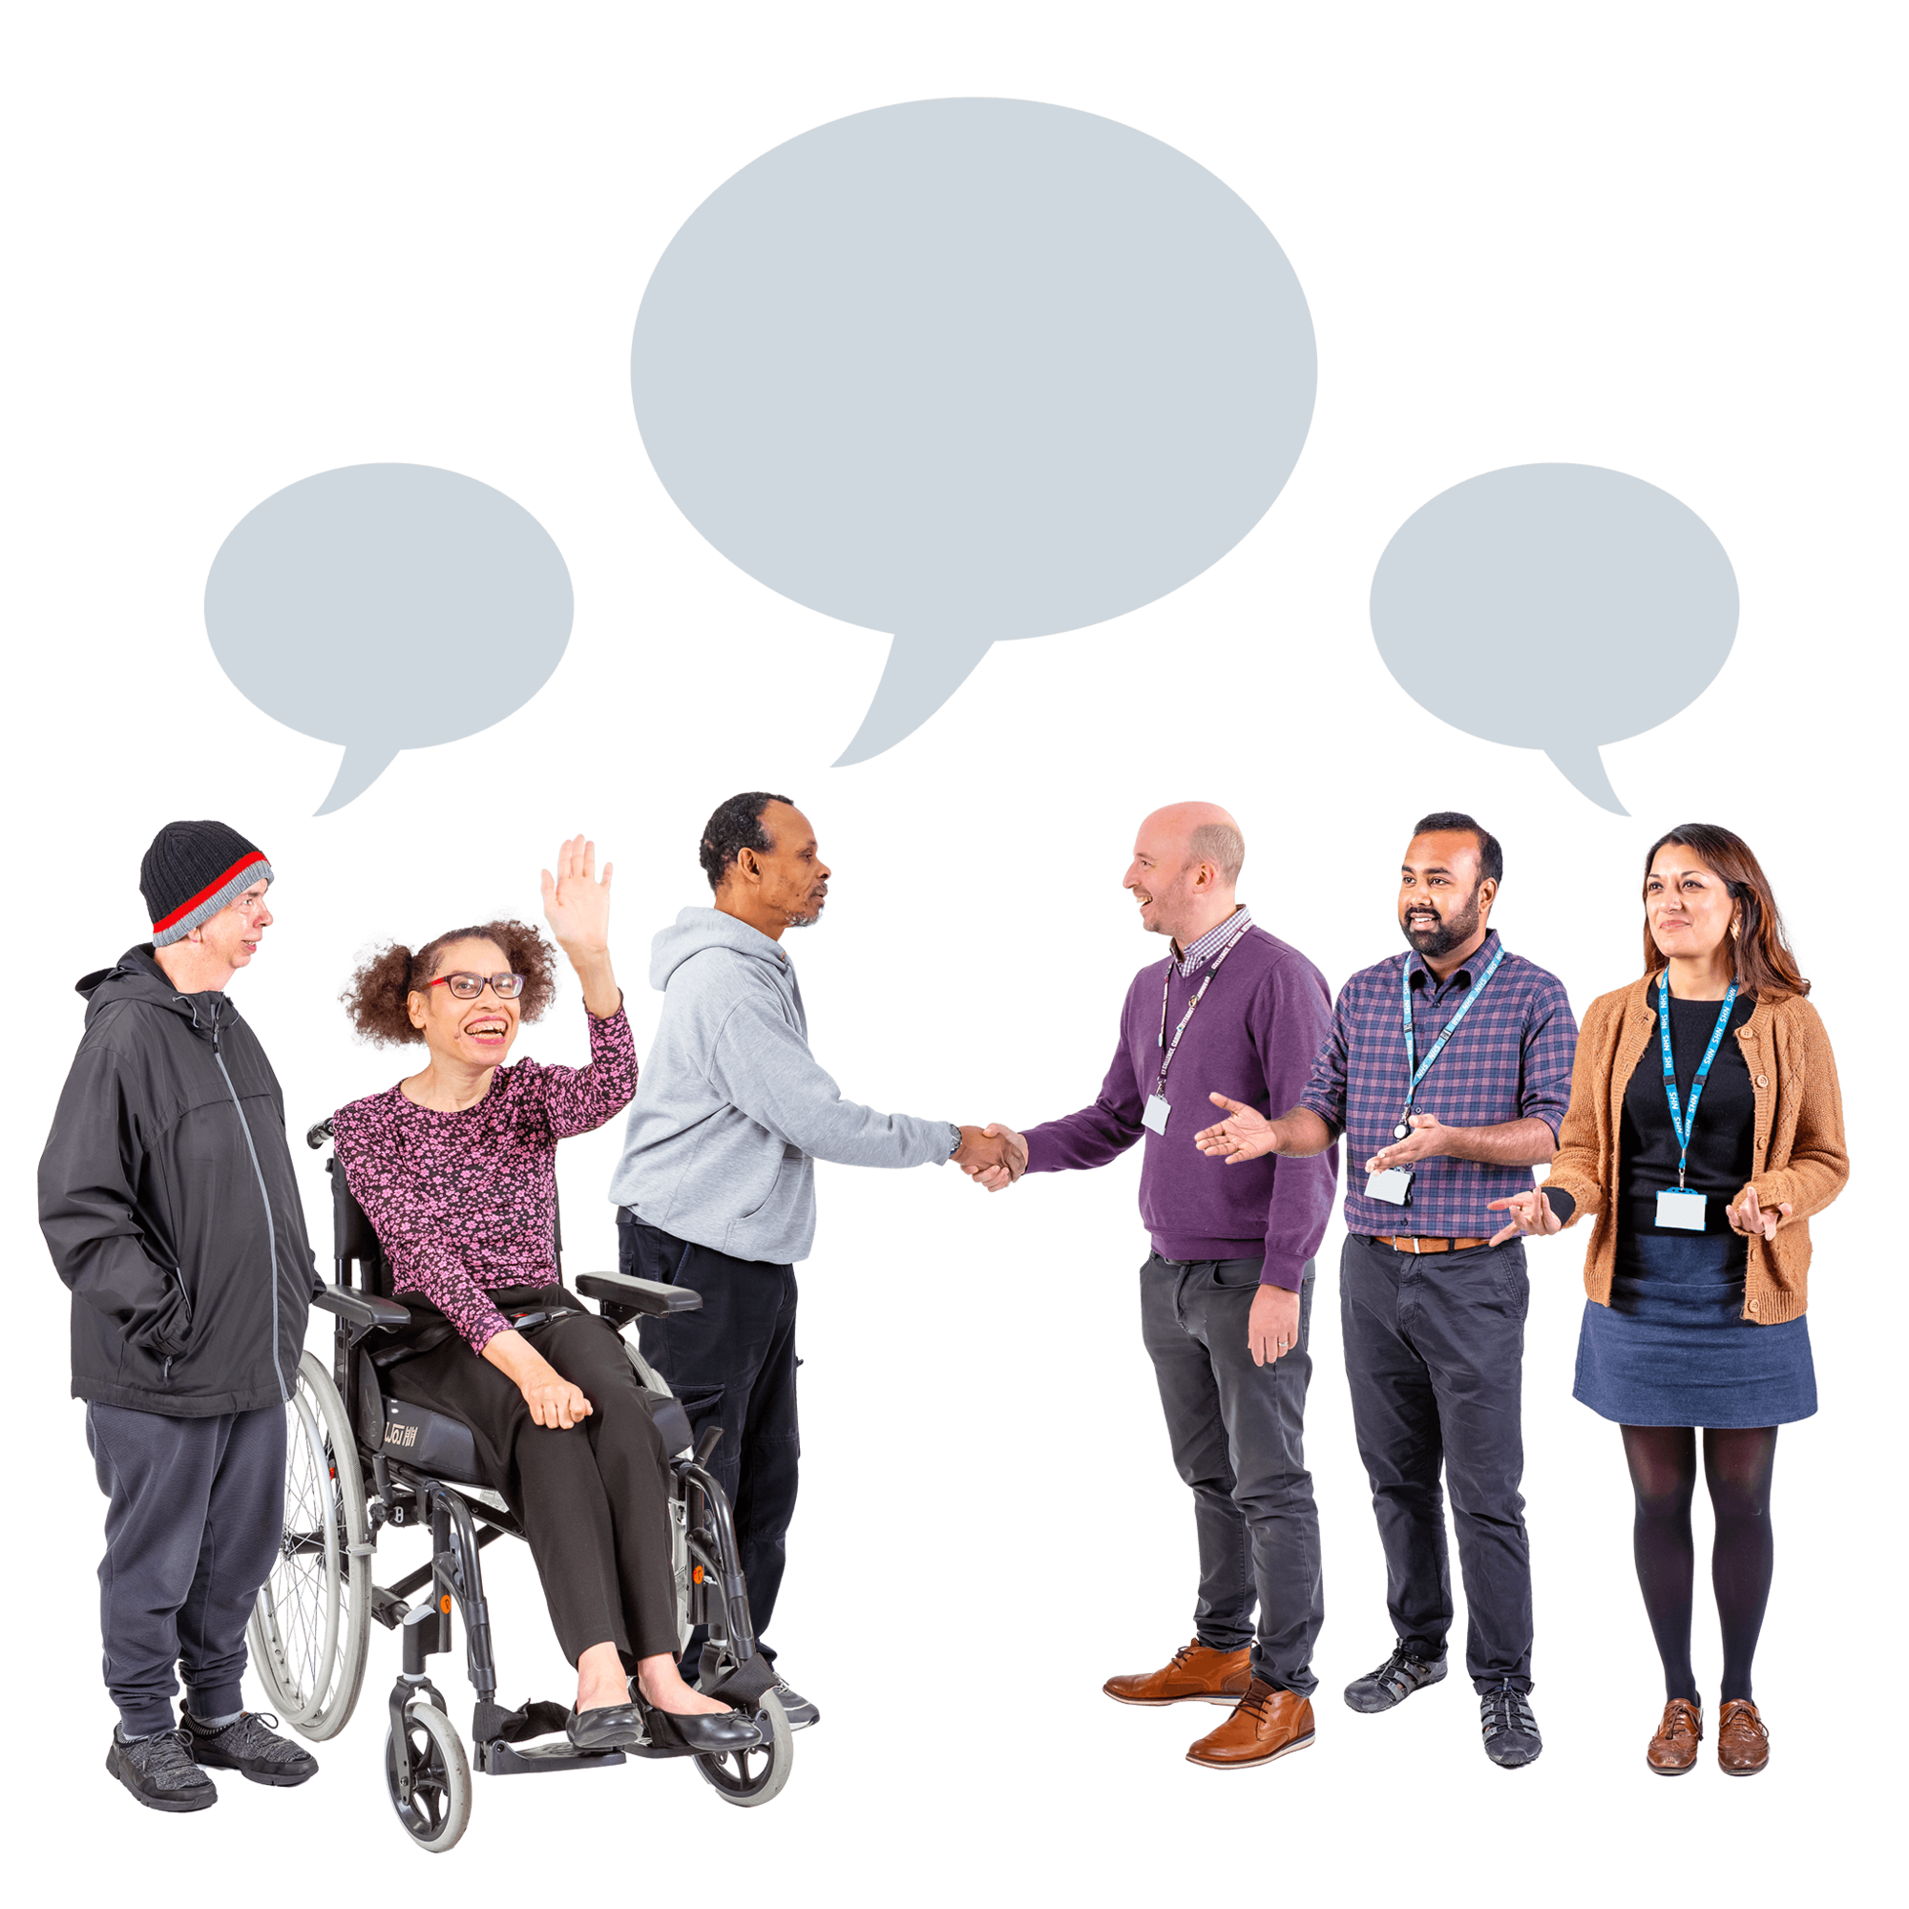 | They can ask us to help fix the problem.
 | We want to support community visitors to support you to make a complaint.
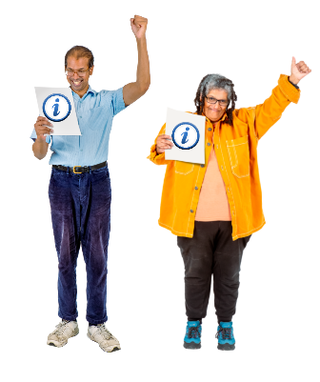 | We can support community visitors by sharing good information.
 | The CVS project looks at what information we can share with the community visitors.
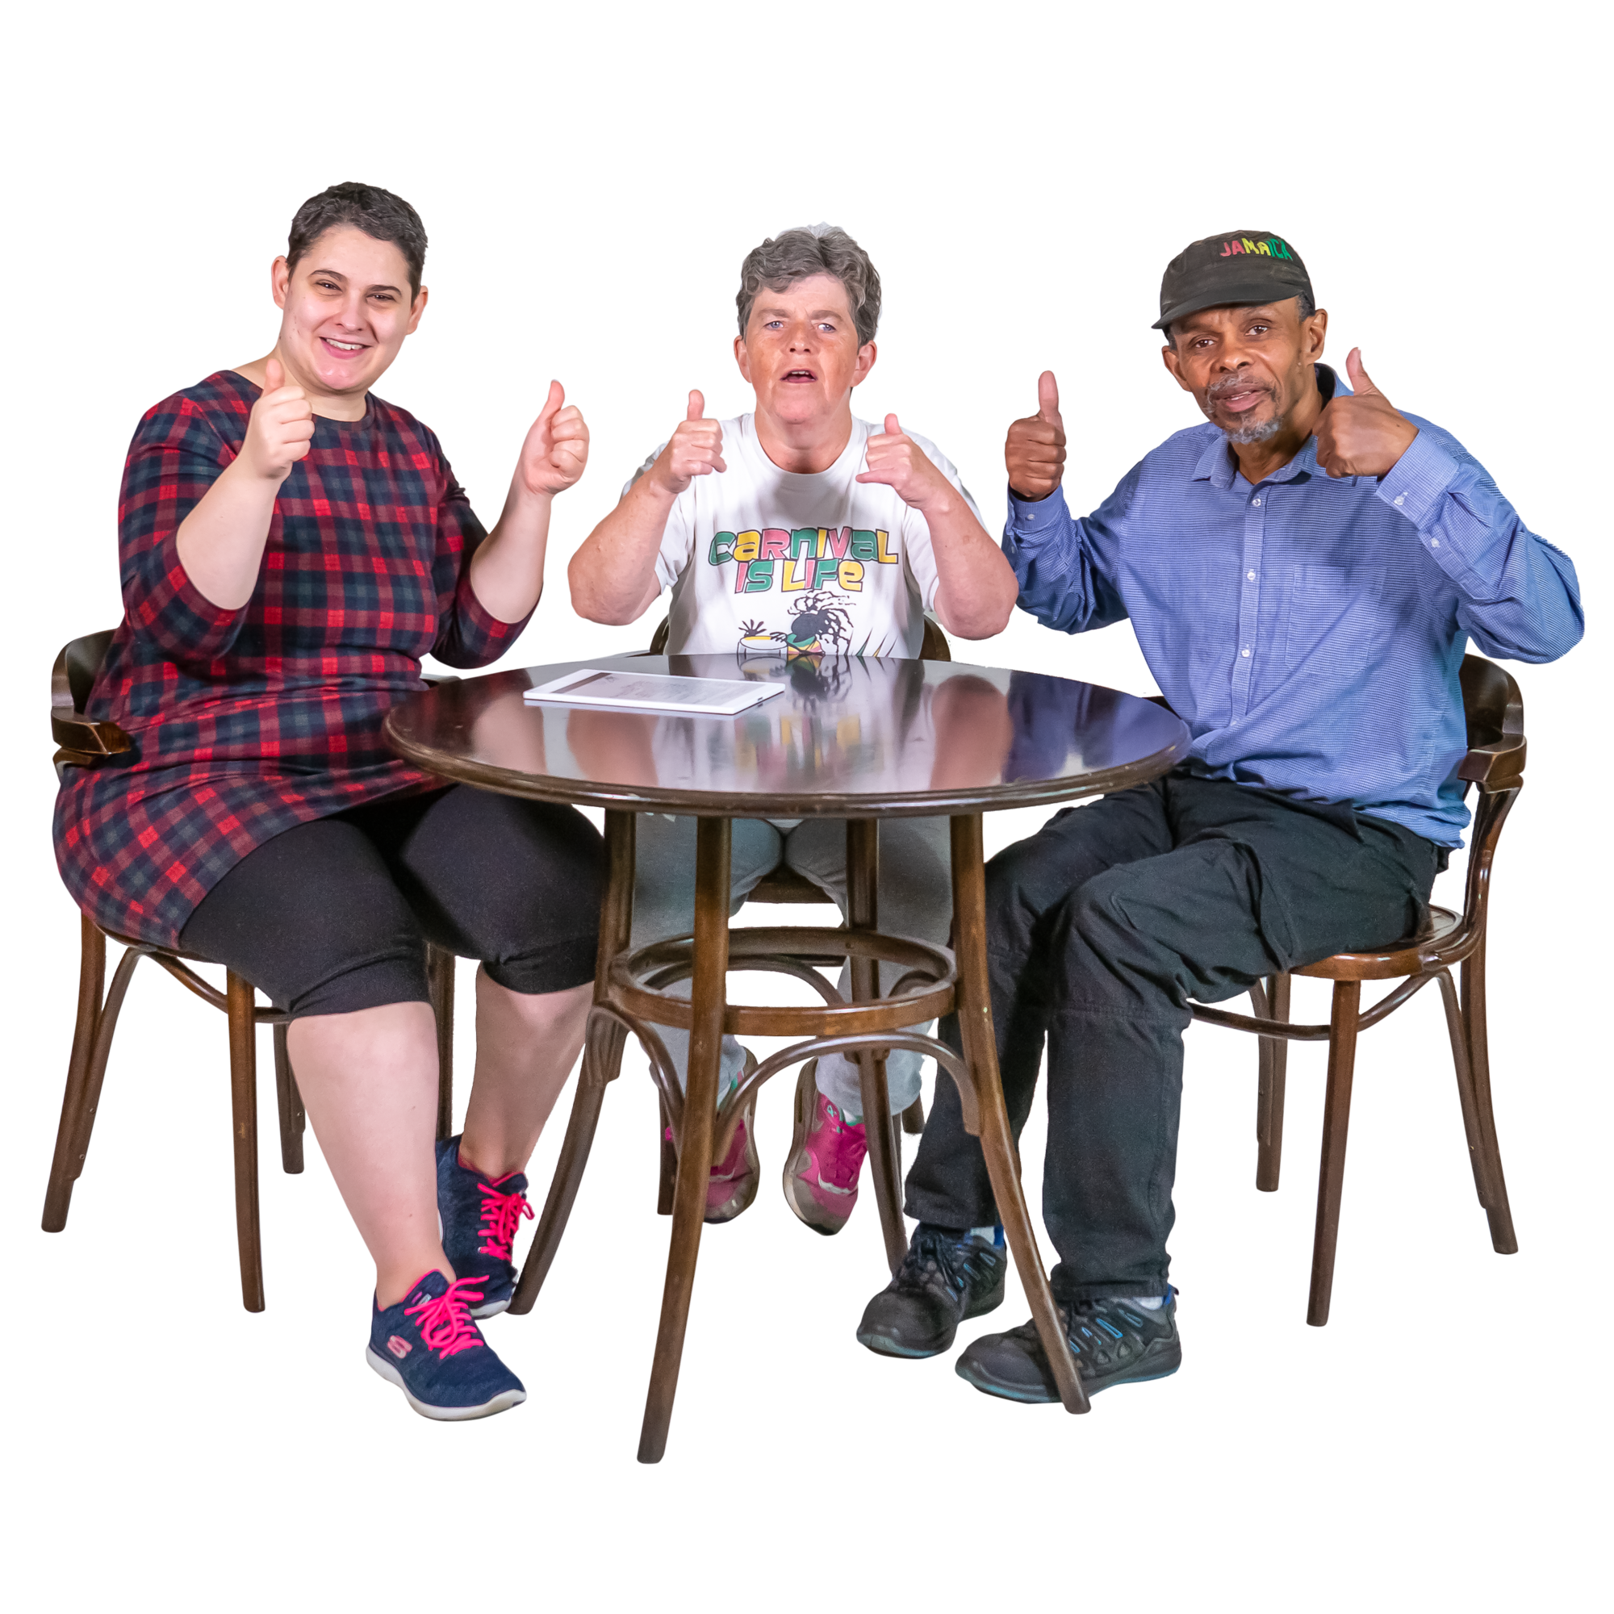 | We want to make sure we share the right information that will help them keep people safe.

Who we work with
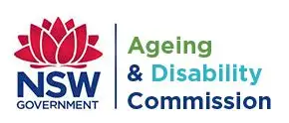 | The CVS project works with the NSW Government Ageing and Disability Commission.
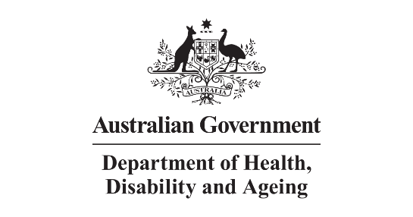 | The National CVS project is being run by the Department of Health, Disability and Ageing.
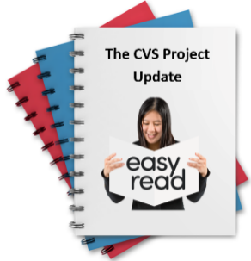 | We will share more updates and progress summaries.

What we are doing now
 | We have sent services information about the CVS project.
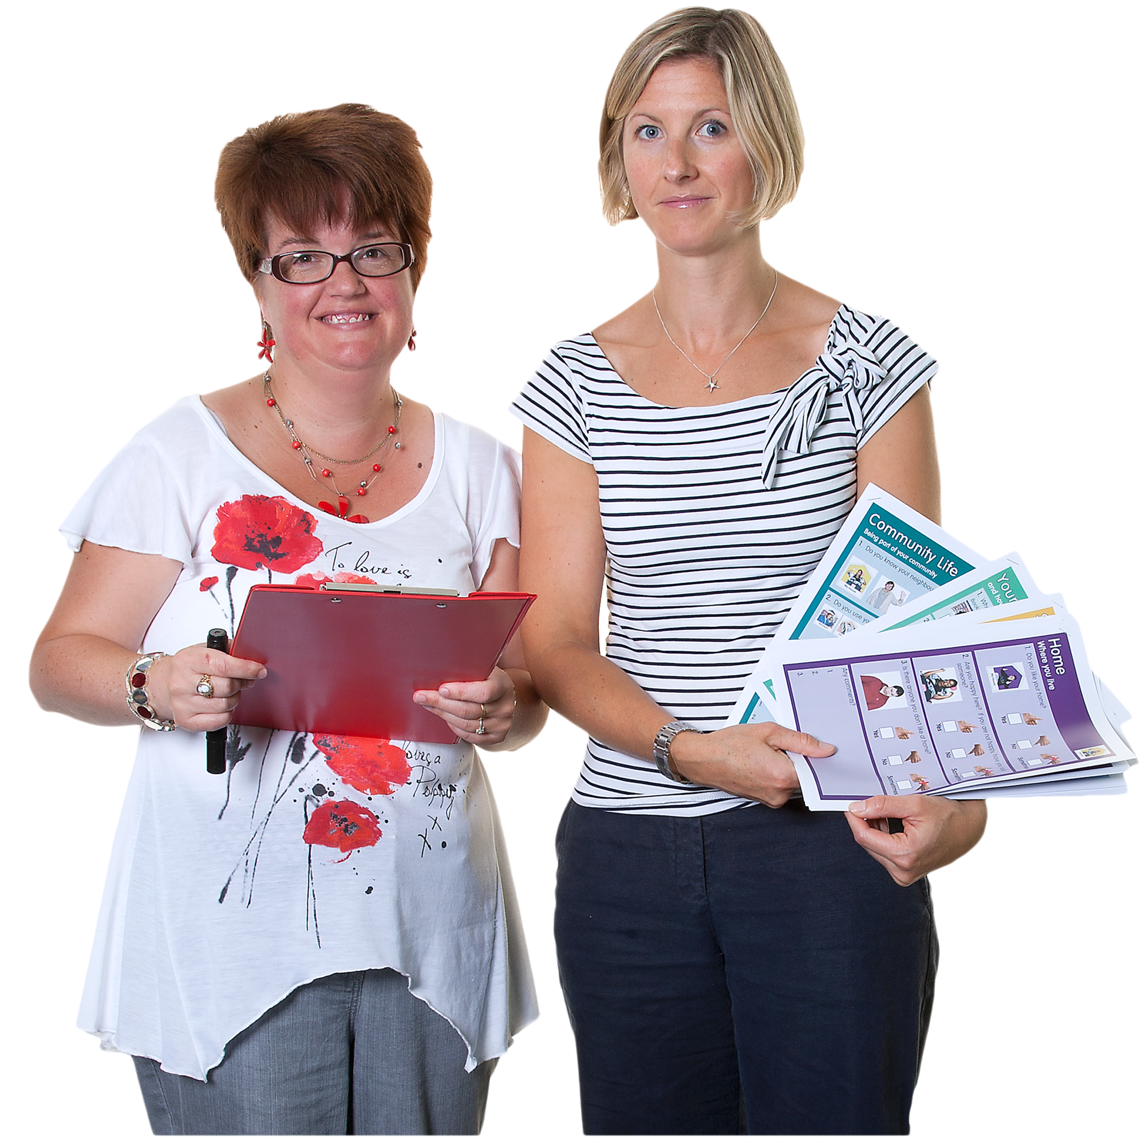 | We have shared information about NDIS services with the Ageing and Disability Commission.
 | We have shared information about 2 kinds of services for people with disability.
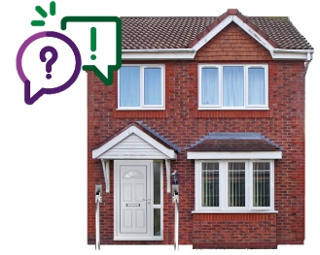 | The information we have shared is about  - Specialist Disability Accommodation or SDA  - Supported Independent Living or SIL.
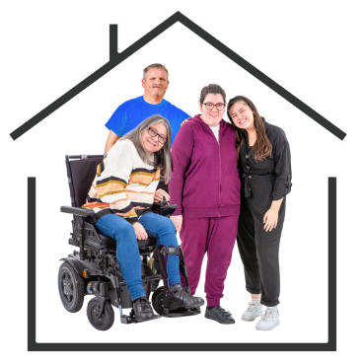 | SDA means homes where people with disability can live and get support.
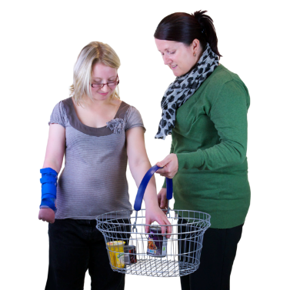 | SIL is support for your daily things like going shopping.
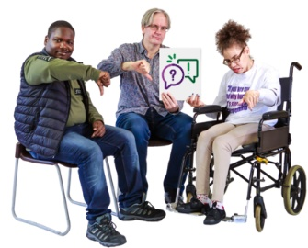 | We shared the information to make it easier  for community visitors to  - Know who to visit and when
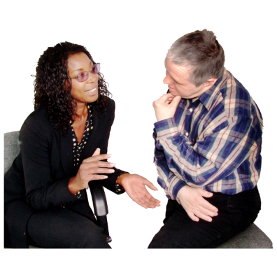 | - Talk with staff
 | - Make sure people are safe
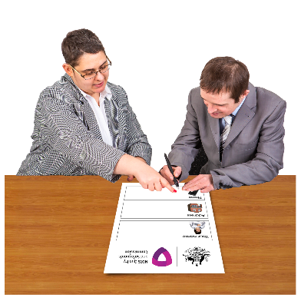 | - To help people if they have a complaint.
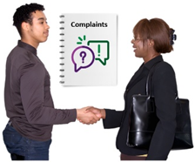 | NSW Community visitors send us complaints that we want to know about.
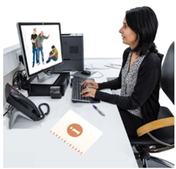 | Good information from community visitors helps  us to know about abuse and neglect.

What we have done so far
 | We have collected information about what community visitors do all over Australia.
 | We have asked the Ageing and Disability Commission what information helps them when they visit people.
 | We have shared information about new services

What we will do next
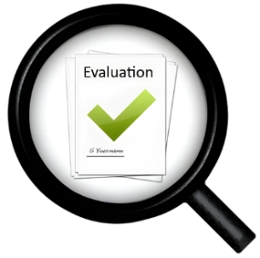 | We will do an evaluation on the CVS Project.
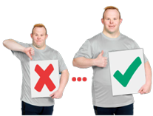 | Evaluation means we look at what  - Went well  - We could do better.
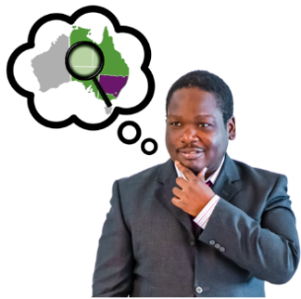 | This will help us know how we can support other community visitors in different parts of Australia.

More information
 | You can contact the NDIS Commission for more information about the CVS project.
 | You can  - Call us on 1800 035 544
 | - Email us at contactcentre@ndiscommission.gov.au
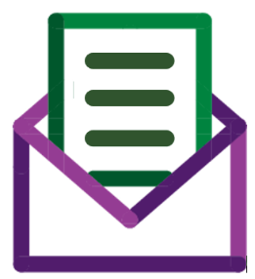 | - Send us a letter to  NDIS Quality and Safeguards Commission  PO Box 210  Penrith NSW 2751.

You can go to our
- Website at www.ndiscommission.gov.au
 | - Facebook page at www.facebook.com/NDISCommission
 | - LinkedIn page at au.linkedin.com/company/ndiscommission

 | The NDIS Commission made this Easy Read information.  You must not use any of the images without asking us first.

