Aspiration pneumonia
Fact sheet
April 2026

How to use this Easy Read fact sheet
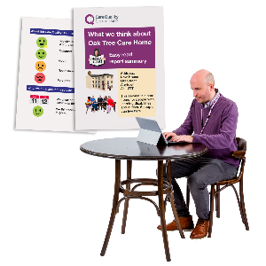 | The NDIS Quality and Safeguards Commission wrote this fact sheet.  We will say NDIS Commission for short.
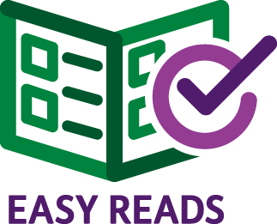 | We wrote this in an Easy Read way.
 | You can ask for help to read this fact sheet.
 | You could ask  - A friend  - A family member  - A support person.

What is aspiration pneumonia?
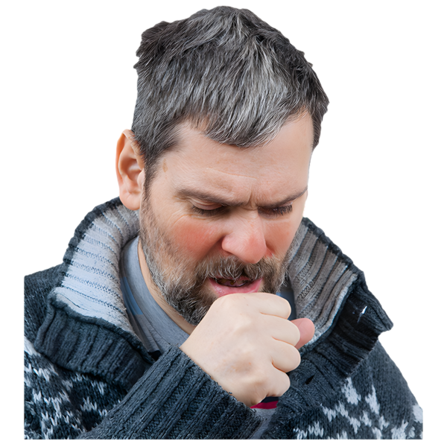 | Aspiration pneumonia is a type of sickness.
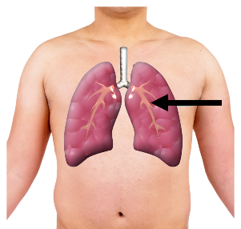 | Aspiration pneumonia can happen when something gets into your lungs that shouldn’t be there.
 | This might be  - Food  - Drinks  - Your saliva.
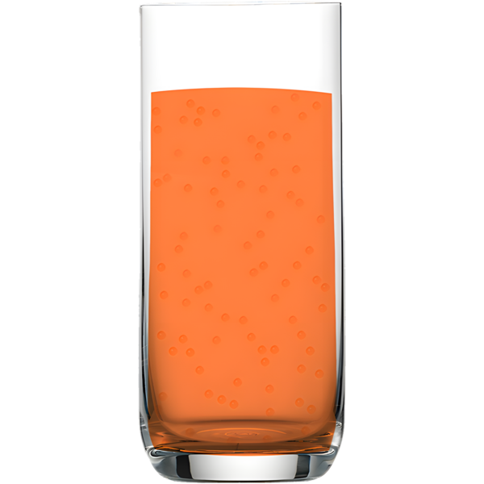 | This might be  - Food  - Drinks  - Your saliva.
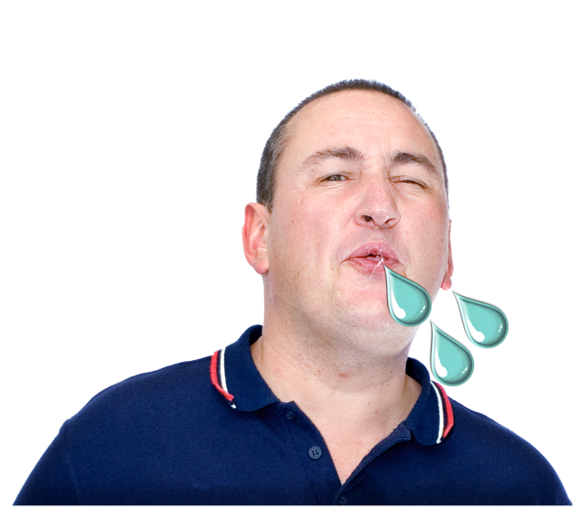 | This might be  - Food  - Drinks  - Your saliva.

What are symptoms of aspiration pneumonia?
 | Symptoms are things that show you might be sick.
 | These are some of the symptoms for aspiration pneumonia.
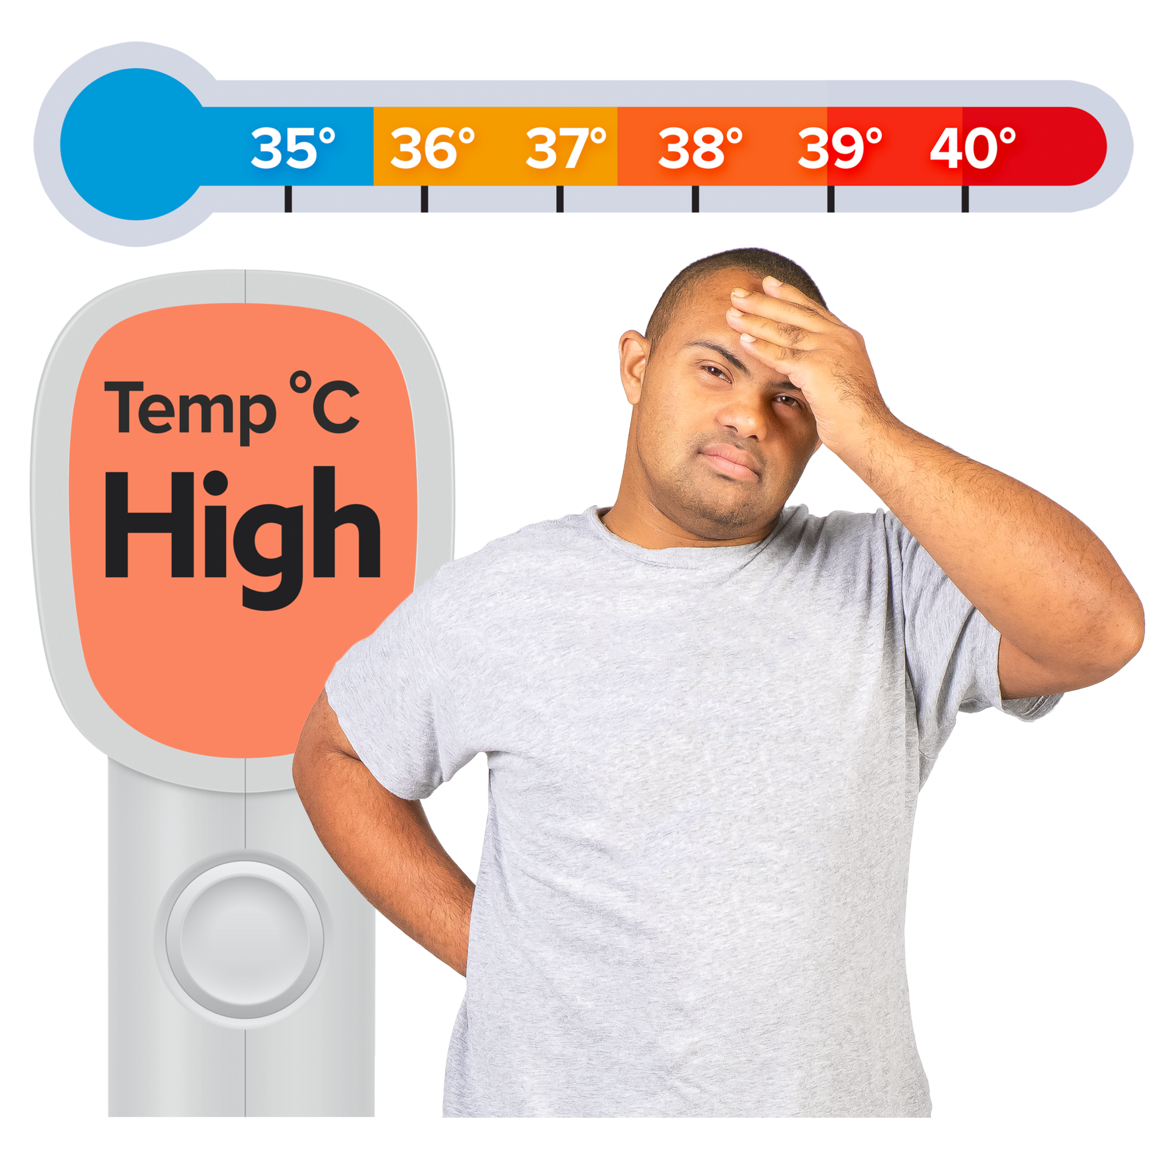 | You might  - Have a fever  - Cough a lot  - Have pain in your chest.
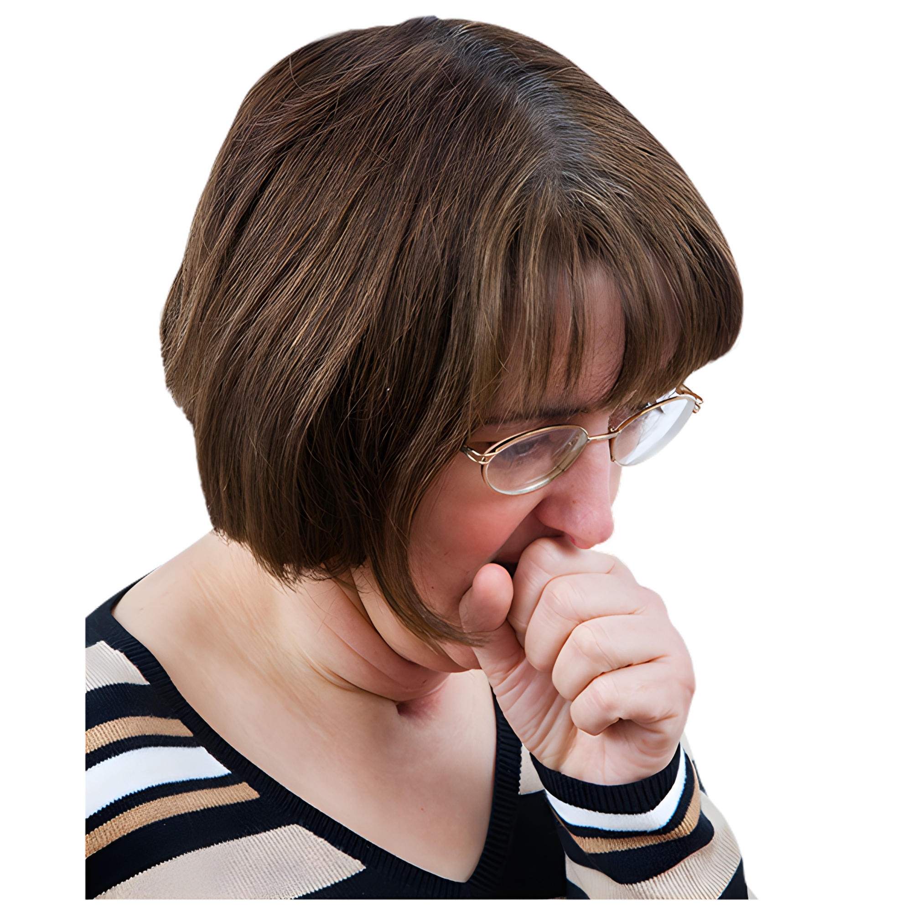


What happens if you get aspiration pneumonia?
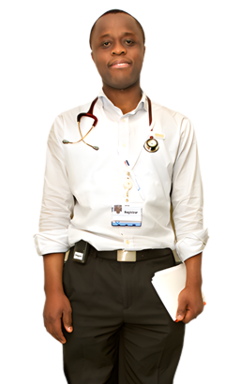 | You should go to the doctor if you think you have aspiration pneumonia.
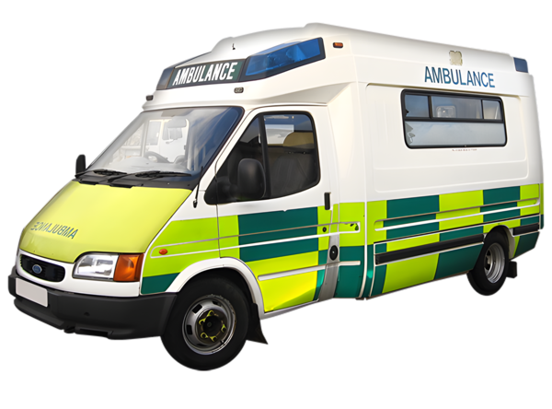 | You should call 000 if you need help right away.
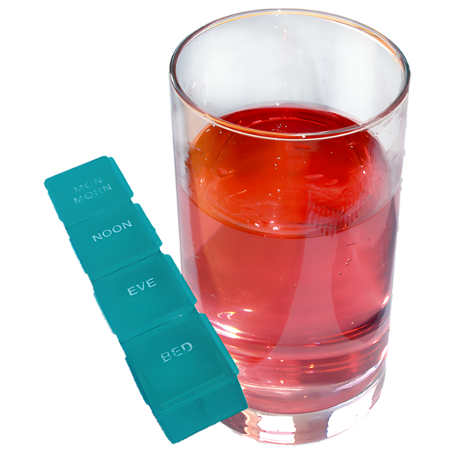 | You might get some medicine.
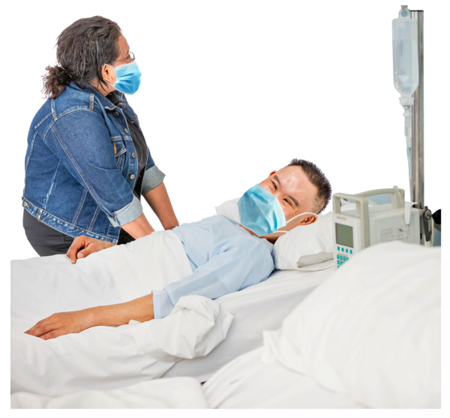 | Some people can get very sick when they have aspiration pneumonia.
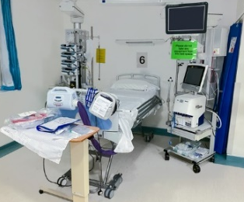 | You might need to stay in the hospital until you are better.
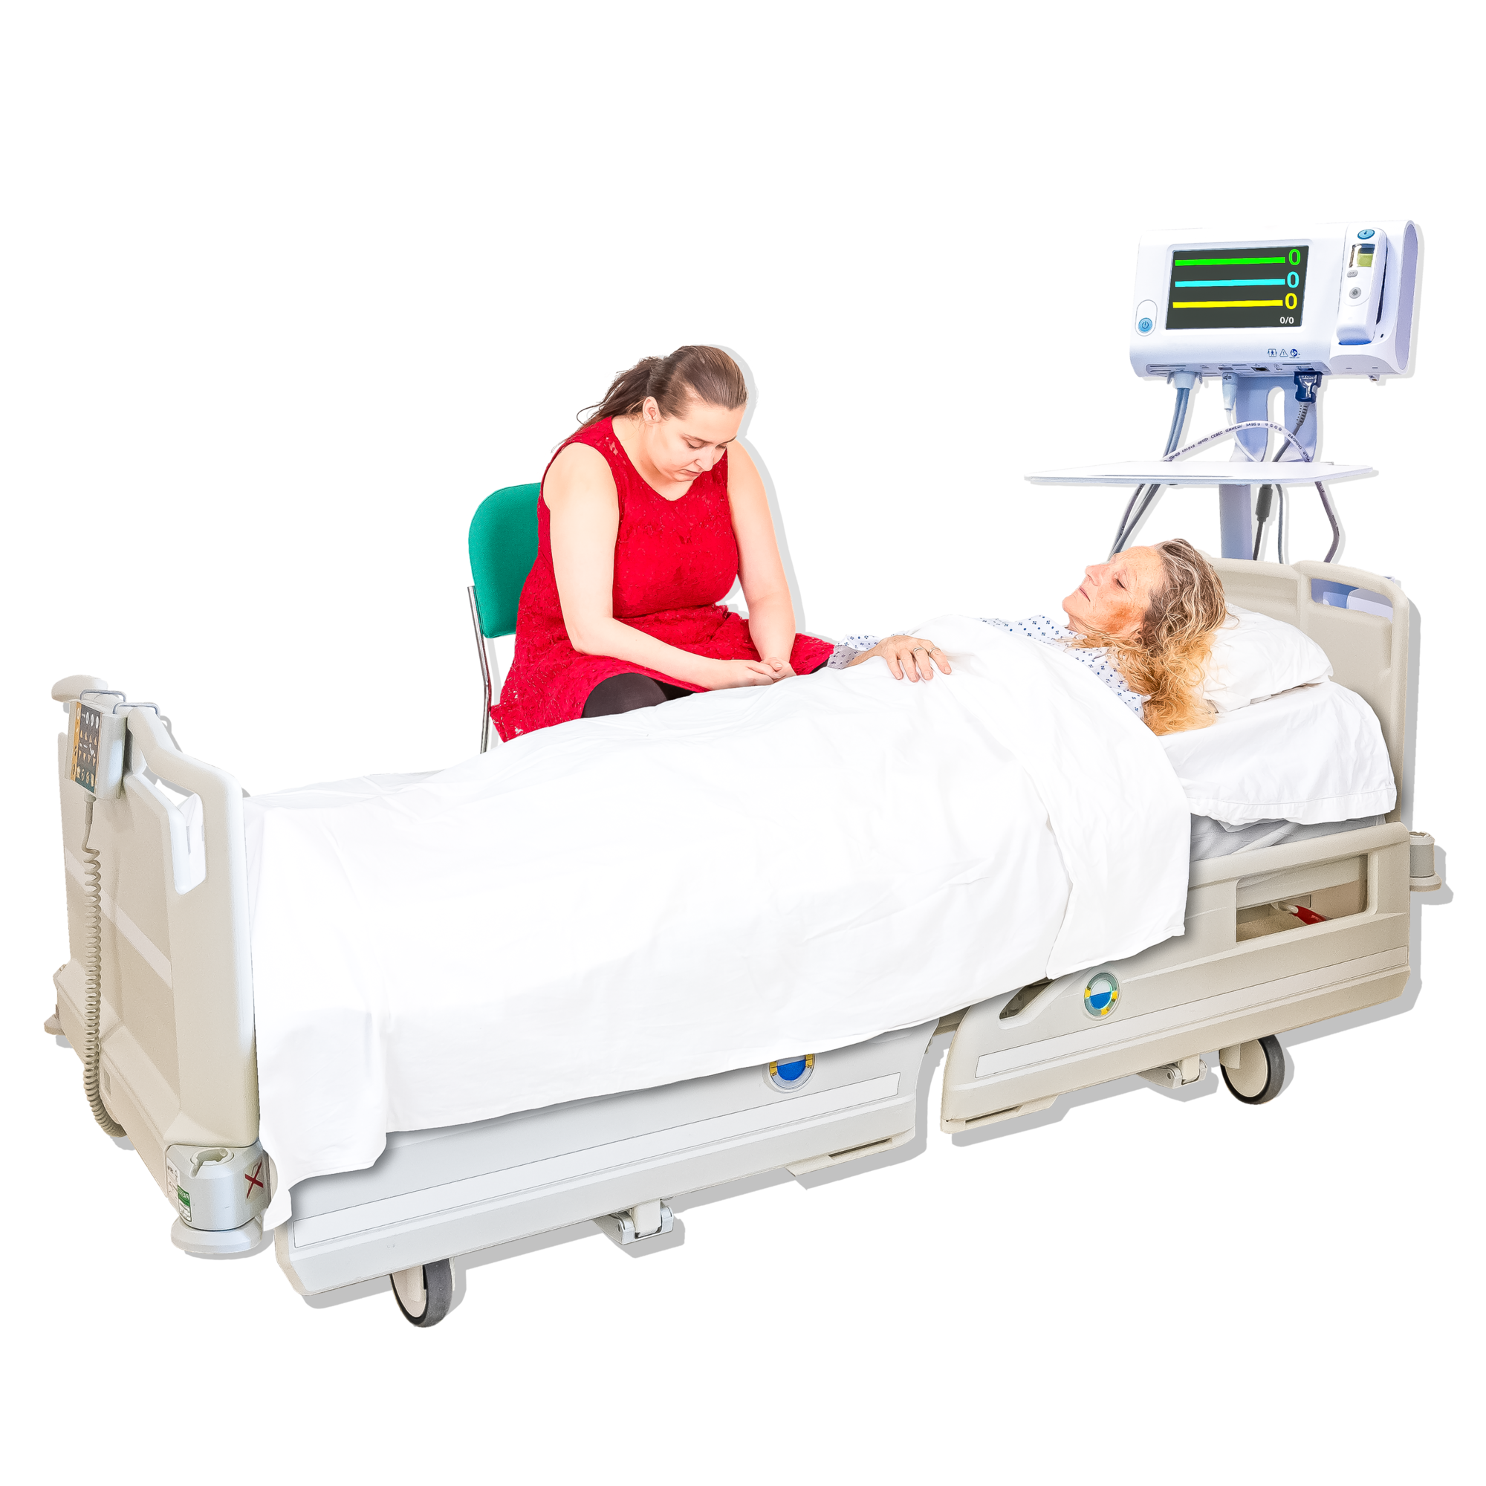 | Sometimes people can die from aspiration pneumonia.

Who can get aspiration pneumonia?
 | Some people are more likely to get aspiration pneumonia than others.
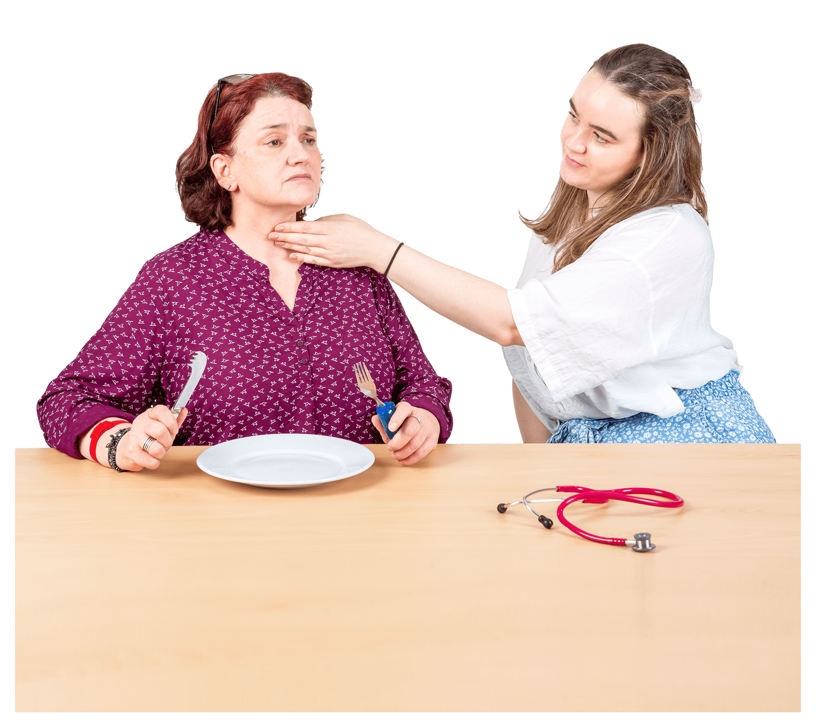 | These include people with dysphagia.
 | Dysphagia is when you find it hard to swallow.
 | When you have dysphagia, you might cough or choke when you eat or drink.

Who can support you?
 | A speech pathologist is someone who supports you to speak with others.
 | They can also support you when it is hard to eat and drink.
 | They can write a mealtime management plan with you.
 | This plan supports you to  - Eat and drink in a safe way  - Enjoy meals.

 | A speech pathologist might tell you to eat and drink sitting upright.
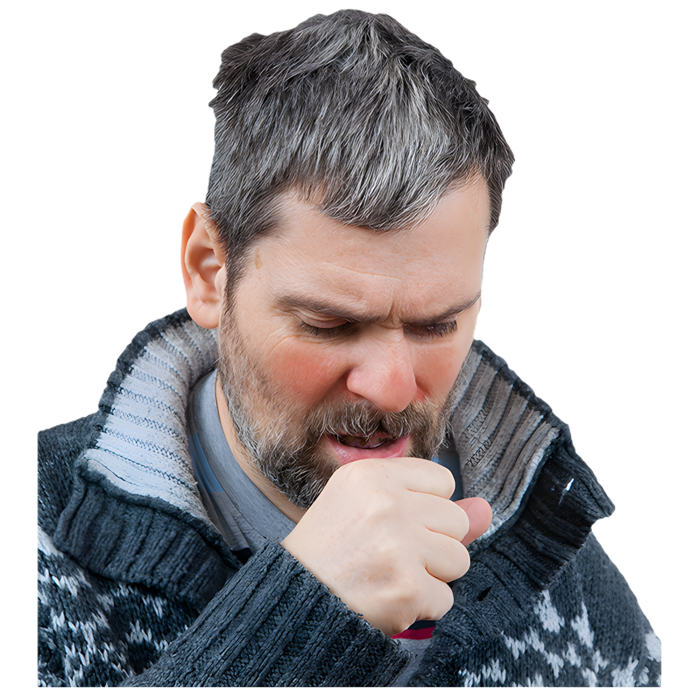 | This can help you not to choke.

What should NDIS workers do?
 | Your NDIS workers must know how to support you in a safe way when you have dysphagia.
 | You should have a plan that your workers can follow to support you well.
 | Your NDIS workers should be trained in your plan.
 | If you need help going to the doctor or a speech pathologist, talk to your NDIS worker.

Choosing what to eat or drink
The people mentioned before can support you to make choices about
- When you eat and drink
- How you eat and drink.


 | If they or someone else don’t let you choose, you can tell us.

Contact Us
 | You can contact the NDIS Commission for more information about aspiration pneumonia.
 | You can  - Call us on 1800 035 544  - Email us at contactcentre@ndiscommission.gov.au  - Send us a letter to:  NDIS Quality and Safeguards Commission  PO Box 210  Penrith NSW 2751



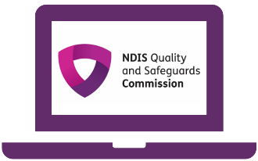 | You can go to our  - Website at www.ndiscommission.gov.au  - Facebook page at www.facebook.com/NDISCommission  - LinkedIn page at www.linkedin.com/company/ndiscommission



 | - Instagram page at www.instagram.com/NDISCommission

The NDIS Commission made this Easy Read information.
You must not use any of the images without asking us first.

