Tip sheet – Giving feedback to workers and providers

Giving feedback is a way to:
- Check how a worker is going with their job

- Tell someone what they are doing well and what they can do better
- Swap ideas on doing things better
- Build the skills and knowledge of the worker.
Giving feedback to workers is also called supervision.
The NDIS Workforce Capability Framework (the Framework) describes the behaviour, skills and knowledge workers should have. We refer to these as capabilities. These capabilities are expected of all workers funded under the NDIS.
You can use the Framework to check workers and providers are showing the capabilities you need when you give feedback.
Directly employing your workers or engaging individuals? Giving detailed feedback or supervision as part of your regular conversations is important.
Getting support from NDIS provider organisations? The provider is responsible for supervising workers and making sure the worker has the capabilities for the work and follows the rules. It is okay to give feedback to your provider and to the worker about how a worker is doing their job.

It is OK to complain – speaking up can help to improve services for you and other people.
Call: 1800 035 544 (free call from landlines). National Relay Service - ask for 1800 035 544.

How to provide feedback to workers:
Focus on how an issue affects you and how you feel when you give feedback. The diagram below shows the way you can give feedback in a conversation.
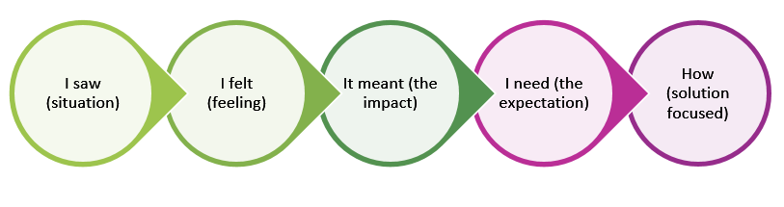
Example: I saw that the dishes were not done yesterday. I felt frustrated as I can’t do them. It meant I didn’t have a clean plate for breakfast. I need the dishes done before you go. How can we make sure there is time to do the dishes?

Points to consider when giving feedback:
- Plan ahead: What do you want to achieve with this feedback? How can you say it in a way that will give you the best chance to achieve it?
- Build on the strengths of the worker: Do not only focus on problems.
- Be specific: Describe what you saw, but do not voice your opinion or leap to judgement. Give examples and talk about what you have seen, how it made you feel, and the impact the action had on you. For example:
‘I noticed you did not undo the laces enough before putting my shoes on, and my feet hurt.’
Not
‘You put the shoes on wrong. Don’t you know how to put shoes on?’
- Explain why it matters: When you describe how something affected you, it helps the worker understand why it is important. Describe the impact to help them see things from your point of view and how their actions affect you.
- Be calm: Some feedback can be hard to give and hard for the worker to hear. You can both get defensive and emotional. Check your own emotions and be supportive of the worker if they get upset. For example, acknowledge how they feel, ask if they want to take a break.
- Encourage reflection: Encourage the worker to think about what might have influenced their behaviour. You can go to the Reflective Practice Tip Sheet for Supervisors and Workers for questions to help guide reflective conversations. For example:
‘How do you think that went?’
‘Were there any circumstances or external things that added to the situation?’
‘Would you handle this differently if it happens again?’

- Focus on a solution: It is important to focus on what a solution might be during the feedback conversation. You can also ask the provider or worker what they think the solution could look like. For example:
‘I would like to hear how you can support me with….’

- Invite feedback: Feedback is a two-way process. It is important to ask the worker how helpful they find your feedback.
Visit the supervision resources for participants for more examples and tips. This can help you when you check in and share regular feedback with your workers.

Example of feedback
The example below shows how you can provide feedback to a worker on the capabilities of ‘communicate effectively’ and ‘manage health and safety’, from the Framework.
I have noticed when you arrive late to help with my morning care and breakfast routine that you rush me. I have tried to tell you how I feel, but you cut me off or interrupt me.
I need to be able to tell you how the delay impacts the rest of the day’s planned activities. Being rushed makes me feel overwhelmed and exhausted for any activities I have planned.
I understand on some days, things can happen and you may be late. I can see you then try to do things quickly to get ready in the morning or to get somewhere quickly. However, the rushed car trips scare me.
If you let me know if you are running late, with some notice, I can reschedule my activities. Then I can have a more comfortable breakfast and travel routine. Is there something I need to know about why you are late to see what we may be able to do? Or is there something else you may be able to do so you are on time?

Useful tips
- Do regular check-ins, like at the end of a shift or week. This helps you and your worker to practice and build confidence in talking about how they are doing.
- Give feedback when you notice your workers or providers are not doing what you expect. For example:
  - To address a one-off issue or mistake
  - Not supporting you as agreed in a position description or service agreement
  - Not showing the capabilities in the Framework that are important to you
  - Not following the NDIS Code of Conduct.
- If you directly employ workers, do you have a position description in place that shows the capabilities they should have? This can be used as a checklist to give feedback.
- Ask new workers how they are going. For example:
‘How are you going after your first few shifts? Is there anything you want to talk about?

- Ask workers to request feedback. For example:
‘You (the worker) can ask me questions if there is something you want to talk about?’
- Decide what to cover. Pick one or two important issues to raise, not a long list.
- Give feedback when a worker or provider supports you well.
- An advocate, support coordinator or a trusted family or friend can help give feedback.
- If you use a provider, does the provider have a system to support inviting and giving feedback from participants such as feedback surveys or workers’ performance reviews?
- If things do not improve after you give feedback, think about whether the worker needs other types of support like training.
- If a worker you directly employ needs training, you should:
  - Record what training they do
  - Assess if they have gained the skills or knowledge they need.
- If a worker keeps doing things wrong or what they do is unsafe or breaks the rules you may need to:
  - Make a formal complaint with the provider, or
  - Tell the NDIS Commission if the worker has not followed the NDIS Code of Conduct.

