Apply for access to the Database (NWSD)
- To obtain access to the NWSD, navigate to the Commission’s website at www.ndiscommission.gov.au.
- Navigate to Portal Login > Applications portal login. 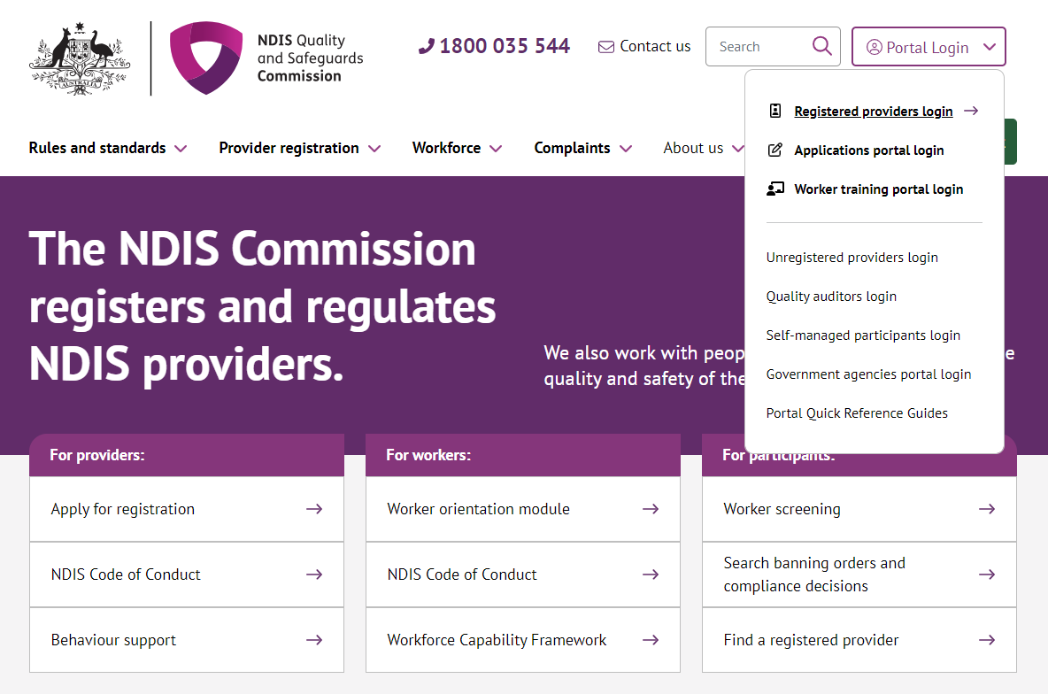
- Once you get to the Applications Portal webpage, click Login

- You can log in to the Applications Portal by clicking either Login to PRODA or Continue with Digital ID. If you do not have a PRODA account or Digital ID account, please create one before proceeding.
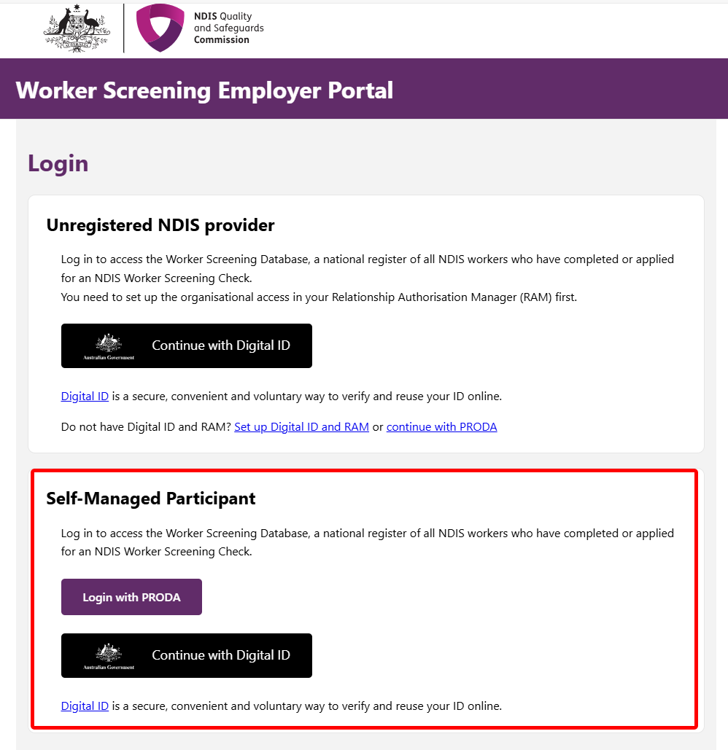
- After selecting the Application Portal and entering the required information. Once submitted, you will receive an email to confirm your email address with instructions on how to proceed with your application.
- Read the Applications Portal conditions, and click I agree. 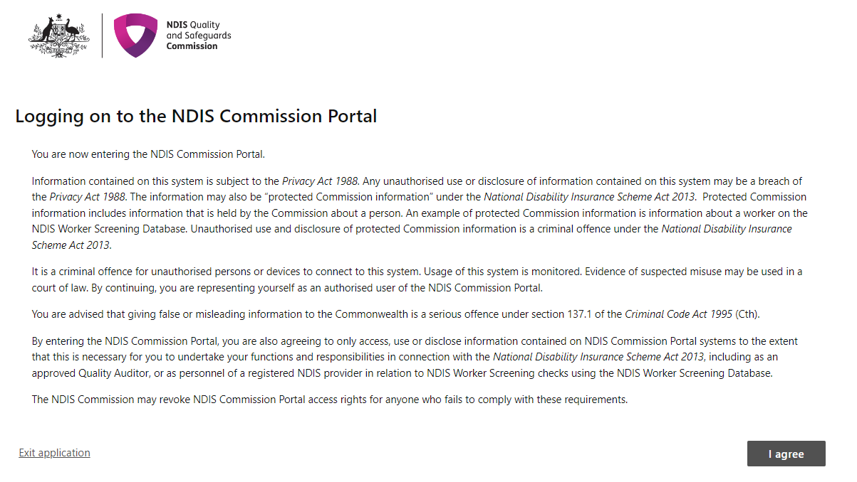
- As a NDIS Participant seeking access to the NWSD, select the tile Apply to become a Worker Screening employer. 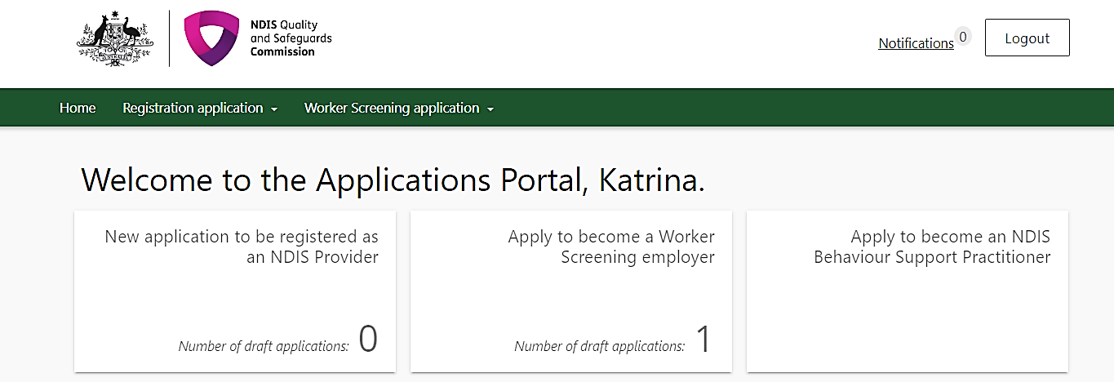
REMINDER: This is not an application for a NDIS Worker Screening Check.
- Click Start new application to become a Worker Screening Employer to verify and link workers in the NWSD. 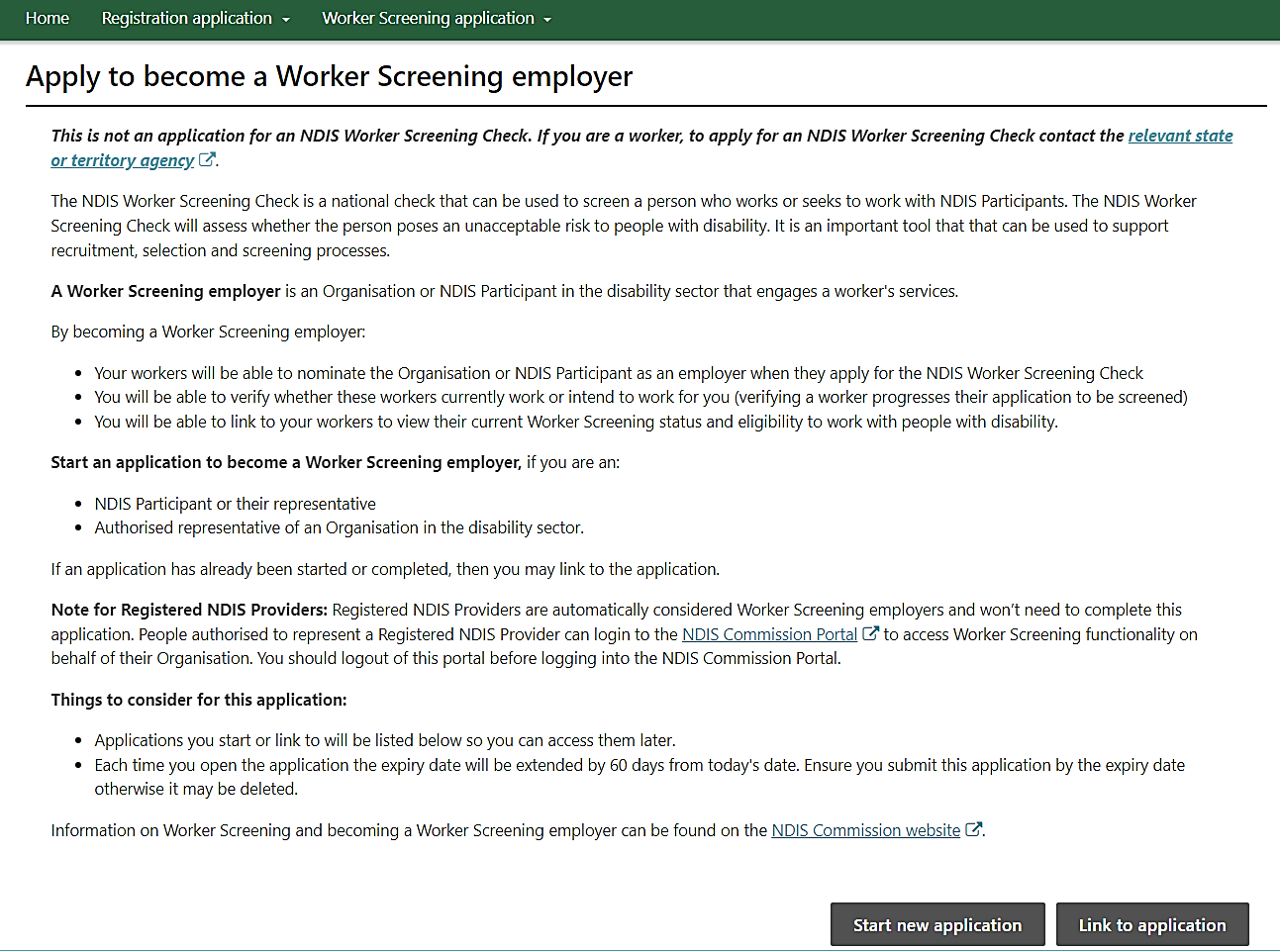
- To continue, select NDIS Participant and select which option applies to how your plan is managed. 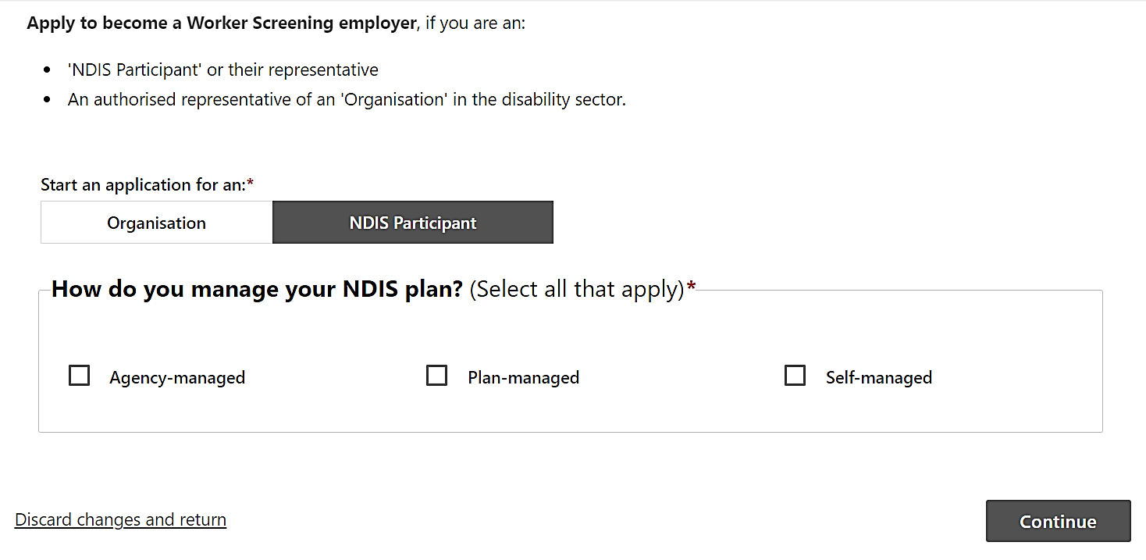
- Provide the Participant’s details. (if this is incorrect the application will be withdrawn)
Please ensure the following Participant details are correct and click Continue. 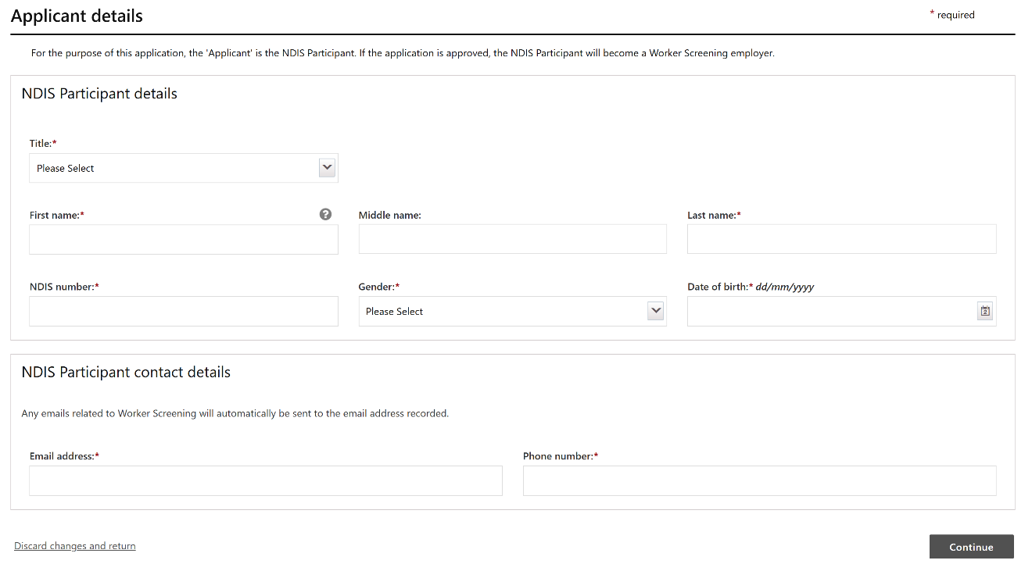
- Ensure you have read and understand the Initial declaration before proceeding. Provide the same email address that you have been using for PRODA or Digital ID. In the application. Click I agree and continue once complete. 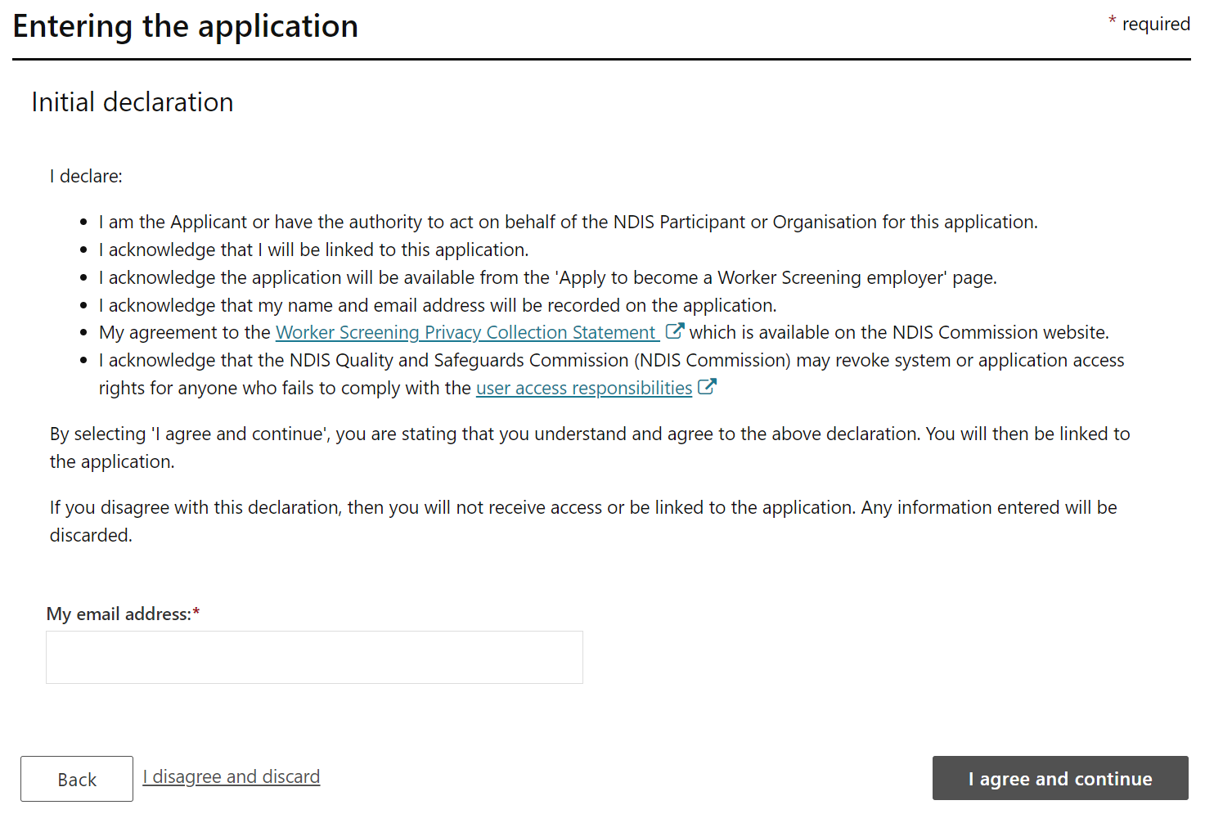
- On the left-hand side of the screen, the orange-coloured dot lets you see the part of the form that requires action before you can proceed to the next page.
Once you have completed this section, select Save and continue then Mark as Complete. This will provide you with a green tick indicating that this section is complete. 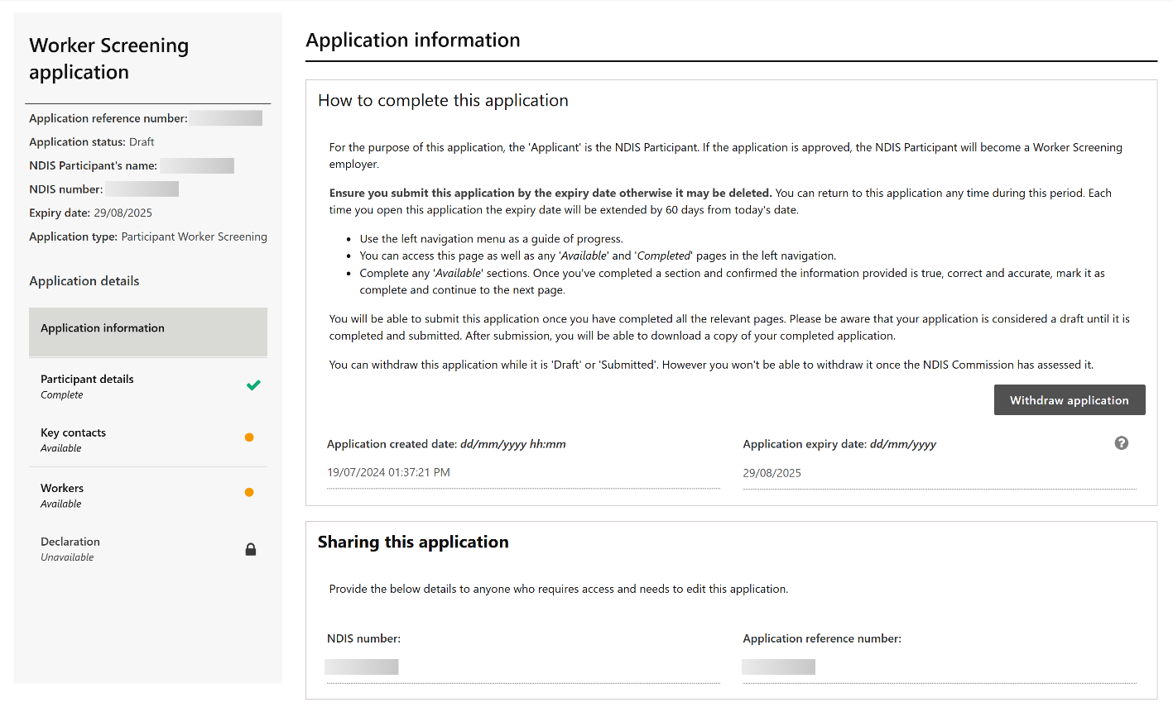
- The person/s listed here is either, the participant completing the application or the nominee on behalf of the participant. If no changes are required, please select Mark as complete and continue. If the information is incorrect or not populated, please select Add and provide the correct contact information.
- Being a nominee means that the NDIS Commission can speak to you on behalf of the participant. This person will have access to manage workers, update details and receive messages on behalf of the Participant.
- If participant is not the primary contact, please do NOT tick make primary contact instead, click Add and enter nominee details.
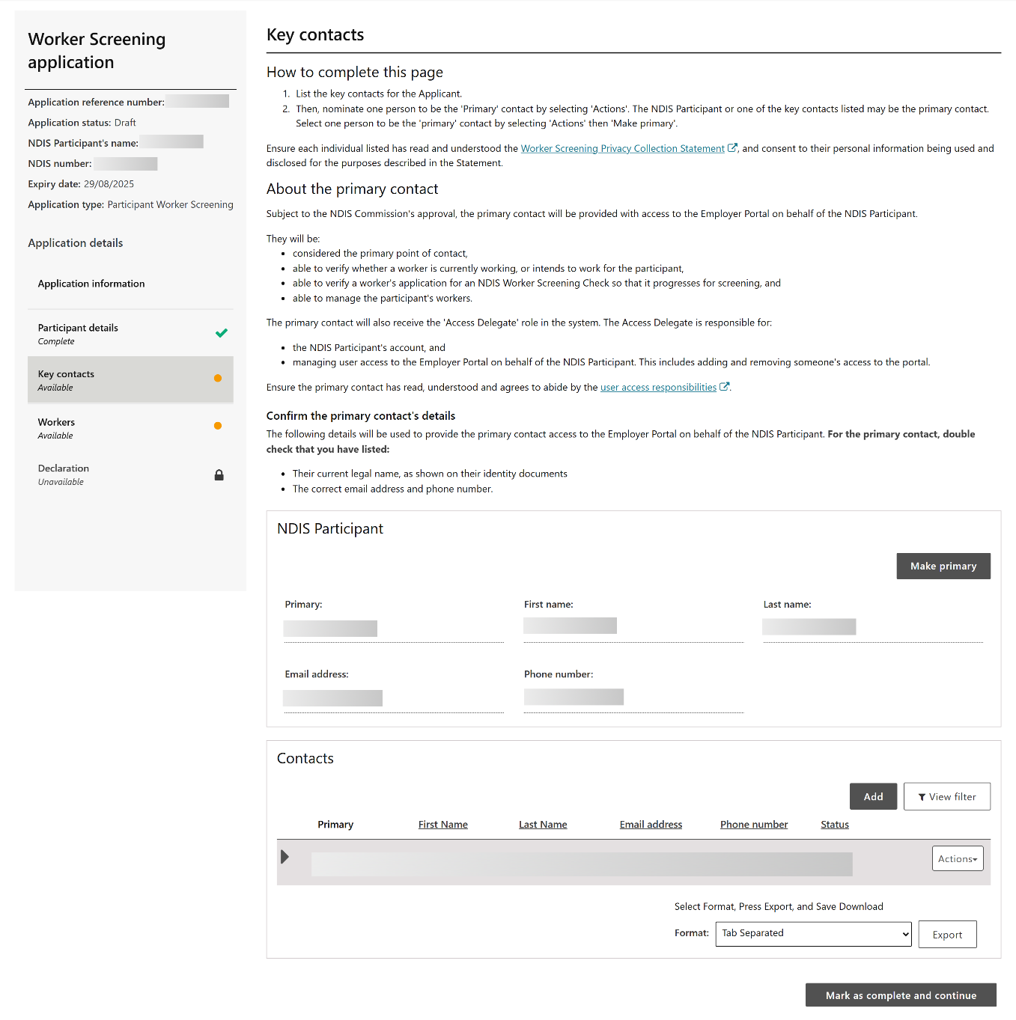
- If you have a worker’s Worker Screening ID and you wish to add them, please do so and select Mark as complete. If you currently have no workers, please leave this section blank and select Mark as complete and continue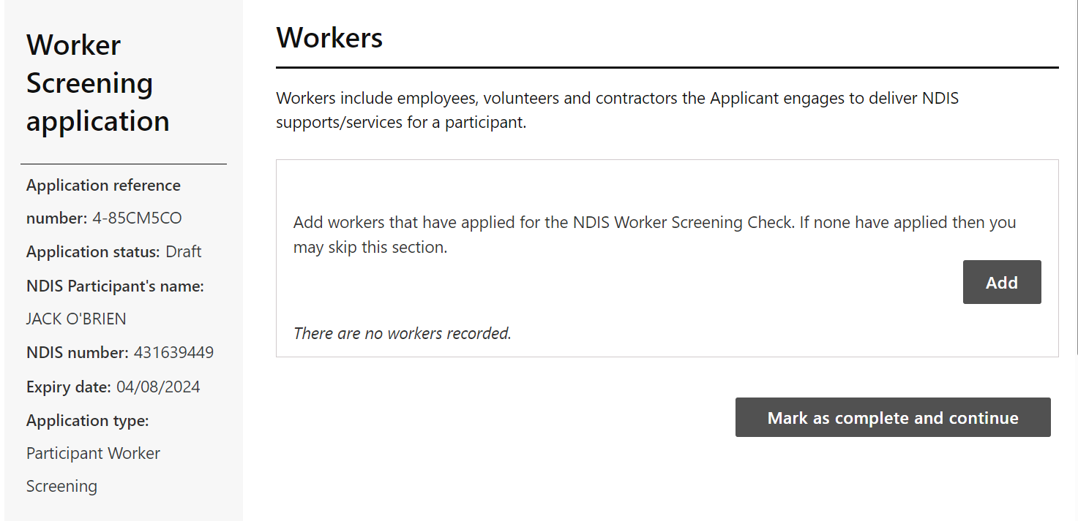
- Ensure that the primary contact information included here is the same as the primary contact entered in the key contacts section. Please take a note of the Application reference number (4-XXXXXXX) in the top left corner of the screen. 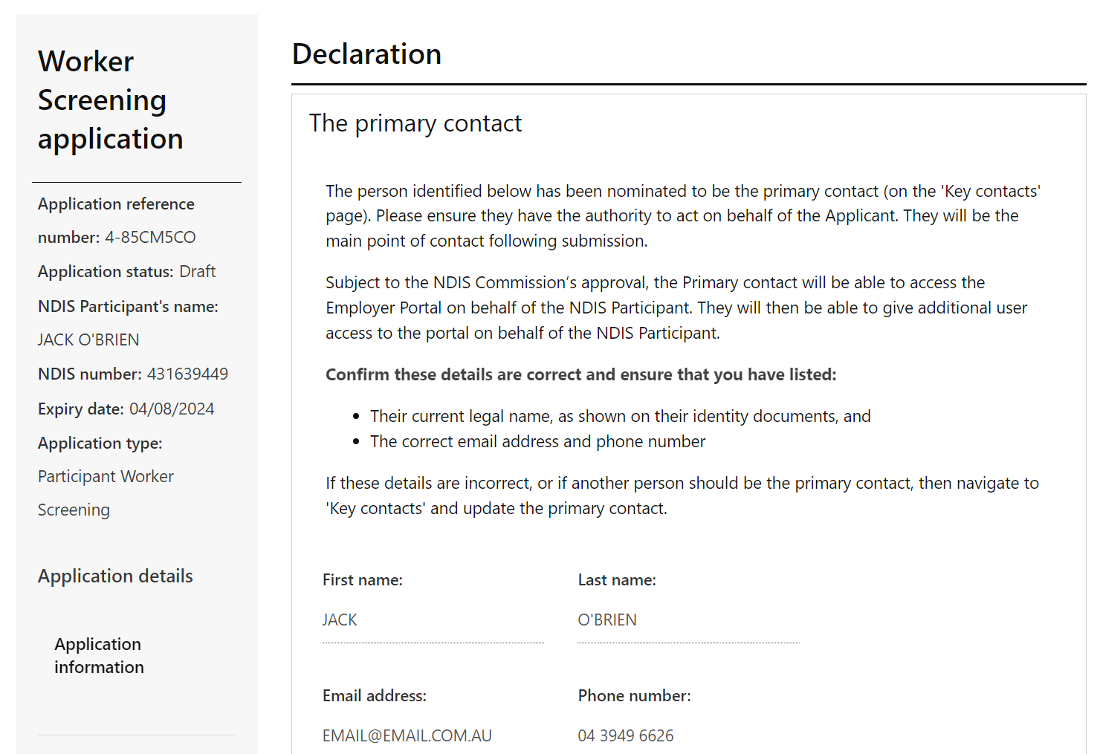
- Ensure you read and understand the declaration before submitting the application. If you have any further questions, please quote the Reference Number (4-XXXXXXX) in any emails you send to the NDIS Commission. You can then select submit the application. 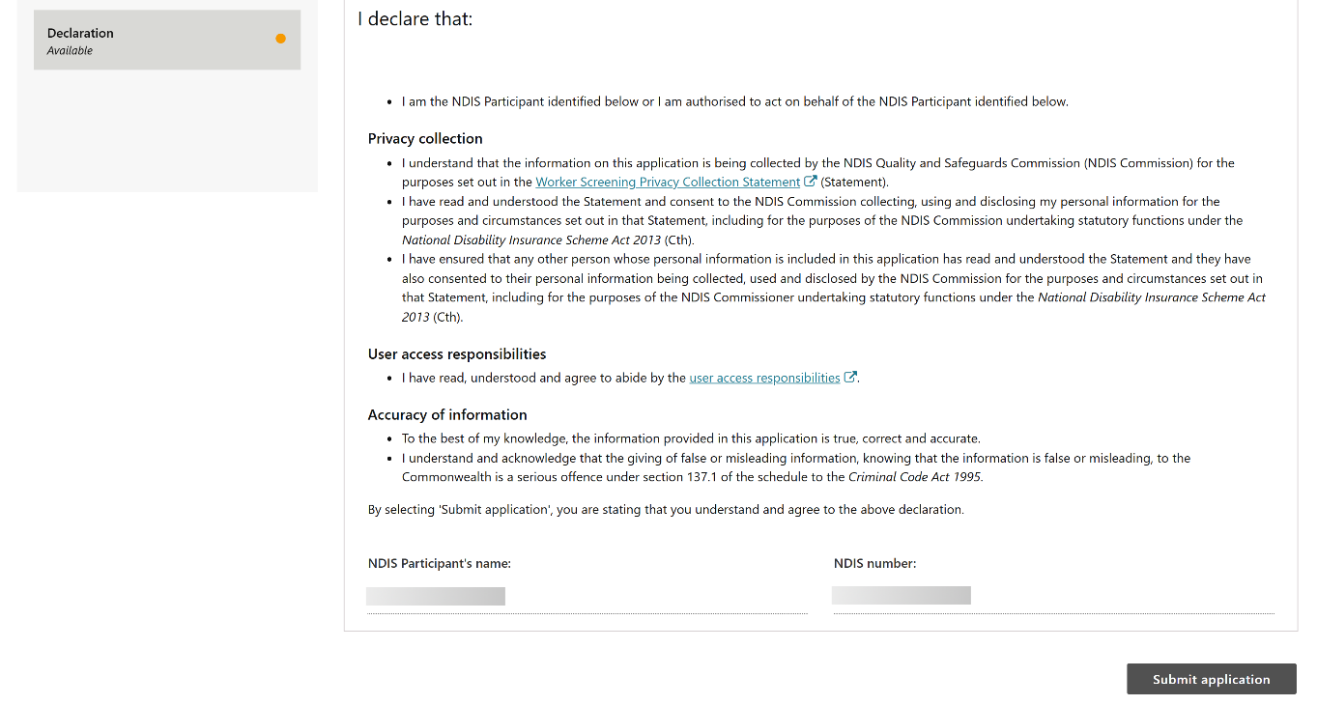
- Your application has now been submitted for assessment. If your application is successful, you will be notified by email to confirm and inform you of the next steps. If we identify an issue with your application, we will contact you by email.
Tip: Once your application has been approved, it will take up to 48 hours to be updated in the database.

