Log in to the database once your access has been finalised: Unregistered providers
- Go to the Homepage | NDIS Quality and Safeguards Commission
Once you have access to the Worker Screening Database you will select the below login option
Go to Portal Login > select Unregistered providers login
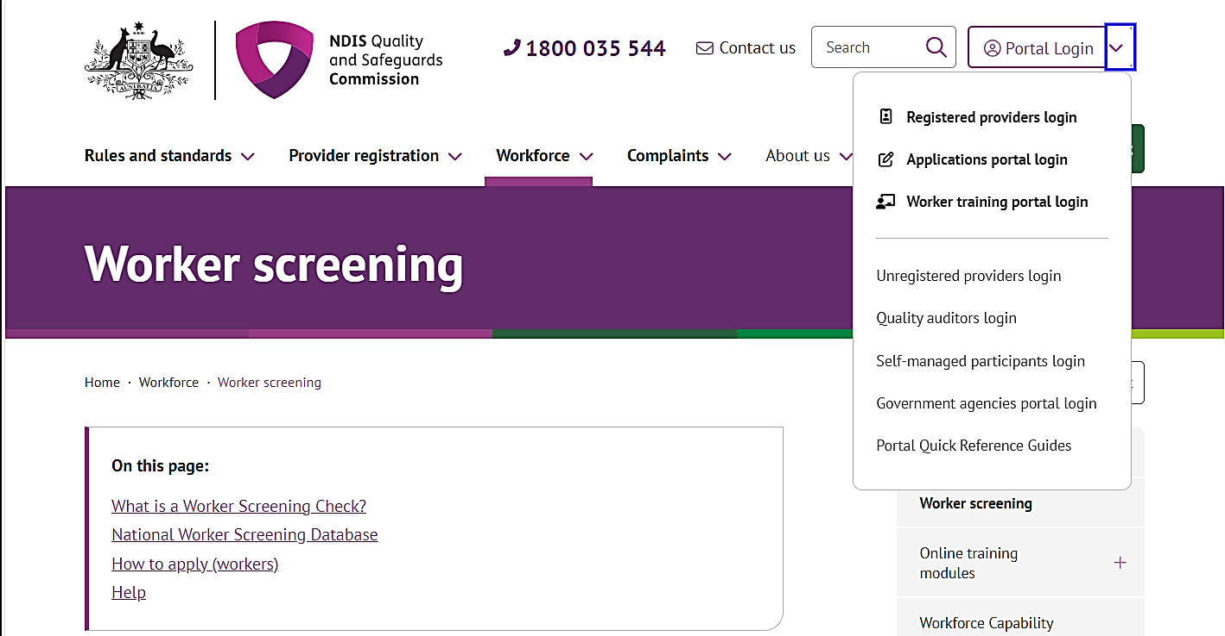
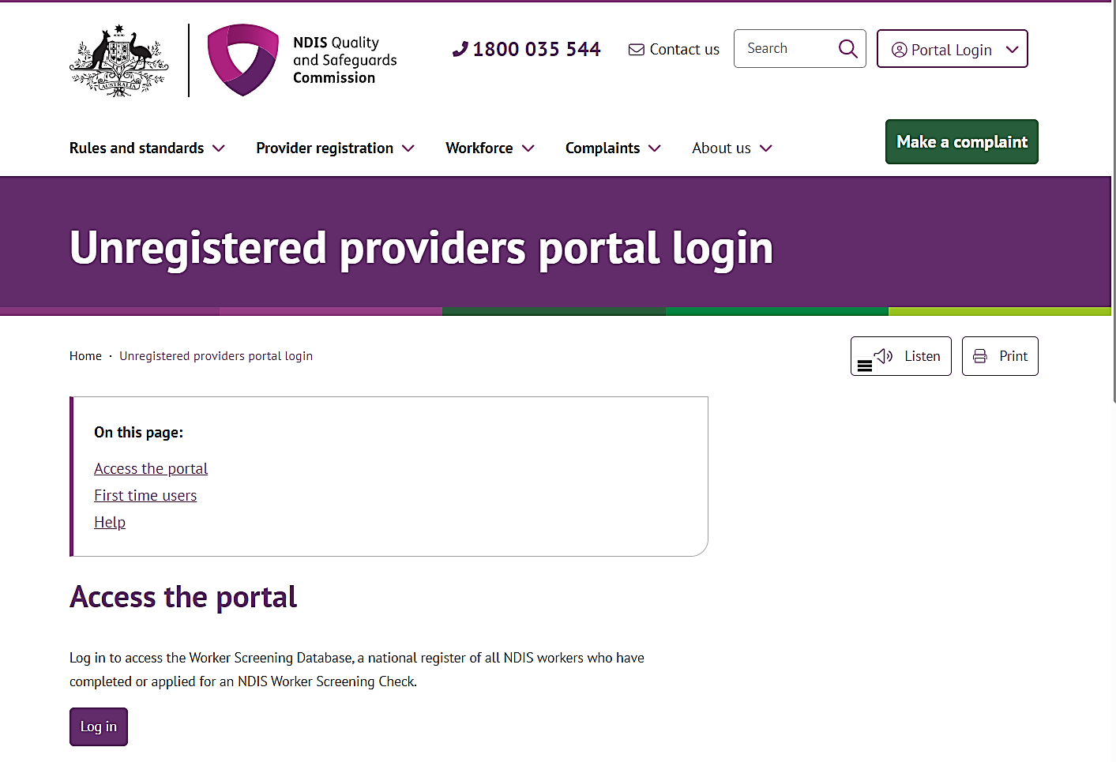
- Click Log in
- Click Continue with Digital ID
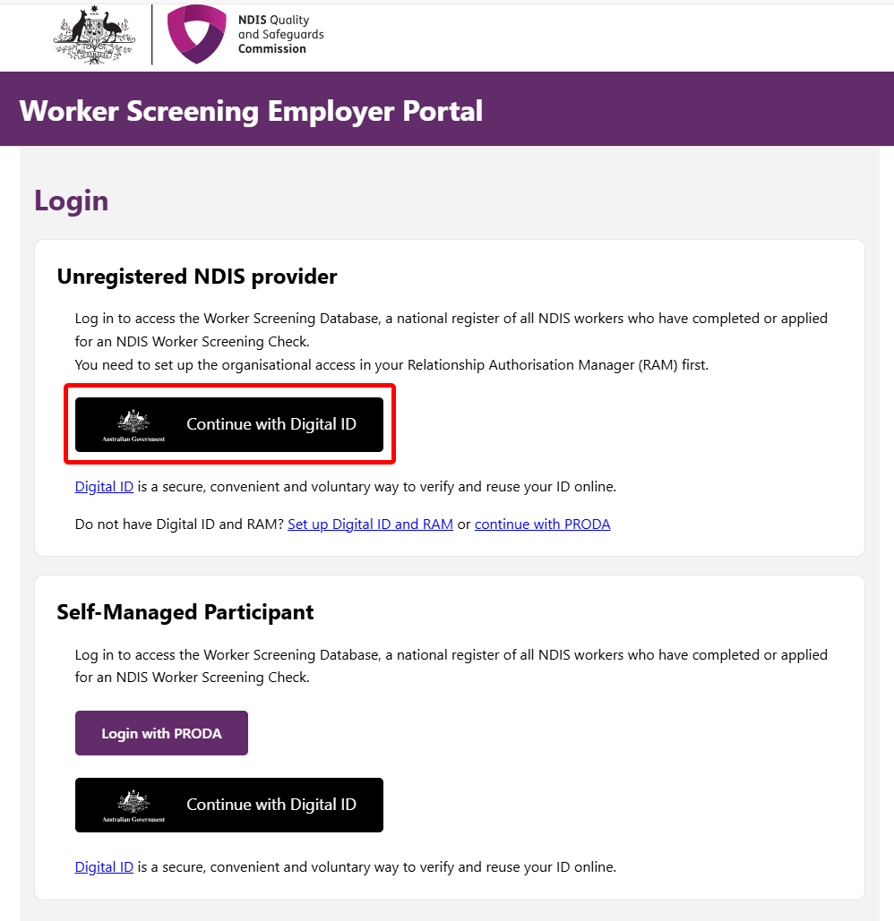
- Click Select myID
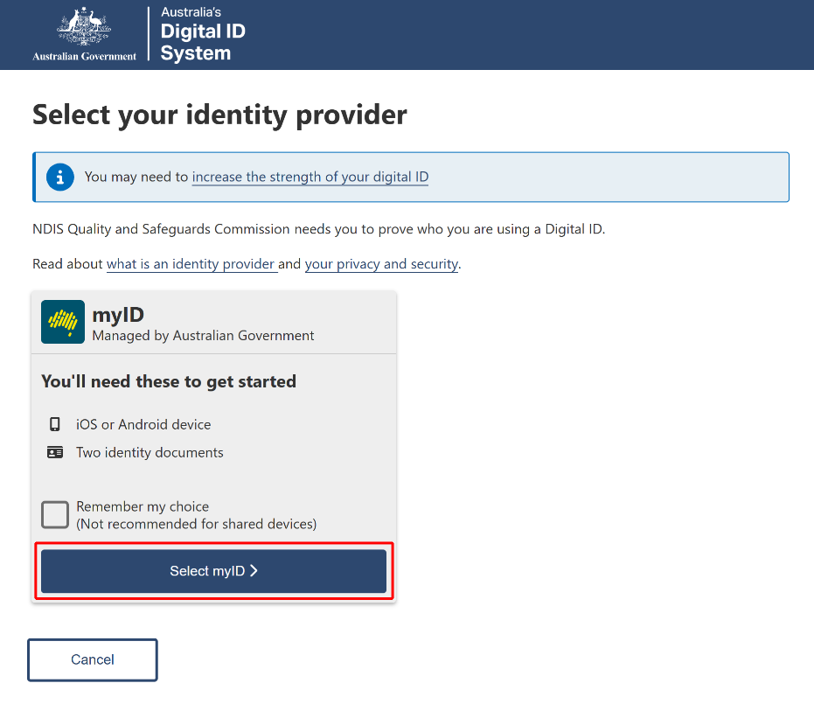
- Enter your myID email and click Get code. If you don’t have an account, you can register for a Digital ID (myID).
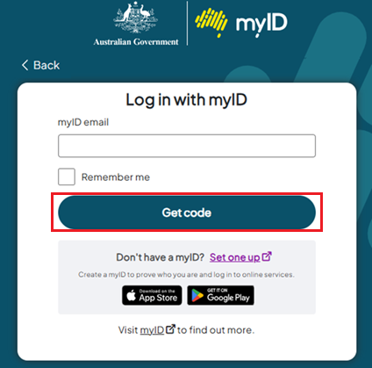
- A code will be generated.
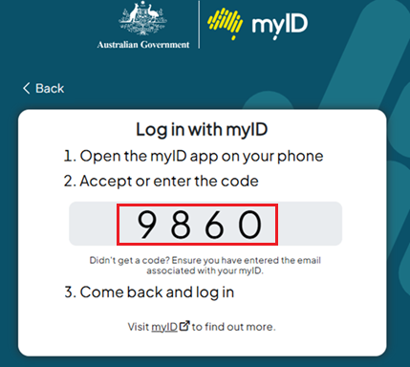
- Open the myID app on your phone and either accept the request or enter the code.

- Select your Organisation > use the dropdown and select Worker Screening for organisation role > Continue.
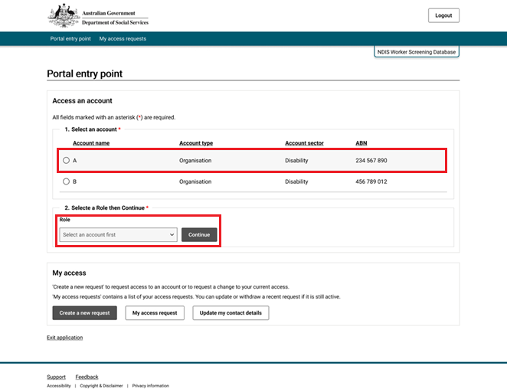
- Click I Agree.
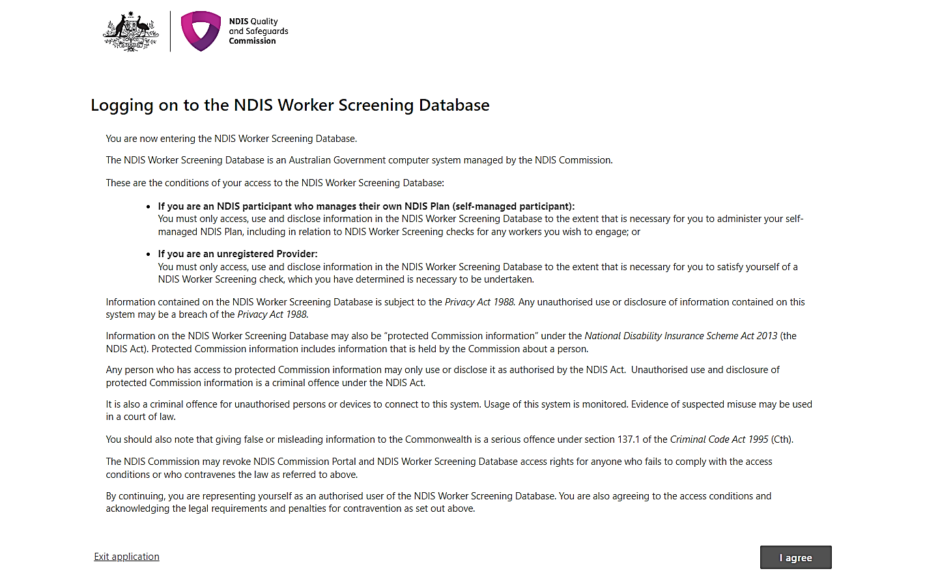
- You are now in the Worker Screening Database
