Finalise access to the database once your application has been approved: Unregistered provider
You will receive an email with a link to continue the finalisation of access, if your link expires or is not working, please follow the below steps.
- Navigate to the Commission’s website at www.ndiscommission.gov.au
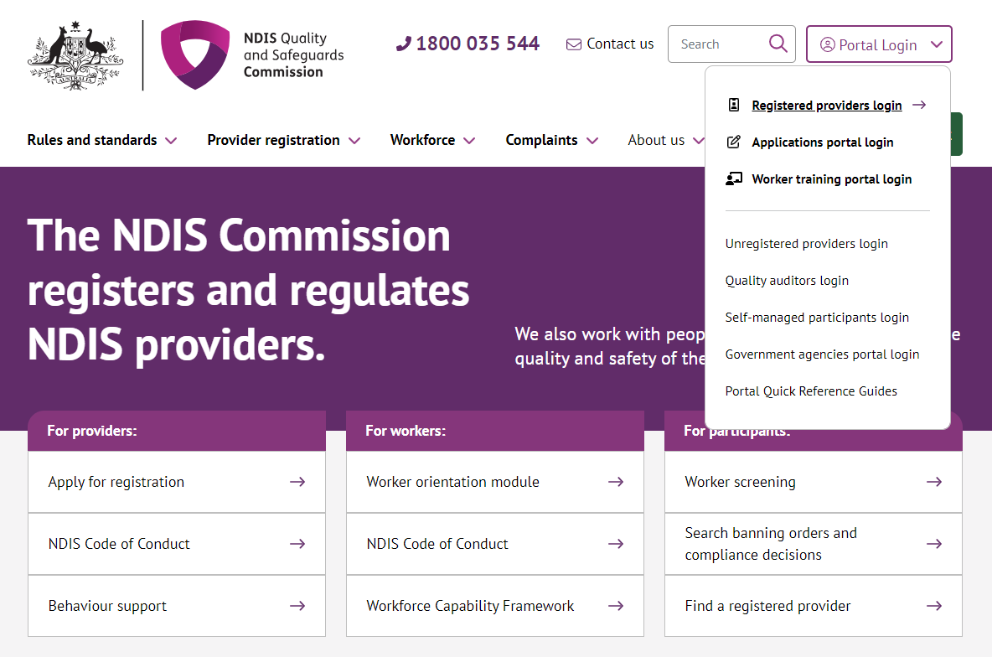
- Navigate to Portal Login > Applications portal login.

- Once you get to the Applications Portal webpage, click Login
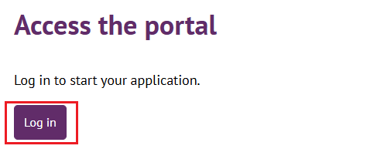
- Click Continue with Digital ID
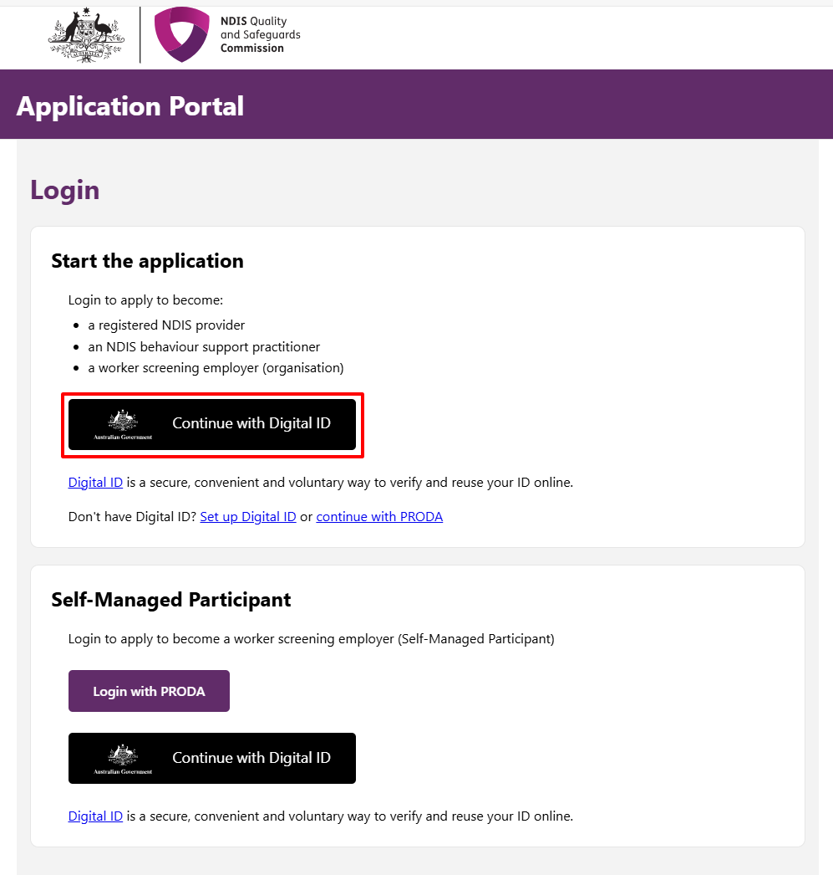
- Click Select myID
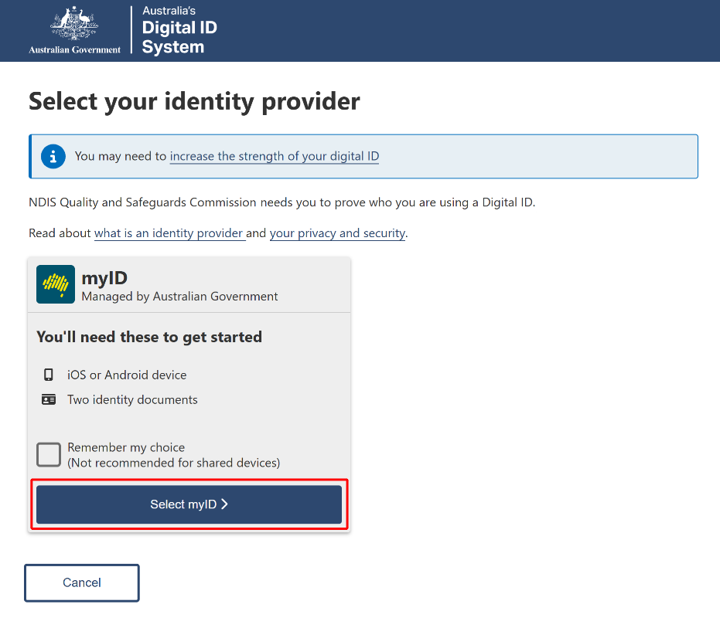
- Enter your myID email and click Get code. If you don’t have an account, you can register for a Digital ID (myID).
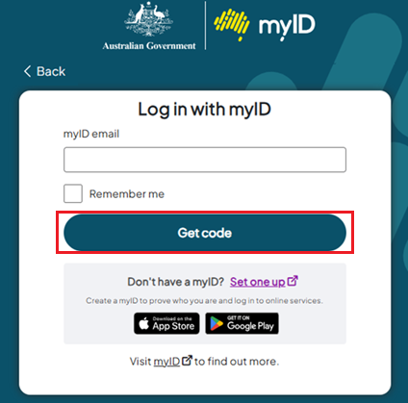
- A code will be generated.
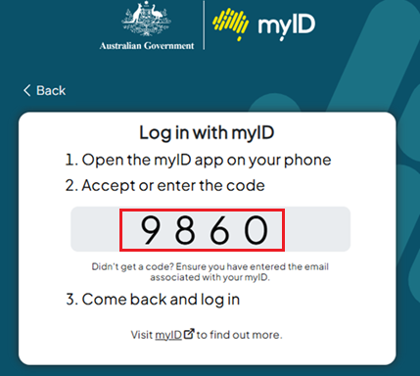
- Open the myID app on your phone and either accept the request or enter the code.
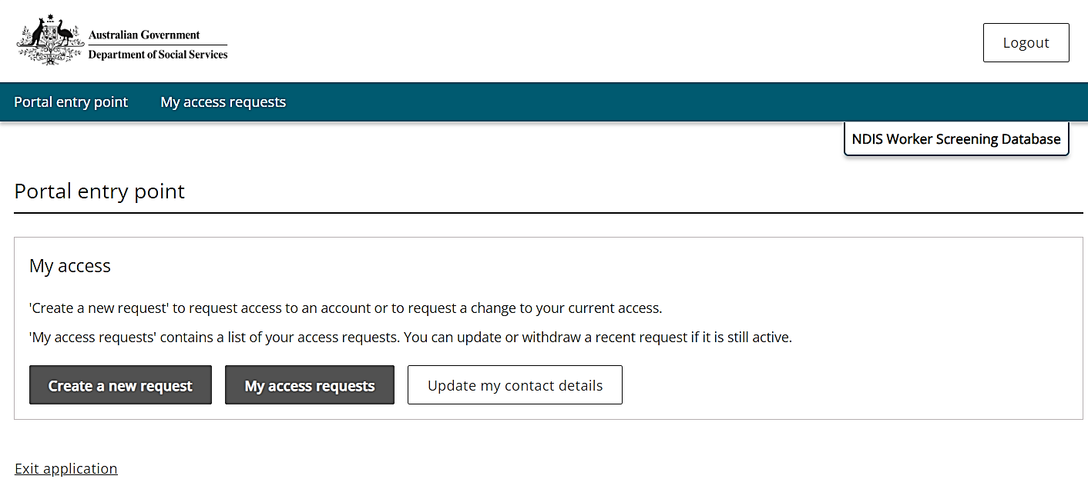
- Click Create a new request.
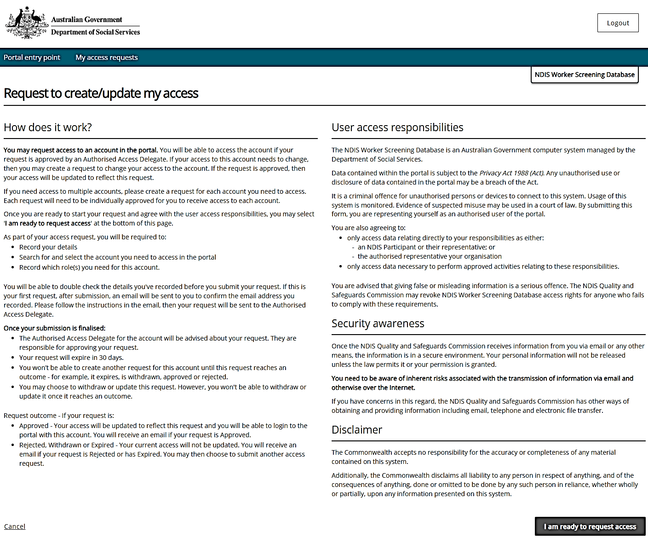
- Click I am ready to request access.
- Click Organisation for Worker Screening employer > Next
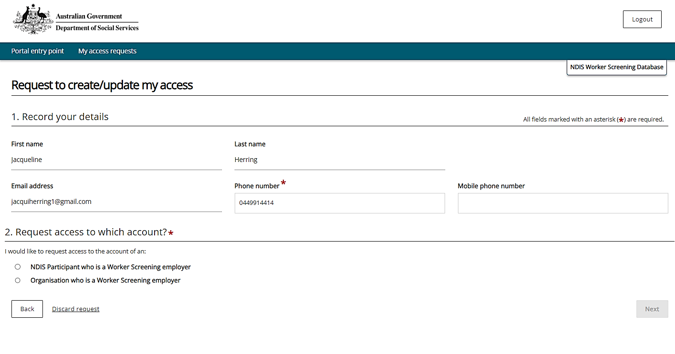
- Enter your ABN only - Account Sector – Disability > Run search
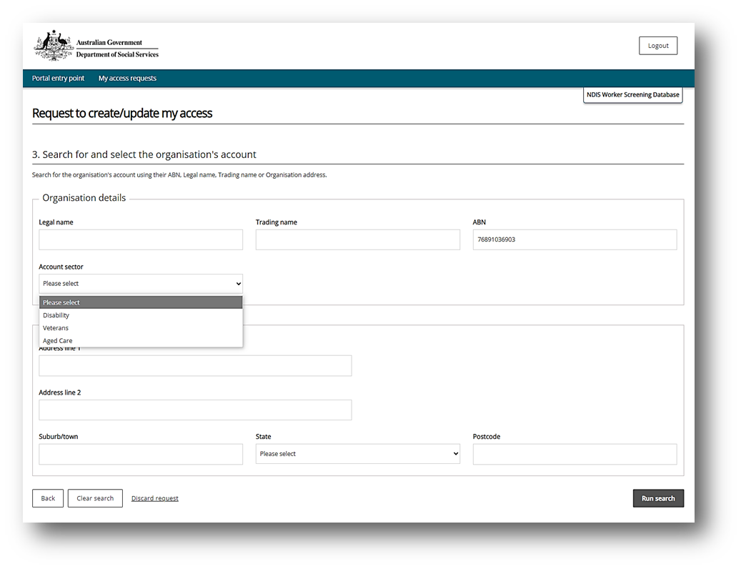
- Select the Organisation.
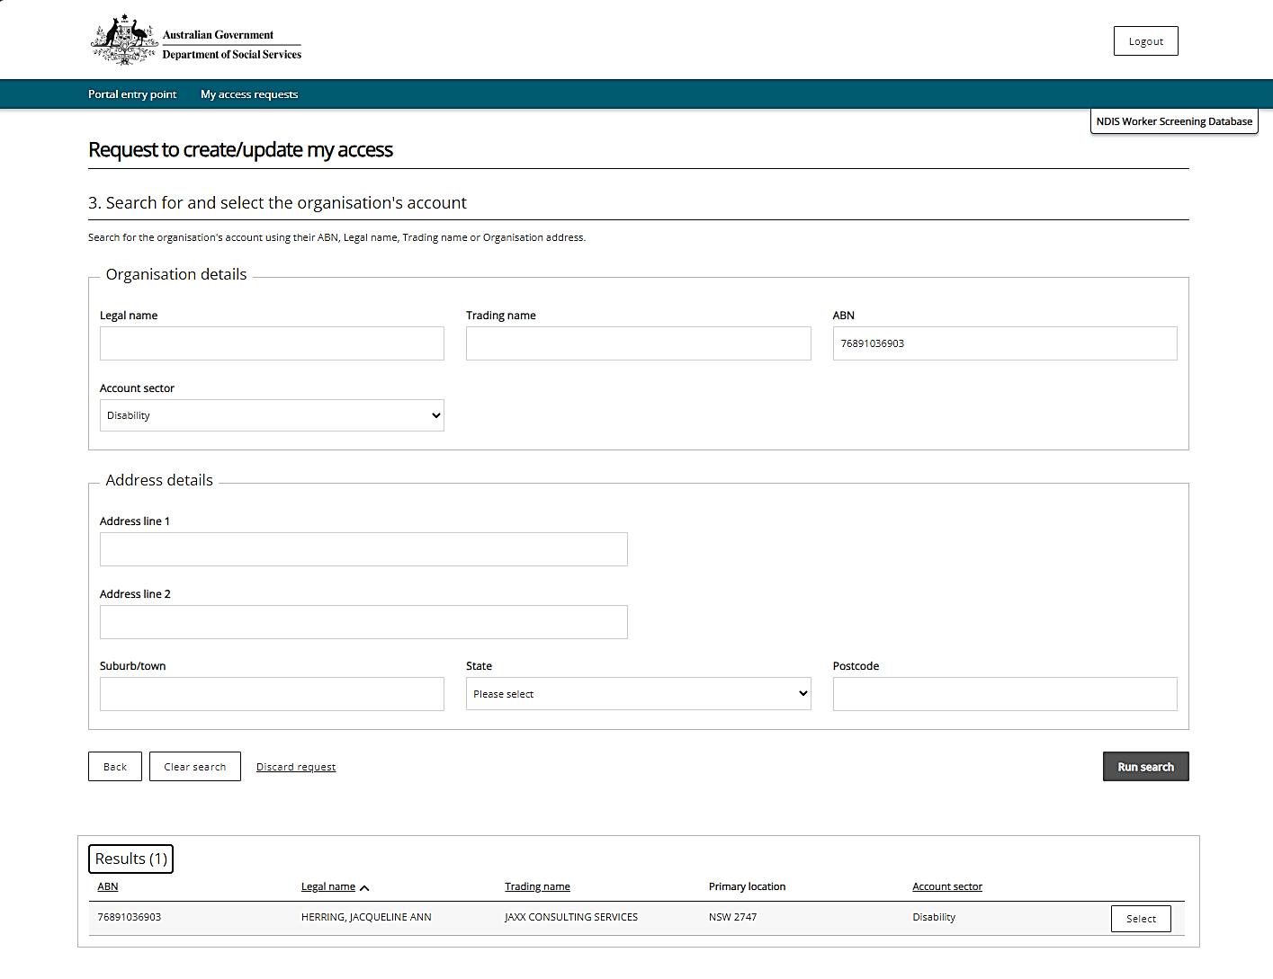
- Select Worker Screening for Organisation and Authorised Access Delegate as the roles > click next.
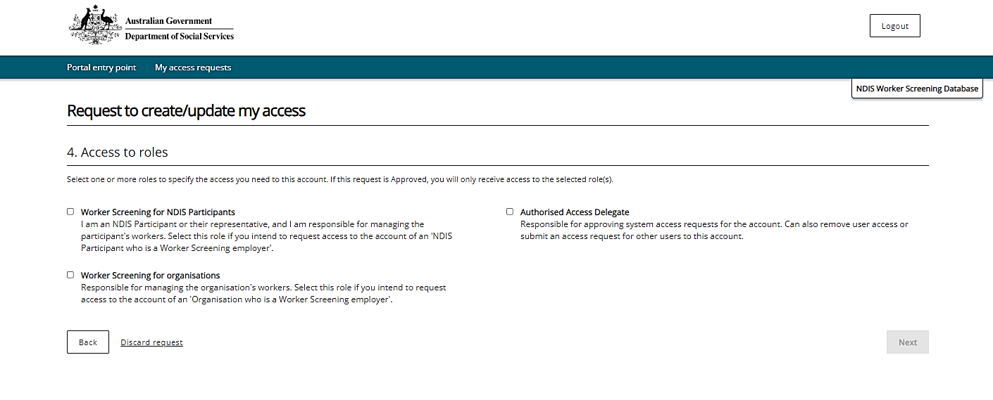

- Tick - I confirm the above details are correct > click submit.
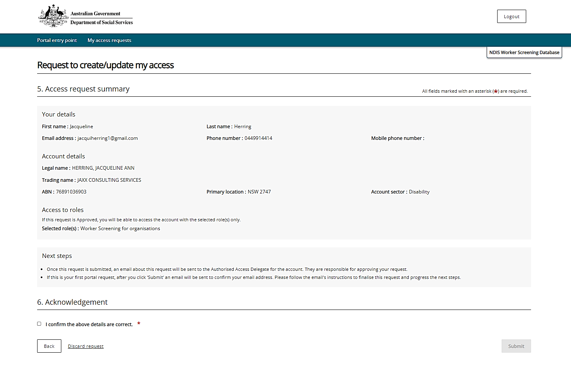
- Click Finish. This access request will generally take 24-48 hours to be updated in the database.

