Apply for access to the Database: Unregistered Providers
- To obtain access to the database, navigate to the Commission’s website at www.ndiscommission.gov.au
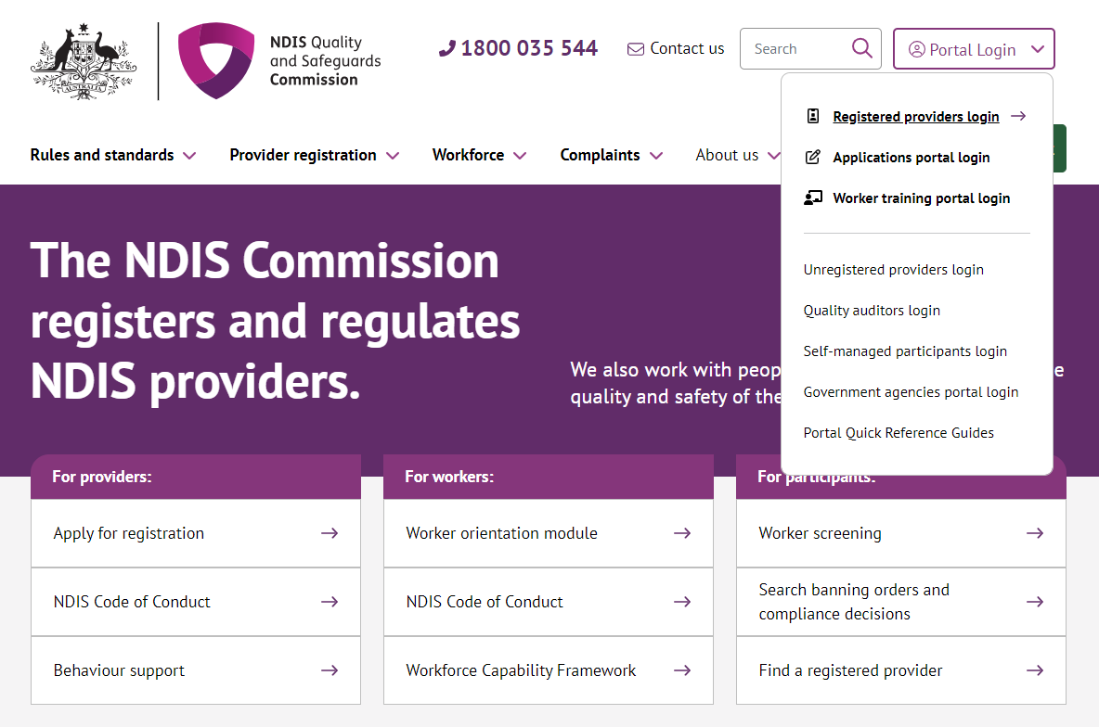
- Navigate to Portal Login > Applications portal login.

- Once you get to the Applications Portal webpage, click Login


- Click Continue with Digital ID
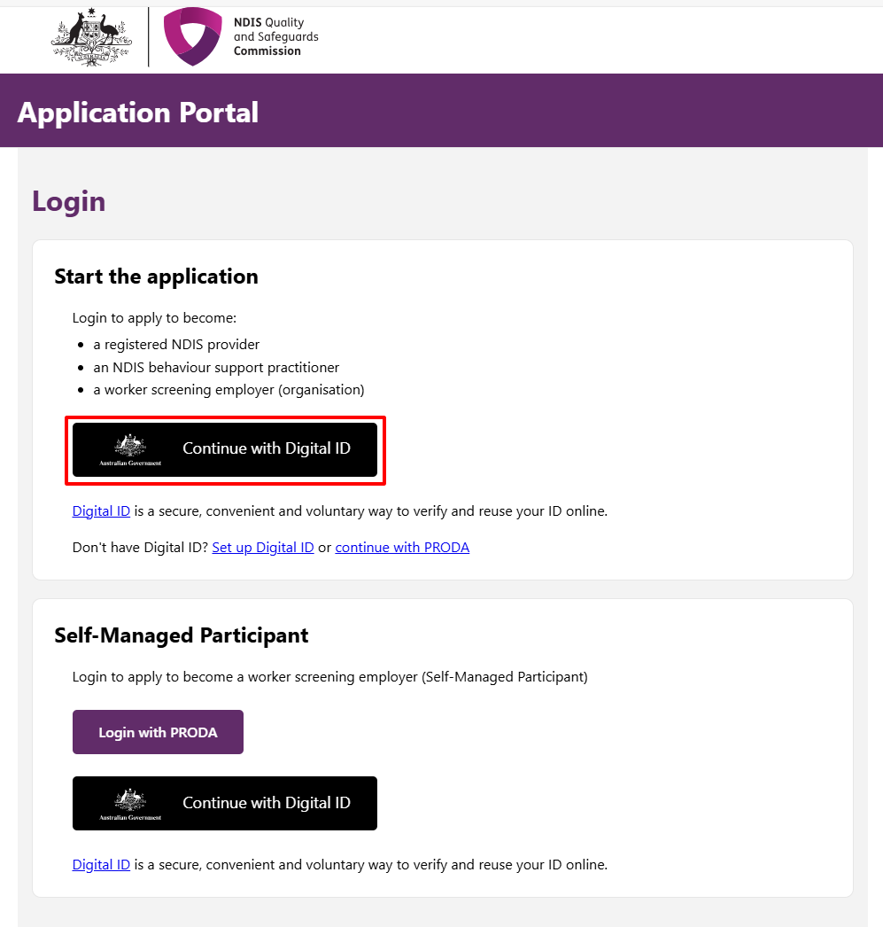
- Click Select myID
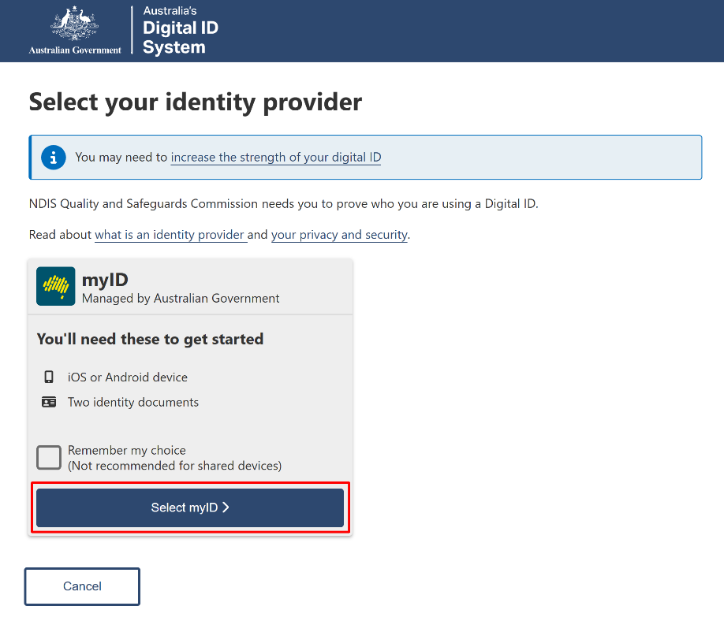
- Enter your myID email and click Get code. If you don’t have an account, you can register for a Digital ID (myID).
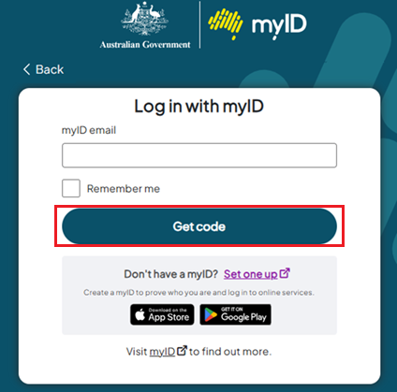
- A code will be generated.
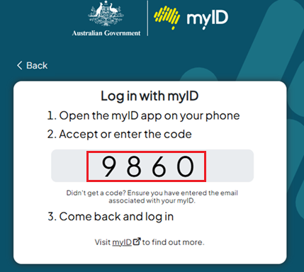

- Open the myID app on your phone and either accept the request or enter the code.

- Please enter the required information and you will receive an email to confirm your details. You will then be directed to log back into the Applications Portal to complete your application.

- Read the Applications Portal conditions and click I agree.
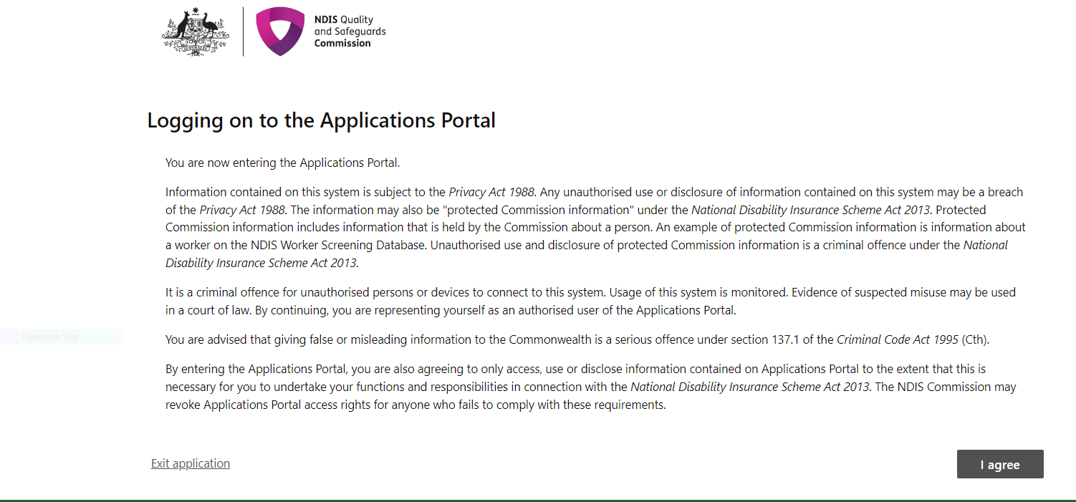

- As an Unregistered Provider seeking access to the NWSD, select the tile Apply to become a Worker Screening employer.
REMINDER: This is not an application for a NDIS Worker Screening Check.
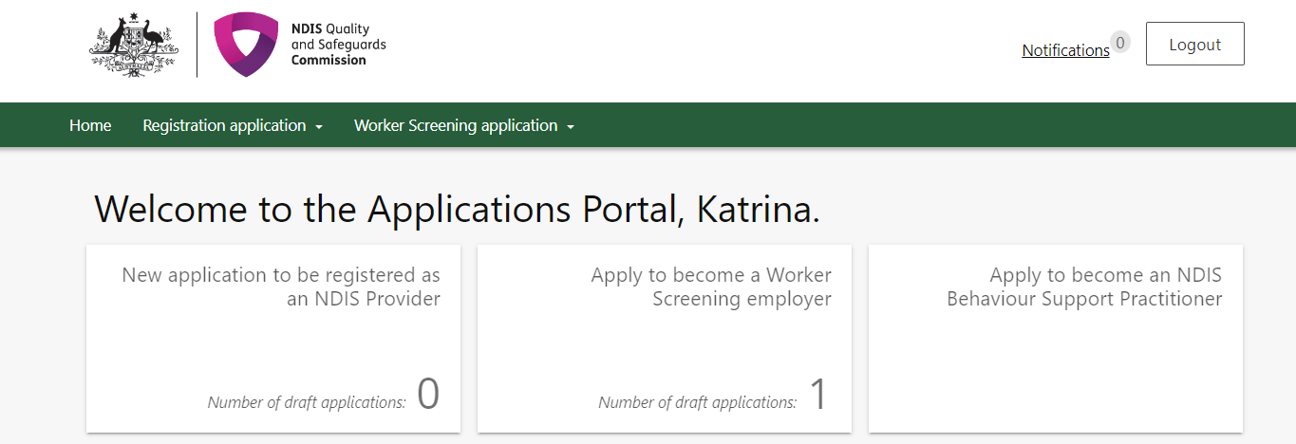

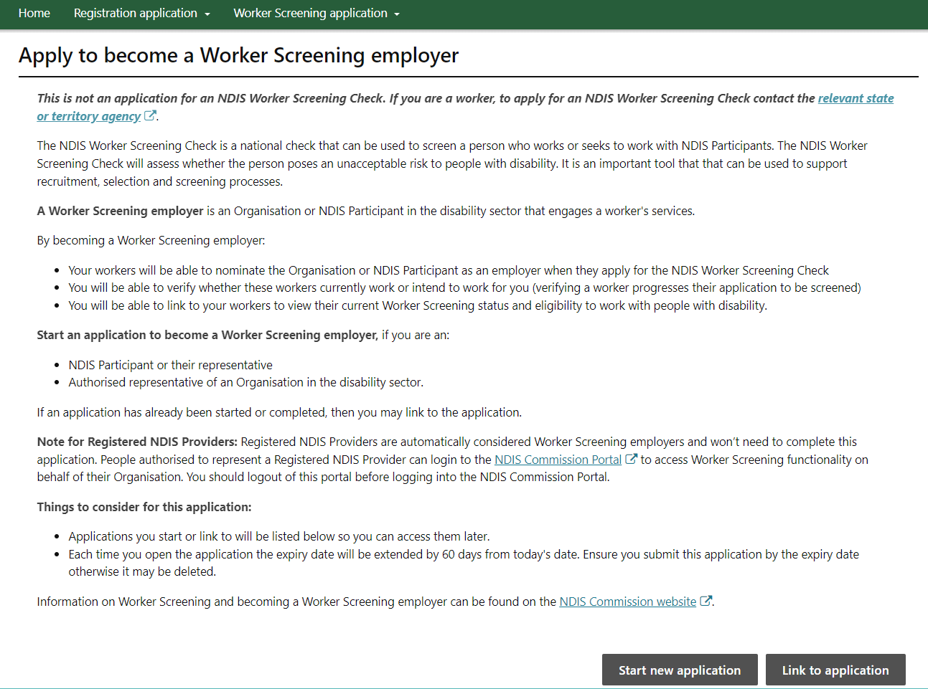
- Click Start new application to become a Worker Screening Employer to verify/link/unlink workers in the NWSD, and to view their Worker Screening status and eligibility to work in the disability sector.
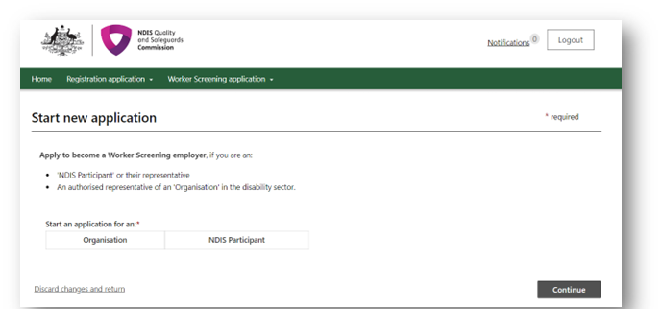
- To continue, select Organisation.
- You will then need to select if/when your organisation will be delivering supports or services to NDIS participants. Select your answer, then click Continue. If you select Not within the next 6 months your application will NOT proceed, as it is a requirement that employers deliver services within 6 months of application.
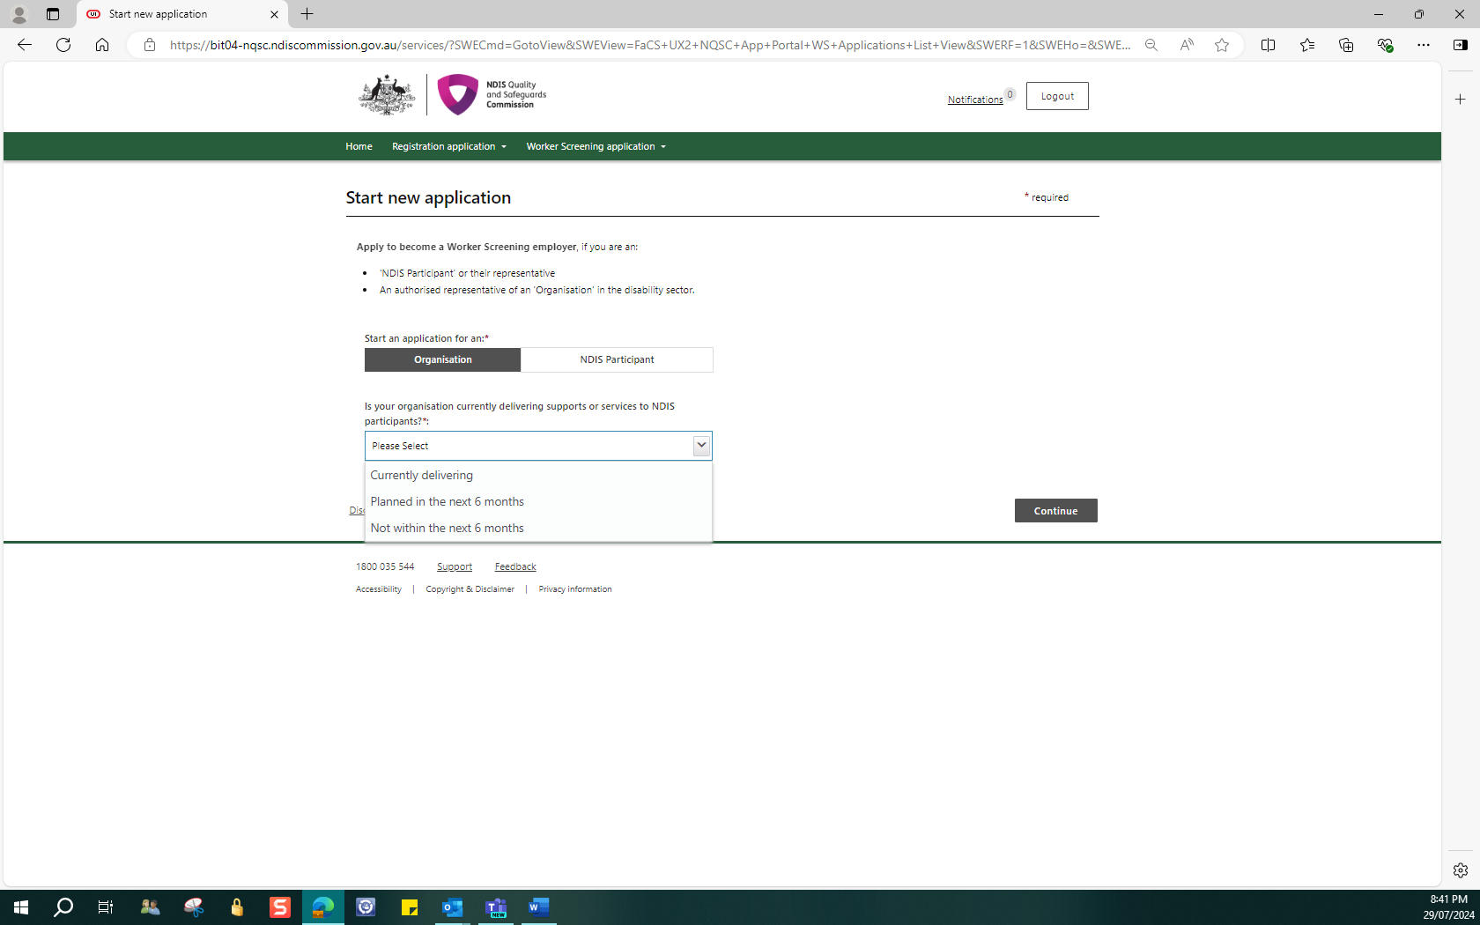

- Please fill in your ABN only and then select the Party type (select the same party type that is listed on the Australian Business Register) from the options provided. Once complete, select Prefill.

Tip: It is recommended that you do not copy and paste your ABN, please enter it manually, without spaces.
Tip: If your organisation is a trust, please select Australian private company.
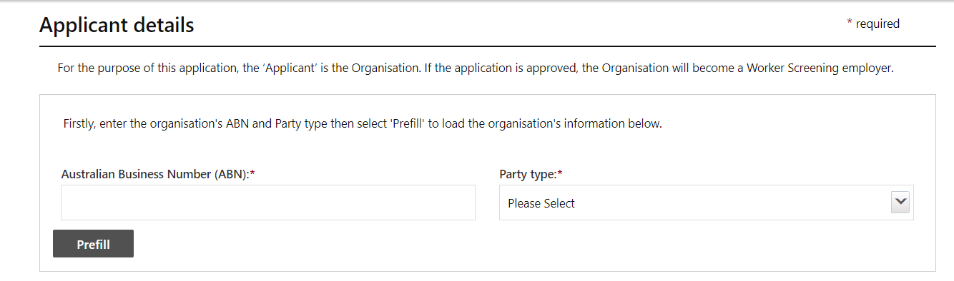

- Please ensure that you select the business name that is listed on the Australian Business Register. If you do not have a business name, use the Legal name (entity name) that is listed on the Australian Business Register. To do this you will need to select Enter a different business name.

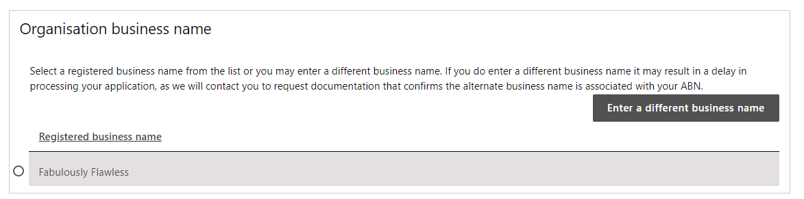

- Enter the same Email address and Phone number that you used to register with Digital ID. Fax number and Website are not required. Select continue once entered.
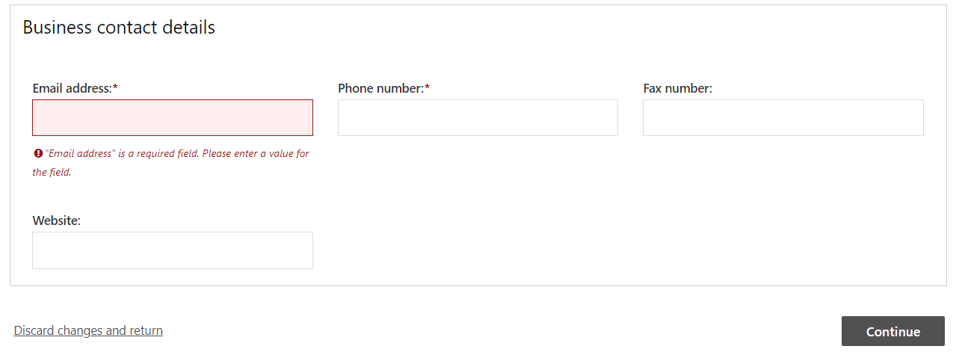

- Ensure you read and understand the declaration before proceeding. Provide the same email address that you have been using for Digital ID and in the application. Then click I agree and continue.
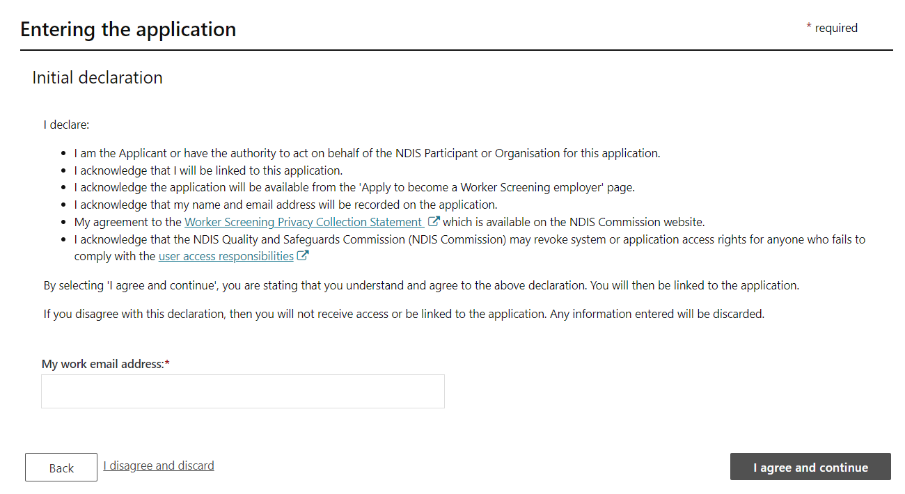

- On the left-hand side of the screen, there are 6 sections that require your attention. The orange dots let you see the part of the form that requires action before you can proceed to the next page. Once you have completed a section, you can select Mark as complete and continue and proceed to the next step. This will provide you with a green tick indicating that this section is complete. You can also select Save as draft to return to the application at a later time.
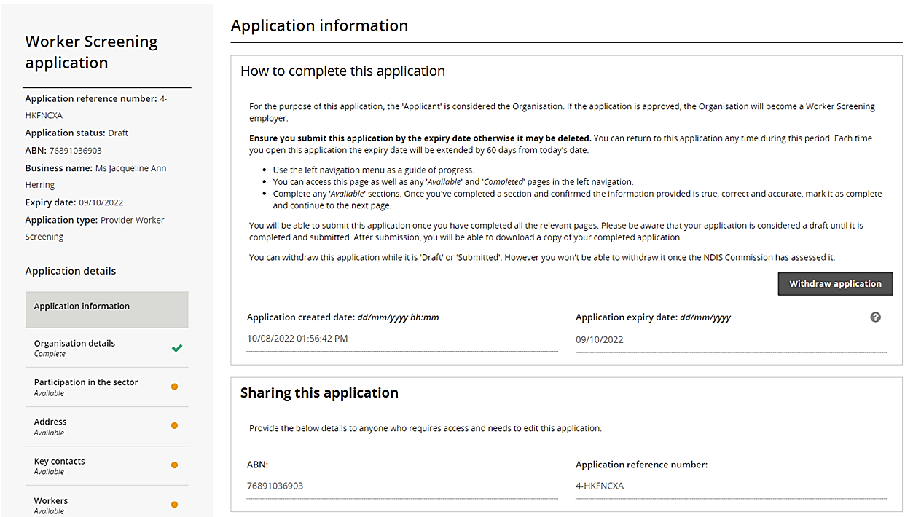
Please note: The following Organisation details section is already pre-populated with information sourced from the Australian Business Register.
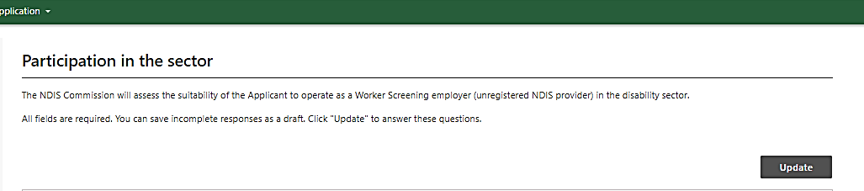
- To complete the Participation in the sector page, you will first need to click Update to start the process.

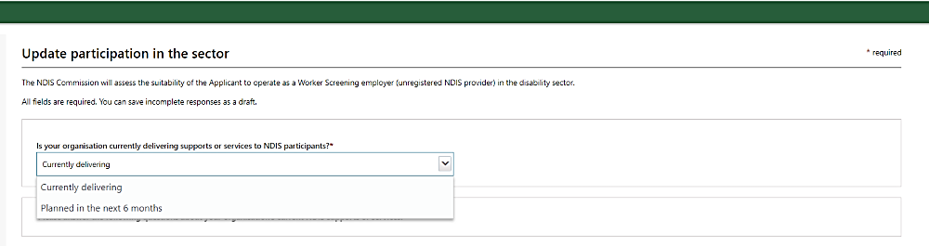
- Select whether you are Currently delivering services or supports to NDIS participants or Planned in the next 6 months.
- If you answered Currently delivering in the previous step, you will then need to answer the following questions. If you answered Planned in the next 6 months these questions will not appear for you.
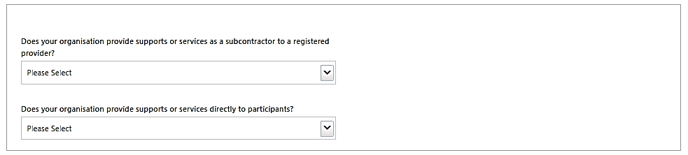

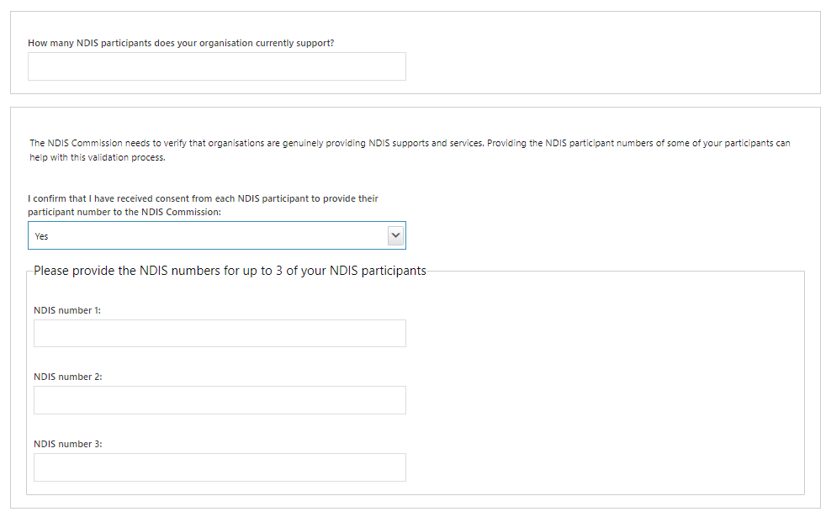
- If you answer Yes to Does your organisation provide supports or services directly to participants? You will need to provide the NDIS numbers of up to 3 of your NDIS participants. Please ensure that you have consent from each NDIS participant. If you answered No these questions will not appear for you.
- Please complete the following questions, selecting all that apply to your organisation. Response to these questions is required for all applications. Once completed select Mark as complete and continue
Please Note: You need to be a Registered Provider to provide the following Supports and Services:
- Behaviour Support
- Plan Management
- Restricted Practices
- Specialised Disability Accommodation
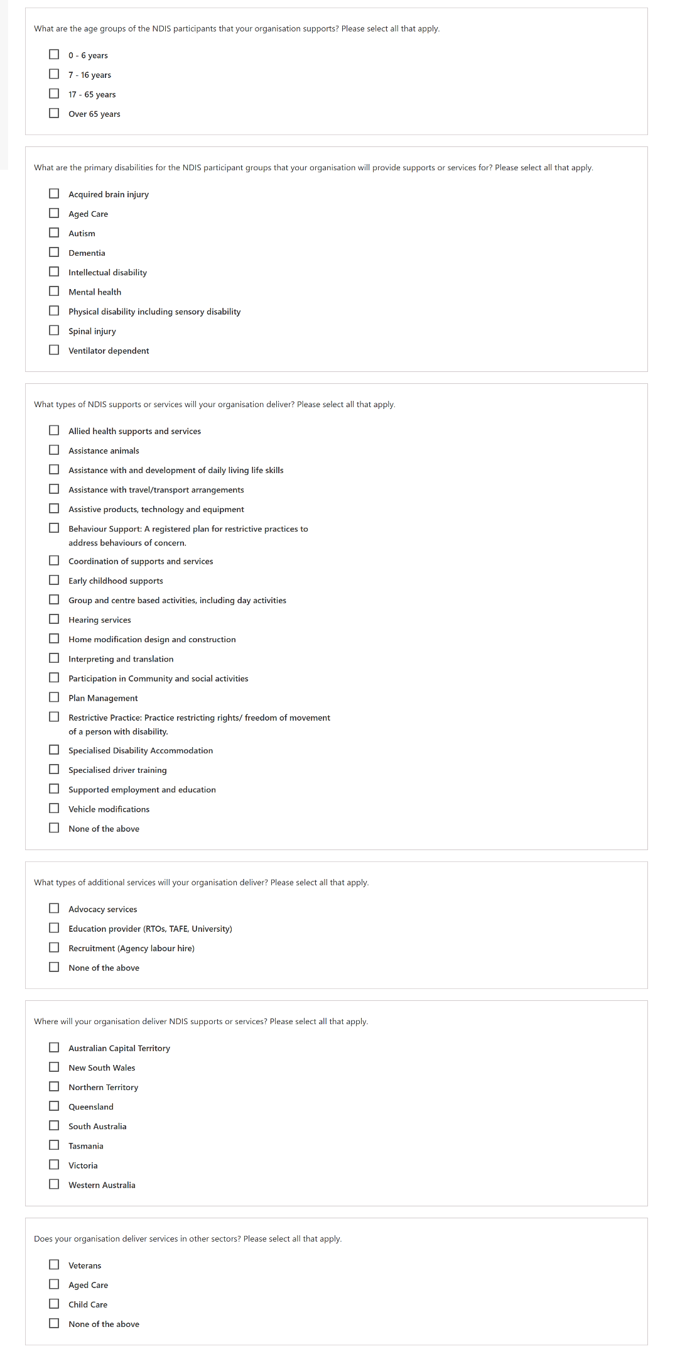
- Ensure the address provided is correct, if no changes are required, please Mark as complete and continue. If the information is incorrect, please select add and provide the correct address.
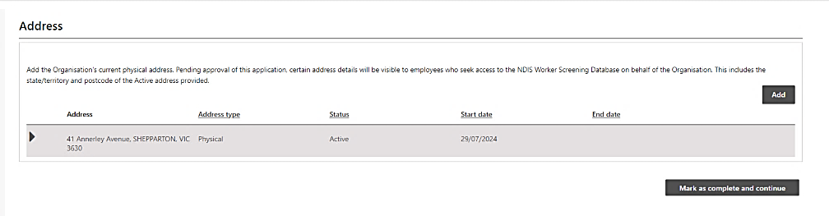
Your previous address will automatically be made inactive
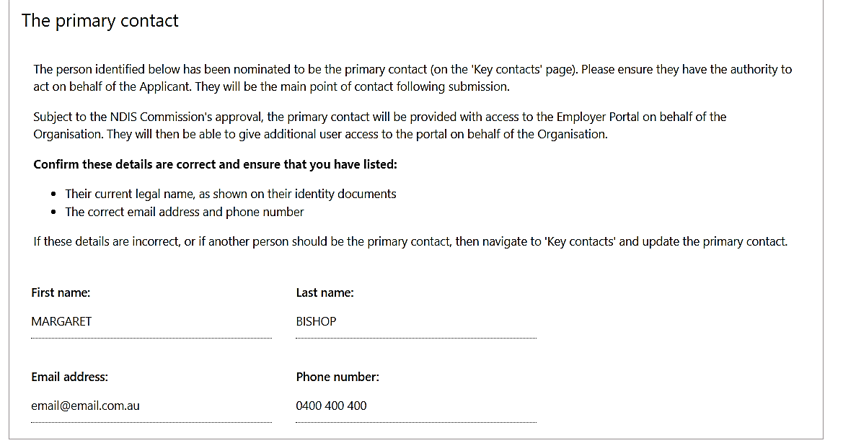
- Please add details of those who will have access to the Database (NWSD). It will include yourself as the Primary contact (the owner of the PRODA account, being used for this application.)
- You can add key contacts, who are trusted persons within your organisation.
The persons listed here are nominated contact persons that the NDIS Commission can speak with regarding the Database Profile/application, or other important matters if appropriate.
Click Save and Return > Mark as complete and continue

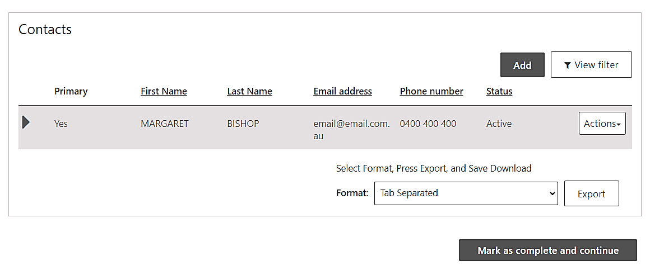
- If you have a worker who already have a NDIS Worker Screening Check, you can add them in this section. Click Add > enter the worker’s information > Mark as complete.
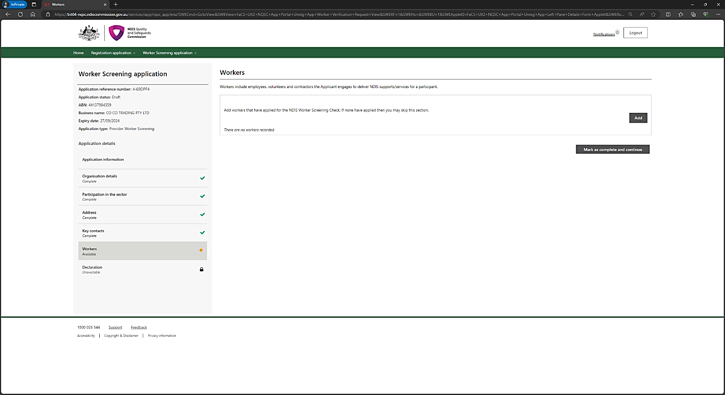
Please do not fill in the Worker Screening Section unless you have a worker whom you wish to add, that has already provided you their Worker Screening ID.
- Declaration
- Ensure that the email address and phone number you provided are correct before submitting.
- Please take a note of the Application Reference Number (4-XXXXXXX) in the top left corner of the screen before submitting.
- If you have any further questions, please quote the Reference number or alternatively your ABN in any emails you send to the NDIS Commission
- Submit the application.

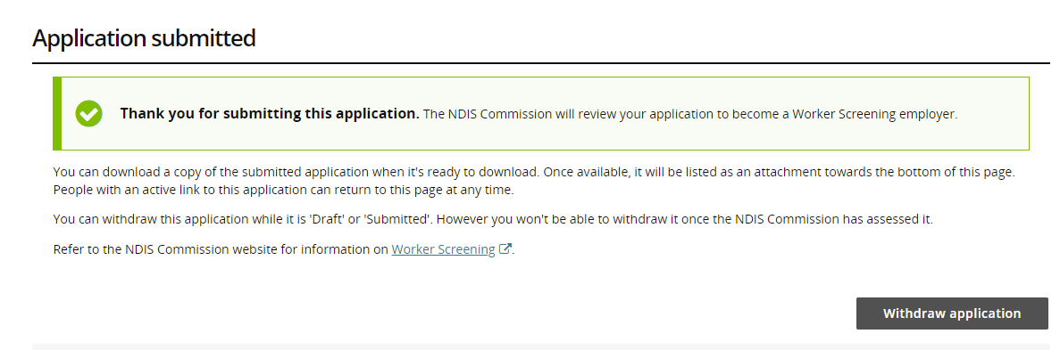
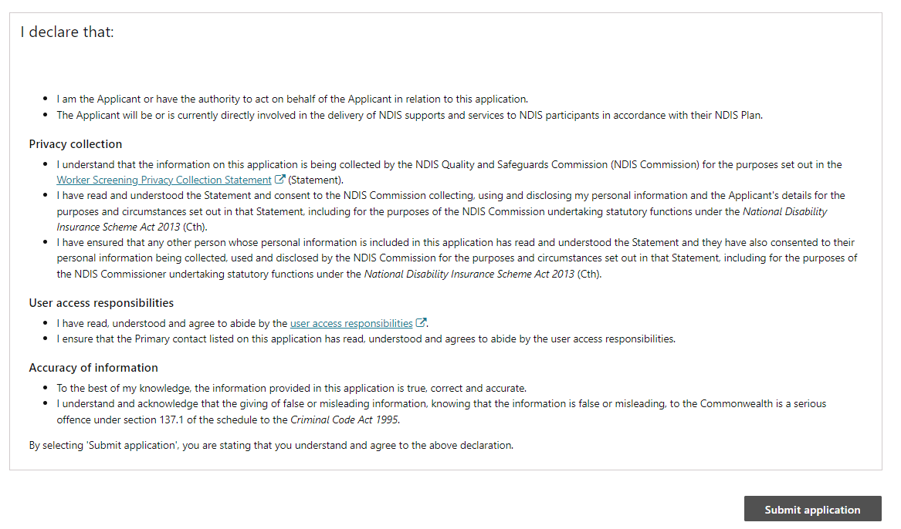
- Your application has now been submitted for assessment. If your application is successful, you will be notified by email to confirm and inform you of the next steps. If we identify an issue with your application, we will contact you by email.
If you no longer wish to continue with your application, you can select Withdraw application

