Approve or reject a request for access (as the Authorised Access Delegate)

- When an employee submits a request for access to the NWSD, the Authorised Access Delegate will receive an email. Click the link in the email to view the access request.

- Log in by selecting Continue with Digital ID.

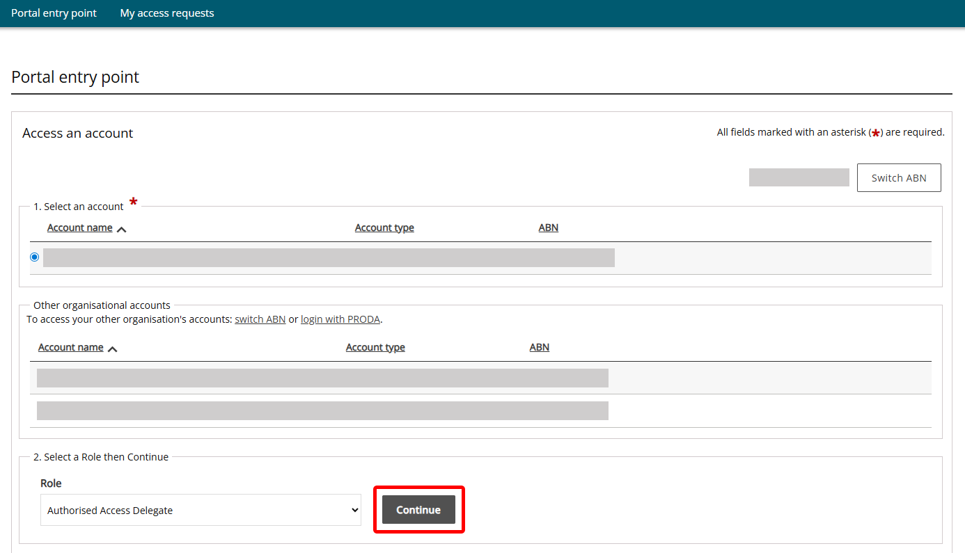
- At the Portal entry point, select the Account name and Authorised Access Delegate as the Role. Click Continue.
- To view pending access requests, select Access requests list. Click View to see the request details and respond.
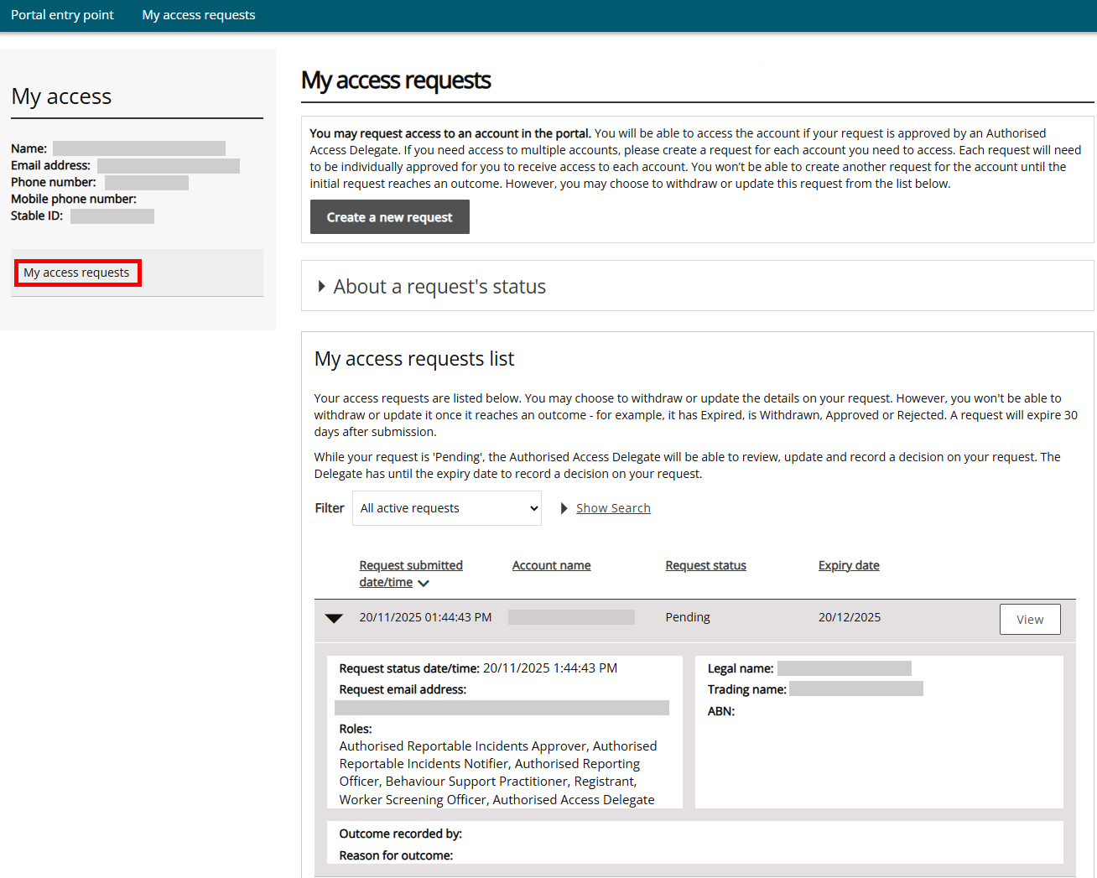

- Review the roles that the applicant has selected and ensure the appropriate checkboxes are ticked and click Approve. If wish to edit the roles selected by the applicant, you can do so here by selecting/deselecting the boxes and clicking Save then Approve. You can also Withdraw or Reject the request. The applicant will receive an email advising them of the outcome.
