Request access to the NDIS Commission Registered providers portal
- To obtain access to the Registered providers portal, navigate to the Commission’s website at www.ndiscommission.gov.au.

- Navigate to Portal Login > Registered providers login.
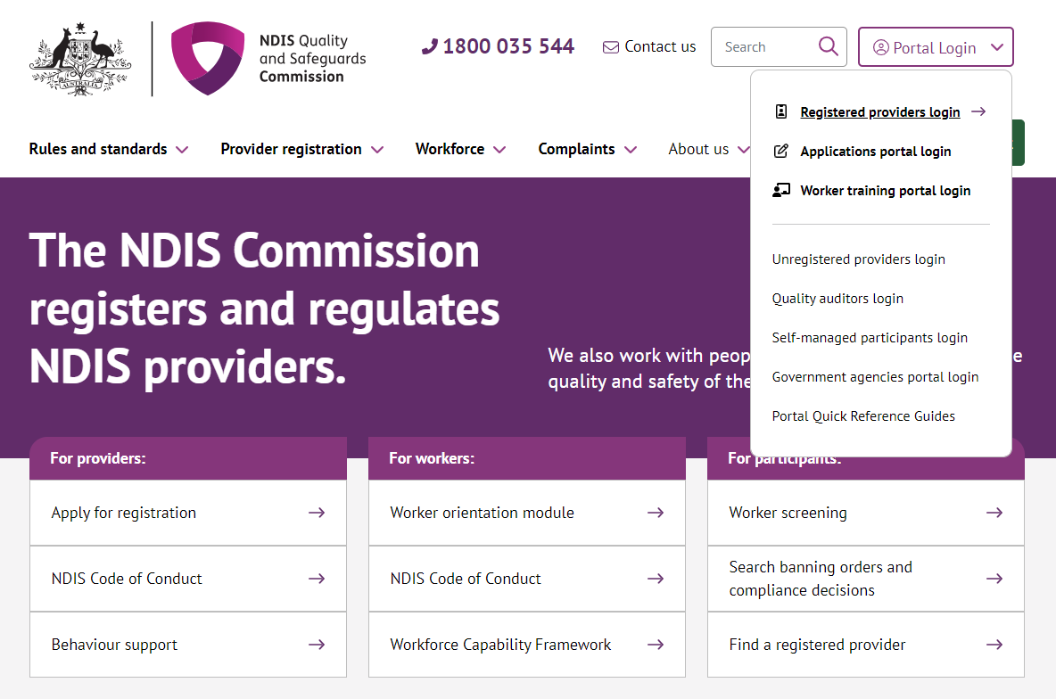
- Once you get to the Registered providers portal webpage, click Login
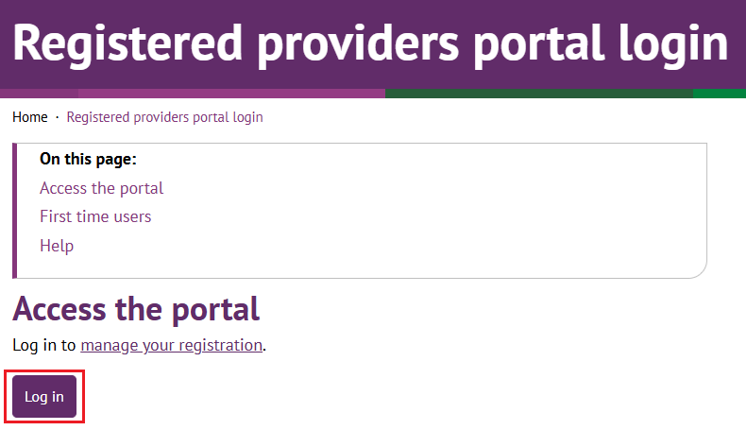
- Click Continue with Digital ID
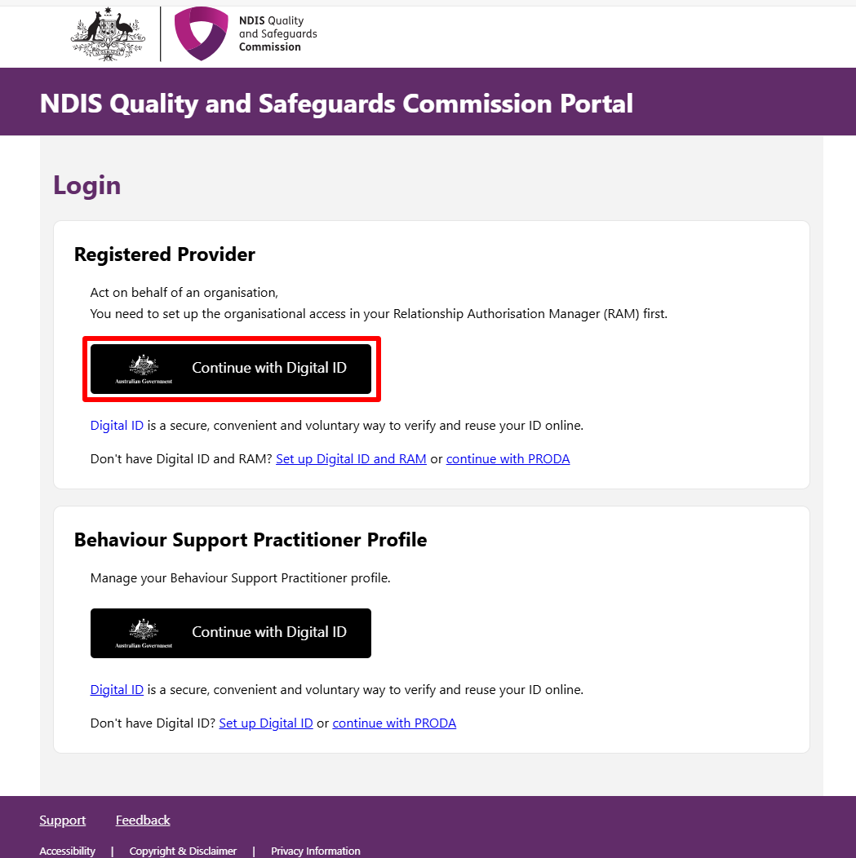
- Click Select myID
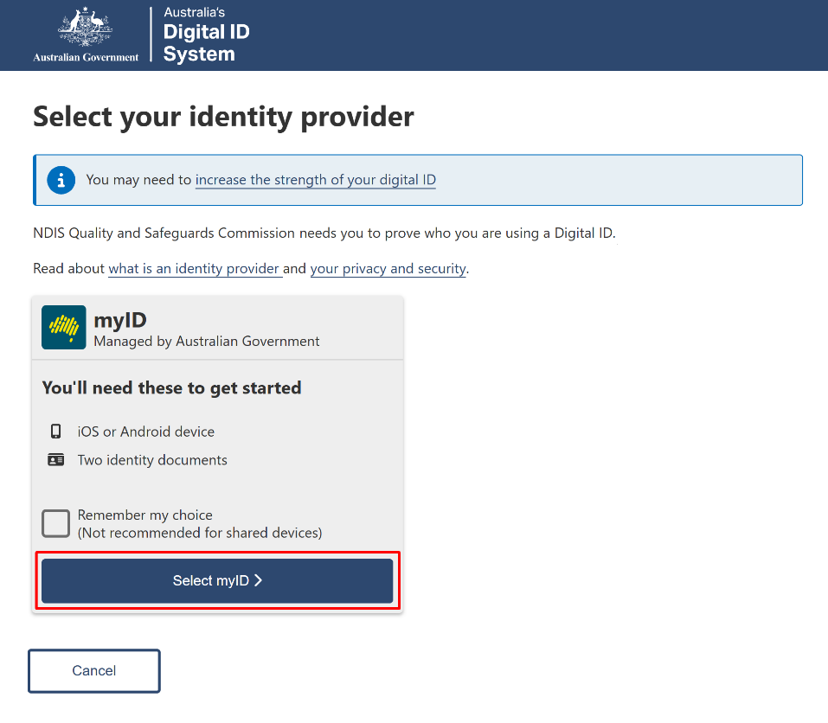
- Enter your myID email and click Get code. If you don’t have an account, you can register for a Digital ID (myID).
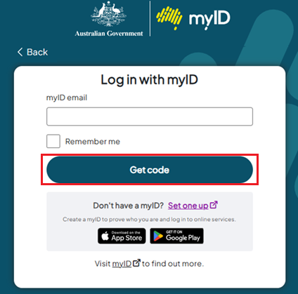
- A code will be generated.
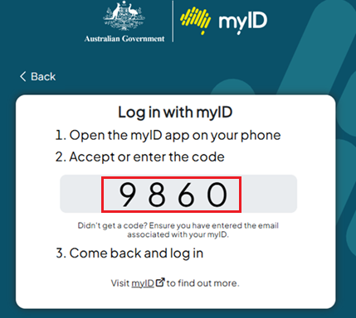
- Open the myID app on your phone and either accept the request or enter the code.
- If you have authority for multiple provider organisations, you will be directed to the RAM Australian Business Number (ABN) selection page, where you must choose the organisation, you wish to represent in the NDIS Commission portals. If you only have authority for one provider organisation, you will bypass this selection page.
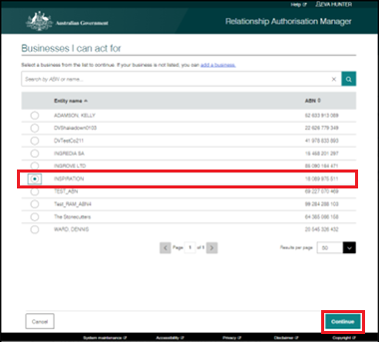

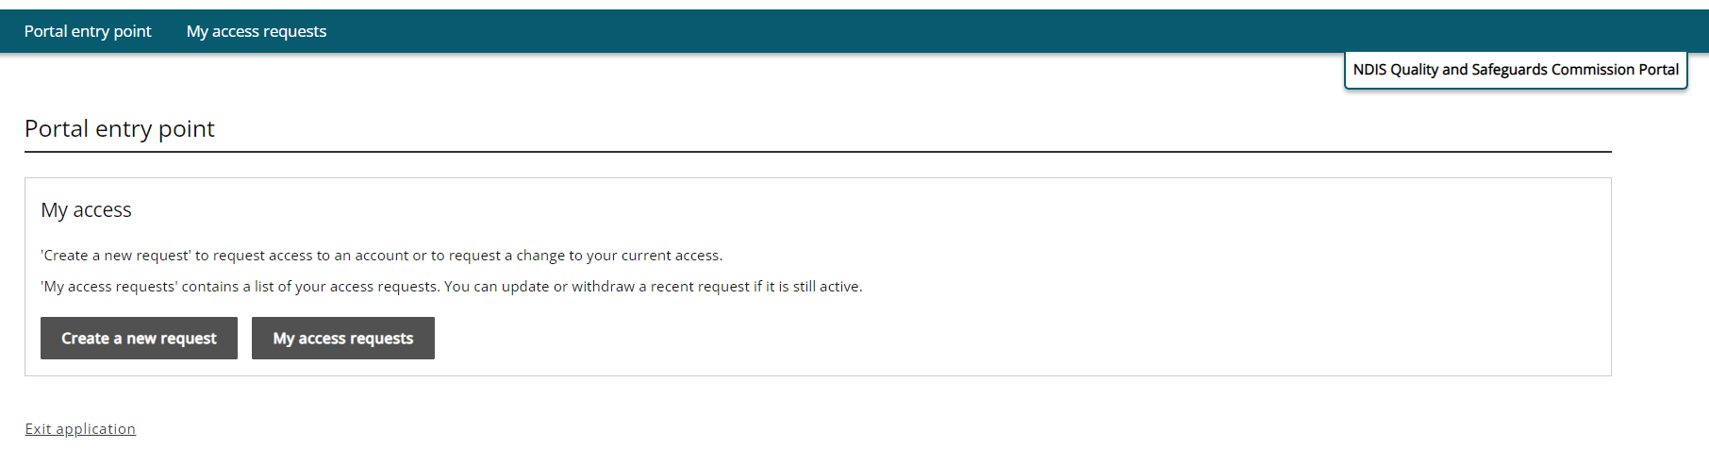
- At the Portal entry point select Create a new request.

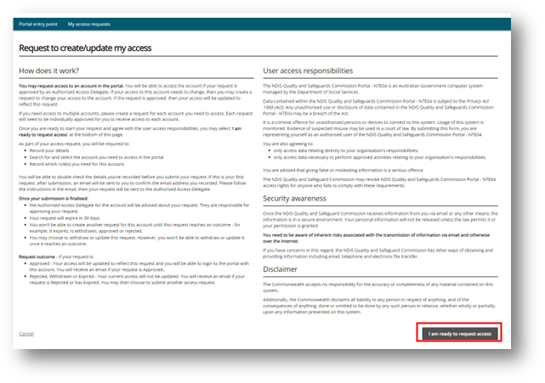
- Read the information on the page and select I am ready to request access.

- Your details will be automatically added to match your myID account. Enter your Phone number and click Next.
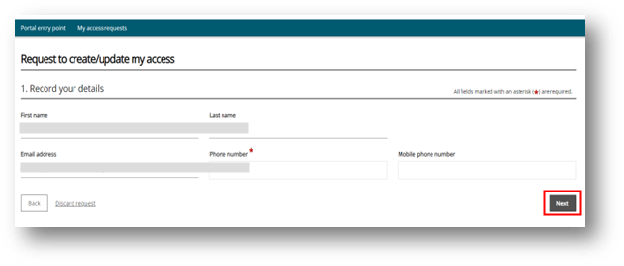
- To request the creation of a user role access, confirm the organisation’s account by clicking Select.

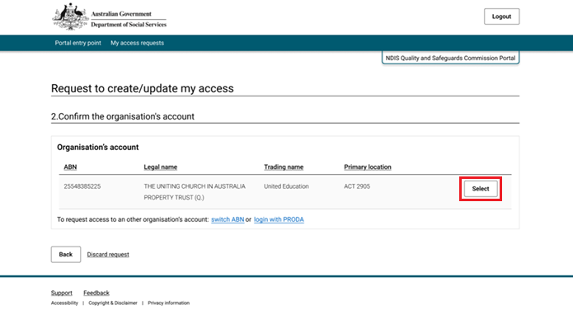
- You will then need to select the roles you require and then click Next.
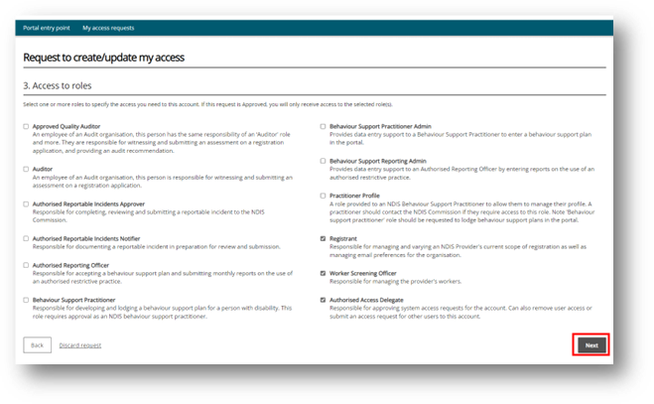
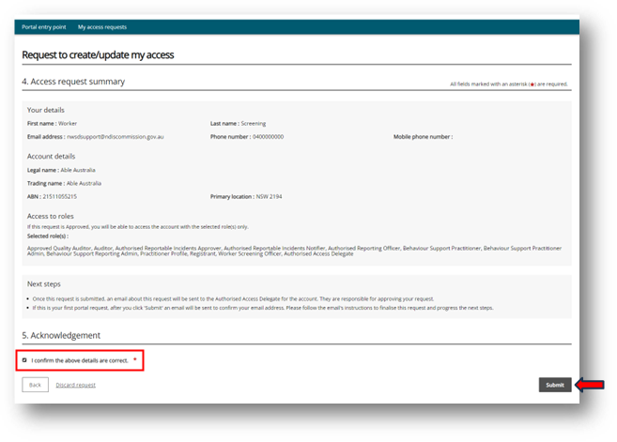
- Select I confirm the above details are correct and click Submit.
- Your request has now been submitted for approval, click Finish. If this is your first access request, you will receive an email to confirm your email address. Once verified, an email will be sent to the Authorised Access Delegate to approve your access request.
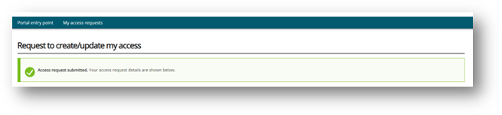
- Once your access has been approved by the Authorised Access Delegate, you will receive an email to finalise your access.

- When you have successfully activated your access, you can follow these instructions to update your access to the Registered providers portal.

