How to log in once your access has been approved: Registered providers
- To obtain access to the NWSD, navigate to the Commission’s website at www.ndiscommission.gov.au.

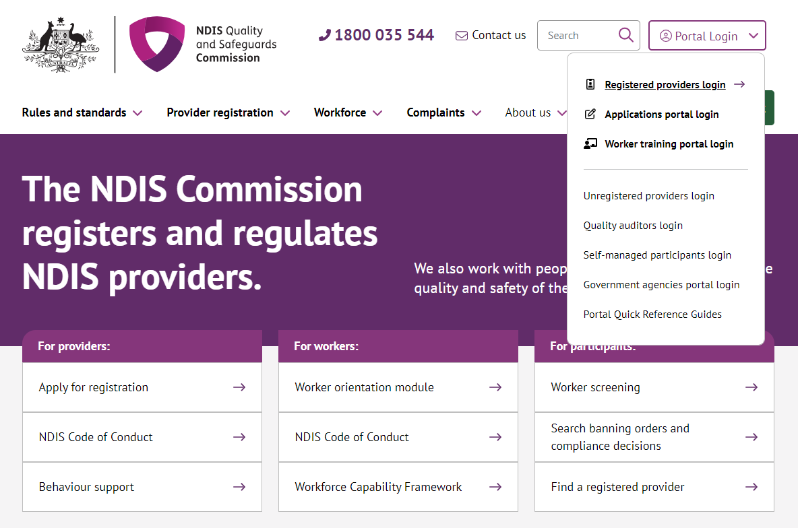
- Navigate to Portal Login > Registered providers login.

- Once you get to the Registered providers portal webpage, click Login
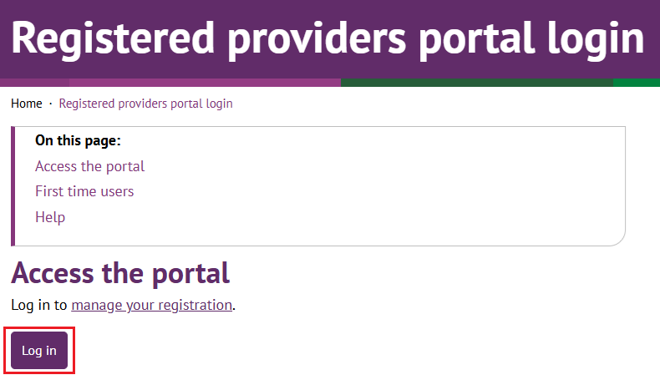
- Click Continue with Digital ID
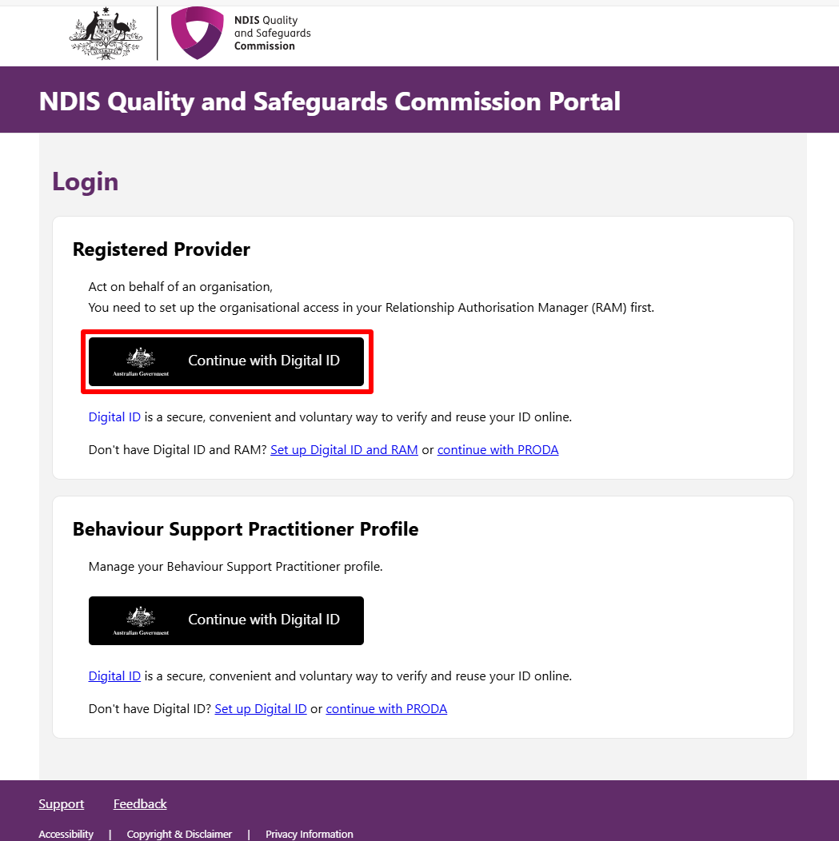
- Click Select myID
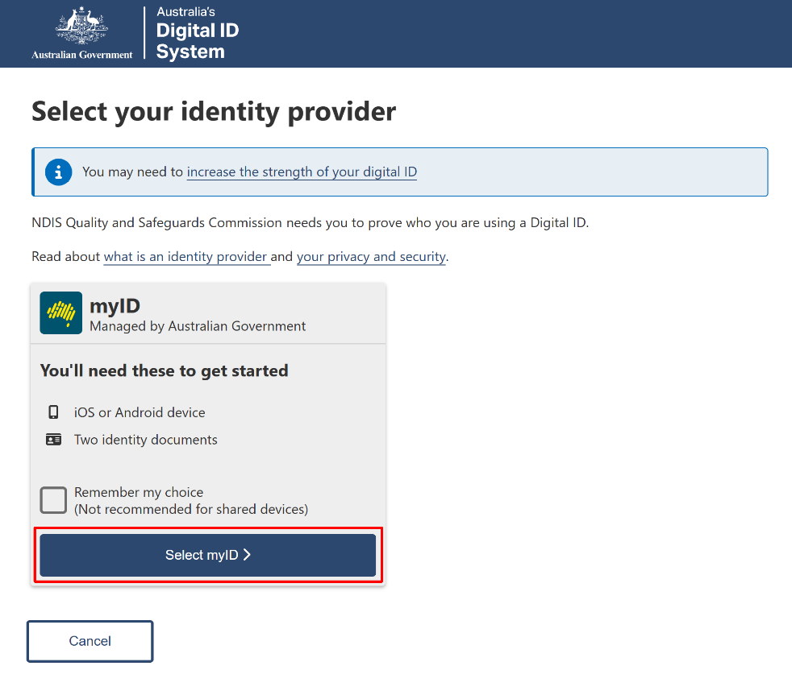
- Enter your myID email and click Get code. If you don’t have an account, you can register for a Digital ID (myID).
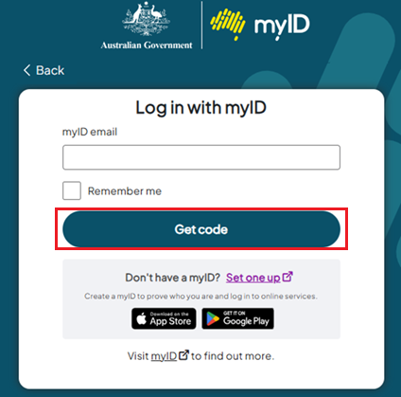
- A code will be generated.
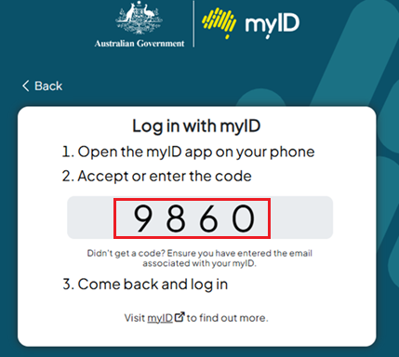
- Open the myID app on your phone and either accept the request or enter the code.
- If you have authority for multiple provider organisations, you will be directed to the RAM Australian Business Number (ABN) selection page, where you must choose the organisation, you wish to represent in the NDIS Commission portals. If you only have authority for one provider organisation, you will bypass this selection page.
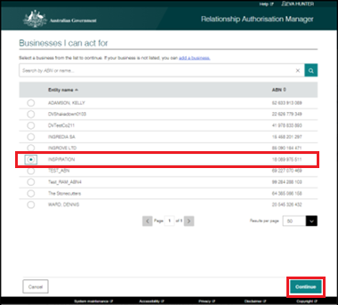

- Select the Provider and the Role to logon and then click Continue. The roles displayed here will differ depending on what you selected when you requested access.
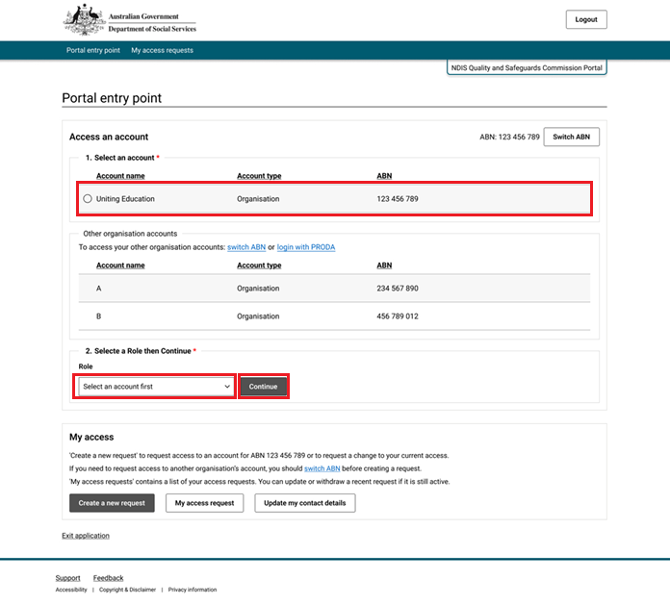

- Read the NDIS Commission Portal conditions and click I agree.
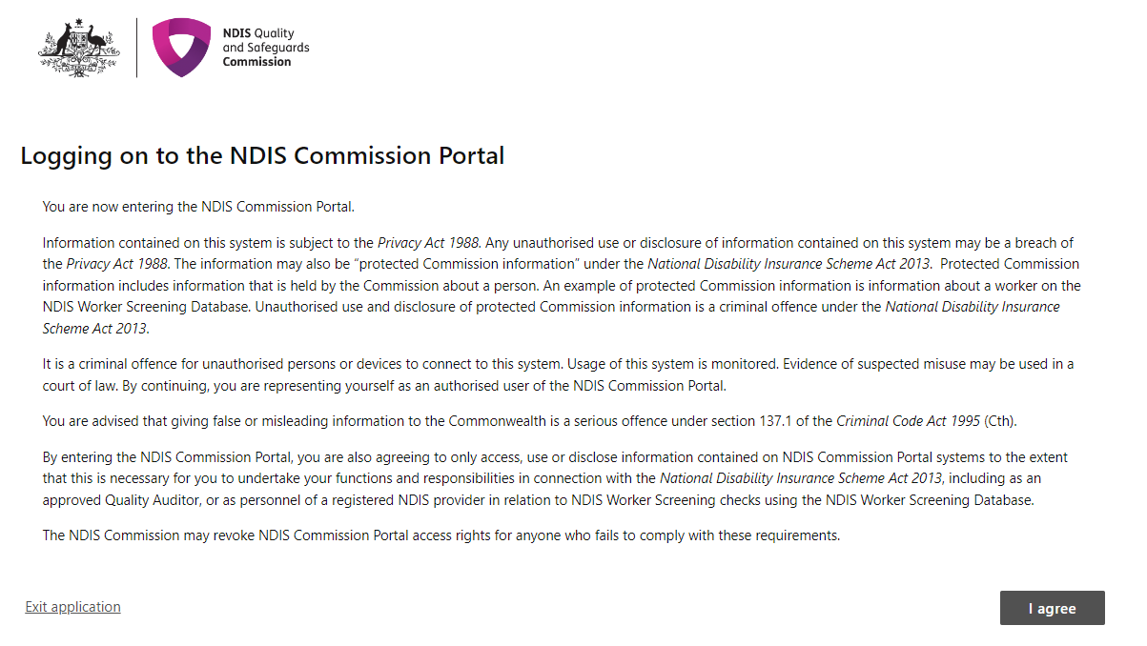

- You are now logged in. Depending on the role you are logged in with, your view of the NDIS Commission Portal will differ. To change your role, click Change role / Manage access.
