Log in to the NDIS Worker Screening Database for the first time: Registered provider

The primary contact on the registration application will automatically receive access as the registrant and Authorised Access Delegate role once the registration has been approved. Once the primary contact confirmation is approved, you will log in directly through the Registered Provider Portal.
- To obtain access to the NWSD, navigate to the Commission’s website at www.ndiscommission.gov.au.
- Navigate to Portal Login > Applications portal login.
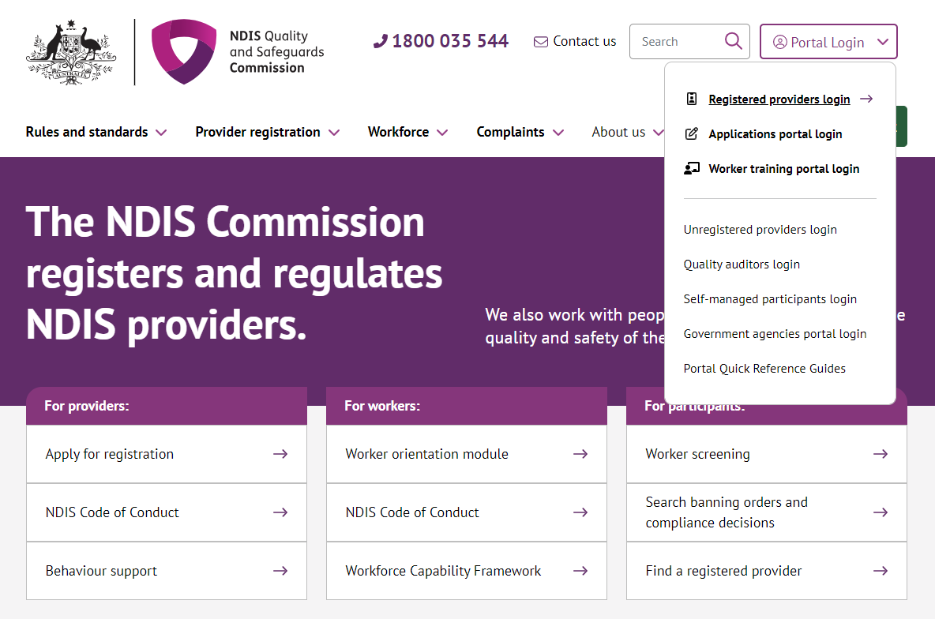

- Once you get to the Registered providers portal webpage, click Login
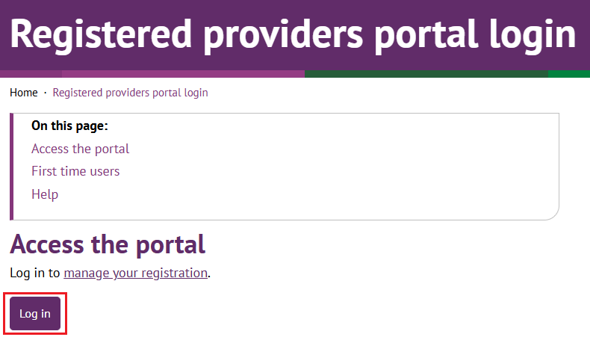
- Click Continue with Digital ID
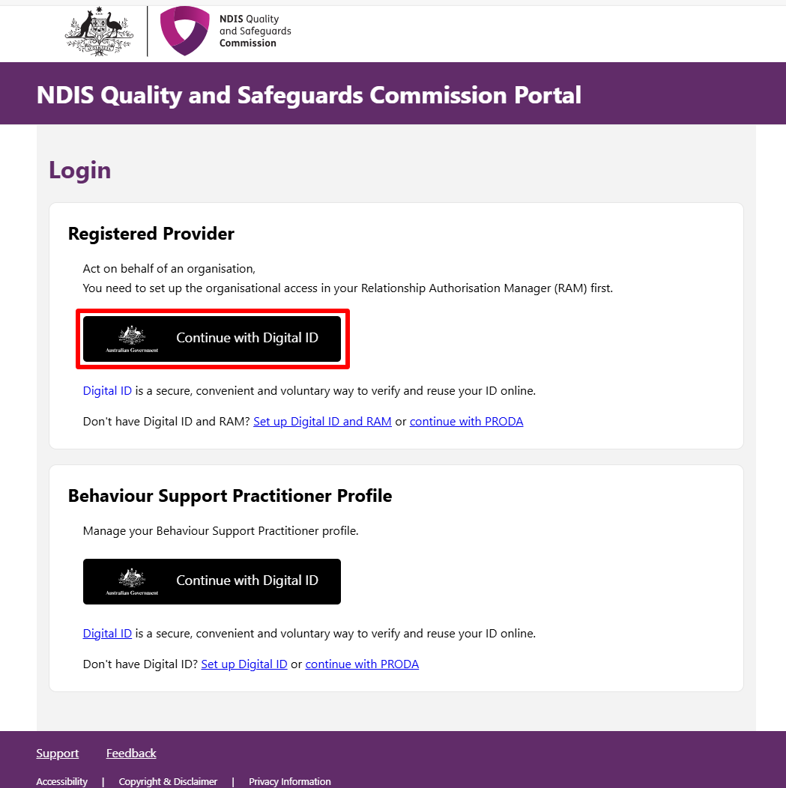
- Click Select myID
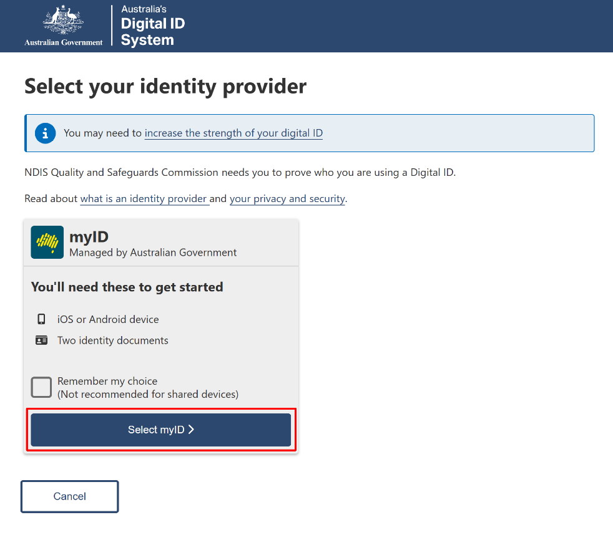
- Enter your myID email and click Get code. If you don’t have an account, you can register for a Digital ID (myID).
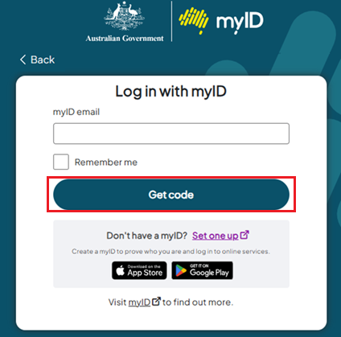
- A code will be generated.
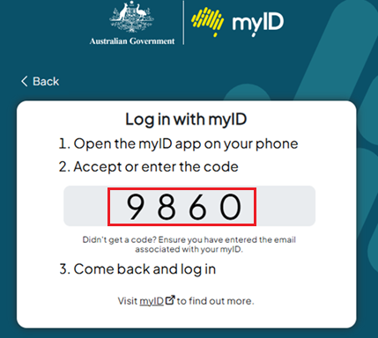
- Open the myID app on your phone and either accept the request or enter the code.
- If you have authority for multiple provider organisations, you will be directed to the RAM Australian Business Number (ABN) selection page, where you must choose the organisation, you wish to represent in the NDIS Commission portals. If you only have authority for one provider organisation, you will bypass this selection page.
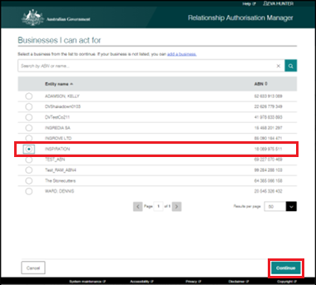

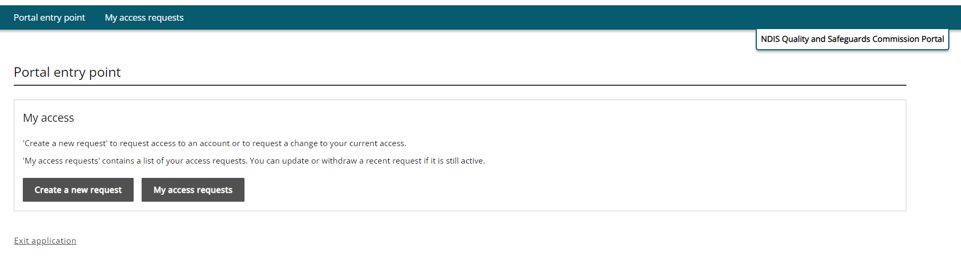
- At the Portal entry point select Create a new request.

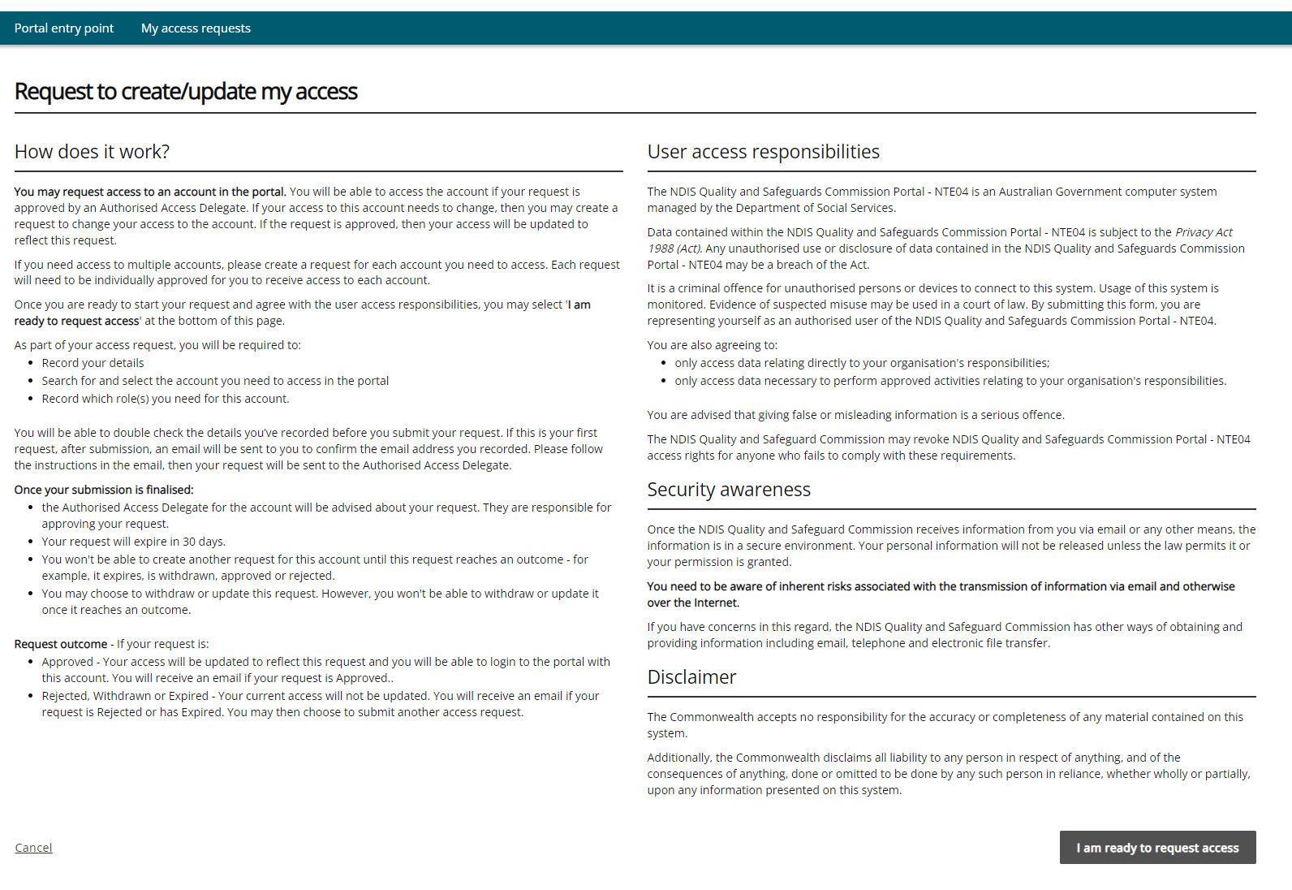
- Read the information on the page and select I am ready to request access.

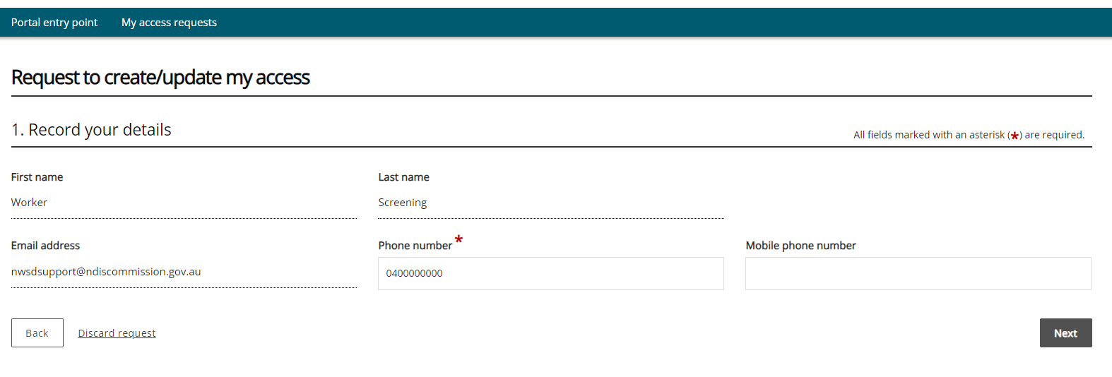
- These details are pre-populated from your PRODA account. Ensure that your details are correct and click Next.
- To request the creation of a user role access, confirm the organisation’s account by clicking Select.

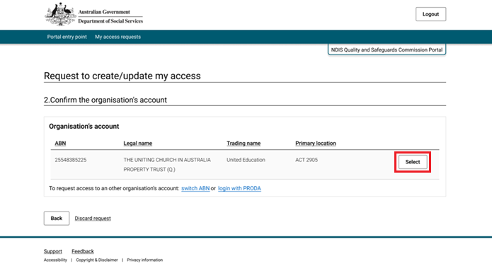

- Please read all the role descriptions, select the roles you require and click Next.
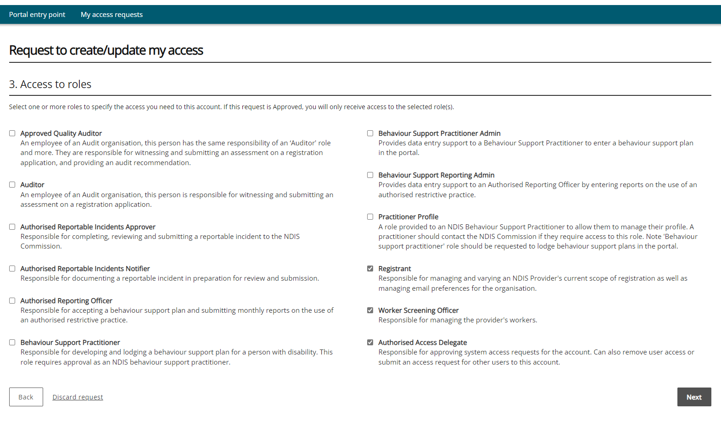

- Ensure that the details provided are correct, select I confirm the above details are correct then click Submit.
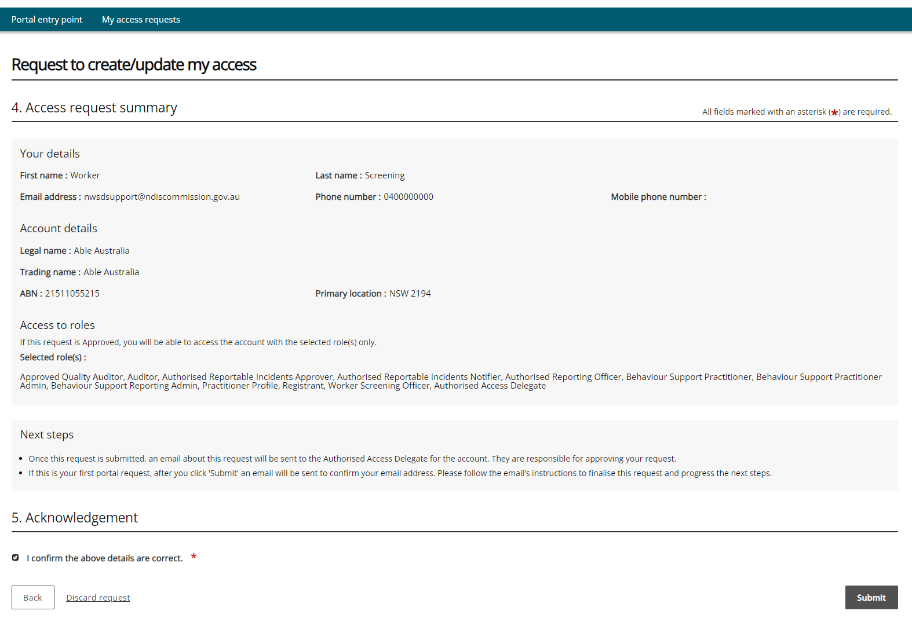

Your request has now been submitted for approval, click Finish

You can view the status of your access requests by selecting My access requests at the top of the screen. You will receive an email once your access has been approved
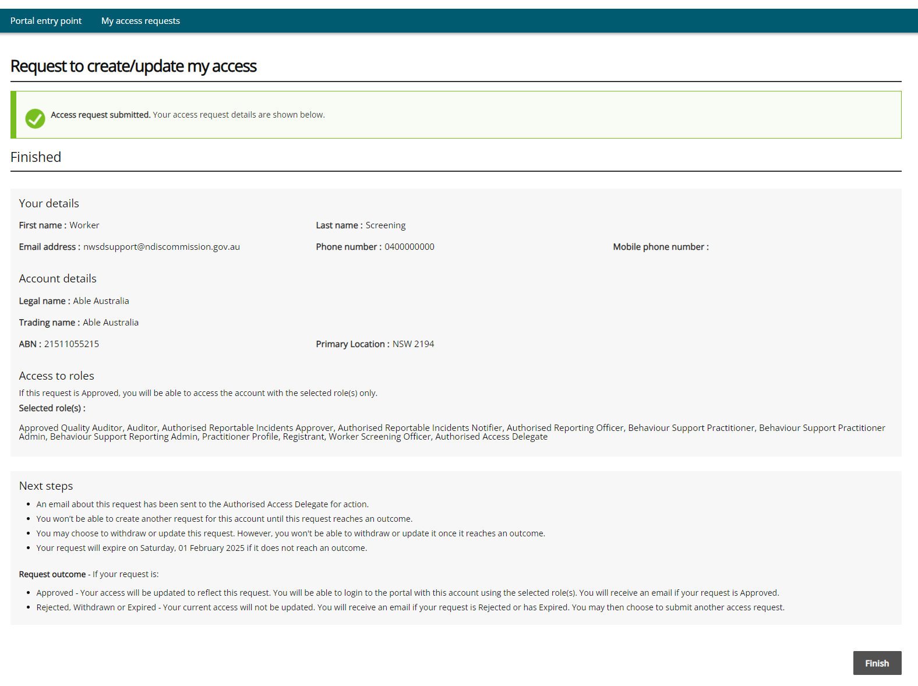
Tip: Once your request has been submitted, it will generally take 24-48 hours to be approved in the database.

