NDIS behaviour support to Practitioners
  - Quick reference guide – Responding to Request For Information through the Applications Portal

Practitioners applying to become an NDIS Behaviour Support Practitioner may have received a Request For Information email for their application. This Quick Reference Guide explains the step-by-step process of completing the Request For Information task through the Applications Portal.

In this guide
- Logging in to the Applications Portal
- Completing a Request For Information task
- About Digital ID and myID app

Logging in to the Applications Portal
- Select Portals. Select Applications Portal.
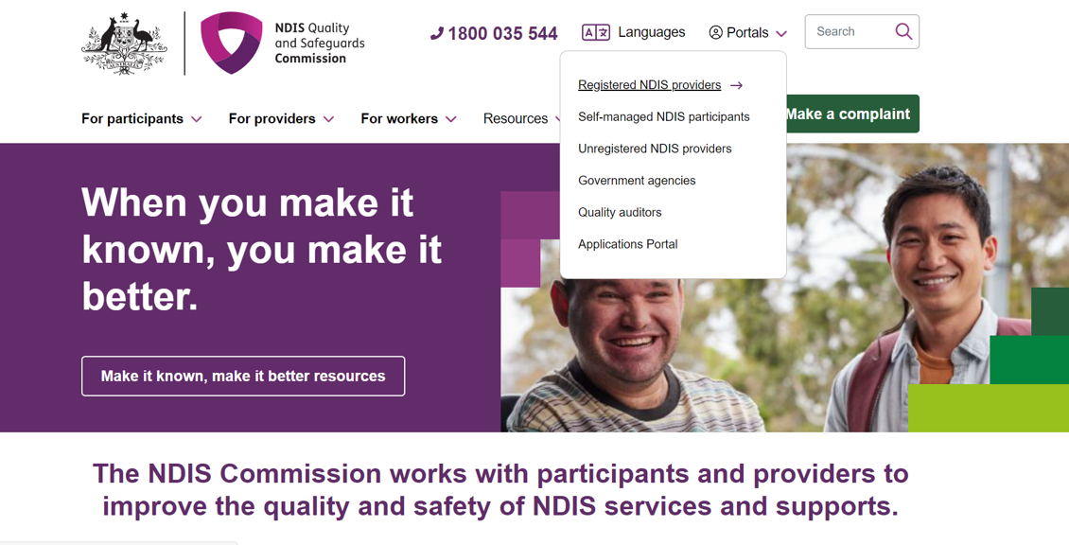

- Once you get to the Applications Portal webpage, Select Login
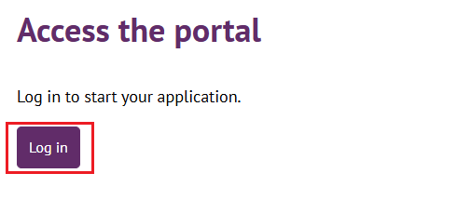

- Select Continue with Digital ID
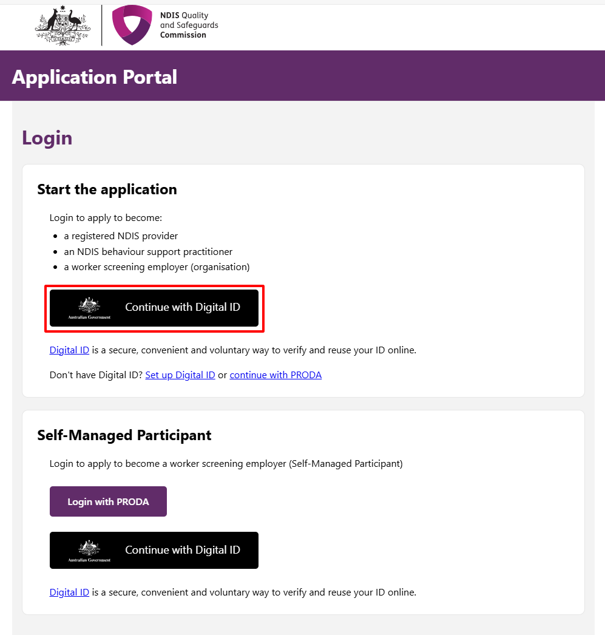

- Click Select myID
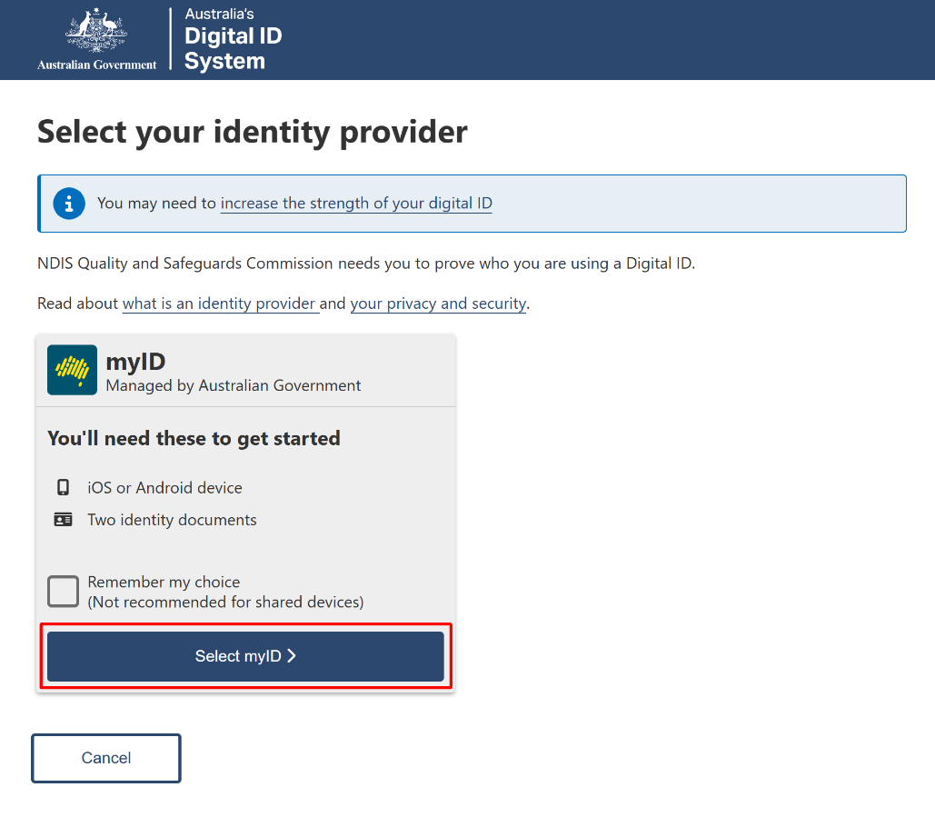
- Enter your myID email and click Get code. If you don’t have an account, you can register for a Digital ID (myID).
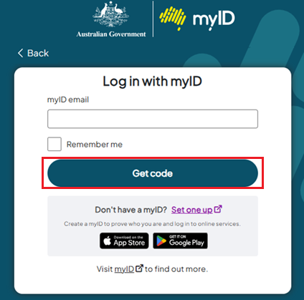
- A code will be generated.
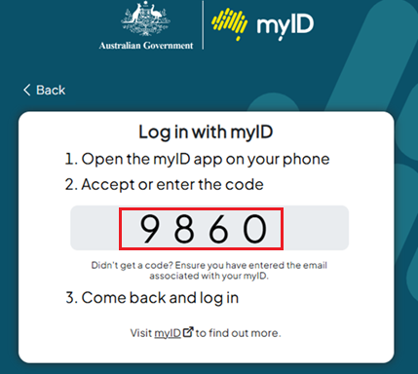
- Open the myID app on your phone and either accept the request or enter the code.
- Select I agree
. 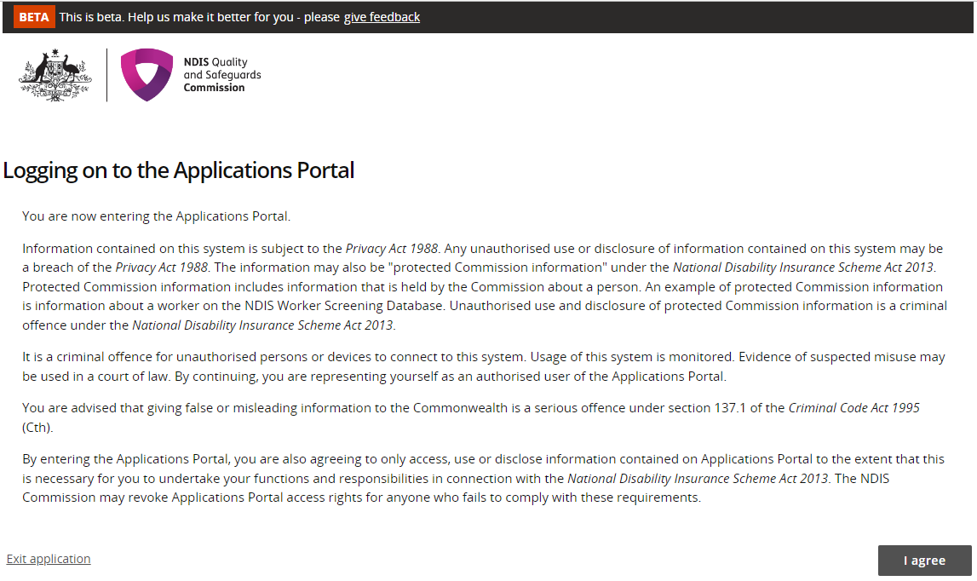
This should successfully log you on to the Applications Portal.

Completing a Request For Information task
- Select Apply to become an NDIS Behaviour Support Practitioner.
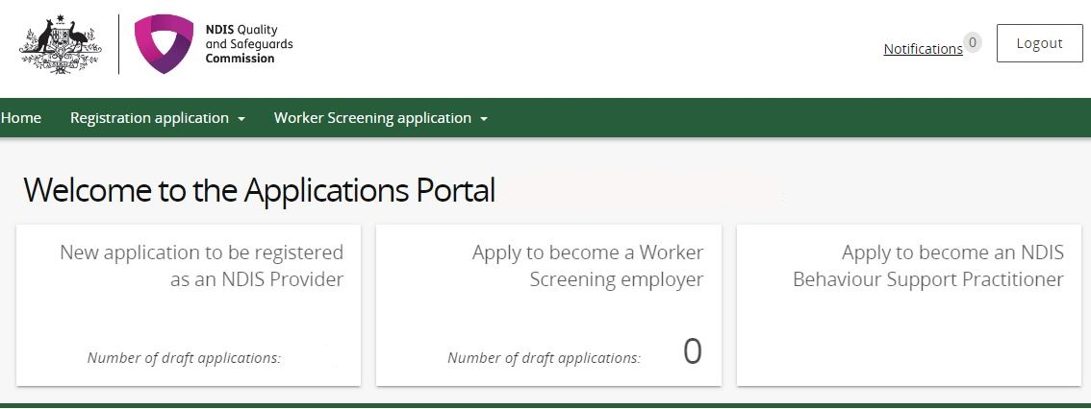

- If your Application status is in Information request, click Actions then View.
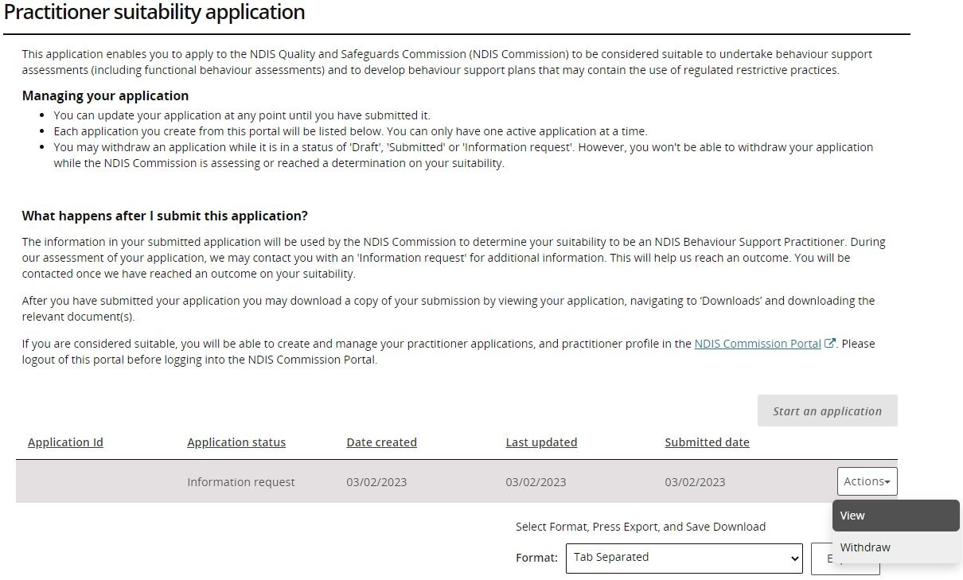

- Click Information requests, on the left side menu.
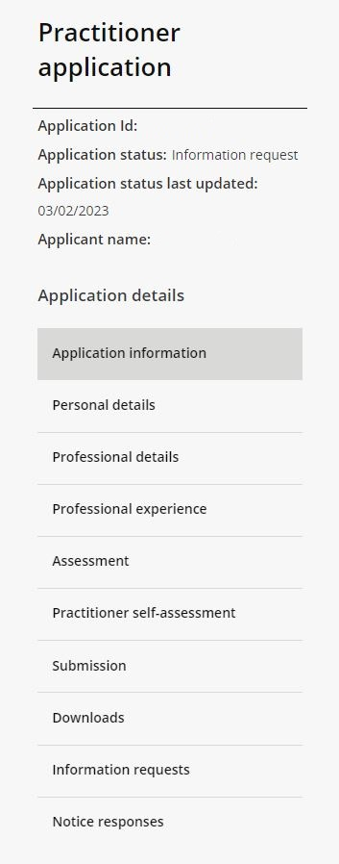

- Select Actions then Update.
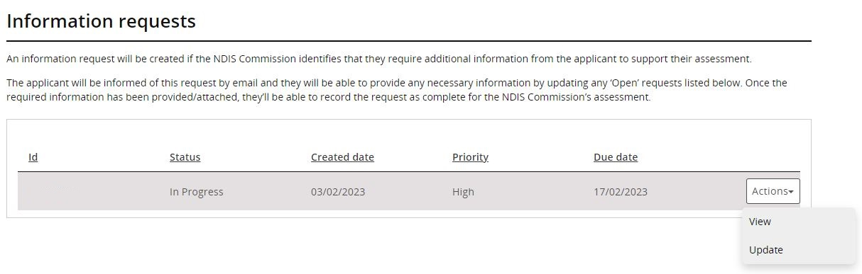

- Read the “Additional information required” to see what information is requested. Once read, please write a response in “Applicant’s response” and click Add attachment for the requested documents.
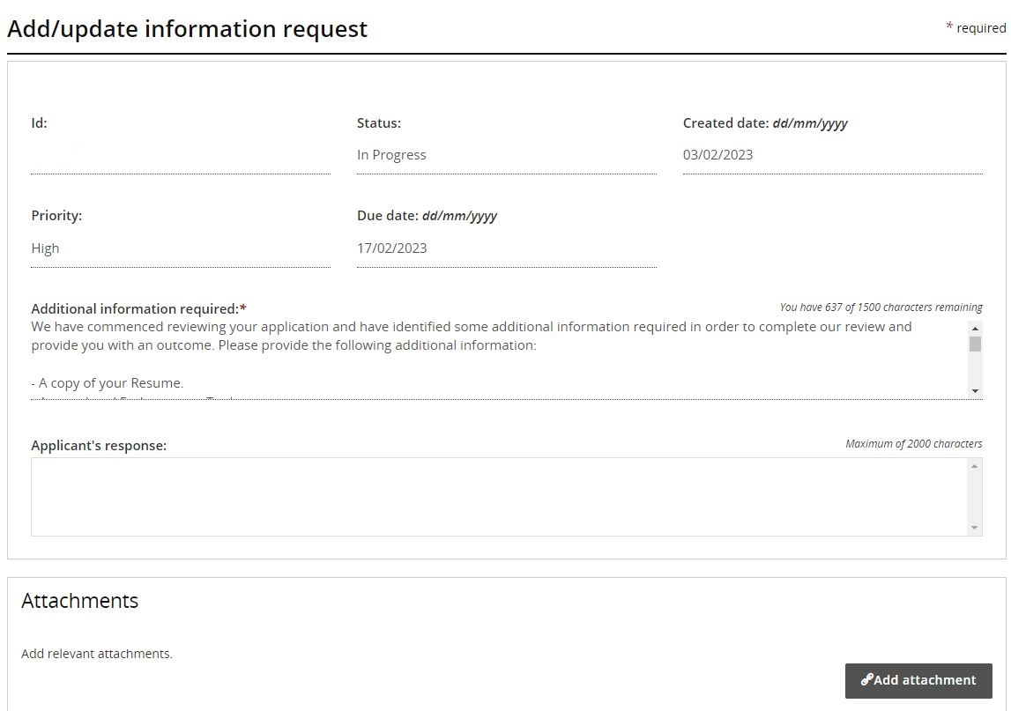

- Select the document you want to attach to the information request task and click Save and close. Please note that this step needs to be completed for each document.
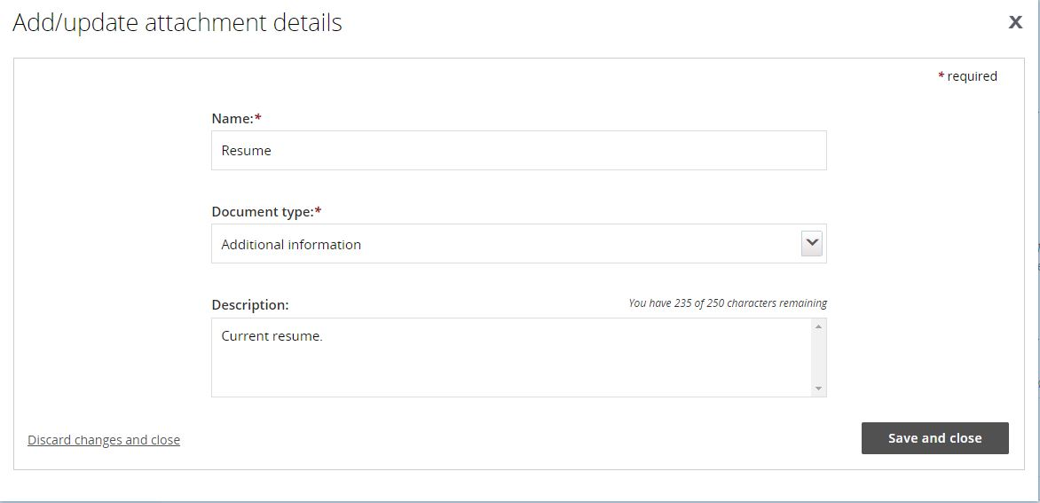

- When all documents have been attached, select Complete request.
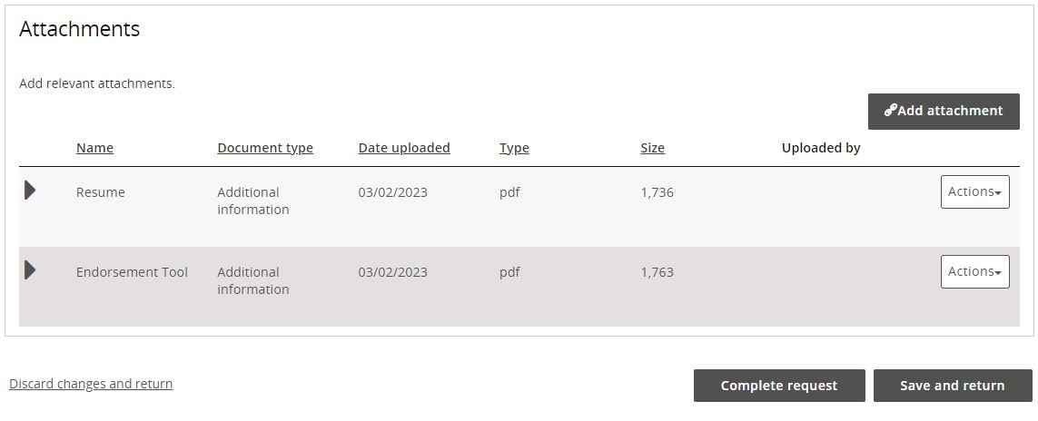

- Check that the status of the Information request has changed to “Done”.
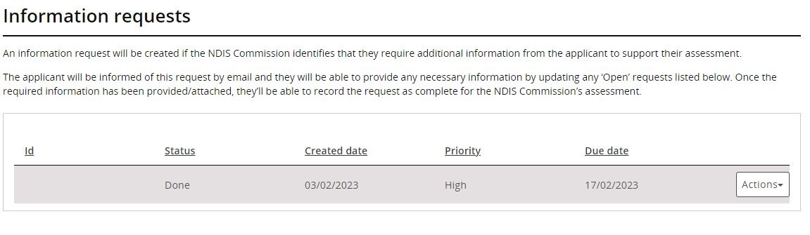
You have now completed your Request For Information task.

About Digital ID and myID app

Digital ID is a whole-of-government digital identity solution which can be used by Australians to prove who they are online and provide an identity that can be used to access participating government online services.
To gain access to the NQSC Application Portal, you will need to have set up your Digital identity in myID app.
Using Digital ID to log into the NQSC portals provides a high level of assurance that only the appropriately identified and authorised people are accessing NQSC systems.

To learn more about Digital ID, visit What is Digital ID? | Digital ID System website.

The Australian Government's Digital ID app is called myID. To access government services using a Digital ID, you need to set up a myID account. please visit the Help section on the myID website.

Further information or support
Contact the NDIS Quality and Safeguards Commission
Phone: 1800 035 544 (Mon-Fri)
Email: ndispractitioners@ndiscommission.gov.au

