NDIS Behaviour Support Practitioners
  - Quick reference guide – How to Update Practitioner Profile
When a behaviour support practitioner is considered suitable, their portal access moves from the Applications Portal to the NDIS Provider Portal.
Important note: An auto-generated verification email is sent when the application is approved. This appears in your spam or junk email folder. You must click on the link in this email to complete your practitioner profile access.
This Quick Reference Guide explains the step-by-step process of logging in to the NDIS Commission Practitioner Profile.

In this guide
- Logging in to the NDIS Commission Provider Portal
- Updating the Practitioner Profile details
- Updating the contact details on the NDIS Commission website
- Accessing your outcome letter
- About Digital ID and myID app

Logging in to the NDIS Commission portal
- Select Portals. Then select Registered NDIS providers.
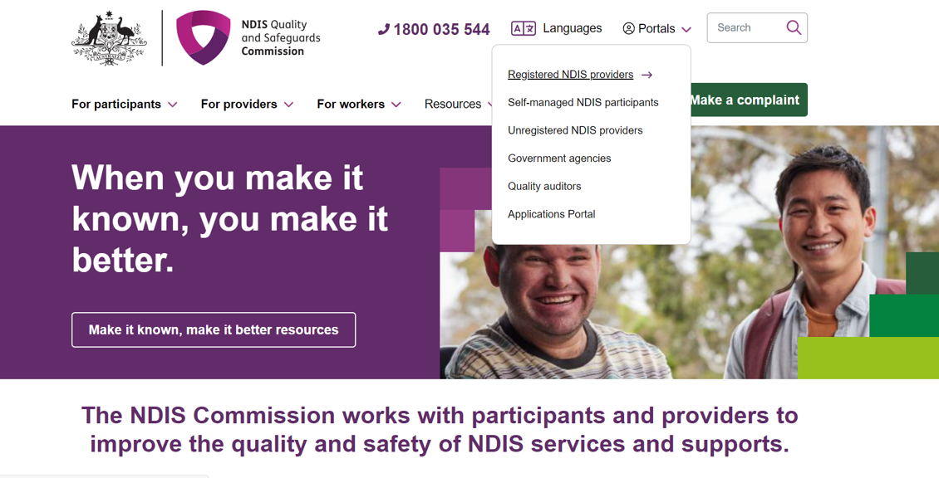
- Once you enter the Registered Providers Portal Log in webpage, select Log in
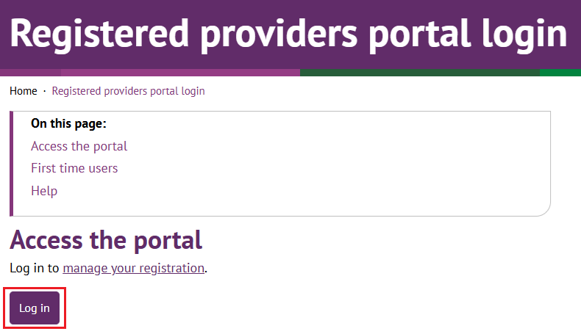

- Select Continue with Digital ID
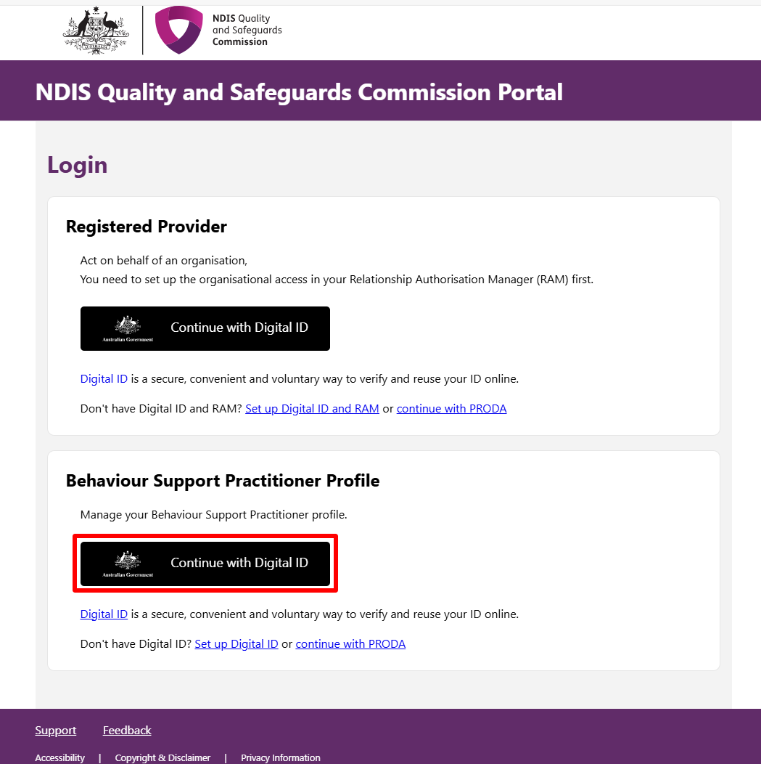

- Click Select myID
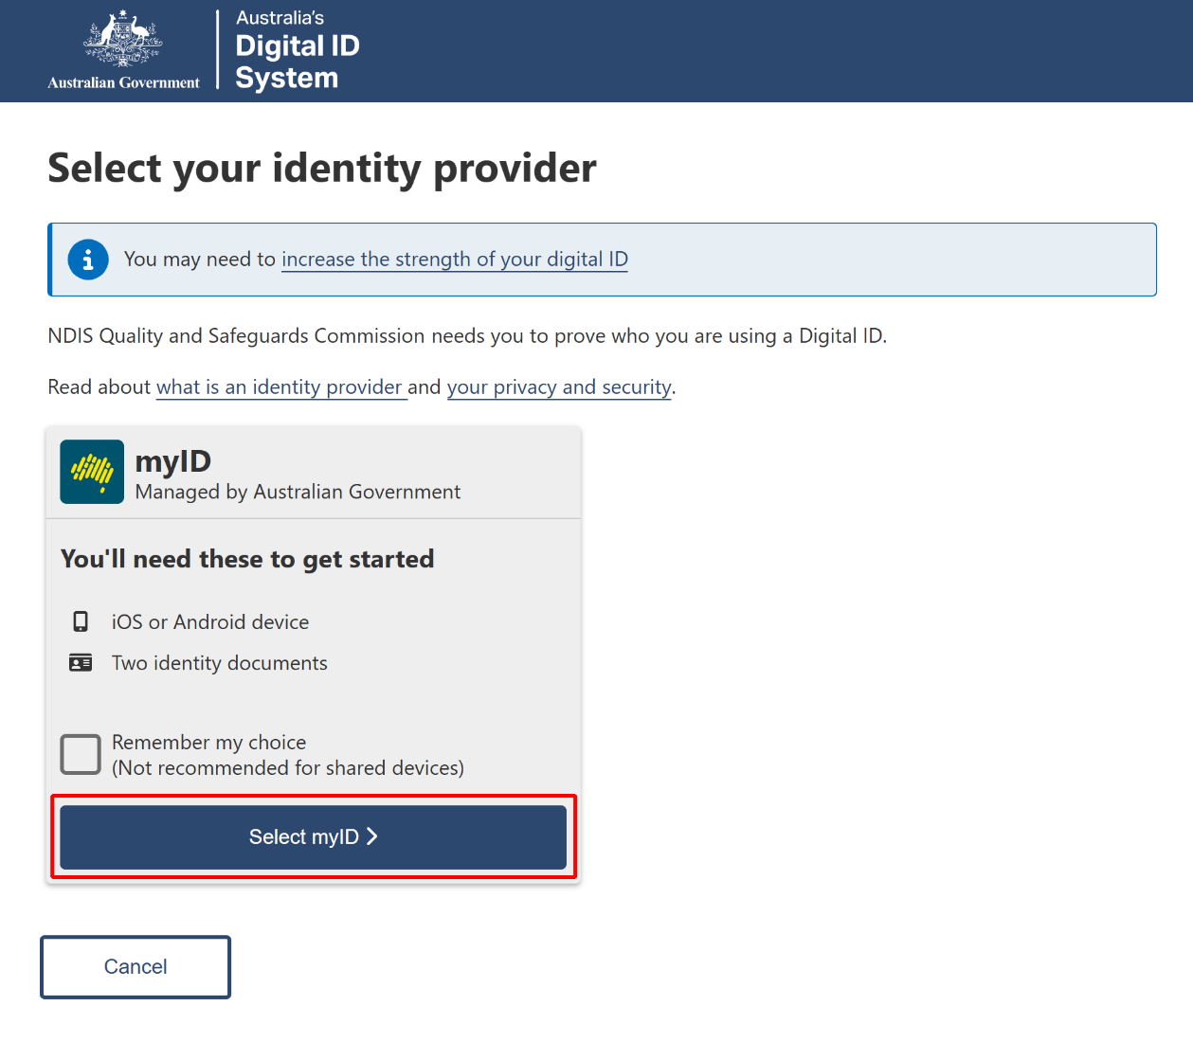

- Enter your myID email and click Get code. If you don’t have an account, you can register for a Digital ID (myID).
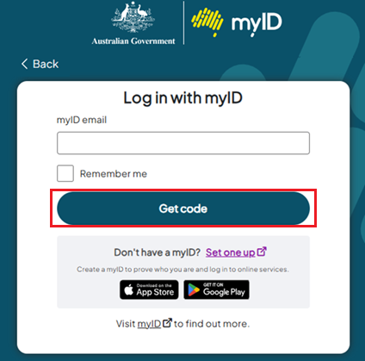

- A code will be generated.
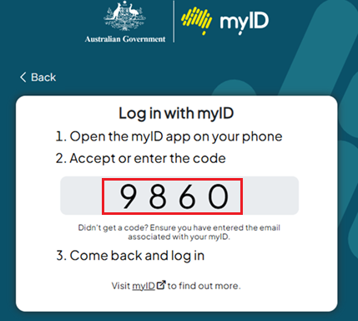
- Open the myID app on your phone and either accept the request or enter the code.
- Select Your account and the Role to log in and then Select Continue
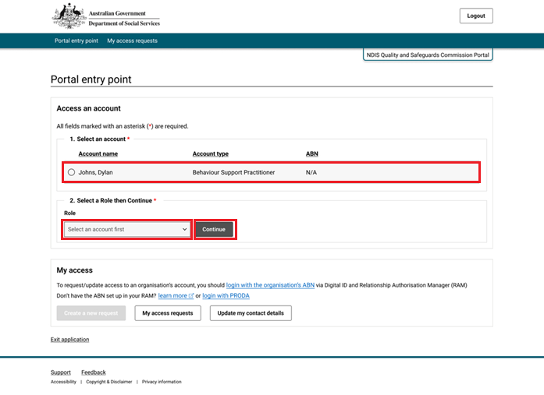

- Select I agree.
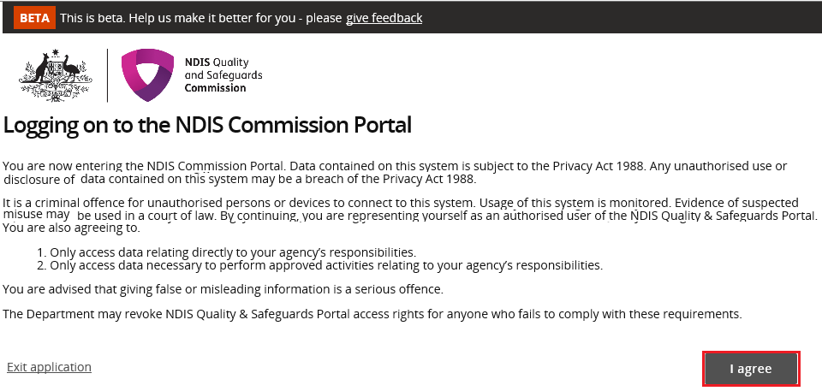
This should successfully log you on to the Portal.

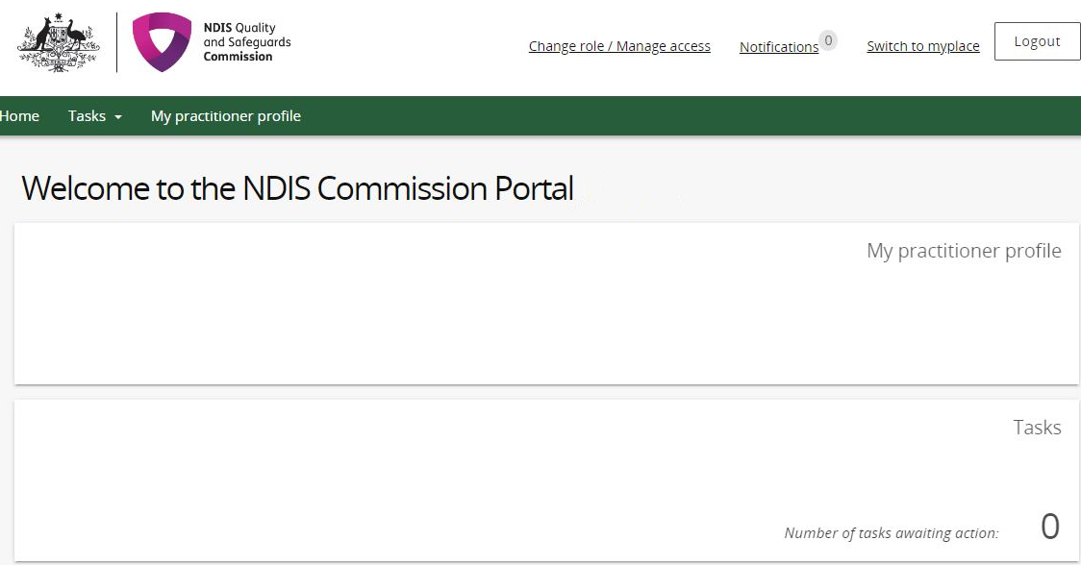
- Select My Practitioner Profile.

Updating the Practitioner Profile details
- Select Personal details / Professional details / Professional experience to make any changes. Ensure your email address listed within your Personal Details is your personal account not work-related account.
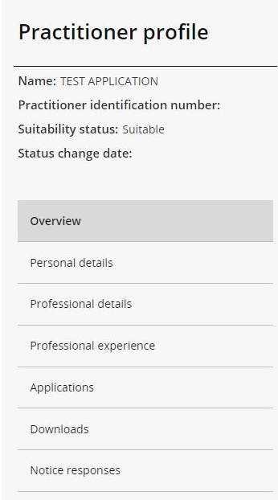

Updating the contact details on the NDIS Commission website
- Select Professional details.

- Select update (this will allow you to consent to your name, email address, phone number and postcode being placed on a list of suitable NDIS behaviour support practitioners to be published on the NDIS Commission’s website).

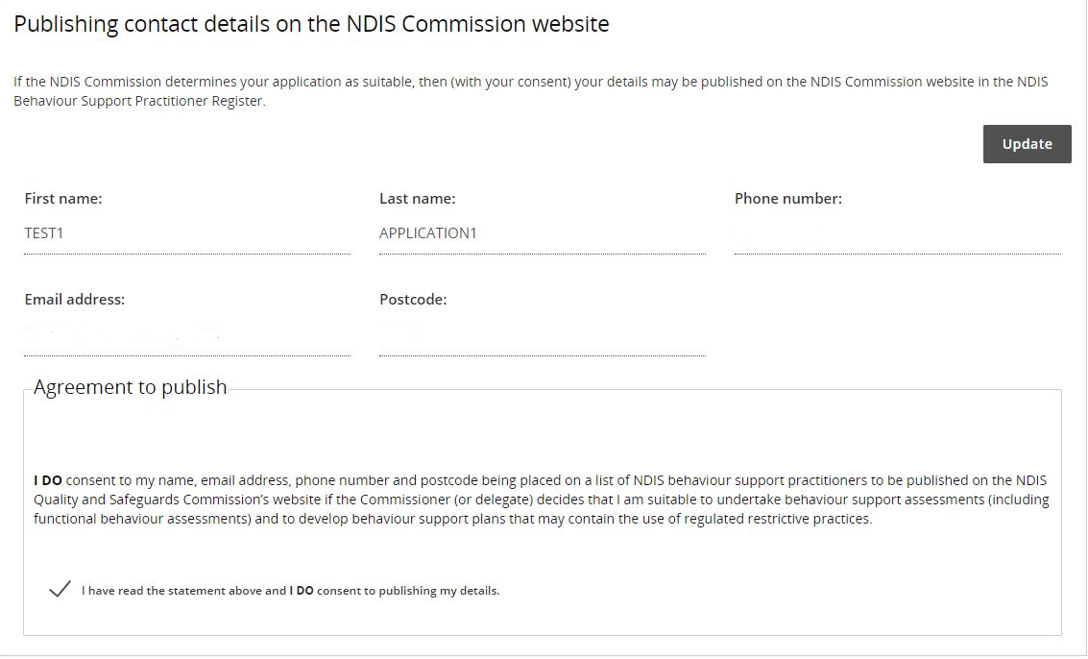

Help with accessing your Practitioner Suitability Outcome letter.
- Login to the NDIS Commission Provider Portal.
- In the Portal entry point, select your name under the provider drop down (please note this is for technical purposes only and you are not considered a provider in this context).
- Select Practitioner Profile under the Role drop down box.
- Select My practitioner profile.
- Select Applications in the left menu.
- Select Actions on your completed application from the drop-down list and select View.
- Select Downloads on the left menu then download the latest Application Outcome Letter from the list.

About Digital ID and myID app

Digital ID is a whole-of-government digital identity solution which can be used by Australians to prove who they are online and provide an identity that can be used to access participating government online services.
To gain access to the NQSC Application Portal, you will need to have set up your Digital identity in myID app.
Using Digital ID to log into the NQSC portals provides a high level of assurance that only the appropriately identified and authorised people are accessing NQSC systems.

To learn more about Digital ID, visit What is Digital ID? | Digital ID System website.

The Australian Government's Digital ID app is called myID. To access government services using a Digital ID, you need to set up a myID account. please visit the Help section on the myID website.

Further information or support
Contact the NDIS Quality and Safeguards Commission
Email: ndispractitioners@ndiscommission.gov.au

