Recall of coloured-sand products – Asbestos alert

Provider Alert – November 2025

Key Points
- The ACCC has published a recall notice over coloured-sand products that may contain asbestos and were sold at various retailers including Officeworks. A number of coloured sands products, commonly used for educational aids, sensory play, and arts and crafts, have been recalled.
- The products are being recalled because the sand may include asbestos, which is a prohibited substance in Australia. The products may cause a risk to health as asbestos has been detected in some samples after laboratory testing.

What providers should do
As a precaution, anyone who has purchased coloured sand, whether from the ACCC list of affected products, or from other suppliers, are advised to take the following action:
- Cease using all coloured-sand products. Do not allow children or adults to play with or handle it.
- Seek information from your relevant state work health and safety (WHS) regulator on safe disposal of materials:
  - New South Wales: SafeWork NSW
  - Victoria: WorkSafe Victoria
  - Queensland: Workplace Health and Safety Queensland
  - South Australia: SafeWork SA
  - Tasmania: WorkSafe Tasmania
  - Northern Territory: NT WorkSafe
  - Western Australia: WorkSafe WA
  - Australian Capital Territory: WorkSafe ACT
- Safe disposal advice for consumers is available from the Asbestos and Silica Safety and Eradication Agency, on the ACCC Product Safety website.

ACCC recall notices
- Recall advertisement - updated 17 November 2025.pdf
- Recall advertisement_3212.pdf
- Recall advertisement - 16 November 2025.pdf
- 24 Nov MIKI Sand Art Set | ACCC Product Safety
- Search consumer product recalls | ACCC Product Safety

Provider obligations
The following are obligations in addition to provider obligations as a Person Conducting Business or Undertaking (PCBU) under work health and safety (WHS) legislation.

NDIS Code of Conduct
All NDIS providers must comply with the National Disability Insurance Scheme (Code of Conduct) Rules 2018 and support workers must also understand and apply the Code in the course of their daily work.
The Code requires, among other things, workers and providers who deliver NDIS supports to:
- promptly take steps to raise and act on concerns about matters that may impact the quality and safety of supports and services provided to people with disability
More information can be found via this link: https://www.ndiscommission.gov.au/about/ndis-code-conduct.

The NDIS Practice Standards
The NDIS Practice Standards and Quality Indicators (NDIS Practice Standards) specify the quality standards to be met by registered NDIS providers who provide supports and services to NDIS participants.
Registered NDIS providers must demonstrate compliance with the NDIS Practice Standards including the following standard:

Risk management
Schedule 1 – Core Module, Part 2 – Provider governance and operational management, of the NDIS Practice Standards.
As part of this standard, registered NDIS providers must have a risk management system that includes, among other risks, emergency, and disaster management.

Product Details
- Kmart Australia Ltd - Active Sandtub 14-piece set, Blue magic sand, green magic sand, pink magic sand
- Educational Colours Ptd Ltd Rainbow sand 1.3kg, Creatistics Coloured sand (1kg and Coloured Decorative Sand (1.3.kg)
- Kadink Decorative Sand 10g 6 pack
- The product was sold at Kmart and Target stores nationally, internationally and online by Kmart Australia Ltd., Officeworks, and a number of other suppliers throughout Australia between 2020 and 2025
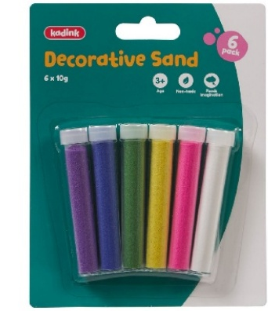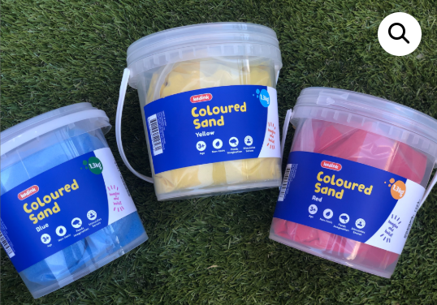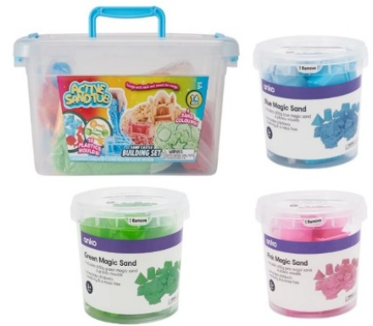
Images sourced from ACCC – productsafety.gov.au

For Providers: Alerts from agencies
- Active Sandtub 14 piece Sand Castle Building Set; Blue Magic Sand; Green Magic Sand; Pink Magic Sand - sold at Kmart and Target | ACCC Product Safety
- Asbestos contamination confirmed in coloured sand product - WorkSafe ACT
- UPDATED: Products added to children’s sand recall | SafeWork SA
- Asbestos in coloured sand | WorkSafe.qld.gov.au
- Product Recall Notice for coloured sand contaminated with asbestos | SafeWork NSW
- Asbestos-Decorative-sand-fact-sheet.pdf - WorkSafe Tas

Further resources

NDIS Commission resources
- NDIS practice standards | NDIS Quality and Safeguards Commission (ndiscommission.gov.au)
- Provider Alert – Emergency Management | NDIS Quality and Safeguards Commission (ndiscommission.gov.au)

