NDIS Quality and Safeguards Commission

Submission to Productivity Commission Inquiry on Delivering Care More Efficiently
September 2025




Acknowledgement of Country
The NDIS Quality and Safeguards Commission acknowledges the traditional custodians of the land on which we live and work. We pay our respects to their Elders past, present and emerging as well as any First Nations People reading this paper.
It is our hope that as Australians we can work together to make a meaningful difference for a more inclusive and respectful society for all.
Artwork by Presten Warren.

Contents
1. Submission Summary 4
2. Aligned not standardised 7
3. Putting rights at the centre of regulatory alignment design 10
4. Supporting quality services starts with who we allow in 11
Provider suitability 11
Worker screening 12
5. Enhancing quality practice and supporting worker and provider capability 13
Registration and audit processes focus on practice quality 13
Worker registration - Enabling workforce capability and mobility 13
6. Connected Systems Benefit Everyone 15
Co-Regulation is complex, and well-designed systems can benefit everyone 15
Greater understanding of costs and benefits is needed 15
Greater alignment can address barriers to effective information sharing 16
A unifying legal framework enables greater system connectivity 16
A single portal will simplify market entry for everyone 17
Regulation is just one part of care and support economy alignment 18
Alignment should build on the momentum of existing reform priorities 19

- Submission Summary
The NDIS has vastly improved the lives of Australians with disability accessing the scheme. Moving towards a better-regulated future means delivering better outcomes, more consistently, in a fiscally sustainable way to the many Australians accessing the NDIS.
The NDIS Quality and Safeguards Commission (the Commission) supports the principle of greater alignment in regulation that removes ‘unnecessary complexities and costs while protecting the rights and safety of care users and ensures regulation remains fit for purpose’ (page 9). The Commission also supports the Productivity Commission’s principle that ‘differences across sectors can justify tailored approaches to regulation in certain circumstances’ (page 14). It is critical that pursuing a goal of greater alignment does not entail standardisation and that there will be necessary differences to reflect the uniqueness of elements of individual sectors and the people accessing these systems.
The NDIS Commission submits that a single regulator may not necessarily be the most effective way to achieve these goals. The assumption that a single regulator is the appropriate future state, effectively posits a solution before there has been sufficient exploration of alternatives. The NDIS Commission encourages the exploration of a future state of regulation that is masterful in its simplicity and able to achieve for service quality and safeguarding what none of the existing regulatory structures currently can. We see more value in focussing on the mechanisms we can put in place to uplift the effectiveness of care and support regulation, rather than focusing on what shape (one or many) regulators may take.
The Productivity Commission has proposed greater alignment in regulation across the Care and Support Economy, starting with alignment across Aged Care, Veterans and NDIS Services and Supports. The NDIS Commission supports reforms that improve regulatory efficiency and outcomes for NDIS participants. The NDIS Commission also supports the Productivity Commission’s recommendation that services for children be included as currently 60% of NDIS participants are under 18 years of age.
The Government’s focus must be on cross-sector reforms that achieve efficiency gains without also resulting in standardising service delivery. The NDIS Commission is committed to ensuring that an approach to greater regulatory alignment does not diminish the rights and diverse needs of the individuals accessing these important services.
Reforming regulation of the NDIS, the largest care and support market in Australia, is critical for productivity and is a vital first step towards greater regulatory alignment. Reforms to advance clearer market entry requirements and a regulatory approach that better incentivises workers and providers to focus on quality practice are paramount. These reforms would promote a market culture committed to supporting people with disability to live better lives and achieve their goals.

The NDIS Commission encourages the Productivity Commission to consider:

- Putting human rights at the centre of regulatory alignment design.
- Clearer requirements on who is allowed to deliver services and supports through expanding worker screening and provider suitability screening.
- Unifying quality practice by focusing on the rights of people accessing services and the behaviours we want to encourage in the market.
- Law reforms delivered in a way that builds on reforms already being progressed and explores approaches including but not limited to only being achieved by a single regulator. Effective co-regulation can address multiple market issues and have positive impacts that go well beyond the reach of a single Commonwealth authority.
- When considering the costs, benefits and risks of a single regulator (Information Request 1.2), the Productivity Commission should take a broad lens that encompasses the human rights, health and wellbeing of participants, impact on sustainability, as well as broader government and community factors. Particular attention should be paid to the unique features of the NDIS market, including NDIS participants, providers and workers.
- Consideration should be given to the impact and sequencing of any changes to the regulators, especially considering the numerous NDIS reforms currently underway and scheduled for implementation in the medium to long term. It is essential that these reforms are given the opportunity to take effect and reveal their impact on the market before any significant alterations are made to how that market is regulated.
Reform of the scale proposed by the Productivity Commission requires deep analysis and collaboration. NDIS reform in practice must ensure key elements of reform design are led by people with disability and accompanied by a full, care-economy wide cost-benefit analysis. Any reform of the scale proposed must carefully consider participant support impacts, provider and market shaping factors and implementation risks. As the Productivity Commission highlighted, it is important to remember that it is people with disability who bear the consequences of unsafe and low-quality care and support – and not just ‘bear the consequences of fragmented regulation through difficulty in accessing care or navigating the system’.

The diagram below conveys how the NDIS Commission envisages a future state of effective, rights centred, co-regulation.
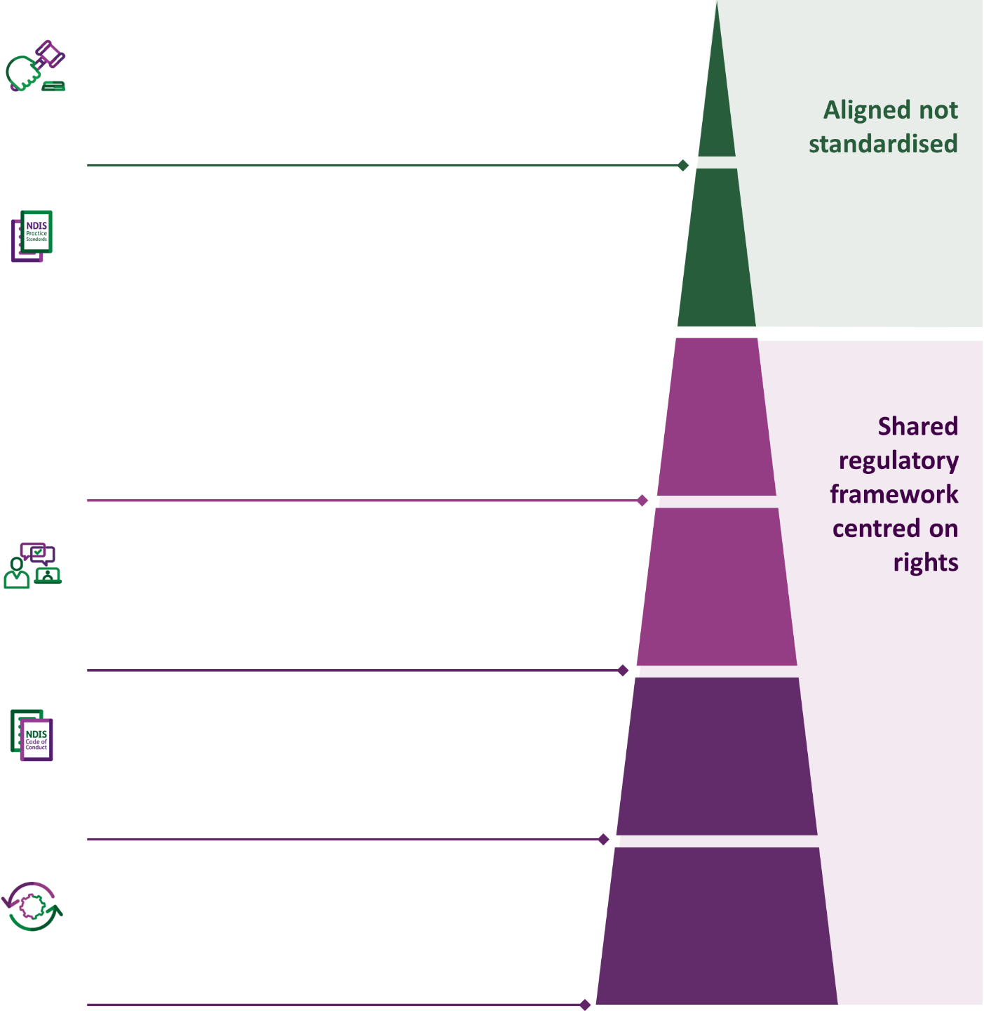

Regulatory intervention
Co-regulation built on information sharing, intelligence analysis and a consistent regulatory approach.

Competency (modular)

Sector and service specific
Provider Practice Standards and worker competencies for specialised supports and unique service environments.

Universal
Provider Practice Standards and worker competencies.

Reporting framework
Registration, audit processes and reporting obligations.

Expectations
Worker and provider code of conduct and statement of individual rights (embedded in law).

Suitability
Expanding and enhancing controls that support quality and safety at the point of market entry.

- Aligned not standardised
The NDIS is a world-first approach to delivering support to people with disability. The National Disability Insurance Scheme Act 2013 (NDIS Act), in conjunction with other laws, gives effect to Australia’s obligations under the UN Convention on the Rights of Persons with Disabilities. The NDIS is built on a strong human rights foundation, but continues to be compromised by preventable quality, integrity and safeguarding issues.
The future of regulation in the NDIS can enable thriving economies where individual rights are paramount, and the culture of service provision is grounded in expectations of ethical conduct. Regulatory alignment can be achieved in a way that does not limit the ability for consumers to access services that meet their individual needs. Striving for regulatory alignment must not lead to services being ‘standardised’, nor should it limit the choice and control of NDIS participants over their services.
The needs of people with disability, older people, and veterans are diverse. Individual differences need to be accommodated even when people are accessing the same type of service, or even from the same provider. To regulate the NDIS market effectively the reforms that are most needed and that can have the greatest impact should address the inequity of the registered/unregistered provider market and correct the regulatory processes that are simply not agile enough to accommodate the market’s complexity and size.
Despite the need for reform, the NDIS’s regulatory framework remains the most mature and effective across the care and support sector in Australia. It also covers the largest and most diverse care and support market. The NDIS market can include any business or person paid to deliver services with NDIS funds. Similarly, the focus of the market on the choice and control of NDIS participants means that regulatory settings must protect and enable the rights of participants to freely choose who provides their services, not be locked into a particular set of providers. Addressing the unique challenges this market poses for regulation through the key reforms described above will ensure that the NDIS market is ready for alignment, and that alignment starts from a rights-based approach.
Table 1. Comparing the relative size of the NDIS Market to other care and support economy markets (all data correct as at June 2024).
 | NDIS | Aged Care | Veterans
Total Payments/Funding | $41.8 billion | $35.7 billion | $123 million for Veterans Home Care  $231 million for Community Nursing
Number of Providers | More than 215,000 active NDIS providers (registered and unregistered)  19,144 Registered NDIS providers | 736 Residential care providers  909 Home Care Package providers  1264 home support providers | Unable to source
Number of Service Users | 661,267 NDIS Participants | 198,362 Residential care residents  275,486 Home Care recipients  934,981 Home support recipients | 34,622 Veterans Home Care recipients  8,426 Community Nursing recipients
The diagram (Diagram 1) below conveys how the NDIS Commission envisages a future state of effective co-regulation. Supporting safe and thriving markets that exist to deliver services that improve the lives of Australians starts with the workers and providers permitted access. For market regulation to be effective, the rights and obligations that are enforceable by the regulator should be grounded in human rights and a strong ethical code of conduct.
Currently, the NDIS is a consumer market that does not have effective controls in place to ensure people with disability can make informed decisions about their services with confidence and ease. Establishing connection between the regulated worker and provider market at the point of market entry, supports a single and enduring point of connection upon which all other elements of regulatory oversight and engagement can be built.
While we have outlined how regulatory alignment is achievable without ‘standardisation’, we appreciate that in practice it will be difficult to determine which elements should be unique and which should be standardised. This cannot be done alone. This requires a significant piece of analysis to be led by people with disability that is underpinned by a full, care-economy wide cost-benefit analysis, which can capture and reflect participant care impacts, provider and market shaping factors and implementation risks.
Diagram 1. Shows how regulatory alignment is achievable without ‘standardisation’. The use of the regulatory pyramid depicts the interplay between regulatory alignment and regulatory frameworks.

Regulatory intervention
Co-regulation built on information sharing, intelligence analysis and a consistent regulatory approach.

Competency (modular)

Sector and service specific
Provider Practice Standards and worker competencies for specialised supports and unique service environments.

Universal
Provider Practice Standards and worker competencies.

Reporting framework
Registration, audit processes and reporting obligations.

Expectations
Worker and provider code of conduct and statement of individual rights (embedded in law).

Suitability
Expanding and enhancing controls that support quality and safety at the point of market entry.

- Putting rights at the centre of regulatory alignment design
A shared commitment to the rights of all individuals accessing these important services can have a transformative effect on current safeguarding and market shaping systems.
Quality service delivery ensures people are treated well and their individual care and support needs are met by competent workers and providers with suitable organisational and personal values. The rights-based principles that inform both NDIS and Aged Care services should be looked to as a suitable unifying structure to progress regulatory alignment while enhancing the current state of the NDIS and other markets.
The human rights principles the NDIS Act is centred on are not directly enforceable, nor do they create direct and positive obligations that must be met by NDIS providers and workers. While registered NDIS providers (7% of the NDIS provider market) have requirements to comply with conditions of registration and other registration requirements, unregistered providers and workers are only required to comply with the NDIS Code of Conduct. There is currently no regulatory process or mechanism that requires all workers and providers operating within the NDIS market to know about, understand and actively agree to comply with the NDIS Code of Conduct. The practical reality is that workers and providers delivering in the NDIS market can do so without any awareness of their obligations. The new Aged Care Act will also be human rights-based and previous reforms included the introduction of a Code of Conduct for Aged Care that was closely informed by the NDIS Code of Conduct.
Putting rights at the centre of alignment also extends to the role of the regulator. Beyond the enforceability of human rights, regulators in rights-based markets also need to focus on the outcomes of service users, like NDIS participants. Our role as a human rights regulator in the NDIS focuses on the effective regulation of a wide range of services, in a variety of circumstances, to ensure that providers and workers are delivering the outcomes NDIS Participants want.
The Productivity Commission identified that a significant proportion of providers and workers operate across the NDIS, Aged Care and Veterans’ services markets. Exploring the establishment of a shared statement of rights and common code of conduct that must be known, understood and actively accepted by all workers and providers would enhance the NDIS Commission’s regulatory effectiveness in the short term and support greater regulatory alignment.
Implementation would require law reform focused on elevating the rights of Australians accessing these important services as well as setting clear expectations for worker and provider conduct. Implementation would also require every worker and provider to be identifiable, which can be achieved by making enhancements to existing shared systems.
Addressing the most urgent regulatory inefficiencies in the NDIS market benefits broader regulatory alignment and gives primacy to the principles that should be at the centre of regulatory design and reform.
- Supporting quality services starts with who we allow in
The Productivity Commission has highlighted the overlap in providers across regulated sectors and the impact this has on providers. The current approach to registration needs reform to support a focus on better service outcomes, and the NDIS Commission already has work underway to achieve this. Enhancing the current systems that inform market participation can have a significant and positive impact on the effectiveness of NDIS market regulation and reduce the administrative burden of regulation for all users.
For the NDIS Commission, having direct visibility of the worker and provider market we are responsible for regulating would be transformative. In the NDIS market there are currently well over 250,000 unregistered NDIS providers (93% of the NDIS market). This means the NDIS Commission does not have a comprehensive view of 93% of the NDIS provider market.
As for workers, the NDIS Commission has direct visibility of workers who have applied for an NDIS Worker Screening Clearance, but not all workers are required to hold this clearance to work. The NDIS workforce is also comprised of a high proportion of sole providers delivering direct support to a small number of people. From a regulatory perspective, sole providers are both NDIS providers and workers. From a workforce perspective, there is a large cohort of self-employed providers who are directly responsible for work, health and safety obligations as well as training and supervision. The NDIS Commission’s Workforce Capability Framework was designed to support workers and providers understand ‘what good looks like’ in delivering quality services. This resource is free to access, but not compulsory to engage with and the NDIS Commission did not receive funding to continue to develop it as an enduring workforce resource.

Provider suitability
The NDIS Commission supports the Productivity Commission’s recommendation to establish a common suitability assessment for providers operating across the NDIS, Aged Care, Veterans Services and Early Childhood Education and Care sectors.
Currently, under the NDIS Act, the NDIS Commission can only make determinations on suitability for registered NDIS providers. There are no equivalent suitability requirements for unregistered NDIS providers. Only a small proportion of NDIS providers are currently required to be registered and just 7% of the NDIS provider market are. The current registration process is formal and requires providers to have completed an audit process against applicable NDIS Practice Standards. While NDIS provider suitability is an important consideration when determining applications for registration, there is an opportunity in a future regulatory model to identify minimum suitability requirements that all NDIS providers can be screened against in order to operate in the NDIS market.
A separate provider suitability ‘screening’ process for all NDIS providers could:
- Prevent market access to businesses and persons already found to have engaged in fraudulent and other exploitative conduct.
- Provide opportunities to harness data and digital technology.
- Enhance information sharing and co-regulation.
- Together with worker screening, provide comprehensive visibility of the broader provider market ecosystem.
- Create opportunities to reduce the regulatory burden on providers operating across multiple markets.
Moving to a consistently regulated market would ensure the market entry requirements are the same for all NDIS providers and could be developed in a way that could be applied to Aged Care, Veterans and Children’s services. Note, however, that while suitability requirements will be standardised across the care and support sector, quality aspects will not be standardised, but instead aligned only where appropriate.

Worker screening
The NDIS Worker Screening Check is well established and is Australia’s first nationally consistent worker screening scheme. The NDIS Worker Screening Database is a highly secure national register that permits varying levels of access to State/Territory and Commonwealth bodies. It also enables third parties (including NDIS participants) to independently verify a worker’s clearance status. It is supported by an Intergovernmental Agreement setting out roles and responsibilities across the States/Territories and Commonwealth.
The NDIS Commission strongly supports the Productivity Commission’s recommendation to expand worker screening. The NDIS Commission believes workers providing supports and services in the NDIS should be required to hold an NDIS Worker Screening Clearance. It is important that the approach to expanding worker screening is designed in collaboration with the disability community to ensure appropriate carve outs and exceptions that address the recommendations suggested by the NDIS Taskforce. Currently only workers engaged in risk assessed roles by registered NDIS providers are required to be screened and hold a clearance. NDIS providers who are not registered may also require their workers to hold a clearance as a matter of organisational policy. NDIS participants who engage workers directly can do the same. In the NDIS market, the current reality is that the NDIS Worker Screening Scheme is underutilised and so the broader harm reduction and harm prevention benefits are not fully realised.
The NDIS Worker Screening Check design was closely informed by State and Territory Working with Children Check schemes and so achieving greater alignment to enhance the protections already in place for child-related sectors is well within reach. The expansion of worker screening for Aged Care services is already well underway. We note that the Department of Finance and the Treasury are consulting on longer-term options for reforming worker screening across the care and support economy. The NDIS Commission supports prioritising the expansion of worker screening in the NDIS market and to support enhanced harm reduction and prevention in other person-centred services. However, it is important that any future state of worker screening also addresses ongoing challenges, such as addressing barriers to accessing screening in regional, remote and First Nations communities.
Expanding worker screening and establishing an equivalent assessment for providers would ensure that persons who pose an unacceptable risk are not permitted to work and organisations that have already demonstrated they are not suitable to operate are not permitted to operate in these high value markets.
- Enhancing quality practice and supporting worker and provider capability

Registration and audit processes focus on practice quality
The Productivity Commission identified that a significant proportion of workers and providers deliver services across multiple markets. Setting clear expectations for provider and worker practice that are anchored in human rights principles can support better quality services being more consistently delivered.
Standards of practice and the way in which quality is conceptualised, measured and reported on is important. Effective standards of practice support continuous improvement and provide a fair and consistent measure of provider practice. In the NDIS, they highlight the role of providers and workers in realising the human rights of people with disability. However, registration and audit processes, if poorly implemented, can be ‘box-ticking’ exercises that increase regulatory burden and the cost of doing business without any positive impact on service quality.
The NDIS Commission is currently reviewing the Practice Standards and co-designing Quality Indicators for supported independent living.
Progressing towards enhanced regulatory alignment in relation to practice standards could start with core standards that should apply to services and support delivery regardless of the type of service, such as being well-lead, provider governance and operational management.
Core Practice Standards, together with a Code of Conduct and Statement of Rights, could form a unifying regulatory framework. The modular approach noted by the Productivity Commission also aligns with the flexible and risk – based approach recommended by the NDIS Review and NDIS Provider and Worker Registration Taskforce. It also ensures that the specific characteristics of each market, such as the importance of choice and control for NDIS participants, can be built into the registration framework for specific sectors (e.g. for the NDIS, through the Taskforce’s proposed self-directed supports category). The NDIS Commission supports a modular and risk-informed approach.

Worker registration - Enabling workforce capability and mobility
The Productivity Commission recommends adopting a unified approach to worker registration across the aged care, NDIS and veterans’ care sectors.
In the Department of Health and Aged Care’s consultation on a national registration scheme to support personal care workers employed in aged care, they noted that a “harmonised approach will promote greater workforce mobility and career opportunities, reduce regulatory burden on workers and employers who deliver cross-care and support economy supports, and increase safety and quality of care and supports for people using aged care, disability support and veterans’ care services.”
Through consultation with people with a disability, we heard that a quality workforce is about workers who have the right attitudes, training and engage in reflective practice. Worker registration should support a shared commitment across NDIS, Aged care, and Veterans to elevating the rights of all individuals accessing these services. This is an opportunity to also align training to a unifying human rights framework.
Workers in the NDIS are increasingly employed in casual roles, rather than permanent full-time roles, and some work across sectors and providers. This means that setting clear minimum requirements for workers is important. However, these requirements must balance the need for greater oversight of the workforce with protections for choice and control that do not discourage workers from entering the sector.
One potential efficiency gain from more consistency across the sectors can come from greater regulation of training standards. Using a standardised credentialing process could reduce the burden of each provider needing to train staff, using evidence to verify that training has been completed already and that the worker is competent and safe to practice. While there will be differences across the sectors, having this framework in place could significantly reduce the cost and burden of duplicate training in similar sectors (e.g. High Intensity Supports).
Worker registration could function as an extension of NDIS Worker Screening with a focus on minimum competencies and requirements for workers. The universal core standards can inform minimum competencies for all workers with additional role specific requirements. The framework for worker registration and capability uplift could leverage off revised Practice Standards and NDIS Workforce Capability Framework. It is important to note that worker registration would be distinct from provider registration requirements, ensuring that workers have specific expectations regardless of which provider(s) they work for.
The NDIS Commission supports the Productivity Commission (as well as the NDIS Provider and Registration Taskforce) recommendation of mutual recognition arrangements for health workers already registered through the National Registration and Accreditation Scheme (NRAS). It is important to note, however, that checks required through the NRAS are not directly equivalent to an NDIS Worker Screening Check. Consideration should be given to how continuous monitoring can be integrated into any screening system applied across the care and support economy.
- Connected Systems Benefit Everyone

Co-Regulation is complex, and well-designed systems can benefit everyone
The Productivity Commission’s interim report identifies efficiency challenges arising out of multiple government oversight and regulatory systems. Different funding models, payment and registration processes and cycles, and reporting obligations and practice standards are all identified as creating complexity for providers. The NDIS Commission agrees, having heard similar feedback through our own consultations on Regulatory Burden. We would also highlight the complexity they create for workers and for NDIS participants and other service users, navigating different regulations to understand their rights.
We agree with the Productivity Commission that co-regulation can be improved but believe a nuanced approach is needed – one that reduces complexity for everyone working in the regulated markets, while ensuring that the specific needs of each sector are still recognised.

Greater understanding of costs and benefits is needed
The Productivity Commission has specifically asked for information on what are the costs, benefits and risks of a single quality and safety regulator across aged care, NDIS and veterans’ care.
The NDIS Commission is supportive of the Productivity Commission’s objectives of achieving a more coordinated, consistent and efficient care and support system. However, the NDIS Commission submits that a single regulator may not necessarily be the most effective way to achieve these goals. The assumption that a single regulator is the appropriate future state, effectively posits a solution before there has been sufficient exploration of alternatives. The NDIS Commission encourages the exploration of a future state of regulation that is masterful in its simplicity and able to achieve for service quality and safeguarding what none of the existing regulatory structures currently can. We see more value in focussing on the mechanisms we can put in place to uplift the effectiveness of care and support regulation, rather than focusing on what shape (one or many) regulators may take.
We strongly support any future alignment reforms being underpinned by a full, care-economy wide cost benefit analysis. This analysis needs to be capable of capturing and reflecting participant impacts, provider and market shaping factors and implementation risks. This also needs to ensure that it contributes to and doesn’t detract from existing reforms to improve the NDIS and ensure the sustainability of the scheme.
In terms of the costs, benefits and risks, we urge the Productivity Commission to consider:
- Benefits need to capture the human rights, health, wellbeing and employment outcomes to participants; and broader government and community benefits such as reduced hospitalisation, housing and other service costs. Focusing on benefits to providers and workers (‘cost savings’) through harmonisation across the care economy misses the underlying policy rationale for government’s involvement in these sectors.
- Costs need to go beyond the fiscal costs (or benefits) of a single quality and safety regulator. Costs also need to cover potential disruption costs to the provision of regulatory coverage, the impact of this on participants, especially if the move towards a harmonised single regulator is prioritised above other reforms seeking to increase regulatory coverage and improve regulatory practices within the NDIS.
- Risks need to consider participant safety and quality, disruption to regulatory efforts by states and territories as regulatory partners (and as joint governors of the NDIS), and implementation of further reforms in a sector already undergoing considerable change.

Greater alignment can address barriers to effective information sharing
The NDIS Commission already operates in a co-regulatory environment. This means that we work closely with other regulators when we have joint roles in regulating a particular issue or group, as well as collaborating where we identify shared issues or challenges. We engage with other regulators including the Aged Care Quality and Safety Commission, state and territory safeguarding and restrictive practices authorities, and a range of other regulatory bodies.
Current approaches to co-regulation, despite best efforts, are blocked by inconsistent frameworks, and information sharing powers are limited by disconnected systems. Different agencies have different levels of information that can be shared, which can limit our ability to identify and flag concerns with providers or workers operating across markets. It can also limit our ability to streamline regulatory requirements – for example, there is limited ability to share audit reports between regulators. Similarly, different agencies can have entirely different regulatory levers, meaning providers can face completely different approaches to enforcing requirements depending on the sector (e.g. Veterans Affairs can use contract-based penalties including recovery of payments).

A unifying legal framework enables greater system connectivity
The statutory frameworks that enable effective regulation are varied and endlessly complex (sometimes unnecessarily so). A unifying and rights-informed regulatory framework that can be implemented across human services sectors without having a ‘standardising’ impact on individual services will achieve effective co-regulation.
We see opportunities for a Shared Legislative Framework to enable key functions across regulators. These could include the core rights framework and enabling streamlined information sharing and intelligence analysis across agencies. It can also involve creating a consistent set of regulatory powers, meaning providers across sectors will understand and be subject to the same enforcement and penalty mechanisms for the same breaches of requirements. It also means that regulators must consider the work being carried out by other regulators before they seek to create separate regulations. This will encourage consistency or joint standards where possible. This will also encourage consistent approaches and support engagement on cross-government issues, such as the impacts of artificial intelligence.
The Shared Legislative Framework will also set a clear framework for how all care and support regulators interact with state and territory agencies. A single information sharing framework will make sharing and requesting information with state and territory agencies more efficient by establishing one set of requirements across the Commonwealth care and support regulators. It will also offer benefits for safe services by enabling regulators like the NDIS Commission to collaborate more smoothly with state and territory emergency services and safeguarding agencies to address urgent issues.
Our view is that prioritising the expansion of worker screening and provider suitability together with establishing an overarching statutory framework would support a smoother progression towards system integration, including with state and territory governments. Consideration should also be given to whether the Commonwealth should establish a national worker screening function.

A single portal will simplify market entry for everyone
The NDIS Commission supports the establishment of a single portal. We agree with the Productivity Commission’s view that this approach would reduce the number of contact points with regulators and centralise information. We also believe that many of the technologies needed to implement such a proposal are available now.
A single portal will only be effective if it is supported by appropriate legislative privacy and information sharing arrangements. Law reform can enable truly effective single portal and support:
- Shared data between care sector regulatory agencies to enable a single view for a provider and workers across the different sectors, and a single public register of providers that have met entry requirements.
- Cross-care economy intelligence analysis and identify common challenges across the sectors.
- Reduce regulatory workloads by enabling providers to use the same point of entry to engage with multiple government processes in one place.
- Encourage quality by enabling regulators to support providers and workers with active feedback. This can include data on provider quality and common trends, supporting regulators to develop targeted advice and guidance on emerging issues.
- Reduce burden for providers by having a single point of entry to operate across Commonwealth programs.

Diagram 2. Shows the various functions that could be achieved through greater regulatory alignment.
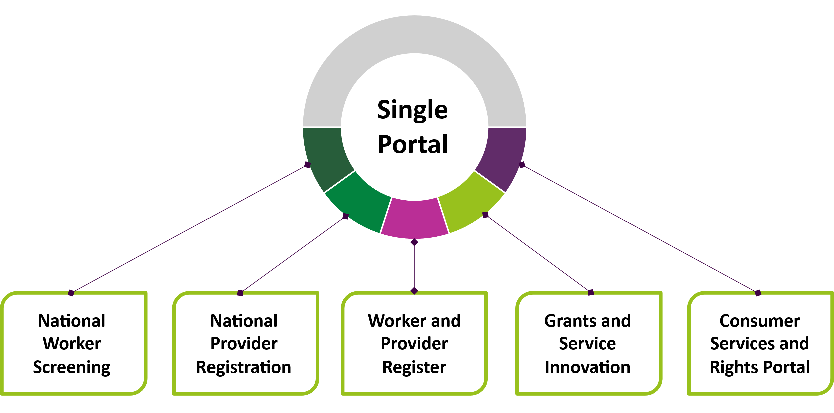
The functions are:
- National Worker Screening
- National Provider Registration
- Worker and Provider Register
- Grants and Service Innovation
- Consumer Services and Rights Portal
Achieving a connected single point of entry is a complex exercise. Consideration should be given to system improvements already underway and opportunities to connect and capitalise on the committed effort that government bodies have already invested in.
Collaboration from State and Territory agencies currently implementing worker screening would also need to be considered. State and Territory engagement would also be valuable for long-term planning around the portal, as other opportunities to streamline regulation emerge (e.g. on reporting obligations for restrictive practices).

Regulation is just one part of care and support economy alignment
While the regulatory environment is a key factor affecting the efficiency and productivity of the care and support economy, it is not the only factor that shapes it. There are several wider policy and pricing considerations that should be considered when developing an approach for alignment across the sectors. While some of these goes beyond the scope of the NDIS Commission’s remit, we believe it is important that these issues are considered:
- Pricing: The Productivity Commission, understandably, has not concentrated on pricing. The NDIS Commission is not responsible for service pricing – in the NDIS market, this is a role for the NDIA. What we can attest to is that pricing does have an impact on service quality. From an alignment perspective, consideration should be given to how pricing is currently managed across the relevant sectors and the impact that pricing approaches may have on broader alignment goals. This should include recognising the differences between agencies that have responsibility for both funding and regulation (e.g. Veterans Affairs) and agencies that only act as regulators.
- Collaborative Commissioning: The Productivity Commission has focused on collaborative commissioning around primary health networks and local hospital networks. In relation to the NDIS, in areas with shortages in care and support services, the Australian Government is increasing its trials of collaborative commissioning of health, aged care, disability and veterans care services. These processes can have a significant beneficial impact on service quality and market culture.
  - Alignment presents several opportunities for streamlining regulation, including in contract-based and collaboratively commissioned services. The universal screening and suitability processes described above could provide baseline regulatory safeguards in these environments, ensuring their use is integrated into existing regulatory structures and therefore reducing regulatory burden for providers.
  - Regulators can also play an important role in collaborative commissioning through the use of grants and similar tools to encourage and support better quality services. The NDIS Commission’s Grants program offers an example of how this can be used to improve provider quality.
- State and Territory Systems: current worker screening, restrictive practice reporting and safeguarding referrals all rely on effective information sharing and engagement with state and territory government agencies. At the same time, providers and workers often face duplicative or parallel reporting obligations. Further work is needed to consider how alignment or streamlining of obligations could be pursued across Commonwealth and state and territory jurisdictions.
  - We support the Productivity Commission’s proposal to explore greater alignment in the regulation of behaviour support plans, and the use of restrictive practices, across the support sectors. We note that work is already underway in this space, including the development of a whole-of-government approach to reduce and eliminate the use of restrictive practices and a joint action plan with states and territories.
- Artificial Intelligence: we agree with the Productivity Commission that the emergence of AI offers significant potential to improve outcomes and productivity in the care economy. We also agree that a consistent approach should be taken across sectors without new specific regulations where possible. We note that for the NDIS, AI usage potentially carries significant privacy implications in relation to health information. Any future approach to regulation across the care and support economy should maintain these considerations in a technology-neutral way to continue to uphold service user rights.
- Barriers to System Engagement: We recognise that many existing systems and processes in the NDIS can be harder to access and engage with for some groups. For example, the NDIS Review identified that NDIS worker screening can detrimentally impact the ability for workers in regional, remote and First Nations communities to provide services. These issues are common across the care and support economy. Any implementation of alignment proposals must ensure there is sufficient nuance to recognise the varied circumstances of service users, providers and workers, and to support their continued engagement in the support economy. Intersectional disadvantage should be carefully considered and recognised in any future framework.

Alignment should build on the momentum of existing reform priorities
The NDIS Commission agrees with the Productivity Commission that regulatory harmonisation requires clear instructions from Government and the authorisation to deliver. The NDIS Commission supports a forward plan that prioritises addressing the challenges in the NDIS’ regulatory framework and further enhances the regulatory mechanisms that the NDIS Commission can use to improve the quality of NDIS services.
We agree this is a multi-year exercise and support the Productivity Commission’s early proposal for an implementation plan. If law reform focuses too early on whether a single regulator should be established, the current state of the NDIS market will not be improved and the issues that require urgent attention will worsen. The cost of reform is not modest and the cost that has the most significant impact on how people with disability experience the NDIS is time. The Productivity Commission notes that several attempts have been made to start this process previously and the NDIS Commission has felt and observed the direct impacts of effort without result. Over many conversations with NDIS providers, workers and people with disability the fatigue of reforms and the shared concern for scheme sustainability weighs heavily.
In this environment, the time is right for the Productivity Commission to draw together key insights from past reviews and reports, and to deliver a clear, actionable plan for Government. This will give the impetus needed to make progress on regulatory alignment, and the certainty our providers, workers and participants need about the future regulation of the NDIS.
The NDIS is undergoing significant reform and changes. Both the NDIA and NDIS Commission have several reform activities in progress which, when completed, will influence the way the NDIS market is regulated, and the visibility we have of provider activities.
A key reform activity is the NDIS Commission’s work on registration changes that will expand the NDIS Commission’s regulatory coverage and effectiveness. Currently the NDIS Commission has comprehensive visibility of just 1 in 16 providers through registration. Higher risk supports including home and living, support coordination and platform provider supports do not have to register, and the NDIS Commission has limited regulatory oversight of their activities.
Addressing the unregistered NDIS provider market should be a priority consideration in the context of broader regulatory alignment. With well over 250,000 unregistered NDIS providers operating, including some providing higher risk supports, the NDIS Commission would start alignment processes with other care and support sectors from a very different regulatory environment. By comparison, the new Aged Care registration model will require all providers to be registered, except in limited circumstances.
Clear advice from government is needed to set direction on priority reforms for the NDIS Commission, with a focus on improving our limited oversight of the wider NDIS market. This means focusing on reforms that expand our oversight of the NDIS market and ensure we can apply a right-fit, risk-based regulatory approach, as recommended by the NDIS Review and NDIS Provider and Worker Registration Taskforce.
Now is the time to future-proof the NDIS and capitalise on the opportunities to achieve greater regulatory alignment dedicated on delivering better outcomes for the many Australians NDIS, Aged Care, Veterans and Children’s services exist to support.

Future state framework for greater regulatory alignment in action:
A shared commitment to the rights of all individuals accessing services will have a transformative effect on current safeguarding and market shaping systems.
Provider suitability | Expectations | Reporting Framework | Competency | Regulatory Intervention
Support101 is a registered NDIS provider that delivers SIL and daily living skills to people with disability.  Support 101 is interested in supporting older Australians.  All workers engaged by Support101 hold worker screening clearances.  Outcome: Support 101 has been screened for suitability to deliver NDIS supports and services. Their registration status indicates they have also demonstrated suitability to deliver higher risk services. Support 101 is subject to ongoing monitoring. | Having a shared statement of rights and common Code of Conduct that must be known, understood and actively accepted by all workers means that all workers at Support101 will already understand what is expected of them and services will be centered on the rights of NDIS participants and older Australians.  Outcome: Services are centred on rights. Support101 can concentrate on reinforcing these expectations. Identifying and addressing worker misconduct is better supported. | Support101 uses the single portal, accessed via myID for NDIS and Aged Care services.  They log in and apply to provide additional categories of support in Aged Care.  Support101 is familiar with the portal and already has suitable complaints and incident management systems.  Outcome: Support101 use the single portal for reporting for both NDIS and Aged Care. Reduced regulatory burden allows increased resources for addressing complaints and incidents further supporting high quality services. | Workers: Disability Support Workers at Support101 are registered through a common worker registration scheme. They have already met core and disability specific competencies. Workers can apply to be a Personal Care Worker.  Provider: Support101 has been audited against core practice standards (and support specific NDIS practice standards). They will need to demonstrate compliance against select Aged Care specific Practice Standards, but will not need to audit for the core practice standards again.  Outcome: Support101 can prepare to deliver aged care services with greater confidence and without duplication. | Support101 is aware of their obligations. They ensure they meet all compliance obligations and know that regulators work collaboratively with consistent regulatory levers.  All Support101’s information is accessible to them and Aged Care and NDIS regulators, including regulatory activities. When Support101 need to update key information they only need to do it once.  Outcome: Regulation in rights-based markets focus on how services meet individual needs and support better outcomes. Regulators can invest as many resources in market building capability as stopping bad actors.
Current State: Providers undergo duplicate registration processes to demonstrate suitability, competency and comply with regulatory requirements. Providers are required to use different systems often to report similar information. In the NDIS, 96% of the Provider market can operate without registering with the regulator. Workers supporting children, older Australians and people with disability have to pay for and hold multiple screening clearances. Providers verify workers through different systems and not mandated for all NDIS workers.

Interim report - Delivering quality care more efficiently p11.
National Disability Insurance Agency (NDIA), NDIS Quarterly Report to disability ministers, Q4 2023-24, NDIA, 30 June 2024, p. 15, 53, 62; NDIS Quality and Safeguards Commission (NDIS Commission), Quarterly Performance Report Q4 2023-24, NDIS Commission, June 2024, p. 19.
Department of Health, Disability and Ageing (DHDA), Financial Report on the Australian Aged Care Sector 2023-24, DHDA, June 2025, p. 7-8.
Productivity Commission, Report on Government Services 2025, Productivity Commission, 30 January 2025, Table 14A.8.
A national registration scheme to support personal care workers employed in aged care p4.

