Restrictive Practices and Me
Easy Read
Version 1.1 (October 2025)

Restrictive Practices and Me

Easy Read Discussion Book

This book belongs to
Your name:
(Add your photo here)

You can get help to fill in this book.
Name of your Behaviour Support Practitioner:

Names of your family, friends, or support workers:

Date completed:

What is in this book?
What is in this book? 2
About this book 3
What are Restrictive Practices? 5
Restrictive Practices and the Rules 8
Chemical Restraint 9
Environmental Restraint 12
Physical Restraint 15
Mechanical Restraint 18
Seclusion 21
Final Questions 24
Contact us 25
Acknowledgement 25
Word List 26

About this book
 | The NDIS Quality and Safeguards Commission made this book.  We say NDIS Commission for short.
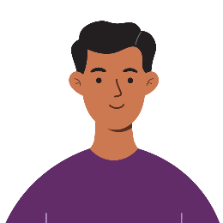 | We wrote this book with, and for, NDIS participants.  NDIS participants are people who get support from the NDIS.  When you see the word “you,” it means NDIS participant.
 | For helpful tips on how to use this book, see our tip sheet.

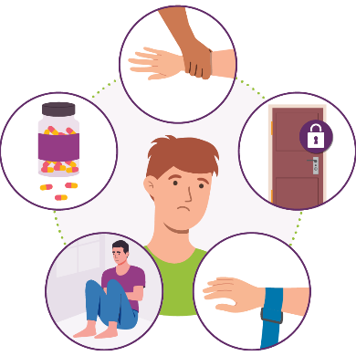 | This book is about restrictive practices.  We explain what restrictive practices are on the next page.
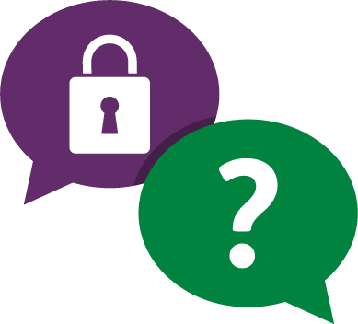  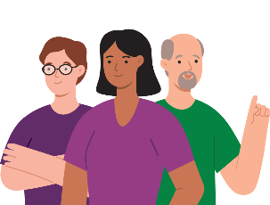 | This book is meant to help you talk about things like:  - what restrictive practices will be used  - how they may affect you  - other ways you will be supported.
 | This book has questions about each kind of restrictive practice.
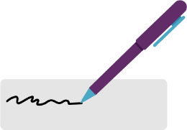 | There are boxes where you can draw or write your answers.  You might choose to add photos too.

What are Restrictive Practices?
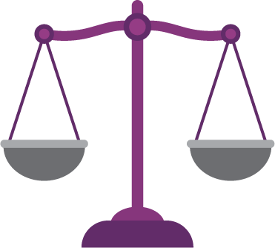 | Restrictive practices are actions that take away your rights.  Rights are rules about how people should treat you:  - fairly  - equally.
Restrictive Practices stop you from:
- moving freely
- doing what you want.

 | There are five kinds of restrictive practices.
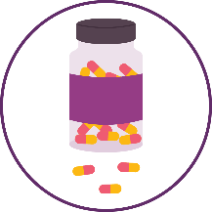 | Chemical restraint is when medicine is used to help stop your behaviour.  For example, to help stop you from hurting yourself.
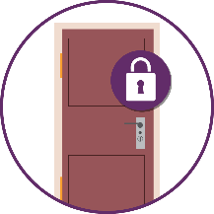 | Environmental restraint is when you are stopped from:  - having or doing certain things  - going to certain places in your home or in the community.  For example, when you are not alone but a door is locked to stop you from going out.
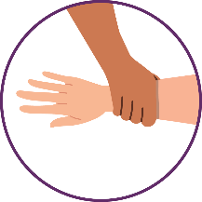 | Physical restraint is when someone holds you or part of your body so you cannot move freely.  They hold you to stop your behaviour.
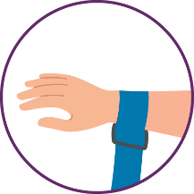 | Mechanical restraint is when a device or piece of equipment is used to stop your behaviour.  It can make it hard for you to move.  For example, an arm strap to stop you hitting yourself.
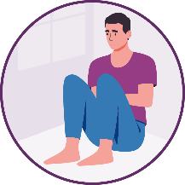 | Seclusion is when you are in a room or place alone and are not allowed to leave.  For example, you might be in a locked room.  You might be told that you cannot leave even if the door is open.

Restrictive Practices and the Rules
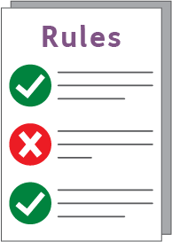 | There are Rules about the use of restrictive practices.
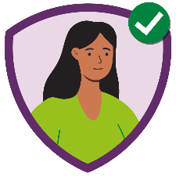 | For example, they must only be used as the last option to help keep you and other people safe.
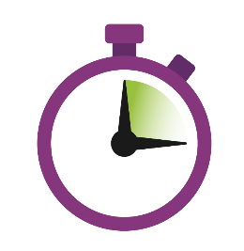 | Restrictive practices must only be used for the shortest time possible.
Restrictive practices must be explained to you.
This should be done in an easy to understand way.
 | For more information about restrictive practices and the Rules see the Easy Read resources on our website.

Chemical Restraint
Fill in this part if you will be taking chemical restraint.
Your behaviour support practitioner or doctor can tell you more about this.
You may need to print extra pages if you take a lot of medicines.
Delete this section if you are not taking chemical restraint.
 | What is the medication?
For example, what is the name of the medicine?
How do you take it?
When do you have to take it?
Who will give it to you?
 | Why do you have to take it?
For example, what behaviour is it for?
How will it help keep you and other people safe?
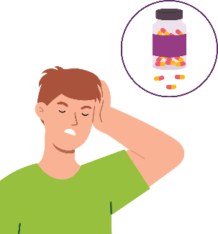 | What are the possible side effects?  A side effect is where something happens that you did not want.  For example, you might feel sick or dizzy.  You can find this in the medicine information sheet.  You can also ask your doctor.
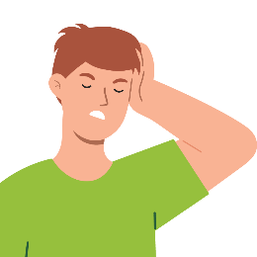 | How will we make sure the side effects are not too bad?
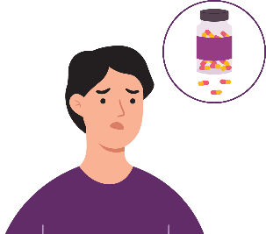 | How do you feel about taking the medicine?
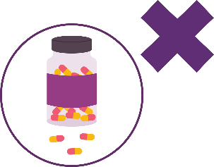 | The goal is to have less medicine or stop it one day.  What is the plan to get there?

Environmental Restraint
Fill in this part if environmental restraint will be used with you.
Your behaviour support practitioner can tell you what the environmental restraint will look like for you.
Delete this section if environmental restraint will not be used.
 | What environmental restraint will be used with you?
For example, what is the environmental restraint?
When will it be used?
How?
For how long?
By whom?
 | Why will it be used?
For example, what behaviour is it for?
How will it help keep you and other people safe?
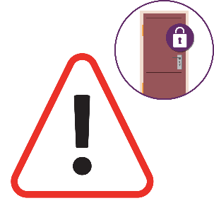 | What are the risks of environmental restraint?  A risk is the chance that something bad could happen.  For example, you lose the chance to do things for yourself.
 | How will we deal with the risks?
 | For example, what will we do?
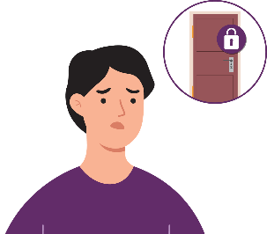 | How do you feel about the environmental restraint?
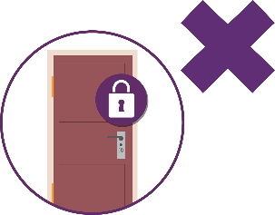 | The goal is to have less environmental restraint or stop it one day.  What is the plan to get there?

Physical Restraint
Fill in this part if physical restraint will be used with you.
Your behaviour support practitioner can tell you what physical restraint will look like for you.
Delete this section if physical restraint will not be used.
 | What physical restraint will be used with you?
For example, what part of your body will be held?
When?
For how long?
By whom?
 | Why will it be used?
For example, what behaviour is it for?
How will it help keep you and other people safe?
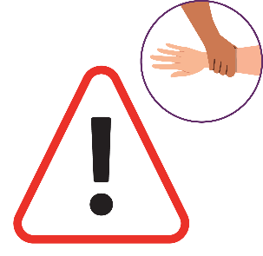 | What are the risks of physical restraint?
 | How will we deal with the risks?
 | For example, what will we do?
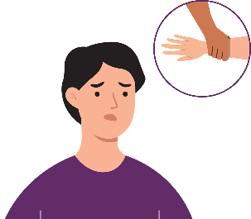 | How do you feel about physical restraint?
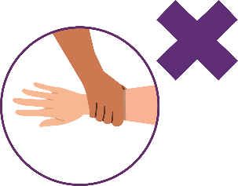 | The goal is to use physical restraint less or stop it one day.  What is the plan to get there?

Mechanical Restraint
Fill in this part if mechanical restraint will be used with you.
Your behaviour support practitioner can tell you what mechanical restraint will look like for you.
Delete this section if mechanical restraint will not be used.
 | What mechanical restraint will be used with you?
For example, what is the device?
How will it be used?
When?
For how long?
By whom?
 | Why will it be used?
For example, what behaviour is it for?
How will it help keep you and other people safe?
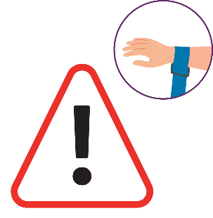 | What are the risks of the mechanical restraint?
 | How will we deal with the risks?
 | For example, what will we do?
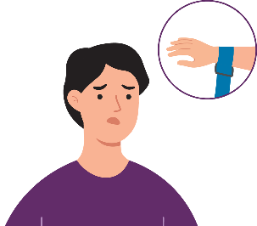 | How do you feel about the mechanical restraint?
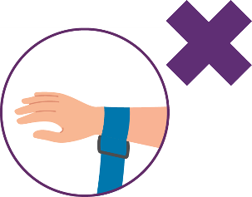 | The goal is to use mechanical restraint less or stop it one day.  What is the plan to get there?

Seclusion
Fill in this part if seclusion will be used with you.
Your behaviour support practitioner can tell you what seclusion will look like for you.
Delete this section if seclusion will not be used.
 | How will seclusion be used?
For example, When?
Where?
For how long?
 | Why will it be used?
For example, what behaviour is it for?
How will it help keep you and other people safe?
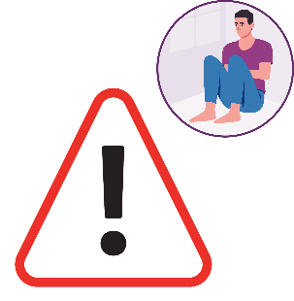 | What are the risks of seclusion?
 | How will we deal with the risks?
 | For example, what will we do?
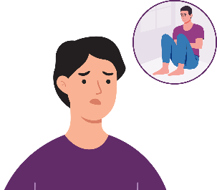 | How do you feel about seclusion?
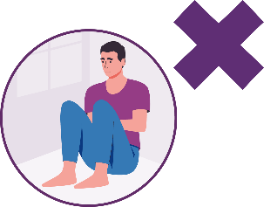 | The goal is to use seclusion less or stop it one day.  What is the plan to get there?

Final Questions
Before we wrap up, here are two final questions.
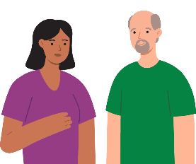 | How else can we support you to make things better?
 | Do you want to ask or say anything else about restrictive practices?

Contact us
You can contact us for more information.
You can also give us feedback about this book.
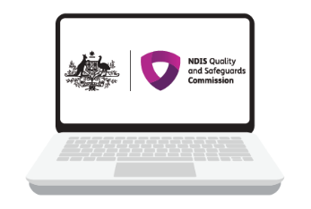 | You can go to our website. www.ndiscommission.gov.au
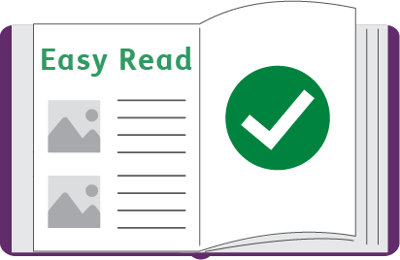 | You can read our Easy Read resources about restrictive practices and behaviour support.  www.ndiscommission.gov.au/rules-and-standards/behaviour-support-and-restrictive-practices
 | You can send us an email at:  behavioursupport@ndiscommission.gov.au

Acknowledgement
The NDIS Commission wants to thank the Council for Intellectual Disability.
CID for short.
CID reviewed and tested this Easy Read.

Word List
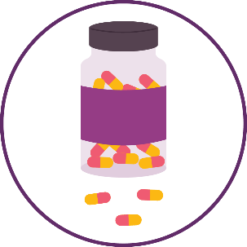 | Chemical restraint  This is when medicine is used to help stop a person’s behaviour.  For example, to help stop you from hurting yourself.
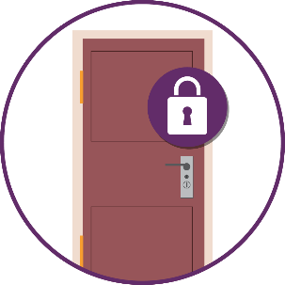 | Environmental restraint  This is when a person is stopped from:  - having or doing certain things  - going to certain places in their home or in the community.  For example, when a person is not alone but a door is locked to stop them from going out.
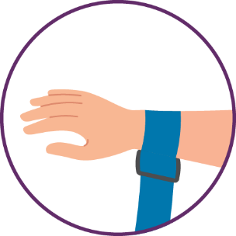 | Mechanical restraint  This is when a device or piece of equipment is used to stop a person’s behaviour.  It can make it hard for them to move.  For example, an arm strap to stop someone from hitting themself.
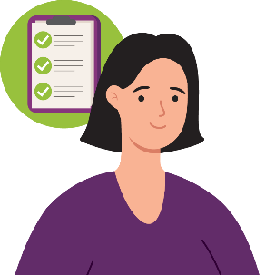 | NDIS Behaviour Support Practitioner  A person who is allowed to do behaviour support.  The NDIS Commission says they can do it.  They have:  - learned about behaviour support  - know how to do it.
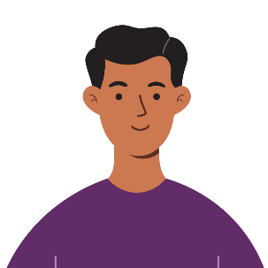 | NDIS Participant  A person who gets support from the NDIS.
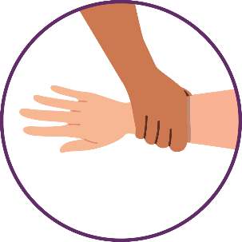 | Physical restraint  This is when someone holds a person or part of their body so they cannot move freely.  They hold the person to stop a behaviour.

Restrictive Practices
Restrictive practices are actions that take away people’s rights.
They stop people from:
- moving freely
- doing what they want.
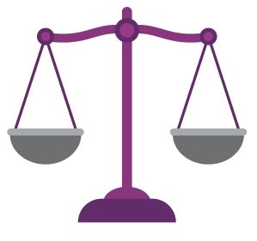 | Rights  Rights are rules about how people should treat others fairly and equally.
 | Risk  A risk is the chance that something bad could happen.
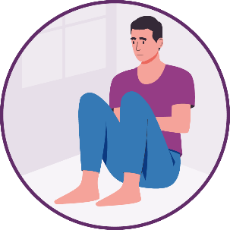 | Seclusion  This is when a person is in a room or place alone and is not allowed to leave.  For example they might be in a locked room.  They might be told they cannot leave even if the door is open.
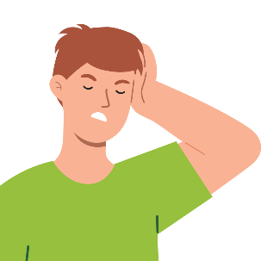 | Side Effect  A side effect is where something happens that is not wanted.  For example, a person might feel sick or dizzy.

