Restrictive Practices and Me
Case Study
Version 1 (July 2025)

Case Study
Kabir is a 22-year-old man with an intellectual disability who loves the Parramatta Eels football team and lives with two other young people with 24/7 NDIS support.
Recently, on four occasions, Kabir has threatened his housemates with a knife, after they have moved or taken his football memorabilia without permission.
Kabir is now being supported by Anna, an NDIS behaviour support practitioner. In the process of getting to know Kabir and developing an Interim Behaviour Support Plan (BSP), Anna has identified the need to restrict Kabir’s access to sharps as a short-term strategy whilst a behaviour support assessment is undertaken. This constitutes environmental restraint.
Anna goes onto the NDIS Commission website and downloads a copy of the Restrictive Practices and Me Easy Read Discussion Book. She removes the pages with questions about the use of chemical restraint, mechanical restraint, physical restraint, and seclusion as Kabir is not subject to these kinds of restrictive practices. She retains the background information and section with questions about environmental restraint.
Over two visits to the house, Anna sits down with Kabir and Jon, his support worker and uses the Easy Read to share information about restrictive practices.
Together they answer the questions about the environmental restraint, what this means for Kabir and other ways he will be supported. During this discussion Kabir shared how he feels about the practice and identifies things he would like his workers to do differently. Anna writes down these answers and later uses this information to inform Kabir’s BSP and daily supports.
*** The following pages provide an example of how Kabir, Anna and Jon filled in the Restrictive Practices and Me Easy Read Discussion Book.

Restrictive Practices and Me

Easy Read Discussion Book

This book belongs to
Your name: Kabir
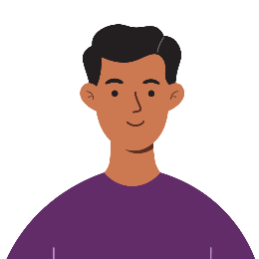

You can get help to fill in this book.
Name of your Behaviour Support Practitioner:
Anna
Names of your family, friends, or support workers:
Jon (Support Worker)

Date completed: 22 May 2025

Environmental Restraint
Fill in this part if environmental restraint will be used with you.
Your behaviour support practitioner can tell you what environmental restraint will look like for you.
Delete this section if environmental restraint will not be used.
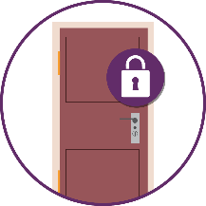 | What environmental restraint will be used with you?
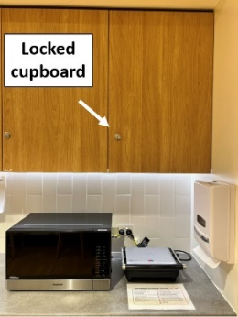 | The knives will be locked away.  This will happen every day at home.  They will be locked in the kitchen cupboard.  Only staff will have the key.
 | Why will it be used?
When James and Muhammad took your football without asking, you threatened to hurt them with a knife.
This has happened four times.
We are going to lock away the knives to help keep everyone safe.

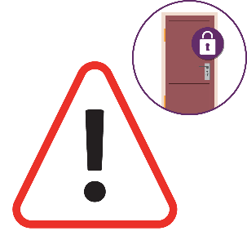 | What are the risks of environmental restraint?  A risk is the chance that something bad could happen.  For example, you lose the chance to do things for yourself.
 | Locking away the knives may make it hard to make meals on your own.
 | What will we do to deal with the risks?
When you are calm staff will
help you to use the knives and make meals.
They will make sure you have the chance to prepare at least one meal each day.

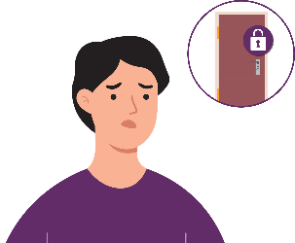 | How do you feel about the environmental restraint?
You do not think it is fair.

James and Muhammad should not have touched your things.

You would like staff to talk to them too.
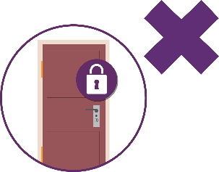 | The goal is to have less environmental restraint or stop it one day.  What is the plan to get there?
- Anna will teach you ways to stay calm.
- If you stay calm, then you can use the knives more each month.
- We will try to stop locking away the knives by the end of the year.

Final Questions
Before we wrap up, here are two final questions.
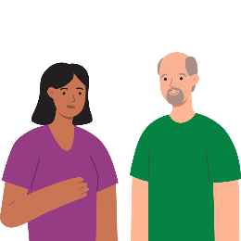 | How else can we support you to make things better?
- You want to go to more football games.
- You do not want anyone to go into your room without asking. This includes staff.
- You want to learn to make pizza.
 | Do you want to ask or say anything else about restrictive practices?
 | No.

