Complaints Policy 2025
External use
Version 2.0 June 2025

NDIS Quality and Safeguards Commission
PO Box 210, Penrith NSW 2751
Copyright
© Commonwealth of Australia (NDIS Quality and Safeguards Commission) 2024
The NDIS Quality and Safeguards Commission encourages the dissemination and exchange of information provided in this policy. The material in this policy is licensed under a Creative Commons Attribution 4.0 International licence, with the exception of:
- the Commonwealth Coat of Arms
- the NDIS Quality and Safeguards Commission logo
- any third party material
- any material protected by a trademark
- any illustration, diagram, photograph or graphic over which the NDIS Quality and Safeguards Commission does not hold copyright, but which may be part of or contained within this policy.
More information on this CC BY licence is set out at the creative commons website: www.creativecommons.org. Enquiries about this licence and any use of this policy can be sent to: communications@ndiscommission.gov.au
Attribution
Use of all or part of these guidelines must include the following attribution:
© Commonwealth of Australia (NDIS Quality and Safeguards Commission) 2024.
Using the Commonwealth Coat of Arms
Terms of use for the Coat of Arms are available at this website: https://www.pmc.gov.au/government/commonwealth-coat-arms
Important notice
The information in this policy is for general guidance only. It does not constitute legal or other professional advice, and should not be relied on as a statement of a law in any jurisdiction. You should obtain professional advice if you have any specific concern.
The NDIS Quality and Safeguards Commission has made every reasonable effort to provide current and accurate information, but it does not make any guarantees regarding the accuracy, currency or completeness of that information.
Parties wishing to re-publish or otherwise use the information in this policy must check this information for currency and accuracy prior to publication. This should be done prior to each publication edition, as NDIS Quality and Safeguards Commission guidance and relevant legislation may change. Any queries should be addressed to communications@ndiscommission.gov.au.
Table of contents
Definitions 4
Purpose 6
Policy scope 6
Relevant legislative provisions 6
Privacy 7
How complaints inform improvement 7
Our complaint management principles 7
Who can complain to us 7
How to complain 8
How we manage complaints 8
Risk assessment 9
Complaint responses 9
Complaint outcomes 10
How to provide feedback or make a complaint about the NDIS Commission 10
Monitoring and evaluation 10

Definitions
Table 1 – Definitions, key terms and abbreviations used in this document
Term or Abbreviation | Description
Advocate | An independent person who helps to ensure that the choices and rights of people with disability are respected and they are being treated fairly. Advocates can be located by using the Disability Advocacy Finder on the NDIS Quality and Safeguards Commission website.
Anonymous complainant | When a complainant requests to remain anonymous the NDIS Commission will not keep a record of the complainant’s name or contact information.
Auslan | Auslan is short for Australian sign language, a language developed by, and for, Australians who are deaf or hard of hearing. It’s a visual form of communication that uses hand, arm and body movements to convey meaning.
Complainant | The person who lodges a complaint with the NDIS Commission.
Complaint | An expression of dissatisfaction or concerns arising out of, or in connection with, the provision of supports or services by an NDIS provider or worker.
Complaints Rules | National Disability Insurance Scheme (Complaints Management and Resolution) Rules 2018.
Confidential complaint | When a complainant provides their name and contact details to the NDIS Commission but asks for their details not to be shared with any other person.
Contravention | The act of doing something that a rule or law does not allow.
Enterprise Prioritisation Criteria | The Enterprise Prioritisation Criteria outline the factors we consider when assessing complaints. They include:  - Impact on human rights and safety of the participant  - Provider or worker non-compliance or breaches of NDIS Legislation and Rules  - Data-led Strategic priorities of the NDIS Commission.
Harm | Includes physical, psychological, emotional and financial harm arising from abuse, exploitation and neglect.
Interpreter | Interpreters deal with the spoken word or signed languages (such as Auslan). They interpret what each speaker is saying or signing into the other person’s language.
NDIS | National Disability Insurance Scheme.
NDIS Act | National Disability Insurance Scheme Act 2013
NDIS Code of Conduct | The National Disability Insurance Scheme (Code of Conduct) Rules 2018, which applies to all NDIS providers regardless of registration.
NDIS Rules | All Rules made pursuant to the NDIS Act.
NDIS Commission | NDIS Quality and Safeguards Commission.
NDIS Commission officers | Staff of the NDIS Commission.
Participants | In accordance with section 9 of the NDIS Act, a person receiving supports and services under the NDIS​.
Parties | The people involved in the cause and/or the resolution of issue/complaint.  This may include:  - A participant or participants,  - A complainant where they are not the participant  - A participant’s family member(s), advocate or support person  - A provider or support worker  - Any other support people
NDIS Practice Standards and Quality Indicators | The benchmark for providers to assess their performance, and to demonstrate how they provide high quality and safe supports and services to NDIS participants.​​
Provider | Registered or unregistered NDIS provider, key personnel or workers.
Reconsideration | Internal NDIS Commission review of a complaint outcome.
Risk assessment | The process of risk identification, risk analysis and risk evaluation.
TIS National | Translating and Interpreting Services National.
TTY | Also known as telephone typewriter or textphone (TTY); a specialised telephone which includes a keyboard and screen. A TTY is a special device that supports people who are Deaf, hearing and/or speech-impaired use the telephone to communicate by allowing them to type messages back and forth to one another instead of talking and listening. A TTY is required at both ends of the conversation in order to communicate.
When we say “us”, “we” or “our staff” | NDIS Commission Officers.

Purpose
- The NDIS Quality and Safeguards Commission (NDIS Commission) regulates the quality and safety of NDIS funded supports and services.
- This policy provides guidance to people who may wish to make a complaint to the NDIS Commission and outlines how we manage complaints.

Policy scope
- This policy outlines our approach to managing complaints about NDIS supports and services.
- Making a complaint under this policy in no way limits a person’s right to complain to another agency or body which can provide assistance.
- This policy is underpinned by our Enterprise Prioritisation Criteria. The Enterprise Prioritisation Criteria outlines the factors we consider when assessing risks to participants. This is used to determine the complaints or complaint issues which require a priority response.
- When a complaint raises issue(s) which indicates a high risk to participants, the issue(s) may be escalated for further assessment and regulatory action. Detailed information can be found in our Regulatory Approach.
Out of scope
- The NDIS Commission does not make decisions about NDIS plans or funding. This policy does not cover the management of complaints made to the National Disability Insurance Agency (NDIA) about those or other agency related matters.
- This policy does not extend to complaints about the NDIS Commission. Those complaints are handled under the NDIS Commission's feedback and complaints policy.

Relevant legislative provisions
- A strong regulatory system recognises there is significant value in providers resolving complaints with participants and their decision makers to restore confidence in their services. Under the NDIS Code of Conduct, all providers must promptly take steps to raise and act on concerns about matters that may impact the quality and safety of supports and services provided to people with disability. Under the National Disability Insurance Scheme (Complaints Management and Resolution) Rules 2018, registered providers have additional responsibilities including analysing complaint data to identify systemic issues in order to improve systems and services.
- The NDIS Commission has responsibility for a complaints function under the National Disability Insurance Scheme Act 2013 (NDIS Act). Our complaints teams have a role in building the capacity of providers and participants in making and resolving complaints. The Complaints Rules provide the basis for the strategies used by the NDIS Commission in dealing with a complaint and improving providers’ responsiveness to concerns.

Privacy
- Please read and consider our Privacy Policy before making a complaint. Information collected as part of the complaints process will be used for the purpose of assessing, actioning and responding to complaints. We report on complaint activities and use complaint data to identify risks and trends in the market. Information people share with us in complaints helps to inform our regulation of the sector and supports the actions and decisions we make.

How complaints inform improvement
- Properly handled complaints help to strengthen the NDIS. Complaints provide opportunities to resolve misunderstandings, address harm or conflict and can lead to increased participant satisfaction and safety. Feedback received during the complaints process informs continuous improvement in order to uplift the quality of service provision across the sector. Workplace cultures where participant voices and feedback are valued and respected, support participants to exercise choice and control over the services they receive.
- The information we receive through the complaints process provides valuable insights into systemic and market risks. We may consider and use information contained in complaints in a range of actions that help us to regulate the sector.

Our complaint management principles
- Our complaint management principals are:
- We will uphold the rights of people with disability, work with people with disability, their carers, families and other significant people to increase their confidence to exercise choice and control and raise issues with providers.
- We will work with NDIS providers to build their capacity to appropriately respond to complaints and respect the human rights of participants.
- We will prioritise complaints that involve the highest risk to the safety, wellbeing and human rights of people with disability.
- We will treat all parties to a complaint fairly and respectfully.
- We will communicate clearly to everyone involved in a complaint and will provide reasons for our actions and decisions.

Who can complain to us
- We welcome complaints from anyone. This includes the person with disability, an advocate, friend, family member, carer, worker, provider or a member of the community.

How to complain
- We consider a complaint to be an expression of dissatisfaction or concerns arising out of, or in connection with, NDIS funded supports or services. Complaints are brought to our attention in a number of ways:
- Completing an online Complaint Contact Form - Make a complaint.
- Calling our Contact Centre on 1800 035 544.
- National Relay Service (ask for 1800 035 544) (free call from landlines) or TTY 133 677. Interpreters can be arranged free of charge.
- People who need an interpreter can call Translating and Interpreting Services National (TIS National) on 131 450 and they can contact us on 1800 035 544.
- If a complaint is made anonymously, we will not keep a record of the complainant’s name or contact details. Anonymous complaints can lead to positive outcomes, however in some circumstances we may not have sufficient information to take action. Without the complainant’s contact information, we are unable to discuss the complaint outcome with them.
- Complaints can be made to us confidentially. In this case we will not share information about you with other parties to the complaint.
- If a person is making a complaint on behalf of a participant, we may need to obtain consent to communicate with this person.
- People who need to speak to a disability advocate can visit Disability Advocacy Finder | Ask Izzy or ask for disability advocacy options by contacting us on 1800 035 544.
- We respect a person’s right to withdraw their complaint at any time. We will consider the participant’s health, safety and welfare before we decide to stop working on a complaint.

How we manage complaints
- We will acknowledge complaints promptly, and assess complaints as quickly as proper consideration of the issues allow.
- We empower our staff to advise at the earliest possibility, if:
- We cannot assist with a complaint. Where appropriate, we may refer complainants to another agency. For example, if a complaint is about a planning decision, we will suggest the complainant contact the NDIA.
- The complaint is about an issue that is better dealt with by another agency. For example, if the complaint is about an allied health provider or nurse, we may tell you if we think Australian Health Practitioner Regulation Agency (AHPRA) is better placed to respond.
- We think the provider is best placed to respond to your concerns. We will provide you with information about your right to complain and guidance around how to complain to the provider directly.

Risk assessment
- We will prioritise complaints in accordance with their urgency, seriousness and complexity.
- When deciding how to respond to a complaint, we consider the relationship between the seriousness of a matter, the presence and nature of any alleged or potential contravention and the NDIS Commission’s regulatory role and priorities. These factors are assessed together to determine if a matter is of high priority.
Diagram 1 –
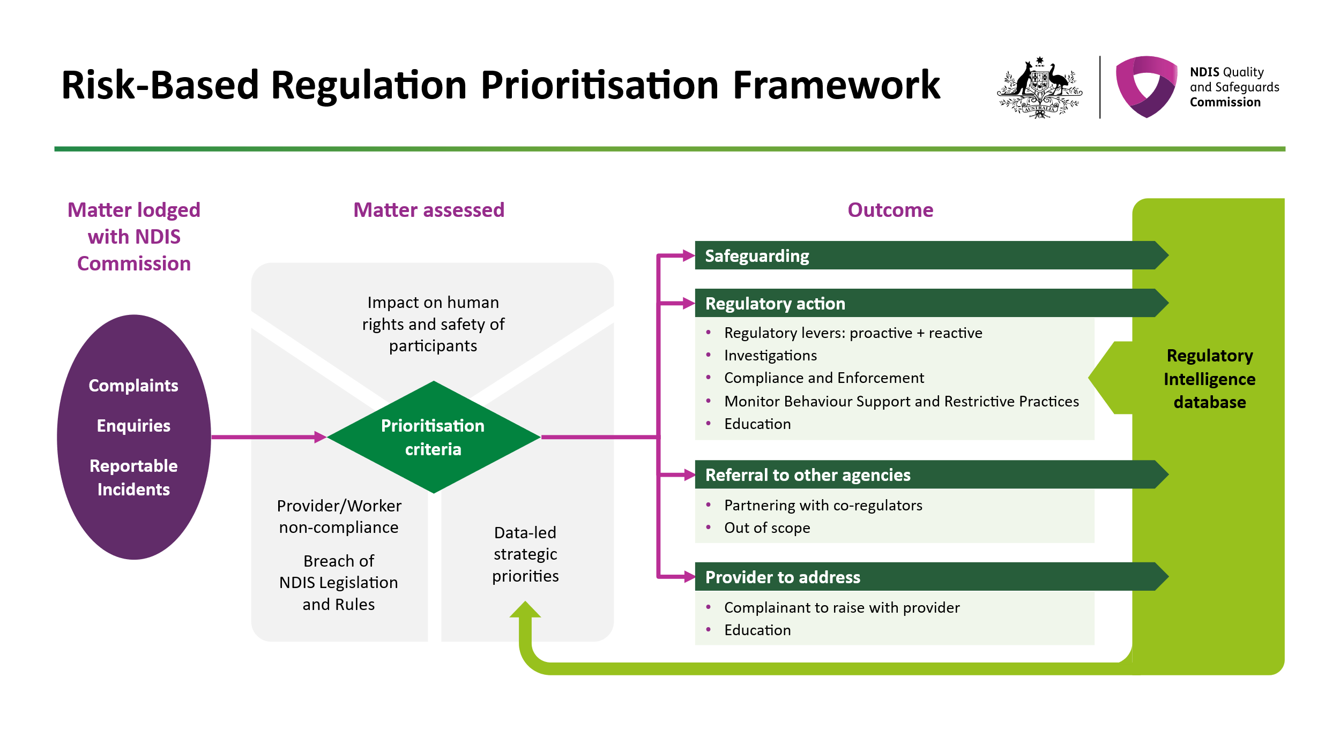

Complaint responses
- We will decide what action to take following our assessment of the issues raised.
- Possible complaint responses include:
- requiring the provider to take certain actions
- educating the provider on their obligations
- giving the provider a warning
- retaining complaint information as intelligence to inform our actions and decisions as a regulator of the NDIS market.
- If we consider the matter requires a specialist response, we may escalate the matter for further regulatory action.
- Regardless of what we decide, we ensure the safety of people with disability is at the centre of the NDIS Commission's decisions at all times. We will identify and respond to any safeguarding concerns at each stage of the complaint process.

Complaint outcomes
- We will ensure complainants are kept informed of complaint outcomes as soon as possible after we have made a decision. We will tell you of our reasons for the decision and advise you of any internal review and external review options.
- Complaints provide us with the opportunity to build the capacity of providers to better manage complaints and helps us to regulate the sector.
- Please visit the NDIS Commission website for more information on further actions we have taken with NDIS Providers and Workers.
If you are not satisfied with the outcome
- If you disagree with our decision about a complaint, you can ask us to reconsider it. Reconsideration requests can be made within 42 days of the decision. You will need to tell us why you believe the decision is wrong. You can do this by:
- Email: reconsideration@ndiscommission.gov.au
- Phone: 1800 035 544
- Post: Contact Centre: Reconsiderations Team, NDIS Commission, PO Box 210, Penrith NSW 2751
- If you are not satisfied with the outcome of a reconsideration, you can complain to the Commonwealth Ombudsman. You may contact the Commonwealth Ombudsman by:
- Phone: 1300 362 072
- Web: Commonwealth Ombudsman: Making a complaint

How to provide feedback or make a complaint about the NDIS Commission
- If you would like to provide feedback or a complaint about a staff member or our services, you can do so by:
- Email: FeedbackandComplaints@ndiscommission.gov.au, or
- Phone: 1800 035 544
- Our website contains further information on complaints about the NDIS Commission.

Monitoring and evaluation
- The complaints policy is evaluated every 12 months for continuous improvement opportunities. We aim to ensure the NDIS Commission amplifies and promotes human rights for people with disability.
- We will continue to identify improvement opportunities through monitoring and evaluating the management of complaints.
- We will continue to collate and review data for publication in our Quarterly report. Complaints data will be regularly reviewed to identify trends in order to demonstrate our commitment to measuring outcomes for people with disability and assessing our regulatory impact.

