Human Rights Guidance Poster
What are human rights?
 | All people have human rights.
 | Human rights are a list of rules the help everyone have a  - Happy  - Safe  - Healthy life.

What is the NDIS?
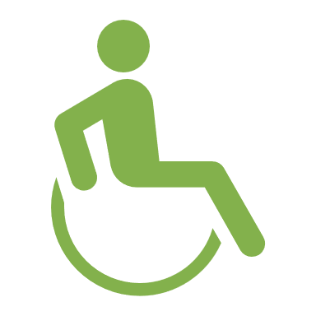 | The NDIS supports Australians with disability by paying for their supports and services.
 | NDIS providers are people who give supports and services to people with disability.

 | The NDIS Commission makes sure NDIS providers are doing a good job.
 | We protect your human rights in many ways.
What is the NDIS Commission?

The NDIS Commission has 3 human rights duties.
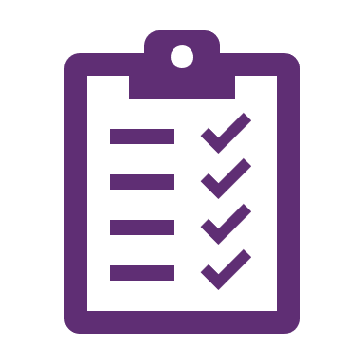 | The Positive Duty means we will think about your human rights when we  - Do things for you  - Make decisions.
   | The Participation Duty means we will help you have a say in what we do.
 | The Duty of Candor means we will  - Be honest with you  - Say sorry when we could do something better  - Learn from when things go bad  - Get better so bad things do not happen again.

How we will also help protect your human rights.

 | We make sure your NDIS supports and services are good.
 | We make sure that the people who NDIS supports and services you protect your human rights.
 | We will make sure you can learn about your human rights.
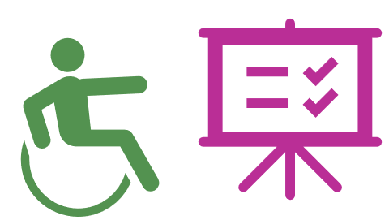 | We will make sure you have ways to be part of decisions.
 | We will make sure that all information is easy to read.

 | We will follow the law when we look after your information.
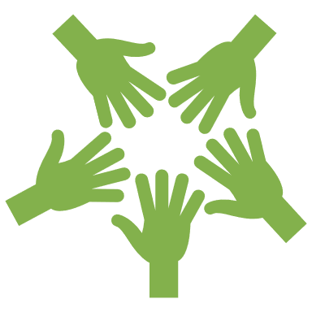 | We will support you to be part of making the NDIS better.
 | We will work with you and experts.
 | Experts are people who know a lot about a topic.
 | We will share what we learn with you and experts.
 | We will use data and feedback to  - understand what is working well  - make things better.
 | Data is information that helps us learn about something.
 | Feedback is when you tell someone about  - A problem  - Something they have done well  - How they could do something better.
 | We will help people do research to learn how we can do better.
 | Research is when we learn about something.

 | We will make ways for you to give us feedback.
   | We will make it clear how you can give us feedback.
 | We will share what we learn with others.
 | We will work with others to make your NDIS supports and services better.

