

Getting access to NDIS Commission
Portal

Quick Reference Guide

Only NDIS Providers registered with the NDIS Commission can access the NDIS Commission Portal.

In this guide:
- Is your organisation registered?
- Logging in to the NDIS Commission Portal
- Request new user roles
- About Proda
- Help with accessing the NDIS Commission Portal

Is your organisation registered?

Transition from Myplace Portal – NSW and SA
From 1 July 2018, NDIS providers in NSW and SA who had been registered with the NDIS to provide supports and services to NDIS participants, transferred to the NDIS Commission. Prior to that date NDIS registered providers used the NDIA MyPlace Portal to manage their registration activities.
The NDIS Commission Portal is now the system that NSW and SA registered providers will use to manage their registration. The MyPlace Portal will continue to be the system that providers will use to manage payments and service bookings for NDIS participants.
As part of this transition, the NDIS Commission gave automatic access to the NDIS Commission Portal for existing users for each transitioned provider.
All users who had an active PRODA account and had access to the Myplace provider portal before 29th June 2018 were transitioned.
These users can access the NDIS Commission Portal using their existing PRODA log on.

Transition from Myplace Portal – NT, QLD, ACT, VIC and TAS
On 1 July 2019, NDIS providers in NT, QLD, ACT, VIC and TAS who are registered with the NDIS to provide supports and services to NDIS participants will transfer to the NDIS Commission.

Prior to that date NDIS registered providers in these states must continue to use the NDIA MyPlace Portal to manage their registration activities.
From 1 July 2019 the NDIS Commission Portal will be now the system that NT, QLD, ACT, VIC and TAS registered providers will use to manage their registration. The MyPlace Portal will continue to be the system that providers will use to manage payments and service bookings for NDIS participants.
As part of this transition, the NDIS Commission will give automatic access to the NDIS Commission Portal for existing users for each transitioned provider.
All users who have an active PRODA account and access to the Myplace provider portal before 29th June 2019 will be transitioned on 1 July 2019. From this date, these users will be able to access the NDIS Commission Portal using their existing PRODA log on.

If your organisation is not registered
New providers wishing to start providing supports and services in NSW and/or SA should apply for registration directly to the NDIS Commission. Providers in NT, QLD, ACT, VIC and TAS should apply directly to the NDIS Commission from 1 July 2019.
New providers who have a pending application with the NDIA to provide NDIS supports and services in NT, QLD, ACT, VIC and TAS at 1 July 2019 will need to submit a new registration application directly to the NDIS Commission.

Logging in to the NDIS Commission Portal – a step-by-step guide
This part of the Quick Reference Guide explains the step-by-step process of successfully logging in to the NDIS Commission Portal.
  - Click Portal.
Figure 1: Screenshot of NDIS Commission website demonstrating Step 1
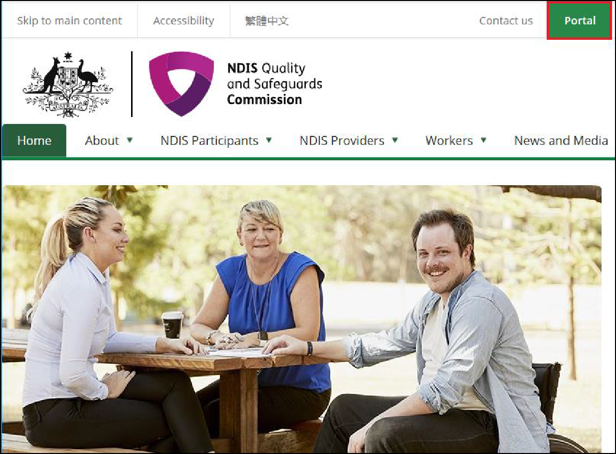
  - Click Login with PRODA.
Figure 2: Screenshot of NDIS Commission Portal page demonstrating Step 2
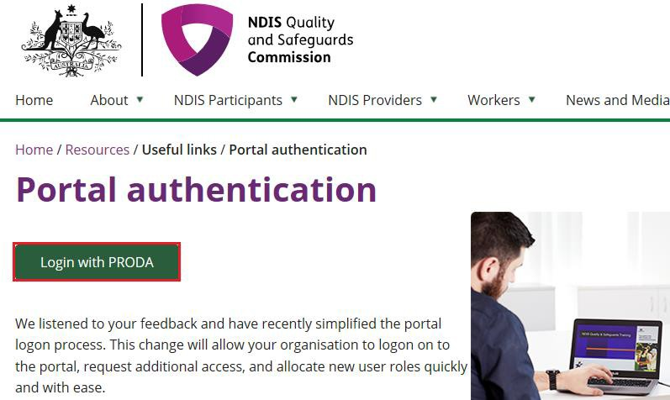

  - Type the PRODA Username and Password then click Login.
Figure 3: Screenshot of PRODA Login page demonstrating Step 3
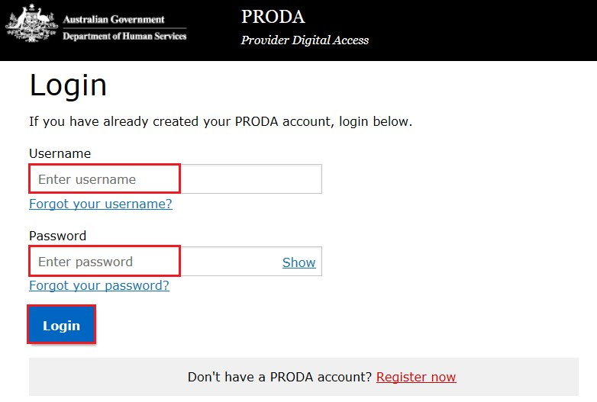
  - Enter the PRODA verification Code then click Next.

Figure 4: Screenshot of PRODA web page demonstrating Step 4
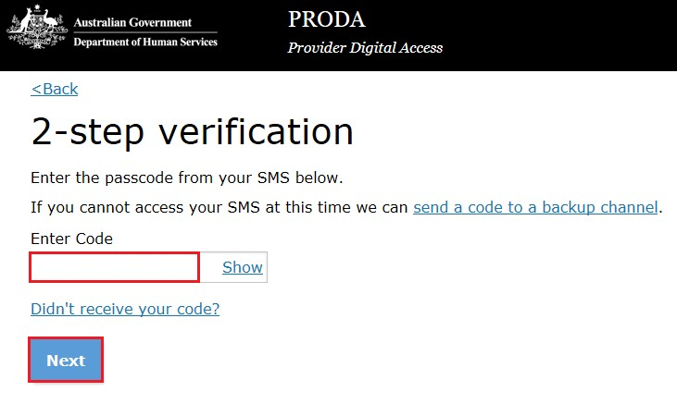
  - Select the Provider name and the Role to logon and the click Continue.
Figure 5: Screenshot of NDIS Commission Portal entry page demonstrating Step 5
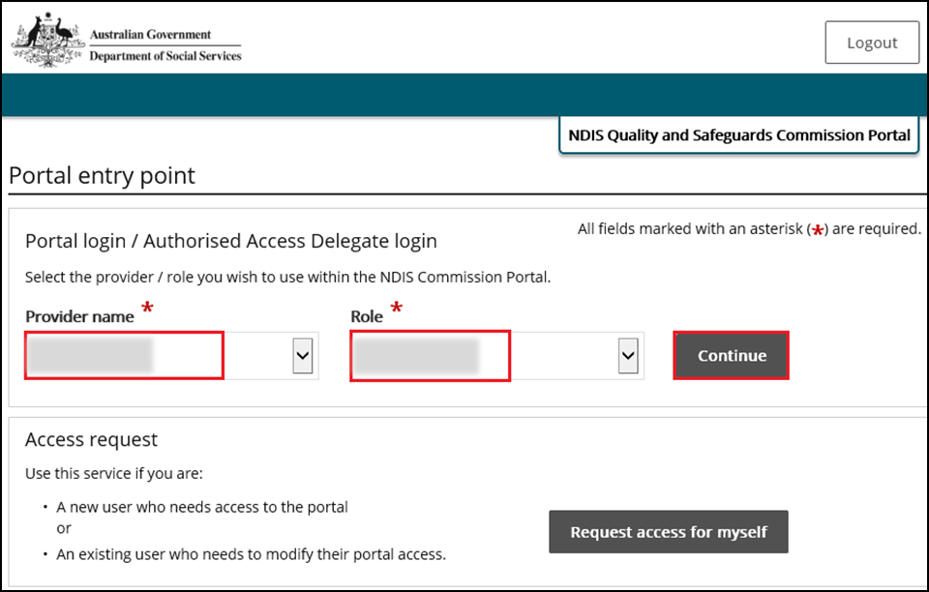
  - Click I agree
Figure 6: Screenshot of NDIS Commission Portal entry demonstrating Step 6
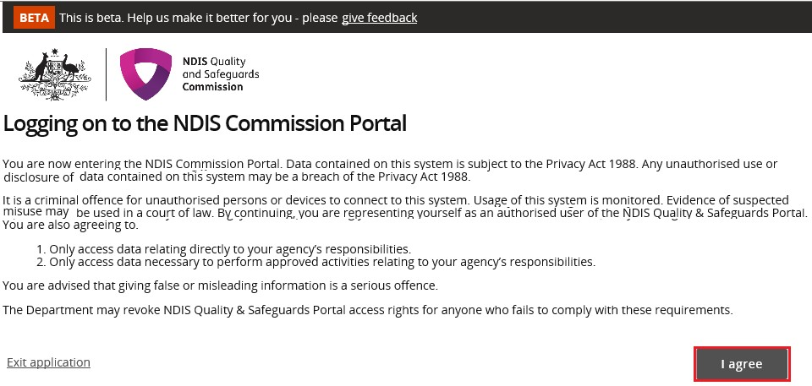
This should successfully log you on to the Portal.

Request new user roles
A staff member can request a new user role using the Commission Portal, for this the user first needs to successfully login to PRODA.
- After logging in to PRODA, at Portal entry screen, click Request access for myself.
Figure 7: Screenshot of NDIS Commission Portal page demonstrating Step 1
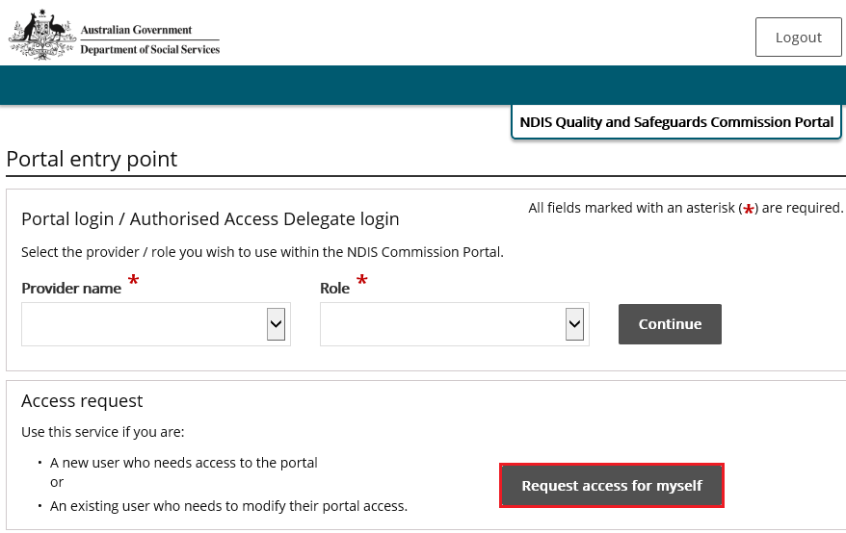

- Click I’m ready to request access.
Figure 8: Screenshot of NDIS Commission Portal page demonstrating Step 2
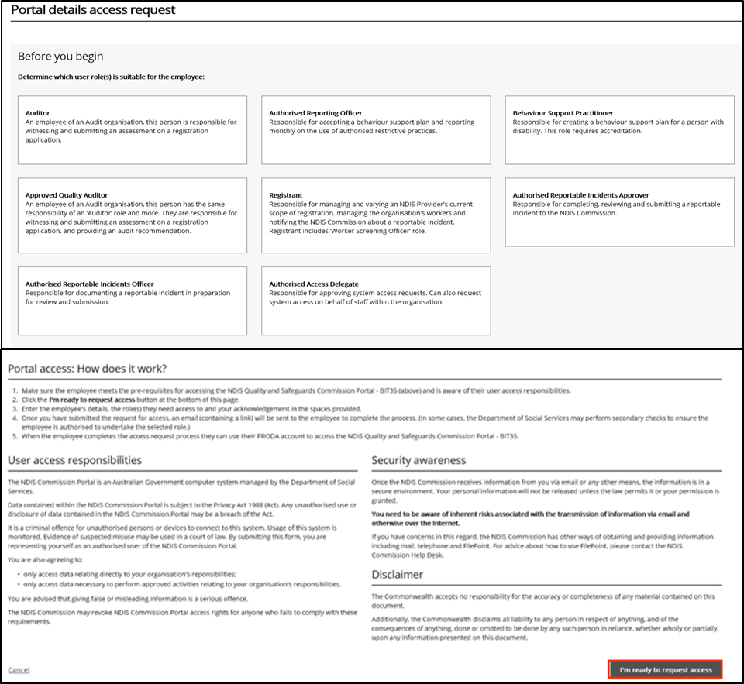

- Select the user roles that are required and click Next.
Figure 9: Screenshot of NDIS Commission Portal page demonstrating Step 3
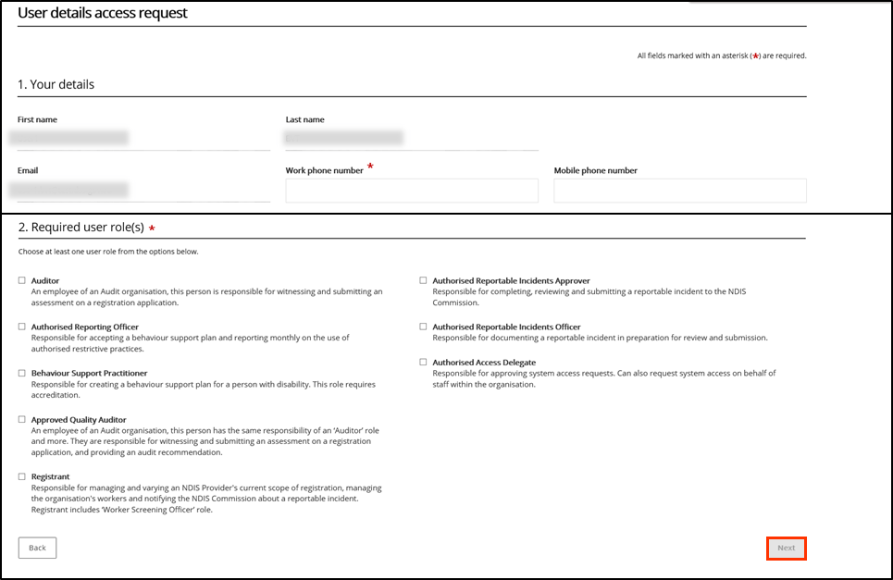

- Access requests for ‘Provider Authorised RI Approver’ and ‘Provider Authorised RI Notifier’ roles will be reviewed and approved by the ‘Provider’s Authorised Access Delegate’. Once the request has been submitted, the individual will be responsible for notifying the delegate of the request, to ensure they can obtain approval in a timely manner.
- Individuals should only nominate themselves either the ‘Approver’ or ‘Notifier’ role.
- The provider is responsible for ensuring the nominated authorised ‘Access Delegate’, ‘Approver’, ‘Notifier’ recorded in the system are up to date and reflect access needs accordingly.

- Enter the related Organisation details for the new user role/s request and click Run search.
Figure 10: Screenshot of NDIS Commission Portal page demonstrating Step 4
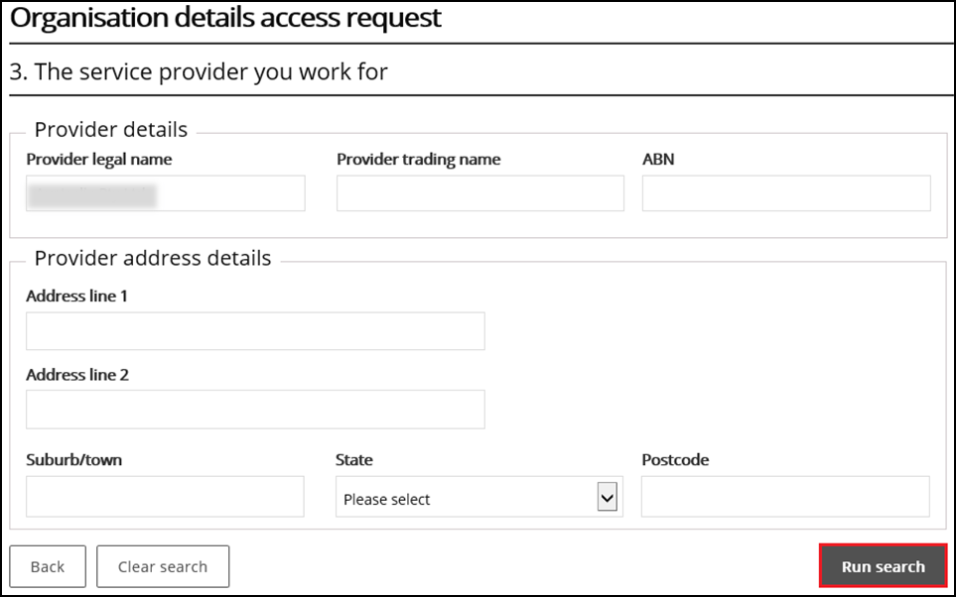

- Review the Summary access request and click Submit.
Figure 11: Screenshot of NDIS Commission Portal page demonstrating Step 5
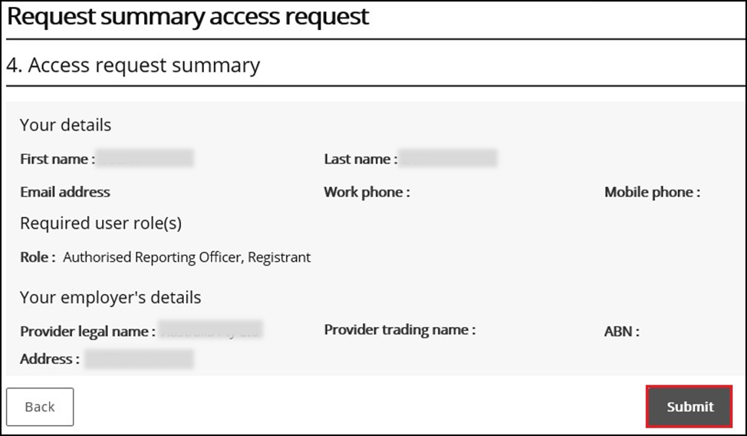

About PRODA
PRODA is an online authentication system used to securely access government online services. PRODA is managed by the Department of Human Services.
Most individuals who need access to the NDIS Commission Portal will require a PRODA account.
Once you’ve authenticated your identity with PRODA, your username and password will allow you to access multiple online services including the NDIS Commission Portal.

Requirements
- An email address which is unique to you (not a shared email address)
- At least 3 specified and valid Australian Government issued identity documents to verify your identity online. A full list of acceptable documents is available on the PRODA registration page.
- Please also check that you are using the minimum browser version required for the service you are accessing through PRODA. To access PRODA to set up an account you’ll need one of these minimum browser versions:
- Internet Explorer 9
- Mozilla Firefox 30
- Google Chrome 39
- Safari 5

Learn more and register
- Register for a PRODA account
- Learn more about PRODA
- PRODA eLearning.
If you require assistance with your PRODA account, see the Contact Us section of the PRODA help page.

Help with accessing NDIS Commission Portal
The following questions and answers are for Providers who are having difficulties accessing the NDIS Commission Portal.

I do not have PRODA account, how can I create a PRODA account?
See Register for a PRODA account to register and create a new PRODA account.

I am unable to create a PRODA account, what can I do?
Please contact the PRODA Help Desk on 1800 700 199 or proda@humanservices.gov.au.

I have a PRODA account but I cannot log on to the NDIS Commission Portal, what can I do?
- If your organisation is registered with the NDIS Commission, operates in NSW or in SA and you have used Myplace prior to 29th June 2018, contact the NDIS Commission ICT Support team on nqsc.ictsupport@ndiscommission.gov.au.
- If your organisation is not registered with the NDIS Commission and operates in NSW or in SA then your organisation is eligible to register with NDIS Commission. See NDIS Provider registration for more information on registering your organisation with NDIS Commission.
- If your organisation is not registered with the NDIS Commission and operates in states and territories other than NSW and SA, see NDIS Provider Toolkit for more information on registering your organisations with NDIS.

