Frequently Asked Questions: Proposed legislative reforms to strengthen the regulatory powers of the NDIS Commission
^{Prepared 14/11/2024}
The Minister for the National Disability Insurance Scheme and Government Services the Hon. Bill Shorten MP announced the second part of legislative reform for the National Disability Insurance Scheme Act 2013 (NDIS Act). Proposed legislative changes will be introduced through the NDIS Amendment (Getting it Back on Track No. 2) Bill (Bill No.2).
More information regarding proposed Bill No.2 quality and safeguarding measures, other NDIS Commission reforms and information on how to participate in consultations can be found at the NDIS Commission’s Reform Hub.

What are the proposed legislative reforms?
The quality and safeguarding reforms proposed for Bill No. 2 is focused on keeping participants safe from fraudulent and negligent providers and workers. The proposed changes in the Bill will improve the quality and safety of NDIS supports for participants by strengthening the compliance and enforcement powers of the NDIS Quality and Safeguards Commission (NDIS Commission).
There are 10 measures proposed for inclusion in the Bill. These measures cover three key areas:
- Penalty framework and statutory requirements (5 measures) – ensuring a fit-for-purpose penalties and offences framework that has a desired deterrence effect.
- Safeguarding (1 measure) – expanding categories of persons against whom a banning order can be imposed to ensure unsuitable persons can be excluded from the NDIS.
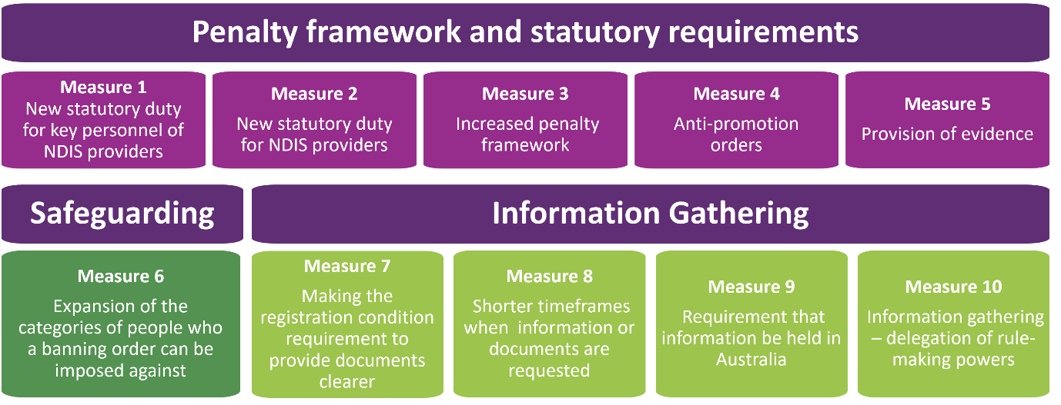
- Information gathering (4 measures) – strengthening powers to obtain relevant information from NDIS providers and other persons within appropriate timeframes.
Figure 1: Proposed Bill No. 2 quality and safeguarding measures
Full detail, including the rationale behind the ten measures, is available in the consultation paper linked below.

Key Links:
- Consultation paper on Bill No. 2 | - Easy Read: Consultation Paper on Bill No. 2
- NDIS Commission’s Reform Hub | - Regulatory Reform Roadmap

Why are the proposed legislative changes needed?
- The Final Report of the Royal Commission into Violence, Abuse, Neglect and Exploitation of People with Disability (Disability Royal Commission) highlighted the quality and safeguarding challenges that still exist for people with disability in the Australian community.
- The NDIS Review and Disability Royal Commission heard from participants, their families, the sector, providers and workers about long standing and emerging risk. Their stories, evidence and experiences informed the NDIS Review and Disability Royal Commission recommendations for the NDIS Commission to have a more active approach to monitoring and a stronger approach to compliance and enforcement.
- The suite of measures will improve the NDIS Commission’s regulatory capability to safeguard participants through measures designed to improve deterrence and encourage behaviour change.
- The proposed legislative changes include measures that will simplify operations and will enable the NDIS Commission to more effectively perform its regulatory functions and activities.

Why is the Government making changes now?
- The proposed quality and safeguarding measures in Bill No. 2 are required to support the NDIS Commission address emerging and long-standing issues of quality and safety within the Scheme and will mean NDIS participants receive higher standards of support and services over time.
- These measures focus on quality and safeguarding of NDIS participants. Ensuring the NDIS Commission has the legislative, policy and operational settings will enable it to better safeguard NDIS participants from violence, abuse and neglect. The proposed changes would increase the NDIS Commission’s regulatory capability to strengthen its monitoring, compliance and enforcement functions.

Consultation on the quality and safeguarding measures

Will there be consultation on these measures and how will consultation work?
- Consultation with the disability community and the disability sector is critical to the success of the proposed changes. Significant consultation occurred during the NDIS Review and the Disability Royal Commission. The proposed measures align with the findings and recommendations arising from these inquiries and aim to help address the issues identified.
- Evidence before the Disability Royal Commission demonstrated wide support for the NDIS Commission to adopt a more active approach to monitoring, and a stronger approach to compliance and enforcement. The proposed measures will enable the NDIS Commission to achieve this.
- We will be consulting on the proposed quality and safeguarding changes in Bill No. 2 for several months prior to releasing an exposure draft which will then be introduced in the Parliament.
- During this time, we will listen to the views of many different groups through activities including:
- A discussion paper, survey and submissions from the public
- Ministerial Roundtables
- Consultation with States and Territories
- The consultation paper is available in both standard and Easy English formats on the NDIS Commission’s Reform Hub.
- A townhall will be held in December so you can hear directly from the NDIS Commission on the proposed measures. To find out more, visit the reform hub on our website.
- We are committed to accessible approaches to consultation and welcome submissions in a format that suits you. Please contact us if we can provide you with assistance in providing a submission or completing the survey.

What are the timeframes for consultation?
- Public consultation: Open now – 20 December 2024 (submissions on consultation paper close).
- Ministerial roundtables: November – December 2024
- Consultation with States and Territories: November – December 2024
- Exposure draft publication (following consultation): The release of the exposure draft will be a decision of Government.

Focus of the measures on the NDIS Commission’s regulatory powers

What will the NDIS Commission do with its additional compliance powers?
- Effective compliance and enforcement activity is a critical part of the NDIS Commission's role as a regulator.
- Effective regulatory powers ensure the NDIS Commission can take strong action to reduce and prevent violence, abuse and neglect of people with disability; drive improvement in provider practice; and exit bad actors from the market.
- Since the NDIS Act was introduced, the NDIS market has evolved and the NDIS Commission’s ability to meet this objective is constrained without strengthened compliance and enforcement powers and measures.
- The proposed measures aim to increase the NDIS Commission’s regulatory capability to effectively exercise its monitoring, compliance and enforcement functions in relation to NDIS providers; enable the NDIS Commission to strengthen compliance and enforcement activities to respond to emerging and longstanding quality and safeguards issues; and contribute to the reduction of inappropriate spending of NDIS funding and support scheme sustainability.

Reform process for Bill No. 2

What happens after the consultation, when will the changes take effect?

- Step 1 and 2: Consultation: Publish a consultation paper and ask for feedback. Hold roundtables and consultation sessions with key stakeholders.
- Step 3: Exposure Draft: Following public consultation, an Exposure Draft of the proposed legislative amendments will be drafted by Government. The Exposure Draft of the Bill will be on the DSS Engage platform for further feedback. The release of the exposure draft will be a decision of Government.
- Step 4: Government will introduce Bill No. 2 into Parliament.
- Implementation: See question below.
To find out more about what we are doing on other topics, and how this fits, please see our Consultation Roadmap.

How will the NDIS Commission implement the measures if they pass through Parliament?
- The NDIS Commission will carefully implement operational changes arising from the measures to ensure changes to its regulatory powers are integrated in the existing continuum of work. The proposed legislative changes include measures that will enable the NDIS Commission to more effectively perform its regulatory functions and activities.
- The NDIS Commission will implement legislative reform through a range of structured and collaborative processes with the disability sector. This includes developing public and internal operational guidelines and policies and developing education and capacity building resources and training for providers, the disability community and people with disability on the new changes and what this means in practice.
- Transitional periods will be considered to give a grace period for providers to comply with any new requirements and will be considered as part of the consultation process.

Impact of the quality and safeguarding measures

Will these measures increase the regulatory burden on NDIS providers impacting services to participants?
- The proposed measures are not intended to create additional regulatory requirements for providers. Some measures will clarify requirements for NDIS providers.
- The proposed legislative changes are not expected to negatively impact the provision of services to NDIS participants.

What impacts will there be for participants?
- All people with disability, including NDIS participants, will benefit from enhanced quality and strengthened safeguarding of disability services. Participants with higher safeguarding risks will benefit from strengthened penalties framework as a deterrent against violence, abuse, neglect and exploitation.
- Holding NDIS providers accountable in this way will help improve the safety of NDIS participants and lift the quality of services and supports. People will also be more likely to raise concerns with the NDIS Commission if they have confidence that it can and will take appropriate action.

What impacts will there be for providers?
- The NDIS commission regulates the whole NDIS market, this includes both registered and unregistered providers.
- The proposed legislative changes impose additional requirements on registered and unregistered NDIS providers in terms of their obligations to respond to requests for information and documents. These additional requirements will apply in limited situations, namely where there is concern in relation to the NDIS provider’s compliance with requirements under the NDIS Act.
- Registered NDIS providers will also be required to hold information within Australia which is a standard requirement for many Government-funded services.
- The proposed measures to introduce new criminal offences and civil penalties, and new statutory duties would apply to both registered and unregistered providers.
- Transitional periods will be considered to give a grace period for providers to comply with any new requirements and will be considered as part of the consultation process.

What impacts will there be for the disability sector?
- The disability sector will also benefit from clear, proportionate and responsive action to breaches of the NDIS Act and NDIS Rules. The proposed legislative changes will increase awareness of regulatory requirements and the compliance actions available. This is expected to drive continuous improvement by providers to deliver quality supports and services.

Alignment of reforms with the NDIS Review and Disability Royal Commission

Do these measures align with the recommendations of the Disability Royal Commission and the NDIS Review?
- The NDIS Review and Disability Royal Commission highlighted a need for strengthening safeguards to protect the rights and wellbeing of participants, and ensuring issues are addressed swiftly and appropriately.
- The Disability Royal Commission (Recommendation 10.25) recommended the NDIS Commission strengthen its monitoring, compliance and enforcement powers in relation to NDIS providers that have a history of non-compliance or repeatedly fail to meet their obligations to provide safe and quality services, have demonstrated a disregard for the safety of people with disability, and have caused serious harm to a person or people with disability.
- The NDIS Review (Action 19.3) similarly recommended the NDIS Commission should have the resources, powers and capability to proactively and effectively regulate the disability supports market.

When will other NDIS Review and Disability Royal Commission recommendations (not addressed in the NDIS Amendments ‘Getting it Back on Track’ legislation) be pursued?
- The Australian Government, in consultation with State and Territory Governments is considering the recommendations of the NDIS Review. It has not yet issued a formal response. The Australian Government will release its full response to the NDIS Review later in the year.
- The Australian Government released its response to the Final Report of the Disability Royal Commission in July 2024. You can find more information on this response and the broader disability system reforms on the Department of Social Services website.

More information
If your question has not been addressed, make sure you have looked at our consultation webpage, and the consultation paper or send through an enquiry via our enquiry form.

Key Links:
- Consultation paper on Bill No. 2 | - Easy Read: Consultation Paper on Bill No. 2
- NDIS Commission’s Reform Hub | - Regulatory Reform Roadmap
If you have more questions about disability reform, you can also go to the Department of Social Services website.

