Evidence-Informed Practice Guide

July 2023

# Key points

* Evidence-informed practice supports NDIS providers to achieve compliance with their obligations under the NDIS legislation.
* Evidence-informed practice means integrating the best available contemporary research with the rights and perspectives of people with disability, the expertise of professionals, and information from the implementing or practice context(s).
* Evidence-informed practice upholds the rights of the person with disability and involves doing more of ‘what works’. It helps providers to continuously learn and improve the quality of the supports and services they provide.
* Evidence-informed practice involves focusing on outcomes, including those which improve the person’s quality of life, inclusion and social participation.
* Evidence-based guidelines and practice alerts are published by the NDIS Commission and other reputable sources. These resources offer helpful summaries of the best available research and outline the implications for practice.
* There are tools and approaches that can support the implementation of best evidence into real-world practice. This involves considering the strength of the available evidence, the fit with current needs and priorities; and the capacity to implement within the available resources.
* People with disability should be provided with accessible information about the best available evidence and support (if required) to make decisions about their supports and services.
* NDIS providers should take all reasonable steps to prevent the use of strategies and approaches that may cause harm or have been proven to be ineffective. Use of such approaches may breach the NDIS Code of Conduct and/or a provider’s conditions of registration, and may result in compliance and enforcement action.

# Purpose

This Guide outlines the NDIS Commission’s position on evidence-informed practice and what is expected of NDIS providers. It describes what evidence-informed practice is, why it is important, how it can be implemented by NDIS providers, and where to find further information.

# Scope

This Guide has been developed for NDIS providers, both registered and unregistered. It may also assist NDIS participants and others who support them to uphold their rights and know what to expect from providers. For more information see the legislative linkage section. An Easy Read version of this document will also be made available.

This Guide acknowledges that evidence is continually evolving and does not comment on specific interventions or new trials being undertaken.

This Guide does not comment on the National Disability Insurance Agency’s planning processes or funding decisions in relation to evidence-informed practice, services or supports. For more information see the NDIA’s guidance on [Evidence-based best practice](https://ourguidelines.ndis.gov.au/how-ndis-supports-work-menu/what-principles-do-we-follow-create-your-plan/what-principles-do-we-use-create-your-plan/evidence-based-best-practice).

# What is evidence-informed practice?

Evidence-informed practice is a process for making informed decisions about the delivery of supports and services. It focuses on outcomes, including those which improve the person’s quality of life, inclusion and social participation. Evidence-informed practice requires stakeholders to work together in the spirit of collaboration to consider the available evidence (as per Figure 1), implement the chosen approach or intervention and monitor outcomes achieved.

For the NDIS Commission, evidence-informed practice means integrating the rights and perspectives of the person with disability, with the best available research with professional expertise and information from the implementing or practice contexts.

This is illustrated in Figure 1 below and the subsequent discussion of each component.

A diagram showing the model of evidence-informed Practice

Figure : NDIS Commission's model of evidence-informed practice

(Adapted from Sackett, et al. 1996 and Hoffman et al. 2016).

For the extended description of Figure 1, refer to the Appendix.

The NDIS Commission has adopted the term “evidence-informed practice” for the purpose of this document and consistency with legislation. It is acknowledged that the term and concept of “evidence-based practice” may be used in other settings and practice contexts. For the purposes of this document, evidence-informed practice and evidence-based practice mean the same thing.

## 1. Rights and perspectives of the person with disability

Evidence-informed practice emphasises and upholds a person’s human rights and dignity. It is a collaborative process that takes into account each person’s values, preferences and circumstances. It considers how best to work with that person and evaluate outcomes in partnership with the person.

This means:

* Respecting and upholding a person’s human rights.
* Recognising that the person with disability is an expert in their own life.
* Focusing on a person’s identity, their unique values, beliefs, preferences, priorities and circumstances.
* Including and considering people important to the person with disability, such as friends and family (with their permission).
* Supporting self-determination and decision making.

See the Supporting participants sections for further information about ways to share information about evidence and best practice to support informed decision making.

## 2. Best research and evaluation evidence

There are two main types of evidence that can be considered in evidence-informed practice:

1. Evidence from the research literature.
2. Evidence collected through practice (“practice-based evidence”).

Where there are gaps in the research literature, providers are more likely to rely on practice-based evidence. In doing so, providers must be mindful that practice-based evidence may not be objective or generalisable to different contexts or situations. This is discussed further in *Practice-Based Evidence*.

### 2. 1 Evidence from the research literature

Providers should consider the best available evidence, according to the evidence hierarchy as shown in Figure 2:

* The evidence hierarchy ranks study types based on the strength of their research method.
* Well-designed systematic reviews and randomised controlled trials have the strongest evidence, and expert opinion and anecdotal experience are the weakest type of evidence.
* The evidence hierarchy considers the effectiveness of a given approach or intervention; and to a much less extent the risks or potential harms of using a given intervention or approach.

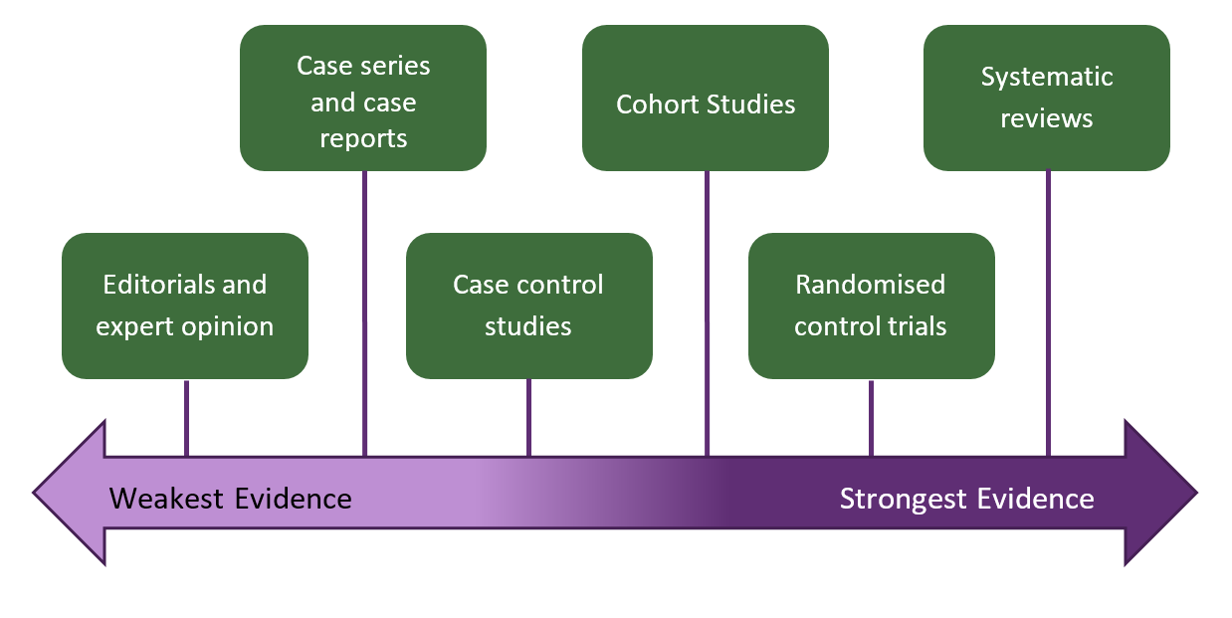

Figure : Hierarchy of research evidence

Source: Adapted from NSW Department of Communities and Justice (2020).

For the extended description of Figure 2, refer to the Appendix.

Providers should also consider the reliability of the sources, the age of the research, and whether there are any potential conflicts of interest:

* Reliable sources include clinical guidelines, university publications, and peak body websites (see *reputable sources* section below).
* With respect to the age of the research, use current and contemporary evidence.
* “*A conflict of interest exists in a situation where an independent observer might reasonably conclude that the professional actions of a person are or may be unduly influenced by other interest”* (NHMRC, 2019). Conflicts of interest can be financial or non-financial.

### 2.2 Practice-based evidence

Practice-based evidence involves the gathering of evidence during practice.

This can include:

* Collecting data as part of routine practice and using that data to evaluate the effectiveness of interventions or approaches over time.
* Obtaining regular feedback from the individual participant to evaluate whether their desired outcomes are being achieved by the particular intervention or approach.

Providers and workers should not rely solely on practice-based evidence unless there are gaps in the research evidence / literature or existing practices have not achieved the desired outcomes. In such circumstances, providers are encourage to refer to *reputable sources* for guidance to prevent harm and ensure the provision of quality and safe supports.

When collecting data and measuring participant outcomes providers should use valid and reliable tools if they are available (Davis et al. 2018). Where such tools are not available, seek the participant’s views on the intervention and collect other data to determine whether it is having its intended effect. For example, asking the participant about the impact of an intervention and / or using incident reports to determine whether it is resulting in the reduction in the use of restrictive practices.

## 3. Clinical and provider expertise

Providers, practitioners, clinicians and workers all have different experience, training, knowledge and judgement that is developed over time. This expertise can be used alongside best evidence and the participant’s perspective in deciding how an intervention or approach should be managed, developed or implemented.

NDIS providers are expected to provide supports and services in a safe and competent manner with care and skill. This includes working with the scope of their knowledge and skills.

If you do not have the right qualifications or enough professional expertise to meet the person’s needs in an evidence-informed way:

* Talk to the participant about options to identify the person or provider that has the right qualifications and expertise to provide the support they need, and facilitate access to that support if appropriate.
* Where appropriate build strategies into your continuing professional development plan in discussion with your supervisor or line manager.
* Engage and collaborate with practitioners, clinicians and providers who have the skills to provide care, and who are qualified to do so. For example, this may involve case conferencing, co-allocations, peer review and supervision process.
* Consider your scope of practice as an individual practitioner or worker and where referrals may be required to ensure the right expertise is available.

## 4. Information from the implementing / practice contexts

The success of any evidence-informed practice or approach can be significantly affected by the environment. Information from the implementing / practice context can be used to influence decisions about what research can be adopted for practice and how research might be used or adapted to address real-world circumstances in accordance with the available resources.

Implementation science (also known as knowledge translation or translational research) offers a scientific way to monitor the implementation or uptake of a practice, policy or approach. There are various models, frameworks and tools that can be tailored to meet the needs of different practice contexts. They may help providers to identify and address barriers and enablers to the delivery of supports (see *Practice Resources* section below).

The [NDIS Worker Capability Framework](https://workforcecapability.ndiscommission.gov.au/tools-and-resources) includes a range of supervisory and management tools to support best practice thinking and design of service models.

# Why is evidence important?

An evidence-informed approach means participants’ needs are met in the best possible way, and their human rights and dignity upheld. As shown in Figure 3, using evidence helps NDIS providers and workers to provide quality supports. It helps them to 1. Do more of ‘what works’ 2. Explain the ‘why’ and 3. Continuously learn and improve together.

A diagram showing a list of three elements along an arch. 
They read 1. Do more of 'what works'.  
2. Explain the 'why. 
3. continuously learn and improve together.

Figure 3: Why is evidence important

Source: Adapted from NSW Department of Communities and Justice (2022).

## 1. Do more of ‘what works’.

Using evidence:

* Helps to provide services that meet the needs of participants and communities.
* Informs participants’ and / or provider decision making.
* Can help avoid harmful or ineffective approaches.

## 2. Explain the ‘why’

* Using evidence helps to explain how outcomes will be achieved, why particular approaches are being proposed, or why a particular service is needed.

## 3. Continuously learn and improve together

* Using and collating evidence of what works for groups or individuals helps to continuously improve the quality of supports and services.
* Undertaking [Practice Reviews](https://www.ndiscommission.gov.au/resources/language-and-formats/easy-read-information#paragraph-id-5142) as part of continuous quality improvement and incident management ensures that services and supports are safe and meet the person’s needs.

# How to do evidence-informed practice

There are five key steps for undertaking evidence-informed practice (adapted from Straus et al. 2011). These are shown in Figure 4:

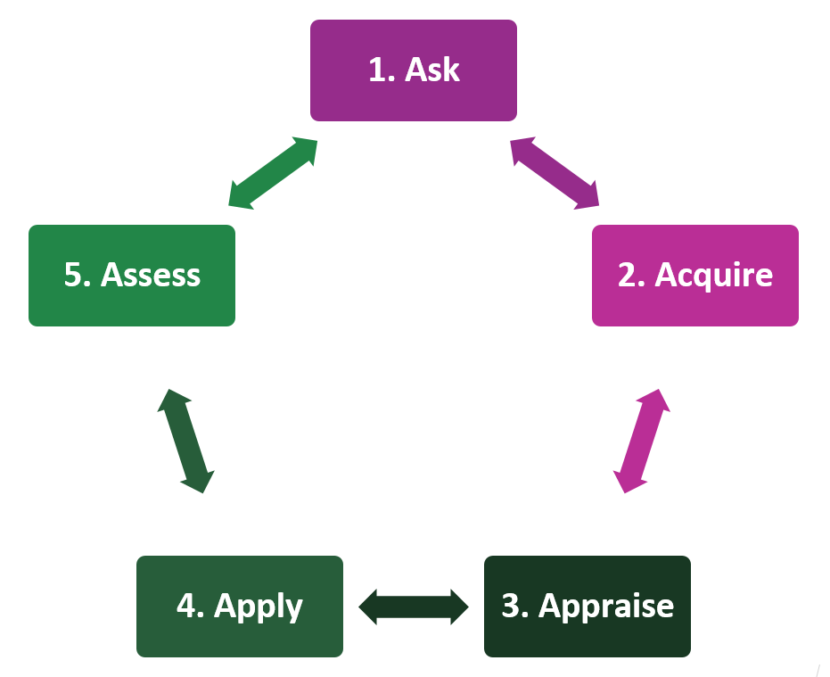

Figure 4: Steps in evidence-informed practice

## **1. Ask**

Formulate a specific question to be answered.

* Ask the participant and their supporters what approaches and outcomes are important to them.
* Define the situation, topic or problem area.
* Identify any specific disability, age or other characteristics of the person or population you are interested in.
* Consider if you want to compare specific approaches or interventions.

## 2. Acquire

Search for the best possible evidence from high quality sources (see *reputable sources* below).

* Use the best research evidence available to inform your supports and services.
* Where there are gaps in the research evidence, review practice-based evidence and seek advice from professionals who have the appropriate expertise.

## 3. Appraise

Appraise the evidence for its quality (see *evidence hierarchy* above) and relevance to the situation.

* Include the participant’s perspectives and the particular service context when appraising the evidence and the situation.

## 4. Apply

Apply the evidence in line with the person’s values and preference and in combination with professional experience and skill.

## 5. Assess

Assess the effectiveness of the approach and ways to improve next time, taking into account the participant’s views and preferences.

# Supporting participants

Providers should support participants to make evidence-informed decisions about their supports and services in accordance with supported-decision making principles by:

✓

* Explaining the best available evidence in an appropriate and accessible format.
* Being transparent about the strength of the available evidence and any limitations or gaps in the evidence.
* Presenting the different options available supported by the evidence.
* Highlighting the benefits and risks of any given strategy or approach.
* Supporting the person to be involved and respecting their right to freedom of expression, self-determination and decision-making.

Where a participant has expressed interest in an intervention or approach that is known to be unproven or harmful, NDIS providers should discuss these risks with the person and promote evidence-informed alternatives. In doing so the principle of dignity of risk must be balanced with the provider’s safeguarding, legal and ethical responsibilities. This may necessitate a referral to other professionals for specialist advice and support.

# What to avoid?

Providers should be particularly cautious about “fads”. A “fad” is an intervention or approach that quickly grows in popularity but has no scientific evidence to support its effectiveness (Jackson, 2016).

It is important to maintain a level of caution, even scepticism about interventions that:

* Seem too good to be true.

🗶

* Promise quick fixes or “cures”.
* Are very expensive.
* Claim to treat or resolve a wide range of issues and conditions across ages and populations.
* Are heavily advertised and marketed in emotive and subjective ways (e.g., testimonials).
* Have not been independently reviewed or evaluated.

Consistent with the NDIS Code of Conduct and providing safe and competent supports and services, NDIS providers should:

* Not use strategies or approaches that can cause harm to the participant or others.
* Not use aversive or unethical approaches which impinge on participant’s rights and dignity.
* Not use strategies or approaches that have been disproven or are known to be ineffective.
* Not ignore or minimise the participant’s perspective.
* Not work beyond their scope of practice without the necessary supports and safeguards (e.g., this could include supervision). Scope of practice means working within your knowledge, skills and experience; engaging in continuous improvement and professional development activities; and knowing when to refer on.
* Be mindful of potential conflicts of interest (e.g., gaining benefit from recommending a particular service and not declaring this openly).

The delivery of dangerous and disproven approaches is likely a breach of the NDIS Code of Conduct and/or a provider’s conditions of registration, and may result in compliance and enforcement action.

# Some examples of reputable sources for evidence

* Australian Commissions for example:
  + NDIS Quality and Safeguards Commission - <https://www.ndiscommission.gov.au/>
  + Aged Care Quality and Safety Commission - <https://www.agedcarequality.gov.au/>
  + Australian Commission on Safety and Quality in Health Care - [https://www.safety‌andquality.gov.au/](https://www.safetyandquality.gov.au/)
  + Australian Human Rights Commission - <https://humanrights.gov.au/>
* Australian Disability Clearinghouse on Education and Training - <https://www.adcet.edu.au/>
* Australian Institute of Family Studies - <https://aifs.gov.au>
* Autism CRC (Cooperative Research Centre for Living with Autism) - [https://www.autismcrc.‌com.au/](https://www.autismcrc.com.au/)
* Cochrane Library of systematic reviews - <https://www.cochranelibrary.com/>
* Guidelines International Network - <https://g-i-n.net/international-guidelines-library>
* Government departments for example:
* Australian Government Department of Health and Aged Care – <https://www.health.gov.au/>
* Professional registration bodies such as the Australian Health Practitioner Regulation Agency (AHPRA) - [https://www.ahpra.gov.au](https://www.ahpra.gov.au/)
* Professional associations such as the Australian Psychological Society - <https://psychology.org.au>
* Raising Australian Children Network – <https://raisingchildren.net.au>
* National Disability Insurance Agency - <https://ndis.gov.au/>
* National Health and Medical Research Council - <https://www.nhmrc.gov.au/>
* NICE Guidance - National Institute for Heath and Care Excellence – <https://www.nice.org.uk/>
* Scottish Intercollegiate Guidelines Network (SIGN) - <https://www.sign.ac.uk/our-guidelines/>
* Sax Institute - <https://www.saxinstitute.org.au/>
* World Health Organisation - <https://www.who.int/>

# Practice resources

* The Hexagon Tool to assess how a program or practice might fit into an implementing provider’s existing work and context – <https://nirn.fpg.unc.edu/resources/hexagon-exploration-tool>
* Dissemination and Implementation Models Webtool for planning and implementing an intervention - <https://dissemination-implementation.org/tool/>
* NDIS Commission Practice Reviews - [https://www.ndiscommission.gov.‌au/resources/language-and-formats/easy-read-information#paragraph-id-5142‌](https://www.ndiscommission.gov.‌au/resources/language-and-formats/easy-read-information%23paragraph-id-5142‌)
* NDIS Workforce Capability Framework – <https://workforcecapability.ndiscommission.gov.au/>
* Implementing Evidence-based Practice - [https://workforcecapability.ndiscommission.gov.au‌/tools-and-resources](https://workforcecapability.ndiscommission.gov.au/tools-and-resources)

# Legislative linkages

The Guide recognises that adopting evidence-informed practice places both registered and unregistered providers in a better position to demonstrate compliance with their obligations under the NDIS legislation.

## NDIS Act

This Guide aligns with the [*NDIS Act 2013*](https://www.legislation.gov.au/Details/C2022C00206), including guiding principle of section 4(15) which states:

“In exercising their right to choice and control, people with disability require access to a diverse and sustainable market for disability supports in which innovation, quality, continuous improvement, **contemporary best practice** and effectiveness in the provision of those supports is promoted.”

It is in furtherance of the Commissioner’s functions, including sections 181E(e) and 181H(b):

181E(e) “to promote continuous improvement amongst NDIS providers and the delivery of progressively higher standards of supports and services to people with disability”

181H(b) “developing policy and guidance materials in relation to behaviour supports and the reduction and elimination of the use of restrictive practices by NDIS providers”

Finally this Guide relates to sections 73J and 73V of the NDIS Act:

73J “registered providers must comply with the conditions of registration”

73V “NDIS Code of Conduct”, which applies to both registered and unregistered providers.

## NDIS Code of Conduct

This Guide supports provider and workers to demonstrate compliance with the [*NDIS (Code of Conduct) Rules 2018*](https://www.legislation.gov.au/Details/F2018L00629), which includes:

“In providing supports or services to people with disability, a Code-covered person must:

(a) act with respect for individual rights to freedom of expression, self-determination and decision-making in accordance with applicable laws and conventions; and

(c) provide supports and services in a safe and competent manner, with care and skill

(f) act with integrity, honesty and transparency; and

(g) take all reasonable steps to prevent and respond to all forms of violence against, and exploitation, neglect and abuse of people with disability”

## Rules and Guidelines for Registered NDIS Providers

This Guide relates to the conditions of registration placed on registered NDIS providers as outlined in the:

* [*NDIS (Provider Registration and Practice Standards) Rules 2018*](https://www.legislation.gov.au/Details/F2021C01137)
* [*NDIS (Restrictive Practices and Behaviour Support) Rules 2018*](https://www.legislation.gov.au/Details/F2020C01087)

The Guide also relates to the quality indicators:

* [*NDIS (Quality Indicators for NDIS Practice Standards) Guidelines 2018*](https://www.legislation.gov.au/Details/F2021C01130)

# Appendix

Extended descriptions for figures 1 and 2

## Figure 1: NDIS Commission's model of evidence informed practice

The image shows four boxes which are titled:

1. Rights and perspectives of the person with disability.
2. Best research and evaluation evidence.
3. Clinical and provider expertise.
4. Information from the implementing or practice context.

Each of the four boxes has an arrow pointing to a central text box which reads: Evidence-informed Practice.

(Return to Figure 1: NDIS Commission's model of evidence-informed practice, page 3.)

## Figure 2: Hierarchy of research evidence

The image shows six different types of research evidence organised along a continuum, with the weakest evidence on the far left and the strongest evidence on the far right.

From weakest to strongest, the types of research evidence are:

1. Editorial and expert opinion.
2. Case series and case reports.
3. Case control studies.
4. Cohort studies.
5. Randomised control trials.
6. Systematic reviews.

(Return to Figure 2: Hierarchy of research evidence, page 5.)

# References

Australian Government (2018) [*‘Australian Code for the Responsible Conduct of Research’*](https://www.nhmrc.gov.au/about-us/publications/australian-code-responsible-conduct-research-2018), NHMRC website, accessed 24 February 2023.

Davis E, Young D, Gilson M, Swift E, Chan J, Gibbs L, Tonmukayakul U, Reddihough D and Williams K (2018) ‘A Rights-Based approach for service providers to measure the quality of life of children with a disability’, *Value Health*, 21:1419–27.

Hoffmann T, Bennett S and Mar CD (2016) *Evidence-based practice across the health professions*,3rd edn, Elsevier Australia, Chatswood.

Jackson S (2016) ‘Help or harm? Spotting fad interventions’, *Altogether Autism Journal,* 1: 8-9.

NHMRC (2019) ‘[Identifying and managing conflicts of interest’](https://www.nhmrc.gov.au/guidelinesforguidelines/plan/identifying-and-managing-conflicts-interest) NHMRC website, accessed 27 June 2023.

NSW Department of Communities and Justice (2022) [*‘What is evidence-informed practice?’*](https://www.facs.nsw.gov.au/providers/children-families/early-intervention/using-evidence-in-the-targeted-earlier-intervention-program/chapters/what-is-evidence-informed-practice), DCJ website, accessed 24 February 2023.

NSW Department of Communities and Justice (2020) [*’What is an Evidence Hierarchy‘*](https://www.facs.nsw.gov.au/__data/assets/pdf_file/0007/789163/What-is-an-Evidence-Hierarchy.pdf), DCJ, accessed 22 May 2023.

Sackett DL, Rosenberg WMC, Gray JAM, Haynes RB and Richardson WS (1996) ‘Evidence Based Medicine: What It Is And What It Isn’t’, *British Medical Journal*, 312:71–72.

Straus S, Glasziou P, Richardson W and Haynes R (2011) *Evidence-based medicine: how to practice and teach it*, 4th edn, Churchill Livingstone Elsevier, Edinburgh.

# Acknowledgement

The NDIS Commission would like to acknowledge the important contributions made to this Guide by people with lived experience of disability, the Senior Practitioners Practice Leadership Group and the Alliance 20.

# For more information

Contact the NDIS Quality and Safeguards Commission

Phone: [1800 035 544](tel:1800035544) (Mon-Fri)

Website: <https://ndiscommission.gov.au/resources/provider-and-worker-resources>

Email: [behavioursupport@ndiscommission.gov.au](mailto:behavioursupport@ndiscommission.gov.au)

[researchandpractice@ndiscommission.gov.au](mailto:researchandpractice@ndiscommission.gov.au)