Unauthorised uses of restrictive practices in the National Disability Insurance Scheme
Unauthorised uses of restrictive practices reported to the NDIS Quality and Safeguards Commission

February 2023

The NDIS Quality and Safeguards Commission (NDIS Commission) regulates the use of regulated restrictive practices by NDIS providers in relation to NDIS participants (participants).
The NDIS Commission does not regulate the use of restrictive practices outside the NDIS, even if the restrictive practices are used in relation to participants. For example, the NDIS Commission does not regulate the use of restrictive practices:
- in health, education or forensic settings (unless they are used by NDIS providers in those settings)
- by family members or other people who provide informal supports to participants.
Regulated restrictive practices are restrictive practices that involve:
- seclusion
- chemical restraint
- mechanical restraint
- physical restraint
- environmental restraint.
Chemical restraint, the most commonly used restrictive practice, is the use of medication for the primary purpose of influencing a person’s behaviour.
Chemical restraint does not include the use of medication prescribed by a medical practitioner for the treatment of, or to enable the treatment of, a diagnosed mental disorder, a physical illness or a physical condition.

Contents
Introduction 5
Purpose of this report 5
Background 5
Caveat 5
URPs since July 2018 6
Number of URP uses 6
Number of participants subject to URPs 7
Intensity of use of URPs 7
Characteristics of participants subject to URPs 10
Participants subject to URPs by state and territory 10
Participants subject to URPs by age band 11
Participants subject to URPs by primary disability 12
Participants subject to URPs by receipt of Supported Independent Living funding 13
Participants subject to URPs by receipt of behaviour support funding 14
Analysis of types of URPs in 2021/22 15
Types of restrictive practices in URPs in 2021/22 15
Chemical restraints in URPs in 2021/22 17
Reducing URPs 21
Compliance and education activities 21
Collaboration with other organisations 22
Own Motion Inquiry into aspects of supported accommodation in the NDIS 23
Priority actions for 2023 23
Appendix 1 25
Data 25
Appendix 2 29
Background 29
About the NDIS Commission 29
The Policy Framework 29
Types of restrictive practices in the NDIS 30
What is required of providers 30
How the regulatory requirements are intended to work 32
Appendix 3 35
Useful resources 35
Published information on regulated restrictive practices 35
Glossary 35

Introduction

Purpose of this report
This report analyses the use of unauthorised restrictive practices (URPs) notified to the NDIS Quality and Safeguards Commission (NDIS Commission) for the period 1 July 2021 to 30 June 2022 (2021/22 period). The data for this report is sourced from the data holdings of the NDIS Commission and the National Disability Insurance Agency (NDIA).
This report builds on the analysis provided in the Unauthorised uses of restrictive practices in the National Disability Insurance Scheme report published in January 2022 (January 2022 URP report) relating to the use of restrictive practices and behaviour support plan activity, and demographic information and characteristics of participants subjected to URPs.
The report also provides an overview of the NDIS Commission’s priorities to uphold the human rights of participants by reducing and eliminating the use of restrictive practices in the NDIS. This priority is achieved through promoting best practice in the use of positive behaviour support strategies to reduce and eliminate the use of restrictive practices with participants.

Background
It is a legislative requirement for registered NDIS providers to report the unauthorised use of restrictive practices to the NDIS Commission. There is a robust regulatory framework for behaviour support in the NDIS, which focuses on upholding the rights, health, wellbeing and safeguarding of people with disability. This is set out in the National Disability Insurance Scheme Act 2013 and associated Rules. Providers registered with the NDIS Commission must comply with obligations and standards in the implementation of behaviour support practices, particularly those involving the use of a restrictive practice.
The NDIS Commission will take strong action against any provider that does not comply with these obligations. In any instance where a provider is unsure of whether a practice is a restrictive practice (i.e., the purpose of a medication is unknown), the provider is able to seek advice from the NDIS Commission’s Behaviour Support teams. The Behaviour Support teams may direct providers to report and consider resources developed by the NDIS Commission to understand the regulatory requirements.

Caveat
The analysis in this report is based on point-in-time data which means that when remediation work is done, the data changes. Consequently, the totals for a number of data sets may not align with the publically reported figures such as in the NDIS Commission’s quarterly Activity Reports.

URPs since July 2018

Number of URP uses
For the 12 months to 30 June 2022, NDIS providers notified the NDIS Commission of 1,422,295 unauthorised uses of restrictive practices (URPs) in relation to 8,830 participants (Figure 1). This indicates that, while the number of URPs reported to the NDIS Commission continues to grow, the rate of growth (57.5%) is slowing compared to the sharp increases experienced between the 2019/20 and 2020/21 periods (212%).

Figure 1 - Instances of URPs by State and Territory from July 2018 to June 2022
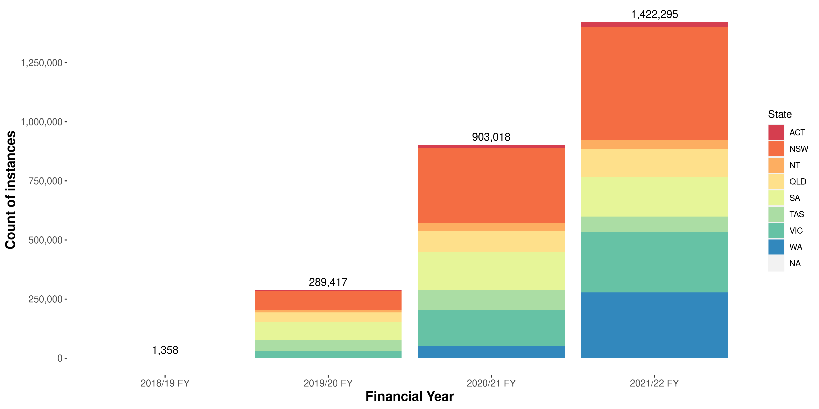
The factors behind the increase in notifications of URPs over time are outlined in the January 2022 URP report.
For the 2021/22 period, the special transitional arrangements under the National Disability Insurance Scheme (Restrictive Practices and Behaviour Support) Rules 2018 (Restrictive Practices and Behaviour Support Rules) for registered NDIS providers who transitioned to the jurisdiction of the NDIS Commission still applied. That is, some Western Australian providers and Residential Aged Care (RAC) providers were still transitioning to the national framework for authorising the use of restrictive practices, and its related reporting requirements. This contributed to the growth in URP notifications for the 2021/22 period.

Number of participants subject to URPs
Consistent with the reporting trends in the number of URPs notified to the NDIS Commission since 2018, there is a continuing upward trend in the number of participants subject to the use of URPs, although the rate of growth also appears to be stabilising (Figure 2). For the 2021/22 period there were 15% more participants subjected to URPs than in the previous period, compared to a 45% increase between the 2019/20 and 2020/21 periods.

Figure 2 - Number of participants subject to URPs by State and Territory, July 2018 to 30 June 2022
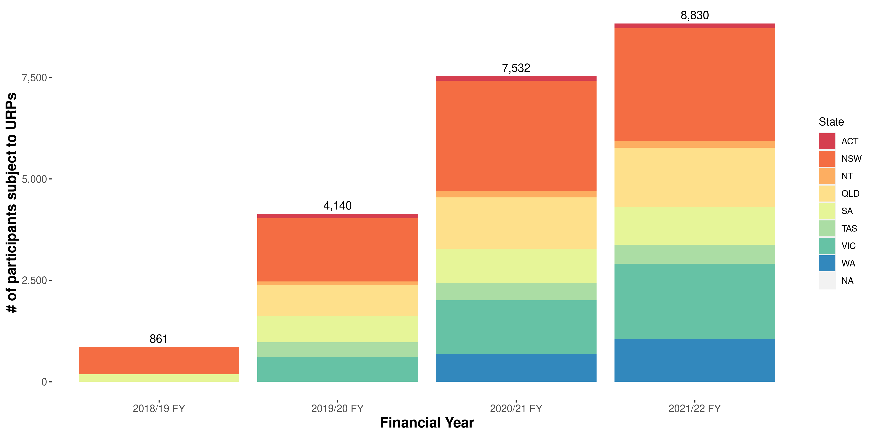

Intensity of use of URPs
Figure 3 provides data on the number of URP uses individual participants were subjected to in each reporting period. One of the important considerations in relation to the use of URPs is the number of URPs to which an individual NDIS participant is subject. High frequency use of restrictive practices and/or the use of multiple types of restrictive practices are associated with greater complexity of a person’s support needs and may represent a greater risk to upholding a person’s human rights. There are some circumstances when restrictive practices are used as a last resort to reduce the risk of harm to the person with disability and/or others.

Figure 3 - Count of participants subject to URPs, July 2018 to 30 June 2022, by number of URPs in Financial Year
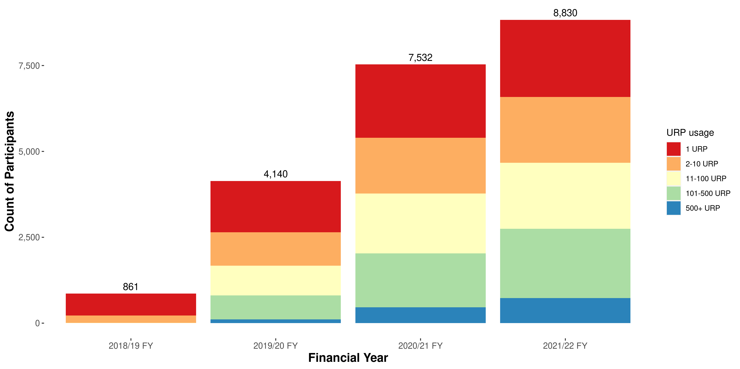
For participants subject to URPs in the 2021/22 period:
- 25% were subject to only one URP during the reporting period,
- 69% were subject to 100 or fewer URPs during the reporting period, and
- 8% were subject to more than 500 URPs during the reporting period.
The relatively consistent proportion of participants subject to a single URP suggests that the reporting of URPs is correctly picking up the use of restrictive practices as single, emergency uses as intended under the NDIS Quality and Safeguarding Framework.
Figure 4 - Instances of URPs used in relation to the 10% of participants subject to the most URPs, July 2018 - 30 June 2022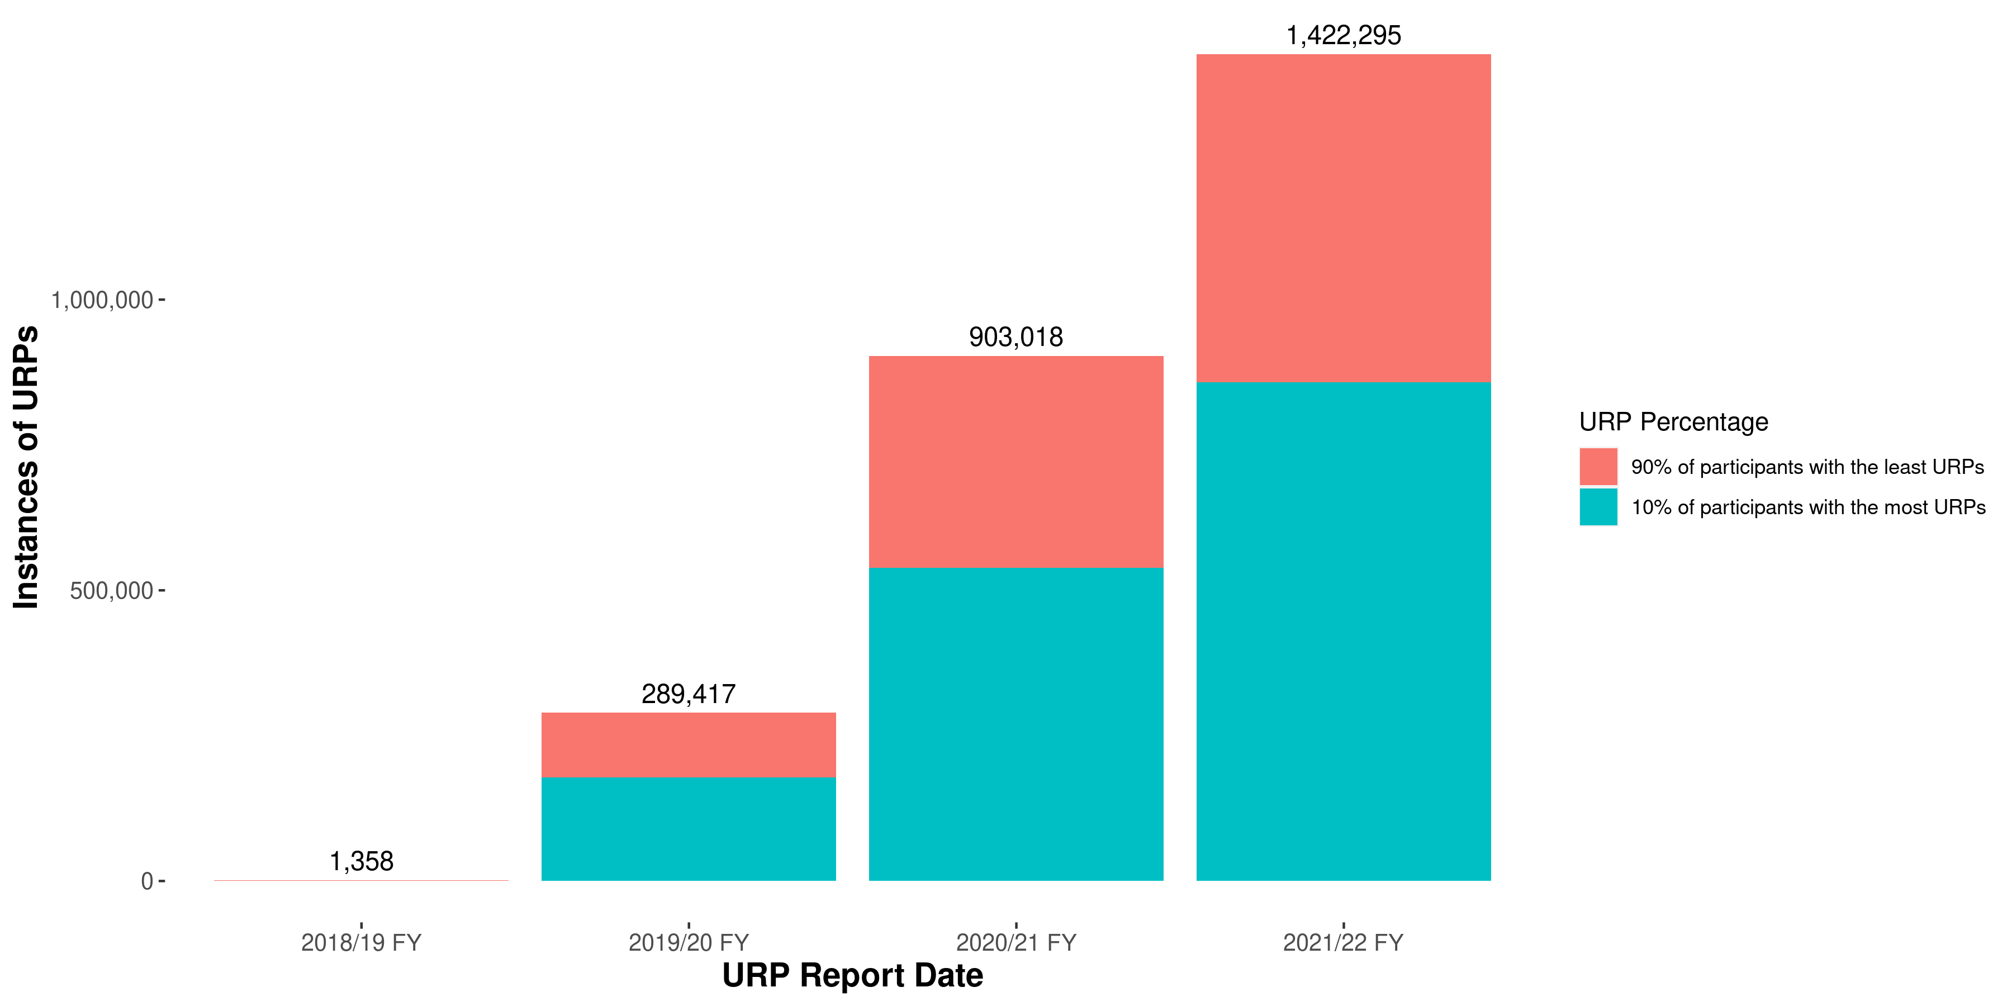
Consistent with the previous report, the 10% of participants subject to the most URPs are subject to more than half of the total number of URPs notified to the NDIS Commission (Figure 4). The NDIS Commission’s attention is most appropriately directed to these participants, to ensure providers who use URPs in relation to these participants, along with any specialist behaviour support providers, are complying with their obligations. Obligations include developing behaviour support plans for these participants, obtaining the requisite authorisation, and supporting implementation of the plans. These obligations support better outcomes for participants through promoting best practice in the use of positive behaviour support strategies, with the goal to reduce and eliminate the use of restrictive practices with participants.

Characteristics of participants subject to URPs
The following data analyses the number, demographics and other characteristics of the 8,830 participants subjected to URPs in 2021/22 by:
- state and territory and as a percentage of the total number of ‘active’ participants in the state or territory,
- age band and as a percentage of the total number of active participants in the relevant age band,
- primary disability and as a percentage of the total number of active participants with the relevant primary disability,
- whether they receive funding for supported independent living (SIL) supports and as a percentage of the total number of active participants who do or do not receive funding for SIL supports, and
- whether they receive funding for behaviour supports.

Participants subject to URPs by state and territory
Table 1 analyses the number of participants subject to URPs in 2021/22 by state and territory and as a percentage of the total number of ‘active’ participants in the state or territory.
It is important to note that the number of participants subject to URPs in Western Australia is likely to be under reported as the obligation to report to the NDIS Commission only commenced in this jurisdiction on 1 December 2020. Special transitional arrangements under the Restrictive Practices and Behaviour Support Rules were in place until 1 December 2021 for some Western Australian providers, while they were transitioning to full reporting requirements under the NDIS Commission. Consequently, the number of reports of URPs and the number of participants subject to URPs in Western Australia is expected to continue to grow in the 2022/23 reporting period.
The lowest rate of active participants subject to URPs in 2021/22 (excluding other territories) was 1.3% in the ACT, QLD and Victoria. The highest rate of active participants subject to URPs in 2021/22 was 3.9% in Tasmania.

Table 1 - Participants subject to URPs in 2021/22 financial year, by state and territory
State/ Territory | Total participants | Participants subject to URPs | Percentage of participants subject to URPs
ACT | 9349 | 123 | 1.3%
NSW | 161055 | 2775 | 1.7%
NT | 4963 | 163 | 3.3%
Other Territories | 48 | 0 | 0.0%
QLD | 111837 | 1452 | 1.3%
SA | 46580 | 935 | 2.0%
TAS | 12104 | 474 | 3.9%
VIC | 142240 | 1856 | 1.3%
WA | 46475 | 1052 | 2.3%
Unknown | 4 | 0 | 0.0%
National | 534655 | 8830 | 1.7%

Participants subject to URPs by age band
Table 2 analyses the number of participants subject to URPs in 2021/22 by age band and as a percentage of the total number of active participants in the relevant age band.

Table 2 - Participants subject to restrictive practices in 2021/22 financial year, by age band
NDIA age band | Total Participants | Participants subject to URPs | Proportion
0 to 6 | 82863 | 88 | 0.1%
7 to 14 | 139087 | 629 | 0.5%
15 to 18 | 43943 | 566 | 1.3%
19 to 24 | 44006 | 1239 | 2.8%
25 to 34 | 47166 | 1558 | 3.3%
35 to 44 | 43206 | 1224 | 2.8%
45 to 54 | 51377 | 1404 | 2.7%
55 to 64 | 61011 | 1460 | 2.4%
65+ | 21996 | 662 | 3.0%
All | 534655 | 8830 | 1.7%
The lowest rates of active participants subject to URPs in 2021/22 were for participants who were 14 years of age or younger (0.1% for 0 to 6 years of age and 0.5% for 7 to 14 years of age). The highest rate of active participants subject to URPs in 2021/22 was for participants who were 25 to 34 years of age.

Participants subject to URPs by primary disability
Table 3 analyses the number of participants subject to URPs in 2021/22 by primary disability and as a percentage of the total number of active participants with the relevant primary disability. Some participants who were subject to URPs may not currently be active participants at the end of the financial year and current disability group information is unavailable.

Table 3 - Participants subject to URPs in 2021/22 financial year, by primary disability
Disability Group | Total Participants | Participants subject to URPs | Proportion
ABI | 16675 | 547 | 3.3%
Autism | 182494 | 2360 | 1.3%
Cerebral Palsy | 17206 | 403 | 2.3%
Developmental delay | 47012 | 21 | 0.0%
Global developmental delay | 11706 | 7 | 0.1%
Hearing Impairment | 24615 | 3 | 0.0%
Intellectual Disability | 96469 | 4028 | 4.2%
Multiple Sclerosis | 9528 | 24 | 0.3%
Other | 6356 | 68 | 1.1%
Other Neurological | 21094 | 531 | 2.5%
Other Physical | 19368 | 27 | 0.1%
Other Sensory/Speech | 2263 | 1 | 0.0%
Psychosocial disability | 56559 | 658 | 1.2%
Spinal Cord Injury | 5563 | 21 | 0.4%
Stroke | 8114 | 105 | 1.3%
Unknown | - | 12 | -
Visual Impairment | 9633 | 14 | 0.1%
All | 534655 | 8830 | 1.7%
Consistent with the January 2022 URP report, the majority of participants subject to URPs are those with the primary disability of intellectual disability or autism, representing 72% of participants subject to URPs.

Of the 8,830 participants subject to URPs in 2021/2022, 45% had a primary disability of intellectual disability and 27% had a primary disability of autism. However, it should also be noted that only 4% of active participants who had a primary disability of intellectual disability were subject to URPs, and only 1.3% of active participants who had a primary disability of autism were subject to URPs.
A higher percentage of active participants who had a primary disability of acquired brain injury or cerebral palsy were subject to URPs (3.2% for acquired brain injury and 2.3% for cerebral palsy) compared to the percentage of active participants who had a primary disability of autism (1.3%). However, there are considerably fewer participants with a primary disability of acquired brain injury or cerebral palsy subject to URPs (547 with acquired brain injury and 403 with cerebral palsy) than participants with a primary disability of autism (2,360).

Participants subject to URPs by receipt of Supported Independent Living funding
Table 4 analyses the number of participants subject to URPs in 2021/22 by whether they receive funding for Supported Independent Living (SIL) supports and as a percentage of the total number of active participants who do or do not receive funding for SIL supports.

Table 4 - Participants subject to URPs by receipt of SIL funding in 2021/22 financial year
SIL funding | Active Participants | Participants subject to URPs | Proportion
SIL | 26950 | 5422 | 20.1%
Non-SIL | 507705 | 3408 | 0.67%
Total | 534655 | 8830 | 1.65%
The majority of participants subject to URPs receive funding for SIL supports.
As SIL is a type of support for participants with higher support needs, relatively few of the total number of active participants receive funding for SIL supports. In 2021/22, 5% of active participants received funding for SIL supports. However, a majority of participants who were subject to URPs in 2021/22 were participants who received funding for SIL supports.
Of the 8,830 participants subject to URPs in 2021/22, 61% received funding for SIL supports. However, it should also be noted that most participants who receive funding for SIL supports are not subject to URPs. Of the 22,485 active participants who received funding for SIL in 2021/22, 20% were subject to URPs.

Participants subject to URPs by receipt of behaviour support funding
Table 5 analyses the number of participants subject to URPs in 2021/22 by whether they receive funding for behaviour supports.

Table 5 - Participants subject to URPs by receipt of Behaviour Support funding in 2021/22 financial year
Behaviour Support funding | Active Participants | Participants subject to URPs | Proportion
Behaviour Support | 53144 | 7270 | 13.7%
No Behaviour Support | 481511 | 1560 | 0.32%
Total | 534655 | 8830 | 1.65%
As Behaviour Supports is a type of support for participants with behaviours of concern, relatively few of the total number of active participants receive funding for Behaviour Supports. In 2021/22, 9.9% of active participants received funding for Behaviour Supports.
The majority of participants who were subject to URPs in 2021/22 were participants who received funding for Behaviour Supports. Participants who are subject only to a single, emergency use of a restrictive practice may not require behaviour support or behaviour support funding. Participants who are subject to ongoing URPs and do not yet have behaviour support funding included in their NDIS plans should seek to have that funding added to their plans. Of the 8,830 participants subject to URPs in 2021/22, 82% received funding for behaviour supports. However, it should also be noted that most participants who receive funding for behaviour supports are not subject to URPs. Of the 53,144 active participants who received funding for behaviour supports in 2021/22, 13.7% were subject to URPs.

Analysis of types of URPs in 2021/22

Types of restrictive practices in URPs in 2021/22
Table 6 for 2021/22 reports the numbers of URPs by state and territory and by type of restrictive practice.

Table 6 - Types of restrictive practices in URPs in 2021/22 financial year
Type of URP | ACT | NSW | NT | QLD | SA | TAS | VIC | WA | Jurisdiction Unknown | Total
Chemical | 10970 | 248437 | 21534 | 51057 | 42901 | 23963 | 165363 | 107269 | - | 671494
Environmental | 7331 | 200074 | 17973 | 50487 | 105911 | 36853 | 79331 | 153158 | - | 651118
Mechanical | 1787 | 25872 | 350 | 11590 | 16914 | 2363 | 11164 | 12899 | - | 82939
Physical | 73 | 2478 | 262 | 3304 | 962 | 821 | 369 | 3230 | 1 | 11500
Seclusion | 6 | 729 | 1 | 1017 | 289 | 318 | 367 | 965 | - | 3692
Unknown | 97 | 438 | 3 | 90 | 9 | 32 | 318 | 565 | - | 1552
Total | 20264 | 478028 | 40123 | 117545 | 166986 | 64350 | 256912 | 278086 | 1 | 1422295
Figure 5 and Table 7 show the number of URPs in 2021/22 by type of restrictive practice and by month.

Figure 5 - Types of restrictive practices in URPs in 2021/22 financial year, by reporting month
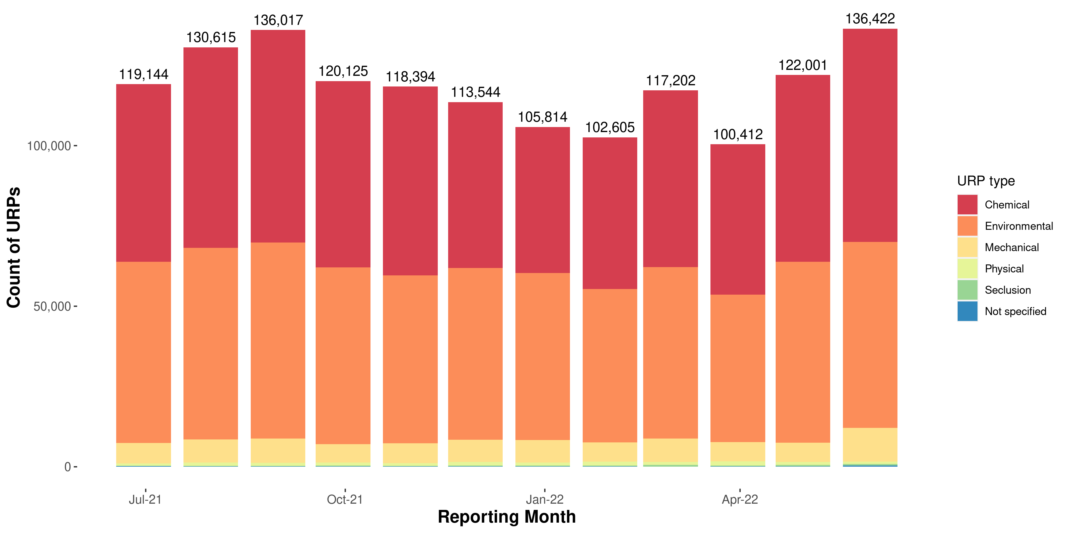

Table 7 - Number of instances of URPs in 2021/22 financial year by type of restrictive practice by month
URP Type | Jul- 21 | Aug-21 | Sep-21 | Oct-21 | Nov-21 | Dec-21 | Jan-22 | Feb-22 | Mar-22 | Apr-22 | May-22 | Jun-22
Chemical | 55306 | 62464 | 66206 | 58010 | 58779 | 51612 | 45524 | 47208 | 54979 | 46776 | 58180 | 66450
Environmental | 56408 | 59599 | 61001 | 55069 | 52315 | 53504 | 51973 | 47807 | 53397 | 45916 | 56287 | 57842
Mechanical | 6392 | 7245 | 7558 | 5724 | 6189 | 6962 | 6994 | 5974 | 7343 | 6010 | 6022 | 10526
Physical | 721 | 1019 | 901 | 913 | 805 | 1107 | 952 | 1191 | 871 | 1318 | 944 | 758
Seclusion | 132 | 185 | 260 | 315 | 223 | 278 | 246 | 315 | 535 | 283 | 460 | 460
Not specified | 185 | 103 | 91 | 94 | 83 | 81 | 125 | 110 | 77 | 109 | 108 | 386
Total | 119144 | 130615 | 136017 | 120125 | 118394 | 113544 | 105814 | 102605 | 117202 | 100412 | 122001 | 136422
Figure 5 - Types of restrictive practices in URPs in 2021/22 financial year, by reporting month

Table 7 - Number of instances of URPs in 2021/22 financial year by type of restrictive practice by month
URP Type | Jul- 21 | Aug-21 | Sep-21 | Oct-21 | Nov-21 | Dec-21 | Jan-22 | Feb-22 | Mar-22 | Apr-22 | May-22 | Jun-22
Chemical | 55306 | 62464 | 66206 | 58010 | 58779 | 51612 | 45524 | 47208 | 54979 | 46776 | 58180 | 66450
Environmental | 56408 | 59599 | 61001 | 55069 | 52315 | 53504 | 51973 | 47807 | 53397 | 45916 | 56287 | 57842
Mechanical | 6392 | 7245 | 7558 | 5724 | 6189 | 6962 | 6994 | 5974 | 7343 | 6010 | 6022 | 10526
Physical | 721 | 1019 | 901 | 913 | 805 | 1107 | 952 | 1191 | 871 | 1318 | 944 | 758
Seclusion | 132 | 185 | 260 | 315 | 223 | 278 | 246 | 315 | 535 | 283 | 460 | 460
Not specified | 185 | 103 | 91 | 94 | 83 | 81 | 125 | 110 | 77 | 109 | 108 | 386
Total | 119144 | 130615 | 136017 | 120125 | 118394 | 113544 | 105814 | 102605 | 117202 | 100412 | 122001 | 136422
Although the monthly numbers vary, the vast majority of URPs in each month involve the use of chemical restraints and environmental restraints.
Chemical restraints involve the use of a medication or chemical substance for the primary purpose of influencing a person’s behaviour. Chemical restraints do not include the use of medication prescribed for the treatment of, or to enable treatment of, a diagnosed mental disorder, a physical illness or a physical condition.
The NDIS Commission does not regulate the use of medications that are not chemical restraint. Until the purpose of a medication is determined, providers should report the use of the medication as an URP, to allow providers to meet their reporting obligations should the medication be determined to be a chemical restraint.
Environmental restraints restrict a person’s free access to all parts of their environment, for example by locking doors or restricting access to knives and other sharps.

Chemical restraints in URPs in 2021/22
Chemical restraints are the most frequently used URP.
All chemical restraints have been prescribed for the participant by the participant’s health practitioner. In contrast to the other categories of regulated restrictive practices, chemical restraints are subject to an additional threshold requirement outside of state and territory authorisation requirements and NDIS Commission behaviour support requirements. That is, regardless of whether the use of a chemical restraint is authorised or unauthorised, it will have been prescribed for the participant by a medical practitioner with authority to prescribe the particular medication or chemical substance.
For the purposes of this report, the NDIS Commission analysed notifications of URPs in 2021/22 involving chemical restraint where the medication or chemical substance was named.
Table 8 below shows the number of participants who were subject to URPs involving chemical restraint where the medication or chemical substance was named by the number of medications to which the participant was subject and by the age group of the participant. Although participants aged 18 years are adults, in this report they are grouped with younger participants. This grouping was used to be consistent with analysis applied by the NDIA to account for participation in school, which may affect the reporting of restrictive practices where they are administered in the school setting, and may be subsequently administered by an NDIS provider when a participant leaves secondary education.

Table 8 - Number of participants subject to unauthorised use of chemical restraint in 2021/22 financial year
Number of medications | Age 0 to 18 | Age 19+ | Total | Percent (%)
1 | 295 | 2095 | 2390 | 55%
2 | 150 | 886 | 1036 | 24%
3 | 83 | 420 | 503 | 12%
4 | 39 | 210 | 249 | 6%
5 | 25 | 92 | 117 | 3%
6 | 8 | 39 | 47 | 1%
7 | 2 | 16 | 18 | 0%
8 | - | 2 | 2 | 0%
9 | 1 | 1 | 2 | 0%
10+ | 1 | 2 | 3 | 0%
Total | 604 | 3763 | 4367 | 100%
A majority of participants (55%) who were subject to the unauthorised use of a chemical restraint in 2021/22 where the medication or chemical substance was named, were subject to only one medication or chemical substance used as a chemical restraint. 91% of the participants who were subject to the unauthorised use of a chemical restraint in 2021/22, where the medication or chemical substance was named, were subject to three or fewer medications or chemical substances used as chemical restraints.
86% of the participants who were subject to the unauthorised use of a chemical restraint in 2021/22, where the medication or chemical substance was named, were 19 years of age or older. However, notifications of URPs received by the NDIS Commission may understate the comparable use of chemical restraints in relation to children, given chemical restraints are more often administered to child participants by persons other than NDIS providers (for example, parents or other family members, or within the education system).
Table 9 below shows the types of medication reported as unauthorised chemical restraints in 2021/22 by medication class, showing both the number of instances of use of each type of medication and the number of participants in respect of whom the type of medication was used.

Table 9 - Types of medication reported as unauthorised chemical restraint in 2021/22 financial year
Disclaimer: Individuals may be reported as receiving more than one class of medication in the period. Where this happens, they are counted once for each type of medication received.
Medication Class | Number of instances | Number of participants | Top 2 drug name
Other | 9604 | 218 | Cannabidiol, Intuniv
Stimulant | 8963 | 177 | Ritalin, Dexamphetamine
Antiandrogen | 6815 | 39 | Cyproterone, Androcur
Antipsychotic | 329030 | 2904 | Risperidone, Olanzapine
Contraceptive | 7585 | 114 | Levonorgestrel, Levlen ED
Anticonvulsant | 118818 | 820 | Sodium valproate, Epilim
Antidepressant | 82892 | 1079 | Sertraline, Mirtazapine
Benzodiazepine | 43104 | 852 | Diazepam, Lorazepam
AntiParkinsonian | 4148 | 55 | Benztropine, Benztrop
Antihypertensive | 40961 | 470 | Clonidine, Catapres
Hormone treatment | 12054 | 310 | Melatonin, Ralovera
Bipolar disorder treatment | 7520 | 63 | Lithium, Lithicarb
The most frequently used medications, both in terms of the number of times they were used and the number of participants in relation to whom they were used, were antipsychotics (2904 participants). The next most frequently used medications in terms of the number of times they were used were anticonvulsants; however, antidepressants were used with more participants (1079) than anticonvulsants (820).
The NDIS Commission has undertaken work to assist NDIS providers to engage with, and obtain clarification from prescribers, where required, as to the purpose of a medication. This involved the development of a Medication Purpose Form. This form is available for providers and assists in determining whether the use of a medication is reportable to the NDIS Commission as a chemical restraint, and must be included in a behaviour support plan, and authorised in accordance with state or territory authorisation (however described).

NDIS providers that notified URPs
Table 10 shows for the period 2021/22:
- the number of providers in each state and territory that reported URPs,
- the number of individual instances of URPs,
- the number of individual instances of URPs that were notified by the 10 providers who notified the highest numbers of URPs in the relevant state or territory or nationally (the ‘top 10 providers’, noting that the group of top 10 providers will be different in each state or territory and nationally), and
- the percentage of URPs that were notified by the relevant group of top 10 providers (for each state, territory or nationally).

Table 10 – provider reporting URPs in 2021/22 financial year by state and territory and by highest usage
Disclaimer: The count of providers of unauthorised restrictive practices nationally is less than the sum of the provider counts in each state and/or territory because providers may operate in multiple states/territories.
The top largest providers by number of URPs reported are identified through separate calculations for each state, territory and nationally. Some providers that are one of the 10 largest in a particular state or territory may not be one of the 10 largest providers nationally.
State/Territory | # of providers | Instances of URPs | Instances of URPs by top 10 implementing providers | Proportion of URPs implemented by the top 10 providers
ACT | 34 | 20264 | 17438 | 86%
NSW | 312 | 478028 | 271396 | 57%
NT | 35 | 40123 | 35739 | 89%
QLD | 273 | 117545 | 64800 | 55%
SA | 134 | 166986 | 113870 | 68%
TAS | 45 | 64350 | 47341 | 74%
VIC | 217 | 256912 | 171687 | 67%
WA | 115 | 278086 | 175793 | 63%
In 2021/22, 1026 registered NDIS providers notified the NDIS Commission of reportable incidents involving URPs in relation to the participants they support.

Reducing URPs

Compliance and education activities
The focus of the NDIS Commission’s compliance and education activities to reduce URPs can be split into four key target groups: participants subject to high volumes of URPs, providers implementing URPs, Behaviour Support Providers, and the NDIS workforce.

Activity targeting participants subject to high volumes of URPs and providers implementing URPs
Commencing in August 2021, the NDIS Commission identified the 200 participants who were subjected to the highest uses of recurring reports of unauthorised restrictive practices. The URP uses for these 200 participants accounted for 312,770 of the uses open with the NDIS Commission. An in-depth review of these 200 participants and the associated 80 registered NDIS providers and 92 specialist behaviour support providers commenced. The NDIS Commission engaged with providers and initiated compliance activity. At the time the targeted activity ended, compliance had been achieved for 178 (89%) of the participants and resulted in the finalisation of 283,236 (90%) of the URPs. Finalisation of URPs can occur where a regulated restricted practice becomes authorised (if required) and included in a Behaviour Support Plan, or where the practice has ceased.
In February 2022, the NDIS Commission commenced a new compliance campaign maintaining the focus on the participants with the highest number of recurring uses of URPs. The NDIS Commission has worked closely with 81 associated registered NDIS providers to reach compliance and successfully support the finalisation of 321,733 URP uses for 434 participants.
The NDIS Commission is making use of primary statutory powers, such as the ability to issue compliance notices, and also powers under subordinate legislation such as the NDIS (Incident Management and Reportable Incidents) Rules 2018. Using these powers, the NDIS Commission is addressing those providers implementing URPs who are not taking every reasonable step to obtain behaviour support plans and to acquire authorisation (if required), or who are failing to mitigate the risk associated with the use of URPs.
The NDIS Commission is requiring providers to undertake specified remedial action in relation to individual participants, within specified time periods, including remedial action to ensure the health, safety and wellbeing of persons with disability affected by the use of URPs, and is also securing systemic improvements to providers’ ability to address the needs of participants.
The NDIS Commission’s attention remains focused on participants who are subject to high numbers of ongoing URPs, and on the providers who use the most URPs.

Activity targeting specialist behaviour support providers
The time that it takes a specialist behaviour support provider to lodge a behaviour support plan is influenced by a number of factors previously described in the January 2022 URP report. In response to these factors, the NDIS Commission is undertaking a series of actions to target compliance with the NDIS (Restrictive Practices and Behaviour Support) Rules 2018 and to increase the capability of specialist behaviour support providers.
The approach undertaken focusses on provider compliance with legislative requirements with the development of behaviour support plans and includes:
- ongoing education and targeted engagements with specialist behaviour support providers and broader stakeholders to address barriers to compliance,
- targeted compliance monitoring and enforcement action with providers,
- the development of resources and grant projects for providers, participants and their support networks (e.g. Participant Fact Sheets to support them to expect timely and quality services from specialist behaviour support providers), and
- the implementation of the Positive Behaviour Support Capability Framework.
The implementation of the Positive Behaviour Support Capability Framework (PBS Capability Framework) commenced in 2021 and is ongoing. A component of this implementation is the processing of suitability applications to ensure that behaviour support practitioners have the knowledge and skills to deliver behaviour support services. Since implementation, a total of 4544 behaviour support practitioners have been considered suitable based on self-assessment evidence submitted against the PBS Capability Framework, with another 1139 behaviour support practitioner applications still in progress.

Activity targeting the NDIS workforce
The NDIS Commission will continue to educate and build the capability of providers and workers who implement restrictive practices in the course of supporting a participant. The NDIS Commission has developed a range of resources and tools to support NDIS providers, workers and participants in using a capability based approach to disability work. The NDIS Workforce Capability Framework describes the attitudes, skills and knowledge expected of all workers funded under the NDIS. It provides clear, practical examples of behaviours that demonstrate worker capability and establishes a shared language of ‘what good looks like’. The NDIS Workforce Capability Framework identifies additional capabilities where support workers are implementing Behaviour Support plans, and/or working with people who have experienced trauma or complex and challenging situations. NDIS Providers are encouraged to use a capability based approach with the tools and guides available to assist providers, workers, and participants with workforce planning and management, recruitment and selection, and supervision.

Collaboration with other organisations
On 21 March 2022, the Australian Commission on Safety and Quality in Health Care, (ACSQHC) the Aged Care Quality and Safety Commission (ACQSC) and the NDIS Commission launched the Joint Statement on the issue of inappropriate use of psychotropic medicines with people with disability and older people as a form of restrictive practice, and committed to collaborative action to reduce it.
The ACQSC, the NDIS Commission and the ACSQHC have agreed to work together to reduce the inappropriate use of psychotropic medicines through:
- raising awareness of the risks associated with inappropriate use of psychotropic medicines amongst healthcare, aged care and disability workforces,
- supporting improvements to the availability and quality of behaviour support planning, and preventative and de-escalation strategies, and
- strengthening understanding and capacity for appropriate informed consent, prescribing, dispensing, administration and cessation of psychotropic medicines.
The NDIS Commission continues to work with states and territories on authorisation processes, with the objective of accelerating the work to achieve national consistency, as set out in the National Framework for Reducing and Eliminating the Use of Restrictive Practices in the Disability Service Sector endorsed by all governments in 2014.

Own Motion Inquiry into aspects of supported accommodation in the NDIS
During 2021 and 2022, the NDIS Commission undertook an Own Motion Inquiry (the Inquiry) focusing on the experiences of participants living in supported accommodation, to better understand the challenges faced by participants in living in these settings and providers in creating environments that support participants’ disability needs, while providing a sense of home.
The majority of participants who were subject to URPs in 2021-22 were participants who received funding for supported accommodation. Inquiry observations relevant to this cohort of participants living in SIL included:
- The NDIS Commission will continue to promote existing resources such as the NDIS Code of Conduct Worker Orientation Module – Quality Safety and You, which is mandatory for all workers delivering supports and services in the NDIS.
- Amending NDIS Practice Standard guidelines to include that the NDIS Workforce Capability Framework be taken into account when assessing compliance with the NDIS Practice Standards should be considered as a way to promote its application in supported accommodation settings to start with, and potentially more broadly.
- All providers of supported accommodation should ensure that they have reviewed and applied the guidance issued by the NDIS Commission on issues of particular risk to participants, including considering how the NDIS Commission’s Practice Review Guidance could be applied in their organisation where they do not currently have a mechanism for those reviews.

Priority actions for 2023
The NDIS Commission will continue its focus on priority actions, including those identified in the January 2022 URP report, which uphold the human rights of people with disability and prevent harm to those who are subjected to restrictive practices, and to reduce or eliminate the use of restrictive practices through increased positive behaviour support.
These priority actions involve increased monitoring and targeted compliance and enforcement action, using the full suite of regulatory powers available to the NDIS Commission, where providers are identified as non-compliant with legislative requirements. In particular, action will focus on providers who are:
- not complying with their obligations to report to the NDIS Commission authorised and/or unauthorised uses of restrictive practices,
- not effectively responding to incidents and preventing further harm to the participant and others, and
- not taking all reasonable steps to facilitate the development of interim and comprehensive behaviour support plans and to obtain state or territory authorisation (where required) where there is, or is likely to be, ongoing use of regulated restricted practices.
The NDIS Commission will place increased emphasis on providers having in place a reliable, systemic approach to forecasting and addressing the needs of participants and meeting these regulatory obligations.
Continuing priorities include the implementation of the PBS Capability Framework and engagement with state and territory restrictive practice authorisation bodies to drive nationally consistent authorisation of restrictive practices, aimed at the reduction and elimination of restrictive practice and upholding participant rights.

Appendix 1

Data

URP instances by state/territory, 1 July 2018 – 30 June 2022, by Financial Year
State/Territory | 2018/19 FY | 2019/20 FY | 2020/21 FY | 2021/22 FY
NSW | 1023 | 79204 | 319712 | 478028
SA | 335 | 74773 | 160515 | 166986
ACT | - | 6385 | 12250 | 20264
NT | - | 10049 | 34788 | 40123
QLD | - | 40559 | 85627 | 117545
TAS | - | 49089 | 87898 | 64350
VIC | - | 29357 | 150575 | 256912
WA | - | 1 | 51652 | 278086
Data not available | - | - | 1 | 1
Top 10% participants subject to URPs, 1 July 2018 – 30 June 2022, by state/territory, by Financial Year
State/territory | Financial Year | Number of Instances | Number of instances against top 10% of participants | Number of instances against other 90% of participants
SA | 2018/19 FY | 335 | 108 | 227
NSW | 2018/19 FY | 1023 | 444 | 579
NSW | 2019/20 FY | 79204 | 51049 | 28155
NT | 2019/20 FY | 10049 | 3263 | 6786
WA | 2019/20 FY | 1 | 0 | 1
ACT | 2019/20 FY | 6385 | 3781 | 2604
QLD | 2019/20 FY | 40559 | 28022 | 12537
TAS | 2019/20 FY | 49089 | 24239 | 24850
VIC | 2019/20 FY | 29357 | 20106 | 9251
SA | 2019/20 FY | 74773 | 38415 | 36358
ACT | 2020/21 FY | 12250 | 7480 | 4770
SA | 2020/21 FY | 160515 | 78183 | 82332
NSW | 2020/21 FY | 319712 | 190506 | 129206
TAS | 2020/21 FY | 87898 | 41323 | 46575
QLD | 2020/21 FY | 85627 | 55313 | 30314
NT | 2020/21 FY | 34788 | 16940 | 17848
WA | 2020/21 FY | 51652 | 29307 | 22345
VIC | 2020/21 FY | 150575 | 98345 | 52230
WA | 2021/22 FY | 278086 | 146494 | 131592
NT | 2021/22 FY | 40123 | 20871 | 19252
TAS | 2021/22 FY | 64350 | 44408 | 19942
ACT | 2021/22 FY | 20264 | 9156 | 11108
SA | 2021/22 FY | 166986 | 92281 | 74705
VIC | 2021/22 FY | 256912 | 171430 | 85482
QLD | 2021/22 FY | 117545 | 79615 | 37930
NSW | 2021/22 FY | 478028 | 270758 | 207270
WA | Date outside range | 7 | 0 | 7
VIC | Date outside range | 3 | 0 | 3

Participants subject to URP, 1 July 2018 – 30 June 2022, by state/territory, by Financial Year
Financial Year | ACT | NSW | QLD | SA | VIC | NT | TAS | WA | Total
2018/19 FY | 1 | 671 | 4 | 184 | 1 | - | - | - | 861
2019/20 FY | 112 | 1555 | 769 | 651 | 611 | 79 | 361 | 2 | 4140
2020/21 FY | 109 | 2726 | 1265 | 840 | 1323 | 154 | 430 | 685 | 7532
2021/22 FY | 123 | 2775 | 1452 | 935 | 1856 | 163 | 474 | 1052 | 8830

Participants subject to URP, 1 July 2018 – 30 June 2022, by number of URPs in Financial Year
Financial Year | 1 URP | 11-100 URP | 2-10 URP | 101-500 URP | 500+ URP | Total
2018/19 FY | 637 | 6 | 218 | - | - | 861
2019/20 FY | 1497 | 867 | 968 | 701 | 107 | 4140
2020/21 FY | 2132 | 1744 | 1625 | 1571 | 460 | 7532
2021/22 FY | 2245 | 1918 | 1917 | 2017 | 733 | 8830

Participants subject to restrictive practices in 2021/22 financial year, by behaviour support funding and age band
NDIA Age Band | Participants subject to URPs | Participants with Behaviour Support funding and subjected to URPs | Proportion
0 to 6 | 88 | 13 | 14.8%
7 to 14 | 629 | 435 | 69.2%
15 to 18 | 566 | 469 | 82.9%
19 to 24 | 1239 | 1068 | 86.2%
25 to 34 | 1558 | 1327 | 85.2%
35 to 44 | 1224 | 1035 | 84.6%
45 to 54 | 1404 | 1170 | 83.3%
55 to 64 | 1460 | 1221 | 83.6%
65+ | 662 | 532 | 80.4%
Total | 8830 | 7270 | 82.3%
Participants subject to restrictive practices in 2021/22 financial year, by behaviour support funding and primary disability
Primary Disability | Participants subject to URPs | Participants with Behaviour Support funding and subjected to URPs | Proportion
ABI | 547 | 454 | 83.0%
Autism | 2360 | 1932 | 81.9%
Cerebral Palsy | 403 | 302 | 74.9%
Developmental delay | 21 | 3 | 14.3%
Global developmental delay | 7 | 2 | 28.6%
Hearing Impairment | 3 | 1 | 33.3%
Intellectual Disability | 4028 | 3387 | 84.1%
Missing | 12 | 0 | 0.0%
Multiple Sclerosis | 24 | 15 | 62.5%
Other | 68 | 61 | 89.7%
Other Neurological | 531 | 446 | 84.0%
Other Physical | 27 | 16 | 59.3%
Other Sensory/Speech | 1 | 0 | 0.0%
Psychosocial disability | 658 | 551 | 83.7%
Spinal Cord Injury | 21 | 16 | 76.2%
Stroke | 105 | 78 | 74.3%
Visual Impairment | 14 | 6 | 42.9%
Total | 8830 | 7270 | 82.3%
Participants subject to restrictive practices in 2021/22 financial year, by behaviour support funding and state/territory
State / territory | Participants subject to URPs | Participants with Behaviour Support funding and subjected to URPs | Proportion
ACT | 123 | 105 | 85.4%
NSW | 2775 | 2470 | 89.0%
NT | 163 | 139 | 85.3%
QLD | 1452 | 989 | 68.1%
SA | 935 | 801 | 85.7%
TAS | 474 | 345 | 72.8%
VIC | 1856 | 1559 | 84.0%
WA | 1052 | 862 | 81.9%
Total | 8830 | 7270 | 82.3%

Appendix 2

Background

About the NDIS Commission
The NDIS Quality and Safeguards Commission is an independent Commonwealth agency established to improve the quality and safety of NDIS supports and services.
The NDIS Commission works with NDIS participants, service providers, workers and the community to implement a new nationally consistent approach so participants can access services and supports that promote choice, control and dignity.
The NDIS Commission regulates the quality and safety of NDIS services and supports. The NDIS Commission’s activities include: upholding the rights, health and safety of people with disability; development of a nationally consistent approach to managing quality and safeguards; registration of providers; education activities and provision of information; complaints management, including, assessment, investigation, conciliation and resolution of complaints; oversight of a provider’s responses to reportable incidents and taking action as appropriate; behaviour support leadership and oversight; compliance and enforcement, including investigations; market oversight; and supporting providers to meet their NDIS worker screening obligations.
The NDIS Commission began operations in New South Wales and South Australia on 1 July 2018. Operations expanded to Victoria, Queensland, Tasmania, the Northern Territory, and the Australian Capital Territory on 1 July 2019. Operations began in Western Australia and residential aged care facilities on 1 December 2020.

The Policy Framework
Consistent with the UN Convention on the Rights of Persons with Disabilities, the Commonwealth, State and Territory Governments established a National Framework for Reducing and Eliminating the Use of Restrictive Practices in the Disability Services Sector (2014) (National Framework). This framework emphasises that restrictive practices should only be use where they are proportionate and justified in order to protect the rights or safety of the person or others. Recording, reporting, and monitoring on restrictive practices is critical to ensuring accountability and awareness.
The NDIS Quality and Safeguarding Framework contextualises the need for regulation of restrictive practices, particularly that:
- such practices would apply to a small proportion of the NDIS participant population, specifically those who require supports to address behaviours which pose a risk to themselves or others,
- restrictive practices have been used as a first line of response for people with behaviours of concern but are now understood to represent serious human rights infringements,
- there is clear evidence that the use of restrictive practices to control individuals’ behaviour has often been harmful and exacerbated the behaviours they were intended to control,
- for most people subject to restrictive practices it should be possible to eliminate the use by understanding and responding to underlying behaviours, but for a small number of people it may not be possible to fully eliminate the use of restrictive practices for example,
- the goal should always be to move to a reduction or elimination. However there might be some emergency of extenuating circumstances where a restriction might be the most appropriate response,
- The NDIS should move toward a system in which the use of restrictive practices in response to behaviours of concern occurs by exception and is underpinned by a positive behaviour support framework.

Types of restrictive practices in the NDIS
The Restrictive Practices and Behaviour Support Rules identify five types of regulated restrictive practice. The rules require NDIS providers to report where these regulated restrictive practices have been used on NDIS participants. The five types of regulated restrictive practice are:
- seclusion, which is the sole confinement of a person with disability in a room or a physical space at any hour of the day or night where voluntary exit is prevented, or not facilitated, or it is implied that voluntary exit is not permitted,
- chemical restraint, which is the use of medication or chemical substance for the primary purpose of influencing a person’s behaviour. It does not include the use of medication prescribed by a medical practitioner for the treatment of, or to enable treatment of, a diagnosed mental disorder, a physical illness or a physical condition,
- mechanical restraint, which is the use of a device to prevent, restrict, or subdue a person’s movement for the primary purpose of influencing a person’s behaviour but does not include the use of devices for therapeutic or non-behavioural purposes,
- physical restraint, which is the use or action of physical force to prevent, restrict or subdue movement of a person’s body, or part of their body, for the primary purpose of influencing their behaviour. Physical restraint does not include the use of a hands-on technique in a reflexive way to guide or redirect a person away from potential harm/injury, consistent with what could reasonably be considered the exercise of care towards a person, and
- environmental restraint, which restrict a person’s free access to all parts of their environment, including items or activities.

What is required of providers
Where a participant’s behaviours of concern place themselves or others at risk of harm, and subsequently a regulated restrictive practice required, a behaviour support plan must be developed and lodged with the NDIS Commission by a specialist behaviour support provider. An interim behaviour support plan must be lodged within one month and a comprehensive plan lodged within six months.
An implementing provider who uses regulated restrictive practices needs to provide monthly reports to the NDIS Commission on the use of these practices. Unplanned or unauthorised use of a regulated restrictive practice must be reported to the NDIS Commission through the reportable incident process.
As the NDIS Commission commenced in each jurisdiction, there was a transitional period where providers did not need to report these practices.

Regulation of restrictive practices
The National Disability Insurance Act 2013 gives effect to Australia’s obligations under the Convention of the Right of People with Disabilities (CRPD). The CRPD is the first binding international human rights treaty to recognise the rights of all people with disability. Australia signed the CRPD in 2008. The NDIS Commission is committed to promoting, protecting and ensuring the full and equal enjoyment of all human rights and fundamental freedoms by people with disability and promoting respect for their inherent dignity.
The NDIS Commission regulates NDIS providers’ use of regulated restrictive practices in relation to persons with disability for the purposes of reducing and eliminating the use of restrictive practices.
A restrictive practice means any practice or intervention that has the effect of restricting the rights or freedom of movement of a person with disability. Under the Restrictive Practices and Behaviour Support Rules certain restrictive practices are subject to regulation. A restrictive practice is a regulated restrictive practice if it is or involves seclusion, chemical restraint, mechanical restraint, physical restraint and environmental restraint.
The use of a restrictive practice is ‘unauthorised’ if its use has not been authorised in accordance with any applicable state or territory requirements for authorisation and/or it is not used in accordance with a behaviour support plan for the participant. Providers must report every instance of a restrictive practice, including each individual use, until evidence of authorisation (if required) and the behaviour support plan are lodged with the NDIS Commission.
Restrictive practices should:
- be used only as a last resort in response to risk of harm to the person with disability or others, and after the NDIS provider has explored and applied evidence-based, person-centred and proactive strategies,
- be the least restrictive response possible in the circumstances to ensure the safety of the person with disability or others,
- reduce the risk of harm to the person with disability or others,
- be in proportion to the potential negative consequence or risk of harm, and
- be used for the shortest possible time to ensure the safety of the person with disability or others.
These requirements are met through the development of a behaviour support plan for the participant, which includes requirements that a specialist behaviour support provider:
- undertakes a behaviour support assessment, including a functional behavioural assessment, of the participant,
- makes changes within the environment of the participant that may reduce or remove the need for the use of restrictive practices,
- identifies opportunities for the participant to participate in community activities and develop new skills that have the potential to reduce or eliminate the need for restrictive practices in the future, and
- consults with the participant and the participant’s family, carers, guardian or other relevant person.
The NDIS Commission regulates NDIS providers’ use of regulated restrictive practices through two mechanisms:
- Behaviour support function:
  - Where the use of the restrictive practice has been authorised (if required) and is included in a behaviour support plan for the participant, evidence of authorisation and the behaviour support plan are lodged with the NDIS Commission and the NDIS provider must report to the NDIS Commission on its usage of the restrictive practice in relation to the participant every month.
- Reportable incidents function:
  - Where the use of the restrictive practice is a single, emergency use the NDIS provider must notify the NDIS Commission of the use as a reportable incident.
  - Where the use of the restrictive practice is ongoing but it has not yet been authorised (if required) or it is not included in a behaviour support plan for the participant, the NDIS provider must notify the NDIS Commission of each use as a reportable incident.

How the regulatory requirements are intended to work
Ideally, only single, emergency uses of restrictive practices by NDIS providers will be notified as reportable incidents, while all ongoing uses of restrictive practices by NDIS providers will be authorised (if required) and will occur in accordance with a behaviour support plan for the participant. Authorisation and behaviour support planning are the best way to uphold the human rights of affected participants and reduce and eliminate the use of restrictive practices.
However, there are circumstances in which ongoing uses of restrictive practices will need to be notified as reportable incidents:
- when an NDIS provider starts using restrictive practices in relation to a participant, each use will need to be notified as a reportable incident until the restrictive practice is authorised (if required) and a behaviour support plan is prepared – this could occur when a person with disability first becomes a participant, when an NDIS provider first decides that it needs to use a restrictive practice in relation to a participant, or when a participant moves from being supported in the family home (where they are subject to restrictive practices used by family members) to supported accommodation (where the restrictive practices are used by an NDIS provider),
- when the restrictive practices being used in relation to a participant change so that a new restrictive practice is used – this could occur if the participant’s prescribing health practitioner changes the participant’s medication to a different medication or a different dosage or adds an additional medication, or if an additional type of environmental restraint is used in relation to the participant, and
- when the authorisation (if required) for the use of the restrictive practice or the behaviour support plan for the participant expire or are no longer current – the NDIS provider will need to report each use of the previously authorised restrictive practice as a reportable incident until authorisation (if required) and a current behaviour support plan for the participant are in place.
In these circumstances, the NDIS Commission’s objective as regulator is to require the use of the restrictive practice to be authorised (if required) and for a behaviour support plan for the participant covering the use of the restrictive practice to be prepared and submitted to the NDIS Commission as soon as possible.
Obtaining authorisation (if required) and a behaviour support plan for a participant involves two different NDIS providers and an NDIS behaviour support practitioner as follows:
- Implementing provider: This is the NDIS provider who uses a restrictive practice in relation to a participant in the course of providing NDIS supports and services to the participant. It is the implementing provider that is required to notify the NDIS Commission of any URP as a reportable incident.
- Specialist behaviour support provider: This is the NDIS provider who is responsible for the development of behaviour support plans for participants. Specialist behaviour support providers must comply with particular requirements under the NDIS Practice Standards to be registered to provide specialist behaviour support services.
- NDIS behaviour support practitioner: This is the individual who undertakes the behaviour support assessment, including the functional behavioural assessment, and develops the behaviour support plan for the participant. A person can be an NDIS behaviour support practitioner only if the NDIS Commissioner considers the person to be suitable to undertake behaviour support assessments and to develop behaviour support plans that may contain the use of restrictive practices.
In addition to notifying the NDIS Commission of any URPs, the implementing provider is also obliged to obtain authorisation (if required) for the ongoing use of any regulated restrictive practice and to take all reasonable steps to facilitate the development of an interim behaviour support plan and then a comprehensive behaviour support plan for the participant. Authorisation (if required) cannot usually be obtained under state or territory requirements until a behaviour support plan has been prepared.
The specialist behaviour support provider is obliged to develop an interim behaviour support plan within one month after being engaged to develop the plan and a comprehensive behaviour support plan within six months after being engaged to develop the plan. The specialist behaviour support provider must engage and NDIS behaviour practitioner to develop the behaviour support plans.
Moving from the unauthorised use of a restrictive practice to use of a restrictive practice that is authorised (if required) and in accordance with a behaviour support plan for the participant typically will require:
- the participant or their nominee, with any necessary assistance from the implementing provider, to choose and engage a specialist behaviour support provider or NDIS behaviour support practitioner
- the NDIS behaviour support practitioner and the participant to be available for the NDIS behaviour support practitioner to undertake the behaviour support assessment, including the functional behavioural assessment
- the NDIS behaviour support practitioner to develop the behaviour support plan
- the implementing provider to use the behaviour support plan and any other necessary inputs to obtain authorisation
- the specialist behaviour support provider to lodge the behaviour support plan with the NDIS Commission
- the implementing provider to accept the behaviour support plan and lodging evidence of authorisation (if required) with the NDIS Commission.

Appendix 3

Useful resources

Published information on regulated restrictive practices
- Behaviour Support and restrictive practices fact sheet
- Implementing providers – Facilitating the development of behaviour support plans that include regulated restrictive practice factsheet
- Practices proposed to be prohibited
- Regulated Restrictive Practices Guide
- RRPs with children and young people with disability: Practice guide

Glossary
Implementing providers – NDIS providers who implement URPs on a participant without a behaviour support plan, and or relevant state or territory authorisation, or implement restrictive practices on a participant as part of a behaviour support plan.
NDIS behaviour support practitioner – Behaviour Support Practitioners must be considered suitable by the NDIS Quality and Safeguards Commissioner to develop a behaviour support plan that contains a RPP. There is no requirement for an individual practitioner to be registered, however they must be engaged by a 0110 registered specialist behaviour support provider.
Specialist behaviour support provider – A specialist behaviour support provider may be both a registered provider under registration group 0110, and an NDIS behaviour support practitioner, however not necessarily in all cases. The provider can simply be an ‘organisation’ registered under 0110 that engages or employs practitioners to provider behaviour support services.
NDIS participant – An NDIS participant is a person with disability who meets the access requirements to become a participant in the NDIS.
NDIS provider –A provider is an individual or organisation who is registered with the NDIS Commission and delivering a support or service to an NDIS participant.
One-off, single emergency use URP – The implementation of an URP that a NDIS provider has only used once as emergency response or a reactive strategy to manage a NDIS participants behaviours of concern and where there is no information held by the NDIS Commission to demonstrate a pattern or continuous use of the URP towards the participant.
PRN – Derived from the Latin phrase ‘pro re nata’. PRN means ‘as required’ or ‘as needed’. The implementation of an URP used as a reactive strategy or planned response to manage a NDIS participants behaviours of concern, where that particular response has been used more than once, therefor not considered one-off.
Prohibited Practice – These practices are associated with a high risk of adverse and catastrophic outcomes for NDIS participants. There are practices that are prohibited by states and territories and there is a proposed list of prohibited practices described by the NDIS Commission.
Regulated Restrictive Practice – as defined in section 6 of the National Disability Insurance Scheme (Restrictive Practices and Behaviour Support) Rules 2018 (legislation.gov.au)
Specialist Behaviour Support provider – means a registered NDIS provider whose registration includes the provision of specialist behaviour support services.
URP – Unauthorised Restrictive Practice.

Active participants are those who have been determined as eligible for the NDIS and have an approved NDIS plan. There are also cases where a participant’s plan has expired and a new plan has not formally commenced, but they have not exited the NDIS. These individuals are also counted as active participants.
Other territories refers to external territories to the mainland or Australia including, but not limited to, Norfolk and Christmas Islands.
A participant’s location is listed as unknown if their location is not recorded within NDIS Commission data.
SIL is a type of support for participants with higher support needs who need some level of help at home all the time. SIL includes help or supervision with personal care, cooking and domestic tasks, and it helps participants live as independently as possible, while building their skills. SIL supports are commonly provided for participants who live in group or shared living arrangements.
Dependent on the participant’s circumstance, NDIS funded support workers may require individualised training specific to the participant to maintain consistency and positive behaviour supports. Practitioners may provide training plans for the support worker or therapy assistant in the development of social skills identified as required due to behaviours of concern. Participants may also receive funding to implement their behaviour support plan and address any behavioural complexities in their current life situation. Collectively these are funded Behaviour Supports. Participants who are subject to ongoing restrictive practices are likely to require behaviour support funding to fund the preparation of their behaviour support plan. They may also receiving NDIS funding for implementation of their behaviour support plan; for example, funding may be required for the behaviour support practitioner who prepared the participant’s behaviour support plan to train the support workers who will be required to implement the positive behaviour support strategies in the plan. The NDIS also provides behaviour support funding to some participants who are not subject to restrictive practices if this is considered reasonable and necessary support for the participant.
National Framework for Reducing and Eliminating the Use of Restrictive Practices in the Disability Service Sector | Department of Social Services, Australian Government (dss.gov.au)
National Disability Insurance Scheme (Restrictive Practices and Behaviour Support) Rules 2018 (legislation.gov.au)
National Disability Insurance Scheme (Incident Management and Reportable Incidents) Rules 2018 (legislation.gov.au)
See s21(3), National Disability Insurance Scheme (Restrictive Practices and Behaviour Support) Rules 2018.
See ss20(3), 21(3) and 21(4), National Disability Insurance Scheme (Restrictive Practices and Behaviour Support) Rules 2018.
NDIS providers are required to report every single use of a restrictive practice until that practice is authorised by a state or territory, and a behaviour support plan is put in place for the participant. For example, if a participant was given a prescribed medication as a chemical restraint three times per day, it
An NDIS provider may be both an implementing provider and a specialist behaviour support provider, but participants may choose to obtain their specialist behaviour support from a different provider, even if the provider of their other supports could also provide their specialist behaviour support.
If the specialist behaviour support provider is a natural person and they are also an NDIS behaviour support practitioner, they can develop the behaviour support plans.

