NDIS Quality and Safeguards Commission
High Level Regulatory Approach
30 January 2023

Acknowledgement of Country

Acknowledgement of Country
The NDIS Quality and Safeguards Commission acknowledges the traditional custodians of the land on which we work.
We pay our respects to their Elders past and present and we believe that as Australians, we can all work together to make a meaningful difference to the lives of Aboriginal and Torres Strait Islanders with disability to create a more inclusive society.
Artwork by First Nations artist Natalie ‘NJ’ Mudford (Wallabalooa, Pajong tribes of the Ngunnawal and Wiradjuri country – NSW) and NDIS Commission staff.

Commissioner’s Statement

The NDIS Quality and Safeguards Commission (NDIS Commission) aspires to be a contemporary, purpose-centred regulator keeping people with disability at the heart of all we do and every decision we make. As the regulator of the National Disability Insurance Scheme (NDIS), our role is to amplify and uphold the rights of people with a disability. We use a broad suite of regulatory powers to elevate quality and safety and enable consumer independence for participants in the NDIS.
Our regulatory approach brings focus to how we can use our regulatory capabilities and resources to maximise quality and safety across the system. It defines our regulatory intent and how we regulate to improve quality and safeguarding for NDIS participants. Our regulatory approach guides the Commission to regulate at multiple levels, use a range of regulatory approaches and a combination of levers and tools. It explains to Providers, workers, participants and the public, how the Commission will regulate the industry in the best interests of NDIS participants.
It builds on our Strategic Plan 2022-2027 which outlines our vision, purpose and three focus areas - rights of people with disability, quality providers and workers and thriving, diverse markets. It also builds on our five cultural principles – lead the way, build trust, keep learning, bring insight and stay connected.
To support our regulatory approach we will implement a new operating model, to maximise our resources in a way that is focussed on the best outcomes for people with a disability. We will continually assess our progress and effectiveness, focus on our skills and cap and refine our regulatory practice
We recognise the importance of working together with others to deliver the NDIS as intended. Thank you to everyone who contributed to the development of our regulatory approach. We look forward to working with all our partners and stakeholders to deliver this regulatory approach. Together, our collaboration strengthens the NDIS.

Tracy Mackey
Commissioner
NDIS Quality and Safeguards Commission

Our strategic frameworks articulate our purpose

Our principles guide our work
Our principles define how we conduct our regulatory activities to ensure we uphold the rights of persons living with disability and act as a contemporary, purpose-centred regulator.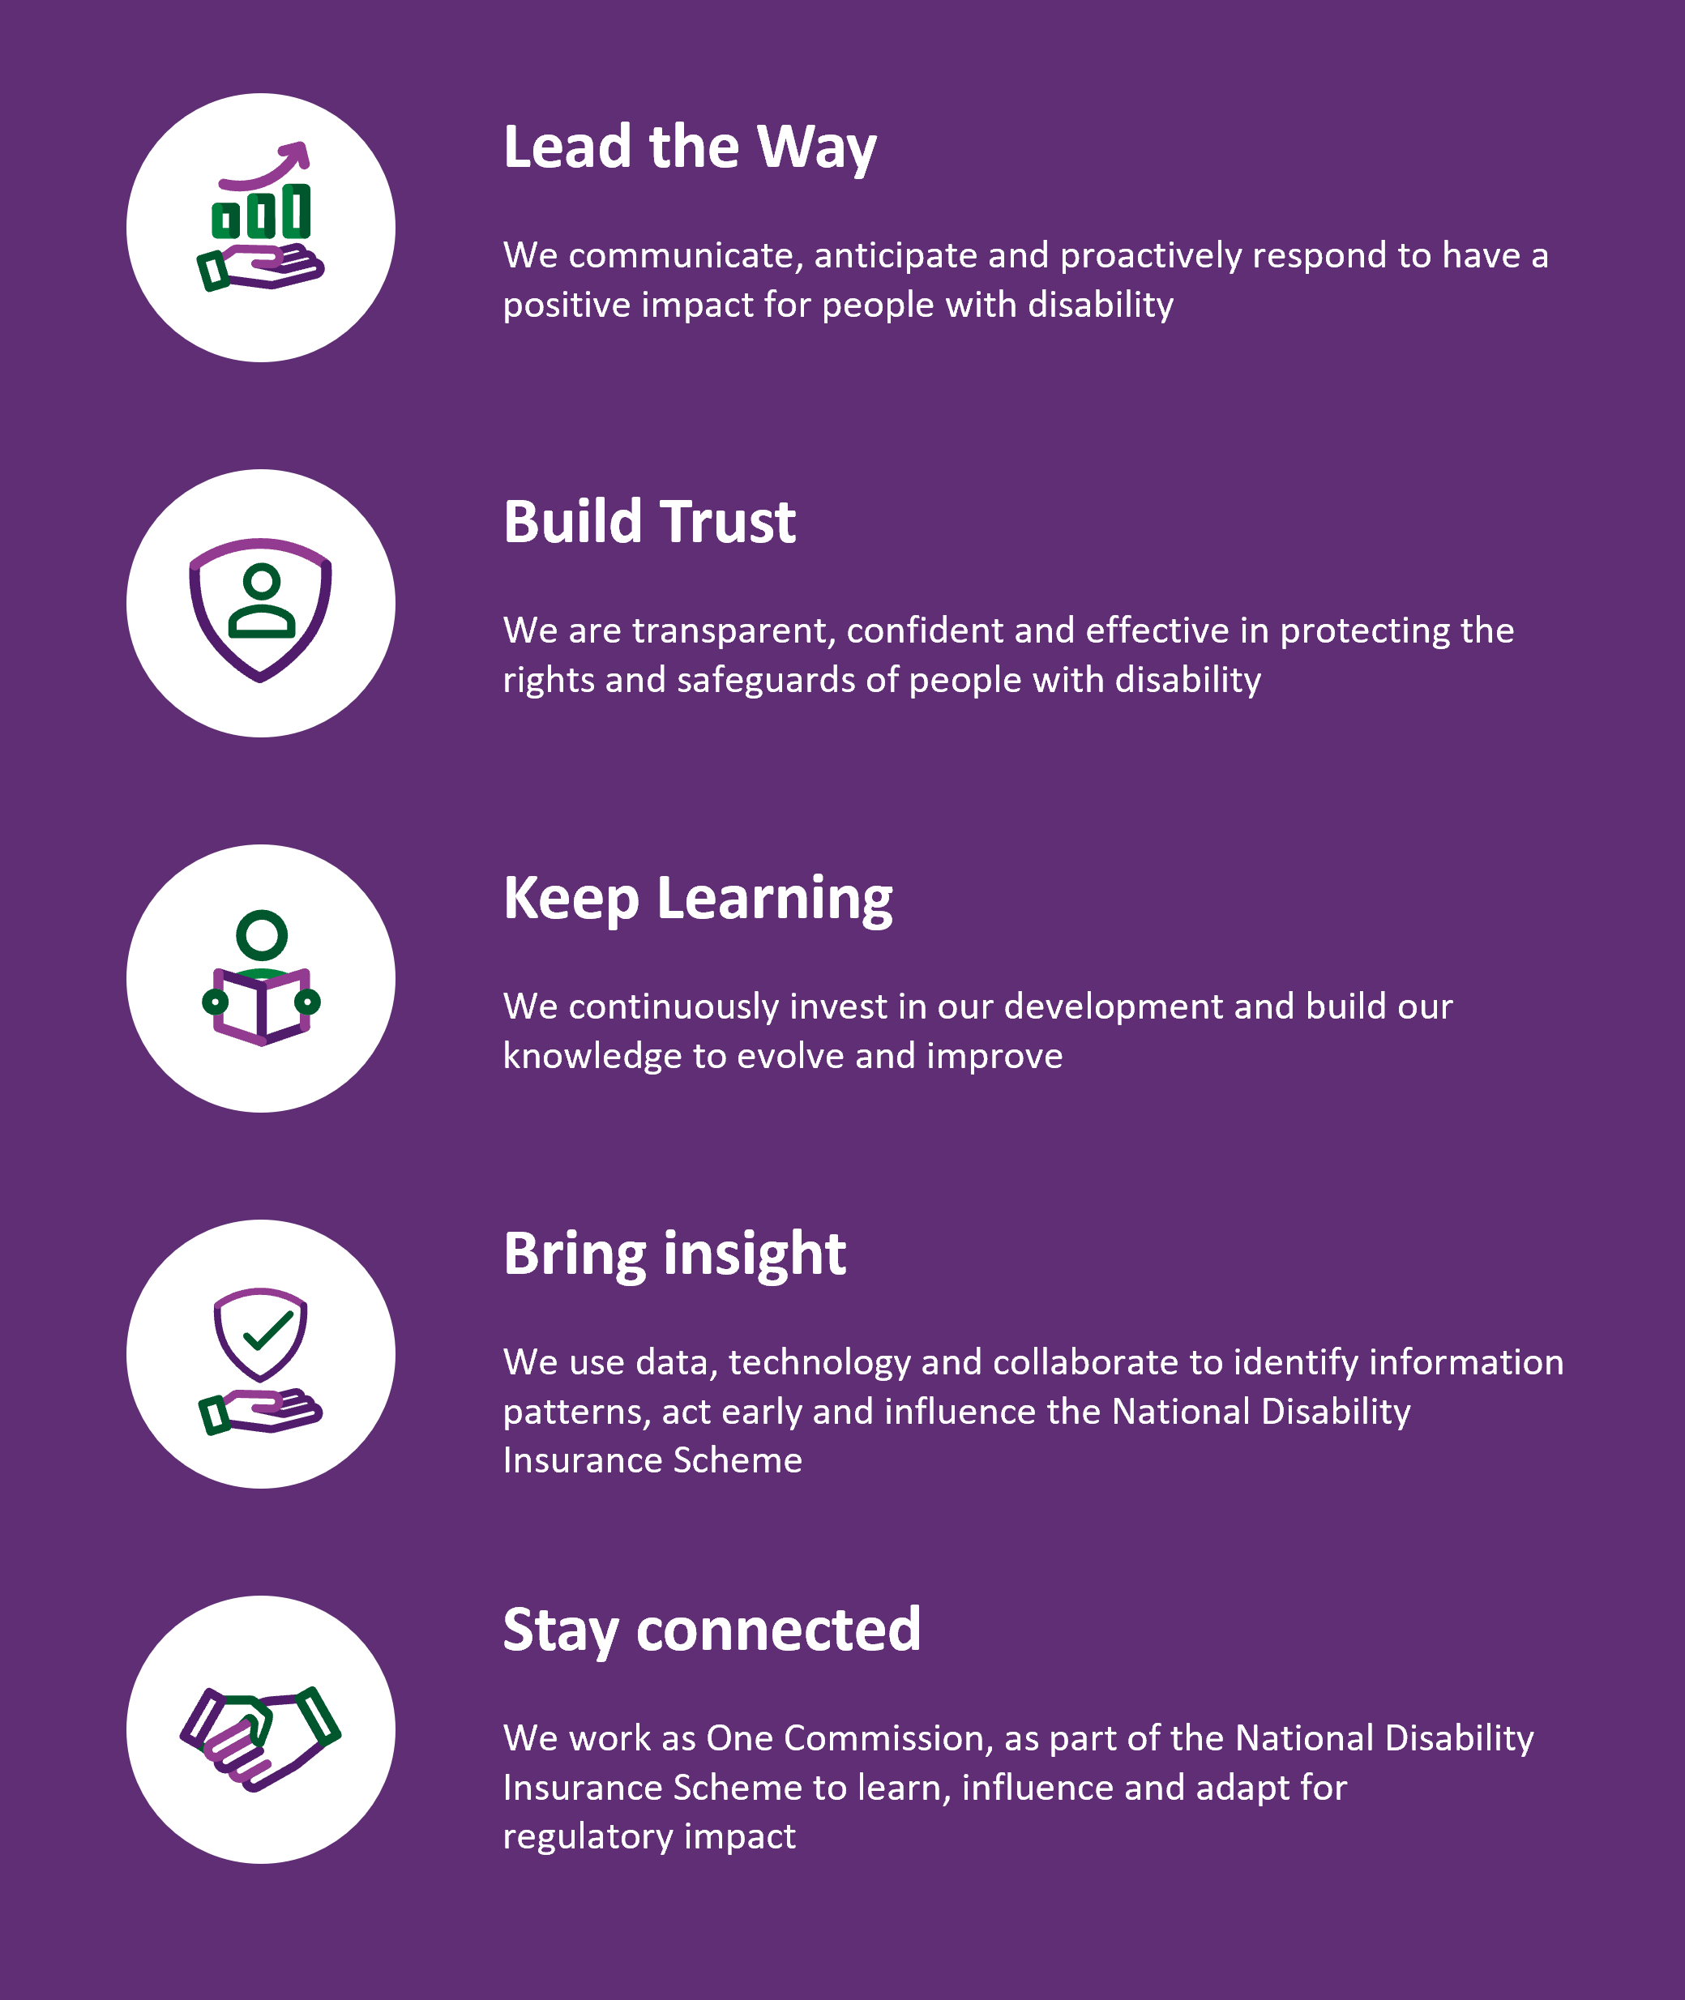

Our strategic plan sets our focus

Summary of our Strategic Plan 2022-2027

Our vision:
People with disability achieve their aspirations

Our purpose:
To uphold the rights of NDIS participants, to elevate quality and safety and enable consumer independence

Strategic enablers:
- Regulate for positive impact
- Practice and regulatory excellence
- Work together to build trust
- Data and digital approaches
- Our people

Our focus | Our impact
Rights of people with disability | The NDIS Commission amplifies and promotes the rights of people with disability
Quality providers and workers | Every NDIS participant has safeguards in place and access to quality services and supports delivered by skilled workers of their choice
Thriving, diverse markets | The NDIS Commission will enable consumer independence for NDIS participants by using regulatory frameworks to promote and remove barriers to quality and safety

Our regulatory approach focuses our regulatory activity
The regulatory approach from the legislative and strategic frameworks in which we operate.

Key regulatory documents
Element | Description
Legislative and strategic frameworks | Foundational frameworks outlining the NDIS Commission’s powers, vision, purpose, and priorities. These frameworks include:  - The National Disability and Insurance Scheme (NDIS) Act 2013,  - NDIS rules, guidelines and external guidance, and policies,  - NDIS Commission Strategic Plan  - NDIS Commission Corporate Plan
Regulatory approach (this document) | Defines the focus of our regulatory activity and the strategies we use to conduct effective and efficient regulation.  The regulatory approach outlines our:  - Regulatory intent, opportunities, and considerations  - Regulatory approach to achieve our regulatory intent
Operating model | Describes how we co-ordinate and deliver our regulatory activity to uphold the rights of NDIS participants. The operating model describes our:  - Operating model framework  - Functions  - High-level processes  - Ways of working

Our Regulatory Focus

Our regulatory approach is articulated in six elements:
Regulatory intent - We proactively use all our regulatory levers and tools to uphold the rights of NDIS participants, ensuring high quality and safe services and supports, and enabling consumer independence and choice.
Opportunities - The NDIS Commission works proactively to realise opportunities to uphold the rights of NDIS participants by elevating quality and safeguards and addressing barriers to participant rights.
Regulatory focus considerations - The NDIS Commission will be satisfied that it has delivered against its regulatory intent if it makes decisions and works to achieve each of its regulatory considerations.
Our approach to achieve our regulatory intent
Regulating at multiple levels - The NDIS Commission regulates at multiple levels to promote quality and safety, acting proactively to drive good practice and minimise risks and acting reactively to mitigate risks and learn lessons when they do occur.
Regulatory approaches - The NDIS Commission meets its regulatory intent, and considerations, through three regulatory approaches: high intensity responses to risks or harm; proactive, targeted campaigns; and ongoing regulatory activities.
Regulatory levers and tools - The NDIS Commission draws on all available regulatory levers and tools to meet its regulatory objectives. These levers and tools are used individually and in combination to drive quality and safeguarding across the system.

Our regulatory opportunities

Opportunities to strengthen the NDIS
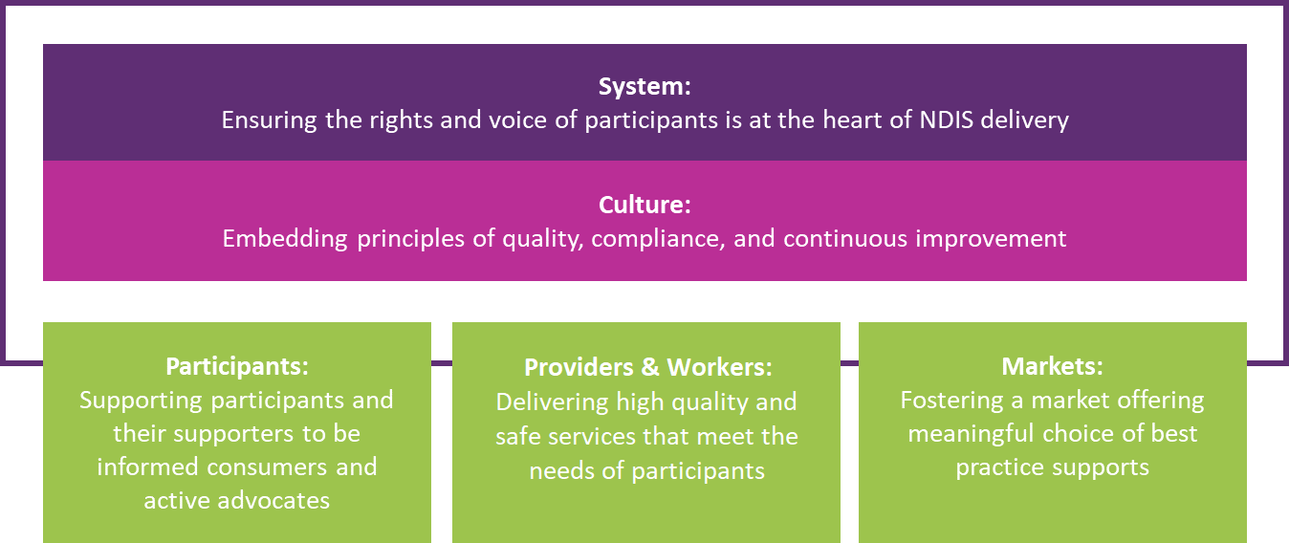

Our regulatory approach considers and responds to five key opportunities to strengthen delivery of the NDIS system.
- System: Ensuring that all parts of the system place the rights and voice of participants at the heart of all NDIS work.
- Participants: Encouraging and supporting participants, their carers, families, advocates and the community to be informed consumers.
- Providers and workers: Building a resilient network of providers and workers that have the skills, capability, and capacity to offer high quality and safe supports and services to an appropriate standard.
- Market: Fostering a market capable of offering participants a meaningful choice of the best practice supports and services they require.
- Culture: Embedding a principles-based culture of proactive quality, compliance, and continuous improvement to ensure the whole system can give effect to the rights and choice of people with disabilities.

Our regulatory intent
We proactively use all our regulatory levers and tools to uphold the rights of NDIS participants, ensuring high quality and safe services and supports, and enabling consumer independence and choice.

Our work involves engaging with participants, oversight of providers, and workers. We use data and intelligence to inform our regulatory activities and use multiple regulatory responses to support quality and safeguarding to uphold the rights of people with disability, ensuring quality providers and workers, and promoting a thriving, diverse market.

Our regulatory considerations
Our regulatory considerations align with our areas of focus as detailed in the Strategic Plan.

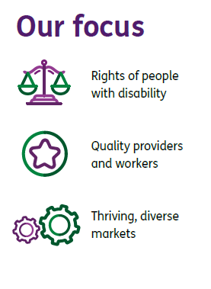 | Our Considerations  Participants’ rights, dignity and aspirations are upheld and are kept at the heart of the sector  Participants choice and control is respected and supported
Participants are free from harm and active safeguarding is in place across the system
High quality service provision, good practice, and skilled workers across the system
Participants are empowered to make informed choices and are involved in matters that affect them
A market of diverse, effective and safe providers and workers, that is viable, accessible and thriving

We work across multiple levels, approaches, and levers, to achieve our regulatory intent
Our regulatory approach includes working at multiple levels of quality and safeguarding. We think about the whole NDIS system as well as the experience and actions of individual participants, providers and workers. This puts participants at the centre of all we do.

We work systemically to strengthen approaches and culture throughout the system and we provide clear standards, training and oversight. We also work directly with individual providers, workers and in individual matters to proactively improve practice, amplify the voice of the particpant and ensure safeguarding.

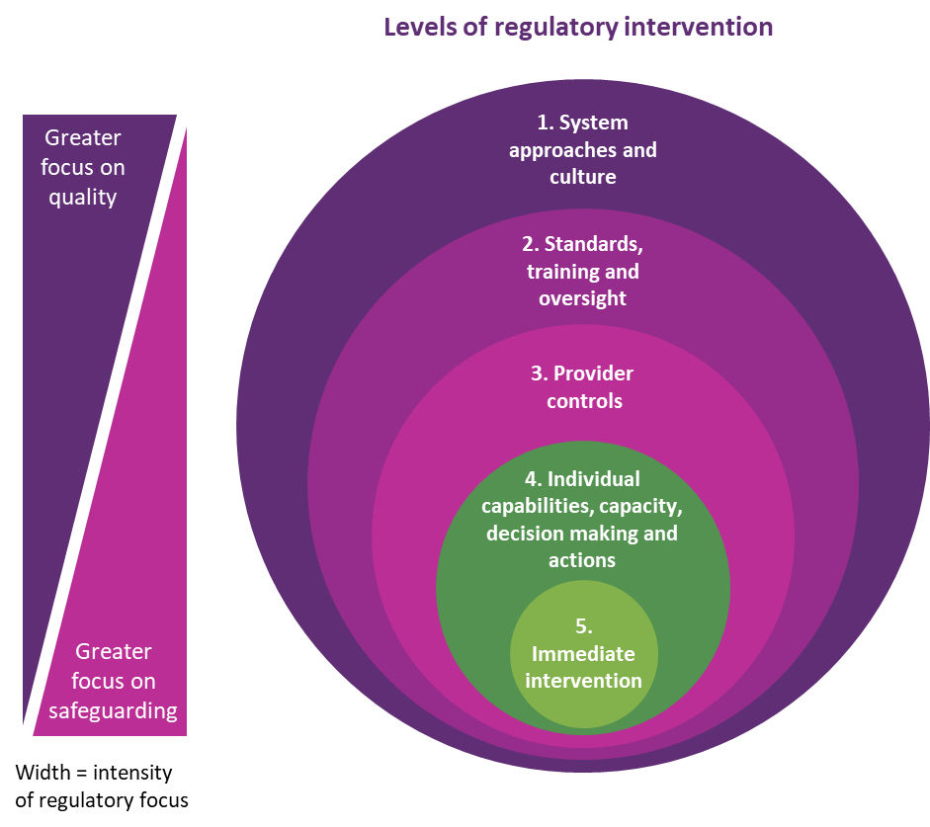

1. We strengthen system approaches and culture
The NDIS Commission takes proactive steps to build system approaches and a system culture that put the rights and voice of participants first. We encourage leading practice approaches across the system that provide participants with a meaningful choice of high quality and safe services and supports. We take system-wide action to address emerging risks that may give rise to harm to participants or challenges for the sector.

2. We provide standards, training and oversight
We set standards, deliver and encourage appropriate training, and provide regular oversight. We support providers in adopting best practice approaches and taking steps to ensuring appropriate skills and capabilities.

3. We establish provider controls
We work with providers to improve the systems and controls they have in place to address emerging risks at an entity level. We ensure that providers and their workforces take an appropriate, rights based, approach to engaging with participants. We establish the processes and checkpoints necessary to ensure all services and supports meet appropriate standards.

4. We monitor individuals’ capabilities, capacity, decision making and actions
We intervene directly with providers, and their workforce, as they deliver services and supports, to ensure that they have the right capabilities, capacity, decision making skills and perform the correct actions. This provides location or individual specific intervention to address emerging risks.

5. We conduct immediate intervention
We conduct immediate intervention in response to potential harms to participants or issues with the system. This provides an instance specific intervention to prevent risks emerging. The NDIS Commission intervenes to protect participants from harm and to preserve quality and safeguarding in the system.

We engage in three key regulatory approaches
The NDIS Commission focuses on three key regulatory approaches – high intensity responses, targeted campaigns and regulatory activities. We aim to direct substantial effort into targeted campaigns to reduce the effort required for high-intensity responses and regulatory activities over time.

Regulatory approaches
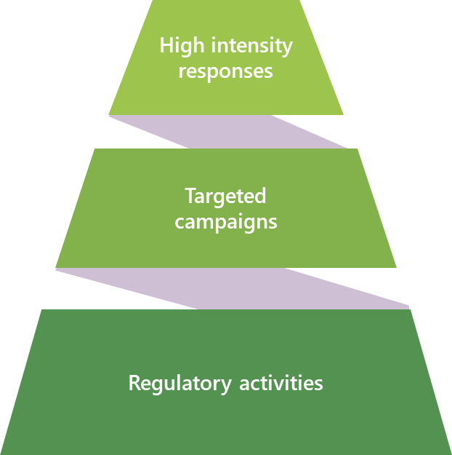

Our high intensity responses address urgent risks to participant rights and critical sector issues
From time to time, despite best efforts to drive quality and safeguarding, the NDIS Commission may become aware of critical or imminent risk to participants, workers or the system. In these circumstances, we use all relevant tools, rapidly and in a coordinated way to ensure that participants’ rights are upheld and risks, issues and harms are addressed as quickly as possible.

Our targeted campaigns avert potential risks to participants and address emerging sector issues
The NDIS Commission actively compiles and monitors data and intelligence to identify targeted systemic opportunities to drive quality, safeguarding, and consumer independence. We shape proactive, targeted interventions to maximise these opportunities.

Our regulatory activities provide ongoing sector regulation and oversight
The NDIS Commission acts as a regulator for the NDIS system. This means that we are responsible for proactively and reactively addressing a range of ongoing regulatory and compliance matters, such as managing provider registration, monitoring the system and provider operations and resolving participant complaints. We do so with a view to ensuring key drivers of quality, safeguarding, and consumer independence are in place and any risks to these are identified and addressed as early as possible. The NDIS Commission invests a significant portion of its effort in this work.

We use a suite of levers and tools to conduct proactive regulation
The regulatory approach encourages the NDIS Commission to use all of its levers to ensure that regulatory intent is met. The NDIS Commission actively uses each of a range of levers, each of which puts the rights of participants at the centre of the action we take. These levers are almost always used in combination to address risk and provide quality and safeguarding support.

Regulatory levers and tools
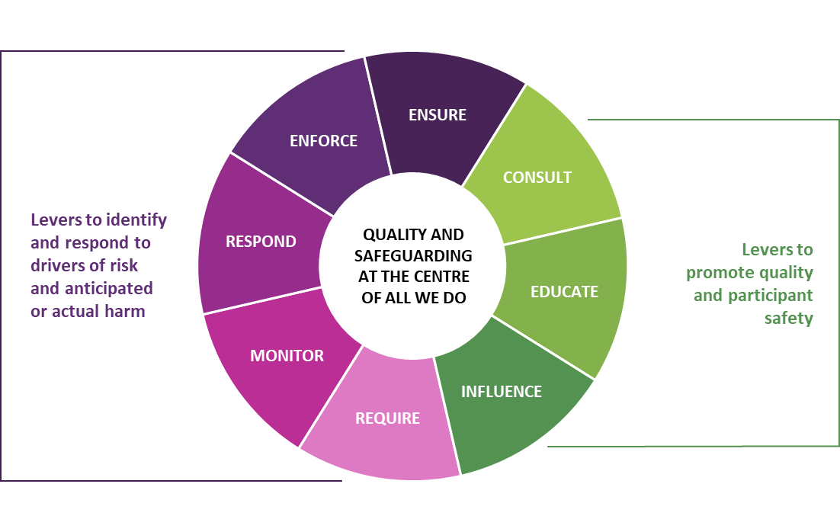

Levers to identify and respond to drivers of risk and anticipated or actual harm
- Where necessary we use our powers to ENSURE all providers and workers understand and respond to key drivers of risk to the system, and comply with the law, in a way that minimises harm to participants and the system. We actively investigate and take action against those who don’t.
- We ENFORCE relevant laws and standards by using our powers to sanction providers and workers as required. This is done sparingly, generally as needed to ensure the safeguarding of participants. We partner with the NDIA and other regulators to ensure any enforcement activity has the greatest possible effect.
- We RESPOND to all complaints and incident reports in a manner that aligns to the risk (and considers participant perspectives, including through contacting them as appropriate). We investigate issues and use the full scope of our powers. We work with stakeholders to get the best outcome for the participant, address the immediate risk or actual harm and address the causes of the risk that occurred.
- We MONITOR the quality of services and the treatment of people with disability through a system wide lens. We pay particular attention to monitoring high risk activities (i.e., restrictive practices) and monitor for risks to the NDIS system and market.
- We REQUIRE businesses and individuals who participate in the market to meet a certain standard of quality and safety. We control who can and cannot provide certain services and ensure that registration requirements reflect the services provided.

Levers to promote quality and participant safety
- We CONSULT and cooperate with participants, supporters, community, providers, and others to improve the experience of participants and the quality of services. We actively involve people with disability in matters that affect them. This informs our regulatory practice.
- We EDUCATE the widest possible audience about the rights of people with disability in the context of the NDIS. In particular, we support providers to understand good practice and work to build their capabilities to provide the best possible supports to participants. We also provide guidance, training and information to participants and providers to help make informed decisions.
- We exert INFLUENCE across the sector, leading by example in embedding a culture of excellence, innovation, and continual improvement among providers. We assist participants, providers, and others to understand their role in the system to uphold the rights and wellbeing of people with disability.

