How to renew my registration
Quick reference guide – Provider registration

Providers can submit a renewal application within 6 months of their registration end date using the NDIS Commission Portal. Expired providers can also submit a new application for registration following these instructions.

Renewal of a registration
- Log in to NDIS Commission Portal. On the Commission website select Portals and then select Registered NDIS providers. You can also use this link if your registration has expired or you are now deregistered.
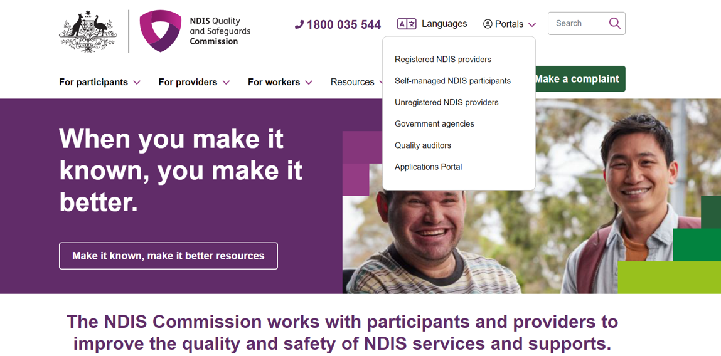
- Log into PRODA using your PRODA User name and Password. Select Login
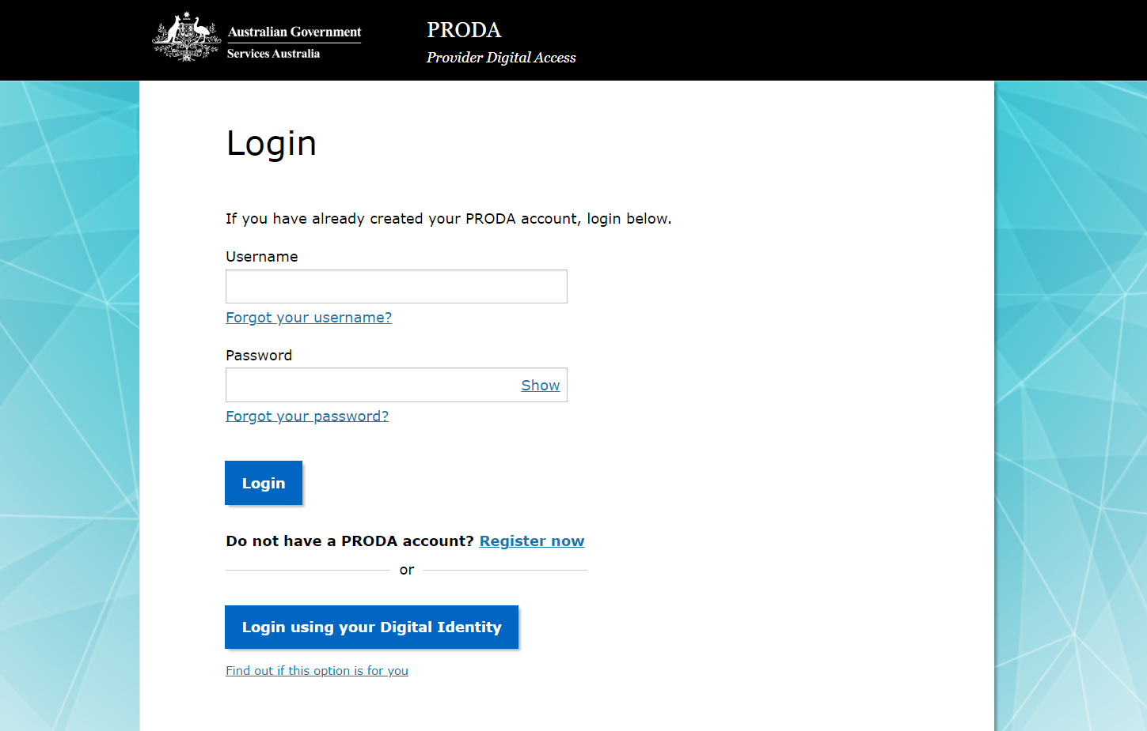
- Enter your verification code. Select Next.
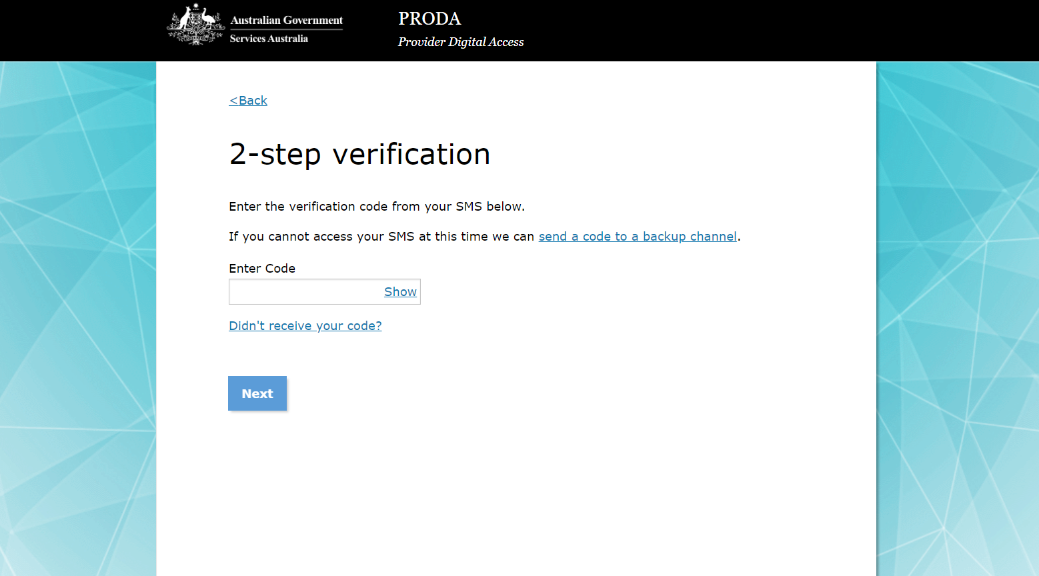

- If PRODA gives you a selection of tiles, select Provider Portal tile.
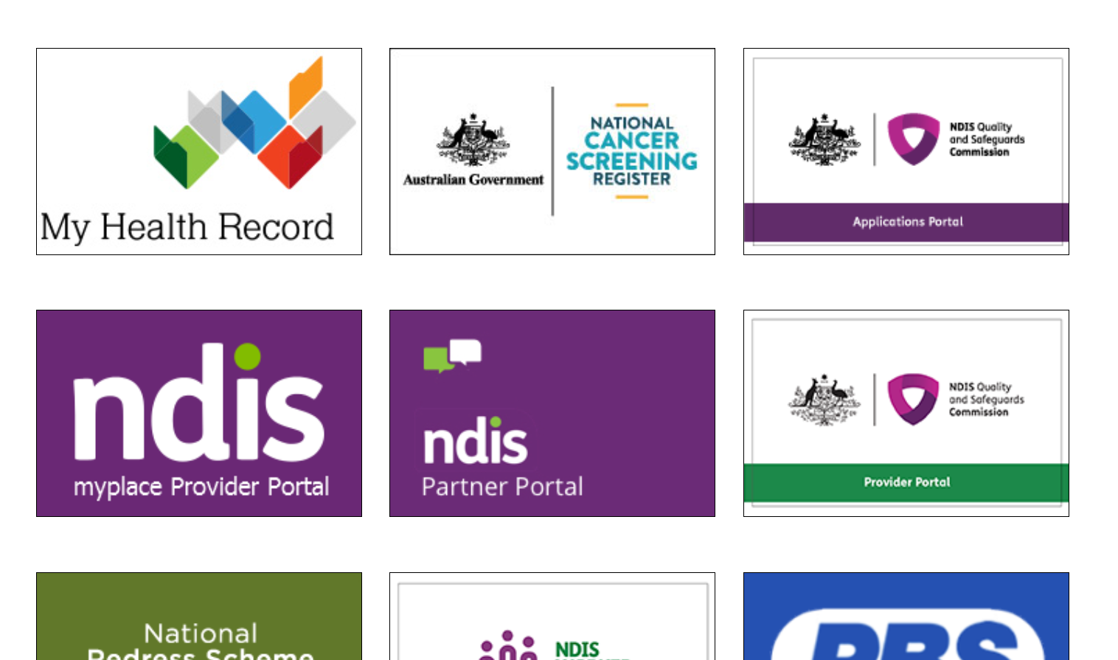
- If your registration is within the final 6 months of the registration end date, you will be able to commence a renewal application. You will see a message on your My applications tile, reminding you to ‘commence a formal renewal’ and the date you must commence by.
If your registration has expired or you are deregistered you will see the following message on your My applications tile, ‘Commence a New Application to register as an NDIS provider’.
In both cases click on the My applications tile.
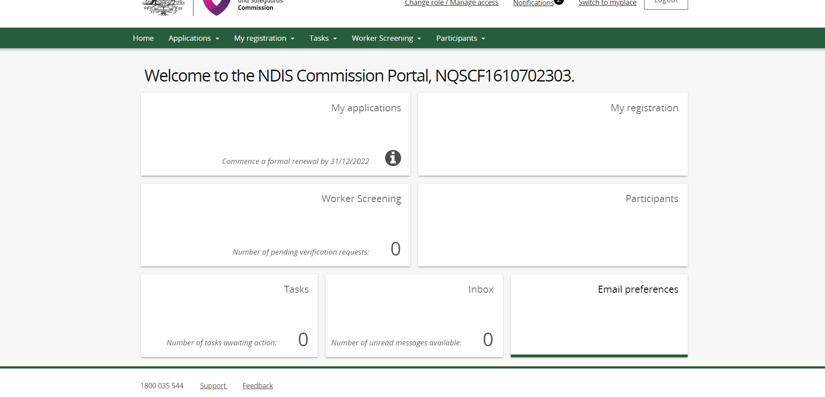
- In the My applications page you will see a message banner with a similar message to the My application tile and a Start application button. Select the Start application button.
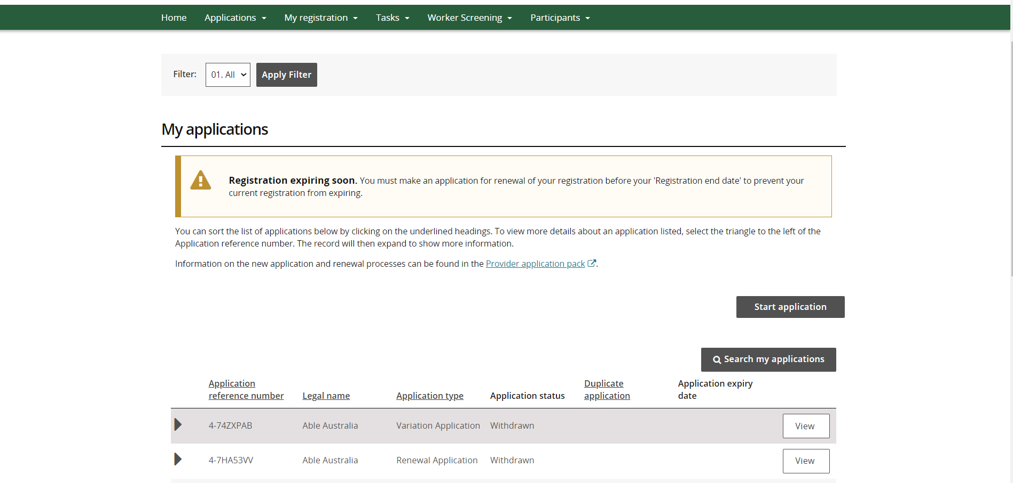
- A confirmation box will appear to notify you that you are about to create an applications on behalf of the provider. Select Confirm to continue.
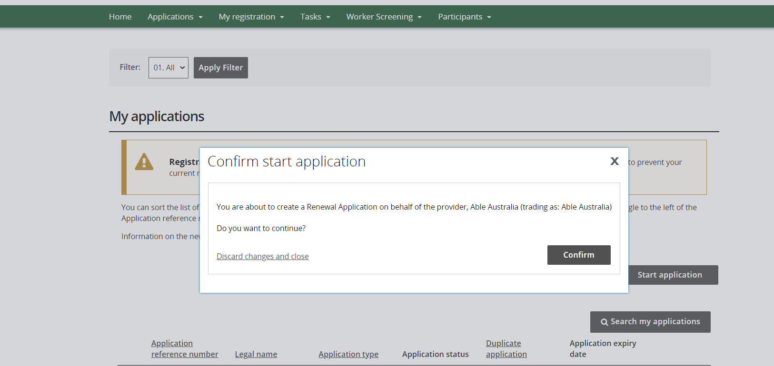
- For a renewing provider a Renewal Application will appear and for an expired or deregistered provider a New Application will appear. You can start your application process by working through the tabs on the left hand side of the application. Work through each section in order.
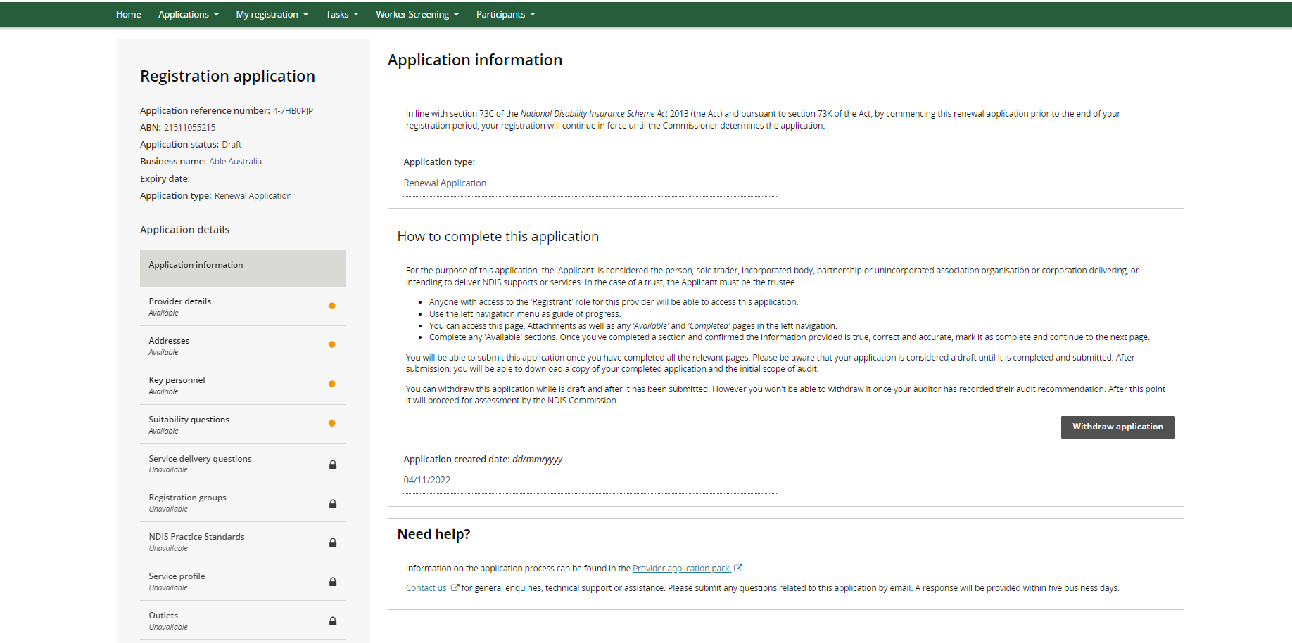
- At the end of each section, select Mark as completed and continue.
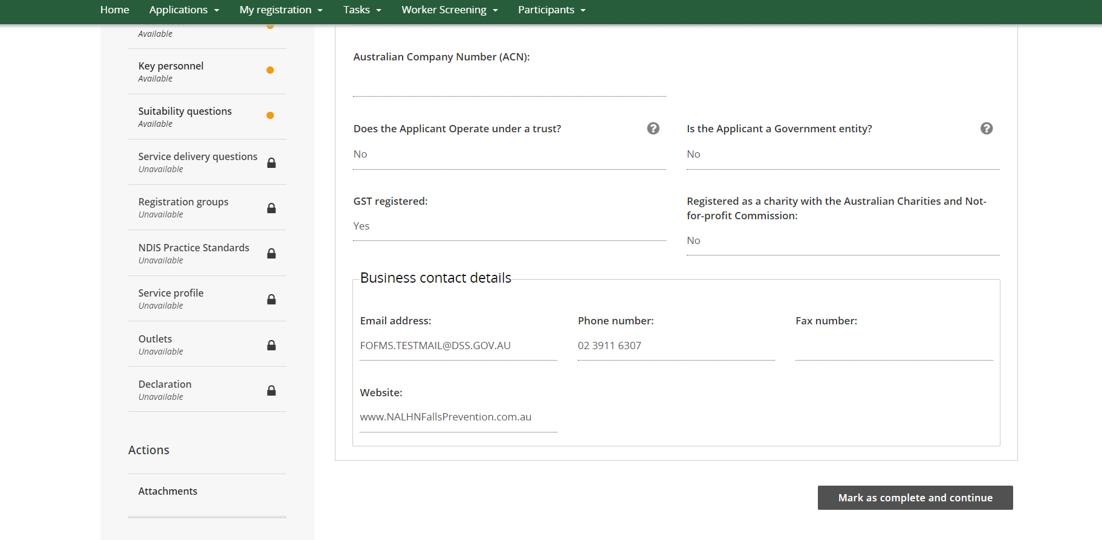
- A green tick will appear on the tab you marked as completed, and the system will progress you to the next tab. As tabs are completed, other tab will unlock for to complete. Work your way through. You can exit your application at any time and come back at a later time.
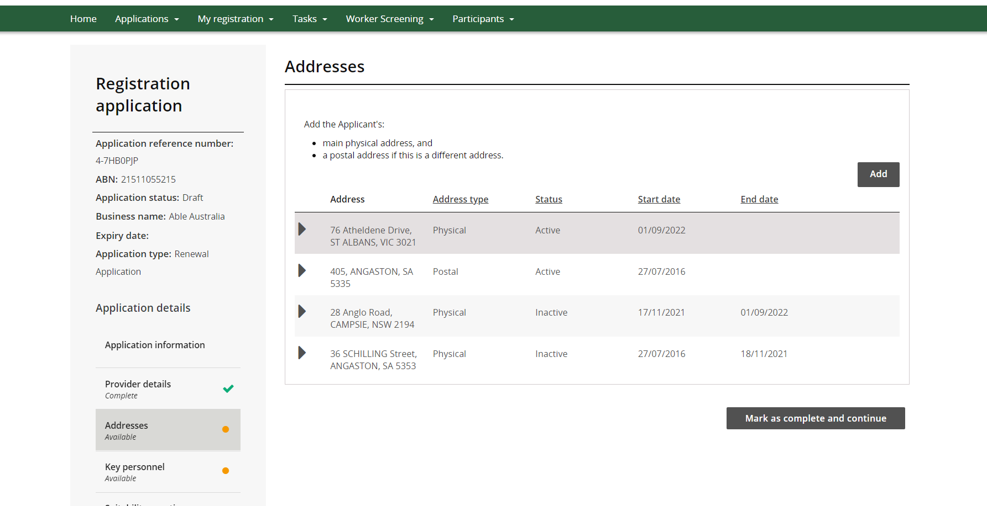
- No workers needs to be added in the Workers page. You can click on Mark as completed and continue.
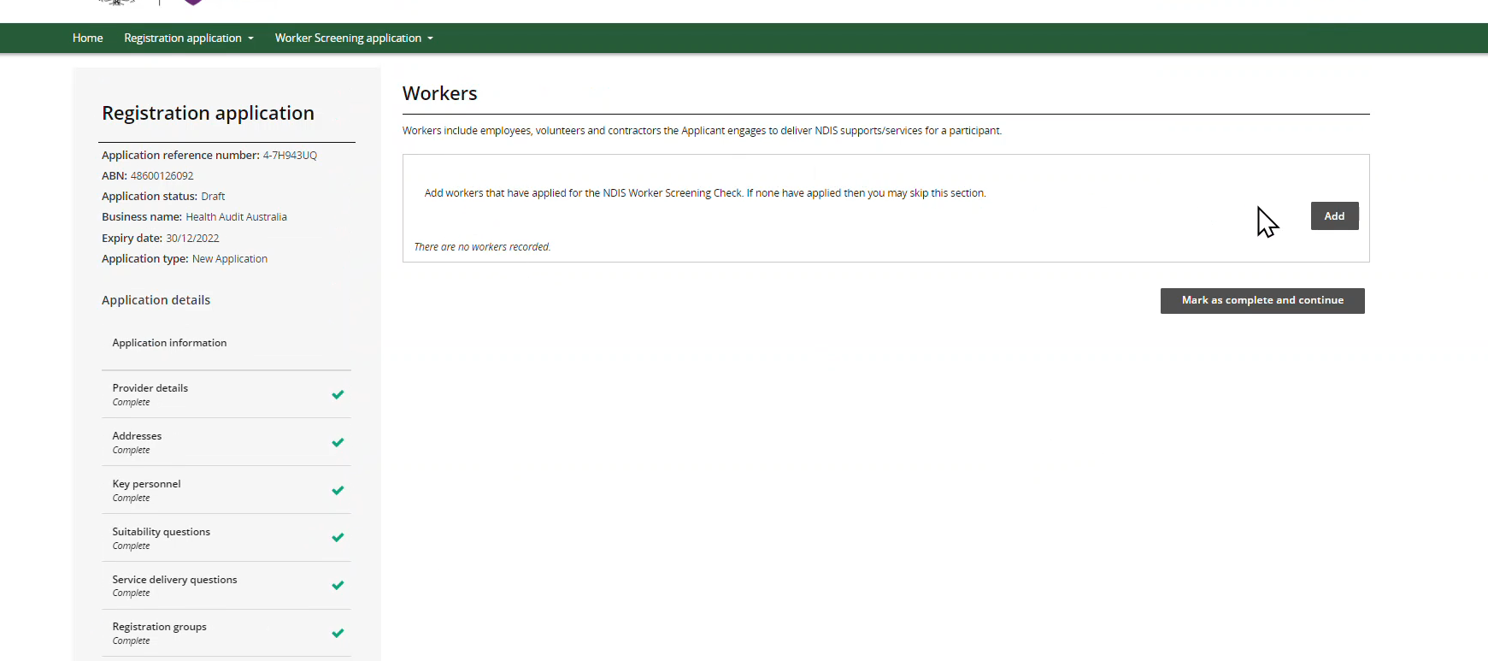
- The last tab you will complete is your Declaration. Check all the details are correct. Select Update and enter any conflicts or potential conflicts interest for this application (if none leave blank).
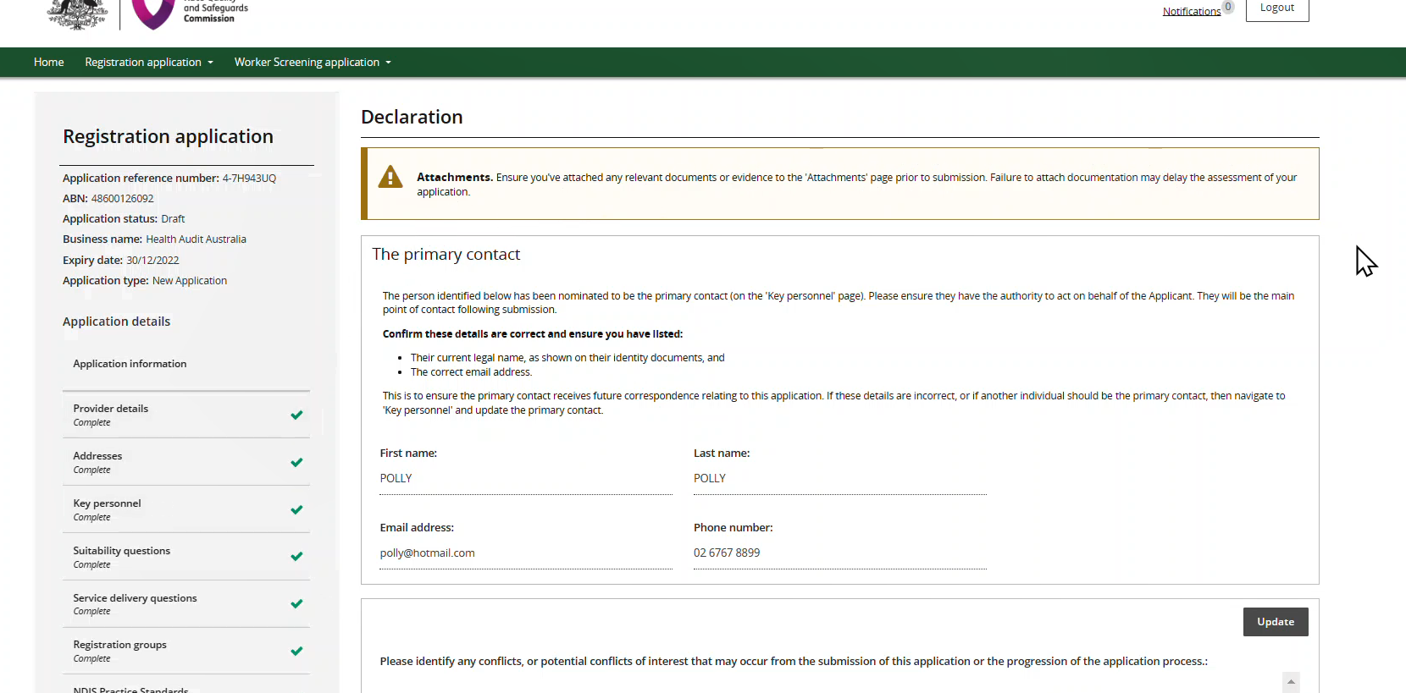
Read the declaration and click on Submit application.
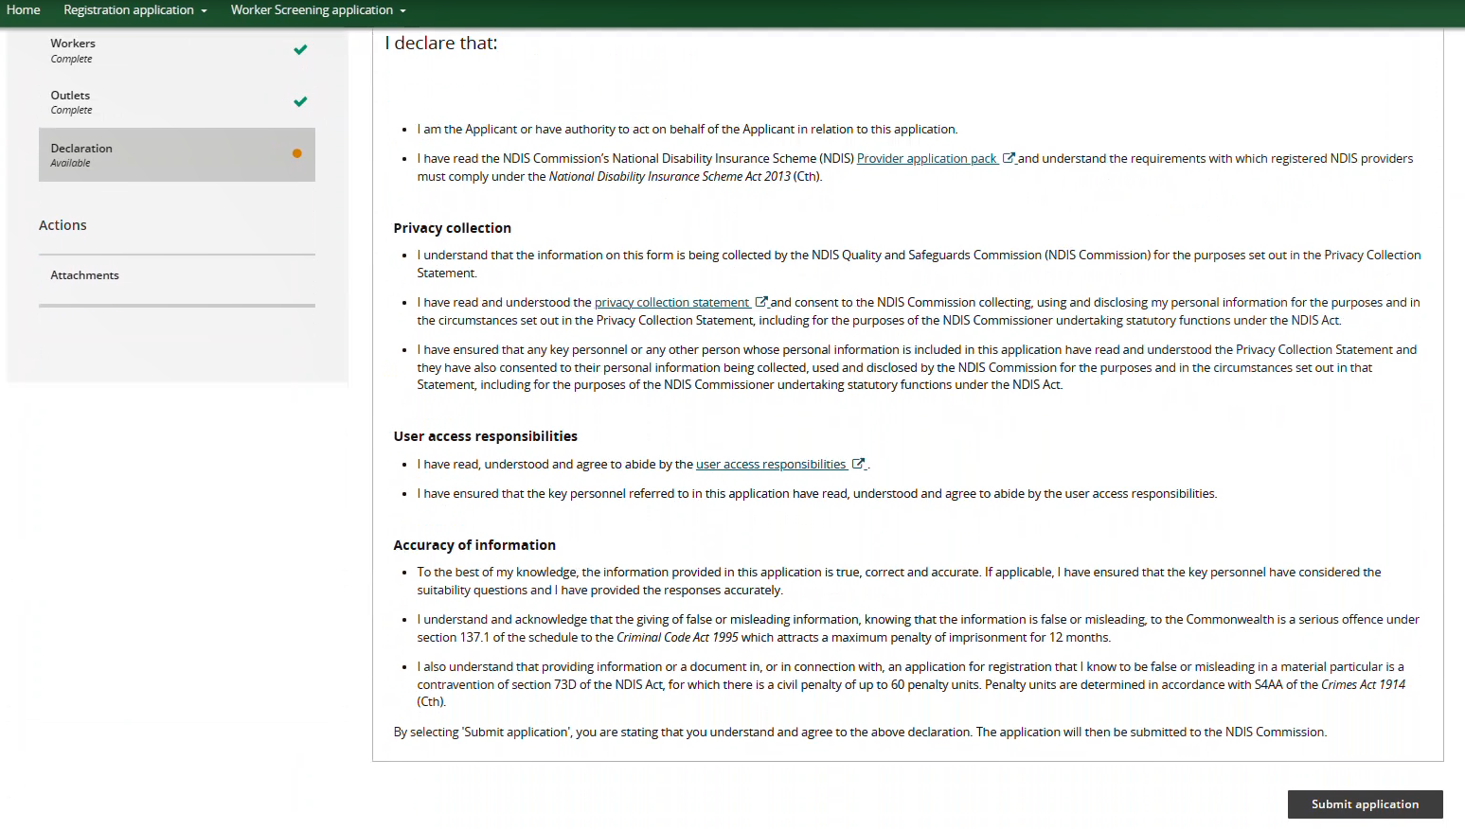

End.

