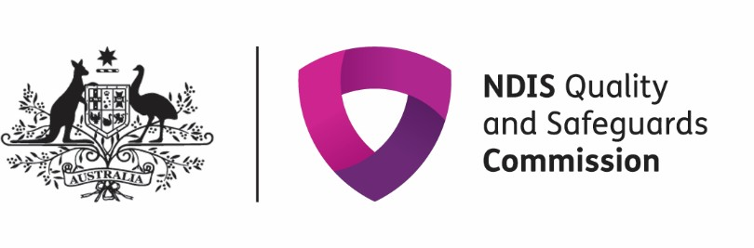
NDIS Quality and Safeguards Commission Communique from Disability Sector and Industry Consultative Committees, August 2022
The Disability Sector Consultative Committee met on Tuesday 2 and the Industry Consultative Committee Wednesday 3 August 2022. Chaired by NDIS Quality and Safeguards Commissioner, Tracy Mackey, both meetings included presentations by members of the NDIS Commission’s Executive Leadership Team.
Commissioner’s update
The NDIS Commission is working closely with the Minister for NDIS, The Hon Bill Shorten, to support government priorities and the evolution of the NDIS Scheme.
The NDIS Commissioner is grateful to the many stakeholders and participants, advocates and providers that have given their time and many insights over the past 6 months, hearing their experiences, challenges and the things that are working well informs our work. The NDIS Commission will now focus on balancing what has been requested by all stakeholders and the priorities that need to be delivered.
The Commissioner provided an update on:
- Strategic and Corporate Plan:
  - The NDIS Commission’s Strategic Plan, developed through broad internal and external engagement will be launched in August 2022.
  - The NDIS Commission’s Corporate Plan will focus on key initiatives that will be addressed in the next 12 months.
- Quality: is a very clear focus for the NDIS Commission and lifting quality across the sector is a key objective. This will be achieved through the Strategic Plan, Practice Standards and Workforce Capability Framework.
- NDIS Commission structure: the NDIS Commissioner has reviewed the structure of the NDIS Commission and made a number of changes, including internal reviews of processes. Ms Catherine Myers recently commenced in the new role of Deputy Commissioner, Regulatory Operations. This position will lead regulatory activity that drives an increase in provider quality.
Unauthorised use of restrictive practices (URP): data from the Activity Report
Data from the latest Activity Report indicates a high number of unauthorised restrictive practices (URP’s) continue to be reported to the NDIS Commission.
The NDIS Commission continues to focus on URP’s with the objective of reducing and ultimately eliminating them. This includes reviewing Positive Behaviour Support Plans and identifying systemic improvements and working with Practitioner to improve their knowledge and skills. The Senior Practitioner is working with State and Territory Governments to progress nationally consistent authorisation processes that align with the NDIS Commission’s definitions of what constitutes regulated restrictive practices.
The NDIS Commission has implemented two compliance strategies focussing on URPs since 2021. Work has also progressed on understanding the barriers that providers experience, reviewing existing resources, processes and strategies, meeting with authorising bodies and liaising with the NDIA, focussing on early interventions that promote the safeguarding of participants and the initiation of preventative and remedial actions with providers and targeted engagement with providers in relation to specific use of URPs with participants.
The NDIS Commission’s latest quarterly activity report (1 April 2022 to 30 June 2022) for all states and territories in Australia is now published on the NDIS Commission’s website.
Research to Practice Framework - Revised Framework and Steering Committee Governance
The Research to Practice Framework will provide the NDIS Commission with expert advice and stakeholder input to guide the content and prioritisation of research activities. It will support the development and identification of high quality, collaborative, participant-focused research to enable the NDIS Commission can provide guidance that will improve the delivery of safe, high quality NDIS supports and services.
The Research Steering Committee will be comprised of representatives from NDIS Commission staff alongside external stakeholders to support the implementation of the Research to Practice Framework.
Representation on the Steering Committee will focus not only on researchers and academics but will include providers and participants to ensure a co-design philosophy. Organisations that bring together the participant voice and those with lived experience are important to ensure a diversity of participants and a life span approach is used. The NDIS Commissioner committed to putting research on the agenda for the tripartite meeting with NDIA and DSS. Members were presented with the terms of reference and provided comments and feedback.
NDIS Commission Strategic Plan and Cultural Characteristics
The strategic plan including cultural principles launch is expected to be held at the end of August. The workshops with the Disability Sector and Industry Consultative Committees and NDIS Commission led engagement activities have shaped the strategic plan. The plan sets out our vision over the next 5 years to enable people with disability to achieve their aspirations supported by the NDIS Commission’s regulatory scope of upholding the rights of NDIS participants, to elevate quality and safety and enable consumer independence.
Regulatory Performance (Industry Consultative Committee only)
The third and final Regulator Performance Framework Self-assessment Report 2020–21, the NDIS Commission’s mechanism for external validation via assessment and validation by the Industry Consultative Committee, was discussed. This is the final such Report to be made against what is now the former Framework. The Industry Consultative Committee was asked to provide feedback and endorse the self assessment. The Report will be provided to the Minister and published on our website soon.
The NDIS Commissioner is committed to an independent assessment of the NDIS Commission’s performance as a regulator in comparison to other like regulators and regulatory best practice moving forward.
Future of Consultative Committees
The next meeting in November 2022 will be the last meeting of the three-year term of the current committees. Members of both committees reflected on their experience and provided feedback to the NDIS Commissioner. All members agreed that it would be beneficial to increase the participant voice. The NDIS Commission will share the future approach at the November 2022 meetings of the consultative committees.

The NDIS Commissioner thanked all attendees.

