How to renew my registration
Quick reference guide – Provider registration

Providers can submit a formal renewal in the final 6 months of their registration using the NDIS Commission Portal.

Renewal of a registration
- Log in to NDIS Commission Portal. Select Portals. Select Registered NDIS providers
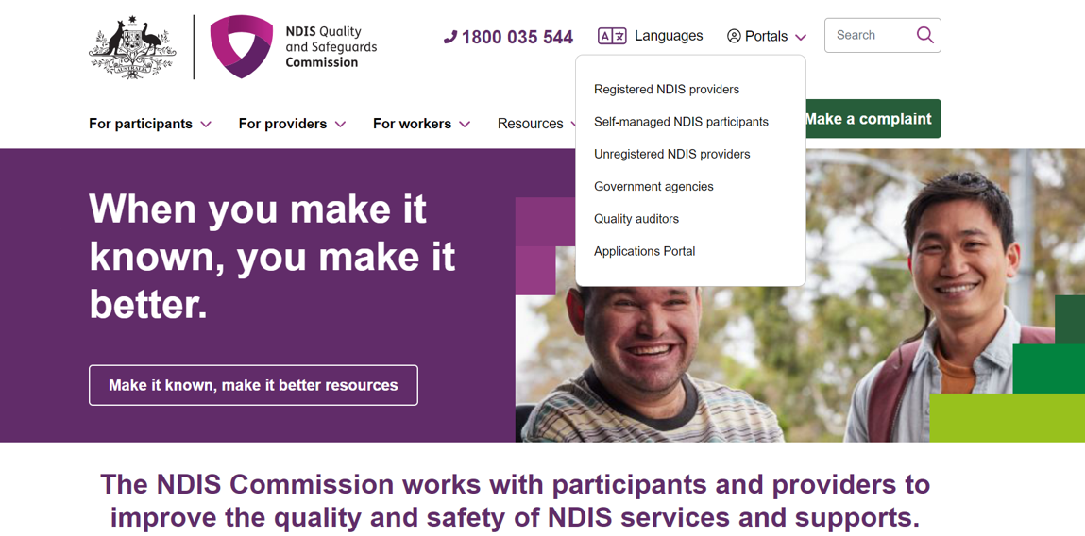
- Select my registration
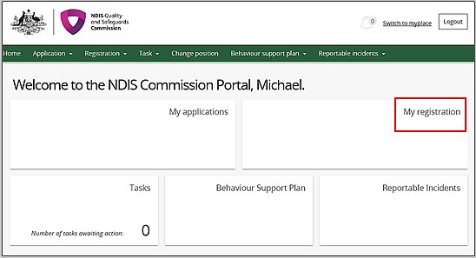
- On the Overview screen, select Formal renewal.
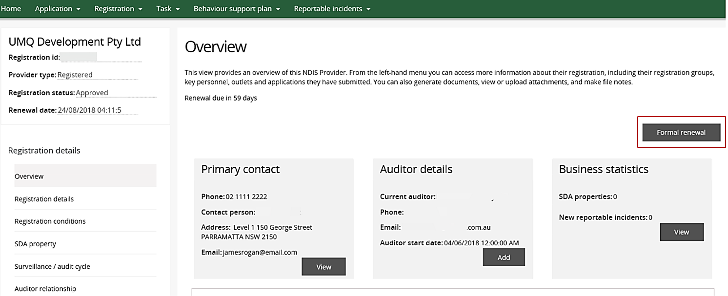
- A prompt will appear to notify you are about to commence a Formal renewal. Click Ok.
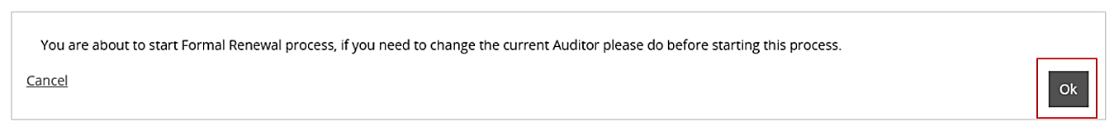
- Start to complete the renewal process by selecting the different sections in the Application details menu and update each screen ensuring the correct details are captured.
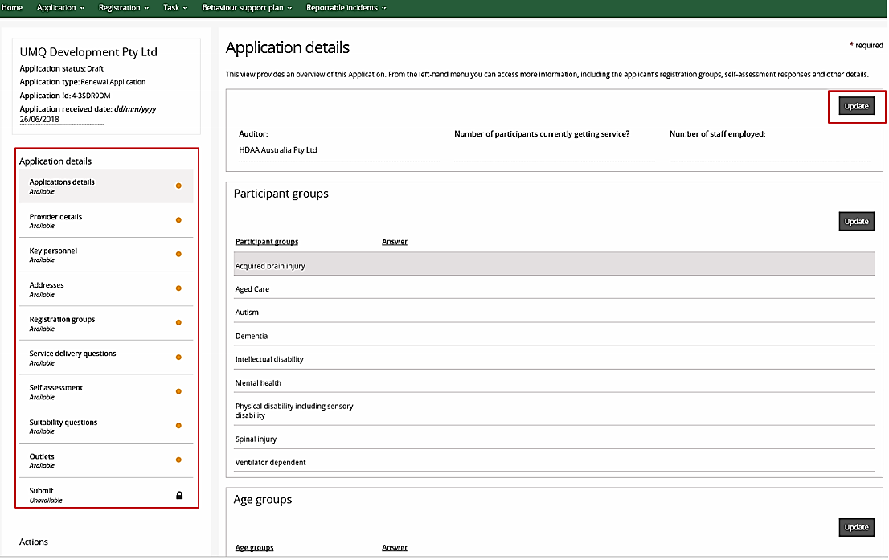
- A prompt will appear to Update application details.
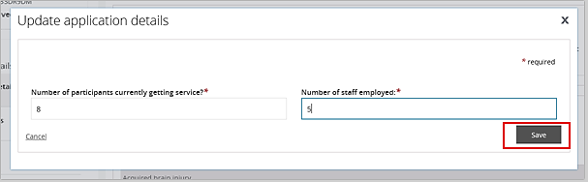
- Update the Participant groups by selecting the drop down menu and click Save.
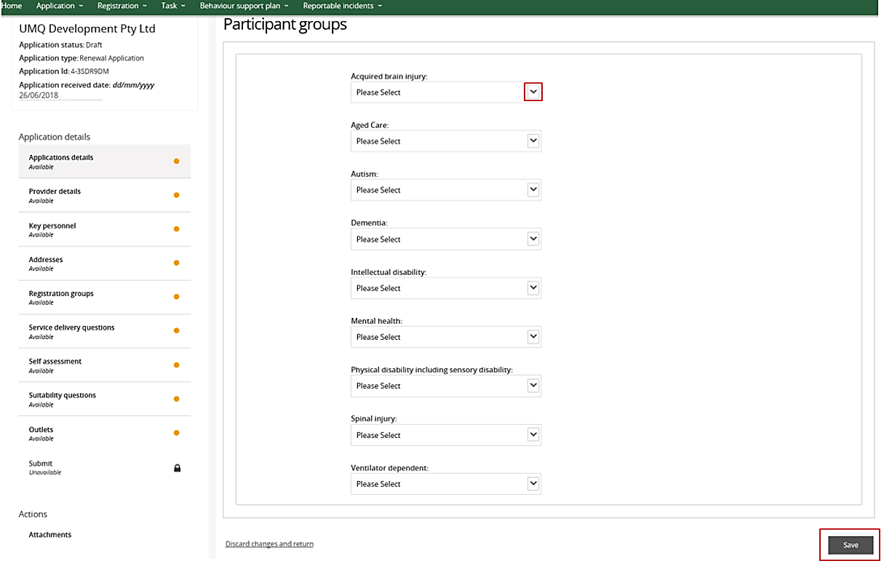
- Update the Age groups and click Save.
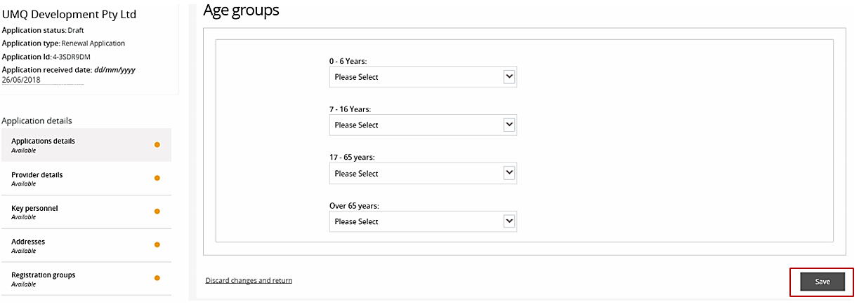
- The word ‘Complete’ along with green ticks will appear as the information is added into the system.
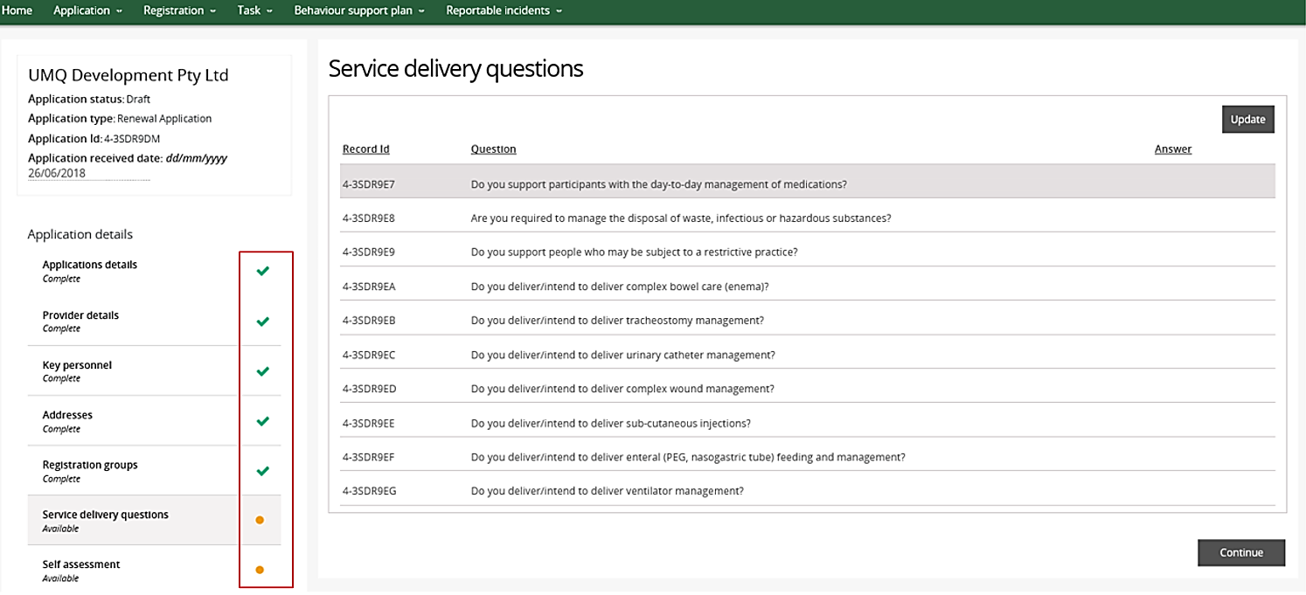
- In the Self assessment section, before you can proceed to the Suitability questions, update the response to each outcome in the individual modules by selecting each module.
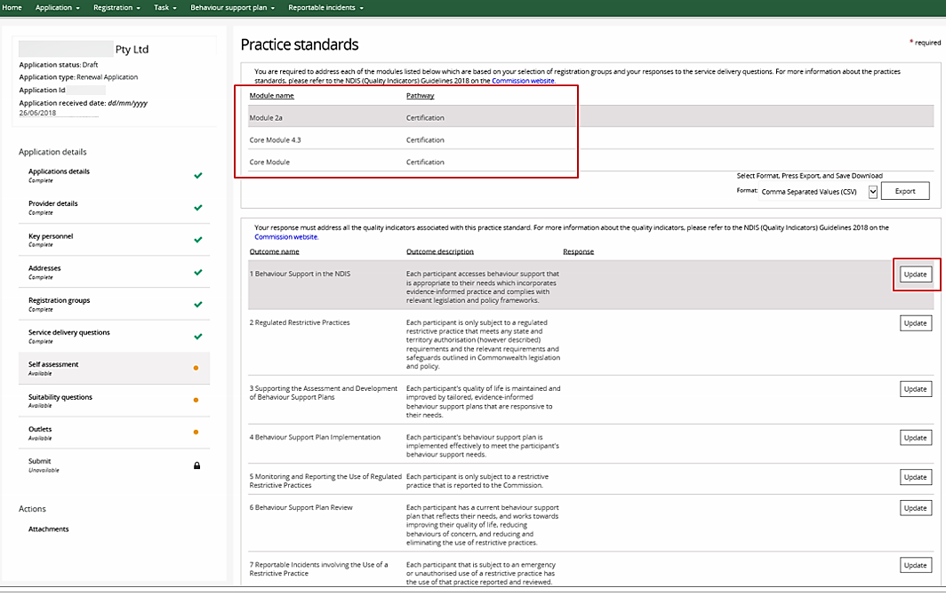
Note: Some modules contain more than one page of outcomes.
- When you choose manage Outlets, note and update the Professions box in the bottom right hand corner if applicable. Some Registration groups have the option to add select professions.
(Registration group with Professions available)
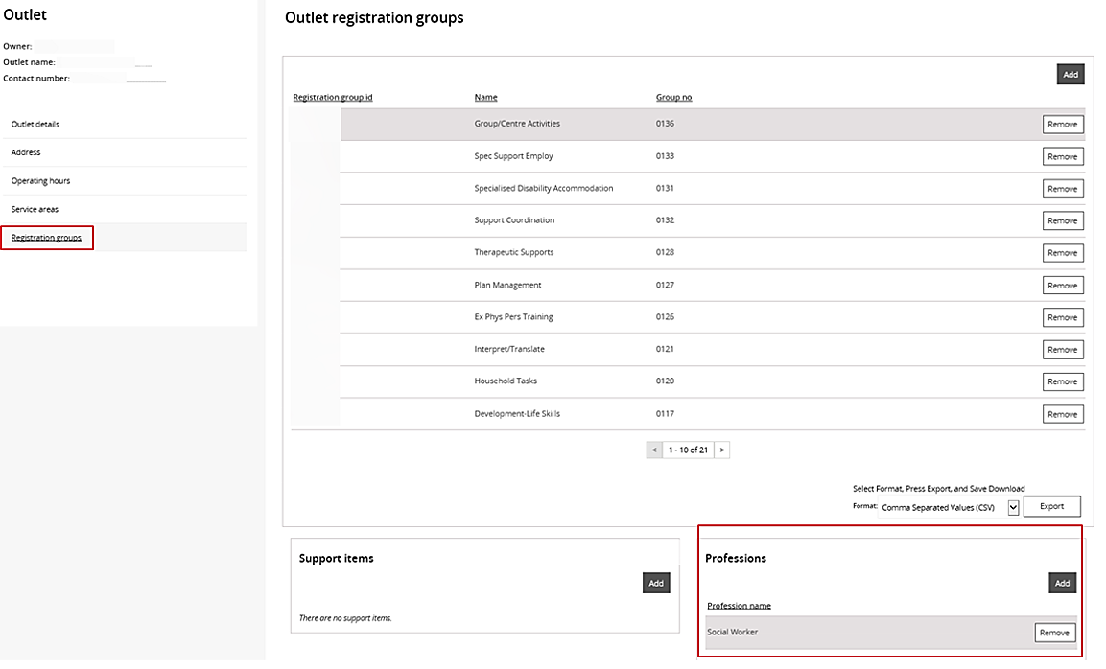
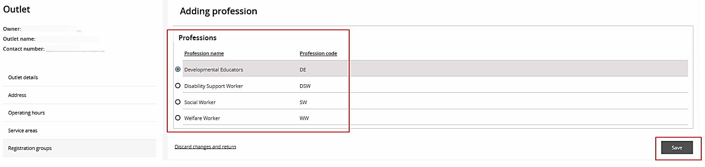
(Registration group without Professions available)
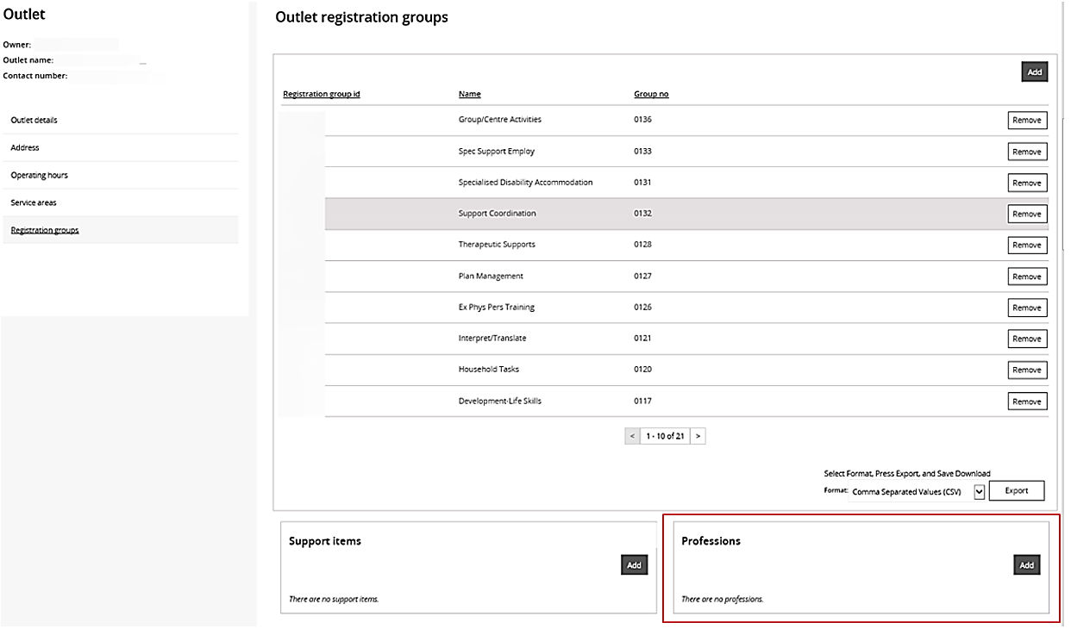
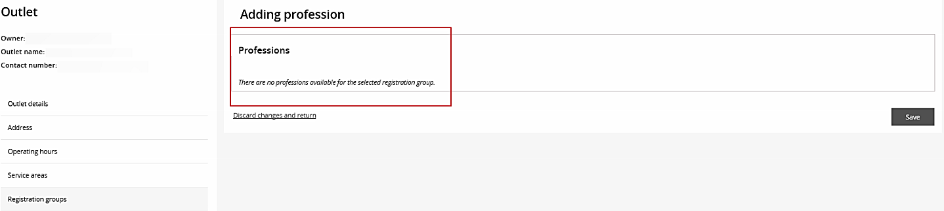
- Before submitting the Renewal application add any attachments that may be required in support of your application
NOTE: Maximum file size is 2MB and there is a limit of 7 attachments.
- Add any attachments by selecting the correct document type then Save and close
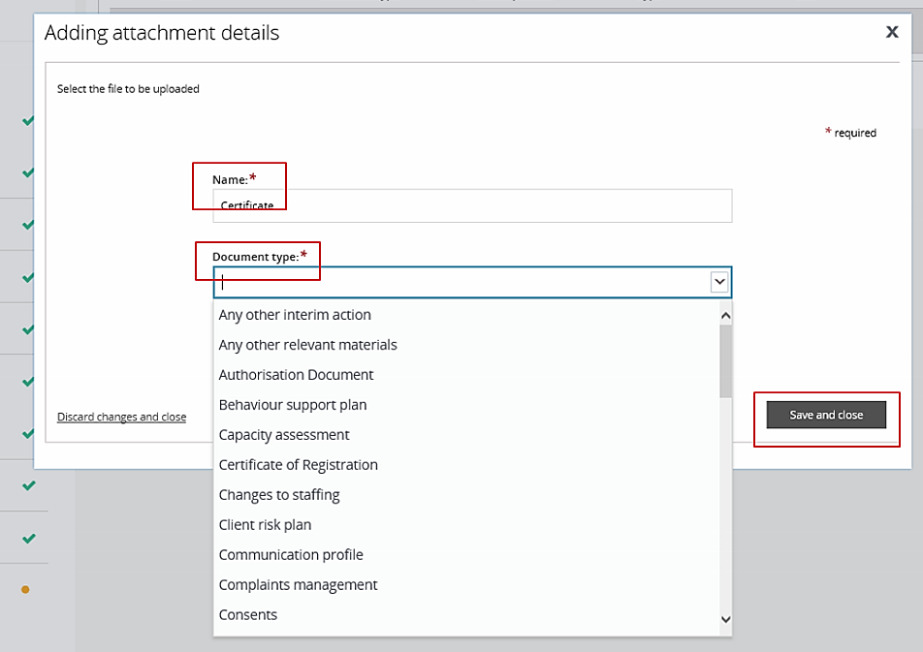
- If you need to remove an attachment, then select Actions and Remove
NOTE: You may provide additional material to the auditor once they have been engaged.
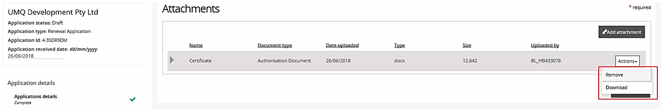

- Read the declaration and select Submit for assessment
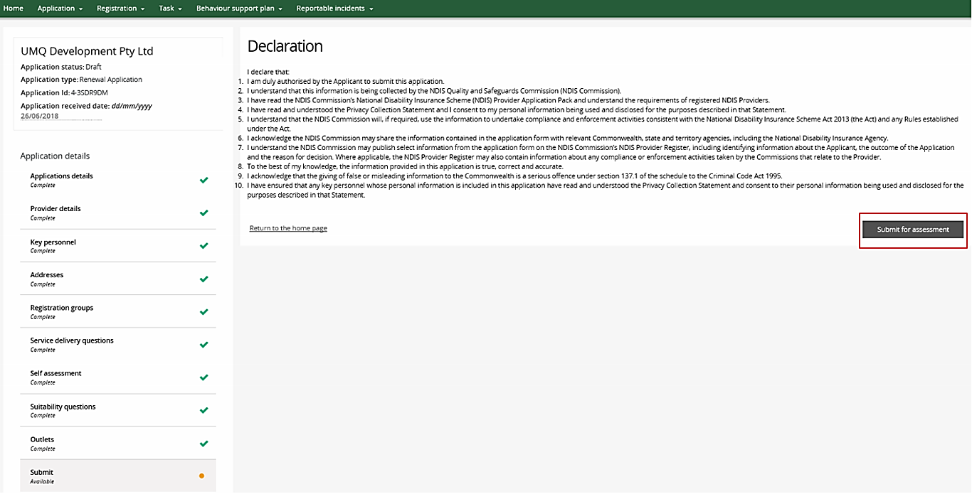
- The application type will change to Renewal Application
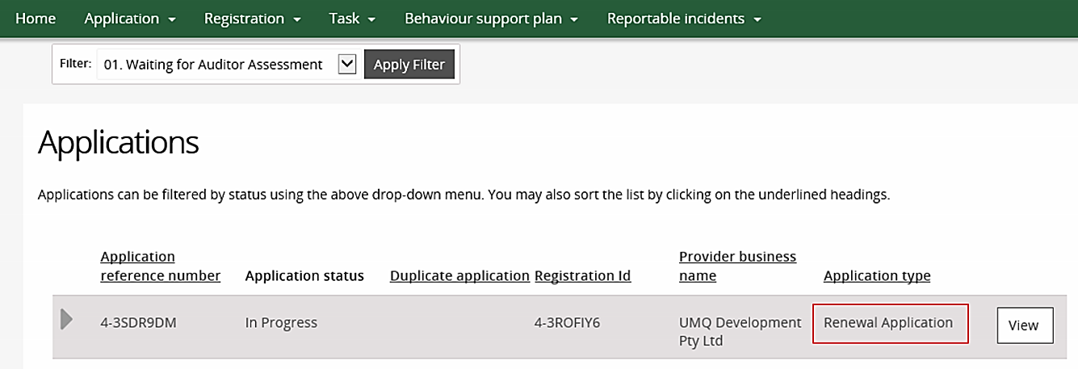

Please Note: There is a further Quick Reference Guide available to assist with assigning a selected auditor.

