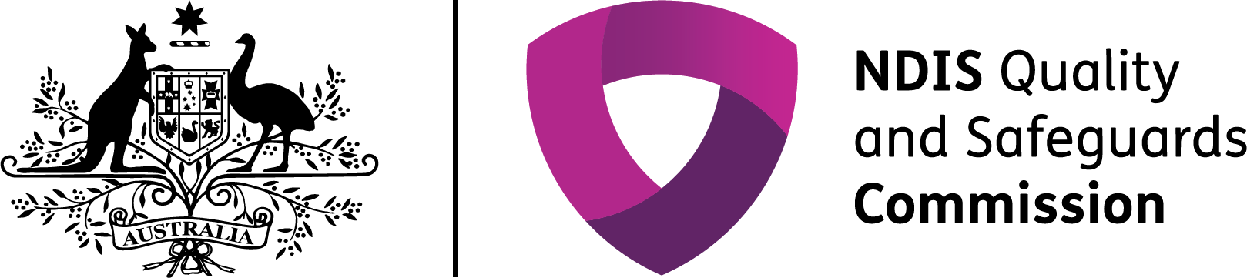

The NDIS Quality and Safeguards Commission

## A new system of quality and safeguards in the NDIS

The NDIS Quality and Safeguards Commission (NDIS Commission) is an independent government body that works to improve the quality and safety of NDIS services and supports, investigates and resolves problems, and strengthens the skills and knowledge of providers and participants.

### The NDIS Commission will commence in Victoria on 1 July 2019 and will progressively roll out across Australia.

Map of Australia showing the commencement dates of the NDIS Commission in each state and territory:
- 1 July 2018 in NSW and SA
- 1 July 2019 in ACT, NT, QLD, TAS and VIC
- 1 December 2020 in WA

When it is operational in all states and territories, the NDIS Commission will provide a single, national registration and regulatory system for providers that will set a consistent approach to quality and safety across Australia.



## Woman in wheelchair, working with office colleagues.What has changed for providers in Victoria?

The NDIS Commission introduced several changes for Victorian providers.

These include a new NDIS Code of Conduct and NDIS Practice Standards, which set out expectations for the quality and safety of the services and supports providers deliver. There have also been changes to provider registration and the way complaints are made, incidents are reported, behaviour support plans are developed and checked, and worker screening is undertaken.

Unregistered providers are also subject to new requirements including the NDIS Code of Conduct and complaints handling arrangements.

**Upward purple arrow with 2 diagonal downward green arrows.**

**The NDIS Commission provides information and guidance to support providers to understand and meet their quality and safeguards requirements.**

Then and now in quality and safeguards

| Function | Prior to the NDIS Commission | Under the NDIS Commission |
| --- | --- | --- |
| Provider registration | Organisations wishing to register with the NDIA, had to achieve and maintain status as a Victorian-approved NDIS provider.  Registered providers were required to meet the NDIA Terms of Business and Victorian requirements listed in the NDIA’s Provider Guide to Suitability. | The NDIS Commission registers providers. Registered providers are required to comply with the NDIS Practice Standards, the NDIS Code of Conduct and requirements for incidents management, complaints management, worker screening and behaviour support (where applicable). |
| Standards of quality and safety | Approved providers were required to undertake an independent review against the approved Victorian Standards (as applicable) within 12 months of registration. Local monitoring staff, monitor providers’ compliance with relevant legislation and policies set out in the Guide to Suitability. | Registered providers must meet and be audited against the relevant NDIS Practice Standards. |
| Code of Conduct | All disability service providers were required to declare commitment to zero tolerance of abuse. All disability workers were required to sign a declaration acknowledging and agreeing to abide by the code of conduct. | All providers and workers in the NDIS must meet the NDIS Code of Conduct. |
| Worker screening | Approved providers were to have conducted national and international police checks and a Working With Children Check (as applicable), and screened their workers against the Disability Worker Exclusion Scheme. | All states and territories will progressively transition to a nationally consistent Worker Screening Check for employees of registered providers who have more than incidental contact with people with disability. |
| Complaints management | Complaints about registered providers were made to the Disability Services Commissioner, Mental Health Complaints Commissioner or the Victorian Department of Health and Human Services and the Department of Education. Providers must have had a complaints management system in place with a clear process to receive and resolve complaints about their services and supports. Complaints about the NDIA or participant plans were made to the NDIA or the Commonwealth Ombudsman. | Complaints about the quality or safety of NDIS supports and services can be made to the NDIS Commission. Complaints about the NDIA or participant plans continue to be made to the NDIA or to the Commonwealth Ombudsman. Registered providers are required to have effective and proportionate internal complaint management and resolution arrangements in place. Registered providers must afford procedural fairness to people when managing complaints. |
| Behaviour support | Disability service providers required authorisation from the Victorian Senior Practitioner to use restrictive interventions.  Organisations would apply for this approval through the Restrictive Interventions Data System (RIDS) and report on restrictive interventions. | Providers who use or are likely to use restrictive practices, or who develop behaviour support plans must be registered with the NDIS Commission and meet supplementary requirements of the NDIS Practice Standards. The NDIS Commission approves behaviour support practitioners using a capability framework. Providers must lodge behaviour support plans with the NDIS Commission and report monthly on the use of restrictive practices. The Victorian government remains responsible for the legislative and policy frameworks regarding the authorisation of regulated restrictive practices in the NDIS. |
| Incident management | Approved NDIS providers registered or approved by the Department of Health and Human Services must have complied with the Client incident management guide. Approved providers of Early Childhood Supports must have complied with the Department of Education’s Incident Management Reporting Guidance for ECIS. | Registered providers must have effective incident management systems in place. Registered providers must notify the NDIS Commission about reportable incidents. These include the death or serious injury of a person with disability, allegations of abuse and neglect of a person with disability, unlawful sexual or physical contact with a person with disability, sexual misconduct committed against a person with disability and unauthorised use of restrictive practice. |

*Where transition arrangements apply after 1 July 2019, the NDIS Commission will work with existing state based agencies and regulatory bodies to handle complaints and manage reportable incidents, in line with the appropriate jurisdiction.*

**Find out more**

You can find more information and resources, including the NDIS Practice Standards and NDIS Code of Conduct, on the NDIS Commission website at [www.ndiscommission.gov.au](http://www.ndiscommission.gov.au/). You can contact the NDIS Commission at [contactcentre@ndiscommission.gov.au](mailto:contactcentre@ndiscommission.gov.au) or on **1800 035 544**.