Fact sheet
New behaviour support practitioners: Applying for suitability
This fact sheet provides guidance to new entry-level behaviour support practitioners who are applying to be considered suitable.

Summary
New entry-level behaviour support practitioners applying to be considered suitable as an NDIS behaviour support practitioner may have limited portfolio evidence. This fact sheet provides guidance on how to complete the assessment process. Ongoing professional development is required to ensure progression towards meeting all Core practitioner level capabilities. New entry-level behaviour support practitioners will have their suitability reconsidered 12 months later.

Alternative assessment pathway
When completing your application in the portal, select ‘alternative assessment’ in the ‘Assessment’ tab. When requested to enter a reason for selecting this pathway, enter “entry-level practitioner seeking suitability for the first time".
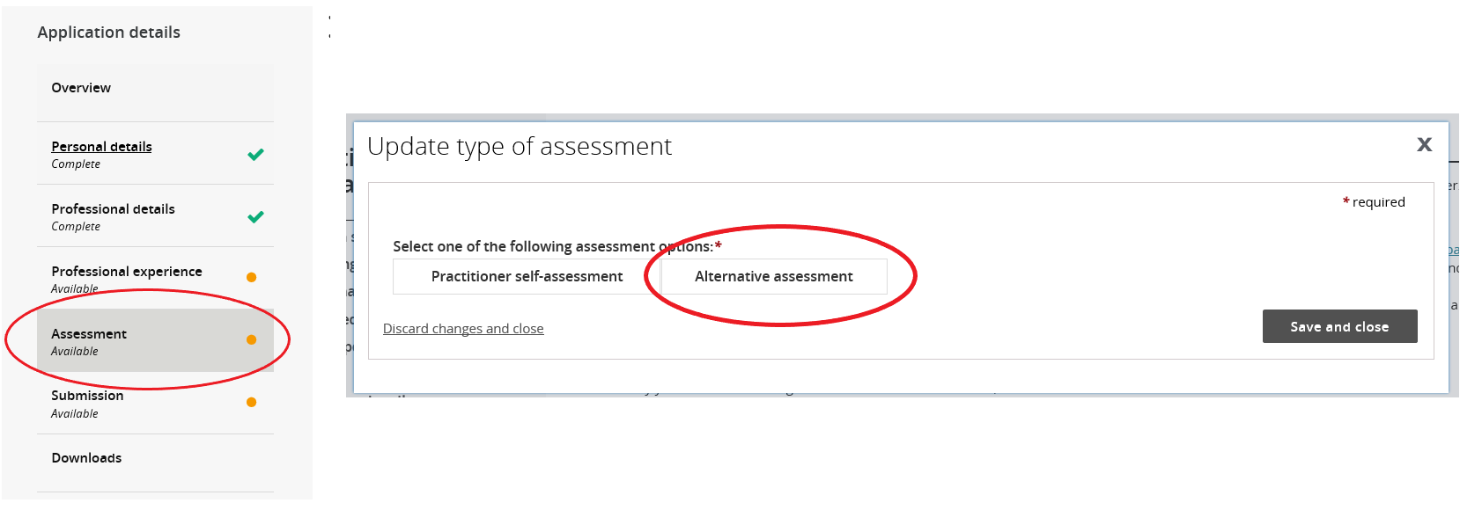

The following evidence must be attached to the application in the portal:
- A resume outlining any relevant experience, training and education;
- Certified copies of any relevant qualifications;
- A professional development plan which identifies how the individual will develop their capabilities across the seven domains of the Positive Behaviour Support Capability Framework
(at the Core practitioner level);
- A supervision agreement with a proficient level behaviour support practitioner or above, who will supervise the individual’s work and / or support them to develop the required capabilities;
- A completed new / entry-level practitioner declaration form (copy below).
- Optional evidence: Any other relevant evidence which demonstrates transferable skills (E.g., a classroom behaviour management plan, a safety plan, or a wellness recovery action plan).
Once submitted the application will be considered and the applicant advised of the outcome in writing.

Reconsideration of suitability
The NDIS Commission may outline additional tasks to be undertaken such as practicing under supervision and collecting a portfolio of evidence to demonstrate development at the core practitioner level.
The NDIS Commission will also specify a date (usually within 12 months) by when the practitioner’s suitability will be reconsidered. At this time, the practitioner will need to complete the self-assessment and endorsement process and upload this information in the applications portal in order to maintain their suitability as a core practitioner.

Further information and resources
The NDIS Commission’s Practitioner Suitability Assessment page contains further details and resources. You can also contact the NDIS Commission about this by emailing ndispractitioners@ndiscommission.gov.au.

General enquiries
Call: 1800 035 544 (free call from landlines).
Our contact centre is open 9.00am to 5.00pm (9.00am to 4.30pm in the NT), Monday to Friday, excluding public holidays.
Email: contactcentre@ndiscommission.gov.au
Website: www.ndiscommission.gov.au

New/entry-level practitioner Declaration Form
The following declaration should be completed and attached in the alterative assessment evidence tab in the applications portal.
Applicant Name: Click or tap here to enter text.

I declare:
☐ I am a new, entry-level practitioner seeking suitability as an NDIS behaviour support practitioner.
☐ I have not previously been considered suitable/provisionally suitable as an NDIS behaviour support practitioner, nor has my suitability status been revoked.
☐ I have attached a copy of my professional development plan which outlines how I will develop my capabilities at the core practitioner level across the seven domains of the Positive Behaviour Support Capability Framework.
☐ I have attached a copy of my supervision agreement with an NDIS behaviour support practitioner who is at the Proficient practitioner level or above, and commit to participating in regular supervision.
☐ I will collect a portfolio of evidence to demonstrate my developing knowledge and skills.
☐ I understand that practitioner suitability alone is insufficient to deliver behaviour support under the NDIS. I understand that I also need to be engaged by a registered provider who is registered for specialist behaviour support.
☐ I understand that my suitability will be reconsidered by the NDIS Commission in 12 months.

Signature:

Date: Click or tap here to enter text.

