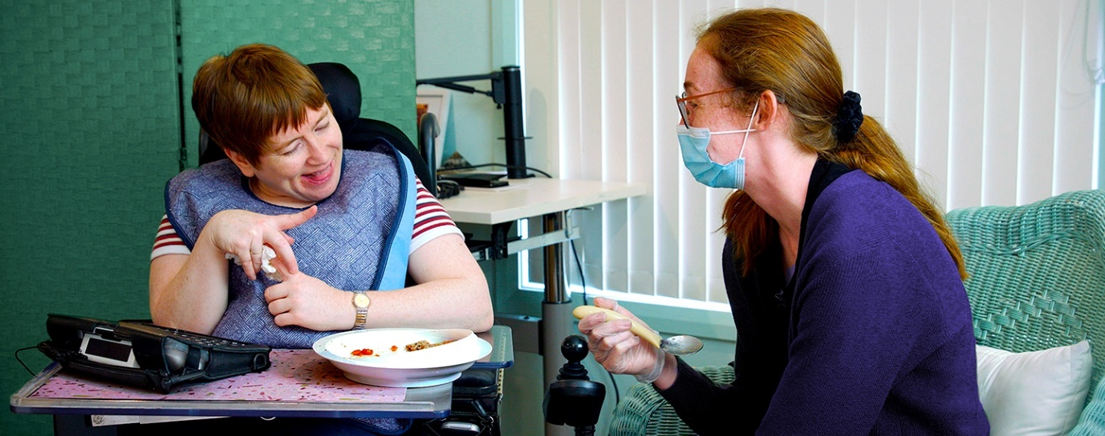
Masterclass
Co-Creating Safe and Enjoyable Meals in Disability Services: Pathways to Implementation Strategies

Introduction

The masterclass is designed to drive implementation of the ‘Co-Creating Safe and Enjoyable Meals for People with Swallowing Disability’ training, and strategies to improve mealtime safety and enjoyment of people with swallowing disability.

Resources include:
- 6 quick things you need to do to prepare for this Masterclass
- Masterclass program
- Worksheet materials
- Building your implementation framework

6 quick things you need to do to prepare for this Masterclass
- Read the Program
- Go online to visit the Project’s ‘Enjoy Safe Meals’ website
    - Watch the overview video, read the blog posts, and
    - Download the Additional Resources, the Cook’s Companion and the Implementation Guide from the resources page.
- Write a list of all of the policies and procedures in your organisation that impact upon meals. List all of the parties that you feel would need training in safe mealtime assistance
- Consider your current training offerings in your organisation, and consider how mealtime assistance training ‘fits’ in that program
- Reflect - Apart from ‘time’ or ‘money’, think of any other barriers to implementation of safe and enjoyable mealtime practices for people with swallowing disability (there are several other barriers to be considered)
- Ask your colleagues and partners about the training, resources, and their impressions.

Please use this word document as a place to keep your notes and ideas in response to the stimulus questions on page 7 and page 8.

You can bring this along on the day and take further notes from the ideas that you hear from others.

Masterclass program

2pm – Masterclass commences
- Acknowledgement of Country and Opening Address
- Overview of the Resources and Training Program and how they align with the NDIS Practice Standards and Quality Indicators in relation to dysphagia and mealtime assistance.
- Small Group Reflection – Initial thoughts about implementation in your organisation (come prepared to share in the small group); how is ‘mealtimes’ and ‘dysphagia’ currently considered and how does this package of resources add to or replace any of that?
- Implementation Planning – Considering common barriers to and facilitators for implementation of the strategies trained.
- 2.50pm – 10 minute break
- Small group discussions focused on the Key Questions listed below – Reflection Points in the Masterclass).
- Sharing in the large group and translation into Implementation Plans.
- Drafting up your own Implementation Plan – where to start and how to proceed from here?
- Implications and impetus for change.
- Online survey evaluating the Masterclass.

4pm – Masterclass ends

Learning outcomes

What will I learn?

The masterclass will help NDIS providers to meet registration requirements relating to the delivery of safe and enjoyable meals, while also reducing the risk of choking death and improving the nutritional benefits of the meals provided to those with swallowing disorders.

At the end of the masterclass you will:
- Understand the content and implications of the Co-Creating Safe and Enjoyable Meals for People with Swallowing Disability, and how this aligns with the NDIS Practice Standards.
- Know how to apply an Implementation Science approach in considering how you or your disability organisation might take forward the resources and materials in the training.
- Be prepared be prepared to discuss and decide within your organisation how to remove barriers and enhance facilitators to providing safe and enjoyable meals for people with swallowing disability.

Masterclass worksheet materials

These reflective questions are informed by the Theoretical Domains Framework for Implementation, the inclusive Onemda Evaluation Framework, and the NDIS Practice Standards and Quality Indicators.

You should familiarise yourself with the NDIS Practice Standards and Quality Indicators.
- Australian Government (2021). National Disability Insurance Scheme Legislation Amendment (Quality Indicators) Guidelines 2021. https://www.legislation.gov.au/Details/F2021N00274
- Australian Government, NDIS (2021). NDIS Workforce Capability Framework. https://www.ndiscommission.gov.au/workers/ndis-workforce-capability-framework

An Overview of Key Target Behaviours in the NDIS Quality Indicators for Standards
- Identify: Disability services/staff identify each participant requiring mealtime management.
- Assess: Each person with disability who requires assessment by a health professional obtains this.
- Include: People with disability are involved in the assessment & development of mealtime plans.
- Manage safety: Staff understand the person with disability’s needs and responds to their risks.
- Staff provide safe and enjoyable meals for people with disability and manage their health risks.
- Access and Follow Mealtime Plans for the people disability; plans are easily accessible to staff.
- Build in individual preferences and health recommendations. Staff plan effective menus with the person with disability, and provide nutritious meals that are enjoyable and meet the person with disability preferences with informed choices. Health professionals and disability services ensure healthcare recommendations are reflected in mealtime plans. Staff proactively manage risks.
- Prepare and provide texture-modified foods. Procedures are in place for workers to prepare and provide texture-modified foods and fluids in accordance with mealtime plans.
- Check the food texture is right, store food safely, and label correctly. Support workers store food safely and check that the correct meal of the correct texture is provided.

Reflection points in the Masterclass (consult with your colleagues before attending if possible)

Barriers/Enablers
- What are the key barriers and facilitators to disability organisations and support workers implementing the strategies needed to meet the NDIS Practice Standards for Mealtimes and Severe Dysphagia? [Indicators 1-9]

Experiences
- What are the experiences of adults with ID of mealtime management? [Indicators 3, 5, 7]
- How are they included in the design of their mealtime plans? Do they have choices?

Behaviours
- What behaviour change techniques are appropriate to target key barriers to support workers implementing the strategies trained in the Co-Creating Safe and Enjoyable Meals training?

Costs and impacts
- What are the costs and impacts of implementing the strategies as intended, to improve the care quality and safety, health and quality of life of adults with disability and dysphagia?

Outcomes
- What outcomes are measurable and demonstrate change in disability services - striving to meet the Practice Standards through their policies, practices, training, and staff support?

Indicators
- What are the indicators of success in the implementation of the strategies to improve mealtime practices? What are the indicators of risks, dangers, and deterioration?

Acceptance
- Will the implementation frameworks make a meaningful difference, in prevention of choking in adults with disability?
- Will the frameworks be adopted by staff to build a culture of inclusive, safe meals?

Influence
- Does the organisation provide a feasible and sustainable approach to enable disability services to meet the NDIS Practice Standards?

Build your own framework for implementation
- Should the organisation embark upon the ‘train the trainer’ model, or outsource the training?
- Who needs training within the organisation? (hint, it is not only Direct Support Workers)
- How often do they need training? (hint, this will vary according to their role)
- How are other staff supported to implement the strategies? (those who have not been trained)
- What policies are needed to support implementation of the trained strategies? (systems level change to support implementation)
- When should the training program commence?
- How will it be supported with time and funding?
- What evaluation points will be important, and who will decide these?
- What outcomes are important to track in the organisation?
- How will the organisation engage with people with swallowing disability in relation to the training and implementation of strategies?

