Recording a mid-term audit - tasking in COS

Including tasking a change in scope as part of the mid-term
Quick Reference Guide – Auditor

If there has been no change in the scope of the registration during the mid-term audit the Auditor is required to complete Part A only of this QRG.
A change in scope to the current registration of a provider is a variation to the registration. When this has occurred within the mid-term, the Auditor is required to complete Part A and Part B of this QRG.
For information on recording the result of assessment against Schedule 1, Part 3, subsection 16A Emergency and disaster management refer to QRG Updating audit outcomes for new NDIS practice standards in COS.

Part A - Add mid-term audit in COS
- Log in to the NDIS Commission’s business application system.
Select Registrations from the menu bar and select Registration search.

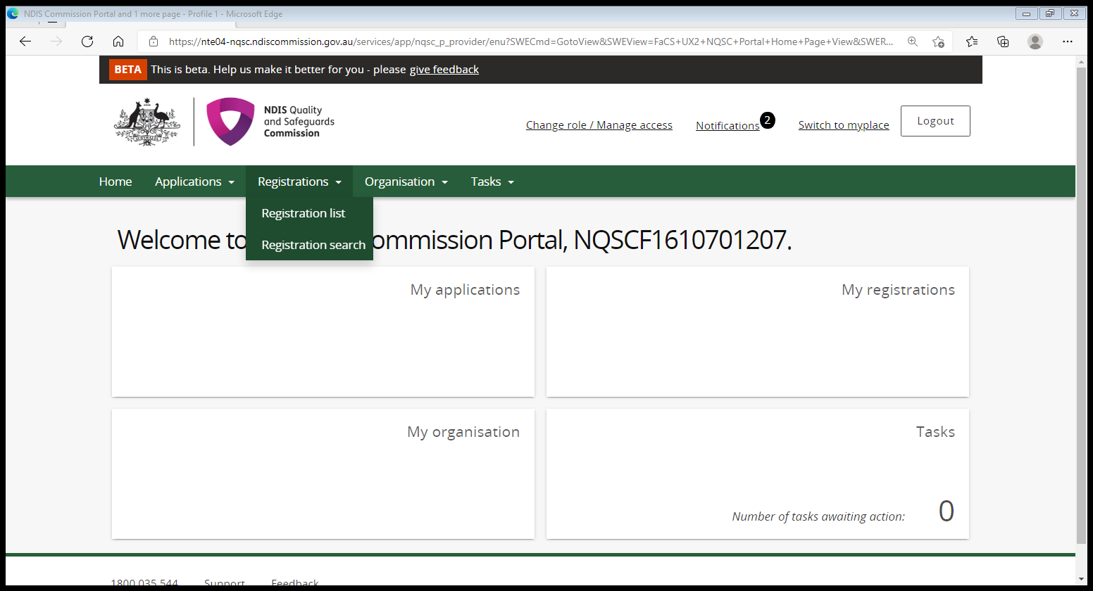

- Enter the Registration ID and Select Run search.

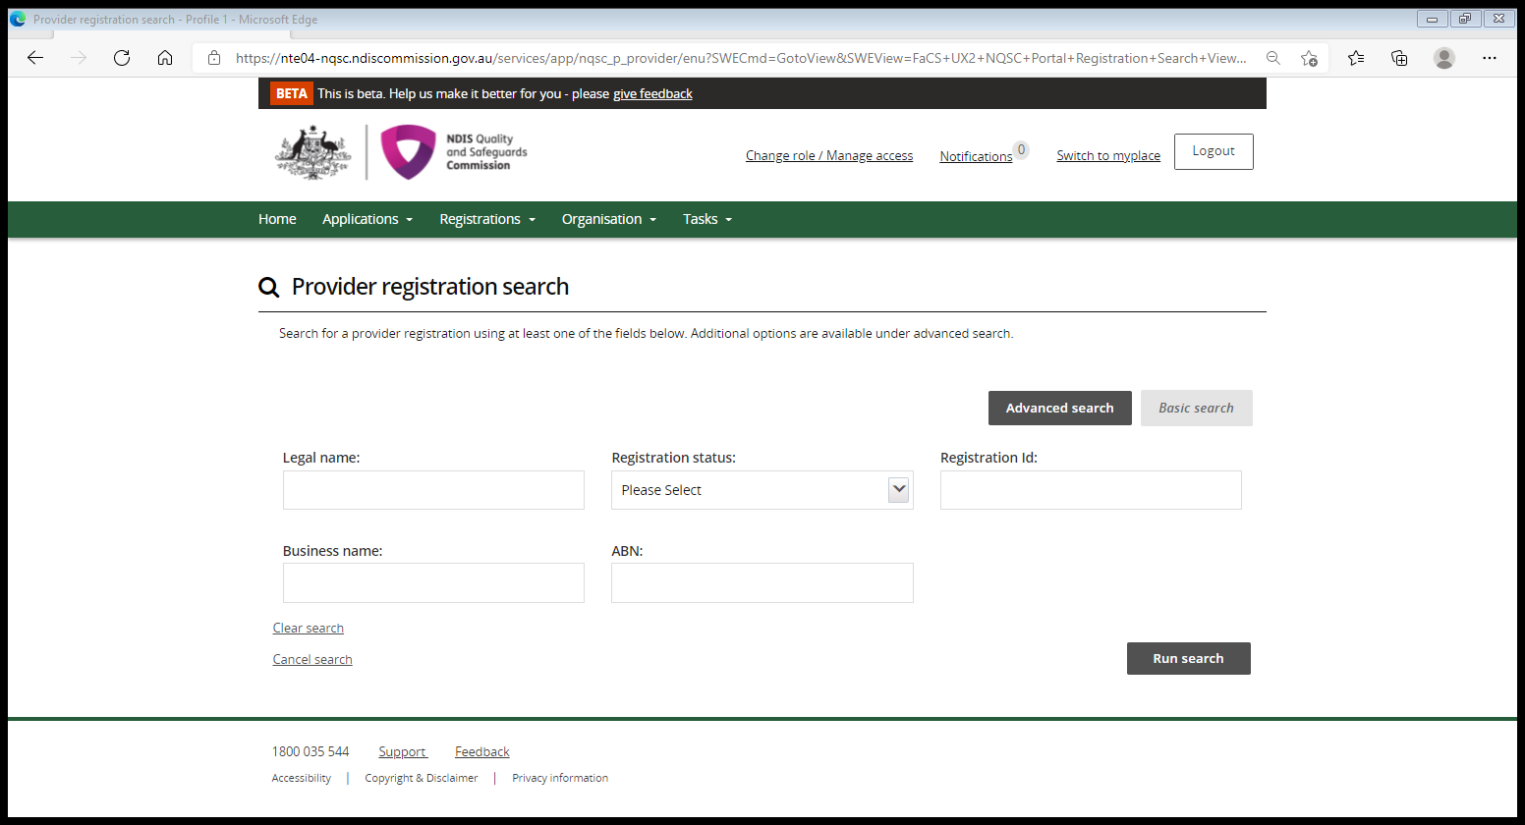

- Select View from the result list.

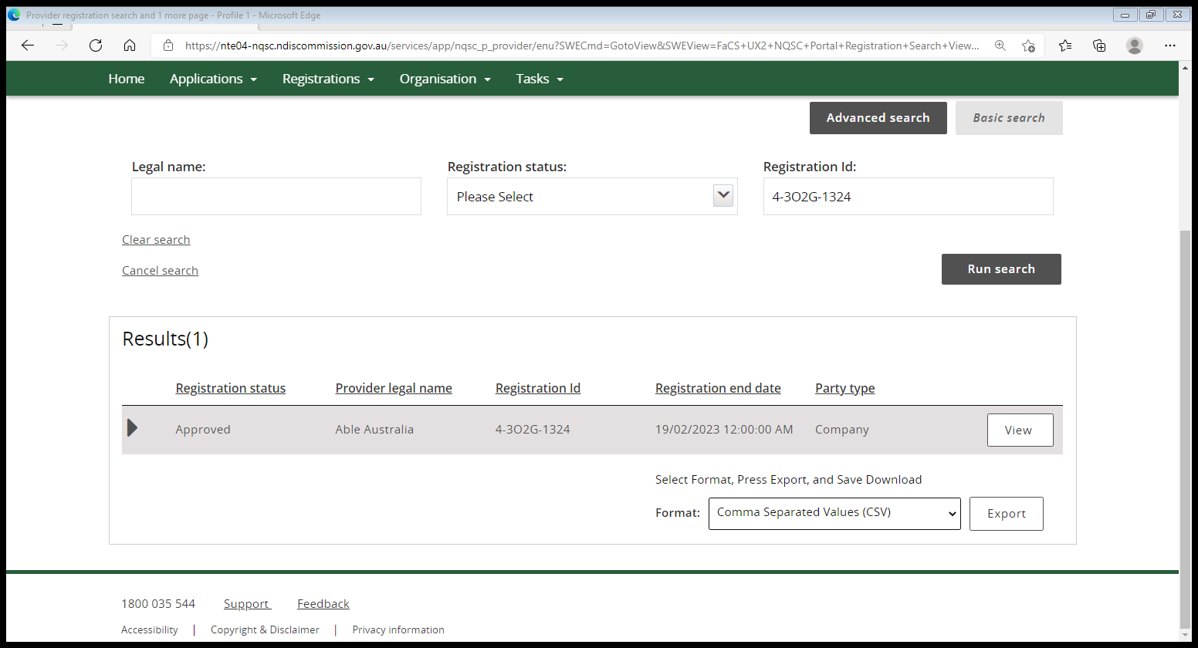

- In the left hand tab select Periodic audits.

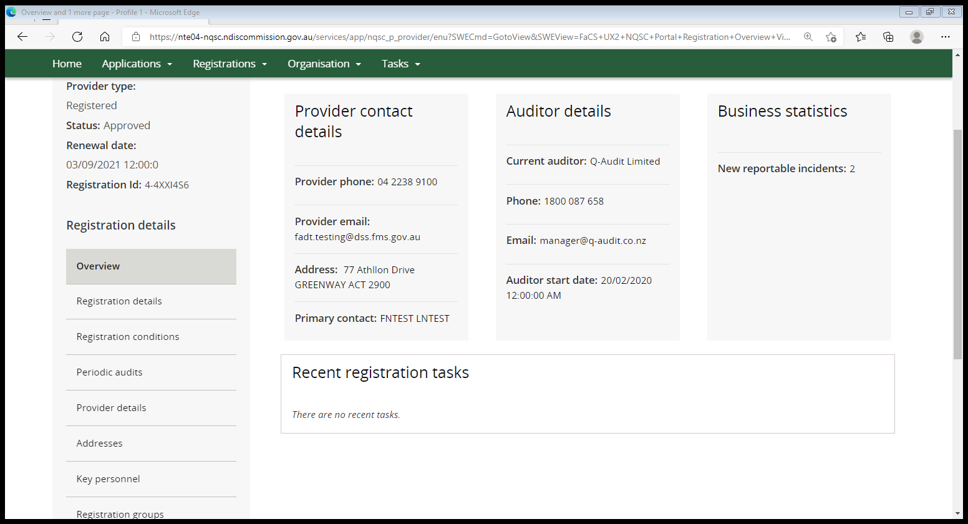

- If the mid-term audit has been created, click on the Action button and select Update. Move to step 8.
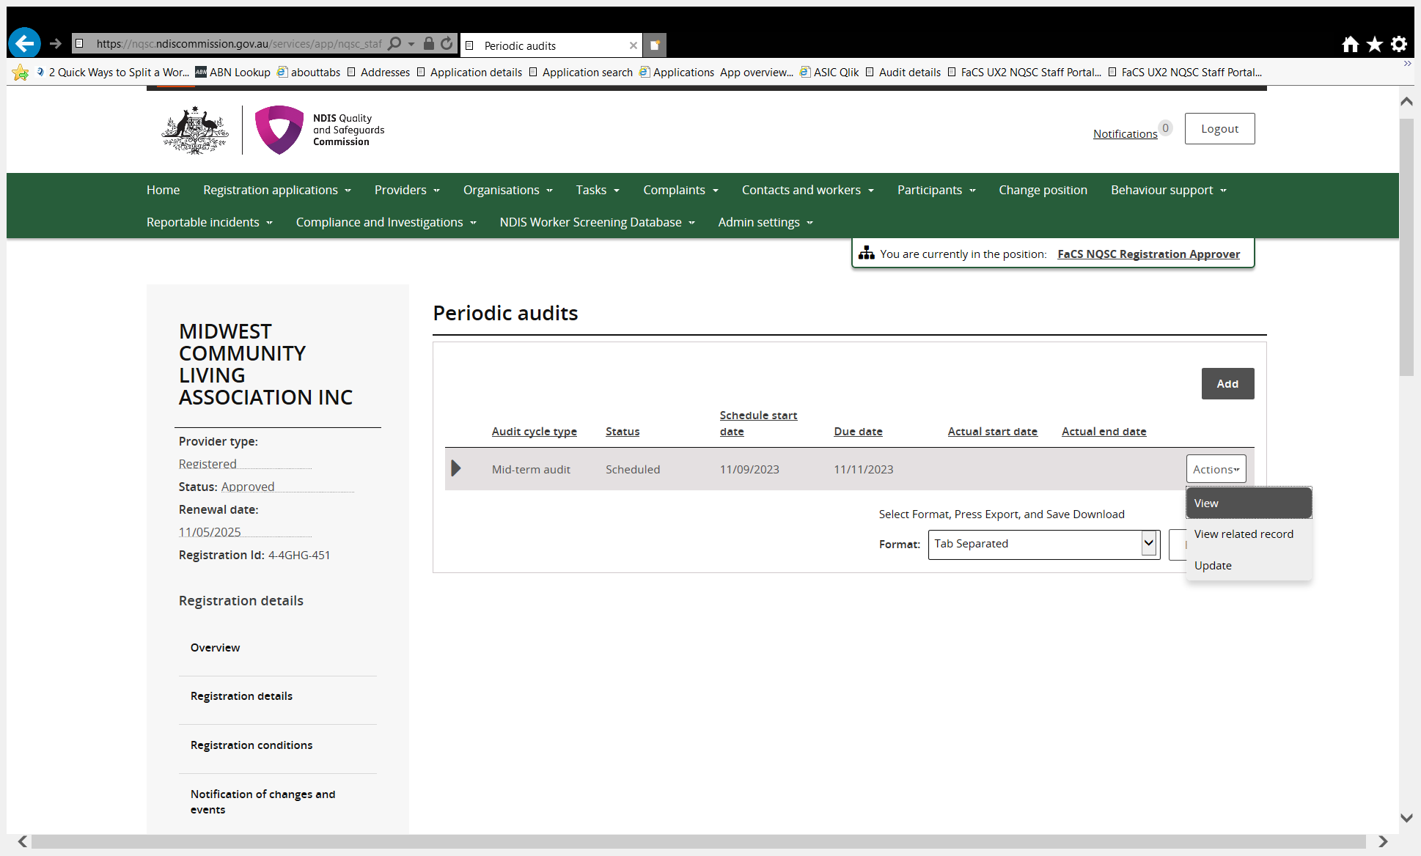

- If the mid-term audit has not been created, select Add to create.

- Update the audit details (only complete the below fields in red), auditor to use exact wording/details shown below. Select Save and return. You have now created a mid-term audit. Move to step 8.

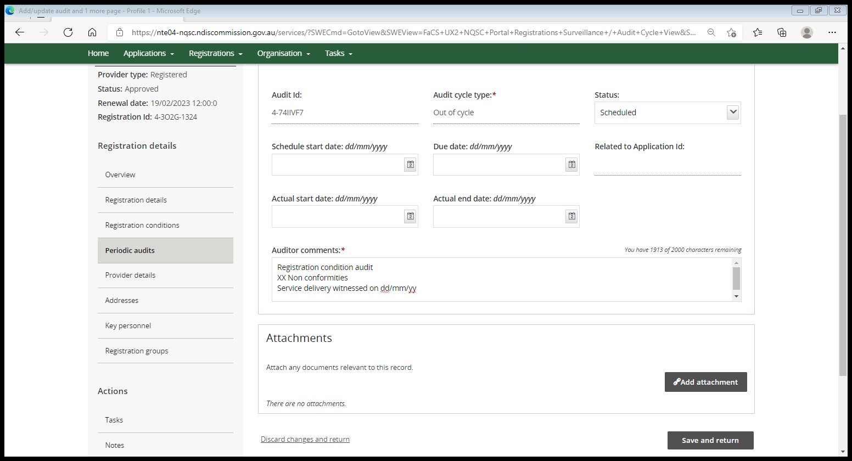
Complete this field with the audit schedule date (18 months from registration start date).
Mid-term audit
Select status to ‘Scheduled’. Do not change status to “In progress” until the audit has commenced. Do not change the status to “completed” until each practice standard has been finalised, the Corrective action plan (if applicable) has been reviewed and documents uploaded. Once the status has been changed to ‘Completed’, no other changes can be made by the auditor or the Commission.

Select ‘Mid-term audit’ from the drop down list.

Cont’d

***IMPORTANT*** From June 2022, providers will receive an automated notice if COS does not reflect that a mid-term audit has commenced by the 18 month mark.

Auditors must update the mid-term to ‘In progress’ in COS as soon as the audit has commenced to prevent notices being sent to providers who have commenced the process.

- To move an audit to In progress, navigate to the Periodic audits tab and select update (only complete the below fields in red), auditor to use exact wording/details shown below. Select Save and return.

In progress
Change status to ‘In progress’ once audit has commenced. Do not change status to ‘Completed’ until each practice standard has been finalised, the Corrective action plan (if applicable) has been reviewed and documents uploaded. Once the status has been changed to ‘Completed’, no other changes can be made by the auditor or the Commission.
Complete this field with the audit start date.
Mid-term audit

Cont’d

- To move an audit to Completed, navigate to the Periodic audits tab and select update, (only complete the below fields in red), auditor to use exact wording/details shown below. Once the audit has been completed, upload any attachments by selecting Add attachment and attach audit report and any other supporting documentation. Select Save and return.

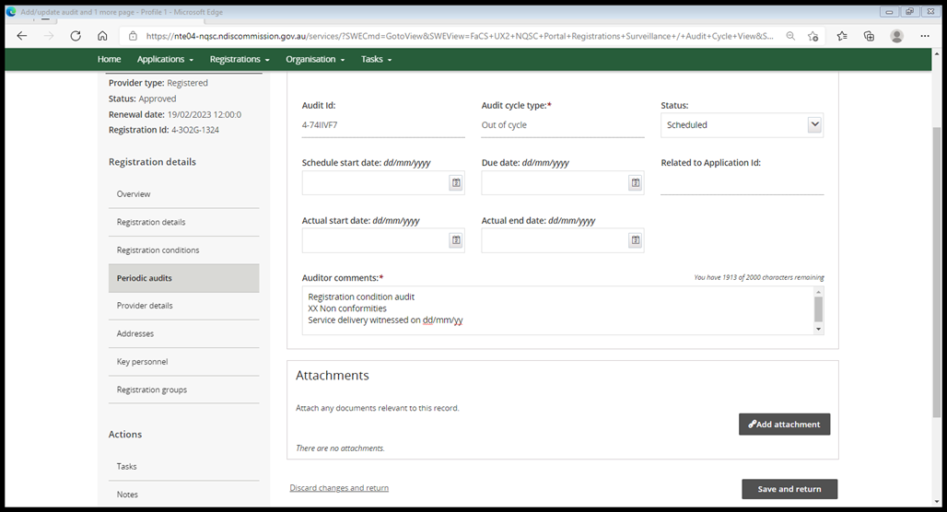
Complete this field with the audit report submitted date.
Change status to ‘Completed’ once audit and each practice standard has been finalised, the Corrective action plan (if applicable) has been reviewed and audit report submitted/ documents uploaded. Once the status has been changed to ‘Completed’, no other changes can be made by the auditor or the Commission.

Completed
Mid-term audit

End.

Continue to next page for Part B

Part B – Create a task in COS

PART B Create Task in COS - tasking a change in scope as part of the mid-term
To be completed ONLY if the mid-term is to increase/decrease scope in service delivery.

- Select Registration from the menu bar then click Registration search
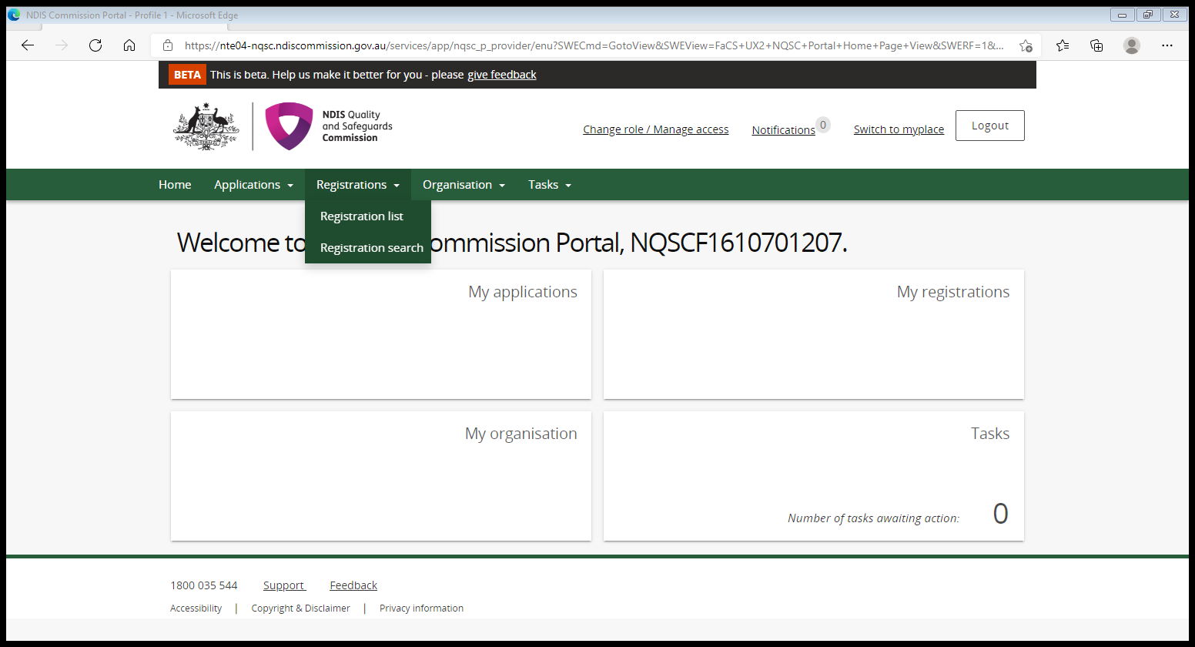
- Enter the Registration Id and select Run search.
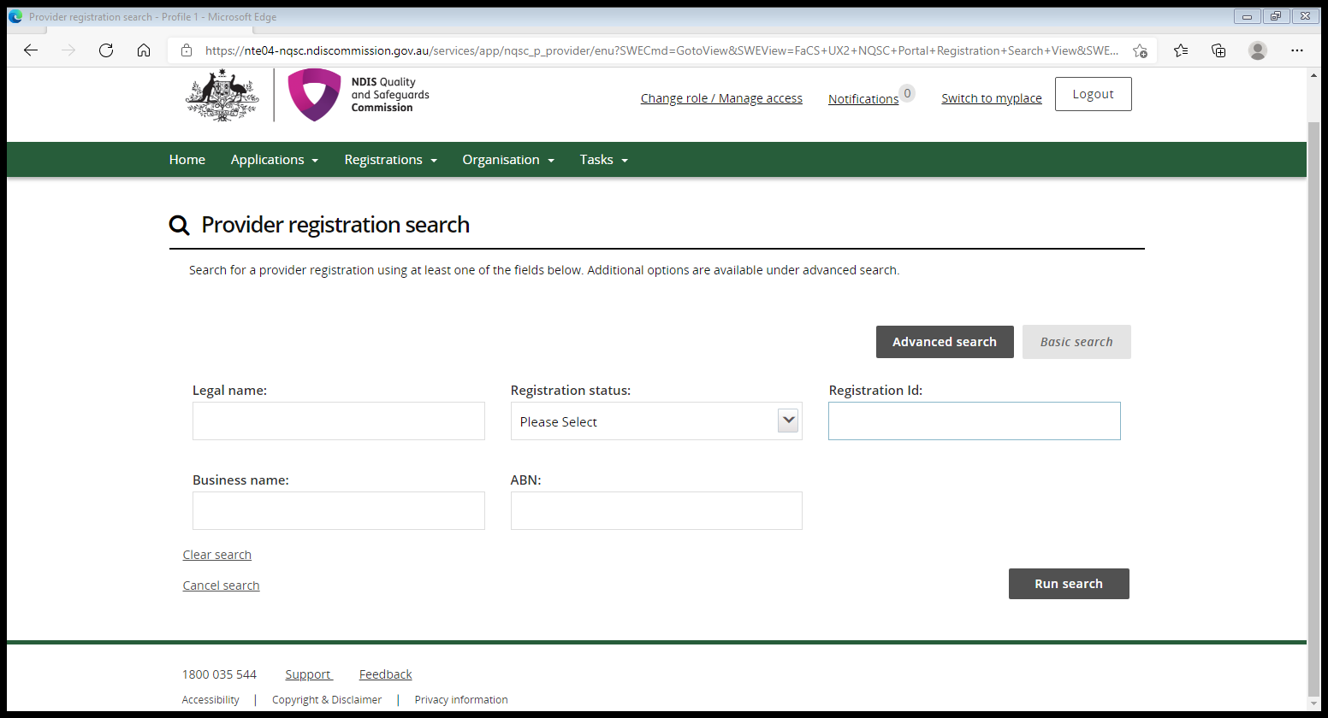
- Select View from the result list.
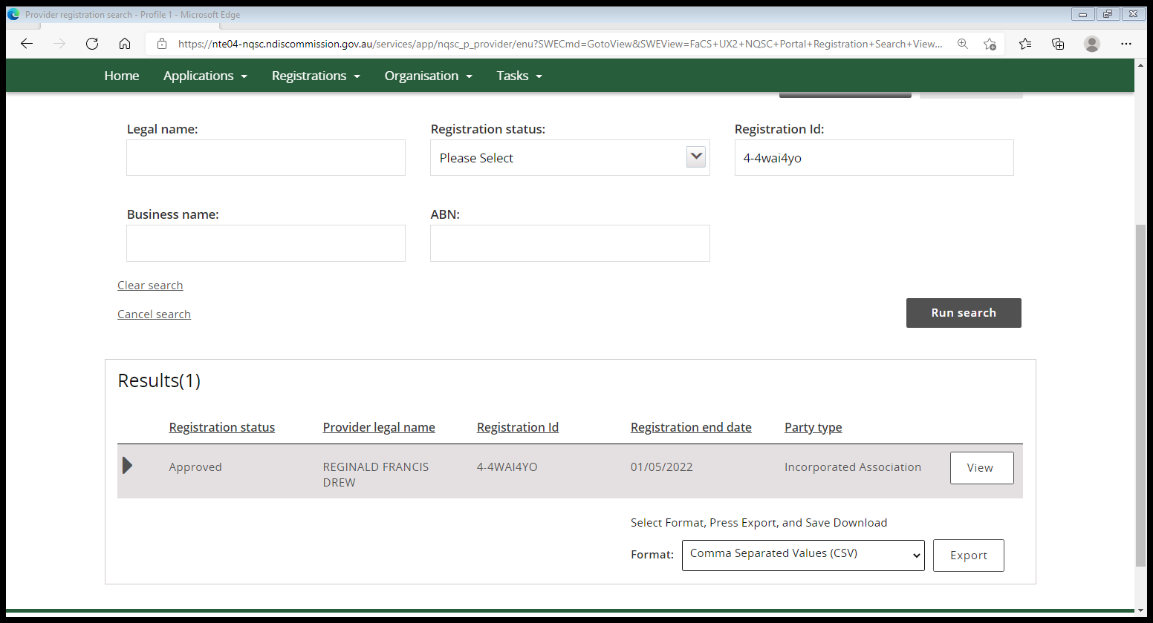

- Scroll down the left hand tab and under the Actions heading select Tasks this will open the Task box.
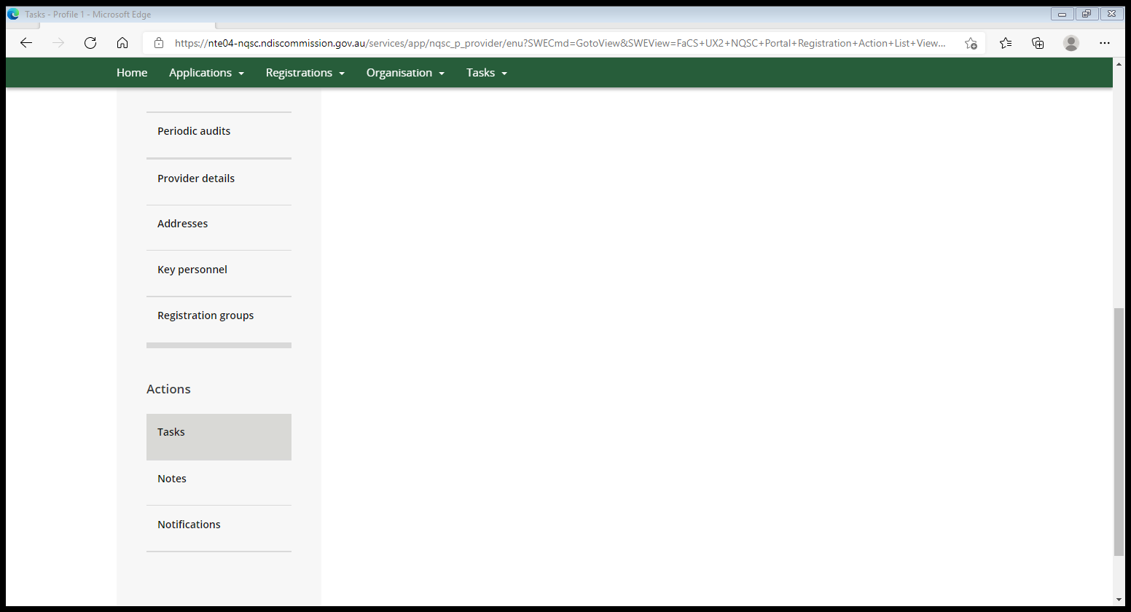

- In the Task box select, Add.
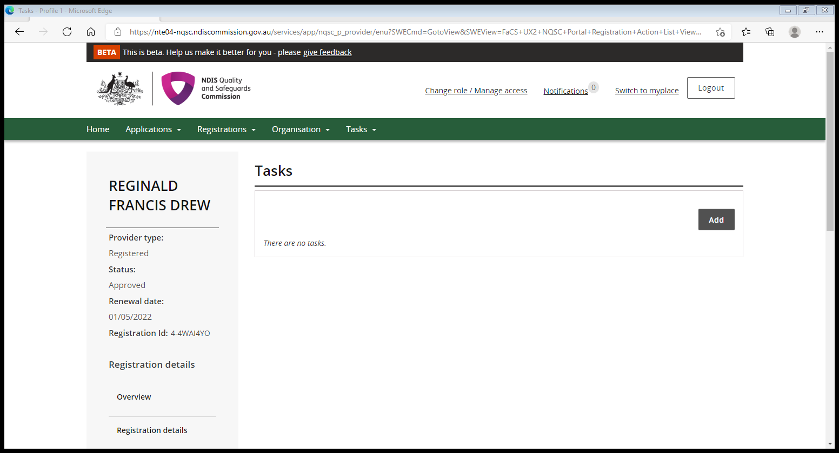

- Complete details (only complete the below fields in red), auditor to use exact wording below.
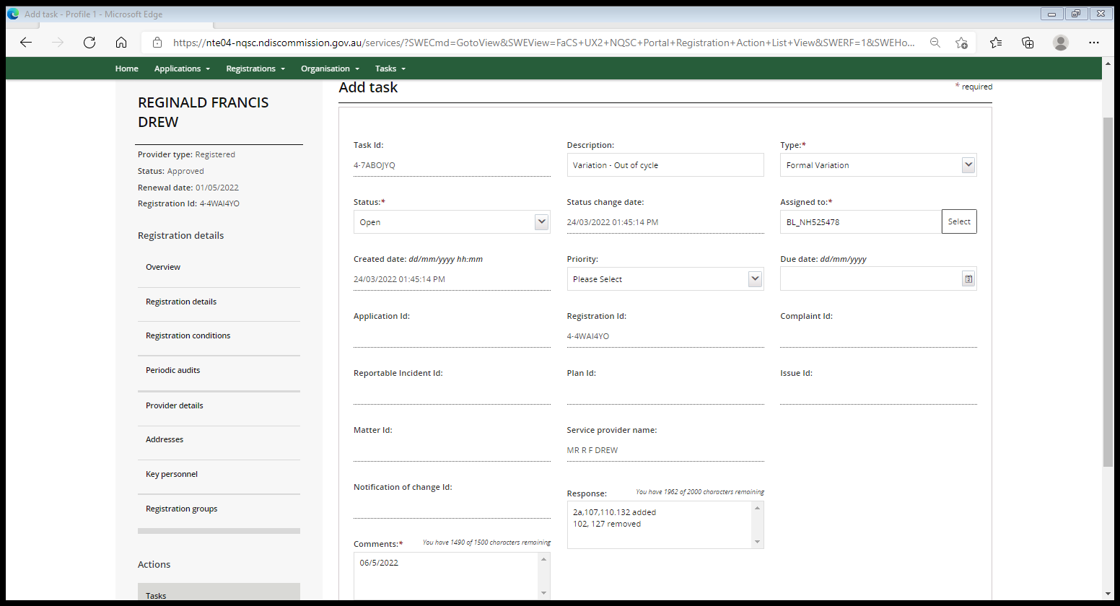
Variation – Mid-term
2a, 107, 110, 132 added
102, 127 removed
Server dysphagia added
Use this field to list the registration groups or service delivery added and the registration groups or service delivery removed. Use the format shown.
Select ‘Formal Variation’ from the drop down list.
06/05/2022
This must be the date the audit report was submitted. Use the format shown dd/mm/yyyy.
Use exact wording, ‘Variation – Mid-term’.

- Once completed select Save and return.
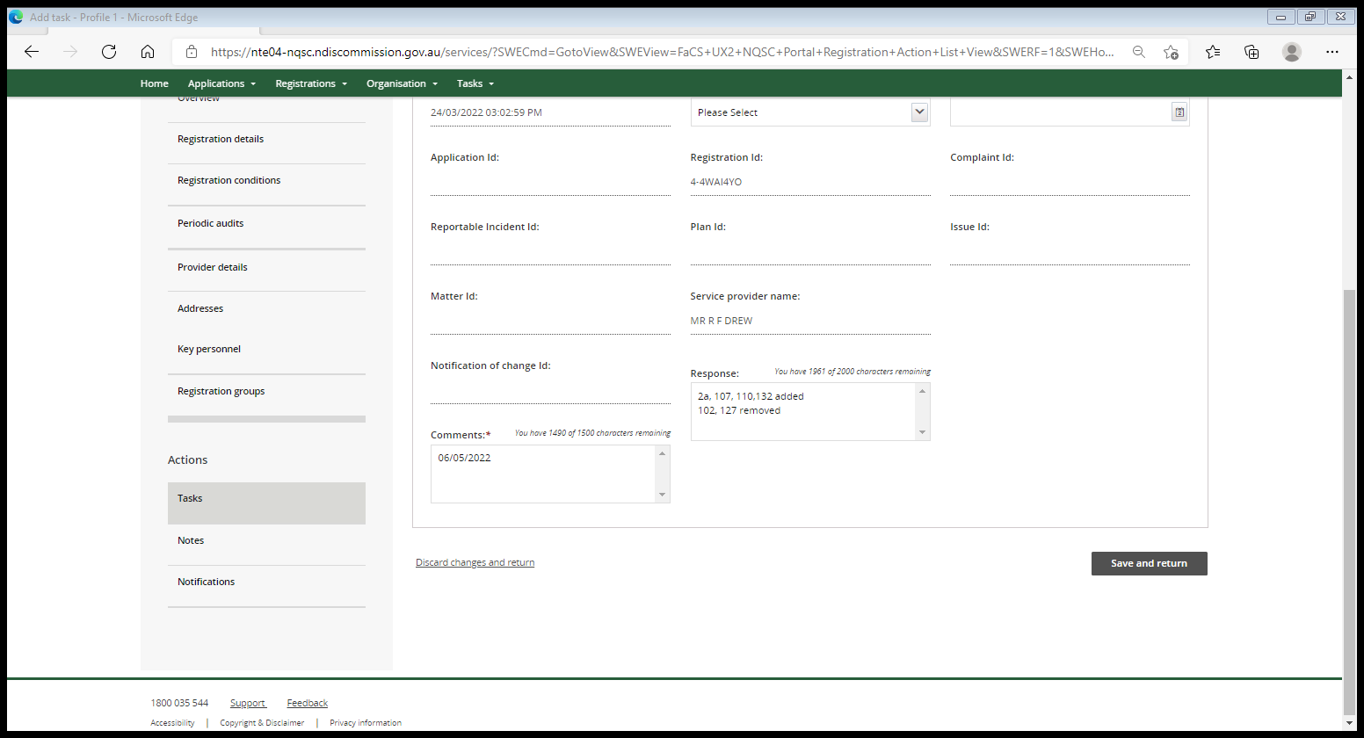
End.

