Quick reference guide: Screening verification requests
Unregistered provider, self-managed participant & plan-managed participant

Contents
Contents 1
Overview 1
Notification about a verification request 2
Respond to a verification request 4
Verify a worker 5
Reject a worker 6
View previous verification requests 6

Overview
- The NDIS Worker Screening Database (NWSD) is a national database which stores NDIS Worker Screening Check information about workers who deliver NDIS supports and services.
- When a worker applies for a NDIS Worker Screening Check they must nominate at least one employer to verify their application. An employer in this regard may include an unregistered provider, self-managed or plan-managed NDIS participant. The nominated employer/s will receive an email notification requesting verification of the worker.
- You must verify the worker if you intend for them to deliver NDIS supports and services and you have decided to require workers to have an NDIS Worker Screening Check. Once verified, you will be able to view the worker’s record in the NWSD and you will receive updates about their NDIS Worker Screening Check status.
- You have 30 days to action a verification request. A reminder email will be sent to you 28 days, 14 days, 7 days and 1 day prior to the expiry of the verification request.
- Once verified, the worker’s application will progress and screening will commence.
Tip 1 - A worker can nominate multiple employers, but only one employer needs to verify their NDIS Worker Screening Check application for it to progress to screening. Once one employer has verified the application, the other employers will no longer receive the verification reminders. However, you must verify the worker if you intend for them to deliver NDIS supports and services.
For further information please refer to the NDIS Quality and Safeguards Commission website
(Unregistered providers and Worker Screening (self-managed and plan-managed participants)).
Alternatively, contact the NDIS Quality and Safeguards Commission on 1800 035 544 or by email at nwsd@ndiscommission.gov.au.

Notification about a verification request
- You will receive a notification about a verification request in your ‘Inbox’.
Unregistered providers:
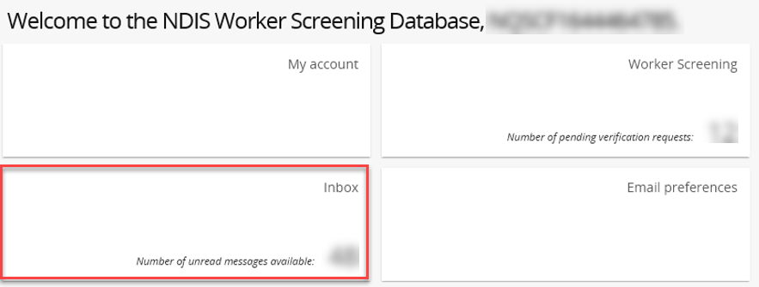

Self/plan-managed participants:

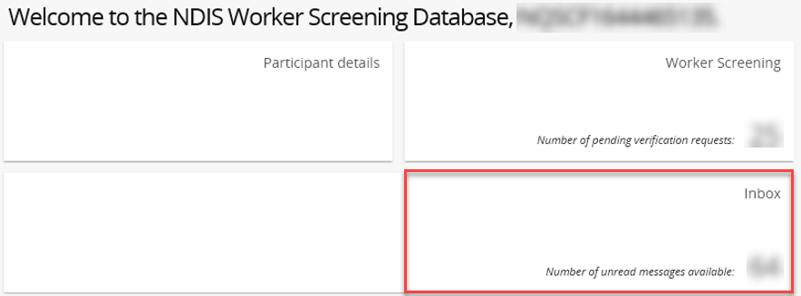

- Identify the ‘New verification request’ or verification reminder message, select ‘Actions’ and ‘View verification requests’.
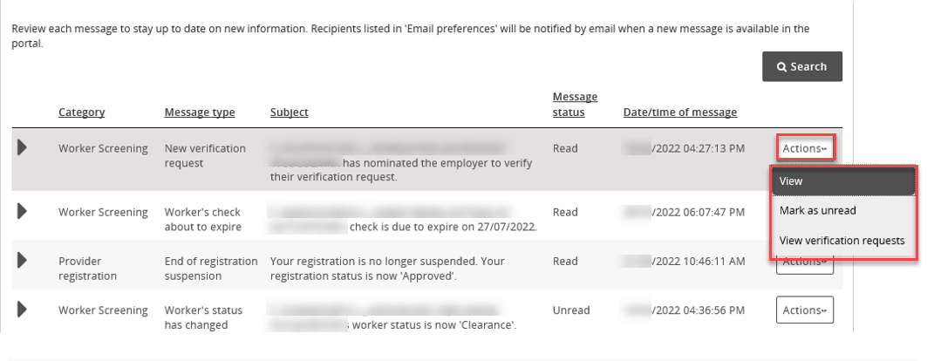
- Select ‘View verification requests’ to navigate directly to the verifications page.

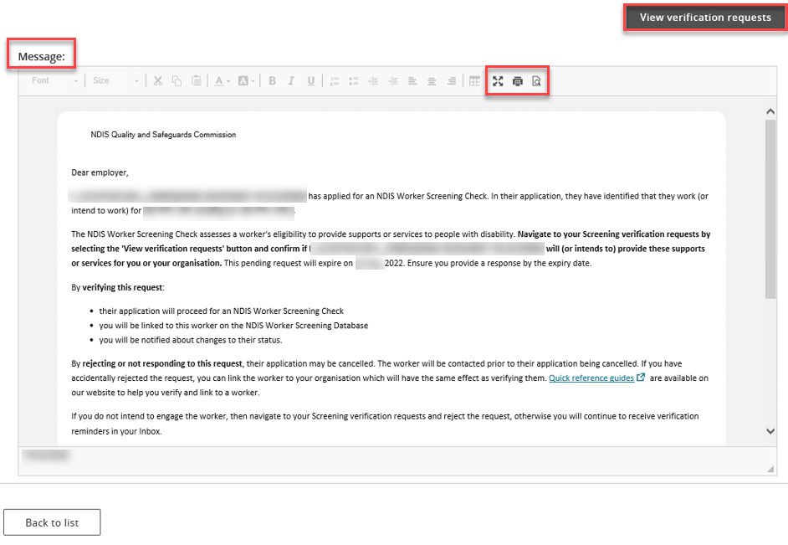

Respond to a verification request

- Locate the worker you have received the verification request for and select ‘Respond’.
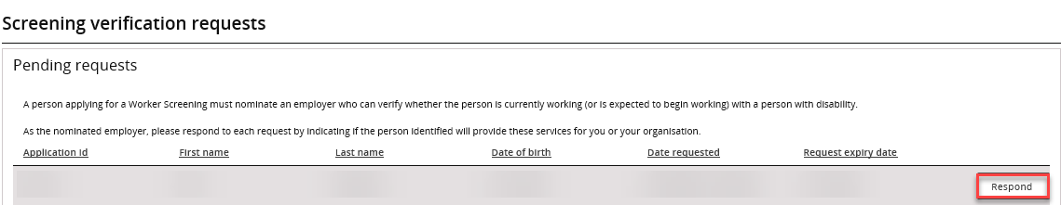
- Select either ‘Verify’ or ‘Reject’.
  - If you verify the worker, you are confirming that they will provide NDIS supports and services for your organisation (if they receive a clearance).
  - If you reject the worker you are confirming that they will not provide NDIS supports and services for your organisation.
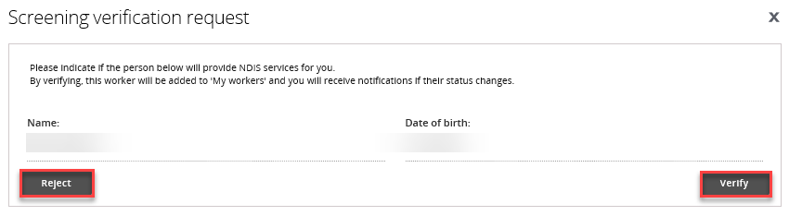

Verify a worker
- Once you select ‘Verify’ the worker will be linked to your organisation and appear on the ‘My workers’ tab.
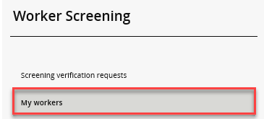
- You will receive updates about the NDIS Worker Screening Clearance status for all of your linked (verified) workers e.g. when they receive an NDIS Worker Screening Clearance, when their NDIS Worker Screening Clearance is due to expire etc.
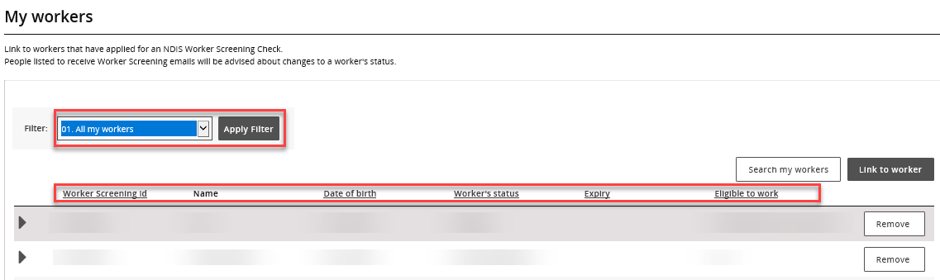

Reject a worker
- If you reject a worker you will not be able to view their worker record and will not receive updates about their NDIS Worker Screening Check status.
Tip 3 - If you accidentally reject a worker, you can link them to your organisation. Refer to the Quick reference guide – Unregistered provider – SMP & PMP - Link a worker. Once linked you will be able to view the worker record and will receive updates about their NDIS Worker Screening Check status.
Tip 4 – If you are the only employer on an application and you accidentally reject a worker, contact the worker and ask them to get in touch with the Worker Screening Unit and request that they are linked back onto the application.

View previous verification requests
- To view your verification request history navigate to the ‘Screening verification requests’ tab and view the ‘Past requests’ section.
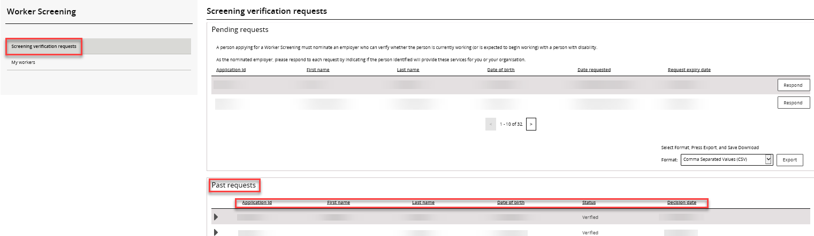
Tip 5 – You will receive email notifications about your verified (linked) workers regarding their NDIS Worker Screening Check status:
0
- 90 days prior to when their NDIS Worker Screening Check is due to expire; and
- if there is a NDIS Worker Screening Check status change e.g. they have been excluded and are no longer eligible to work.

