Quick reference guide:
Generate Employer ID document
Unregistered NDIS Provider & Self or Plan-Managed Participants

KEY MESSAGES
- This quick reference guide provides information about how to generate a document to give to workers which provides the Employer ID. Providing this document will assist your workers in accurately selecting you as an employer as part of their application for an NDIS Worker Screening Check.

- When a worker applies for a NDIS Worker Screening Check they must nominate at least one employer to verify their application.

- Using an organisation’s Employer ID is the most accurate way for a worker to nominate an employer for their NDIS Worker Screening Check application.

- If a worker nominates your organisation as their employer, you have 30 days to action a verification request. A reminder email will be sent to you 28 days, 14 days and 7 days prior to the expiry of the verification request.

- Once verified, a worker’s application will progress and screening will commence.

CONTACT US
WEB | Worker screening EMAIL | nwsd@ndiscommission.gov.au PHONE | 1800 035 544

How to generate Employer ID document

Access the ‘About my role as an employer’ section
- Go to the NDIS Commission Website and select the ‘Portals’ button and ‘Unregistered NDIS providers’ or ‘Self-managed NDIS participants’ option.
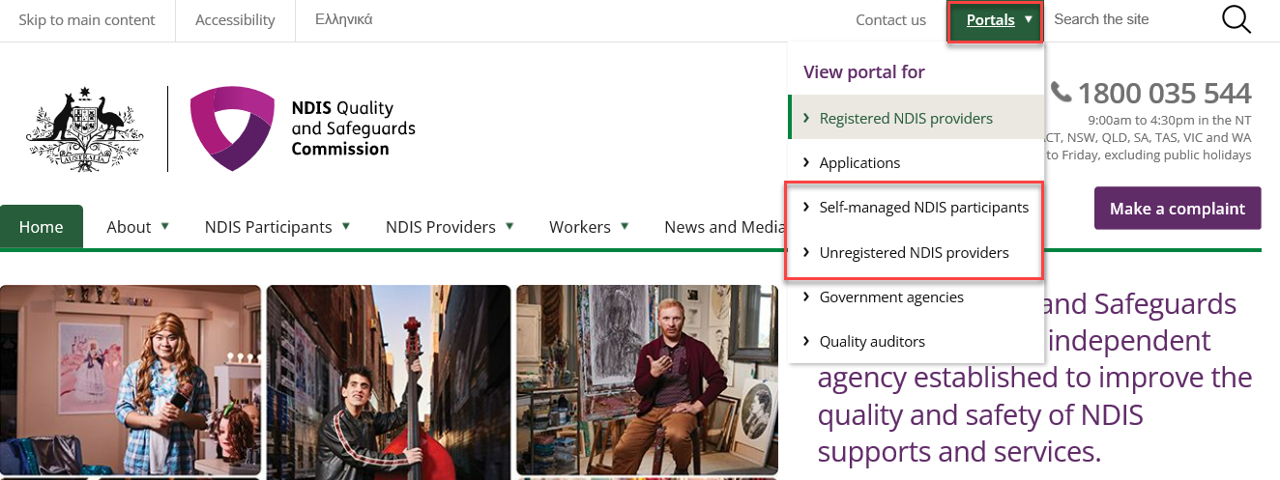
- Select ‘Login with PRODA’.
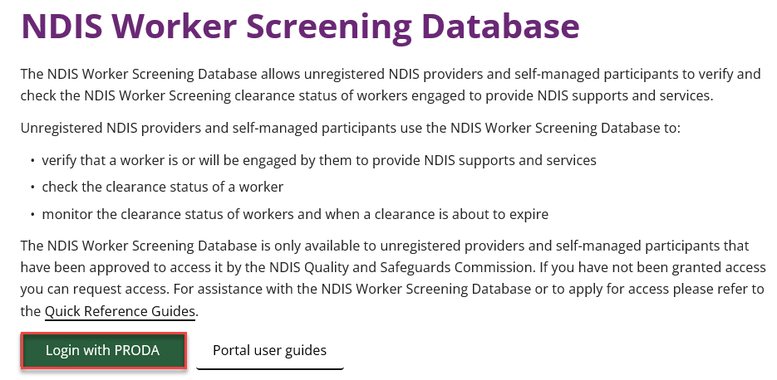
- At the ‘Portal entry point’ select the ‘Provider name’ of the unregistered NDIS provider, self or plan-managed participant that you are logging into the NDIS Worker Screening Database on behalf of. Select either ‘Worker screening for organisation or ‘Worker screening for participants’ as the ‘Role’.

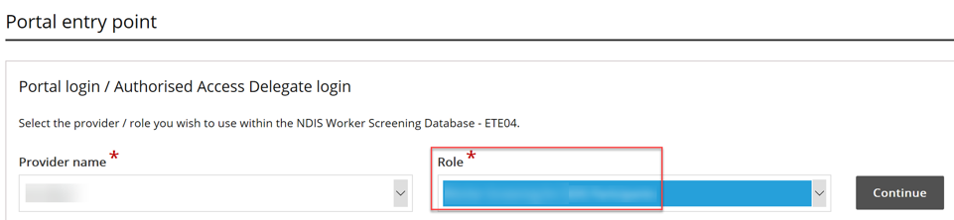
- Select the ‘Worker Screening’ tile.

Unregistered providers:

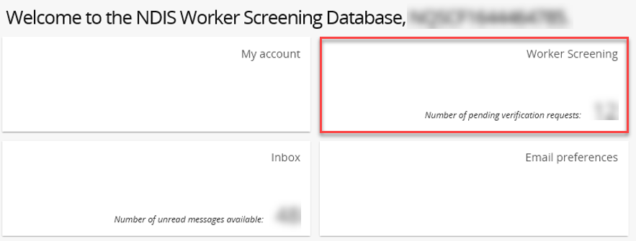

Self or plan-managed participants:

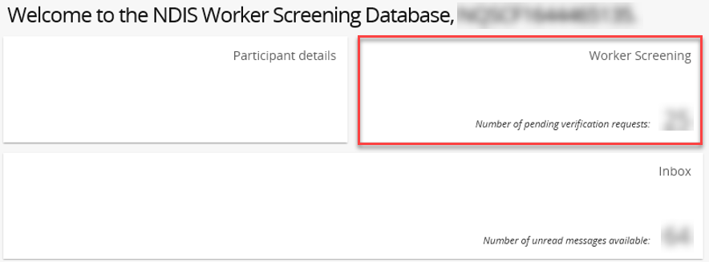

- Select the ‘About my role as an employer’ menu option.

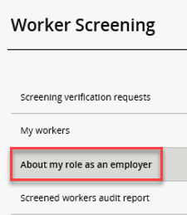

Generate a document with your Employer ID

- You will be presented with information about your role as an employer. 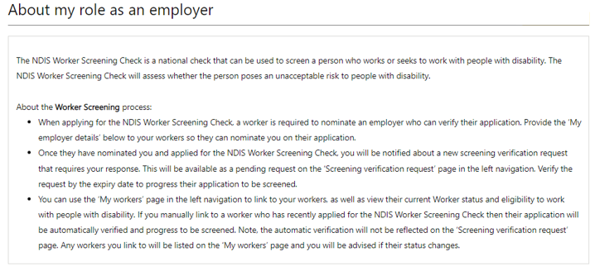

- To generate a document to provide to your workers’ that includes your Employer ID, select ‘Generate document’, and ‘Download’ the document.
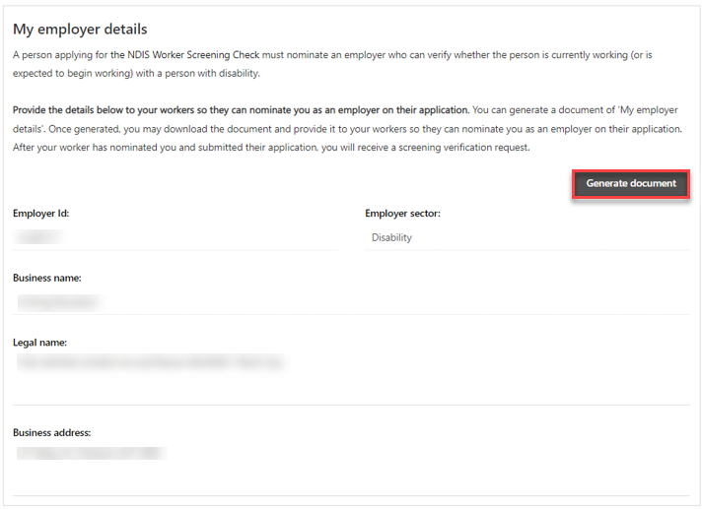
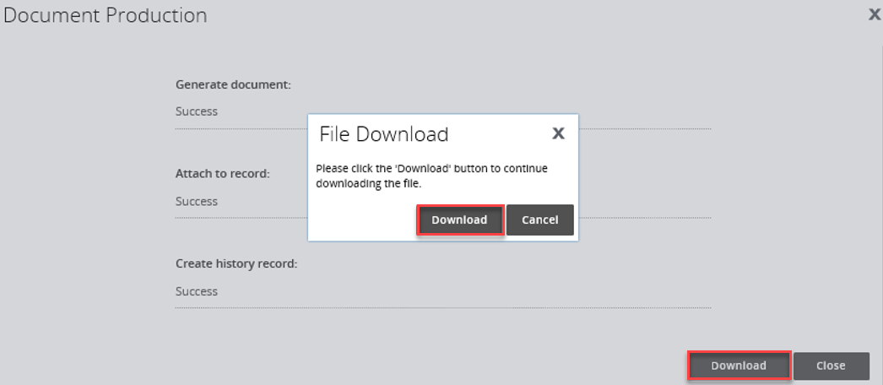

- The document can be saved and will be available on the ‘Attachments’ section of the page once it has been downloaded.

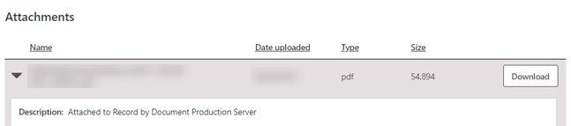
- An example of the document which will be generated is provided on the next page. Provide this to your worker’s so that they can accurately nominate your organisation on their NDIS Worker Screening Check application by using your Employer ID.

