Update registration application
IT Quick Reference Guide – Auditor

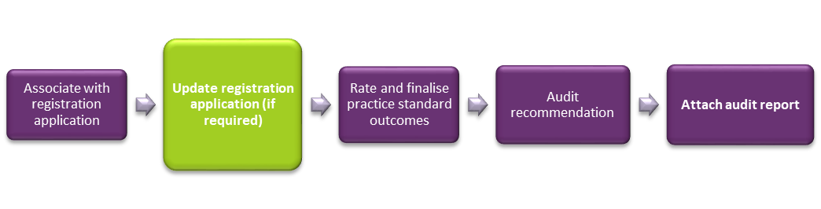
This guide demonstrates how to update a registration application in the NDIS Commission business system. This guide will help you to do the following:
- Search for and view the registration application
- Update provider details
- Add key personnel
- Update key personnel
- Remove key personnel
- Add address
- Add an outlet
- Manage an outlet
- Remove an outlet

Search for and view the registration application
- Type the Application reference number then click Run search.
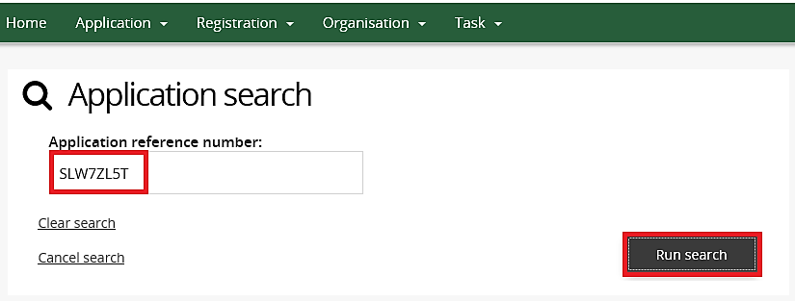

- Click the Actions drop down menu and then select View.
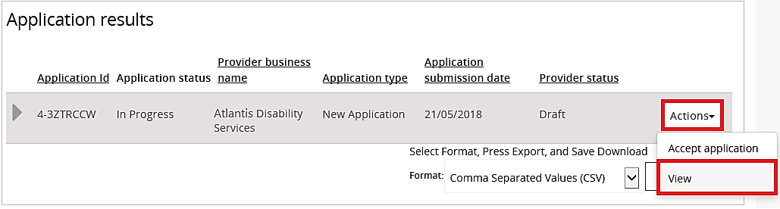
The registration application is displayed.

Update provider details
- Click Provider details from the left hand side menu then click Update.
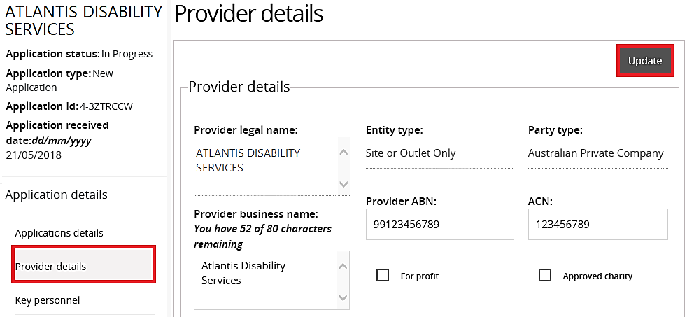
- Update the required Provider details.
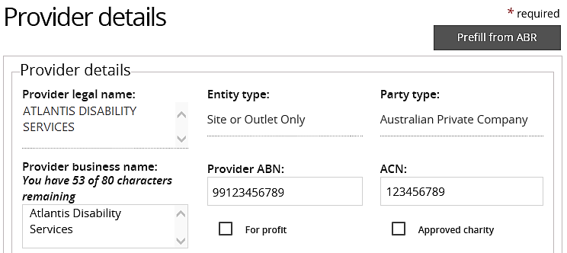

- Click Save.
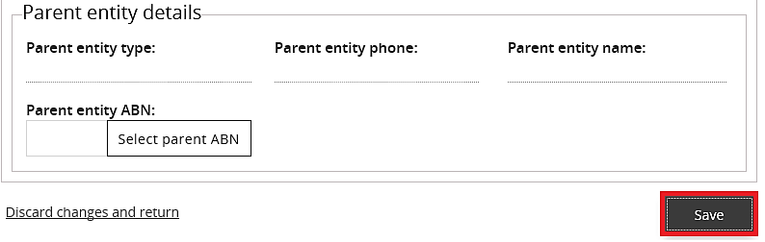
The Provider details have been updated.

Add key personnel
- Click Key personnel from the left hand side menu then click Add.
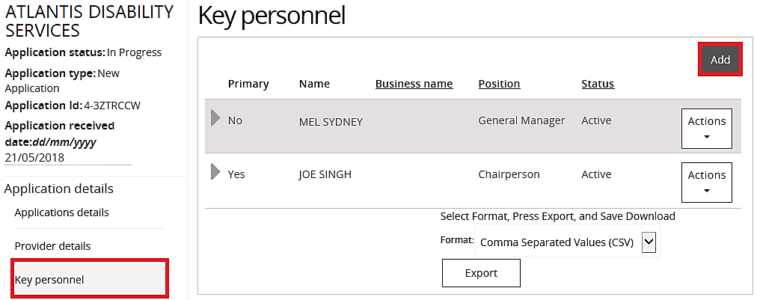
- Type the Key personnel details then click Save and close.
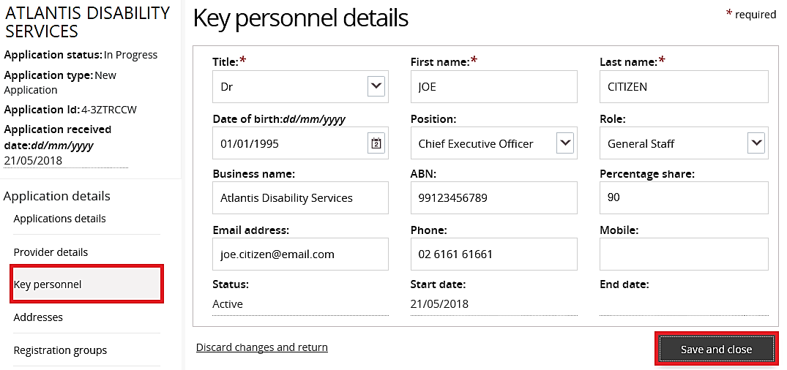
New Key personnel have been added.

Update key personnel
- Click Key personnel from the left hand side menu.
- Select the Key personnel to update, click the Actions drop down menu then select Update.
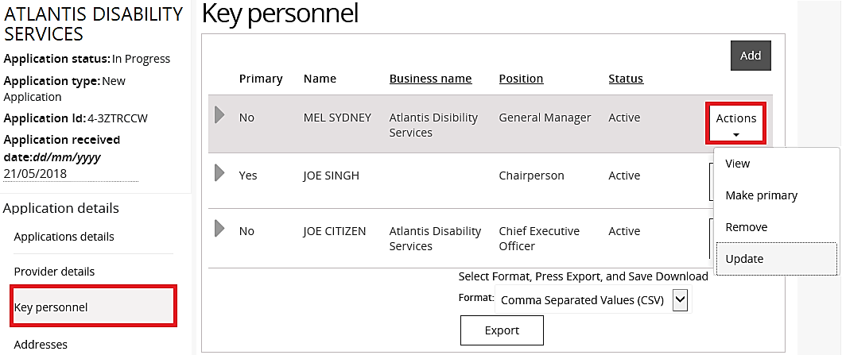
- Update the Key personnel details then click Save and close.
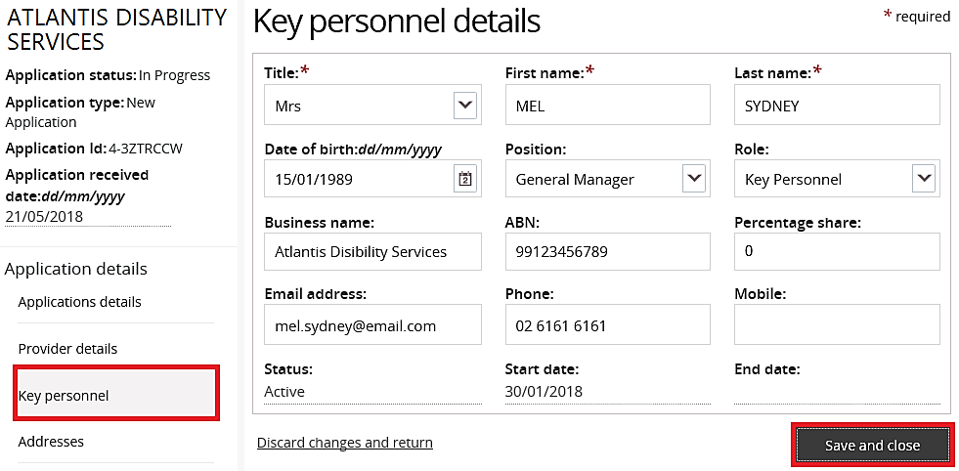
The Key personnel have been updated.

Remove key personnel
- Click Key personnel from the left hand side menu.
- Select the Key personnel to remove, click the Actions drop down menu then select Remove.
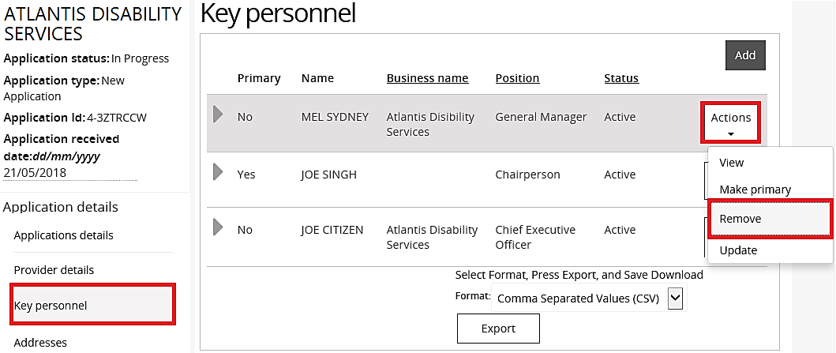
The Key personnel status will change to Inactive.

Add address
- Click the Address from the left hand side menu then click Add address.
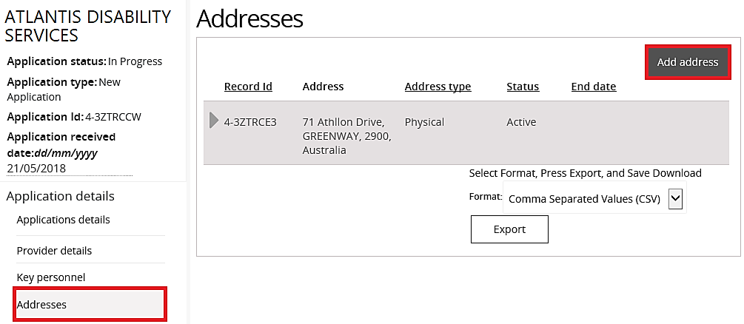
- Type/Select a From date, select an Address type then type the Address and click Save
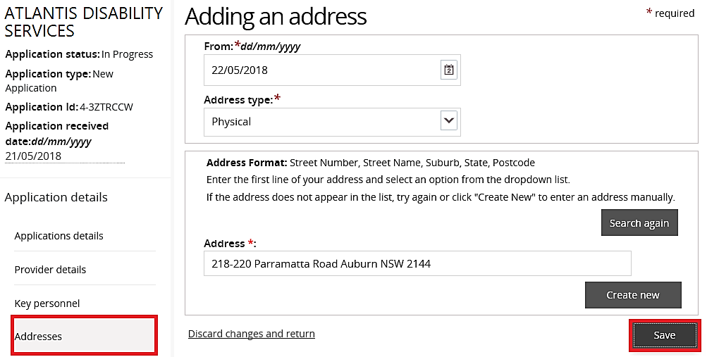
An address has been added.

Add an outlet
- Click Outlets from the left hand side menu then click Add.
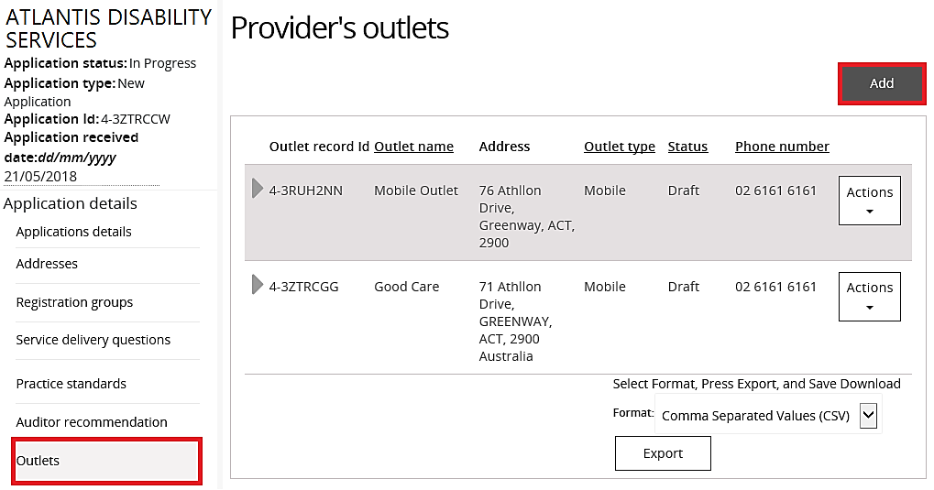
The Add outlets window opens.

- Type the new outlet details then click Add address.
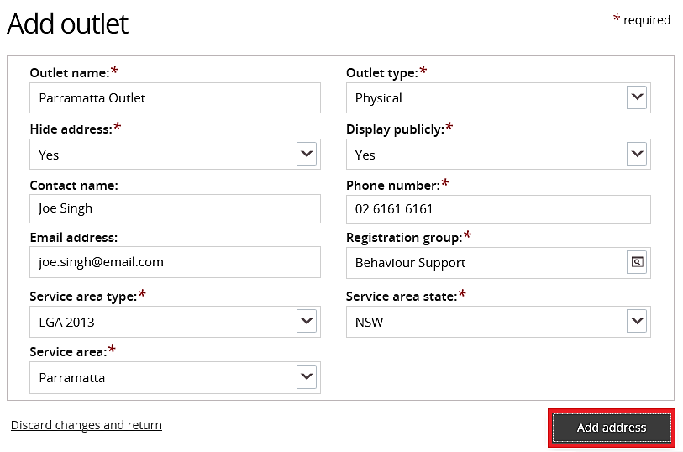

- Type or select a From date, then type an Address.
- If the address is recognised, it will appear in a drop down list. Select the address.
- If the address is not recognised, click Create new to create a new address.
Click Save.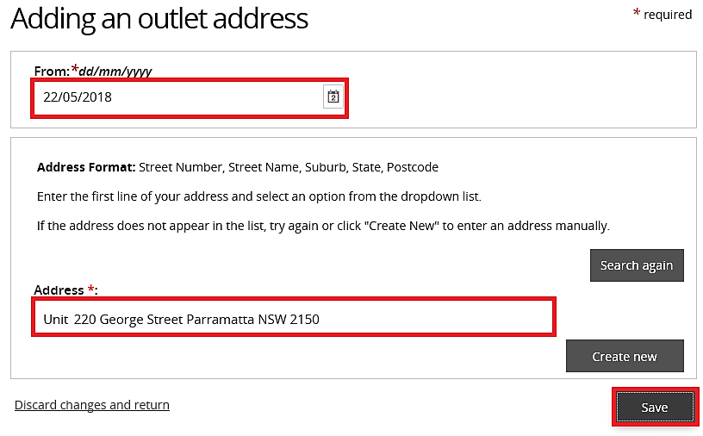
The new outlet has been created.

Manage outlet
The Auditor can change the details of an existing outlet on behalf of a provider.
- Click Outlets from the left hand side menu.
- Select the outlet to be managed. Click the Actions drop down menu then select Manage outlet.
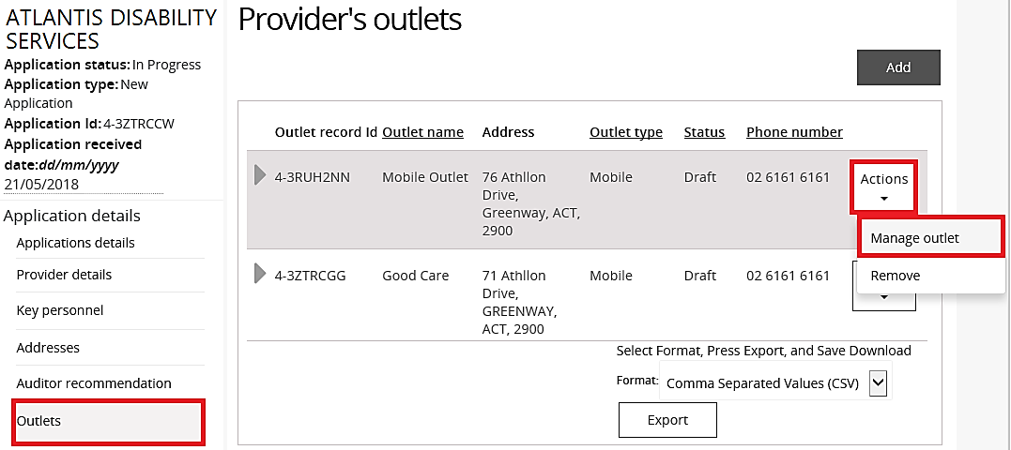

- Click Update outlet.
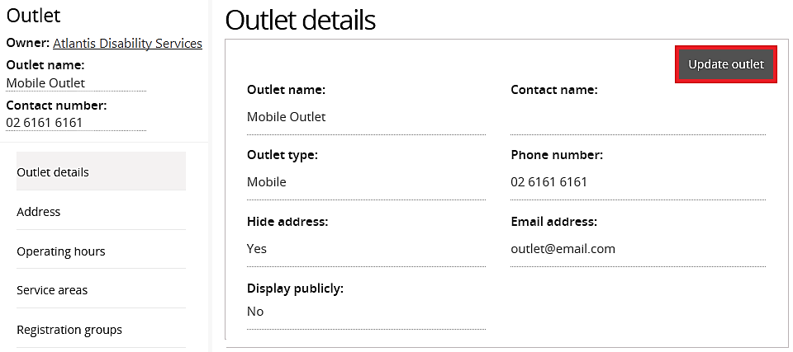

- Update outlet details then click Save.
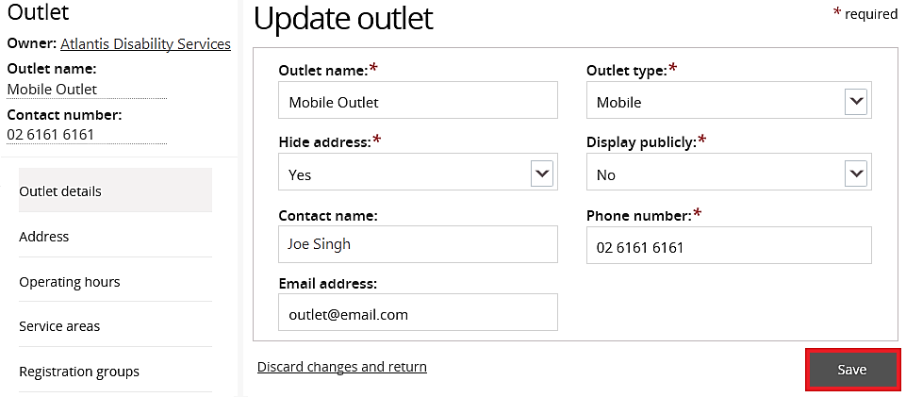

Add a Registration group within an Outlet
- Click on registration groups on the side menu
- Click on Add button
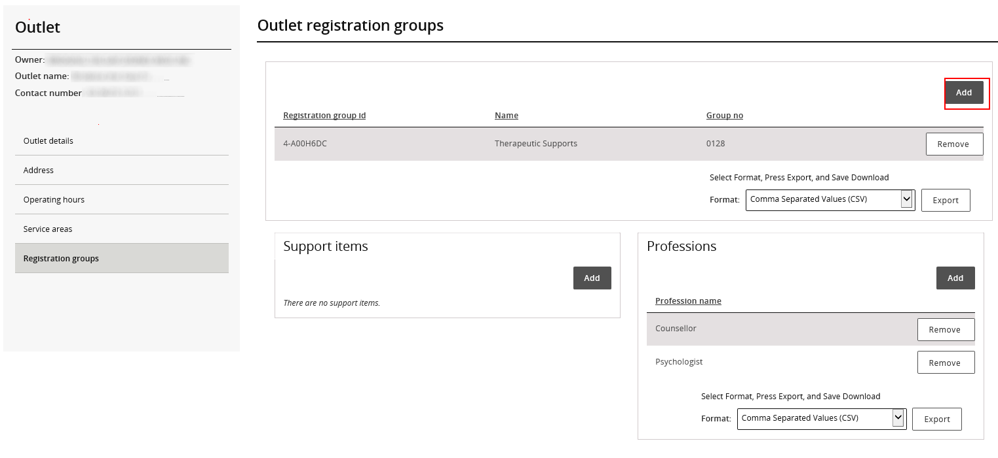

- Select or confirm registration groups as required
- Click Save
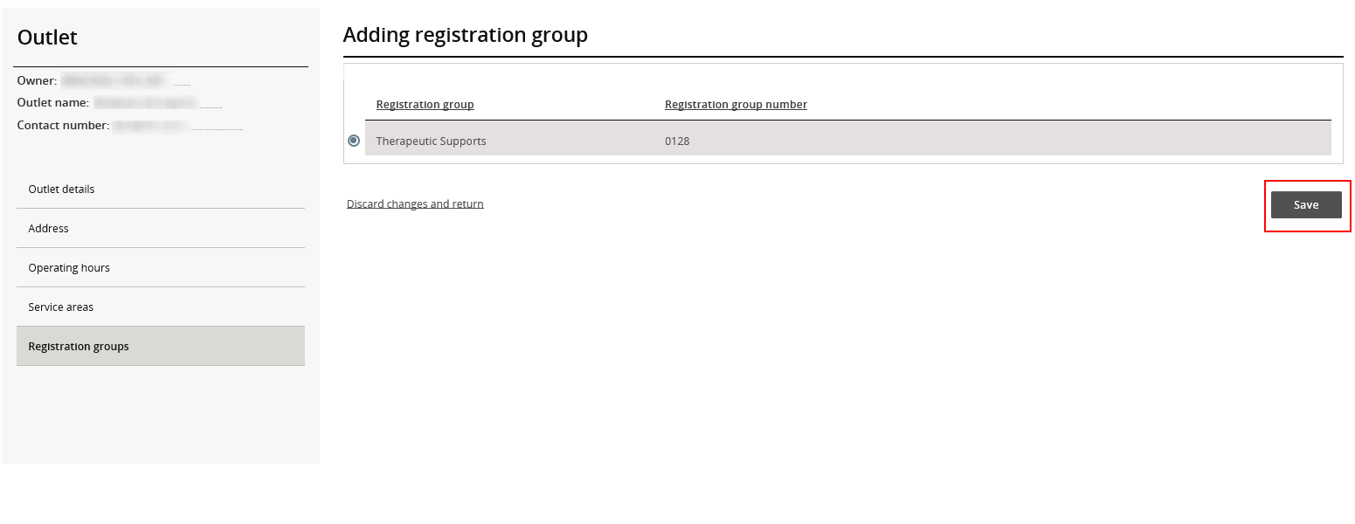

Add or Remove a profession within an Outlet
- Click on Add button within Professions
- Add or remove appropriate professions as required
- Click Save
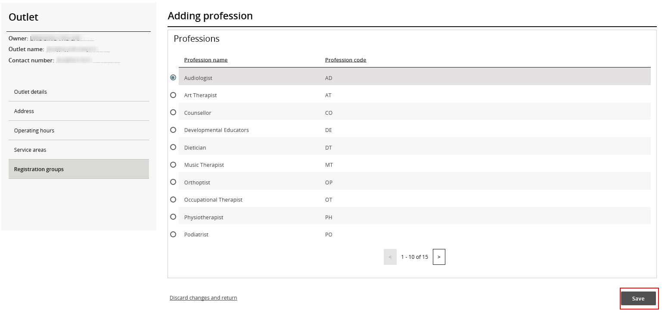

NOTE: Each outlet must have at least one registration group attached to it. Additionally each registration group must have at least one profession.

Remove an outlet
- Click Outlets from the left hand side menu.
- Select the Outlet to remove, click the Actions drop down menu then select Remove.
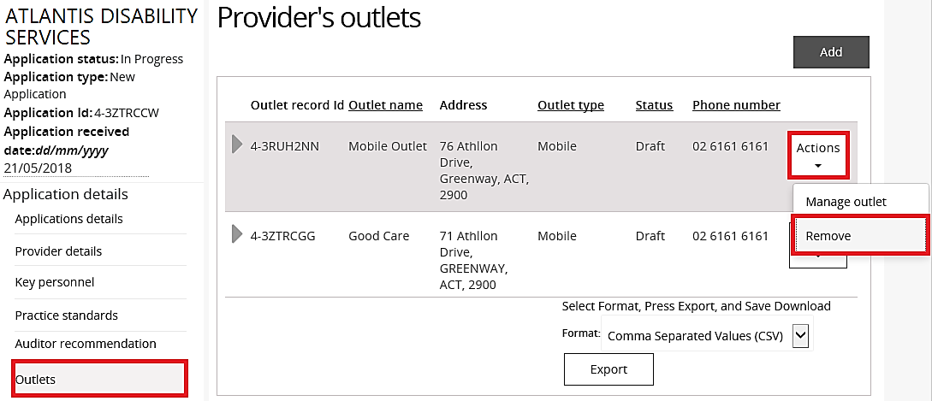
The outlet has been removed and the status of the outlet changes from Draft to Inactive.

