Quick reference guide: Unlink a worker
Unregistered provider, self-managed & plan-managed participant

Contents
Contents 1
Overview 1
Find a linked a worker 3
Unlink a worker 5

Overview
- The NDIS Worker Screening Database (NWSD) is a national database which stores NDIS Worker Screening Check information about workers who deliver NDIS supports and services.
- Unregistered NDIS providers, self-managed participants (SMPs) and plan-managed participants (PMPs) can decide whether they will require their workers to have a NDIS worker screening check. More information about this can be found on our website – Unregistered providers and Worker Screening (self-managed and plan-managed participants).
- When a worker applies for a NDIS Worker Screening Check they must nominate an employer/s to verify their application. An employer in this regard may include an unregistered provider, self-managed or plan-managed NDIS participant. Once verified, the worker will be linked to the employer and the employer will be able to view the worker’s record and will receive updates about the worker’s clearance status.
- Once a worker is no longer delivering NDIS supports and services for an employer the link to the worker in the NWSD must be removed (unlink).
- The quick reference guide provides information about how to unlink a worker that no longer delivers NDIS supports and services for you / your organisation.
For further information please refer to the NDIS Quality and Safeguards Commission website
(Unregistered providers and Worker Screening (self-managed and plan-managed participants)). Alternatively, contact the NDIS Quality and Safeguards Commission on 1800 035 544 or by email at nwsd@ndiscommission.gov.au.

Find a linked a worker
- Log into PRODA and select ‘Worker Screening for NDIS Participants’ (for self-managed or plan-managed participants) or ‘Worker Screening for Organisation’ (for unregistered providers) to access the NWSD.
Tip 1 - Refer to the Quick reference guide – Unregistered Provider – Request access to the NWSD or Quick reference guide – SMP & PMP – Request access to the NWSD.
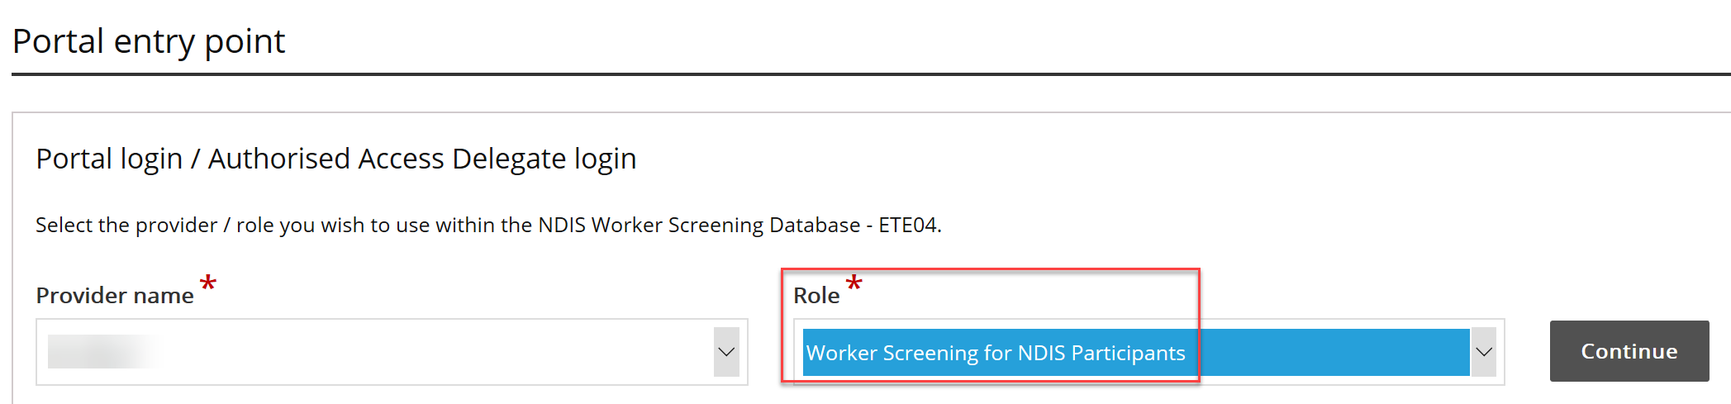
- Select the ‘Worker Screening’ section, then navigate to the ‘My workers’ tab.
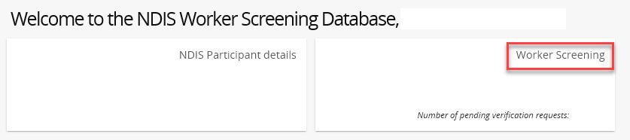
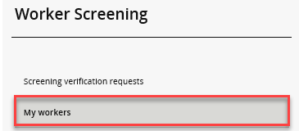
- To find a worker select search and enter the worker’s details you have available. Select ‘Run search’.
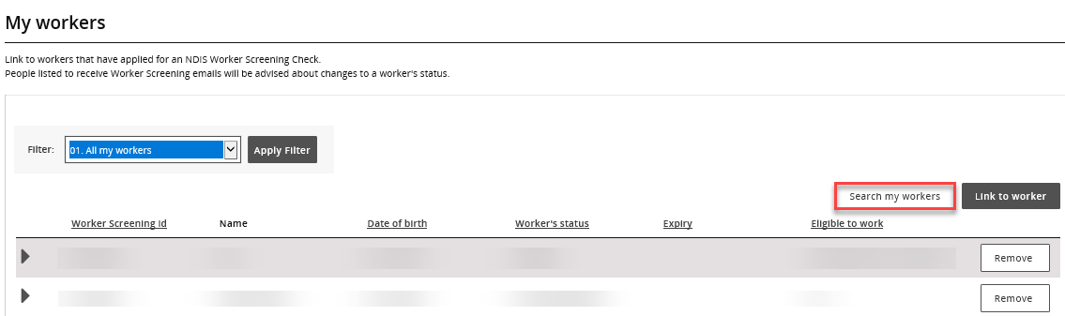
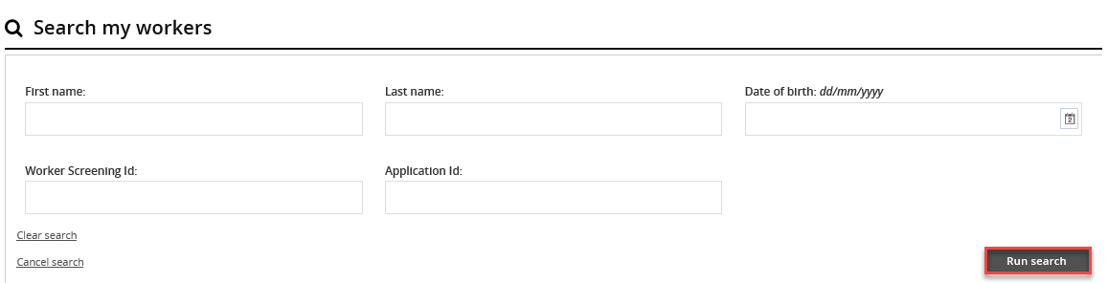
- Alternatively you can filter the list of workers on the ‘My workers’ tab by selecting ‘Filter’ and ‘Apply Filter’ and/or sort the columns selecting the column heading.
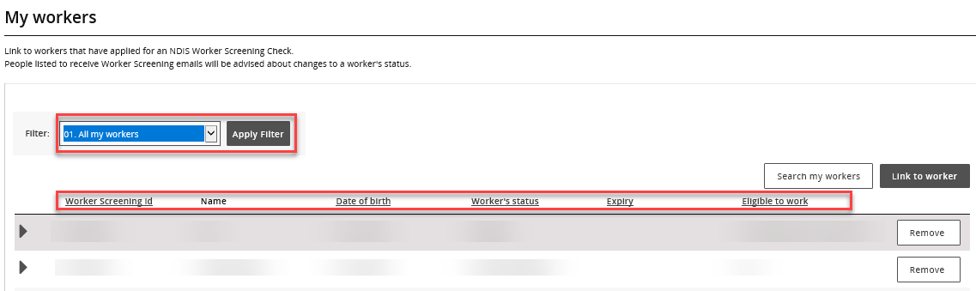
Tip 2 – To view all of your linked workers in a spreadsheet, export a list from the NWSD by selecting a ‘Format’ from the dropdown (Tab Separated Values (TSV) is recommended) and selecting ‘Export’.
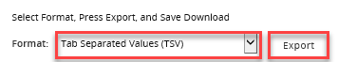

Unlink a worker
- If a worker is no longer delivering NDIS services and supports for your organisation, unlink them from your organisation.
Tip 3 – You may need to unlink a worker if they no longer work for you, or if you have accidentally verified a worker.
- Navigate to the ‘My workers’ tab, locate the worker and select ‘Remove’.
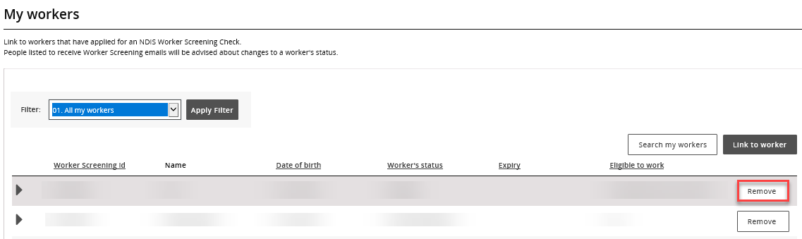
- Select ‘Remove’ if you are sure you want to unlink the worker. You will no longer be able to view the worker record and won’t receive clearance status update about the worker.

