Quick reference guide: Link a worker
Unregistered provider, self-managed participant & plan-managed participant

Contents
Contents 1
Overview 1
Linking a worker 2

Overview
- The NDIS Worker Screening Database (NWSD) is a national database which stores NDIS Worker Screening Check information about workers who deliver NDIS supports and services.
- Unregistered NDIS providers, self-managed participants (SMPs) and plan-managed participants (PMPs) can decide whether they will require their workers to have an NDIS Worker Screening Check. More information about this can be found on our website – Unregistered providers and Worker Screening (self-managed and plan-managed participants).
- When a worker applies for a NDIS Worker Screening Check they must nominate an employer/s to verify their application. An employer in this regard may include an unregistered provider, self-managed or plan-managed NDIS participant. Once verified, the worker will be linked to the employer and the employer will be able to view the worker’s record and will receive updates about the worker’s clearance NDIS Worker Screening Check status.
- This quick reference guide provides information about how to manually link a worker (if you haven’t verified them).
For further information please refer to the NDIS Quality and Safeguards Commission website
(Unregistered providers and Worker Screening (self-managed and plan-managed participants)). Alternatively, contact the NDIS Quality and Safeguards Commission on 1800 035 544 or by email at nwsd@ndiscommission.gov.au.

Linking a worker
- Log into PRODA and select ‘Worker Screening for NDIS Participants’ (for self-managed or plan-managed participants) or ‘Worker Screening for Organisation’ (for unregistered providers) to access the NWSD.
Tip 1 - Refer to the Quick reference guide – Unregistered Provider – Request access to the NWSD or Quick reference guide – SMP & PMP – Request access to the NWSD.
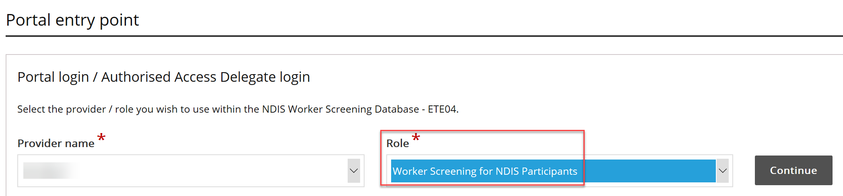
- Navigate to the ‘My workers’ tab.
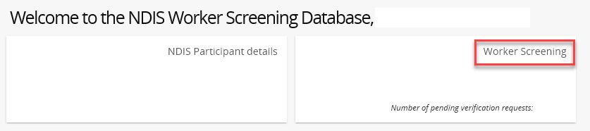
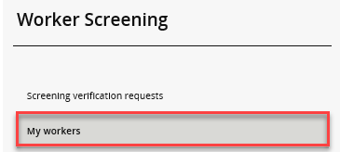
- If a worker is delivering NDIS services and supports for you/your organisation, link them by selecting ‘Link to worker’.
Tip 2 – If you have already verified the worker they will automatically be linked to your organisation. Refer to the Quick reference guide – Unreigstered provider – SMP & PMP Screening verification requests.
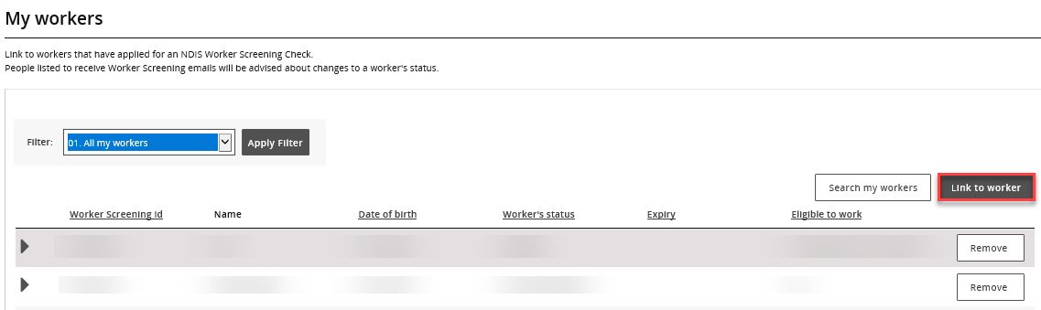
- Enter the worker’s last name plus an application ID or worker screening ID and select ‘Search’. You should have these details available to you if you are intending for the worker to deliver NDIS supports and services for you/your organisation.
Tip 3 – The search is case sensitive so make sure you enter the details exactly as they appear.
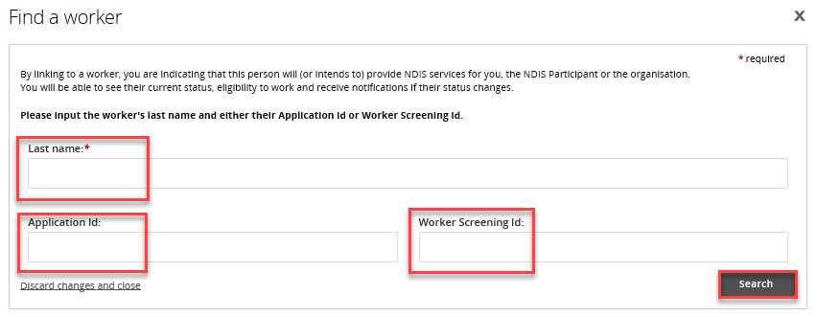
- Select the radio button next to the worker’s name and select ‘Confirm’. The worker will now be linked to your organisation/SMP record and appear on the ‘My workers’ tab.
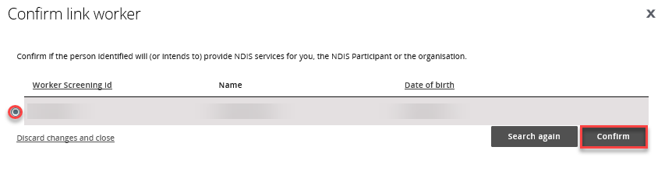
- You will receive updates about the NDIS Worker Screening Clearance status for all of your linked workers including when they receive an NDIS Worker Screening Clearance and when their NDIS Worker Screening Clearance is due to expire.
Tip 4 – You will receive email notifications about your linked workers regarding their NDIS Worker Screening Clearance status:
0
- 90 days prior to when their NDIS Worker Screening Clearance is due to expire; and
- if there is a NDIS Worker Screening Clearance status change e.g. they have been excluded and are no longer eligible to work.
Tip 5 – For instructions on how to check a linked worker’s clearance refer to the Quick Reference Guide – Unregistered provider – SMP - Find a worker and check their clearance status.
0

