Quick reference guide: Manage NWSD access &
email preferences
Unregistered provider

Contents
Contents 1
Overview 1
Managing access to the NWSD 2
Manage access as the Authorised Access Delegate 2
Update the access of an existing employee 2
Create access of a new employee 3
Employee requests for access 5
Approve or reject a request for access (as the Authorised Access Delegate) 7
Managing email preferences 9

Overview
- The NDIS Worker Screening Database (NWSD) is a national database which stores NDIS Worker Screening Check information about workers who deliver NDIS supports and services.
- To gain access to the NWSD, the representative of an unregistered provider must make an application (refer to Quick Reference Guide – Unregistered Providers – Request access to the NWSD). The person nominated as the ‘Primary contact’ on the application will become the default ‘Authorised Access Delegate’.
- The Authorised Access Delegate will be able to add, remove and vary the access of other members of the organisation (employees) to the NWSD.
- This quick reference guide provides information about how to update access to the NWSD and set NWSD email preferences.
For further information please refer to the NDIS Quality and Safeguards Commission website - https://www.ndiscommission.gov.au/providers/unregistered-providers. Alternatively, contact the NDIS Quality and Safeguards Commission on 1800 035 544 or by email at nwsd@ndiscommission.gov.au.

Managing access to the NWSD
- There are two ways in which an unregistered provider can manage access to the NWSD for their employees:
- the ‘Authorised Access Delegate’ can add, remove and change the type of access employees of an organisation have; or
- an employee may request access or a change to the type of access they have, which the ‘Authorised Access Delegate’ will then consider and approve or reject.
Both methods are described below.

Manage access as the Authorised Access Delegate

Update the access of an existing employee
- Log into PRODA and select the appropriate ‘Provider name’ and choose the ‘Authorised Access Delegate’ role.
Tip 1 – You must apply for access to the NWSD and register for a PRODA account before you can log in. Refer to Quick Reference Guide – Unregistered Provider – Request access to the NWSD for more information.
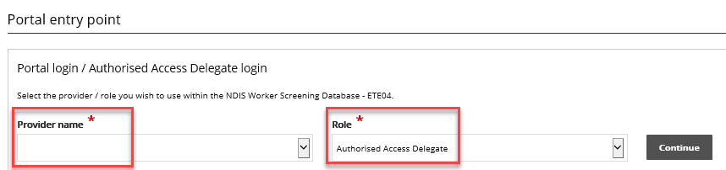
- Select ‘User access list’ from the side menu and ‘Select’ the employee you want to update the access for.
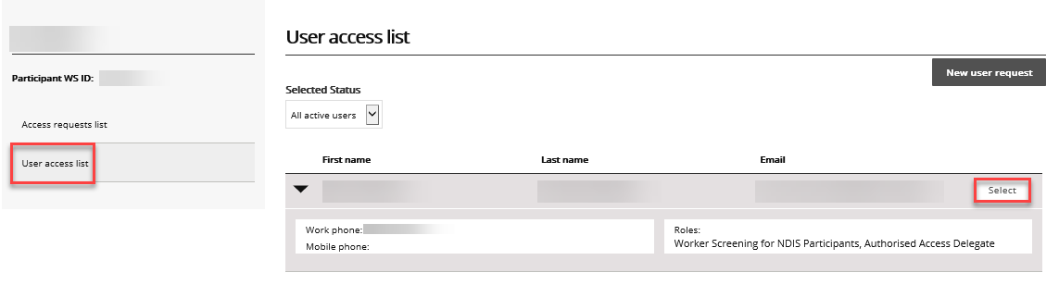
- To add additional access for the employee, in the ‘Required user role(s)’ section select all the user roles you want the employee to have and click ‘Save’.
Tip 2 – Unregistered providers should only select ‘Worker Screening for organisations’ and/or ‘Authorised Access Delegate’. The ‘Worker Screening for NDIS Participants’ option is for the use of self-managed participants and their representatives.
- To remove access, in the ‘Required user roles(s)’ section select the user roles you want to removed and select ‘Revoke access’.

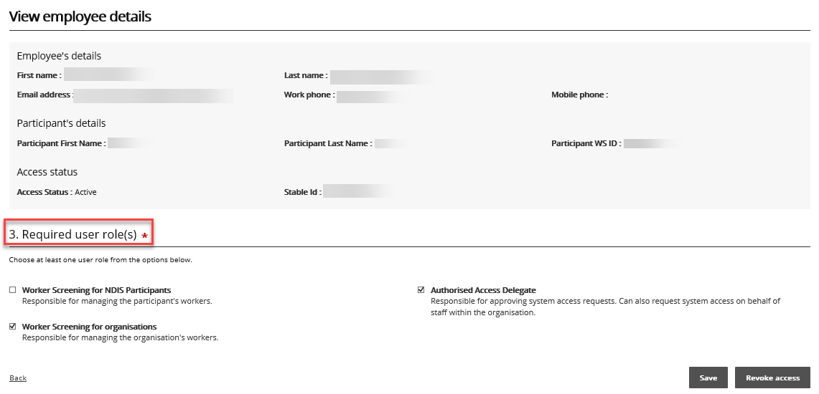

Create access of a new employee
- To give a new employee access to the NWSD, log into PRODA, select the appropriate ‘Provider name’ and choose the ‘Authorised Access Delegate’ role.
- Select ‘New user request’.
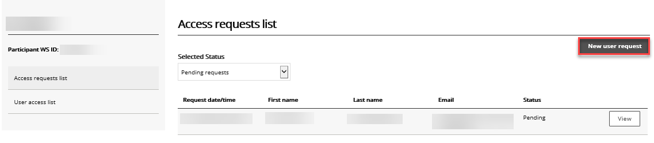

- Read the information presented and if you are ready to continue select the ‘I’m ready to request access’ button.
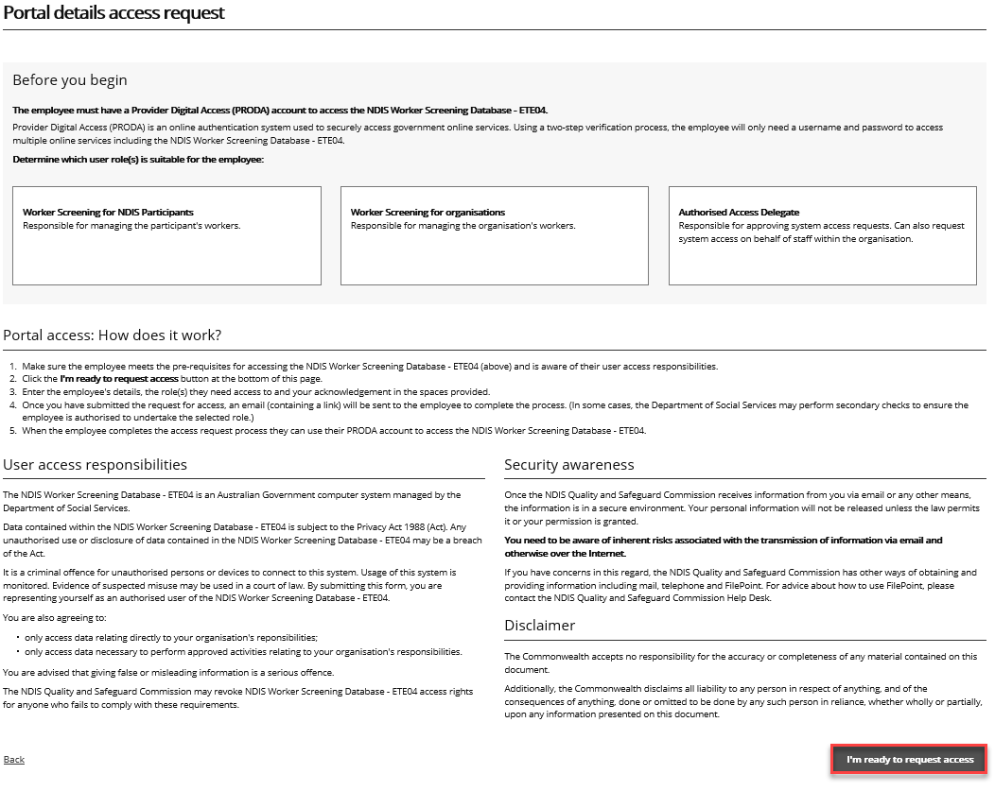
- Enter the required information and in the ‘Required user role(s) section’ select:
  - ‘Worker Screening for organisations’ which will provide you with access to the NWSD to verify workers and check the status of a worker’s NDIS Worker Screening Check; and/or
  - ‘Authorised Access Delegate’ which enables you to manage who in your organisation has access to the NWSD e.g. approving or rejecting requests for NWSD access.
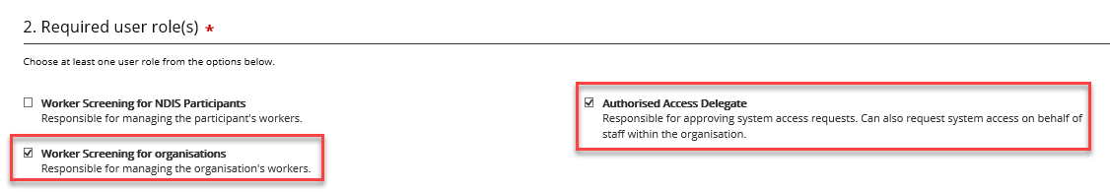

Employee requests for access
- If you are an employee seeking access to the NWSD, log into PRODA and select the ‘Request / update my access’ button.
Tip 3 – You must register for a PRODA account before you can log in. If you are having trouble registering for PRODA contact the PRODA Helpdesk on 1800 700 199.
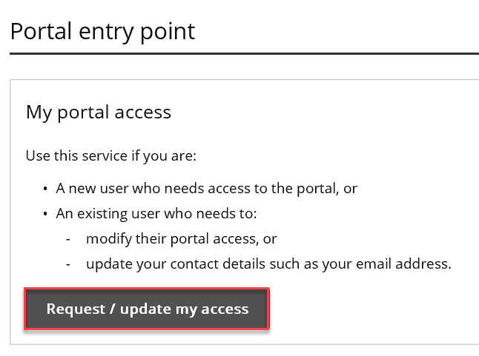
- Read the information presented and if you are ready to continue select the ‘I’m ready to request access’ button.
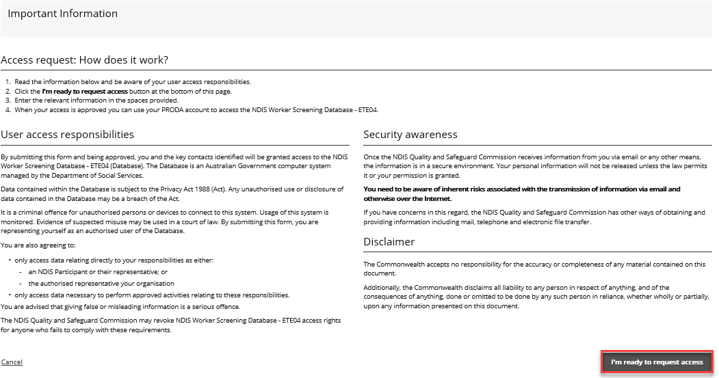
- Enter the required information and in the ‘Required user role(s) section’ select:
  - ‘Worker Screening for organisations’ which will provide you with access to the NWSD to verify workers and check the status of a worker’s NDIS Worker Screening Check; and/or
  - ‘Authorised Access Delegate’ which enables you to manage who in your organisation has access to the NWSD e.g. approving or rejecting requests for NWSD access.
- In the ‘Request access to which account’ section select ‘Unregistered organisation in the disability sector who is registered for Worker Screening’ if you are the employee of an unregistered provider. Then select ‘Next’.
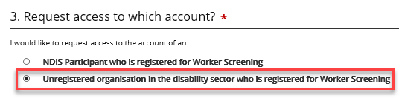
- On ‘The organisation that you work for’ page, enter in the details of the unregistered provider that you work for.
Tip 4 – The ‘Authorised Access Delegate’ of this organisation will be the person who considers your request for access to the NWSD.
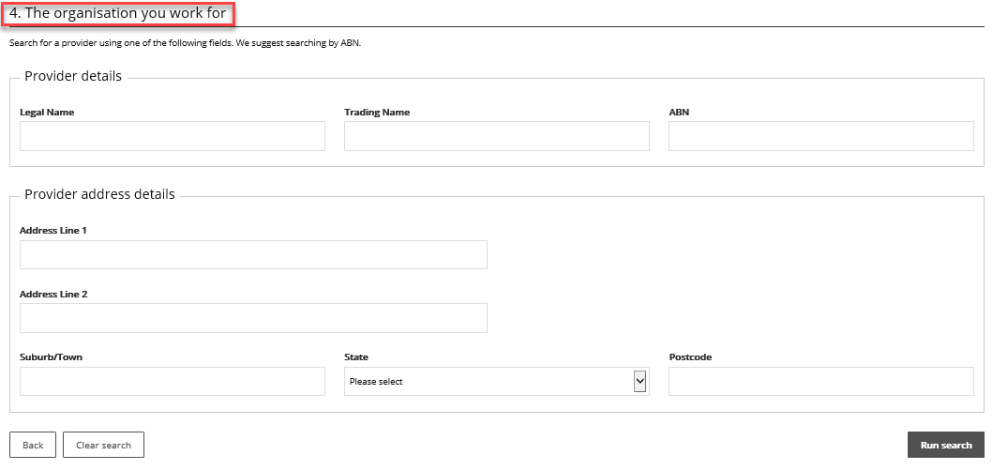
- Your request will be submitted to the current ‘Authorised Access Delegate’ for consideration. You will receive an email once your request has been approved or rejected.

Approve or reject a request for access (as the Authorised Access Delegate)
- When an employee submits a request for access to the NWSD, the ‘Authorised Access Delegate’ will receive an email. Click the link in the email to view the access request.
- Log into PRODA and select the appropriate ‘Provider name’ and ‘Authorised Access Delegate’ as the ‘Role’. Select ‘Continue’.
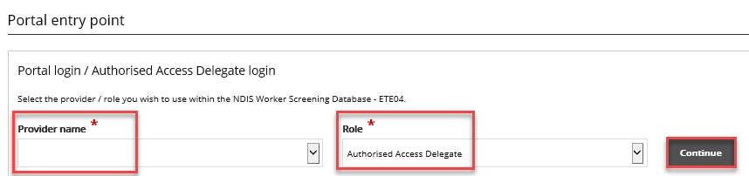Navigate to the ‘Access requests list’ and select ‘View’ next for the application you want to assess.
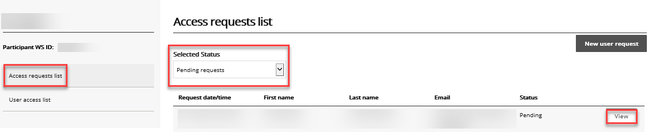
- Review the ‘Required user role(s)’ that the applicant has selected and ensure the appropriate checkbox is ticked.

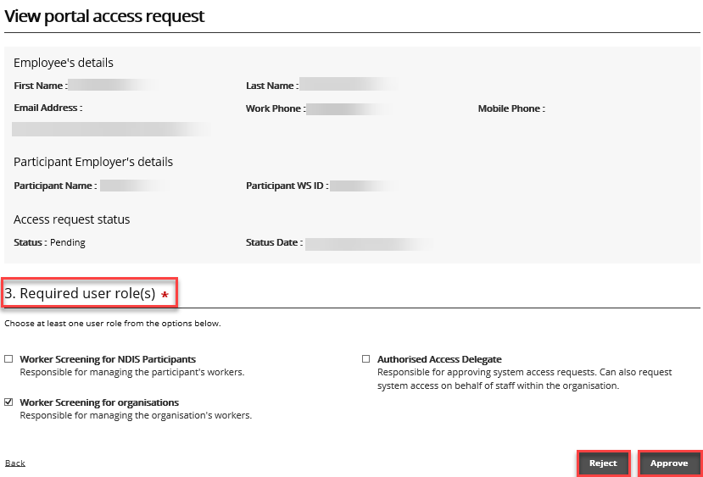
- Select ‘Reject’ or ‘Approve’. The applicant will receive an email advising them of the outcome.

Managing email preferences
- Log into PRODA and select ‘Worker Screening for Organisations’ to access the NWSD.
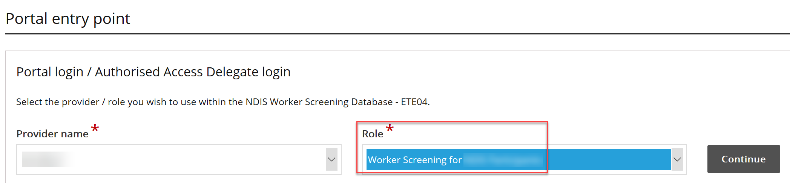
- Select ‘Email preferences’ to manage who will receive emails, and what types of emails each person will receive, from the NDIS Quality and Safeguards Commission on behalf of your organisation.
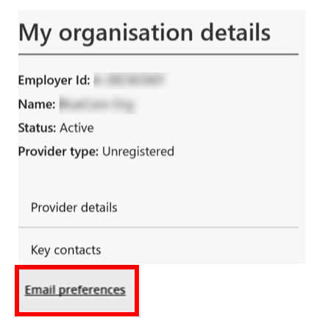
- A list of category descriptions will display at the top of the screen. This describes the different categories of emails that will be received. For each email contact a category from the list must be selected e.g. these are the types of emails they will receive.
- To add an email contact to the list, select ‘Add’, enter their details and choose the category of emails they will receive. If they require multiple categories, they will need to be added multiple times.
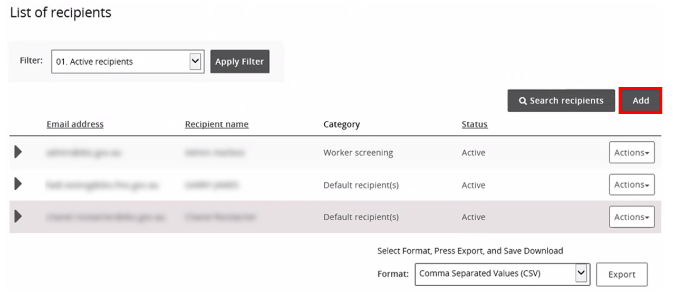
- To remove an email contact, select ‘Action’ and ‘Remove’.
- To update the details of an email contact e.g. change their email category, select ‘Action’ and ‘Update’.
