NDIS Commission Portal User Guide
Implementing providers: Reporting on the use of regulated restrictive practices
V.3 April 2021
This guide is for implementing providers who must report monthly on the use of regulated restrictive practices
Table of Contents
Accessing the NDIS Commission Portal 2
Accepting a behaviour support plan 2
1. View the plan 3
2. Accept/approve the plan and attach evidence of authorisation (where applicable) 4
Reporting on regulated restrictive practices in a lodged behaviour support plan 6
3. Report when a regulated restrictive practice is not used 6
4. Report the use of a routine regulated restrictive practice 9
5. Report the use of a PRN (as needed) regulated restrictive practice 11
6. Remove a report entered in error 13
Reporting when no behaviour support plan is lodged 14
7. Create a record in the NDIS Commission Portal 14
8. Add person details 15
9. Add disability details 18
10. Add address details 18
11. Enter details about start and end date 19
12. Enter behaviours of concern 20
13. Add restrictive practices 20
14. Activate the record to enable monthly reporting 21
14. Close an RP Record 22
Contact us 22

Accessing the NDIS Commission Portal
Step 1: Obtain a PRODA account
To access the NDIS Commission Portal, you will need a PRODA account. For instructions, see the Quick Reference Guide: Getting access to NDIS Commission Portal.
Step 2: Self-request access role
Authorised Reporting Officer (ARO) role
Once you have your PRODA account, login to the NDIS Commission Portal and request access for ‘Authorised Reporting Officer’ (ARO). This role is approved by the Authorised Access Delegate role within your organisation.
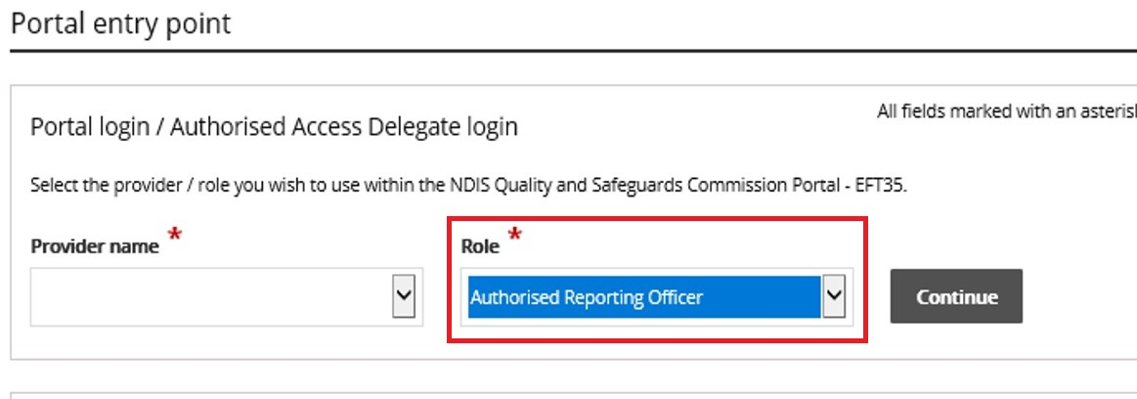
- Tip: Any ARO can accept the plan by locating the plan through search, navigating to the implementing provider view, and clicking the Approve button (see ‘Accepting a behaviour support plan’)
- Tip: You may have multiple access roles in the NDIS Commission Portal, so it is important that you are logged in as the ARO role when accepting behaviour support plans and completing monthly reporting. If any of the buttons referred to these instructions are not visible, you may be logged in under a different access role. Check this first before contacting the NDIS Commission for help.
Behaviour Support Reporting Admin role
- This access role also allows a user to approve behaviour support plans and to enter monthly reports about the use of regulated restrictive practices outlined in the behaviour support plan.
- The Admin role cannot submit monthly reports; only the ARO role can do this.
- This role is approved by the Authorised Access Delegate within your organisation.

Accepting a behaviour support plan
Once the plan is lodged in the NDIS Commission Portal by the specialist behaviour support provider, the implementing provider needs to approve/accept the plan and complete monthly reports on their use of the restrictive practices.

View the plan
1.1. Select the Behaviour Support plan tab
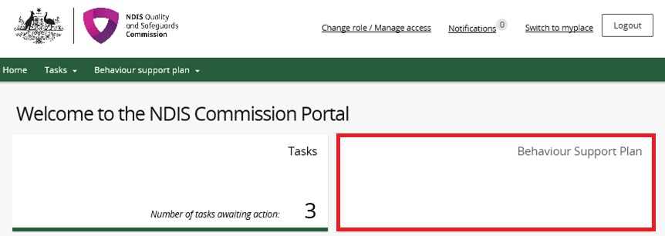
1.2. Search for the participant using the Plan ID or participant’s name and click Run search. The results will be displayed at the bottom of the screen. Select the plan and click View.
- Tip: The search engine is sensitive so it is important that the spelling of the person’s name is accurate.
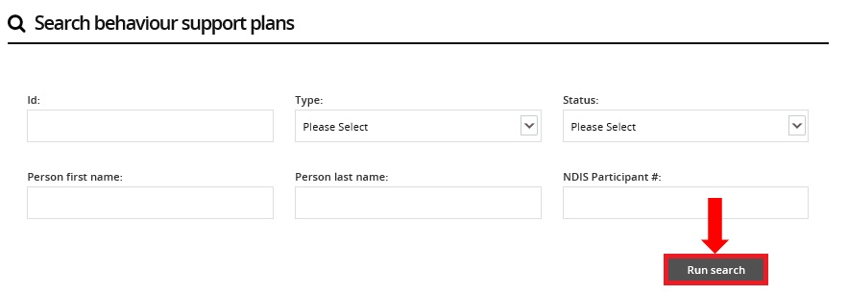
1.3. Click Person details and check it is the right person.
1.4. Click Details, and check the start and end date of the plan.
1.5. Click Schedule of restrictive practices and check that all restrictive practices being used are listed accurately, including matching the information contained within the attached behaviour support plan. If they are not, contact the specialist behaviour support provider.
1.6. Click Attachments. A copy of the behaviour support plan is located here. If there are no attachments, contact the specialist behaviour support provider. The specialist behaviour support provider is required to attach a copy of the plan as part of the lodgement and a copy of the functional behaviour assessment as part of the lodgement of the comprehensive behaviour support plan
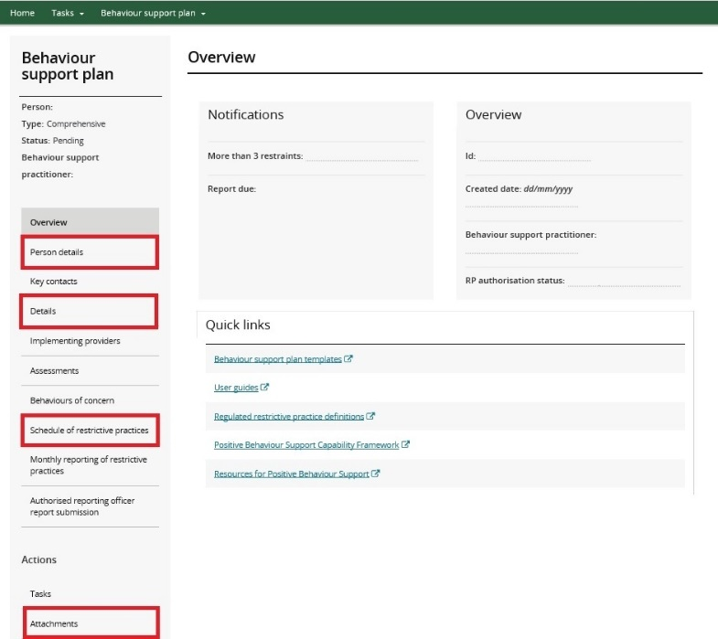

- Tip: If there are any errors in the NDIS Commission Portal, contact the specialist behaviour support provider. If the plan is in ‘Pending’ they are able to change the status back to draft and rectify the error. (Note: once you click the approve button and the plan status is ‘Active’ changes cannot be made to the plan). Therefore, it is integral that this stage is recognised as an important check point and is reflective of your organisation’s use of the regulated restrictive practices.

2. Accept/approve the plan and attach evidence of authorisation (where applicable)
2.1. Click Schedule of restrictive practices from the left hand side navigation menu. For each restrictive practice, click the Actions button and then then click Update.
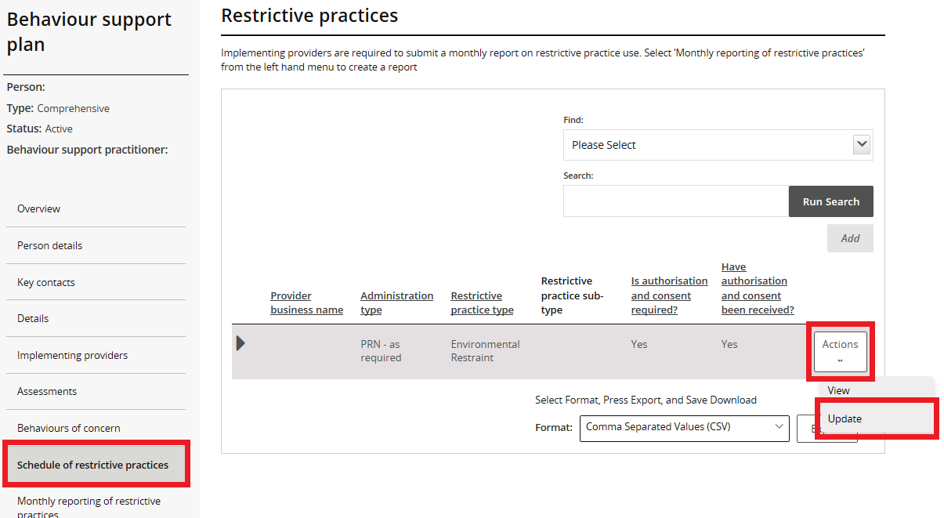
2.2. It is the role of the implementing provider to seek authorisation for the use of each practice. Update the authorisation information and attach the evidence of authorisation. These fields can be updated by the ARO or the Behaviour Support Reporting Admin, even when the plan is active.
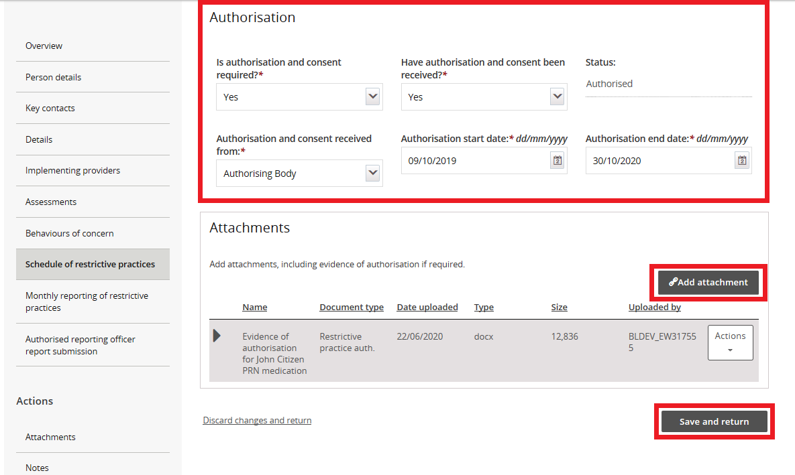
- Tip: NSW, ACT, VIC, TAS, NT, QLD and WA should use ‘Authorising Body’ in the drop-down list. SA should use ‘Guardian’.
2.3. To lodge the evidence of authorisation, click Add attachment.
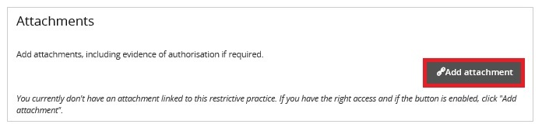
- Tip: If you have not yet received written evidence of authorisation you can come back and update these sections when you have received it.
2.4. Attach evidence of authorisation. Select Restrictive practice auth. as the ‘document type’ and click Save and close. Attach evidence to each restrictive practice listed. Note: the ‘Description’ field is not mandatory.
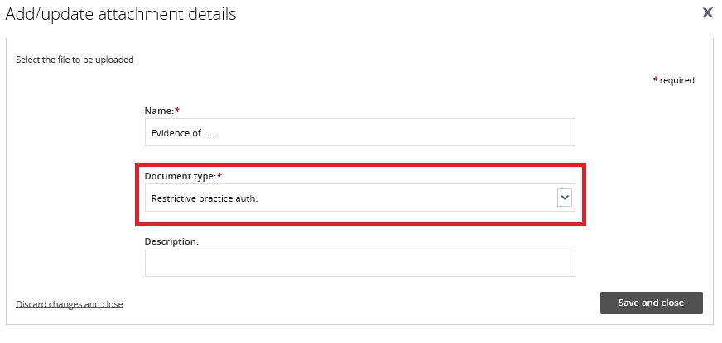
2.5. Once all details have been reviewed, click Implementing Providers in the left hand side navigation menu and click Approve. The plan status will become active and is now ready for reporting.
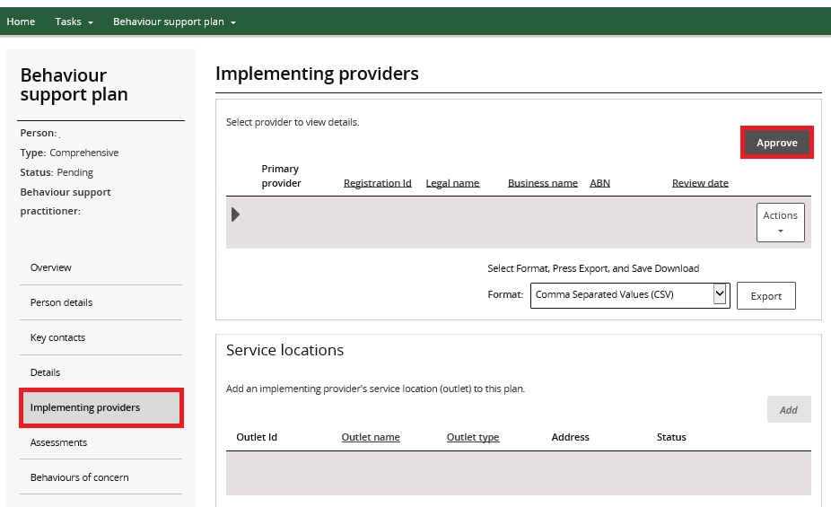

Reporting on regulated restrictive practices in a lodged behaviour support plan
When a behaviour support plan is lodged, the specialist behaviour support provider creates a list of the regulated restrictive practices. The implementing provider is required to report monthly on the use of these practices.

3. Report when a regulated restrictive practice is not used
Monthly reporting should be completed for all regulated restrictive practices in the behaviour support plan, including reporting if they are not used. Monthly reporting should be completed within 5 business days of the following month.
3.1. From the left hand side navigation menu, click Monthly reporting of restrictive practices. When the plan status is 'Active’, the Report button becomes available. Click the Report button to enter a monthly report.
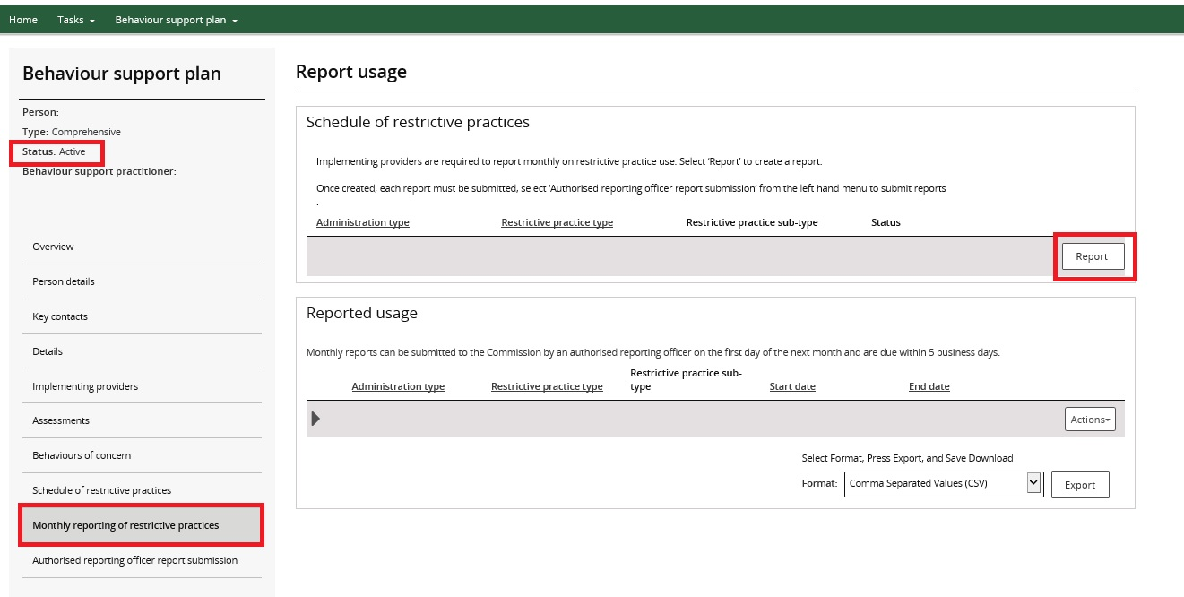
3.2. Select the ‘RP not used’ option from the drop-down list and click Save.
Please note, if there has been a change in circumstances for the participant, contact the behaviour support provider as they may need to review the behaviour support plan.
3.3. Click Update to enter the dates the regulated restrictive practice was not used.
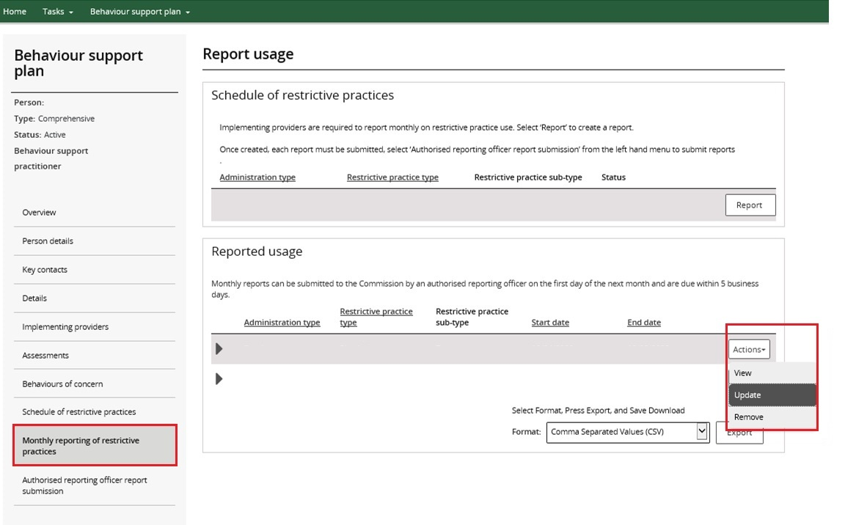

3.4. Enter the dates when the regulated restrictive practice was not used, then click Save.
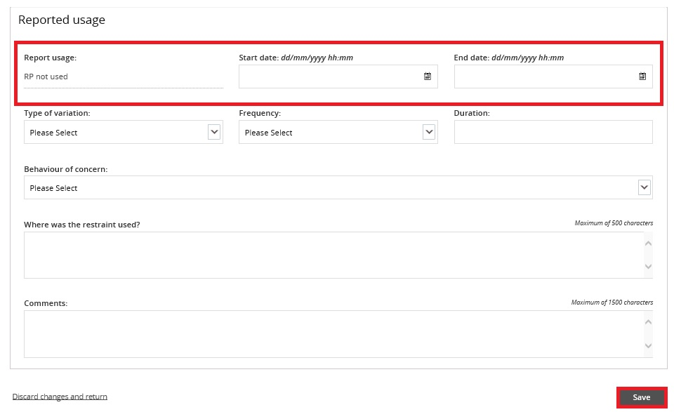

3.5. After the reports are entered, select the ‘Authorised reporting officer’ tab. Click Submit reports.
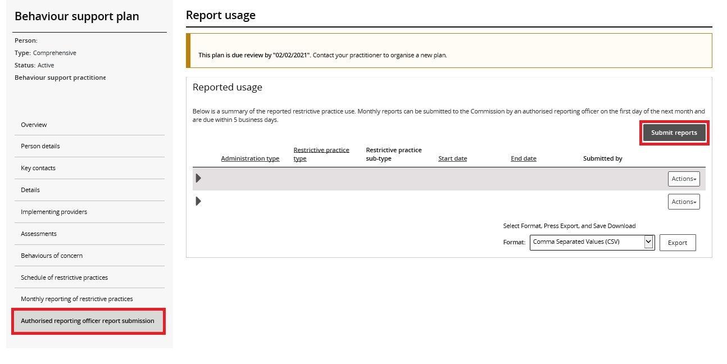
Only the ARO role can submit the reports.
All reports can be submitted at the same time using the Submit reports button, or they can be submitted individually by clicking the Actions button.

4. Report the use of a routine regulated restrictive practice

Reporting where the use was in accordance with the behaviour support plan
4.1. Select Report use from the drop down options and click Save.
Note: If there was a change in the way the routine regulated restrictive practice is used, select Report variation instead and move to step 4.3.
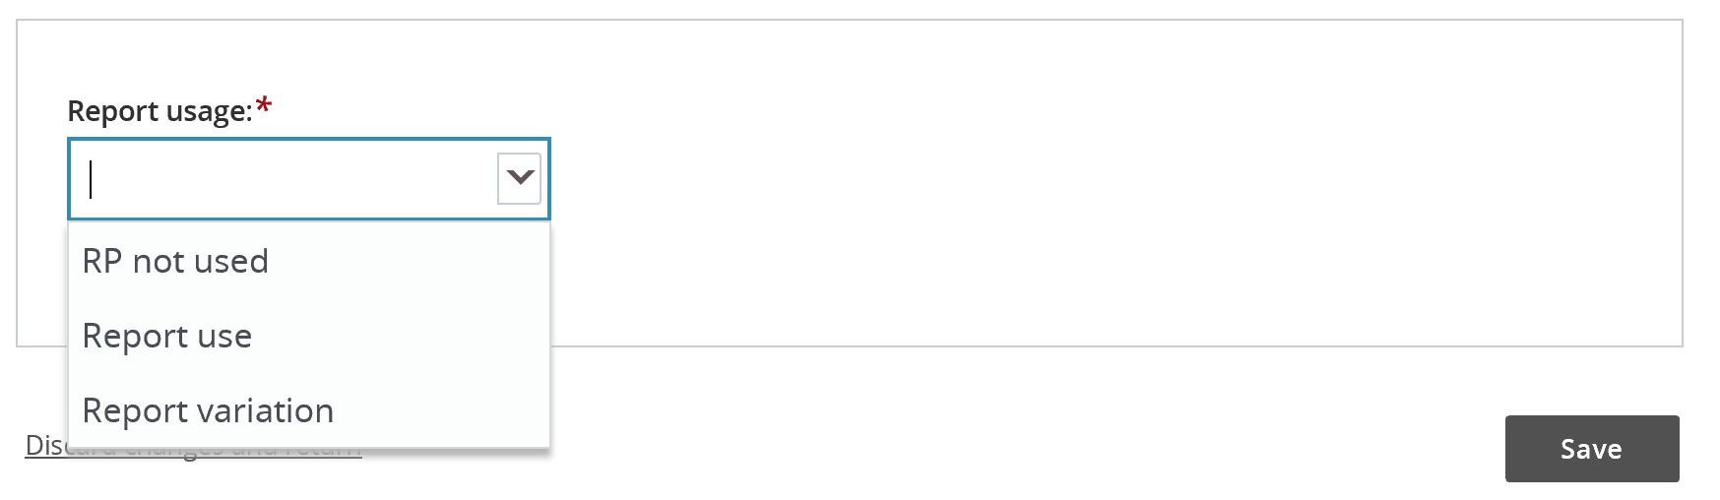
4.2. Enter the dates the routine regulated restrictive practice was in place and select the behaviour of concern the practice was used to manage. Then click Save.
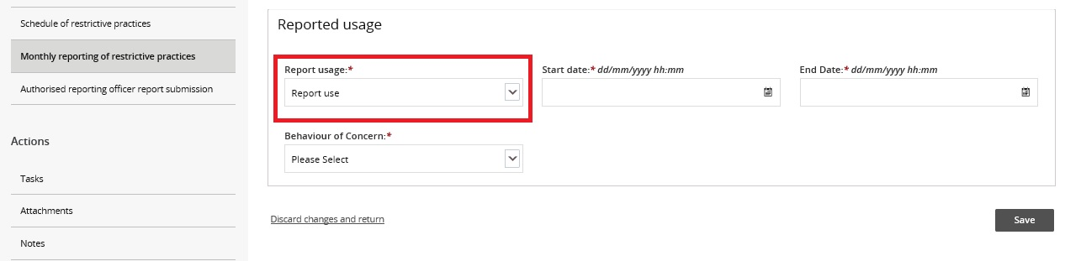

Reporting a variation in the use of the regulated restrictive practice
The report variation option can be selected when (for example):
- a change in medication dosage or frequency that does not require re-authorisation in the state or territory where the practice is used; or
- a participant’s medication is being changed due to the prescriber trialling different dosages or medications, resulting in multiple variations to medications over a period specified by the prescribing medical practitioner; or
- the implementation of a regulated restrictive practice changes from routine to PRN due to fade out strategies and re-authorisation is not required in the state or territory where the practice is used.
Any change to the implementation of regulated restrictive practices that is not strictly in accordance with the behaviour support plan is considered a reportable incident. Any changes to a regulated restrictive practice that requires re-authorisation in accordance with State/Territory requirements would also be considered a reportable incident. The implementing provider should engage the behaviour support practitioner to review the plan where there are changes to the way regulated restrictive practices are being used.
4.3. Select the Report variation option from the drop-down menu and click Save.
4.4. Enter the dates when the variation applied and details of how the practice varied. Click Save.
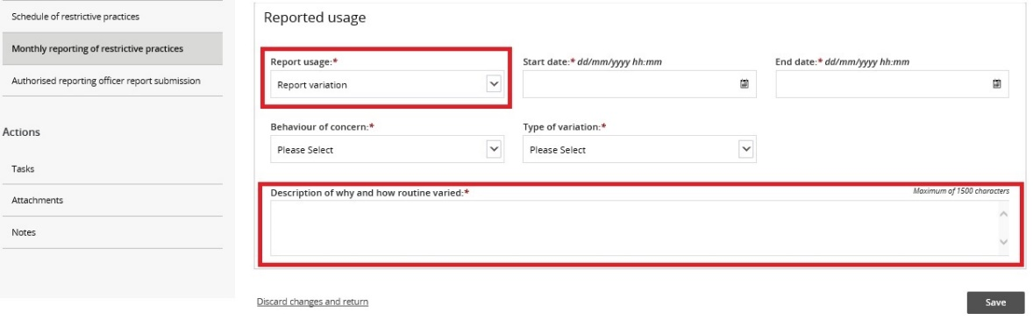
4.5. After entering the reports, select the ‘Authorised reporting officer’ tab. Click Submit reports.
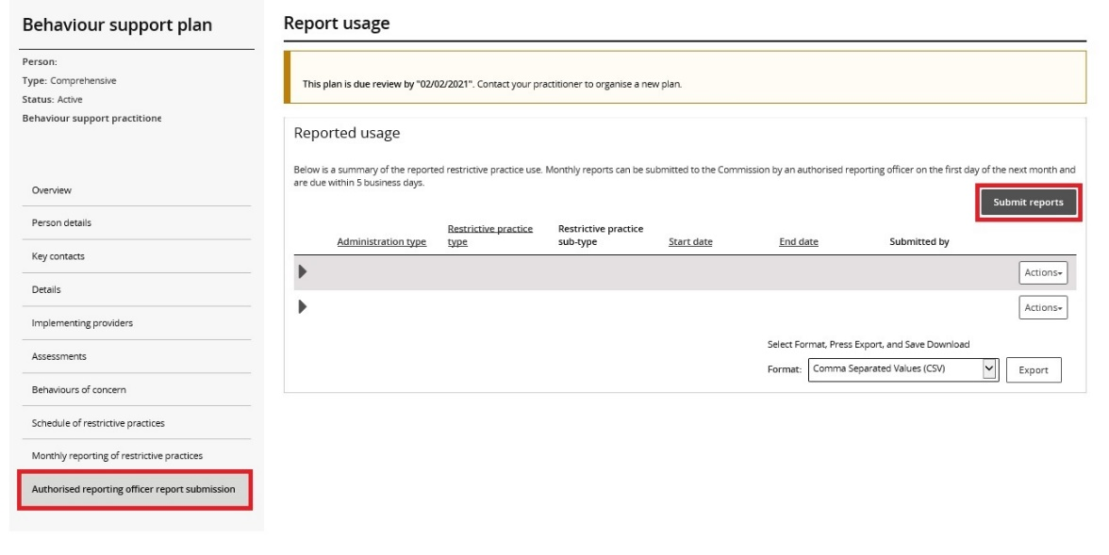
Note: only the ARO role can submit the reports.

5. Report the use of a PRN (as needed) regulated restrictive practice
5.1. For a PRN practice, each use of the practice must be reported. For a chemical restraint PRN, the end date can be left blank, just complete the date and time the PRN was used in the Start date field. For seclusion, physical restraint, environmental restraint or a mechanical restraint that is used as needed, include the start date/time and the end date/time.
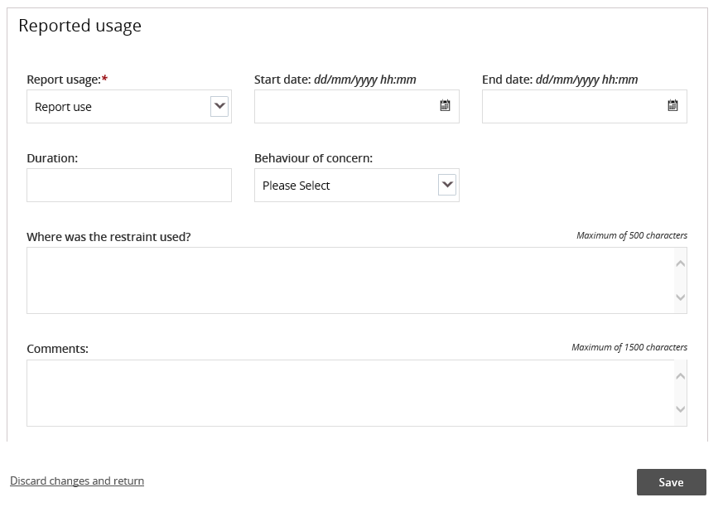
5.2. To enter additional uses of PRN regulated restrictive practices, click Monthly reporting of restrictive practices and click the Report button to report a second use.
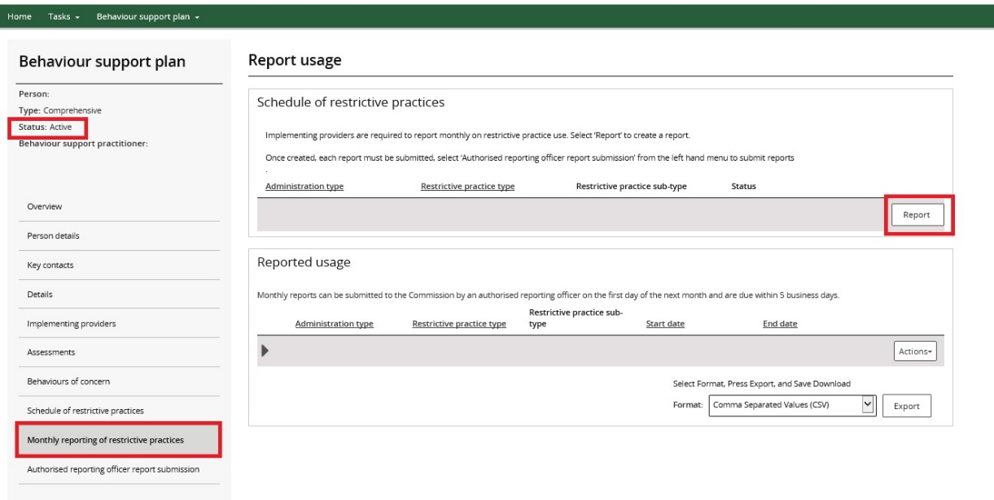
- Tip: PRN uses of regulated restrictive practices can be reported any time after the use.
5.3. After the reports are entered, select the ‘Authorised reporting officer’ tab and click Submit reports.
Only the ARO role can submit the reports.

6. Remove a report entered in error
6.1. To remove a report entered in error, Click the Actions button and then click Remove.
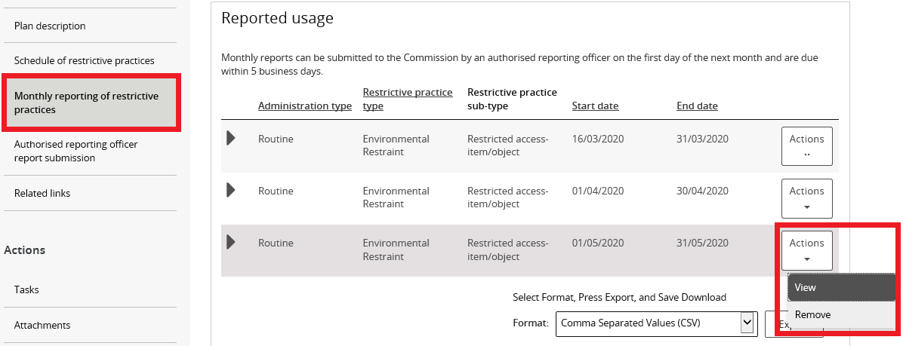

Reporting when no behaviour support plan is lodged
As noted above, an NDIS implementing provider’s use of a regulated restrictive practice is required to be reported to the NDIS Commission.
The “RP Record (no BSP)” function in the portal is designed to enable implementing providers to report the use of regulated restrictive practices in exceptional circumstances where a participant has a behaviour support plan (BSP) and authorisation that covers the use of restrictive practices but the behaviour support plan is not required to be lodged with the NDIS Commission. For example if a participant’s BSP has been funded and developed through an alternative program (for example out of home care or a forensic psychologist prior to a participant leaving a secure setting) and the implementing provider is being funded through a participant’s NDIS package. Implementing providers are still required to report on the use of regulated restrictive practices.
To facilitate this, the implementing provider can create an RP Record in the NDIS Commission Portal. This establishes the schedule of restrictive practices that the person is subject to, and allows monthly reports on the use of practices to be entered into the NDIS Commission Portal.
Please note, where there is no behaviour support plan in place, the use of a regulated restrictive practice is a reportable incident. The provider must notify the NDIS Commission about the use within 5 business days. Further information about this is available on our website: https://www.ndiscommission.gov.au/providers/incident-management-and-reportable-incidents.

7. Create a record in the NDIS Commission Portal
7.1. Click on the Behaviour Support Plan tile
7.2. Click on Create plan.
7.3. A type of plan is created called an RP Record (no BSP). Click Save and continue.
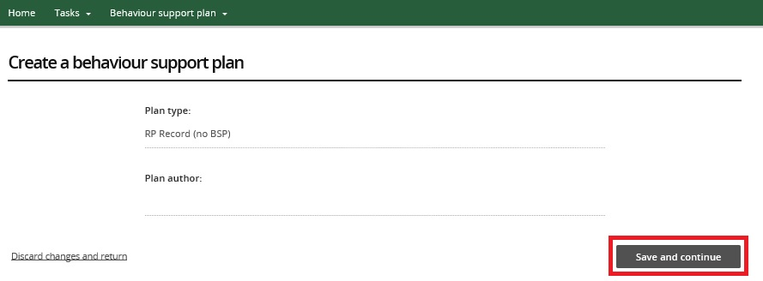

8. Add person details
8.1. Click the Person details from the left hand side menu then click Select person.
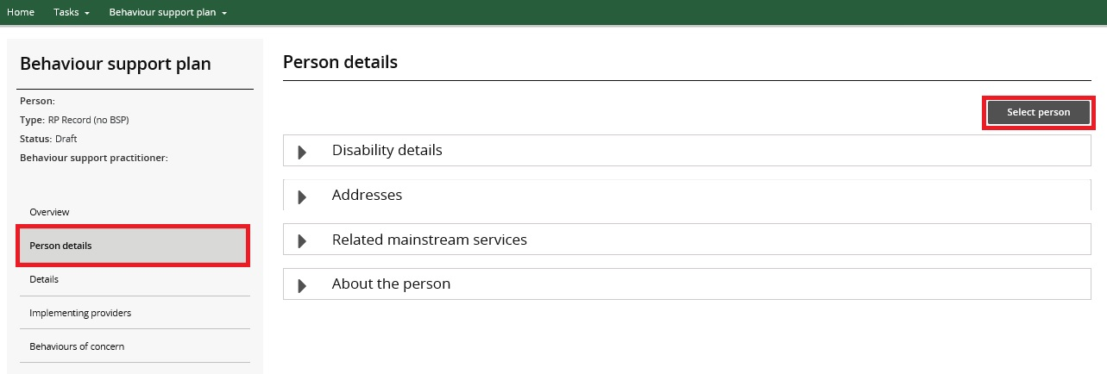
8.2. Click Select.
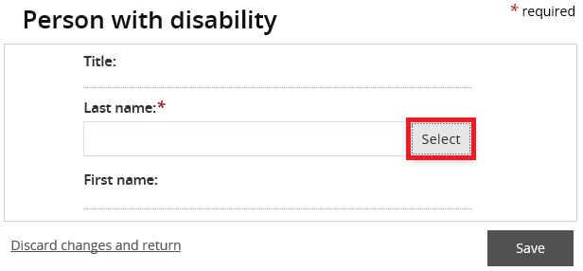
8.3 Type the Participant’s details and then click Search.
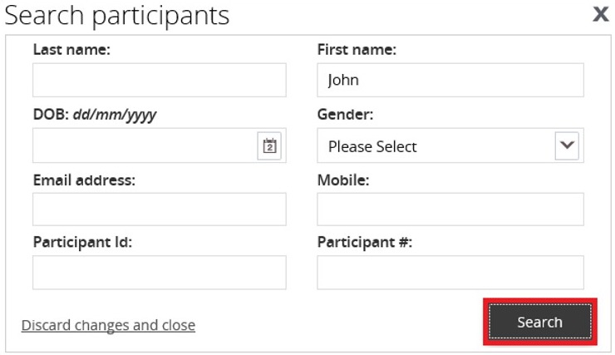
8.4. Select a Participant record to add then click Select and close. If no participant records appear, click Create and refer to step 8.6.
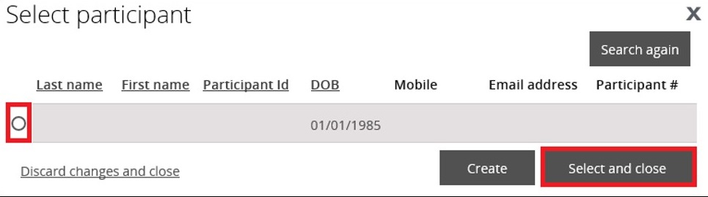
8.5. Check the Participant details for accuracy. Update the person’s details if they are incorrect. Click Save.
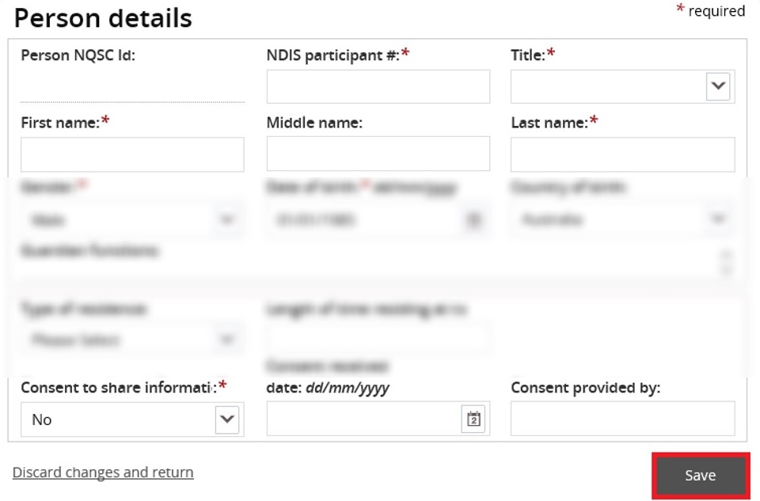
8.6. If no participant records appear after searching, click Create.
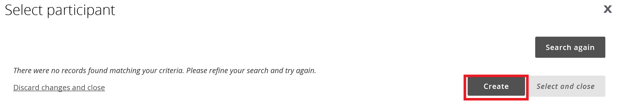
8.7. Enter the details of the participant. Scroll down and click Save.
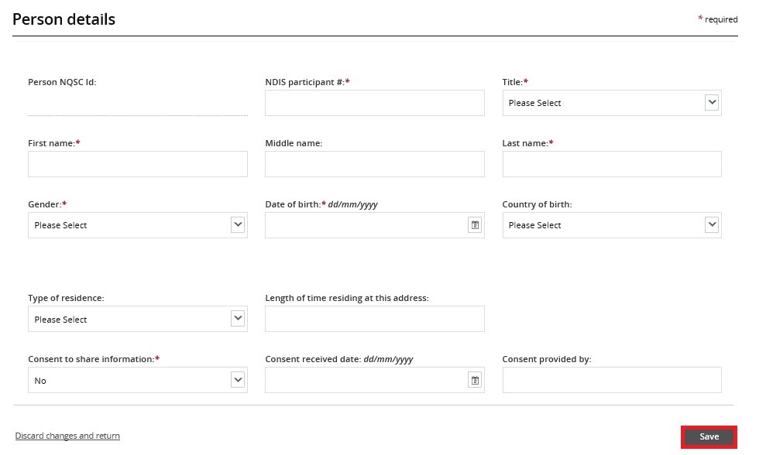

9. Add disability details
9.1. Select the Disability details tile then click the Expand button.
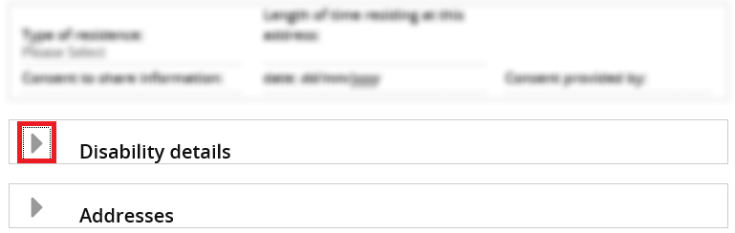
9.2. Click Add.
9.3. Click the Disability type drop down field, select a disability then click Save.
If there are further disabilities to add, repeat steps 9.2 – 9.3.

10. Add address details
10.1. Select the Addresses tile then click the Expand button.
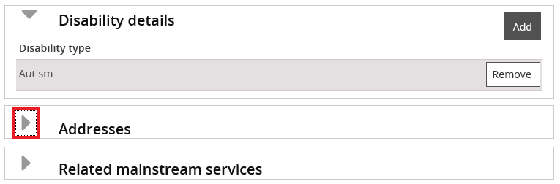

11. Enter details about start and end date
11.1. Enter the start date and end date you expect to be reporting on the use for.
11.2. Enter the State the participant is living in.
11.3. If the restrictive practice is used in Queensland or South Australia only, indicate whether a short-term approval is in place.
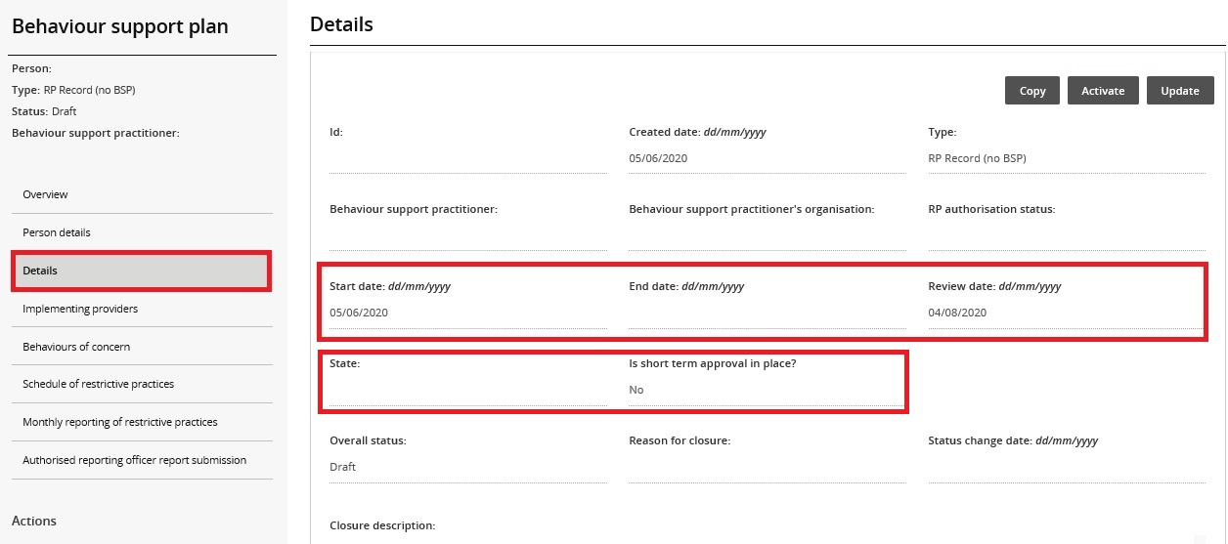
11.4. When an implementing provider creates an RP Record (no BSP), the implementing providers name should appear under Implementing Providers automatically.
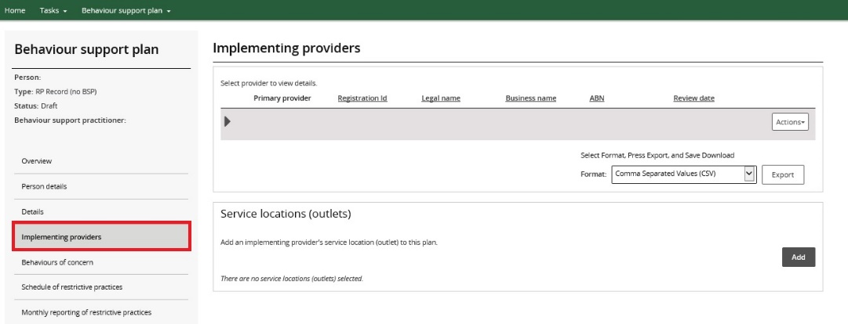

12. Enter behaviours of concern
12.1. Click Behaviours of concern from the left hand side menu and click Add.
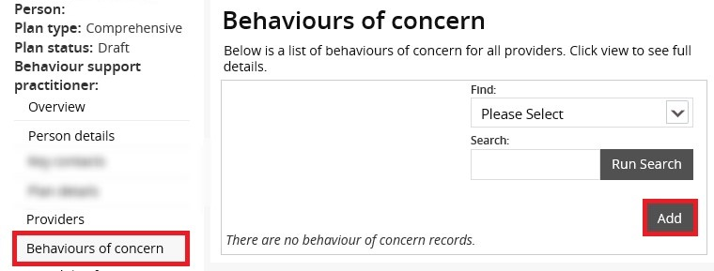
12.2. Select a Behaviour of concern from the Behaviour of concern drop-down menu. Click Next.
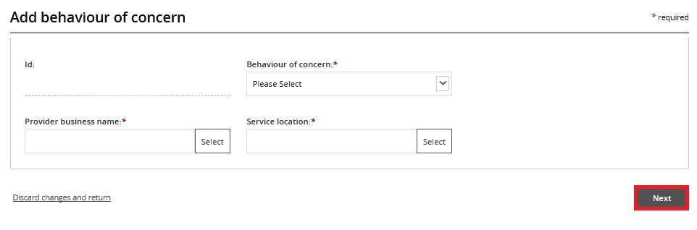
If there are more behaviours of concern to add, repeat steps 12.1. – 12.2.

13. Add restrictive practices
13.1. Click the Schedule of restrictive practices from the left hand side menu. Then click Add.
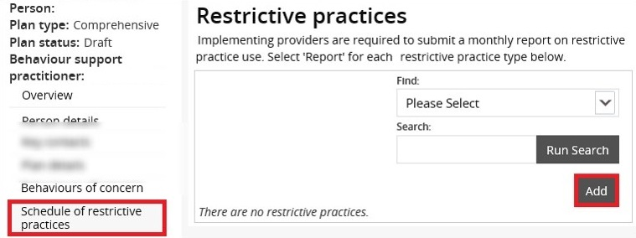
13.2. Select Restrictive practice type information from drop-down menu. Then click Next.
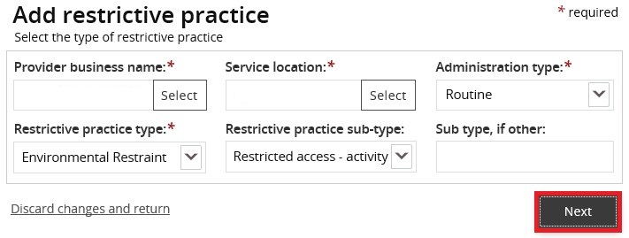
13.3. Enter the Restrictive practice details then click Save.
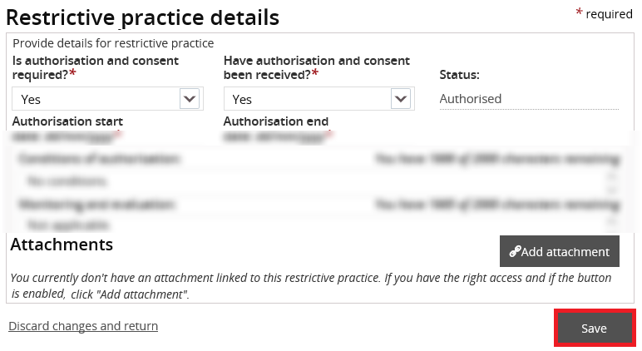
If there are more restrictive practice to add, repeat steps 13.1. – 13.3.

14. Activate the record to enable monthly reporting
An RP record created by an implementing provider must be activated once it is completed to enable monthly reporting. The steps for this are different from approving an interim or comprehensive behaviour support plan.
14.1 To activate the RP Record, click Details, then click Activate.
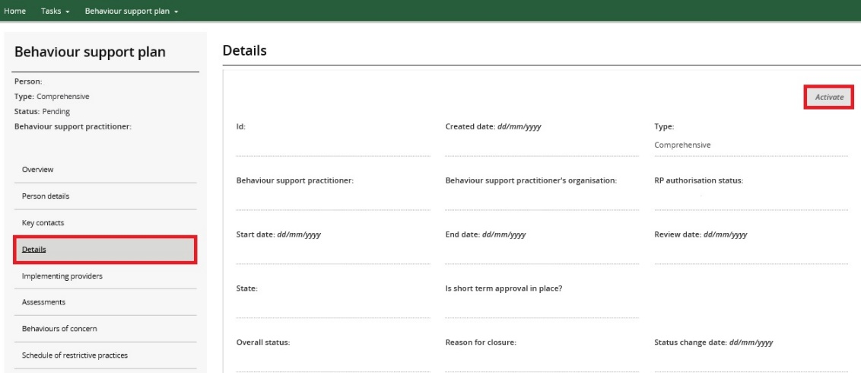

14. Close an RP Record
If a new NDIS behaviour support plan is lodged in the NDIS Commission Portal, close the RP Record and commence reporting against the interim or comprehensive behaviour support plan.
To close the RP record, go to the Details page, click Update and then change the status to Closed.
If you are unable to close the RP Record, email the NDIS Commission.
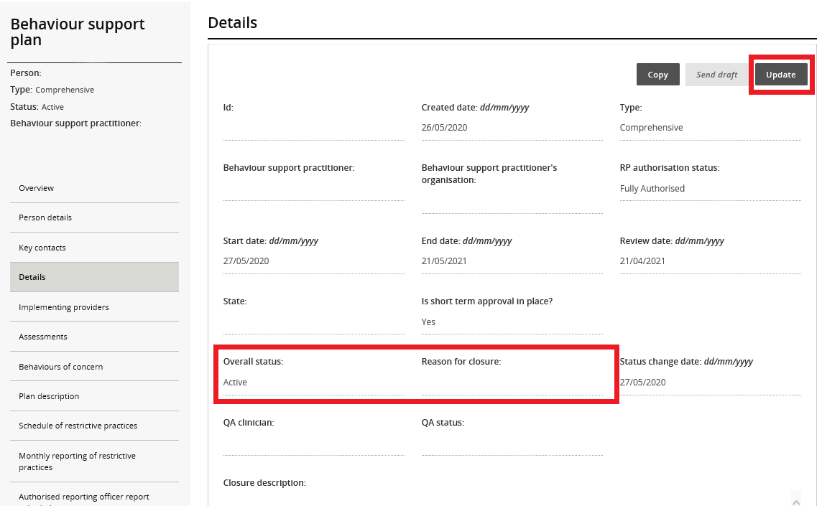

Contact us
Call: 1800 035 544 (free call from landlines). Our contact centre is open 9.00am to 4.30pm in the NT, 9.00am to 5.00pm in the ACT, NSW, QLD, SA, TAS and VIC Monday to Friday, excluding public holidays.
Email: contactcentre@ndiscommission.gov.au
Website: www.ndiscommission.gov.au

