COVID-19 Worker Vaccination Reporting
Quick Reference Guide – Updated 19 February 2022

Submitting COVID-19 worker vaccination information
This Quick Reference Guide explains the step-by-step process of successfully logging in to the NDIS Commission Portal and submitting information required in relation to worker COVID-19 vaccination.
- Access the NDIS Commission Portal using the Registrant role.
For more information on how to access the Portal and update access roles, refer to the Quick Reference Guide: Getting access to NDIS Commission Portal located at https://www.ndiscommission.gov.au/document/1021.
- Select the My Registration tile.
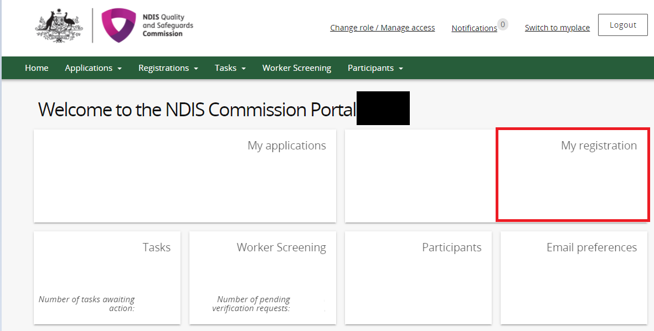
- Select Notification of changes and events from the left hand menu bar.
- Select Add.
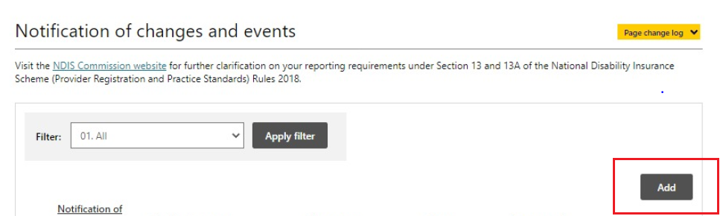
- Select COVID-19 vaccine report from the Change type drop-down menu.
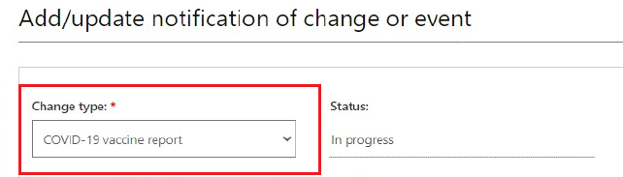
- Enter relevant numbers into the following fields:
Field | Guidance
Number of workers required to be fully vaccinated* | Record the number of workers required to be fully vaccinated to deliver NDIS supports or services, in accordance with the relevant Public Health Orders in effect in the states and/or territories in which relevant workers are located.  To provide this number, you will need to assess what requirements apply in each state or territory in which you operate and assess the number of workers you employ, or otherwise engage, to deliver NDIS supports and services that are required to be fully vaccinated as at a certain date.  If you determine that you have no workers that are required to be fully vaccinated, you may enter ‘0’ in this field. If you enter ‘0’ in this field, all other mandatory fields should also be populated with a ‘0’ response.  Definitions:  ‘Fully vaccinated’ means as at a date:  - two doses of a primary vaccination course of two doses in a state or territory requiring two doses; or  - two doses of a primary vaccination course and a booster dose(s) in a state or territory requiring two doses and a booster dose(s).  ‘Primary vaccination course’ means two doses of a COVID-19 vaccine, or additional dose(s) where medically advised, and does not include booster dose(s).  For example:  I have 30 employees and engage 10 contractors (collectively ‘workers’) who work in two states. I assess the Public Health Orders that apply in each state and note that:  - As at 25 February 2022, 25 of my 40 workers are required to be fully vaccinated. For 15 of my workers this means a primary vaccination course and a booster dose and for the remaining 10, a primary vaccination course only; and  - 15 of my workers do not engage in duties or working in a role that require them to be fully vaccinated in accordance with Public Health Orders (this includes two staff that are on long-term leave and administrative staff).  I submit a count of 25 in my COVID-19 Report.  Note: If you have workers who you employ, or otherwise engage, and are not currently providing NDIS supports and services (e.g. they are on long-term leave or have been stood down), you do not need to include these workers in your counts. If this changes, you should reflect these changes in subsequent reports to the NDIS Commission.
Number of workers exempt from receiving the COVID-19 vaccination* | Of the workers who are required to be fully vaccinated, record the number of workers who are exempt from receiving a COVID-19 vaccination. Record the count of workers that have been verified (by sighting proof) as part of this cohort.  Definitions:  An ‘exemption’ is defined in a state or territory public health order and supporting information that sets out an acceptable reason that a worker does not need to have a COVID-19 vaccine.  The state and territory public health orders and published supporting information provide information on the requirements for workers to provide evidence.
Number of workers partially vaccinated* | Of workers required to be fully vaccinated, record the number that have had at least one dose of a COVID-19 vaccine but are not yet fully vaccinated.  This means:  - 1 dose of primary vaccination course of 2 doses in state requiring 2 doses; or  - 2 doses of primary vaccination course in state requiring 2 doses and a booster dose(s))’  For example:  Joe is an employee located in a state where he is required under Public Health Orders to have had two doses of a primary vaccination course and a booster dose by 28 February 2022 to be able to provide NDIS supports and services from 16 February 2022. As Joe’s employer, I sight proof of his vaccination status on 25 February 2022 and note he has received two doses of a primary vaccination course only. I include Joe in the count of workers partially vaccinated in my COVID-19 Report reflecting worker vaccination status as at 25 February 2022.
Of the workers partially vaccinated, how many have a booking for a further dose(s) | Of the workers who are partially vaccinated, record the number of workers that have been verified (by sighting proof), as having a booking(s) for an additional dose(s) of a COVID-19 vaccine.  Note: You will only be required to make an entry if you enter a figure of 1 or more in the field ‘Number of workers partially vaccinated’.  For example:  I have one worker who I have identified as partially vaccinated as at 25 February 2022 as the worker is yet to receive a booster dose that is required under the applicable public health order to be considered fully vaccinated.  I request that worker shows me evidence of a booking for a booster. The worker shows me an email confirmation of a booking at a vaccination clinic for 4 March 2022.  I make an entry of 1 in this field.
Number of workers fully vaccinated* | Of the workers required to be fully vaccinated, record the number of workers that have been verified (by sighting proof) as being fully vaccinated.  The state and territory public health orders and published supporting information provide information on the requirements for workers to provide evidence.  For example:  I submitted that 25 workers are required to be fully vaccinated. Of these workers, I have sighted proof of 23 workers being fully vaccinated by sighting their Australian Immunisation Register immunisation history statements or their digital certificate in the state government app.  I determined that these 23 workers are fully vaccinated as they have received their primary vaccination course and a booster dose as required in accordance with the public health order in effect in the state in which all 23 workers work.
A number of 0 or higher must be entered for those fields with a red asterisk.
Help fields are available by hovering over the grey question mark.
Note:
- If the sum total of entries entered in the in second, third and fifth fields does not equal to number entered in the first field, an error will appear.
- You are not required to enter how many workers you have identified as potentially unvaccinated (i.e. have not received at least one dose of a COVID-19 vaccine). This is automated by the NDIS Commission based on a deduction of the number of workers exempt, partially vaccinated and fully vaccinated from the figure you provide for the number of workers required to be fully vaccinated.
- Select Yes or No from the drop-down menu in response to the question ‘I confirm that for all relevant workers I have sighted proof of vaccination/exemption status, booking for further dose(s)/I have 0 relevant workers’.
Note: You will not be able to submit the form until Yes has been selected.
- You may select Save and return to continue to work on your entries until you are ready to Submit and return.
To edit an entry that has been saved, identify the entry from the Notification of changes and events page and select the down arrow on the Actions selection and select View.
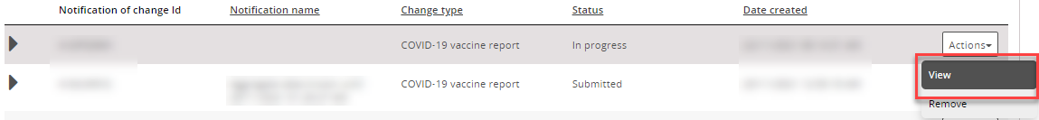
Once open, select Update.
- Once all information is accurate and entered and you have confirmed that you have sighted proof of all workers' vaccination/exemption status and/or booking for a second dose, select Submit and return.
Note: Once submitted, you will no longer be able to edit the entry.

