Add an Auditor relationship
Quick reference guide (Provider Registration)

A provider is able to add an auditor relationship in the NDIS Commission Portal.

Search for an application
- Log in to the NDIS Commission Portal.
- Select My registration.
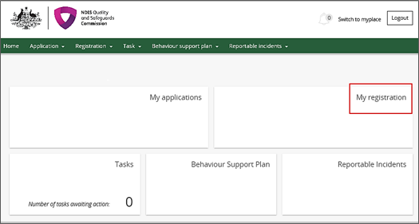

- Click Overview in the left hand side menu bar then click Add in the Auditor details section.
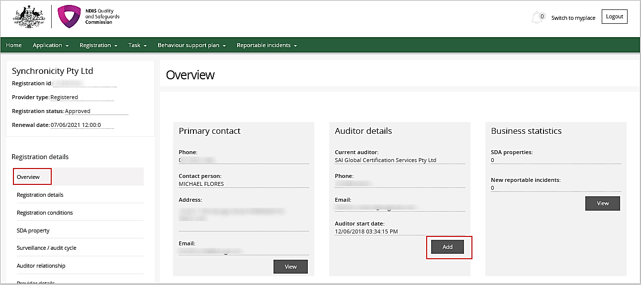

- Select the relevant auditor then click Save.
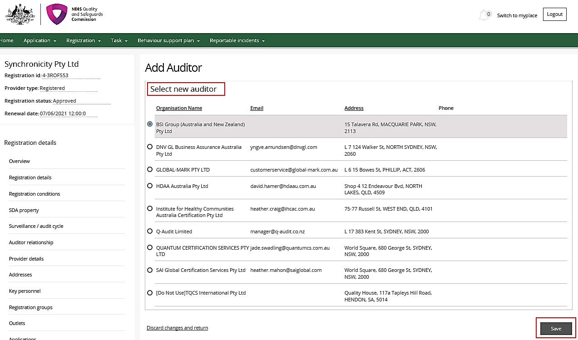
- The auditor details can now be viewed in the Overview tab in the left hand menu bar.

