Dear registered NDIS provider,

Request for information about the status of COVID-19 vaccination of workers
This letter is a request for information under section 73F(2)(i) of the National Disability Insurance Scheme Act 2013 (NDIS Act) relating to the COVID-19 vaccination status of workers who provide intensive support services (as defined below) to NDIS participants.
It is a condition of your registration that, on request, you must give to the Commissioner of the NDIS Commission:
- information specified in this request
- within the period specified in the request (which must not be less than 14 days).
The information you must provide, and the timeframes within which you must provide it, are set out below.
You have been identified as being registered to provide one or more classes of intensive support services to NDIS participants. Intensive support services are:
- assistance with daily life tasks in a group or shared living arrangement;
- assistance with daily personal activities;
- group and centre-based activities;
- specialised supported employment;
- community nursing care; and
- therapeutic supports.
Requests are being issued to all registered NDIS providers who are registered to provide one or more of classes of supports listed above.
Why is the NDIS Commission requesting this information?
On 10 November 2021 (date corrected), the Australian Health Protection Principal Committee (AHPPC) issued a statement recommending mandatory COVID-19 vaccination for certain disability workers, noting that mandating of vaccination for workers providing services and supports to people with disability provides an important protection for people with disability during the COVID-19 emergency. We issued an alert on 12 November 2021 regarding this statement.
All states and territories now have in force public health orders (or equivalent legal directions) that, broadly speaking:
- prevent unvaccinated workers from providing disability services in certain circumstances, and/or
- require registered NDIS providers to take certain steps to ensure that their workers comply with those requirements.
This letter asks for information about the extent to which your workers have been vaccinated in accordance with applicable state and territory public health orders. ‘Workers’ means the people you employ or otherwise engage to provide NDIS-funded supports or services.
The NDIS Quality and Safeguards Commission (NDIS Commission) is asking for this information to assist in:
- monitoring registered NDIS provider compliance with conditions of registration under section 73F(2)(a) of the NDIS Act, being compliance with public health orders; and
- managing the risks to NDIS participants arising from unvaccinated workers.
Information about your obligations under state and territory public health orders
To comply with this request, you will need to familiarise yourself with the public health orders that apply in each state or territory in which you operate. Further information concerning public health orders can be accessed from the NDIS Commission’s website at https://www.ndiscommission.gov.au/resources/coronavirus-covid-19-information#pro and on the state and territory specific pages linked under the heading ‘Provider alerts and communications’.
You should ensure you keep up to date with the relevant public health orders that apply, including those within other states and territories in which you may operate.
Details of information that must be provided
The information that you must provide is:
- The number of workers required to be fully vaccinated to deliver NDIS supports or services, in accordance with the relevant public health orders in effect.
- Of the workers who are required to be fully vaccinated, the number of workers that you have sighted proof of being exempt from receiving a COVID-19 vaccination.
- Of the workers required to be fully vaccinated, the number of workers that you have sighted proof of having had one dose of a COVID-19 vaccination only (does not include those who have had two doses or a booster).
- Of the workers who are partially vaccinated at point 3, the number of workers that you have sighted proof of having a booking for a second dose of a COVID-19 vaccination.
- Of the workers required to be fully vaccinated, the number of workers that you have sighted proof of being fully vaccinated (i.e. had two doses).
How to provide the required information
An online reporting form provides the most convenient and effective way for you to provide the requested information. Attached to this letter is a quick reference guide to assist you in using the form via the NDIS Commission Portal.
If you have difficulties in using this form, please contact the National Compliance team on 1800 035 544 or at national.compliance@ndiscommission.gov.au.
When providing the information, do not identify individual workers who are or are not vaccinated. As explained above, the NDIS Commission is gathering general data only. This request for information does not ask for sensitive and personal health information about individual workers.
The information requested relates to the period 10 December 2021 to 4 March 2022. This is an interim arrangement whilst the Commissioner progresses amendments to the Rules, including in consultation with disability and industry stakeholders as well as states and territories as required under the NDIS Act.
Please provide the information for each period according to the following timetable:
Information known by the provider | Deadline for reporting
Information as at 10 December 2021 | 17 December 2021
Information as at 17 December 2021 | 24 December 2021
Information as at 24 December 2021 | 7 January 2022
Information as at 7 January 2022 | 14 January 2022
Information as at 21 January 2022 | 28 January 2022
Information as at 28 January 2022 | 4 February 2022
Information as at 4 February 2022 | 11 February 2022
Information as at 11 February 2022 | 18 February 2022
Information as at 18 February 2022 | 25 February 2022
Information as at 25 February 2022 | 4 March 2022
How will the information collected be used?
The NDIS Commission is requesting this information to assist in monitoring provider compliance with public health orders and managing the risks to NDIS participants related to unvaccinated workers. It may also be:
- used to inform decisions by the Commission as to whether monitoring or investigation action may be warranted, or
- shared with other persons or bodies (including State, Territory or Commonwealth government agencies), where permitted by law.
This data will also be kept in the NDIS Commission’s secure record system.
Do I need to comply with this request?
It is a condition of your registration that you must provide information requested under section 73F(2)(i) of the NDIS Act within the period specified in the request (which must not be less than 14 days). The NDIS Act requires you to comply with the conditions of your registration.
If you hold concerns about complying with this notice, consider obtaining legal or other independent advice.
Yours sincerely

Delegate of the NDIS Commissioner
A/Registrar
NDIS Quality and Safeguards Commission
24 January 2022

COVID-19 Worker Vaccination Reporting
Quick Reference Guide

Submitting COVID-19 worker vaccination information
This Quick Reference Guide explains the step-by-step process of successfully logging in to the NDIS Commission Portal and submitting information required in relation to worker COVID-19 vaccination.
- Access the NDIS Commission Portal.
For more information on how to access the Portal, refer to the Quick Reference Guide: Getting access to NDIS Commission Portal located at https://www.ndiscommission.gov.au/document/1021.
- Select Registration from the menu bar then click Registration details.
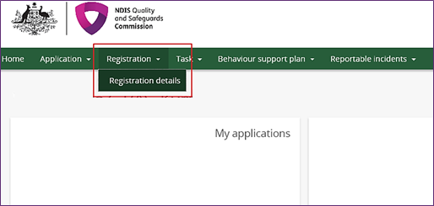
- Select Notification of changes and events from the left hand menu bar.
- Select Add.
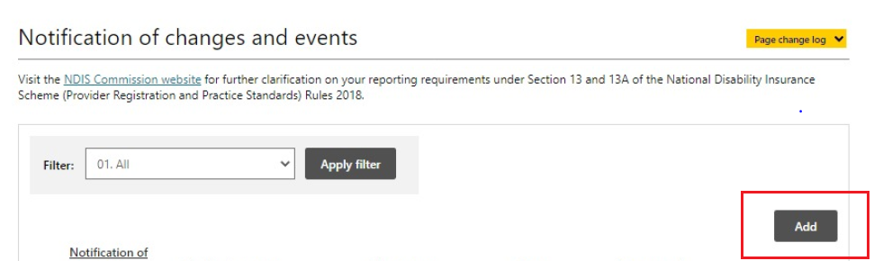
- Select COVID-19 vaccine report from the Change type drop-down menu.
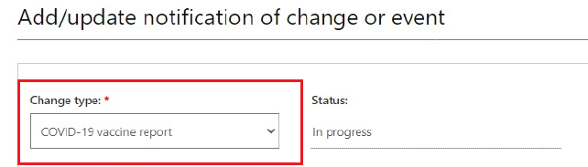
- Enter relevant numbers into the following fields.
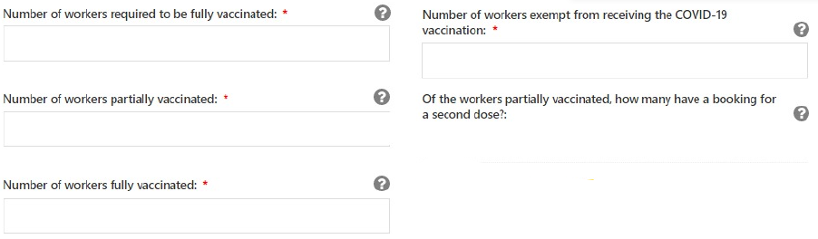
A number of 0 or higher must be entered for those fields with a red asterisk.
Help fields are available by hovering over the grey question mark.
Note: If the sum total of entries entered in the in second, third and fifth fields does not equal to number entered in the first field, an error will appear.
- Select Yes or No from the drop-down menu is response to the question ‘For workers contributing to counts, identify if you have sighted proof of all workers' vaccination/exemption status and/or booking for a second dose’.
Note: You will not be able to submit the form until Yes has been selected.
- You may select Save and return to continue to work on your entries until you are ready to Submit and return.
To edit an entry that has been saved, identify the entry from the Notification of changes and events page and select the down arrow on the Actions selection and select View.
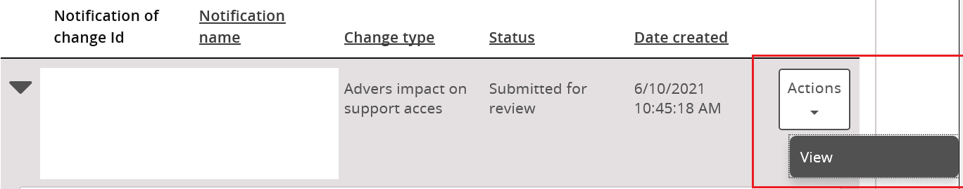
Once open, select Update.
- Once all information is accurate and entered and you have confirmed that you have sighted proof of all workers' vaccination/exemption status and/or booking for a second dose, select Submit and return.
Note: Once submitted, you will no longer be able to edit the entry.

