Annual Report 2019-2020
NDIS Quality and Safeguards Commission
The National Disability Insurance Scheme (NDIS) Quality and Safeguards Commission is an independent agency established to improve the quality and safety of NDIS supports and services.

Acknowledgement
The Annual Report cover features talent from our Commission Collateral project, designed to help providers, participants and other stakeholders understand what the NDIS Commission does.

This document, NDIS Quality and Safeguards Commission Annual Report, is licensed under the Creative Commons Attribution 4.0 International Licence.
Licence URL: www.creativecommons.org/licenses/by/4.0/legalcode
Please attribute: © Commonwealth of Australia (National Disability Insurance Scheme Quality and Safeguards Commission) 2020.
ISSN - 2652-2586 (Print) ISSN - 2652-2594 (Online)
Notice:
- If you create a derivative of this document, the NDIS Quality and Safeguards Commission requests the following notice be placed on your derivative: Based on Commonwealth of Australia (NDIS Quality and Safeguards Commission) data.
- Inquiries regarding this licence or any other use of this document are welcome. Please contact: Director - Engagement, Education and Communications, NDIS Quality and Safeguards Commission. Email: communications@ndiscommission.gov.au
Notice identifying other material or rights in this publication:
- Australian Commonwealth Coat of Arms — not Licensed under Creative Commons, see www.pmc.gov.au/government/commonwealth-coat-arms
- Certain images and photographs (as marked) — not licensed under Creative Commons.
If you are deaf or have a hearing or speech impairment, you can use the National Relay Service to ask for the NDIS Quality and Safeguards Commission on 1800 035 544.
TTY users — phone 133 677 and ask for 1800 035 544.
Speak and Listen users — phone 1300 555 727 and ask for 1800 035 544. Internet relay users — visit the National Relay Service website at https://internet-relay.nrscall.gov.au/
WARNING: Aboriginal and Torres Strait Islander readers are warned that this document may contain images of deceased persons.
Connect with the NDIS Quality and Safeguards Commission via social media: www.linkedin.com/company/ndiscommission
www.facebook.com/ndiscommission

NDIS COMMISSIONER'S REVIEW

Year in Review
In 2019-20, the NDIS Quality and Safeguards Commission (the NDIS Commission), expanded operations and continued working towards full national regulation of quality and safeguarding under the National Disability Insurance Scheme (NDIS).
We expanded operations from the two foundation states of New South Wales (NSW) and South Australia (SA) into five more jurisdictions: Victoria (VIC), the Northern Territory (NT), the Australian Capital Territory (ACT), Queensland (QLD), and Tasmania (TAS). We also established an office in Perth and are now preparing to commence operations in Western Australia (WA) on the agreed transition date of 1 December 2020.
Our primary focal points during this second year of operation were:
- building awareness of our role with NDIS participants and the stakeholders who represent them
- deploying compliance activities to adjust provider behaviour under the new regulatory model
- establishing an evidence base to act on factors increasing the risk of harm to people with disability
- continuing to mature as an organisation, through further development of our operating model and the strengthening of our relationships with key stakeholders.
We worked closely with people with disability, advocate and peak bodies representing the interests of people with disability, industry bodies and providers, and state and Commonwealth agencies in order to progress and expand these operations, to provide NDIS participants with ever-greater support.
During the year, we continued to contribute to and support both the Royal Commission into Violence, Neglect and Exploitation of People with Disability and the Royal Commission into Aged Care Quality and Safety, through witness statements, oral evidence and the broad provision of information.
The past year also required a focus on responding to the COVID-19 pandemic, in particular ensuring NDIS providers were able to continue to fulfil their obligations in delivering quality and safe supports to NDIS participants while taking necessary precautions to reduce the risk of infection. We worked closely with the National Disability Insurance Agency (NDIA) and other Commonwealth, state and territory agencies to respond to the needs of participants during this unprecedented period, with regular engagement and advice from advocates and peak bodies. Targeted response and compliance activities specific to the COVID-19 emergency were established in response to notifications of changes to support by providers.

In 2019–20, the NDIS Commission also:
- successfully transitioned an additional 11,486 providers into our jurisdiction
- built provider capability through access to specialist expertise and educational resources
- received 4,469 complaints about NDIS supports and services
- initiated compliance activities with more than 3,000 providers
- took a variety of regulatory actions against registered and unregistered providers in all jurisdictions within which we operate
- commissioned a scoping review of – and commenced an extensive program of work to change – provider practice, to reduce risk of harm and avoidable deaths of people with disability
- made adjustments to the provider registration requirements to remove a disproportionate regulatory burden on small business and individuals delivering low-risk supports
- determined 2,437 applications for registration.
The preceding was achieved while we continued to expand our scope, commenced activities in five new jurisdictions, prepared to start regulation in our final jurisdiction, developed and refined our operating model, and maintained a high standard of governance.
As an emerging agency required to play a significant role during a national emergency, the NDIS Commission experienced an eventful year. However, I am proud that our people met all challenges head on and with the goal of upholding the rights of people with disability always in the front of our minds. We look forward to continuing to serve NDIS participants and their families, carers, service providers and advocates in 2020-21.
Graeme Head AO
NDIS Quality and Safeguards Commissioner

Table of Contents
NDIS COMMISSIONER'S REVIEW 4
Year in Review 4
LETTER OF TRANSMITTAL 7
PART 1. ABOUT THE NDIS COMMISSION 8
NDIS Commission overview 8
NDIS Commission functions and powers 10
Our organisational structure 12
NDIS Commission activities 13
Key matters 2019-20 19
Case Study 1: Support through quick, remedial response 22
Activity report 2019-20 23
The Executive 27
Case Study 2: Improving communication for better service delivery 30
PART 2. PERFORMANCE REPORT 31
Annual Performance Statements 2019-20 31
Case Study 3: Changing outcomes for vulnerable young people 44
PART 3. MANAGEMENT AND ACCOUNTABILITY 45
Mandatory reporting 45
Financial performance 52
Management of human resources 52
FINANCIAL STATEMENTS 60
PART 5. APPENDICES 97
Appendix 1: Annual report list of requirements 97
Appendix 2: Work health and safety 102
Appendix 3: Engagement activities, major events and resources 103
Appendix 4: Glossary 110
Appendix 5: Information about remuneration for key management personnel, senior executives, and other highly paid staff 112
Appendix 6: Entity Resource Statement 114
ALPHABETICAL INDEX 115
CONTACT US 118

LETTER OF TRANSMITTAL
The Hon Stuart Robert MP
Minister for the National Disability Insurance Scheme Parliament House
Canberra ACT 2600
Dear Minister,
I present the Annual Report of the NDIS Quality and Safeguards Commission (NDIS Commission) for the year ended 30 June 2020. This report has been prepared for the purposes of section 46 of the Public Governance, Performance and Accountability Act 2013 (PGPA Act).
The report has been prepared in accordance with all applicable obligations under the PGPA Act. It includes our annual performance statements as required by section 39 of the PGPA Act, and our audited financial statements as required by section 43(4) of the PGPA Act.
I certify that the NDIS Commission has prepared a fraud risk assessment, a fraud control plan, and appropriate fraud prevention, detection, investigation, and reporting mechanisms that meet our specific needs, and we have taken all reasonable measures to appropriately deal with fraud relating to the NDIS Commission.
Graeme Head AO
NDIS Quality and Safeguards Commissioner
13 October 2020

PART 1. ABOUT THE NDIS COMMISSION

NDIS Commission overview

NDIS Commission’s role and responsibilities
Our role is to promote the provision of safe and quality supports and services to people with disability under the National Disability Insurance Scheme (NDIS). We are responsible for delivering nationally consistent and responsive regulation of all NDIS supports and services.

Responsible Minister
The Hon Stuart Robert MP, as Minister for the NDIS, had ministerial responsibility for the NDIS Commission, including the exercise of specific powers under the National Disability Insurance Scheme Act 2013 (NDIS Act), for the entire reporting period.

The Accountable Authority
The Accountable Authority was Mr Graeme Head, the NDIS Quality and Safeguards Commissioner, for the entire reporting period except for 4 to 15 November 2019 inclusive, during which time Ms Samantha Taylor was Acting Commissioner.

Commencement of NDIS Commission operations
The NDIS Commission was established through amendments to the NDIS Act to improve the quality and safety of NDIS supports and services, investigate and resolve issues related to quality and safety, strengthen the skills and knowledge of NDIS providers and workers, and support NDIS participants across Australia to have a stronger voice. This fulfils the Australian Government’s major responsibility under the NDIS Quality and Safeguarding Framework agreed by the Council of Australian Governments (COAG) in early 2017.
From 1 July 2019, we commenced operations in Victoria, Queensland, Tasmania, the Australian Capital Territory and the Northern Territory. On 1 December 2020, we will commence in Western Australia. New South Wales and South Australia commenced on 1 July 2018.

NDIS Commission Accountabilities
As a non-corporate Commonwealth entity within the Social Services portfolio, we are accountable under the Public Governance, Performance and Accountability Act 2013 (PGPA Act) and the Public Service Act 1999 (Public Service Act).

Jurisdiction of the NDIS Commission
We regulate quality and safeguarding in the delivery of all NDIS-funded supports and services to NDIS participants.

The NDIS Commission Corporate Plan
This Annual Report, including the Annual Performance Statements, was prepared in the context of the NDIS Quality and Safeguards Commission Corporate Plan 2019–2020.
The purpose of the NDIS Commission as stated in the Corporate Plan is “…to work with people with disability, providers and the community to deliver nationally consistent, responsive and effective regulation of providers, [and to] promote the delivery of safe and quality supports and services to people with disability under the NDIS. [The Commission] will approach its responsibilities in a consultative and inclusive way [and] will be guided by the underpinning principles outlines in the NDIS Act.”

Purpose and outcomes
Our purpose and outcomes, as listed in the Portfolio Budget Statements 2019-20, are outlined below:

Purpose and outcomes
Outcome 1: Promote the delivery of quality supports and services to people with disability under the National Disability Insurance Scheme and other prescribed supports and services, including through nationally consistent and responsive regulation, policy development, advice and education.
Program 1.1 – Support for National Disability Scheme providers in relation to registration - Support for NDIS providers in relation to registration to support service providers with the costs of obtaining NDIS registration and to support the provision of education and training for providers, workers and auditors. | Program 1.2 – Program Support for the NDIS Quality and Safeguards Commission – To provide departmental funding for the annual operating costs of the NDIS Commission to enable the NDIS Commission to achieve its outcomes.

NDIS Commission functions and powers

Functions of the NDIS Commissioner
All powers exercised by the NDIS Commission are vested in the NDIS Commissioner. The NDIS
Commission’s function is to assist the Commissioner to exercise these powers. Commission staff routinely exercise powers delegated from the Commissioner.
The NDIS Commissioner has core functions set out in section 181E of the NDIS Act:
- upholding the rights of, and promoting the health, safety, and wellbeing of, people with disability receiving supports or services, including those received under the NDIS
- developing a nationally consistent approach to managing quality and safeguards for people with disability receiving supports or services, including those received under the NDIS
- promoting the provision of advice, information, education, and training to NDIS providers and people with disability
- securing compliance with the NDIS Act through effective compliance and enforcement arrangements
- promoting continuous improvement amongst NDIS providers and the delivery of progressively higher standards of supports and services to people with disability
- developing and overseeing the broad policy design for a nationally consistent framework relating to the screening of workers involved in the provision of supports and services to people with disability
- providing advice or recommendations to the NDIA or the NDIA Board in relation to the performance of the NDIA’s functions
- engaging in, promoting, and coordinating the sharing of information to achieve the objectives of the NDIS Act
- providing NDIS market oversight, including:
– by monitoring changes in the NDIS market which may indicate emerging risk
– by monitoring and mitigating the risks of unplanned service withdrawal.
In addition, the NDIS Commissioner has functions set out in the NDIS Act related to:
- registration and reportable incidents
- complaints
- behaviour support.
In addition to powers set out in the NDIS Act, the NDIS Commission’s activities are prescribed through a series of Rules.

Powers of the NDIS Commissioner
The NDIS Act provides the NDIS Commissioner with compliance and enforcement powers so that the NDIS Commission can promote best practice among NDIS providers and respond to risk to NDIS participants.
We work with NDIS providers so they comply with their quality and safeguards requirements, which includes their engagement with education and training surrounding their obligations.
We also investigate complaints and reports of non- compliance with the NDIS Practice Standards, NDIS Code of Conduct and other quality and safeguards requirements where they apply.
We have the power to investigate alleged breaches by NDIS providers and their workers of the NDIS
Act and Rules. We can impose sanctions including, in the most serious cases, banning workers and providers, and de-registering providers.
In exercising our compliance, investigation and enforcement powers, we adhere to the requirements of procedural fairness, which means the NDIS Commissioner and staff of the NDIS Commission will:
- avoid actual and perceived conflicts of interest and act in an impartial and objective manner
- afford a person an opportunity to be heard before making a decision affecting their interests.
The NDIS Commissioner is required to publish an NDIS Provider Register, which includes information about the registration arrangements for providers. If a provider’s registration is subject to a condition or has been suspended, or if a person is subject to a compliance notice or banning order, the NDIS Act requires this information be published on the NDIS Provider Register.
The NDIS Commissioner is required to conduct compliance and enforcement activities in a risk responsive and proportionate manner. The NDIS Commissioner’s monitoring, compliance, investigation and enforcement powers are proportionate and comparable to other Commonwealth regulators.

Our organisational structure
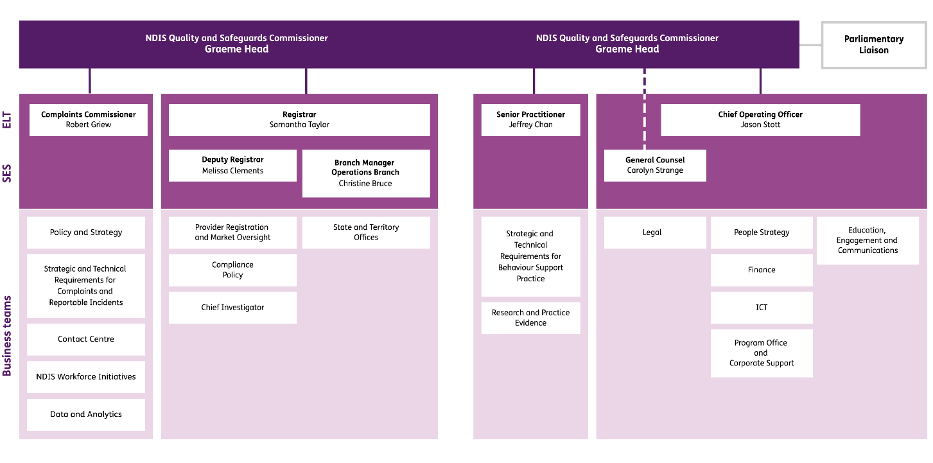

NDIS Commission activities

Overview
Our principal activities include:
- registration of NDIS providers
- regulation of both registered NDIS providers and unregistered NDIS providers
- behaviour support
- complaints
- reportable incidents
- compliance and enforcement
- market oversight
- partnering with external entities
- communications and engagement.

Registration
We register NDIS providers to deliver safe, quality supports and services to NDIS participants. NDIS providers must be registered if they wish to deliver supports and services to participants whose plans are managed by the NDIA. NDIS providers must also be registered to deliver certain support types to any participant, and this includes specialist disability accommodation, specialist behaviour support services, and implementing regulated restrictive practices. Our registration process is proportionate to the risk and complexity of supports being delivered to participants and the size and scope of the provider. The process involves:
- completion of an application and self- assessment by the provider
- an independent audit by an approved quality auditor against the NDIS Practice Standards that apply for the supports being delivered
- an assessment by the NDIS Commission of the suitability of the applicant provider and its key personnel to provide supports and services to NDIS participants.
Our NDIS Approved Quality Auditor Scheme establishes third party audit arrangements that providers must use to undertake a review of their practice against relevant NDIS Practice Standards. Auditing firms approved by the NDIS Commission under the scheme are accredited with JAS-ANZ, an internationally recognised accreditor of auditing firms. Individual auditors complete training provided by the NDIS Commission.

NDIS providers registered with the NDIS Commission must:
- comply with the conditions of registration prescribed through various Rules and stated on their certificate of registration
- comply with the NDIS Practice Standards applicable to the types of services and supports they are registered to deliver
- comply with the NDIS Code of Conduct
- have a complaints management and resolution system
- have an incident management system
- report certain incidents (including allegations) to the NDIS Commission
- fulfil national worker screening requirements
- meet behaviour support requirements, including reporting the use of restrictive practices to the NDIS Commission if applicable.
We monitor registered NDIS providers’ compliance with these obligations.
This activity helps provide assurance to the NDIS Commission that the NDIS providers we register are suitable and competent to provide safe, quality supports and services to NDIS participants, and ensures they can support us in undertaking our NDIS market oversight responsibilities.

Regulating unregistered providers
In addition to overseeing registered NDIS providers, we also regulate providers that deliver NDIS supports and services and are not required to be registered. NDIS participants may use unregistered providers if their plan is not managed by the NDIA (for example, if they self-manage or have a plan manager to assist them), except where the services consist of providing specialist disability accommodation, using regulated restrictive practices, or undertaking a behaviour support assessment or developing behaviour support plans for participants.
While unregistered providers do not have to comply with conditions of registration, we still regulate them through:
- the requirement that all NDIS providers comply with the NDIS Code of Conduct
- supporting participants who wish to complain directly to an unregistered provider
- receiving and acting on complaints made about an unregistered provider, or a person employed or otherwise engaged by the provider, including taking further action where a complaint raises a compliance issue.
This activity plays an important role in giving all NDIS participants the ability to make complaints about the NDIS supports and services they receive, and allows for action to be taken if those supports and services do not meet the expectations of quality and safety set out in the NDIS Code of Conduct.

Behaviour support
We oversee the use of behaviour support strategies and restrictive practices. This involves:
- developing and maintaining the Positive Behaviour Support Capability Framework (the framework) to help ensure practitioners deliver high quality behaviour supports
- assessing the suitability of behaviour support providers and practitioners against the framework
- undertaking random audits on the quality of behaviour support plans that are lodged with the Commission
- providing best practice guidance and advice to practitioners, providers, participants, families, and carers
- receiving, reviewing and analysing provider reports on the use of restrictive practices
- responding to the unauthorised use of restrictive practices
- reporting on the level of use of restrictive practices
- undertaking research to inform better practice.
We work with practitioners and providers to implement strategies designed to help reduce the occurrence and impact of behaviours of concern, and reduce and eliminate the use of restrictive practices. This activity helps to improve the capability of the sector through research and education to share best-practice advice with practitioners, providers, and participants, their families, and their carers.

Reportable incidents
We receive reports of certain incidents involving NDIS participants that occur in connection with the delivery of NDIS supports and services. This involves:
- overseeing the management of reportable incidents by registered NDIS providers and referring matters to other relevant authorities when appropriate
- where incidents identify potential or actual breaches, investigating and managing any requisite action
- requiring providers to take a variety of actions to respond to the incident, if we are not satisfied that appropriate actions have already been taken
- reviewing and sharing reportable incident data to identify systemic issues to be addressed, and driving improvement actions through NDIS provider reporting on reportable incidents and compliance activity.
We monitor registered providers’ compliance with their obligations to identify, report and respond to incidents, and we identify and act on incidents requiring a regulatory response. Our objective is to improve provider quality and safety processes, as well as capability in responding appropriately to incidents – including the use of restrictive practices – where these are not authorised by state or territory authorising bodies, or where participants have no behaviour support plan in place.
The inclusion of unauthorised use of restrictive practices is designed to drive compliance by NDIS providers to have a behaviour support plan in place and seek to have restrictive practices authorised.

Complaints
We manage complaints in connection to the services delivered by NDIS providers. This involves:
- supporting NDIS participants to make a complaint to a provider about the quality of their supports and services
- taking complaints about NDIS supports and services and supporting complainants to resolve their issues through conciliation
- where complaints identify alleged breaches, investigating and managing complaints
- supporting people with disability and other complainants to go to other bodies where their complaint is not in scope of the Commission’s remit, and referring matters to other relevant authorities when appropriate
- analysing complaints data to identify systemic issues to be addressed through compliance activities
- reporting on the number, types, and causes of complaints and the outcomes of complaint- handling processes.
We respond to complaints about NDIS supports and services and have the powers necessary to take compliance action regarding breaches of the Code of Conduct or conditions of registration.
Complaints activity is a key element of our continuous monitoring of the quality and safety of the NDIS market. This activity also has an important role in assisting NDIS providers to adjust their practice when delivering NDIS supports and services and to continuously review and improve the quality of their supports and services in accordance with the Practice Standards.

Compliance and enforcement
We undertake compliance and enforcement activities. This involves:
- applying appropriate regulatory responses to non-compliance and/or emerging issues that require compliance monitoring
- determining registered NDIS provider compliance with conditions of registration, NDIS Practice Standards, the NDIS Code of Conduct and other applicable requirements and, where necessary, using influence or statutory tools to compel compliance
- establishing compliance programs that address areas of risk for various types, classes of supports or services, or certain obligations
- using information-gathering and other powers in response to apparent non-compliance
- taking protective action in serious cases of persistent and high-risk non-compliance.
If compliance cannot be secured through the above actions, we can remove an NDIS provider from the market.
We have a comprehensive range of compliance and enforcement powers, tools, and methods. These include the following actions:
- educating NDIS providers to understand their obligations and achieving ongoing compliance
- monitoring and investigating compliance with the NDIS Code of Conduct, the NDIS Practice Standards and other quality and safeguard requirements where they apply
- issuing compliance notices directing a provider to do, or refrain from doing, certain things
- entering into enforceable undertakings that commit a provider to specific action
- seeking injunctions from a court to compel a person to take, or refrain from taking, certain action
- issuing infringement notices
- seeking civil penalties through a court
- varying, suspending or revoking a provider’s registration
- making banning orders that prohibit or restrict specified activities by a provider, or a person employed or otherwise engaged by a provider.
Actions to be taken are determined on a case by case basis taking into consideration factors outlined in the NDIS Commission’s Compliance and Enforcement Policy, including the seriousness of the issue, the appropriateness of the provider’s or other person’s response, and the likelihood of further harm to NDIS participants.
This activity helps to prevent poor service delivery and to protect participants from harm. It also helps ensure public confidence in the NDIS and in services delivered by NDIS providers.

Market and regulatory oversight and risk
We identify, categorise, assess and manage systemic risks to protect people with disability from harm that arises from poor-quality or unsafe supports or services provided under the NDIS. This involves:
- identifying, monitoring and responding to intelligence on emerging risks based on a range of data sources, including compliance data, data collected through complaints, reportable incidents and restrictive practices reporting, and data collected through external stakeholders such as the NDIA, other regulators, and state and territory governments
- determining appropriate regulatory responses that are proportionate to the level of risk identified across the NDIS system
- monitoring changes in the NDIS market which may indicate emerging risk and service shortfalls in relation to the NDIS Commissioner’s functions.
This activity reduces regulatory risk that might lead to non-compliance, helps to ensure effective regulatory activities, and helps monitor the adequacy of supports available in the marketplace.

Partnering with external stakeholders and regulatory bodies
We partner with external stakeholders and other bodies to undertake key activities. This involves:
- building linkages between systems and stakeholders to help ensure effective and coordinated responses to issues
- sharing information with other bodies (such as child protection agencies and industry complaints bodies) to help ensure coordination of regulatory and other responses
- establishing information sharing arrangements with other government agencies, such as the Australian Health Practitioner Regulation Agency, the Australian Securities and Investments Commission, the Australian Competition and Consumer Commission and the Department of Health, to support us in improving the quality of supports.
- convening the Disability Sector Consultative Committee and the Industry Consultative Committee. The committees comprise senior sector and industry leaders brought together to provide advice to the NDIS Commission. They represent, respectively: the interests and perspectives of NDIS participants and their support networks; and industry perspectives surrounding the ability of NDIS providers to deliver quality and safe supports and services in a regulated NDIS market.
This activity helps to ensure responses to issues are well coordinated and thoroughly informed by all relevant information, and that we interface seamlessly with broader protections and safeguards, such as state and territory worker screening units.

Education and communication
We build the capacity and capability of providers, workers and participants through a variety of communication activities. This includes:
- providing best-practice guides and training including publishing guidance materials with examples of good and poor practice
- delivering targeted education campaigns designed to build the capability of providers and behaviour support practitioners in identified focus areas
- delivering targeted engagement and communications campaigns to build the knowledge and awareness of participants, NDIS providers and behaviour support practitioners
- building provider capability to prevent and respond to serious incidents and complaints through education and engagement
- undertaking all communications in a manner that maximises accessibility and is mindful of the different communication needs and preferences of stakeholders
- ensuring providers have access to specialist expertise, guidance, and educational resources to support best-practice approaches to positive behaviour support.
This activity helps to ensure providers are well- informed about their obligations and about any changes in policy or practice, that participants understand their rights and ability to complain, and that the role, regulatory function, and powers of the NDIS Commission are understood.

Key matters 2019-20
The past year has been challenging, with a range of natural disasters and the COVID-19 pandemic, however the NDIS Commission managed to accomplish a wide range of activities.

Black Summer bushfires
In response to the bushfires that affected many communities around Australia in late 2019 and early 2020, the NDIS Commission:
- communicated with NDIS providers to remind them they should contact the NDIS Commission if they were unable to continue to deliver services as a result of a bushfire, or had concerns regarding any of their usual reporting requirements
- issued alerts to providers
- established a protocol where NDIS providers affected by bushfires were able to lodge Reportable Incident notifications by telephone
- worked with affected providers, and with the NDIA, to make any necessary interim arrangements to support them with their obligations.

COVID-19
The emergency response to COVID-19 was a priority for the NDIS Commission.
Key activities included:
- establishing a COVID-19 response team led by the Registrar, Ms Samantha Taylor
- issuing extensive material to NDIS providers between 7 February 2020 and 30 June 2020, to assist them in meeting their obligations to NDIS participants and in accessing resources from the Department of Health and state and territory health authorities
- engaging in targeted compliance activities, to address issues identified through complaints and to assess provider preparedness to avoid and manage risk of infection
- continuing to use and distribute our tools and resources to ensure that NDIS participant safety was paramount, critical supports were maintained, disruption and loss of continuity of supports was minimised, and changes in the NDIS market were monitored
- providing support to staff and tailoring responses to individual circumstances such as adjusting working hours or attendance to reduce exposure to risks, approving appropriate leave, and/or agreeing to working-from-home arrangements
- encouraging all staff to take reasonable care of their health, including appropriate monitoring and management.

Transition
From 1 July 2019, the NDIS Commission operated in seven of eight states and territories, with preparations underway for WA to transition to the NDIS Commission. On 21 May 2020, the Western Australian government announced that WA would be delaying the transition of NDIS quality and safeguarding functions to the NDIS Commission from 1 July 2020 until 1 December 2020. Existing quality and safeguarding regulatory arrangements in WA will remain in place until 30 November 2020.
Key activities included:
- transitioning 11,486 providers who were previously registered with the NDIA in QLD, ACT, VIC, TAS, and the NT. This was in addition to the 9,703 providers that transitioned from NSW and SA on 1 July 2018. With some providers leaving the market and others joining, there were 17,253 registered providers as at 30 June 2020, up from the 8,302 providers that were registered as at 30 June 2019
- recruiting NDIS Commission staff in all new jurisdictions, including recruitment to prepare for commencement of operations in WA
- preparing the NDIS Commission’s Perth office for transition on 1 December 2020.

The Disability Royal Commission and Aged Care Royal Commission
NDIS Commission continued to cooperate and work with the Royal Commission into Violence, Abuse, Neglect and Exploitation of People with Disability (Disability Royal Commission), and the Royal Commission into Aged Care Quality and Safety (Aged Care Royal Commission).
Key activities included:
- the NDIS Commissioner providing a witness statement to the Aged Care Royal Commission at the end of July 2019. This witness statement responded to a number of questions about the NDIS Commission’s role, functions and early experience in regulating quality and safeguarding in the NDIS, and built on the comprehensive Information Paper on the work of the NDIS Commission that was provided in response to a request from the Aged Care Royal Commission at the end of June 2019
- providing information to the Disability Royal Commission in the public interest under the information protection and disclosure provisions in Part 2 of Chapter 4 of the NDIS Act and the NDIS (Protection and Disclosure of Information — Commissioner) Rules 2018 in November 2019
- providing information to the Disability Royal Commission in response to a notice in December 2019
- the NDIS Commissioner providing a witness statement to the Disability Royal Commission in response to a notice in February 2020. The NDIS Commissioner also gave evidence on 27 February 2020 at the Disability Royal Commission’s hearing in Sydney on the provision of health care to people with disability, particularly people with intellectual or cognitive disability.

Response to the death of Ms Ann-Marie Smith, an NDIS participant
Ms Ann-Marie Smith died in appalling circumstances on 6 April 2020 in South Australia. Leading up to and at the time of her death, Ms Smith was receiving supports and services by registered NDIS provider Integrity Care (SA) Ltd (Integrity Care). Ms Smith’s death is the subject of an active investigation by the South Australian Police and the NDIS Commission.
While its investigation is ongoing at 30 June 2020, the NDIS Commission has already taken a number of compliance actions against Integrity Care, including: the issue of a compliance notice; applying additional conditions of registration; and issuing a penalty infringement notice for a specific breach.
In addition, the NDIS Commission used its powers to require more than 2,700 providers delivering assistance with daily personal activities to disclose whether they had any single-worker arrangements and, if so, how they were ensuring that supports were being provided in a safe and competent manner.
During the course of the NDIS Commission’s investigation and as further information becomes known, the Commission may take a range of further compliance and enforcement actions against Integrity Care.
The Commissioner appointed the Hon. Alan Robertson SC, a former Federal Court judge, to lead an independent inquiry into the systems and processes of the NDIS Commission in its regulation of Integrity Care.

Legislative and regulatory changes
The NDIS Commission monitors the impact of new regulatory requirements, including registration and audit costs on small business.
In the past year:
- changes were made to the rules under the NDIS Act to address disproportionate regulatory impact on smaller businesses delivering lower risk supports. Importantly, these changes have not reduced the safeguarding effects of the regulatory arrangements for NDIS participants. The changes, which came into effect on 1 January 2020, removed the mandatory requirement that all providers that are body corporates undergo a comprehensive and more costly type of audit known as certification, irrespective of the types of supports being provided. Now, all providers delivering lower- risk supports will undergo a lighter touch, generally desktop based process, known as verification
- changes were made to requirements that apply to providers that provide higher-risk supports - they now undergo a mid-term audit during their three-year registration period, rather than two surveillance audits as previously required. This change allows the NDIS Commission to focus mid-term audits on specific areas for review, and does not diminish the oversight the NDIS Commission has on provider practice
- the Australian Government announced the powers of the NDIS Quality and Safeguards Commissioner will be expanded to ban unsuitable providers and workers from working with NDIS participants, regardless of whether they are active in the sector or not. During this reporting period the Strengthening Banning Orders Bill had been introduced but not yet passed by the Parliament.

Case Study 1: Support through quick, remedial response
Choking is one of the leading causes of preventable death in people with disability, so it is important to ensure the risk of choking is managed properly and quickly. Through our reportable incident function, we identified that an NDIS participant was experiencing choking problems frequently. Our priority was to ensure immediate action was taken to address the choking risks of the participant.
We worked closely with the provider to review their practices and risk management approach. We also supported the provider to engage with the participant’s multidisciplinary health team to review their health care and allied health supports; and to put in place a number of new practices – including training for staff - to reduce the risk of choking.
As a result, the participant’s choking episodes reduced, and staff were better equipped to deal with episodes when they arose. The provider also employed a specialist to review its practices with all participants who had choking risks, to improve the safety and quality of their service to all participants.
In this case our actions were swift and corrective in nature. The provider was willing to make the changes and did so with our instruction. The participant was engaged and their networks were involved in the plan in order to improve their supports.
In addition, the Commission undertook initiatives aimed at improving the detection and management of the swallowing problems that can cause choking. These included a grant to develop a training course for people with disability, direct support workers, family members and NDIS service providers on swallowing disorders and mealtime management.
The Commission also developed Provider Practice Alerts, which provide brief, easy to read guidance for Disability Provider services on the recognition and management of swallowing problems.

Activity report 2019-20
The NDIS Commission commenced in New South Wales and South Australia on 1 July 2018, and in Victoria, Tasmania, Queensland, Northern Territory and the Australian Capital Territory on 1 July 2019. The NDIS Commission will commence in Western Australia from 1 December 2020.

All Participants
367,612 excluding WA
Participant numbers are from the NDIA Q4 report as at 30 June 2020
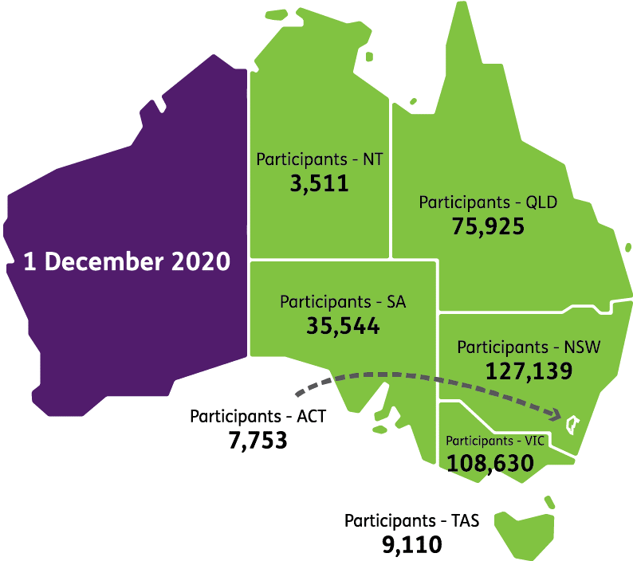

Five most popular registration groups
(as at 30 June 2020)
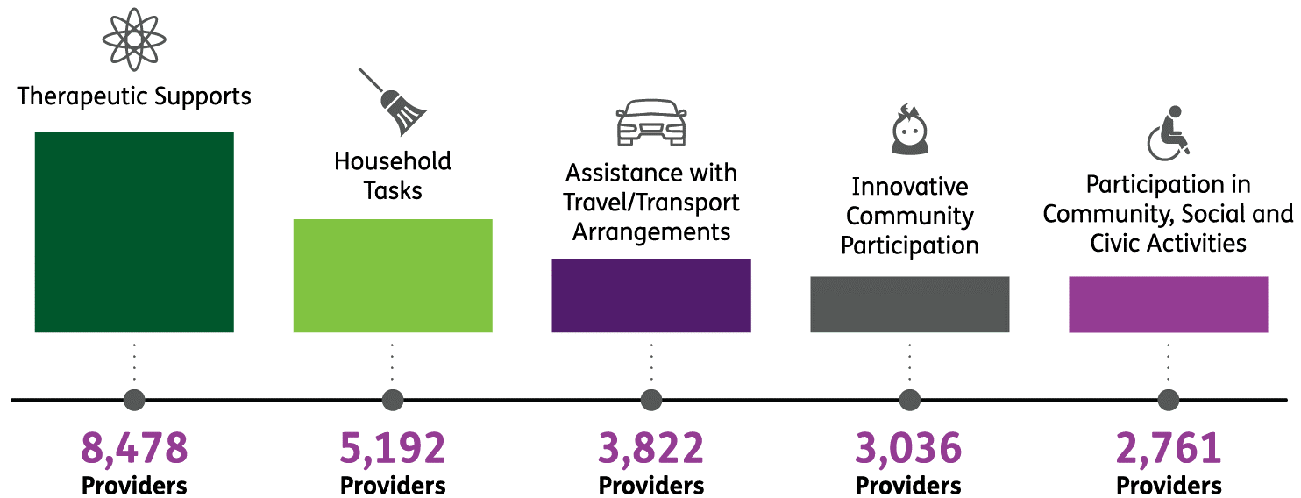
Registered service providers include all sizes of organisations and businesses, from sole traders to large corporates and not-for-profits
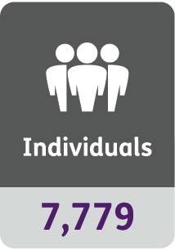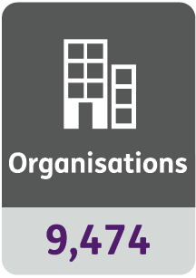
7,601 registrations (as at 30 June 2020) covering the five specialised service groups in which providers are required to meet additional standards
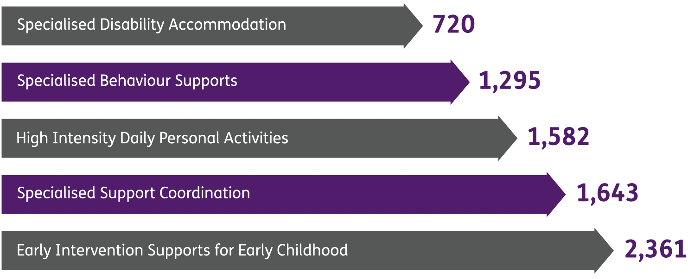
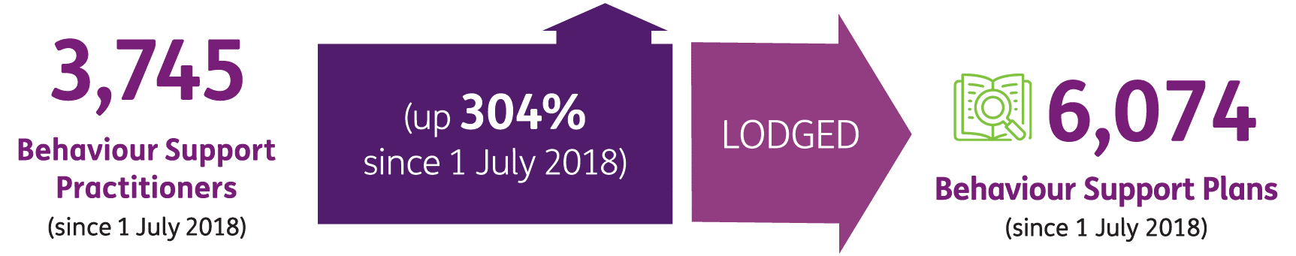
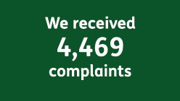
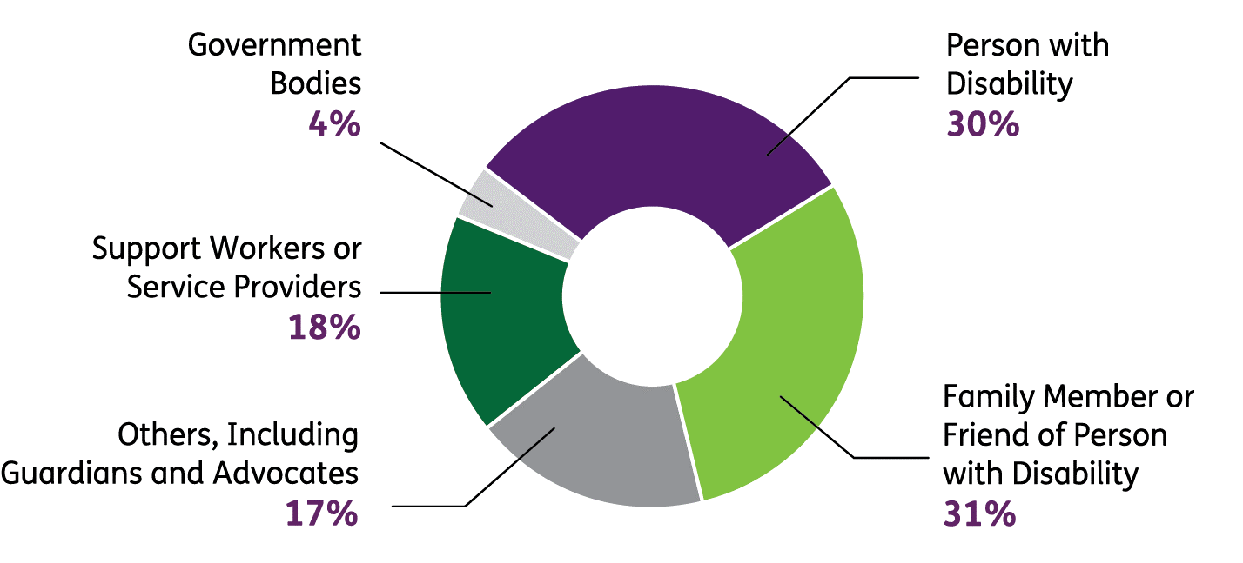
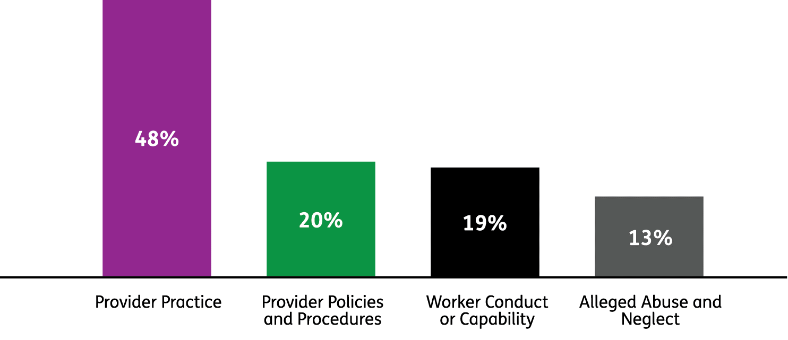
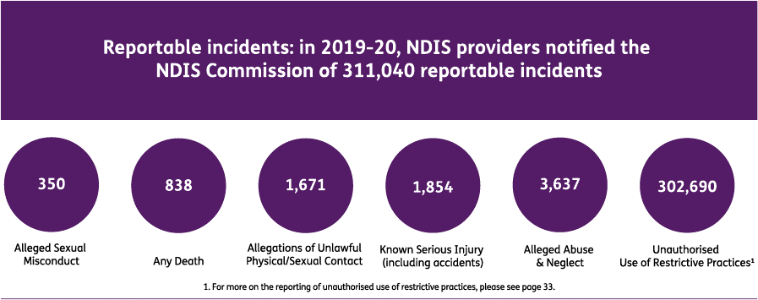
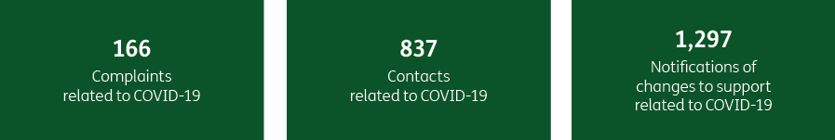

The Executive
Executive team biographies

Graeme Head AO
NDIS Commissioner
Mr Graeme Head has had a long and distinguished career in public administration and public policy. He was the Chief Executive of three NSW government agencies – notably as inaugural Public Service Commissioner for six years – and one federal agency. He served as a deputy secretary in both NSW and Commonwealth governments and his experience spans policy, regulatory, and central agencies, with a focus on social policy, environmental policy, and public sector employment.
Graeme Head is a Fellow of the Institute of Public Administration and was made an Officer of the Order of Australia in the 2019 Australia Day Honours.

Samantha Taylor PSM
Registrar
Ms Taylor held senior executive roles for more than 15 years in the NSW public service working in human and social services portfolios. Ms. Taylor was Executive Director of NDIS Implementation in the NSW Department of Family and Community Services. In this role, she led NSW negotiations on the NSW NDIS agreement, and managed all facets of the NSW transition to the NDIS, giving effect to the $6 billion agreement with the Australian Government. She also advised on the transfer of NSW Government-operated specialist disability services to the non-government sector.
In 2017, Samantha Taylor was awarded a Public Service Medal for her leadership in disability reform in NSW.

Jason Stott
Chief Operating Officer
Mr. Jason Stott has extensive experience leading governance, program management, service delivery, and corporate operations across federal departments and other agencies. His achievements include business process and ICT transformation, strategic governance reform, leadership in complex programs, and implementation of high- profile initiatives and measures.
Amongst his diverse experience Mr Stott worked extensively with Indigenous communities in Cape York and is a Jawun Program alumnus. He also led teams deployed to scrutinised international disasters including the Bali tragedy, the Middle East evacuation, and the Christchurch Earthquake.
Jason Scott is an active reservist.

Robert Griew
Complaints Commissioner
Mr. Robert Griew joined the NDIS Commission as Complaints Commissioner in April 2020. Mr Griew has extensive experience in leadership roles across a wide range of areas of social policy and across sectors. He has senior executive experience in the Commonwealth, state and territory governments, and non-government sectors; he also has significant experience in consulting to government.
Mr Griew’s public service experience spans health, education, aged care, child protection, and other social policy domains. Notably, he was the Secretary/CEO of the Northern Territory Department of Health and Community Services and has held Associate Secretary and Deputy Secretary positions in the Australian Commonwealth.

Dr Jeffrey Chan
Senior Practitioner
Dr. Jeffrey Chan has worked in disability and health services for nearly 30 years in government, non-government, and statutory roles. He was the inaugural Victorian Senior Practitioner with the responsibility of protecting the rights of people with disability subject to restrictive interventions and compulsory detention. Dr Chan was also Queensland’s inaugural Chief Practitioner and Director of Forensic Disability (a Governor-in-Council appointment) where he was responsible for protecting the rights of people with cognitive impairment subject to restrictive practices. Prior to his current role, Dr Chan was Deputy CEO of the largest intellectual disability service provider in Singapore.
Jeffrey Chan was an International Rotary Scholar to the University of Sydney 1988. He received the Rotary Club of Ryde Pride of Workmanship Award in 2002 for this work in rehabilitation services. He was also a Finalist in the Australian Human Rights Award 2010 for Community (Individual) category for his work in protecting the rights of people with disabilities subjected to restrictive interventions. He continues to research and publish in international refereed journals in the area of disability and is an Adjunct Professor at the University of Queensland’s School of Education.

Christine Bruce
Branch Head Operations
Ms. Christine Bruce brings more than 30 years of experience in social policy and an energy and commitment across a broad range of functions including corporate services, communication and engagement strategies, policy and program design, program implementation, and service delivery in NSW, VIC and TAS. She has delivered complex government services in western NSW working with Aboriginal communities on improving outcomes to deliver Closing the Gap targets to address Indigenous disadvantage. Ms Bruce introduced the National Disability Parking Scheme and the National Companion Card Scheme in 2010 and prior to joining the NDIS Commission she was leading the Department of Health grant program transition of the Department of Social Services Community Grants Hub.
Christine Bruce has served on a number of Boards, including the Institute of Public Administration in VIC, and has formal qualifications in project management and a Master’s in Public Administration. She has a deep understanding of the interaction and dependencies of the NDIS, the Social Security Payments Scheme and the not-for-profit sector in weaving a comprehensive framework to improve the lives of marginalised Australians.

Melissa Clements
Deputy Registrar
Ms. Melissa Clements has more than 25 years of experience in the disability sector in a range of policy, program, and service delivery roles. Previously she was Director, Disability, Learning and Support in the NSW Department of Education, leading policy and program delivery, and reforms supporting more than 100,000 students with disability in NSW public schools. She also led work across the Department to support the transition to NDIS and its interface with education provision.
Melissa Clements held a number of roles with the NSW Ombudsman and Community Services Commission for over 10 years, oversighting community and disability service provision as well as a range of direct service delivery roles supporting people with disability.

Carolyn Strange
General Counsel
Ms. Carolyn Strange came to the NDIS Commission with a long and varied career as a lawyer and regulator in the NSW and Commonwealth public sectors, most recently as General Counsel at the NSW Public Service Commission, after starting out as a commercial litigation solicitor. Her other public sector legal experience has included positions in the Commonwealth Office of General Counsel, the NSW Environment Protection Authority, NSW Parliamentary Counsel’s Office and the Office of the NSW Solicitor General and Crown Advocate.
Ms Strange has also held senior management roles in non-legal positions with regulatory dimension, including Director, Quality Assessment and Regulation in the Early Childhood Education and Care Directorate of the NSW Department of Education and Director, Contaminated Sites in the NSW Environment Protection Authority.

Case Study 2: Improving communication for better service delivery
The family of a person with disability who lives in supported independent living (SIL) had a long-running dispute with the participant’s provider which they had been unable to resolve. The person’s family made a complaint to us about concerns that supports were not being provided to the participant in a safe and respectful manner.
We worked with the family, advocates, and the provider to reach an agreement that addressed the family’s concerns about the quality of supports being provided to the person. We identified that the major contributing factor to the dispute was the provider’s poor communication with the family about the day to day life of the participant. This was identified as a systemic issue affecting other people with disability supported by the provider, who we found were not receiving regular communication from the provider.
We supported the provider to change their communication practices. As a result, the provider made systemic improvements to the way it communicated with family and carers, receiving positive feedback from those stakeholders in return.

PART 2. PERFORMANCE REPORT

Annual Performance Statements 2019-20

Introductory statement
I, as the accountable authority of the NDIS Quality and Safeguards Commission, present the 2019–20 annual performance statements of the NDIS Quality and Safeguards Commission, as required under paragraph 39(1)(a) of the Public Governance, Performance and Accountability Act 2013 (PGPA Act). In my opinion, these annual performance statements are based on properly maintained records, accurately reflect the performance of the entity, and comply with subsection 39(2) of the PGPA Act.
Graeme Head AO
NDIS Quality and Safeguards Commissioner
13 October 2020

Entity purpose
Our purpose as listed in the Portfolio Budget Statements (PBS) 2019-20 for both programs is identical to Outcome One, as described below. All performance measures in the performance statement contribute to this purpose. Our performance is measured in accordance with the PBS and our 2019-20 Corporate Plan.

Portfolio Budget Statement 2019 - 20
Outcome 1: Promote the delivery of quality supports and services to people with disability under the National Disability Insurance Scheme and other prescribed supports and services, including through nationally consistent and responsive regulation, policy development, advice and education.
Program 1.1 – Support for National Disability Scheme providers in relation to registration – Support for NDIS providers in relation to registration to support service providers with the costs of obtaining NDIS registration and to support the provision of education and training for providers, workers and auditors. | Program 1.2 – Program Support for the NDIS Quality and Safeguards Commission – To provide departmental funding for the annual operating costs of the NDIS Commission to enable the NDIS Commission to achieve its outcomes.

Results against performance criteria
The following table reports on performance measures contained in our Corporate Plan, which align with the PBS Programs as indicated below.
Corporate Plan Performance measure | PBS Program | Results
1.Participant experiences with us are positive | 1.2 | To gain insights into participants and complainants experience with the NDIS Commission, we conducted interviews with a range of stakeholders, including members of our Community Consultative Committees.  The feedback received was very positive regarding the accessibility, transparency, appropriateness of our communication, both with participant and complainant and the sector overall. Stakeholders praised the NDIS Commission’s focus on empowering participants, including through the Speak Up campaign. Interviewees commended the NDIS Commission’s attempts to communicate directly with participants.  The NDIS Commission also received valuable feedback regarding the use of a wider range of communication strategies to maximise effective communications with both participants and providers and to improve clarity among all stakeholders about the Commission’s scope and processes. In addition the interviewees gave suggestions for exploring and addressing factors which may inhibit participants, especially disadvantaged groups of participants, from approaching the Commission.
2. NDIS participants are increasingly confident to complain | 1.2 | People with disability have the right to complain about the services they receive. Most NDIS providers do their best to provide quality supports and services to people with disability, but issues can occur. The NDIS Commission can take complaints from anyone about NDIS providers, and NDIS participants may receive support from family, a friend or an independent advocate in making a complaint.  During 2019-20, 30% of complaints were made by NDIS participants on their own behalf, while 31% of complaints were made by family members or friends of NDIS participants, 18% by support workers or service providers, 17% by others (including guardians and advocates), and 4% by government bodies.
3. Our decisions have integrity | 1.2 | During 2019-20 none of the decisions made by the Commissioner or the Commissioner’s delegates were challenged in legal proceedings.  The National Disability Insurance Scheme Act 2013 (NDIS Act) provides that some types of decisions made by the Commissioner or the Commissioner’s delegates are ‘reviewable decisions’. Each person directly affected by a reviewable decision may request a review of the decision by an officer of the Commission and may then apply to the Administrative Appeals Tribunal for a review of the decision made by that officer. During 2019-20 there were requests for a review of four reviewable decisions made by delegates of the Commissioner. Three of these requests for internal review were completed within the 2019- 20 period. Two of those internal reviews resulted in variations to the original decision. None of these decisions made by the internal reviewers was the subject of an application to the tribunal.  During 2019-20, the Commonwealth Ombudsman’s Office notified the NDIS Commission of nine complaints about the NDIS Commission in relation to which the Ombudsman was conducting a preliminary inquiry (eight complaints) or an investigation (one complaint) under section 7A or 8 respectively of the Ombudsman Act 1976. The Ombudsman subsequently advised with respect to each preliminary inquiry that it would not progress the matter further to an investigation, and, with respect to the complaint which triggered an investigation, that it would not be investigated further.  Provisions of the NDIS Act help to promote the integrity of decision-making by the Commissioner or the Commissioner’s delegates. For example, the NDIS Act requires the Commissioner to have due regard to procedural fairness in performing the Commissioner’s functions and requires the Commissioner to use best endeavours to conduct compliance and enforcement activities in a risk responsive and proportionate manner. The Commission has also developed guidelines and policies that help to ensure the integrity of our decision-making, such as the published Compliance and Enforcement Policy and the Infringement Notice Policy. Further, the Commission has internal governance arrangements to support the making of decisions with integrity, including in particular a compliance and enforcement committee.
4. We are using the right regulatory  interventions to produce the right outcomes | 1.2 | The NDIS Commission uses a range of compliance tools to prevent and address breaches of the NDIS Act including education, and working closely with other complaints and regulatory bodies. The NDIS Act also provides the Commission with a range of compliance and enforcement powers, including banning orders, compliance notices and court-based outcomes.  During 2019-20 the NDIS Commission commenced 365 compliance matters and 168 investigations of which 61 per cent commenced following information received from providers through reportable incidents. Actions taken during 2019-20 included reviewing and investigating potential breaches of the NDIS Code of Conduct and, conditions of registration, monitoring the compliance of providers and their workers and educating providers on how to comply with their obligations under the NDIS Act.  During 2019-20, the NDIS Commission issued 17 banning orders, revoked 3 registrations, suspended 4 registrations (noting that multiple suspensions sometimes applied to the same registration), issued 1 infringement notice, and issued 2 compliance notices.  In addition to the compliance and enforcement actions taken in 2019-20, the NDIS Commission had previously, during 2018-19, issued 6 banning orders, suspended 2 registrations (noting that multiple suspensions sometimes applied to the same registration) and issued one compliance notice.  During 2019-20, the NDIS Commission also issued 29 warning letters as a result of compliance and investigation activity and issued requests for information to providers, including 2,466 requests sent in May 2020 to providers registered to provide assistance with daily personal activities.
5. We effectively resolve complaints | 1.2 | The aim of the NDIS Commission is to help participants resolve complaints quickly and simply. To do this, the NDIS Commission reviews information provided and talks to appropriate parties about this information. A complaint may be resolved via a resolution process or conciliation, or may be dealt with through compliance action, including investigations. The NDIS Commission can also make the decision to end a complaint resolution process for a variety of reasons including:  - the complaint is better handled by another complaints body  - the information given was not given in good faith  - a person with disability involved in the complaint does not wish to continue  - the complaint is the subject of formal legal proceedings  - the complaint was withdrawn  During 2019-20 the NDIS Commission received 4,469 in-scope complaints. Complaints received by the NDIS Commission in  2019-20 were open for a median of 43 days. 39% of complaints were open for up to 30 days, 60% up to 60 days, and 74% up to 90 days.
6. Increasing numbers of providers are resolving complaints directly with participants | 1.2 | The NDIS Commission can take complaints from anyone about:  - NDIS services or supports that were not provided in a safe and respectful way  - NDIS services and supports that were not delivered to an appropriate standard  - how an NDIS provider has managed a complaint about services or supports provided to an NDIS participant.  Participants are encouraged to raise concerns or complaints with their provider first, if they feel comfortable doing so. All registered NDIS providers must have a complaints management and resolution system in place.  As well as dealing with complaints, the NDIS Commission works to educate providers about delivering quality and safe supports, and effectively responding to complaints.  During 2019-20 the NDIS Commission received 295 complaints (6.6% of in scope complaints) about how an NDIS provider has managed a complaint about services or supports provided to an NDIS participant.
7. We are providing leadership in the practice of positive behaviour support and in the reduction and elimination of the use of restrictive practice | 1.2 | We provide extensive leadership and assistance in the field of behaviour support. Our behaviour support team responded to 15,610 external inquiries, with the most common enquiry themes being advice to providers about their obligations, assisting with provider understanding of restrictive practices and practitioner suitability, and enquiries relating to the NDIS Commission Portal. The behaviour support team also responded to 4,978 inquiries from within the Commission, providing advice and consultancy on behaviour support functions, clinical advice and data analytics.  The Commission received 302,690 reports by 492 providers of the use of unauthorised restrictive practices, with 4,327 persons subject to an unauthorised restrictive practice, where the practice was not authorised by the relevant state or territory authority, or where a behaviour support plan was not in place for the person. 96% of reports of unauthorised use of restrictive practice were related to chemical or environmental restraint, with each use of the restraint required to be reported. The volume of reports on the unauthorised use of restrictive practices increased month-on-month due to increased provider reporting compliance, and in particular the introduction of streamlined reporting mechanisms in October 2019.  The NDIS Commission oversees behaviour support practitioners and providers who develop behaviour support plans that include restrictive practices used in supporting NDIS participants. Only behaviour support practitioners found suitable by the NDIS Commission are able to develop behaviour support plans. Behaviour support plans are authorised by the relevant state or territory, but must be lodged with the NDIS Commission.  In 2019-20, 2,264 additional behaviour support practitioners were considered provisionally suitable across all participating states and territories.  The NDIS Commission reviews provider reports on the use of restrictive practices, reviews behaviour support plans and responds to the use of restrictive practices reported through the NDIS Commission’s reportable incident function. From 1 July 2019 to 30 June 2020, 6,003 behaviour support plans were lodged with the NDIS Commission.  During 2019-20 the behaviour support team completed an audit of 100 randomly selected behaviour support plans. This review gave insight into the extent to which they may require development.
8. We are registering providers to ensure market capacity to provide quality support, including through appropriate audits | 1.1 and 1.2 | Providers must be registered to deliver supports and services to participants whose plans are managed by the NDIA. Providers must also be registered to deliver certain support types to any participant: specialist disability accommodation, behaviour support, and implementation of regulated restrictive practices.  There were 17,253 registered NDIS providers as at 30 June 2020. The majority of these providers were transitioned providers previously registered with the NDIA who transferred to the NDIS Commission when it commenced in each state and territory.  On 1 July 2019, we transitioned 11,486 providers who were previously registered with the NDIA in QLD, the ACT, VIC, TAS and the NT. This was in addition to the 9,703 providers that transitioned from NSW and SA on 1 July 2018.  All providers that transition to the NDIS Commission must apply to renew their registration if they wish to continue to provide supports and services to NDIS participants. As at 30 June 2020, 1,657 applications to renew registration had been approved, and 11,117 providers had commenced the process to renew their registration, with some of these still in the very early stages of renewal.  Of the 17,253 registered providers as at 30 June 2020, 9,144 were ‘active providers’ meaning they had made a claim for NDIS payment in the last three months.  Registered NDIS providers are required to make a new application for registration prior to their registration renewal date, in order to maintain their registration. As at 30 June 2020, 3,662 providers’ NDIS registration had expired. Of these 89% were inactive in the NDIS market.  During 2019-20, the NDIS Commission received 5,439 new provider applications. We also received 1,857 applications to vary registration.  The NDIS Commissioner approved an additional five certified audit bodies to operate within the NDIS bringing the total to 16 approved audit bodies. The NDIS Commission trained an additional 217 individual auditors bringing the total to 498 individual auditors trained.  During 2019-20, 5,803 audits were completed.
9. We are enabling and engaging the NDIS market to mature with diverse composition and increasing compliance | 1.1 and 1.2 | The 17,253 providers registered with the Commission (as at 30 June 2020) provide a wide range of supports and services to NDIS participants. These services and supports are categorised into registration groupings.  Five per cent of providers provide supports or services across multiple registration groups meaning they can deliver a range of supports to NDIS participants.  Specialised registration groups provide higher intensity supports to NDIS participants. There are 7,601 registrations across the five specialised service groups. Nearly one third of these NDIS providers are registered to deliver Early Intervention Supports for Early Childhood.  Registration group Number of Providers  Early Intervention Supports for Early Childhood 2,361  Specialised Support Coordination 1,643  High Intensity Daily Personal Activities 1,582  Specialised Behaviour Supports 1,295  Specialised Disability Accommodation 720  Total 7,601  As at 30 June 2020, 9,474 or 55% of registered providers were organisations, and 7,779 or 45% were individuals.  During 2019-20 the NDIS Commission developed specific resources to target areas of provider governance or practice. This included:  - the development of the incident management compliance program in 2019-20, including provider resources, for implementation in 2020-21  - continued support for the online course Worker Orientation Module. This interactive online course explains the obligations of workers under the NDIS Code of Conduct from the perspective of NDIS participants and had been completed by over 245,000 people as of 30 June 2020  - publication of detailed guidance and quick reference guides for providers about their incident management system requirements, reportable incidents and the expectations of workers delivering services.  In addition, provider resources are being produced through grant programs administered by the NDIS Commission. The programs support providers to meet the new NDIS registration requirements and include a focus on small local NDIS providers and those operating in geographically challenging circumstances. Deliverables under these grants include training products, information sessions, webinars, tools and a range of other accessible resources. Free resources and tools released in 2019-20 as part of these grants included resources such as:  - workshop and webinar materials for behaviour support practitioners  - workshops on the NDIS Code of Conduct and recognising restrictive practices  - webinar materials for NDIS providers that support people with psychosocial disability  - practice resources with online forums, fact sheets, a helpdesk and a range of practical resources focusing on best practice  - verification resources and upcoming webinars for allied health professionals.
10. We are well regarded and are able to influence other system players | 1.2 | To research a response to this measure, we conducted interviews with a range of stakeholders, including members of our Community Consultative Committees, which provided insights into the influence of and overall regard for the NDIS Commission.  Overall interviewees reported that the Commission was well regarded, and they gave positive feedback regarding the credibility and approachability of key frontline managers and leaders in the Commission.  Interviewed stakeholders commended the timely and continuing response to COVID-19 from the Commission, where the NDIS Commission worked with others across government and the disability sector to include the disability perspective in pandemic response.  Interviewees also commended the Commissioner on his response to the death of Ms Ann-Marie Smith and the commissioning of the Robertson Review. Interviewees regarded this as best practice in terms of transparency and ethical handling of a significant system failure.  The NDIS Commission also received valuable suggestions for enhancing its engagement with a range of agencies and educational strategies to maximise its positive influence on the system outcomes.
11. Sound governance informs our operation and decisions | 1.2 | The NDIS Commission carries out governance in accordance with standard practices for non-corporate Commonwealth entities. The NDIS Commissioner is the Accountable Authority and sole statutory officer overseeing all Commission operations. The Commissioner delegates powers to Commission staff through instruments of delegation for various acts, and ensures correct use of those powers through a set of Accountable Authority Instructions and a variety of policies and procedures.  The Commission’s operations are monitored by an Audit Committee, and internal committees provide executive oversight; examples include the Executive Leadership Team, which is the Commission’s senior committee and focusses on strategic business decisions, and the Compliance and Enforcement Committee, which focusses on operational compliance and enforcement decisions.
12. We will establish office locations across Australia | 1.2 | The NDIS Commission commenced operations in Brisbane, Hobart, Darwin, Melbourne and Canberra at the start of the reporting period, which joined the existing operations in Adelaide and Penrith. During the reporting period, the Commission leased and fitted out a new office in Perth, which will commence operations when Western Australia transitions to regulation through the Commission. With the completion of the Perth office, the Commission will have completed establishing an office in all States and Territories across Australia.
13. We have strengthened the capacity and capability of the NDIS Commission | 1.2 | The NDIS Commission commenced operations in the ACT, TAS, QLD, VIC and the NT from 1 July 2019. During the reporting period, this involved completing recruitment and onboarding for these offices.  The NDIS Commission provided capability development programs including in-house delivery leadership workshops for Executive Level staff, implementation of a Learning Management System (Learnhub) to provide eLearning courses for all staff on a wide variety of subjects, and release of a safety portal to provide information and training links which boosted capability in relation to safety.  Capacity and capability was strengthened through refinements to the management team and reporting lines including the establishment of new positions, particularly a Chief Investigator and a Data Analytics Director.
14. We are developing our performance metrics, data analytics capacity and evaluation framework | 1.2 | In June 2020, the Commission completed comprehensive analysis and development of appropriate performance metrics. Initially, this fed into the performance metrics promulgated as part of the Commission’s 2020-21 Corporate Plan. Going forward, it will inform future Corporate Plans, as well as approaches and metrics for use in performance evaluation more generally.  The Commission has developed an integrated central data and analytics capability whose work spans data management and includes developing methods for the use of our data in enabling proactive safeguarding. The data and analytics group supports the Commission to report on, and progressively evaluate, short-term outputs and mid and longer-term outcomes. It is intended that findings from these reports will support the prioritisation of future research and will inform the Commission of emerging trends and issues.
In addition to the above performance measures, the NDIS Commission also measures its performance against performance criteria listed in the PBS. The above performance measures also respond to those PBS measures; while data relevant to a specific PBS criteria may be located in multiple areas, the primary performance measures which address each PBS performance criteria are:
PBS Performance Criteria | Relevant Performance Measures
Program 1.1 – Support for National Disability Scheme providers in relation to registration
Establish quality management expectation of service providers | 8 (We are registering providers to ensure market capacity to provide quality support, including through appropriate audits)
New service providers registered in NDIS Commission Provider Registration system | 8 (We are registering providers to ensure market capacity to provide quality support, including through appropriate audits)
Program 1.2 – Program Support for the NDIS Quality and Safeguards Commission
The NDIS Commission will establish office locations across Australia | 12 (We will establish office locations across Australia)
The NDIS Commission will expand internal capacity to deliver its outcome | 13 (We have strengthened the capacity and capability of the NDIS Commission)
Refine performance measures | 14 (We are developing our performance metrics, data analytics capacity and evaluation framework)
Handle complaints about the quality and safety of NDIS service | 5 (We effectively resolve complaints)

Analysis of results
This analysis describes factors that contributed to our performance in achieving our purpose. The reporting period featured a number of significant external events, most particularly the COVID-19 pandemic, which required significant response by the Commission, including the issue of extensive guidance to providers and changes to work practices. In addition, this was the Commission’s first year of operations in five jurisdictions: Queensland, Victoria, the Australian Capital Territory, the Northern Territory and Tasmania. Bringing these jurisdictions online, maintaining our operations in New South Wales and South Australia, and preparing to bring Western Australia online were a significant focus for the Commission.
The Commission also continued to mature its organisation, including by further refining our performance measures and our operating model, and developing the capability of our people.
Acknowledging the external factors mentioned above, the Commission effectively carried out its normal operations. Key factors in achieving this outcome were effective internal procedures, an ICT environment that allowed for effective home based work during the COVID-19 pandemic, and presence in the labour market of appropriately skilled staff to carry out Commission operations.
In addition to the pressures associated with COVID-19 as outlined above, the NDIS Commission saw a higher than predicted level of activity across key functions during the reporting period. This triggered a review of the NDIS Commission’s resources, the outcome of which was announced in the 2020-21 budget.

Case Study 3: Changing outcomes for vulnerable young people
A community member in Victoria contacted the Commission to advise that on arriving home with their two young children, they discovered a 14-year-old male participant who had been voluntarily relinquished to out-of-home care and lived next door was covered in blood. The community member had sustained extensive bite injuries while restraining the participant in order to try to protect his children.
He further advised the Commission that neighbours had earlier witnessed the participant’s carers kicking him. The community member reported that he thought the participant was not being supported appropriately and that service staff were abusing him.
The Commission found an expired pending interim behaviour plan for the participant, which included in-place chemical and environmental restrictive practices. No Reportable Incident reports had been submitted by the participant’s NDIS service provider.
We contacted the NDIS provider to determine why there was no comprehensive behaviour support plan in this case, and established they were no longer engaged with the participant. There had been some prior engagement between the service provider and the NDIS Commission, where we had advised the provider of their responsibilities, but there had been no follow up.
The provider refused to submit reports and then sought legal advice. The case was referred for Compliance action due to concerns surrounding the lack of reporting and the use of unauthorised restrictive practices. We provided behaviour support advice to our investigations team who visited the house where the participant was living. A report on the conditions of the house and the participant’s care found numerous safety risks and a lack of consideration for, or actions surrounding, the participant’s needs.
The investigations team liaised with Children, Youth and Families (part of the Victorian Department of Health and Human Services) to move the participant to a new house – a purpose-built respite facility for people with a disability – and a new service provider. The new provider was assisted by the Behaviour Support Team to understand their obligations regarding care and reporting, and they soon commenced reporting of unauthorised use of restrictive practices on a weekly basis, until a behaviour support plan was established.
The final comprehensive plan, authorised by the Victorian Senior Practitioner and lodged with the Commission, included the same chemical restraints, but drastically reduced environmental restrictions, and involved no use of seclusion or physical restraint.
The frequency of the participant’s behaviours of concern reduced, and in a short amount of time he was provided full access to all indoor and outdoor domestic areas and was engaging well with staff. Staff are now working with the behaviour support practitioner to graduate the participant to safe community outings.
Ongoing investigation action with respect to the original provider is occurring.

PART 3. MANAGEMENT AND ACCOUNTABILITY

Mandatory reporting

Disability reporting
The National Disability Strategy 2010–2020 (the strategy) is Australia’s overarching framework for disability reform. It acts to ensure the principles underpinning the United Nations Convention on the Rights of Persons with Disabilities are incorporated into Australia’s policies and programs that affect people with disability, their families, and carers.
All levels of government will continue to be held accountable for the implementation of the strategy through biennial progress reporting to the COAG. Progress reports can be found at www.dss.gov.au.
Disability reporting is included the Australian Public Service Commission’s State of the Service reports and the APS Statistical Bulletin. These reports are available at www.apsc.gov.au.

Freedom of Information
We provide access to information under the Freedom of Information Act 1982 (FOI Act) as required. Documents released under the FOI Act are listed publicly on the FOI Disclosure Log on our website, other than documents that are exempt from this requirement.
As required under Part II of the FOI Act, we publish an Information Publication Scheme (IPS) statement on our website at www.ndiscommission.gov.au/about/information-publication-scheme. We progressively publish the required operational information on the website.

Corporate governance
The governance of the NDIS Commission is in accordance with normal practices for non- corporate Commonwealth entities. The NDIS Commissioner is the Accountable Authority, and is the sole statutory officer overseeing all functions of the NDIS Commission. The NDIS Commissioner delegates powers through instruments of delegation, including instruments of delegation for:
- financial governance, including powers under the PGPA Act
- human resources related matters including powers under the Public Service Act and other relevant legislation
- the NDIS Commissioner’s functions and powers under the NDIS Act and related Rules
- matters relating to functions and powers under the FOI Act
- matters relating to functions and powers under the Public Interest Disclosure Act 2013.
We provide relevant instructions on the use of those powers through a set of Accountable Authority Instructions supported by a variety of policies and practices.
Key committees providing governance for the NDIS Commission include:
- the Executive Leadership Team, which focuses on strategic organisational decisions
- the Compliance and Enforcement Committee, which focuses on operational compliance and enforcement decisions
- the ICT Investment Committee, which focuses on key decisions relating to the ongoing development of the Commission Operating System (COS): a purpose-built ICT system which is used for business processing requirements.

Audit Committee
We have an Audit Committee to provide appropriate assurance and oversight. Our Audit Committee’s charter can be found at www.ndiscommission.gov.au/document/2326. The below table shows Audit Committee membership during 2019–20, the number of meetings attended by each member during the year, and the total remuneration that each member received.

Member Name | Number of meetings attended/ total number of meetings | Qualifications, knowledge, skills, or experience | Total annual remuneration
Mr Nick Baker  (Chair) | 5/5 | - Bachelor of Arts in Computing Studies  - Graduate Diploma in Professional Accounting  - Certificate IV Commonwealth Fraud Investigations  - Fellow Certified Practising Accountant Australia  - Member Australian Computer Society | $14,000 (no GST)
Ms Jenny Morison  (External member) | 4/5 | - Bachelor of Economics  - Fellow - Chartered Accountants Australia and New Zealand  - Fellow - Australian Institute of Management  - Specialist in government financial reforms, governance, and consulting  - Independent member and Chair of Commonwealth audit and risk committees and financial statement sub-committees for large and small government entities | $14,240 (incl GST)  $12,945.44 (GST excl)
Ms Carolyn Strange (General Counsel of the NDIS Commission) | 4/5 | - Master of Laws  - Bachelor of Laws  - Bachelor of Arts  - Commercial litigation Solicitor  - General Counsel at the NSW Public Service Commission  - General Counsel, NDIS Quality and Safeguards Commission | $0
Mr Ian McPhee*  (External member) | 1/5 | - Bachelor of Business  - Bachelor of Arts  - Financial management and budget experience, Department of Finance  - Fellow of Chartered Accountants Australia and New Zealand  - Fellow CPA Australia, and the Institute of Public Administration Australia  - Financial statement and performance audit experience with Australian National Audit Office | $2,200 (incl GST)  $2,000 (excl GST)
* Mr Ian McPhee was a stand-in attendee for one meeting only, as a member of the portfolio department’s audit committee.

Fraud control
We comply with section 10 of the Public Governance, Performance and Accountability Rule 2014 (PGPA Rule). Our Fraud Control Framework reflects the requirements of the Commonwealth Fraud Control Framework and establishes the systems and processes for the prevention, detection, monitoring, evaluation and reporting of fraud matters within the NDIS Commission.
The Accountable Authority Instructions provide the instruction to officials for fraud control. The Fraud Control Policy operationalises the instructions.
We maintain a fraud control plan informed by assessing fraud risks and the implementation of controls and treatment strategies to mitigate fraud risks. Mechanisms to deal with matters of fraud are compliant with the Australian Government Investigations Standards and the Commonwealth Fraud Control Framework.
We have a zero-tolerance approach to fraud and have taken all reasonable measures to deal with the risk of fraud. We recognise the importance of being vigilant in relation to fraud risk and communicate the importance of fraud awareness and prevention to staff and contractors. Fraud awareness training is a mandated requirement for all staff and contractors operating within the NDIS Commission.
Senior officers have provided assurance for the year 2019–20 of their obligations in relation to the implementation and operation of the systems designed to prevent and detect fraud. Senior officers have also asserted that no cases of irregularities, fraud, or misappropriation were reported to them over the period, and they have no knowledge of any irregularities, fraud, or misappropriations.
We take seriously our responsibility for ensuring public resources are used appropriately, and in 2020–21 will be introducing an enhanced Fraud Control Framework to better support the management of fraud risk to the NDIS Commission.
For clarity, the above disclosure relates to management of fraud risk within the NDIS Commission. For matters of fraud relating to the NDIS, we have established fraud referral arrangements with the NDIA. We are establishing further information sharing arrangements with other law enforcement agencies to identify and take administrative and/or enforcement action whereby individuals and/or providers are found to have defrauded the NDIS. Administrative and enforcement action includes the suspension and revocation of registration and making banning orders that prohibit a person or entity from providing disability supports or services to participants.

External scrutiny
The Disability Royal Commission was in operation during the reporting period. The NDIS Commissioner provided evidence to a public hearing of the Disability Royal Commission through a witness statement dated 11 February 2020, oral evidence on 27 February 2020, and a supplementary witness statement dated 13 March 2020. The NDIS Commission also provided information in response to notices requiring provision of information to the Disability Royal Commission. Amendments to the NDIS Act which commenced on 10 December 2019 enabled Royal Commissions to compel the NDIS Commission to provide information in response to formal notices; before this date, we provided information to the Disability Royal Commission voluntarily on the basis that it was in the public interest to do so. We also provided input into a number of Australian Government responses to the Disability Royal Commission’s public hearings and issues papers. The NDIS Commissioner and the NDIS Commission also provided less formal assistance to the Disability Royal Commission, such as through briefings.
The Aged Care Royal Commission was in operation throughout the reporting period. The NDIS Commissioner gave a witness statement to the Aged Care Royal Commission on 25 July 2019 and gave oral evidence on 16 September 2020. This input followed on from an Information Paper provided to the Aged Care Royal Commission in the prior reporting period.
The Parliamentary Joint Standing Committee on the National Disability Insurance Scheme was in operation during the reporting period. On 13 May 2020, this Committee tabled its Report into Supported Independent Living, which contained recommendations relating to the NDIS Commission. The Committee also commenced an inquiry into the NDIS Commission on 23 June 2020.
The Senate resolved to establish a Select Committee on COVID-19 on 8 April 2020. The NDIS Commissioner appeared before the Senate Select Committee on 30 April 2020.
The NDIS Commissioner commissioned an independent review into the NDIS Commission’s regulation of the provider of NDIS supports and services to Ms Ann-Marie Smith, an NDIS participant. Mr Alan Robertson SC was appointed in May 2020 and is to report to the Commissioner by 31 August 2020.
No judicial decisions, decisions by administrative tribunals or decisions by the Australian Information Commissioner had a significant effect on our operations.
No reports on our operations by the Auditor- General were issued other than inclusion of the NDIS Commission into the Audits of the Financial Statements of Australian Government Entities for the Period Ended 30 June 2019, issued on 17 December 2019. No reports were issued by Parliamentary Committees on our operations other than the inclusions in the Report on Supported Independent Living noted above. No reports on our operations by the Commonwealth Ombudsman were issued. No capability reviews of the NDIS Commission were released.

Purchasing
Our approach to procuring goods and services, including consultancies, is consistent with, and reflects the principles of, the Commonwealth Procurement Rules. These rules are applied to activities through our accountable authority instructions, supporting operational guidelines and Procurement Framework.

Consultants
We engage consultants when we require specialist expertise or when independent research, review or assessment is required. Decisions to engage consultants during 2019–20 were made in accordance with the PGPA Act and related regulations, including the Commonwealth Procurement Rules and relevant internal policies. We use consultants to manage discrete one-off projects when specialist expertise is required for a limited time.
During 2019-20, two new consultancy contracts were entered into involving total actual expenditure of $231,800. In addition, one ongoing consultancy contract was active during the period, involving total actual expenditure of $131,610.
Annual reports contain information about actual expenditure on contracts for consultancies.
Information on the value of contracts and consultancies is available on the AusTender website.

Australian National Audit Office access clauses
No contracts with a value of $100,000 or more (inclusive of GST) were let during 2019–20 that did not provide for the Auditor-General to have access to the contractor’s premises.

Exempt contracts
No contracts with a value in excess of $10,000 (inclusive of GST) or standing offers were exempted by the Accountable Authority from being published on AusTender on the basis that they would disclose exempt matters under the FOI Act.

Small business
We support small business participation in the Commonwealth Government procurement market. Small and Medium Enterprises (SME) and Small Enterprise participation statistics are available on the Department of Finance’s website www.finance.gov.au/procurement/statistics-on-commonwealth-purchasing-contracts. We recognise the importance of ensuring small businesses are paid on time.
We support the use of small and medium-sized businesses through using standardised contracts for low-risk procurements valued under $200,000.

Executive remuneration
Executive remuneration information is provided at Appendix 5.

Other mandatory information
We did not conduct advertising campaigns during 2019–20.
Information on grants awarded by the NDIS Commission during 2019–20 is available at www.ndiscommission.gov.au.

Risk management
We have a Risk Framework that accords with normal Commonwealth practices, including a Risk Management Policy, a Risk Management Framework, and a set of Risk Management Guidelines. These documents prescribe our approach to managing risk, including methods for documenting and managing risk and our risk appetite. The Risk Management Framework outlines leadership and staff roles in overseeing and managing risk.
The Audit Committee provides external oversight of our risk profile.

Environmental performance
For the purposes of section 516A of the Environment Protection and Biodiversity Conservation Act 1999, we report that our activities accord with the principles of ecologically sustainable development outlined in section 3A of that Act, particularly through development of a management culture that ensures social, economic, and equitable considerations are factored into decisions. Our operations are, for the most part, not significant from an environmental perspective: our primary impact is through our operation of office premises. We receive environmental sustainability services from our property service provider, Jones Lang Lasalle, and our offices generally meet appropriate standards of energy efficiency. Only one NDIS Commission lease is of sufficient size to warrant a green lease schedule, and that lease includes a compliant schedule.

Carers Act
For the purposes of the Carer Recognition Act 2010, we report that we take appropriate measures to comply with sections 7 and 8 of that Act, including by making the Statement of Australia’s Carers available to NDIS Commission staff, which confirms our commitment to valuing and recognising the role of carers in society, and partnering with the carers of employees or clients with disability. We also incorporate due regard for carers into our human resources policy development as appropriate. We will continue to develop and evolve our approach in this regard as we mature.

Information required by other legislation
Other than the information as described as above, and throughout this report, no other information is required by other legislation.

Financial performance
Our financial statements are presented in Part 4 of this report. The Australian National Audit Office issued an unqualified audit opinion for the financial statements on 13 October 2020.
A summary of our financial performance for departmental activities and activities administered on behalf of the Australian Government in our second year of operation is provided below.

Departmental activities
We recorded an operating loss of $1.5 million in 2019–20 due to service delivery payments made for significant improvements to our Customer Relationship Management (CRM) Siebel-based system.

Activities administered on behalf of the Australian Government
In 2019–20, we administered one program on behalf of the Australian Government with expenses of $5.1 million, including:
- $4.8 million provided as grants to assist providers in meeting the requirements set out under the NDIS Act and Rules
- $0.3 million used to run education and engagement activities for providers in Perth, the remaining transitioning jurisdiction, to assist them in understanding the new registration requirements.

Finance law compliance
No significant issues relating to non-compliance with the finance law were reported to the Minister under paragraph 19(1)(e) of the PGPA Act.

Management of human resources
In the past year, we continued to increase our workforce to ensure we can deliver quality services. We developed a Strategic Workforce Plan in 2019–20, which will be implemented along with operational plans throughout 2020–21.

Our performance expectations are consistent with the APS Employment Principles in the Public Service Act and the Australian Public Service Commissioner’s Directions 2016. In particular, the Principles require effective performance of each employee, support the concept of managers and employees having regular and honest discussions about performance, and provide for two formal reviews during an annual performance cycle.

Our People
We continued to onboard staff in our offices across Australia to support our operations in all jurisdictions except Western Australia (which is due to be established on 1 December 2020).
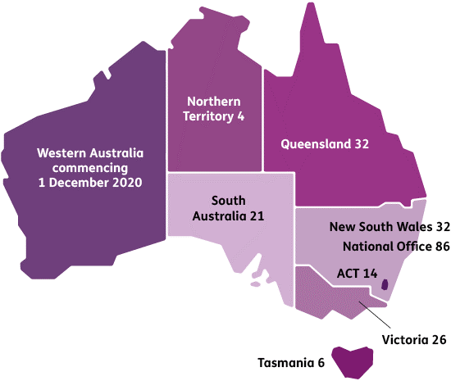
National Office |  | NSW | SA | ACT |  | NT | VIC |  | QLD | TAS
86 |  | 32 | 21 | 14 |  | 4 | 26 |  | 32 | 6
Workforce by Location and Employment Type — for the period ending 30 June 2020
 | Ongoing |  |  |  | Non-Ongoing |  |  | Total
SA | 21 |  |  |  | - |  |  | 21
QLD | 32 |  |  |  | - |  |  | 32
ACT | 14 |  |  |  | - |  |  | 14
NT | 4 |  |  |  | - |  |  | 4
TAS | 6 |  |  |  | - |  |  | 6
VIC | 26 |  |  |  | - |  |  | 26
NSW | 116 |  |  |  | 2 |  |  | 118
TOTAL | 219 |  |  |  | 2 |  |  | 221

Our workforce mix
Our workforce comprises ongoing APS, non-ongoing APS, and labour hire (contractor) employees. As at 30 June 2020, our APS employee headcount was 221.
The average staffing level (ASL) in the Portfolio Budget Statements (PBS) for 2019–20 was 237.
The ASL for 2019–20 as at 30 June 2020 was 211.75. Our staffing level was managed below the ASL cap to the last quarter of 2019–20 to ensure positions were available to support the establishment of the WA office from 1 July 2020. The transition of WA was postponed to December 2020.
Our Full-Time Equivalent (FTE) employee count at the beginning of the financial year was 216.6, and this remained relatively consistent throughout the financial year. This does not include labour hire (contractor) staff.
Of our 221 employees, 99 per cent are ongoing employees with 1 per cent engaged on a non- ongoing basis. Approximately 71 per cent of our workforce is female.

All Ongoing Employees — for the period ending 30 June 2020
 | Female |  | Male | Did not disclose* | Total
 | Full Time | Part Time | Full Time
SA | 15 | 2 | 4 | n.f.p. | 21
QLD | 22 | 1 | 9 | n.f.p. | 32
ACT | 9 | - | 5 | n.f.p. | 14
NT | 2 | 1 | 1 | n.f.p. | 4
TAS | 4 | - | 2 | n.f.p. | 6
VIC | 13 | 1 | 12 | n.f.p. | 26
NSW | 72 | 14 | 29 | n.f.p. | 116
Total | 137 | 19 | 62 | 1 | 219

*Breakdown by location not for publication (n.f.p.) due to the low number of employees in this category – this risks the identification of individuals.

All Non-Ongoing Employees — for the period ending 30 June 2020
 | Female | Male | Total
 | Full Time | Full Time
NSW | 1 | 1 | 2
Total | 1 | 1 | 2
*Breakdown by classification not for publication (n.f.p) due to the low number of employees in this category – this risks the identification of individuals.

Ongoing Employees by Classification — for the period 30 June 2020
 | Female |  | Male | Did not disclose* | Total
 | Full Time | Part Time | Full Time
APS3 | 3 | 1 | - | n.f.p. | 4
APS4 | 13 | - | 3 | n.f.p. | 17
APS5 | 30 | 3 | 11 | n.f.p. | 44
APS6 | 30 | 9 | 12 | n.f.p. | 51
EL1 | 38 | 4 | 17 | n.f.p. | 59
EL2 | 19 | 2 | 15 | n.f.p. | 36
SES BAND 1 | 3 | - | - | n.f.p. | 3
SES BAND 2 | 1 | - | 3 | n.f.p. | 4
NDIS  Quality and Safeguards Commissioner | - | - | 1 | n.f.p. | 1
Total | 137 | 19 | 62 | 1 | 219

Non-Ongoing Employees by Classification — for the period 30 June 2020
 | Full-time
EL2 | 2
Total | 2

Diversity
We aim to continue our focus on ensuring our workforce reflects the community we support by developing an inclusion approach that provides internal policies and strategies to eliminate barriers to inclusion. We support flexible working arrangements, and 9 per cent of our employees have part-time working agreements in place. We strive to source a quality workforce who have lived experience of disability. To date, more than 5 per cent of our employees have shared their disability status in our human resource system.

Employees with Disability — for the period ending 30 June 2020
Ongoing | 12
Total | 12

Employees who identified as Aboriginal and / or Torres Strait Islander — for the period ending 30 June 2020
Ongoing | 2
Total | 2

Employees by full time and part-time status — for the period ending 30 June 2020
 | Ongoing |  | Non Ongoing | Total
 | Full Time | Part Time | Full Time
APS3 | 3 | 1 | - | 4
APS4 | 17 | - | - | 17
APS5 | 41 | 3 | - | 44
APS6 | 42 | 9 | - | 51
EL1 | 55 | 4 | - | 59
EL2 | 34 | 2 | 2 | 38
SES BAND 1 | 3 | - | - | 3
SES BAND 2 | 4 | - | - | 4
NDIS  Quality and Safeguards Commissioner | 1 | - | - | 1
Total | 200 | 19 | 2 | 221

Enterprise agreement
The NDIS Quality and Safeguards Commission Enterprise Agreement 2019–2022, was negotiated and approved consistent with the Workplace Bargaining Policy 2018 and came into effect on 15 October 2019. We engaged ORIMA Research to undertake the ballot and a ‘yes’ vote of 96.63 per cent was achieved. Our Enterprise Agreement provides the employment terms for our non-SES APS employees. More information about remuneration in the APS is available in the APSC’s Remuneration Report available at www.apsc.gov.au.

Remuneration
Senior Executive Service (SES) Remuneration
The Remuneration Tribunal sets the remuneration and conditions for the NDIS Commissioner. SES employees’ remuneration and employment conditions are provided via individual Determinations, which may deviate from standard salary ranges.

Total remuneration for SES employees includes salary, Executive Vehicle Allowance, and superannuation. Superannuation arrangements vary depending on whether an SES employee is in a Defined Benefits Scheme member or a member of an accumulation fund. In 2019–20, the salary ranges for SES employees are:
- SES Band 1: $174,710 – $203,042
- SES Band 2: $225,472 – $251,443
No SES staff received performance pay.
Non-Senior Executive Service remuneration
The NDIS Quality and Safeguards Commission Enterprise Agreement 2019–2022 (the Agreement) provides salary entitlements and employment terms for non-SES employees. The Agreement includes provision for salary advancement subject to satisfactory performance and other factors and for the payment of a range of allowances such as Workplace Contact Officer Allowance, Higher Duties Allowance, and reimbursement of reasonable costs associated with relocations.
No non-SES staff received performance pay. The salary ranges for 2019–20 are shown in the following table:
Classification | Annual salary rate
APS 1 | 45,344 - 50,742
APS 2 | 52,995 - 58,971
APS 3 | 61,245 - 66,452
APS 4 | 69,388 - 74,582
APS 5 | 76,204 - 81,381
APS 6 | 83,468 - 93,819
EL1 | 103,997 - 118,049
EL2 | 122,576 - 144,520
The following salary ranges are for employees who work in the legal field.
Classification | Local Title | Annual Salary Rate
APS Level 4 | Lawyer | 73,490 - 74,582
Soft Barrier - Work Value/Availability Barrier
APS Level 5 | Lawyer | 80,463 - 81,381
Soft Barrier - Work Value/Availability Barrier
APS Level 6 | Lawyer | 83,468 - 95,086
Hard Barrier – Advancement subject to a merit process
Executive Level 1 | Senior Lawyer | 109,602 - 126,606
Hard Barrier – Advancement subject to a merit process
Executive Level 2 | Principal Lawyer | 133,138 - 150,302
Work Value/Availability Barrier
Executive Level 2 | Special Counsel | 150,711

Non-salary benefits
Non-salary benefits provided to employees include leave options, flexible working arrangements (which include part-time work and home-based work) and employer superannuation contributions paid to defined benefits schemes and paid to accumulation funds. Employees also have access to salary packaging, in particular, novated leasing arrangements and salary packaging of superannuation.
SES entitlements are specified in a Determination made by the NDIS Commissioner under section 24(1) of the Public Service Act. SES benefits other than salary include salary, parking, and payment of an Executive Vehicle Allowance.
13.6 per cent of employees had salary packaging arrangements in place as at 30 June 2020.

NDIS Quality and Safeguards Commission

FINANCIAL STATEMENTS
for the year ended 30 June 2020

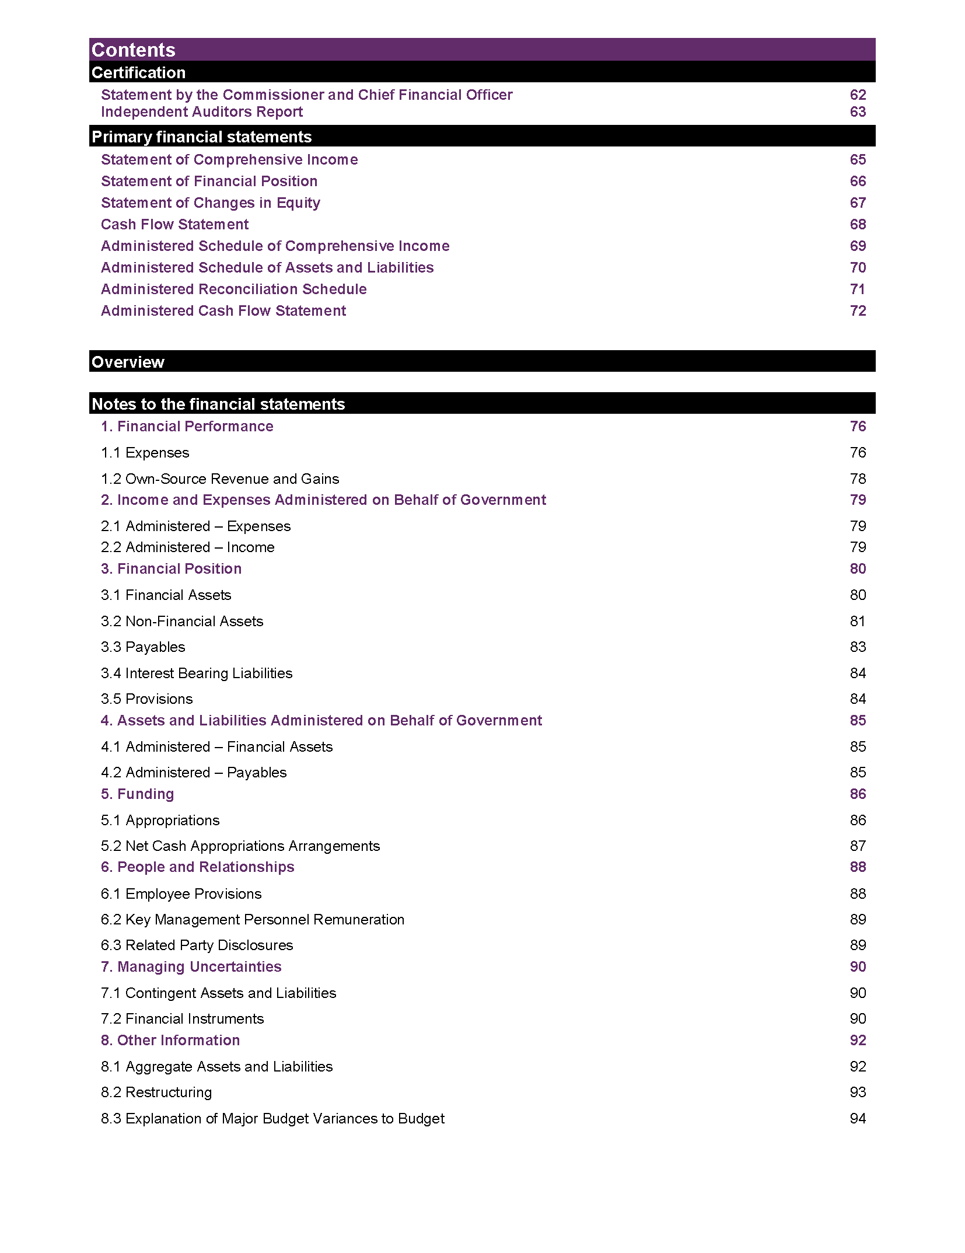

NDIS Quality and Safeguards Commission
STATEMENT BY THE NDIS COMMISSIONER AND CHIEF FINANCIAL OFFICER
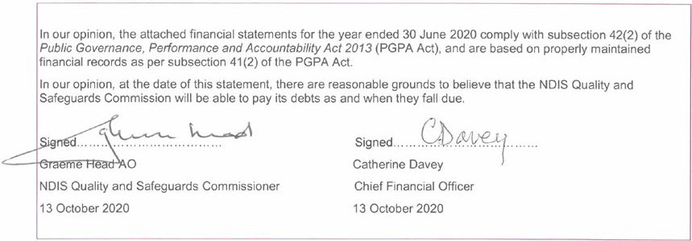
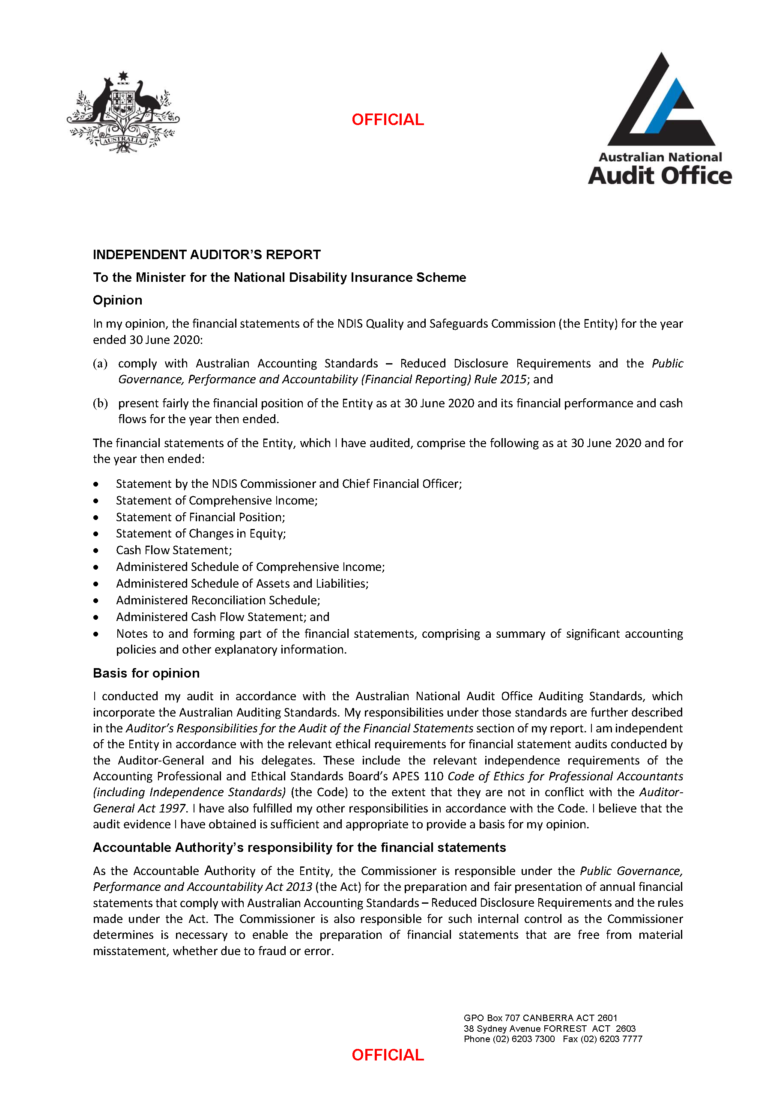
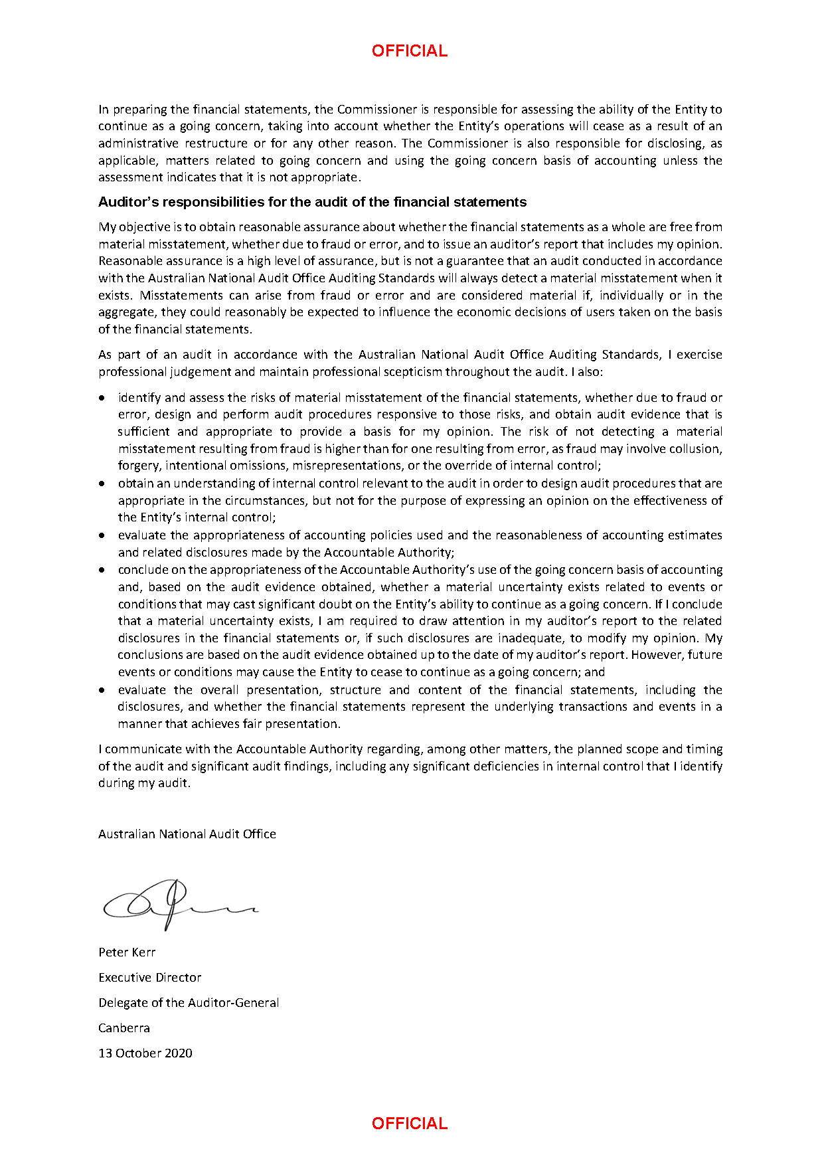

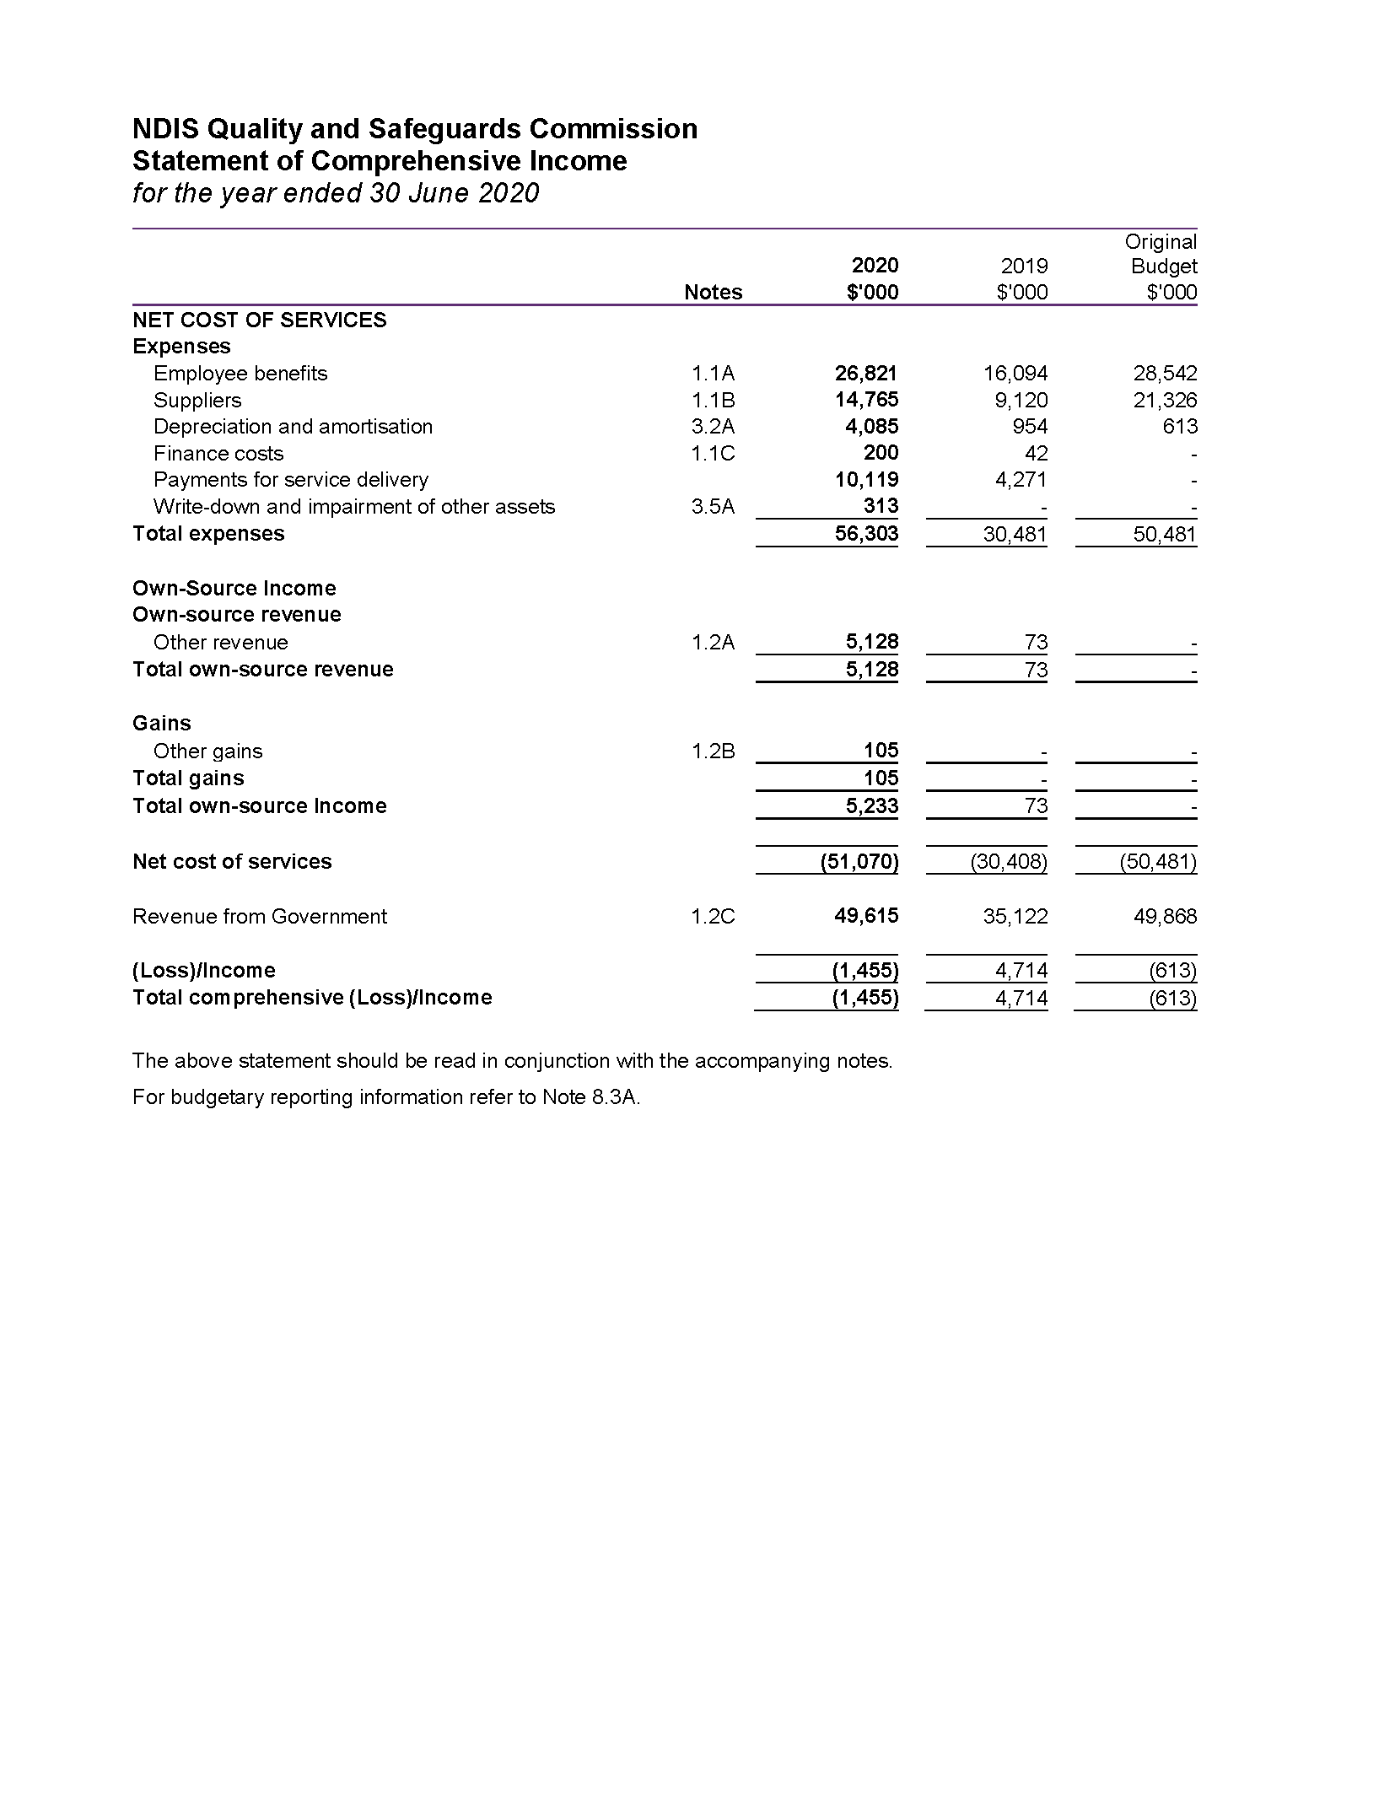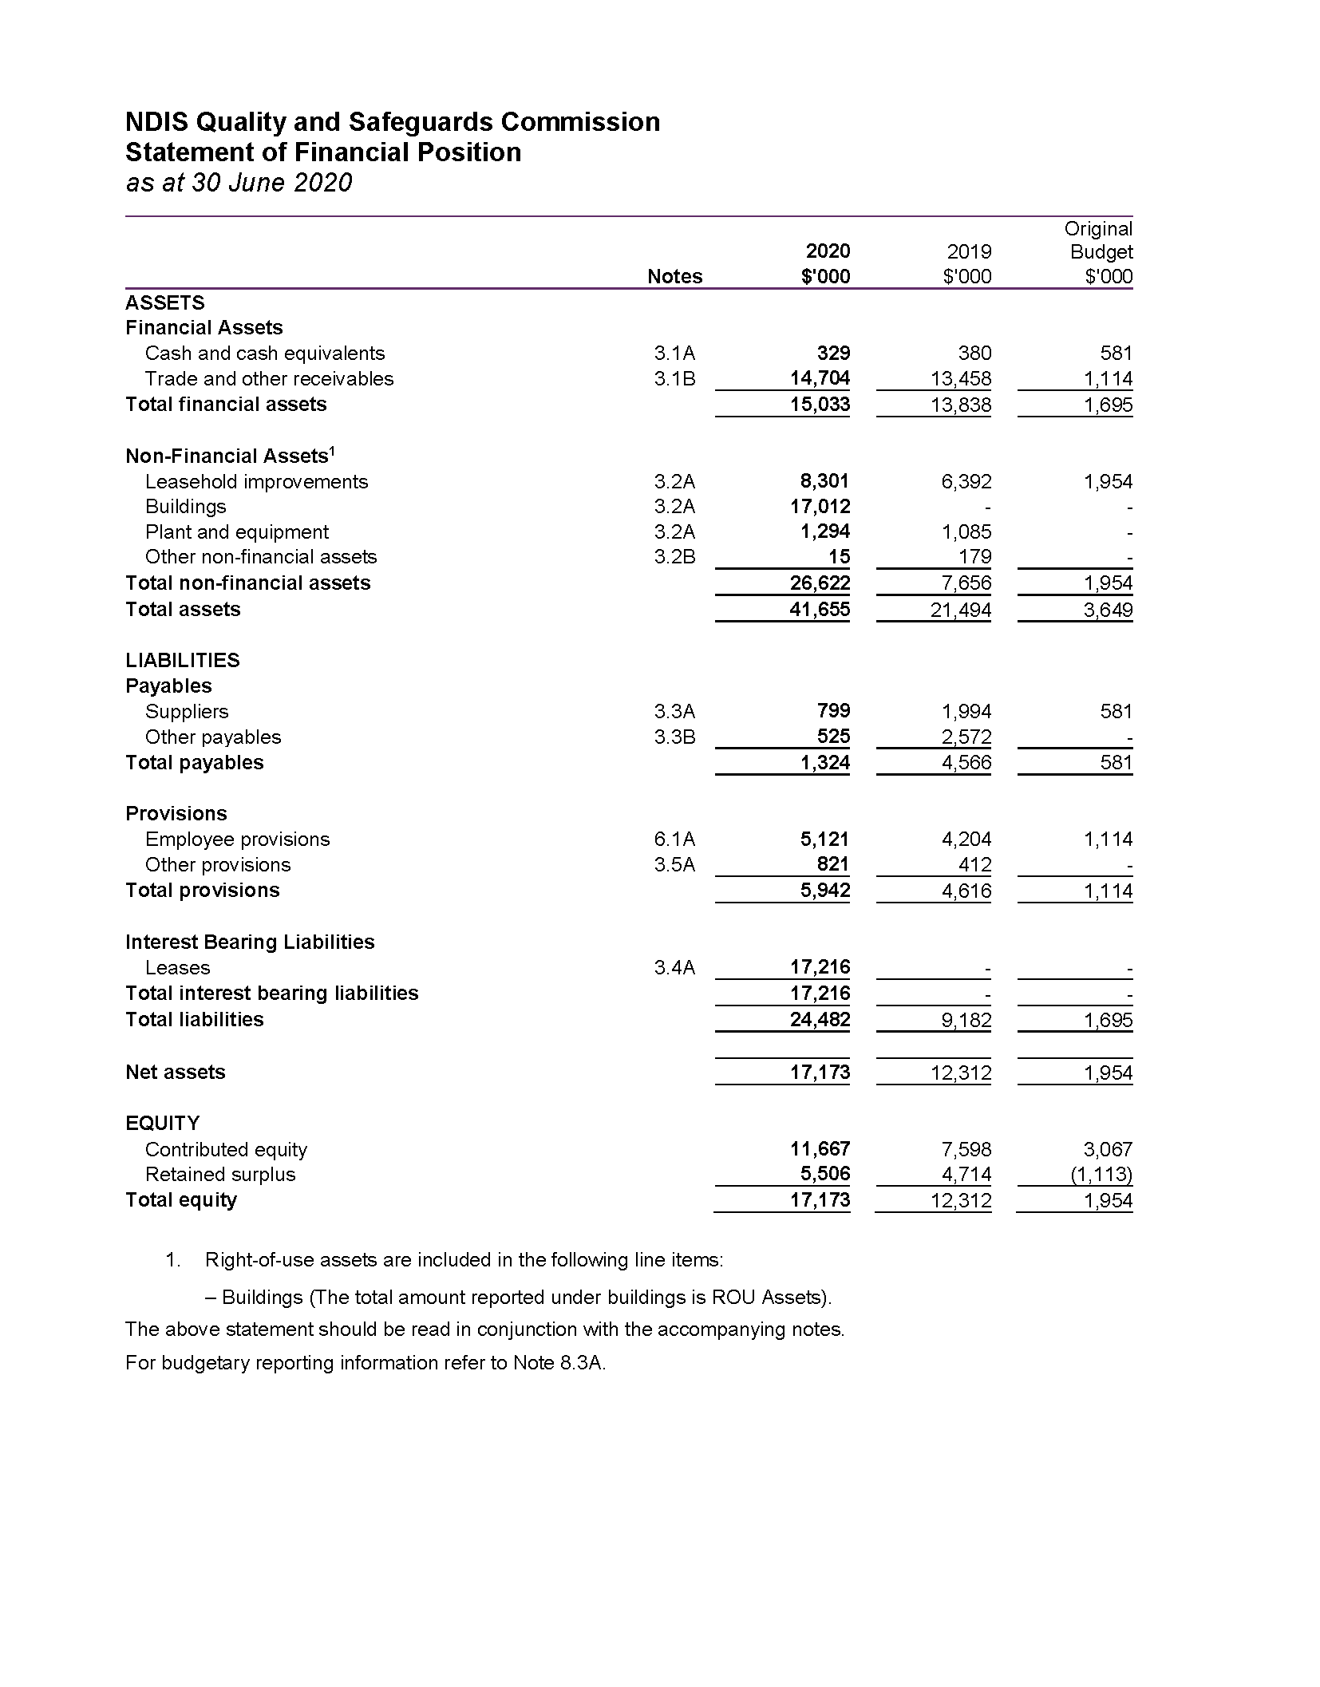
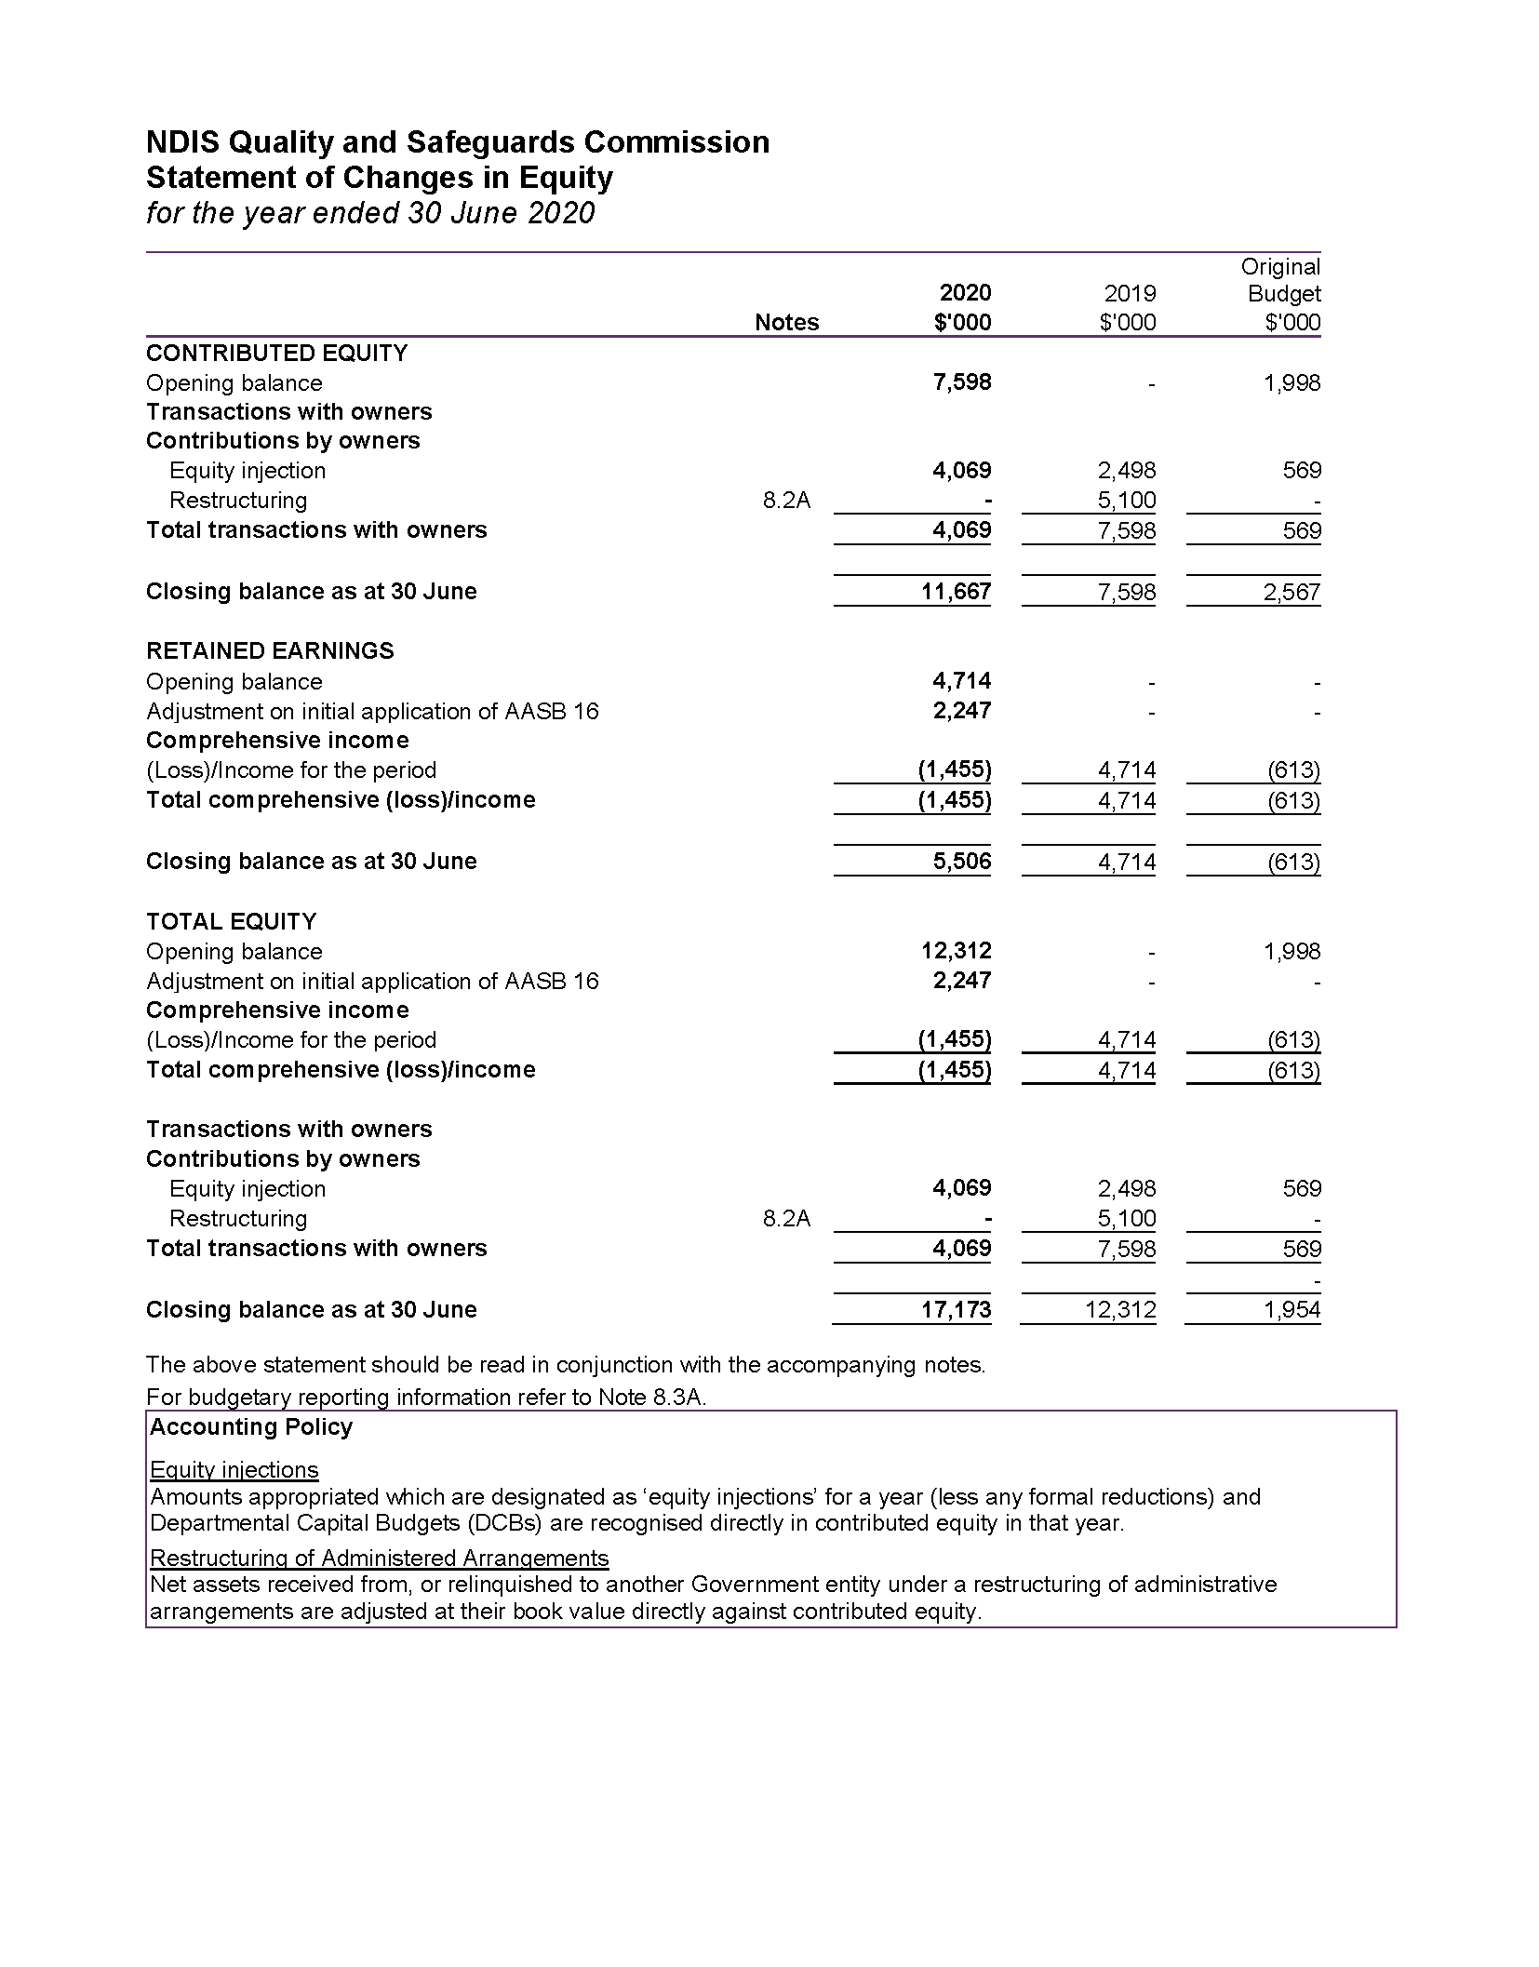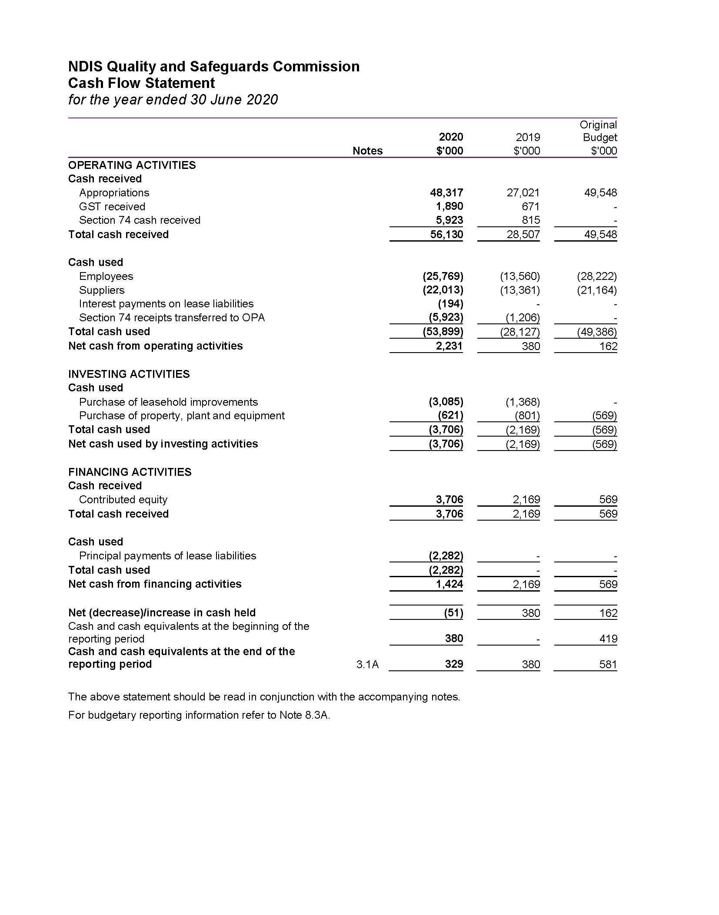
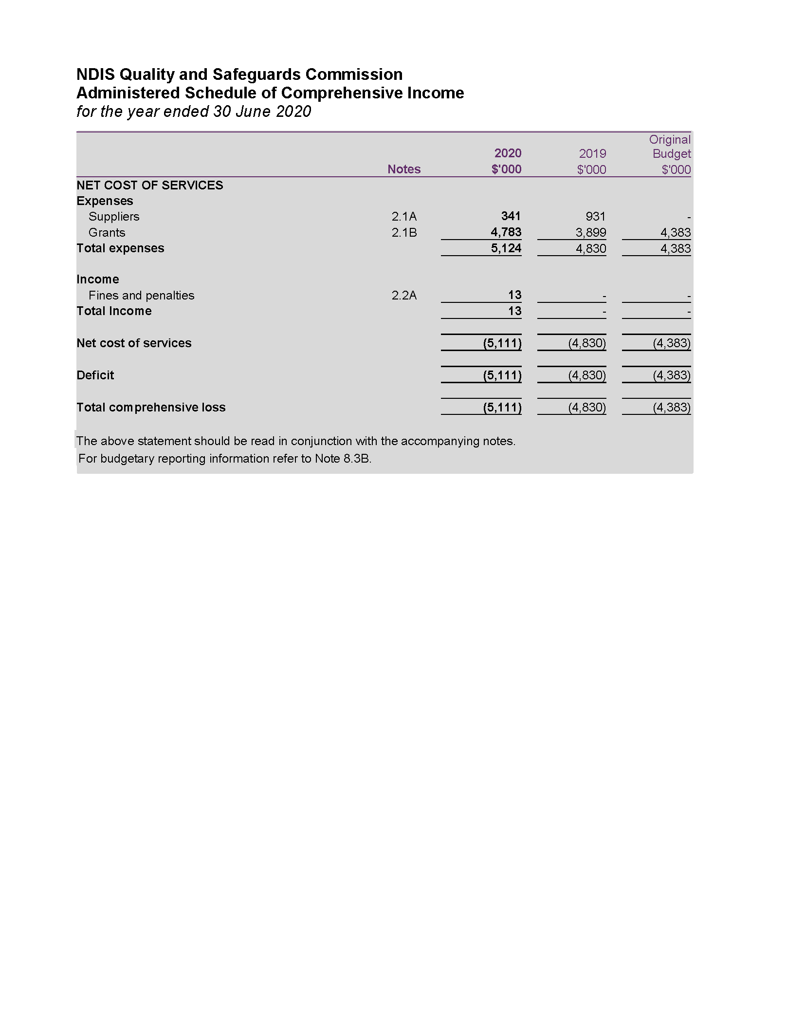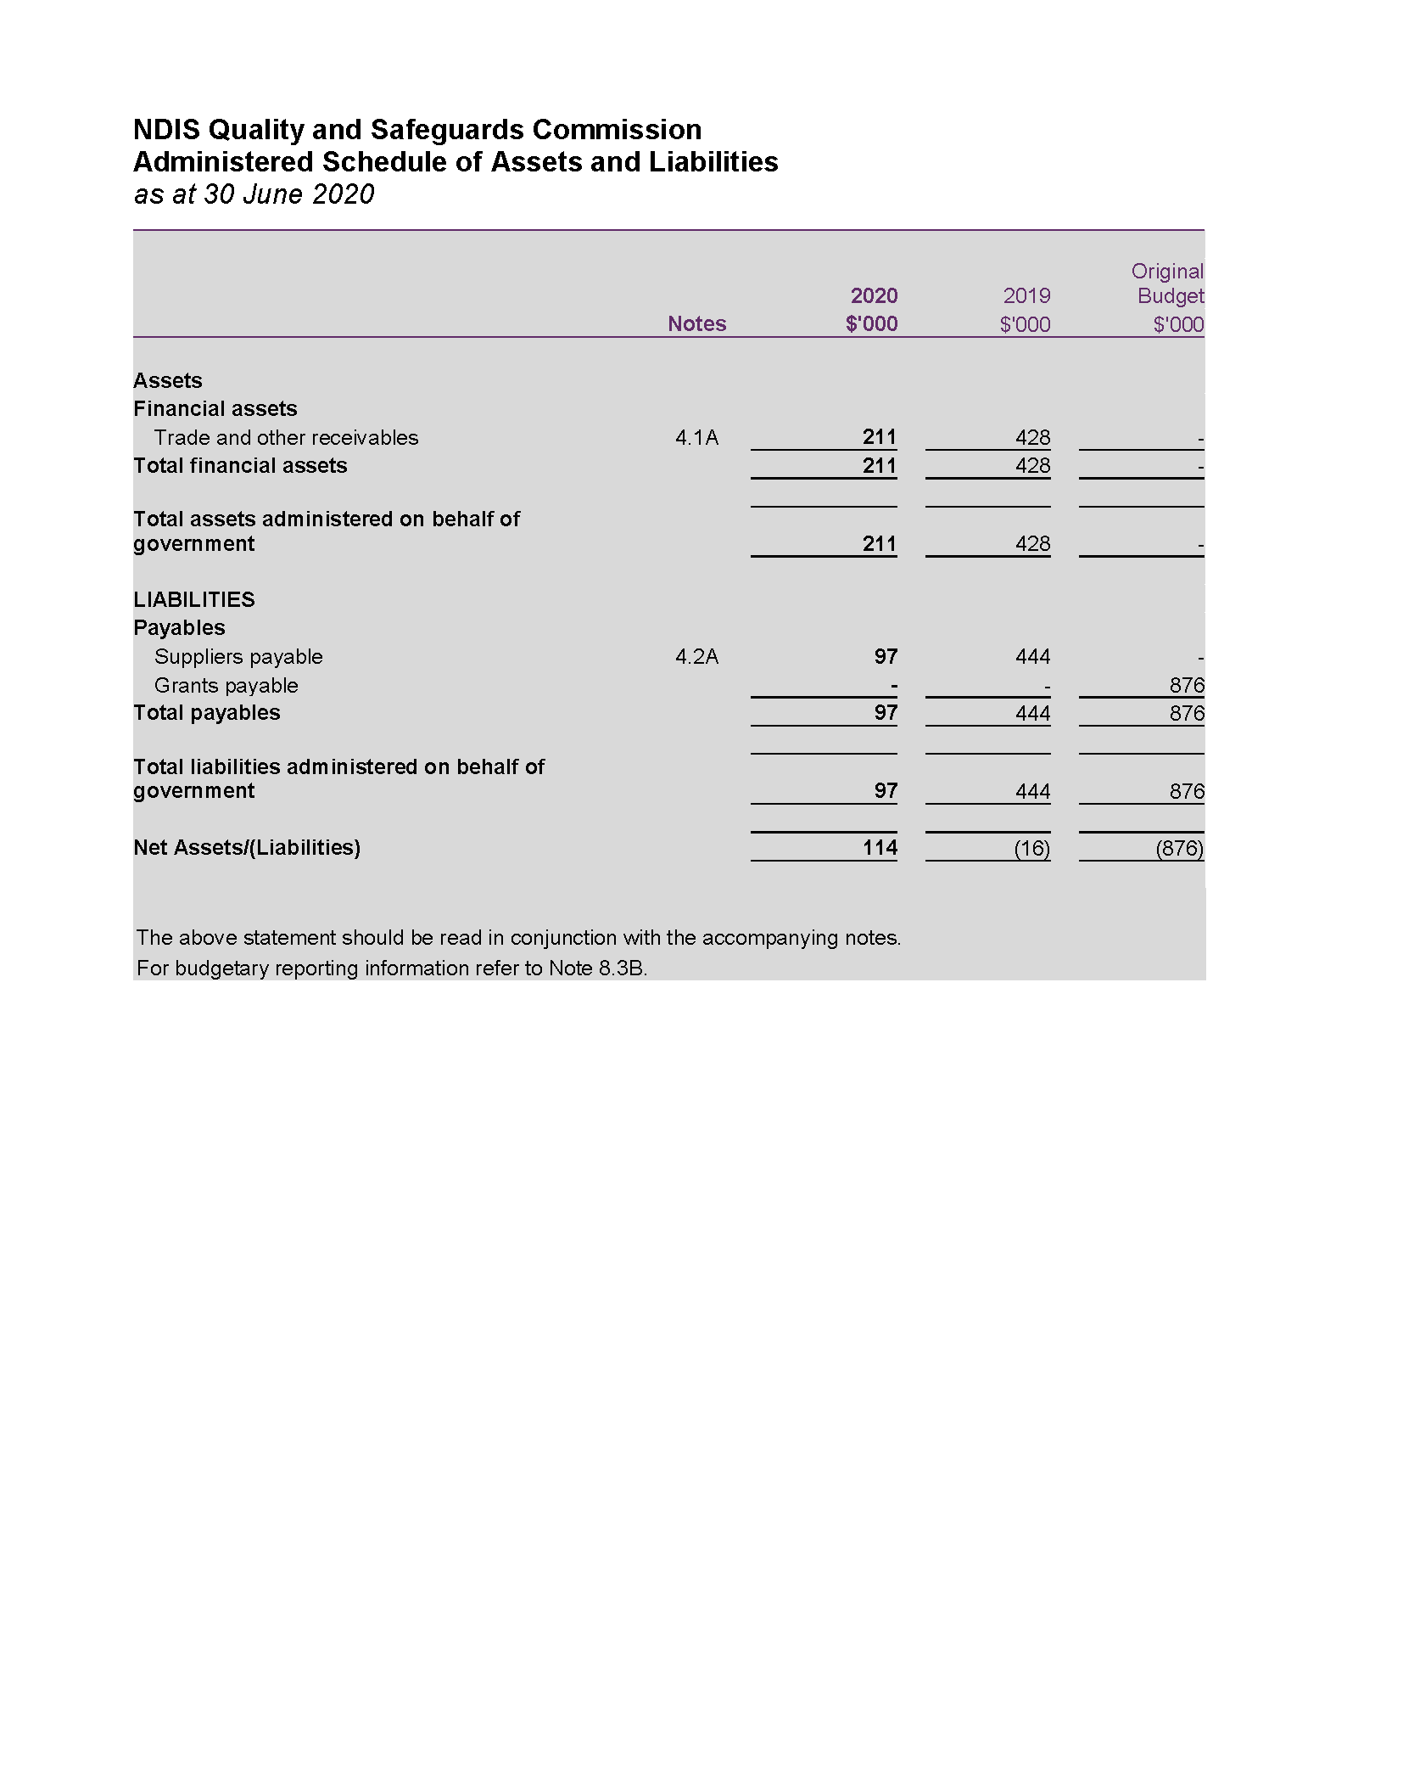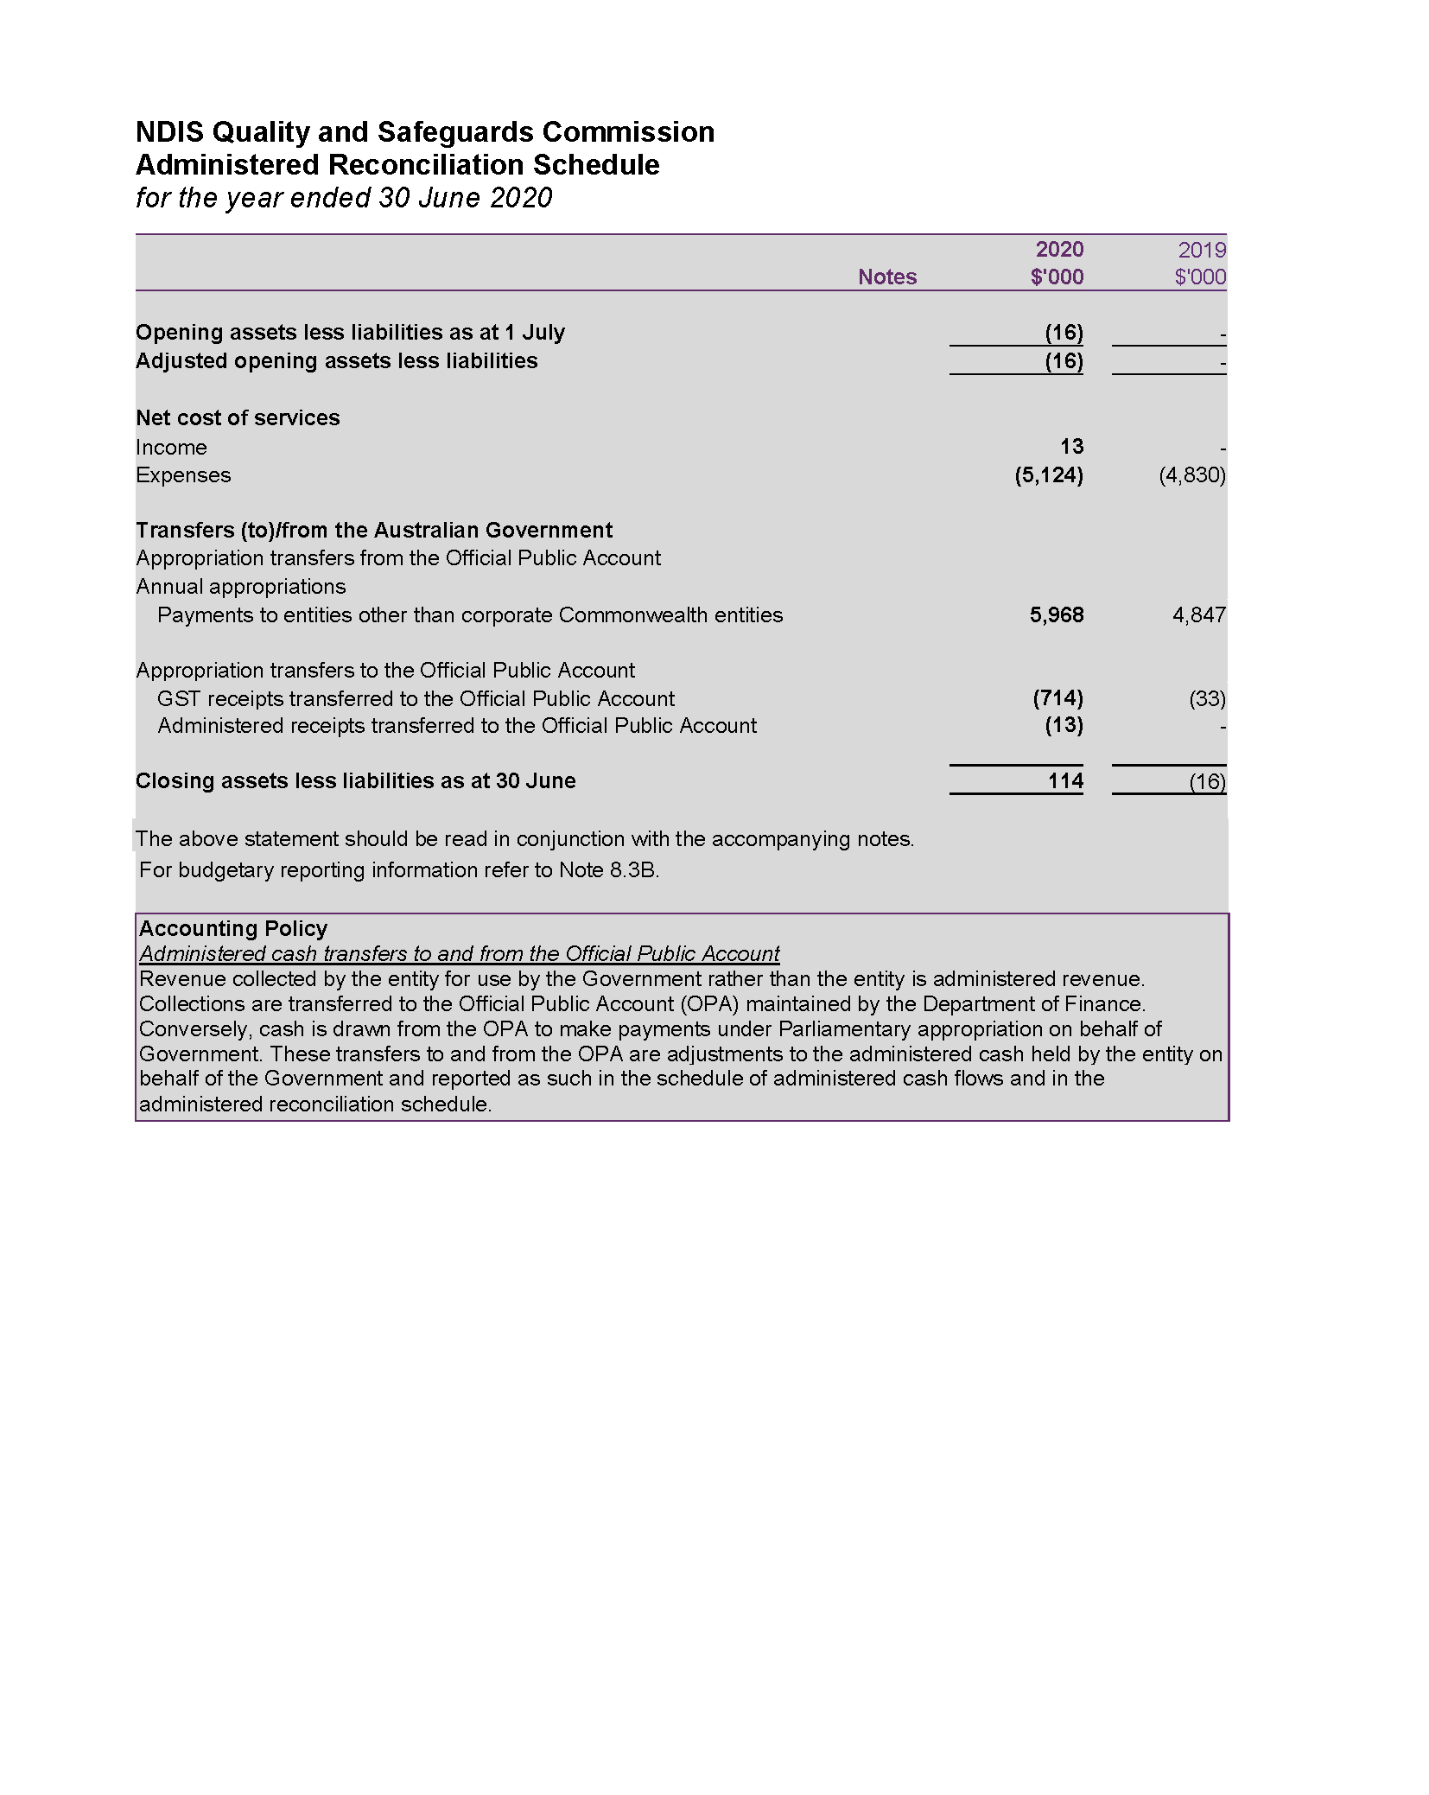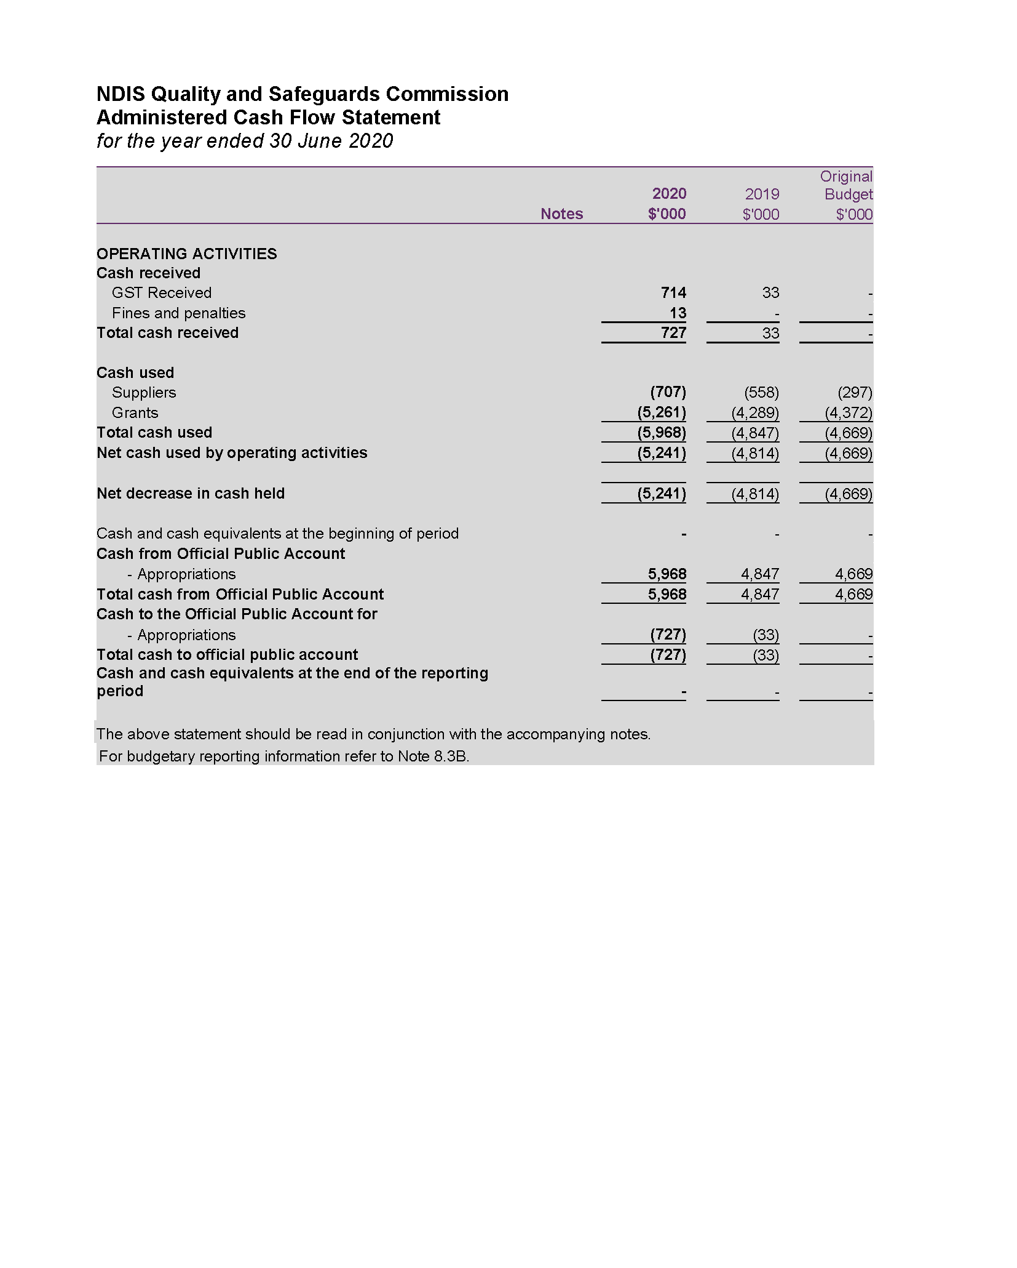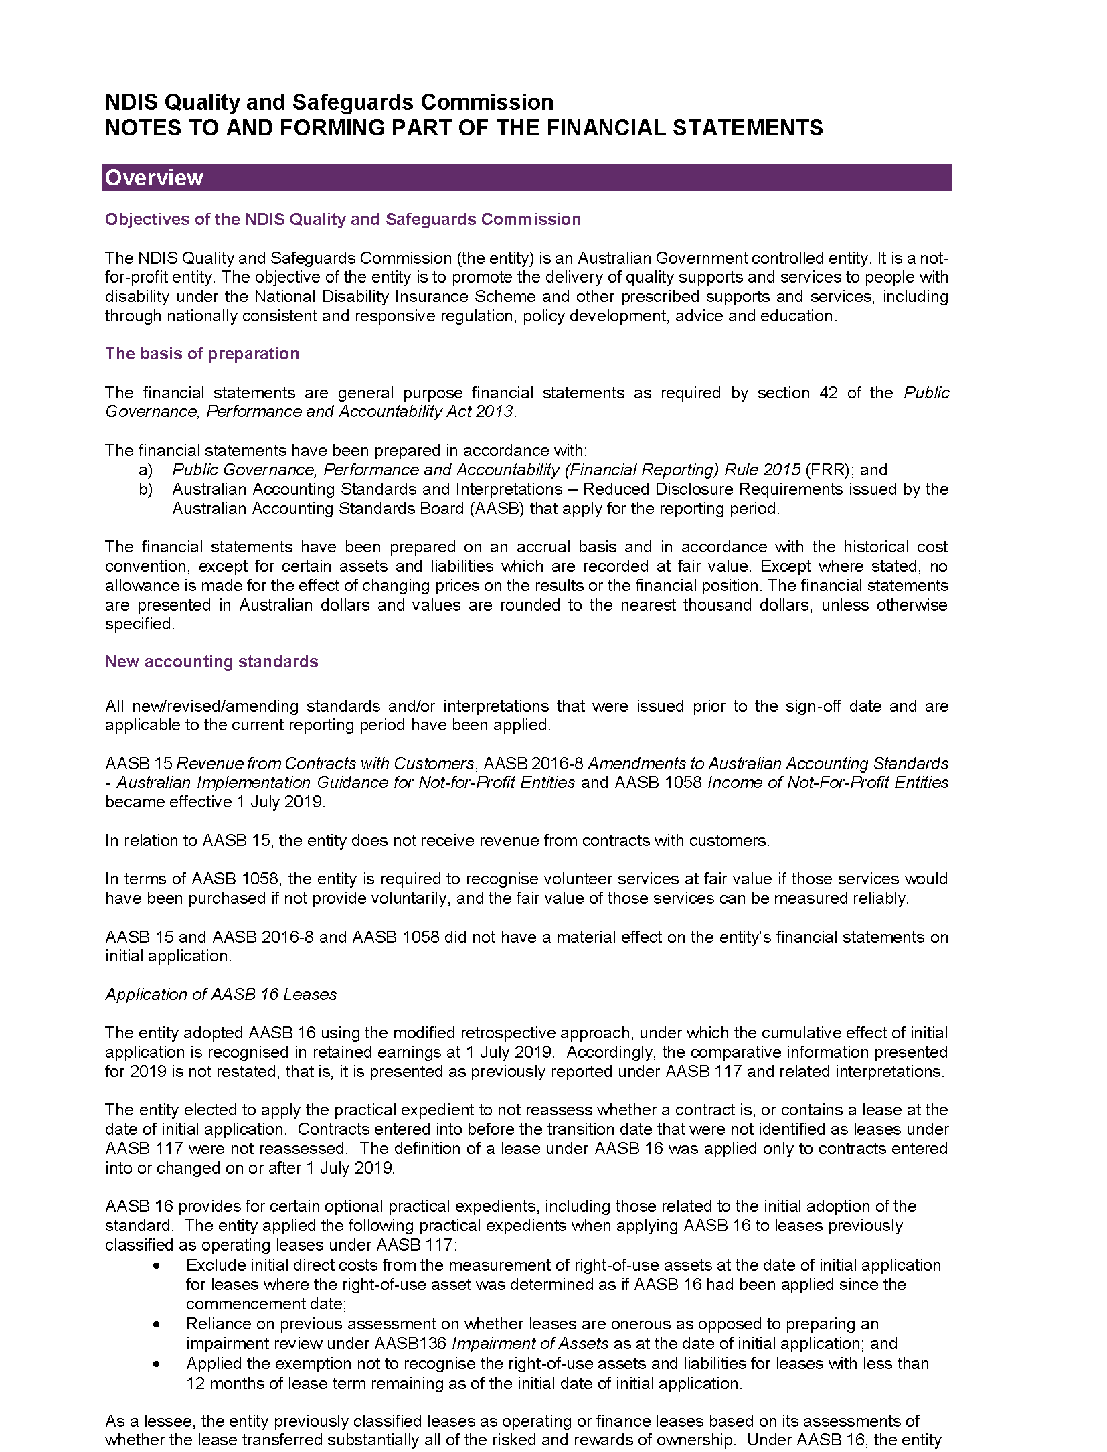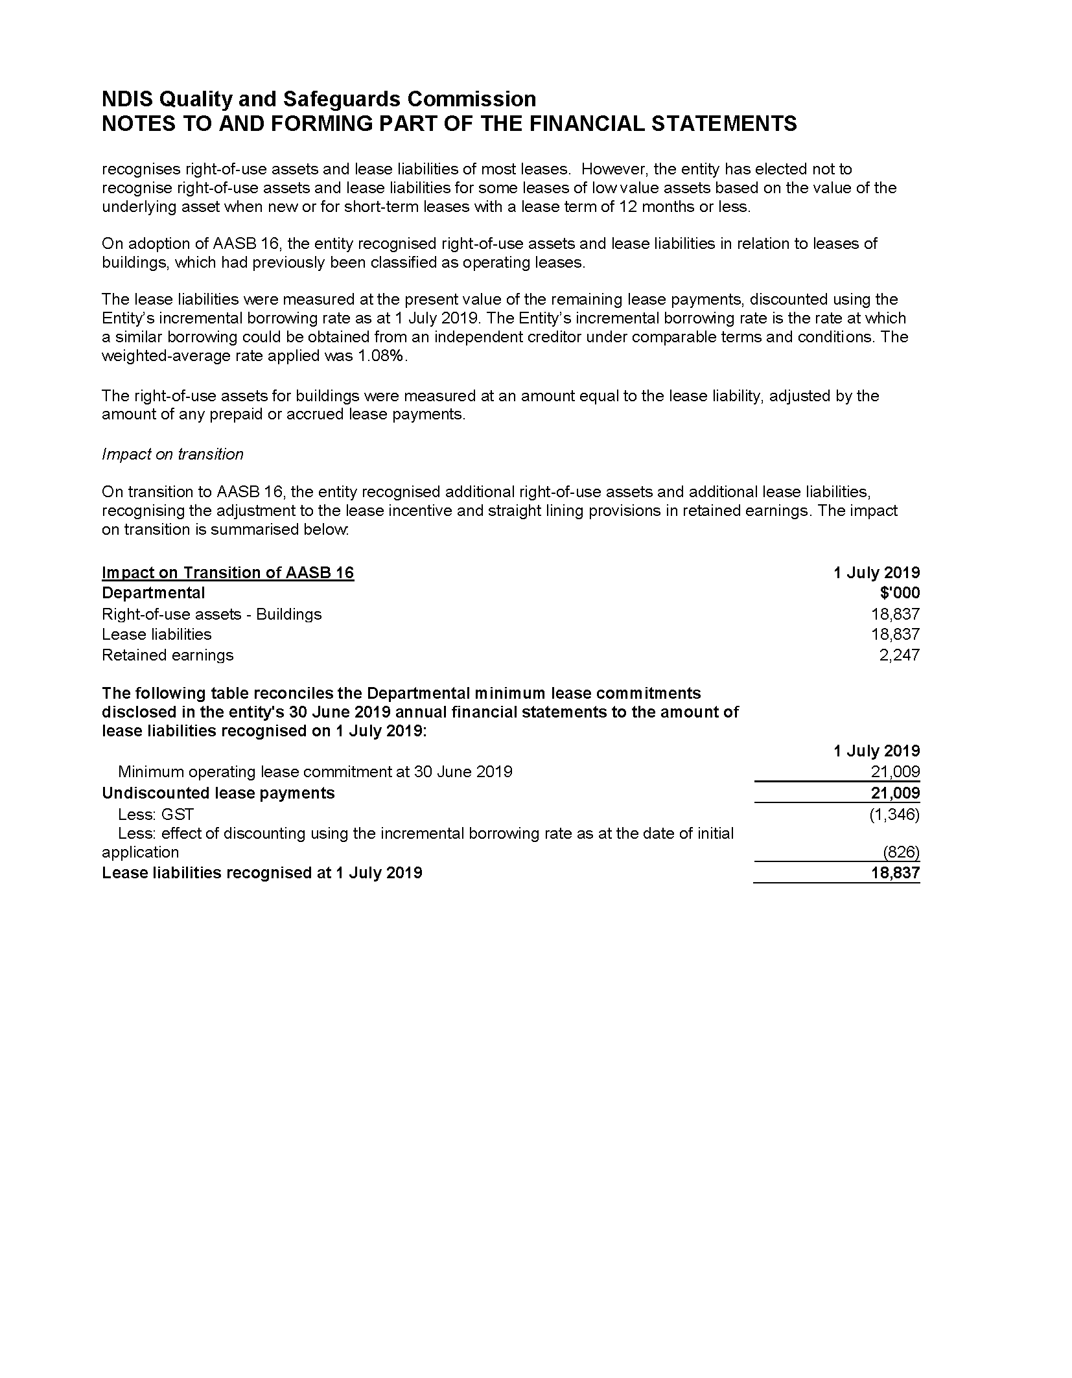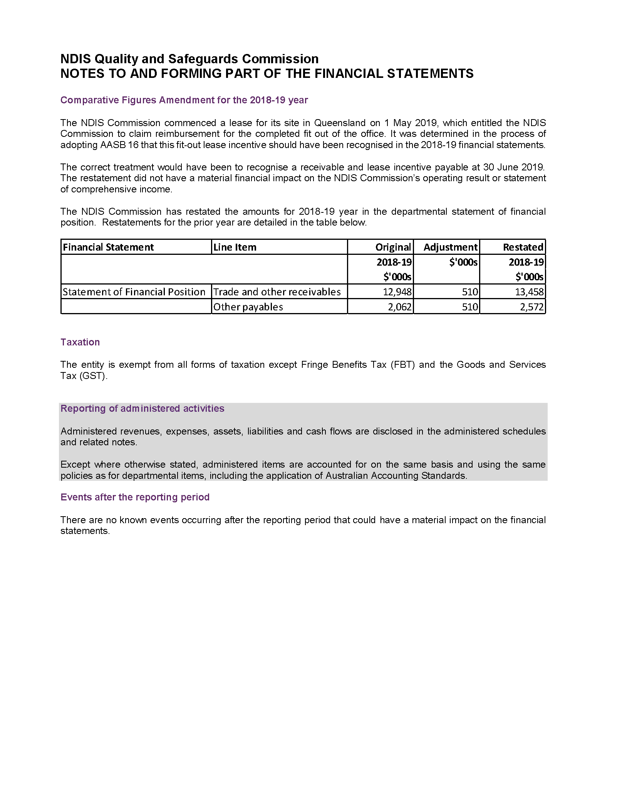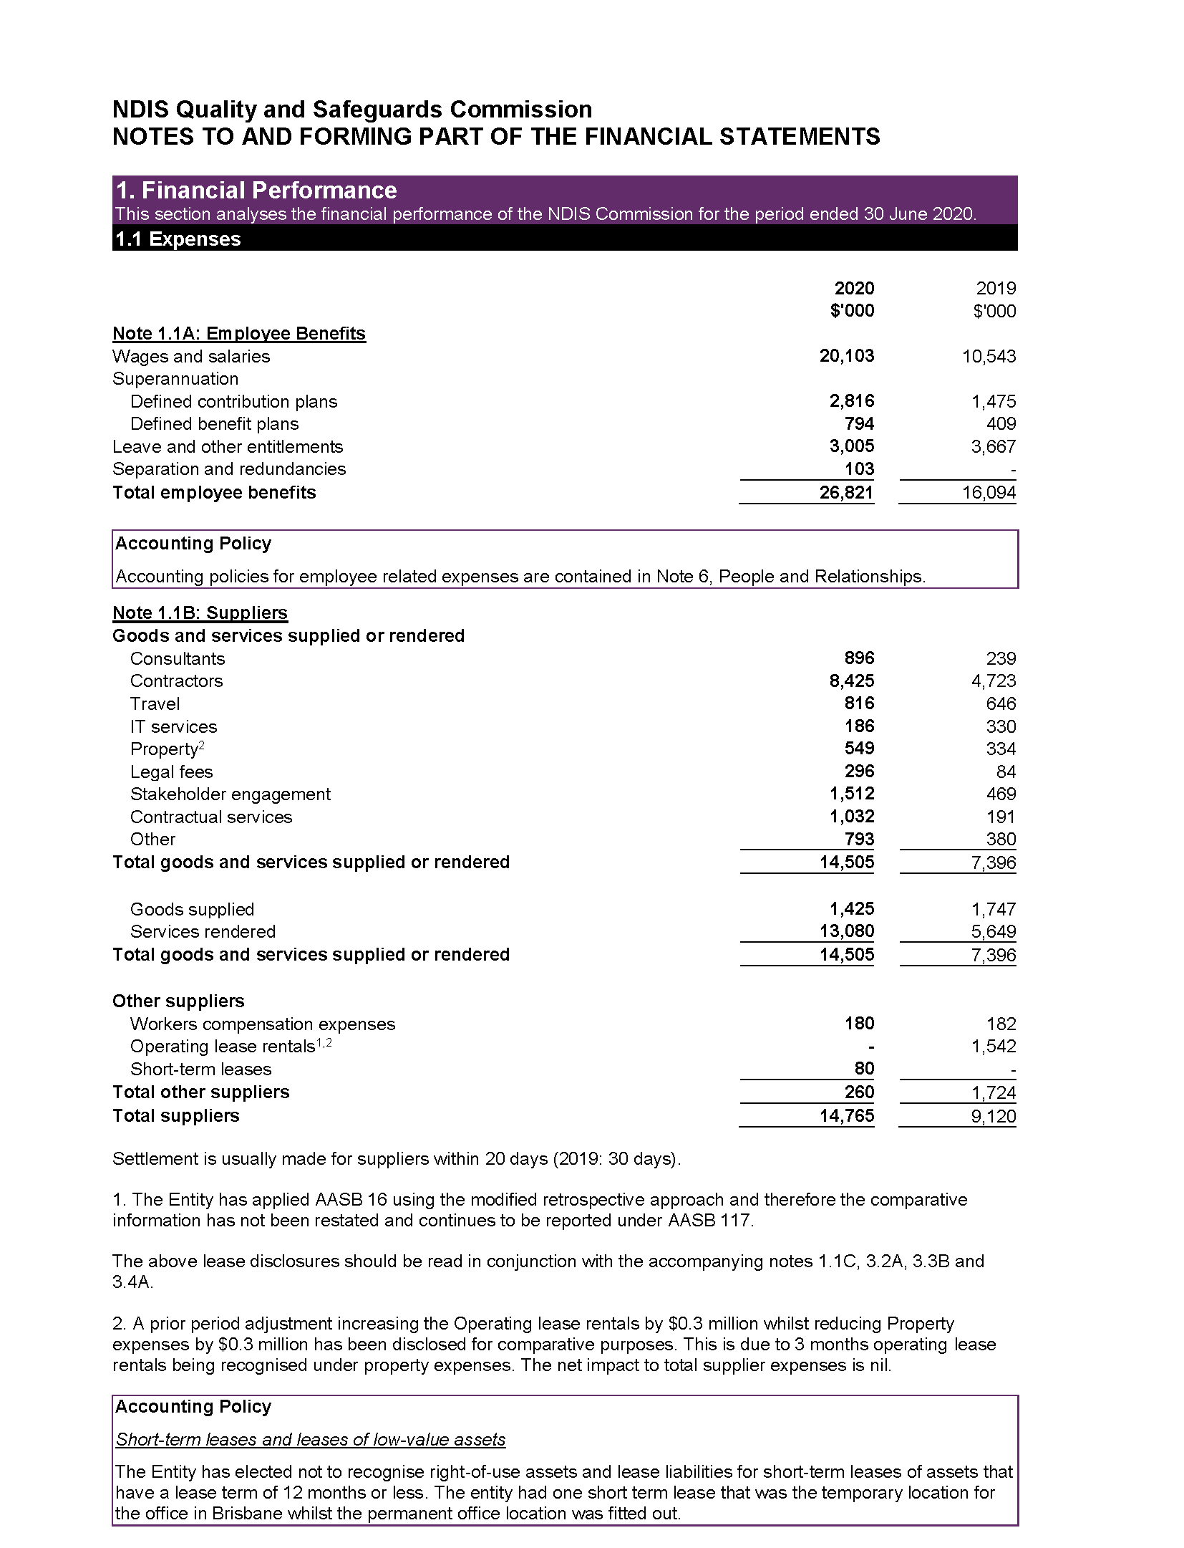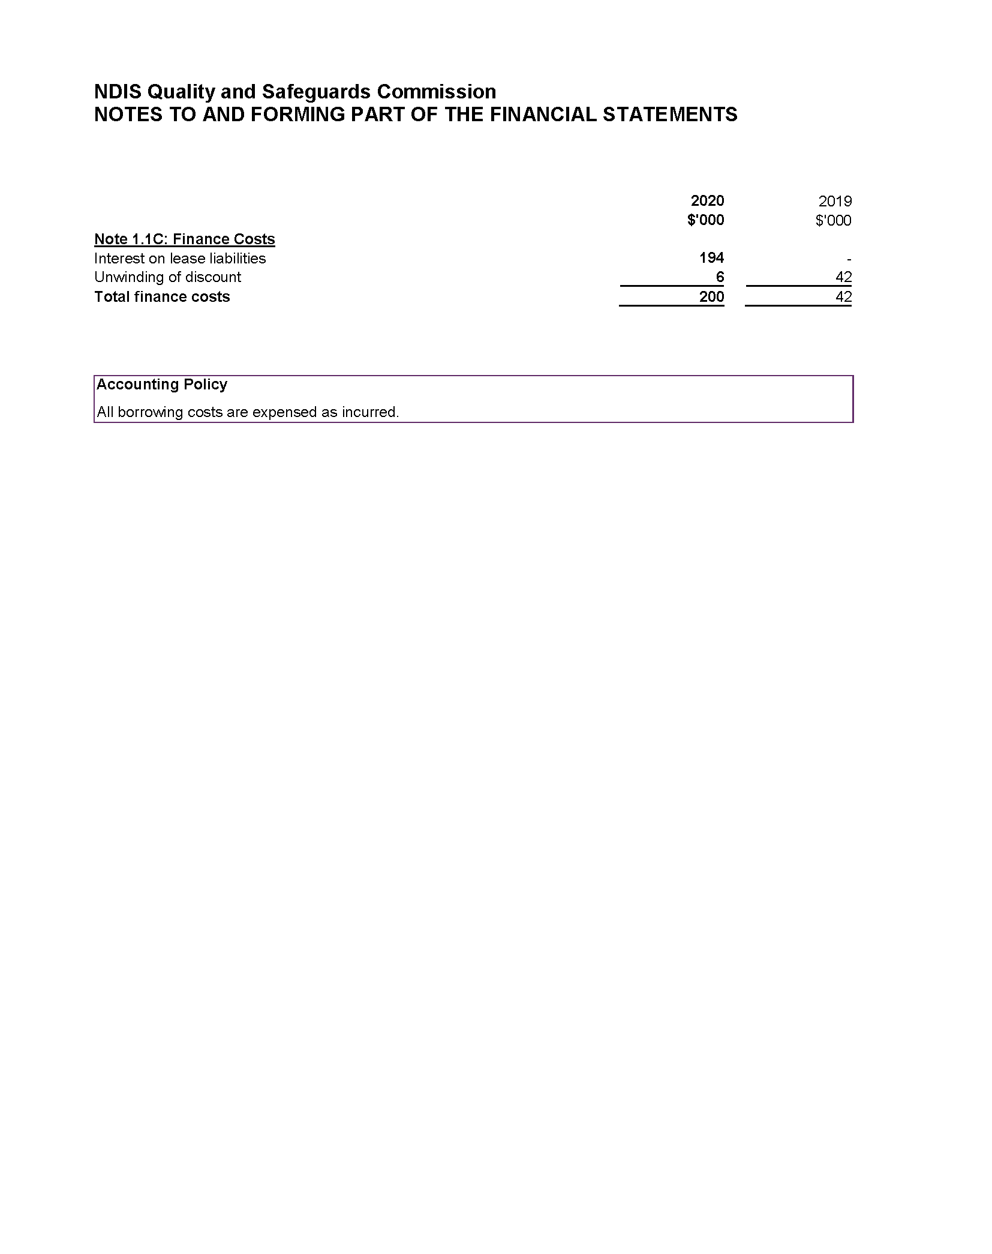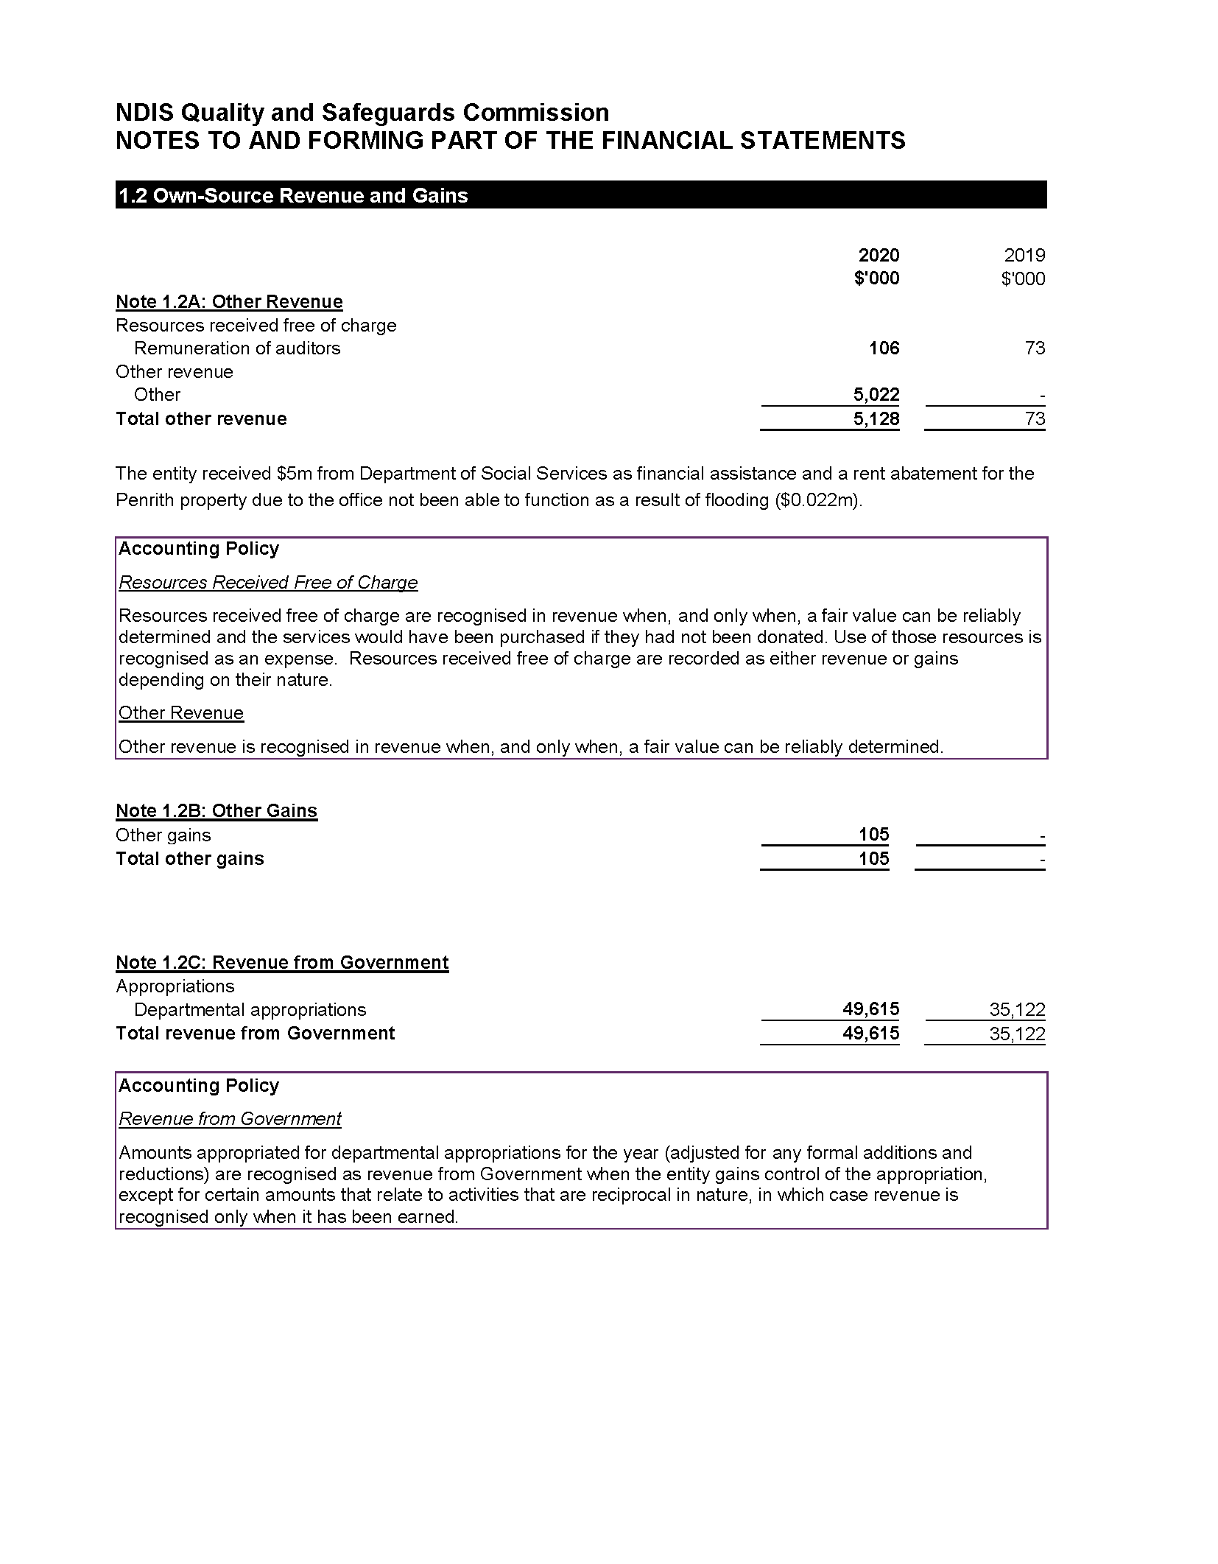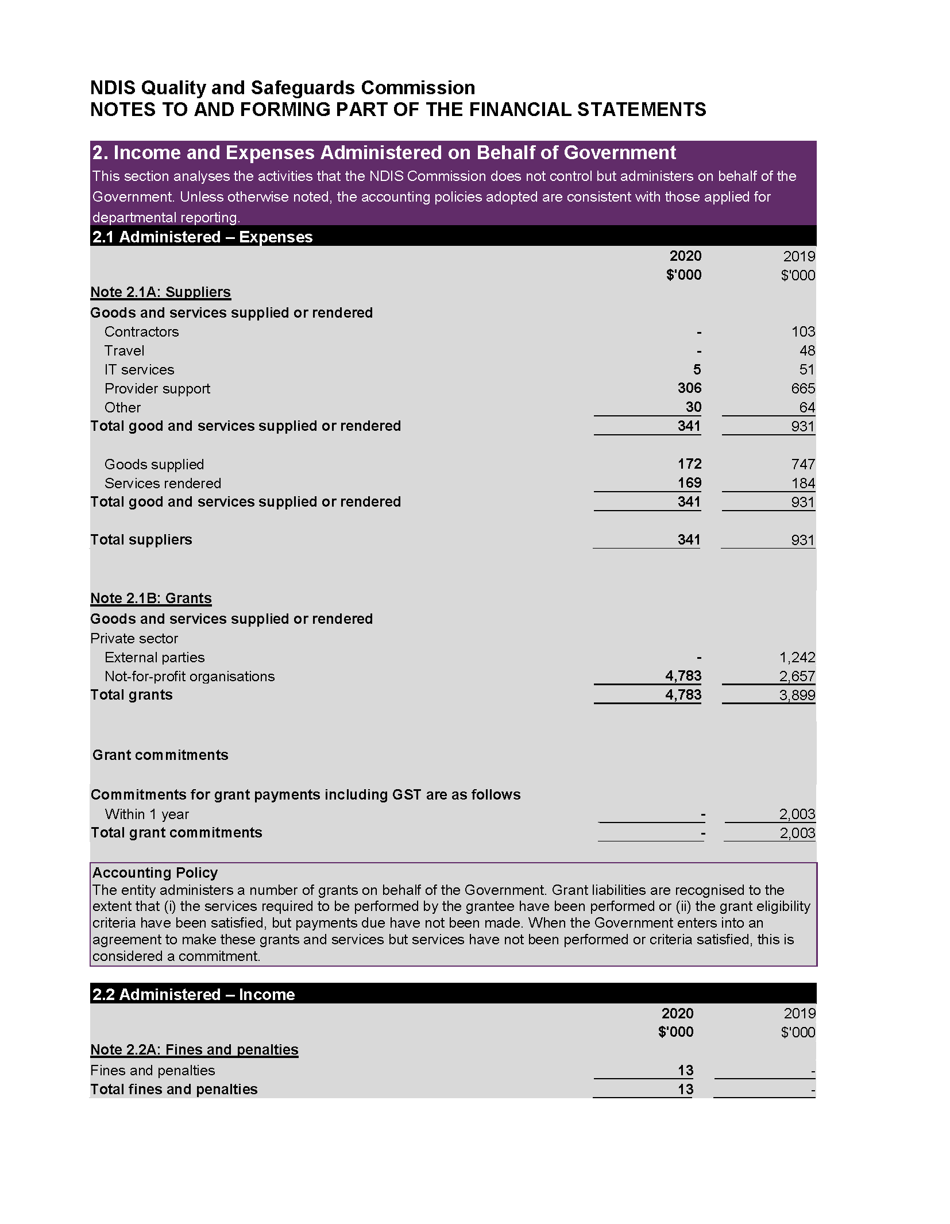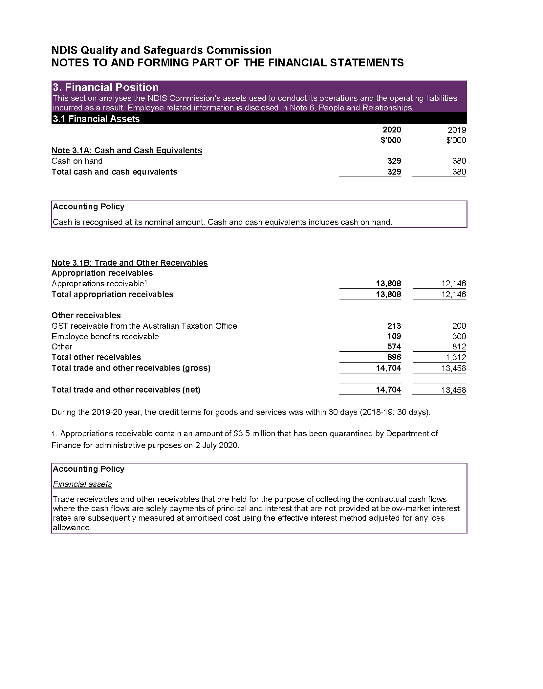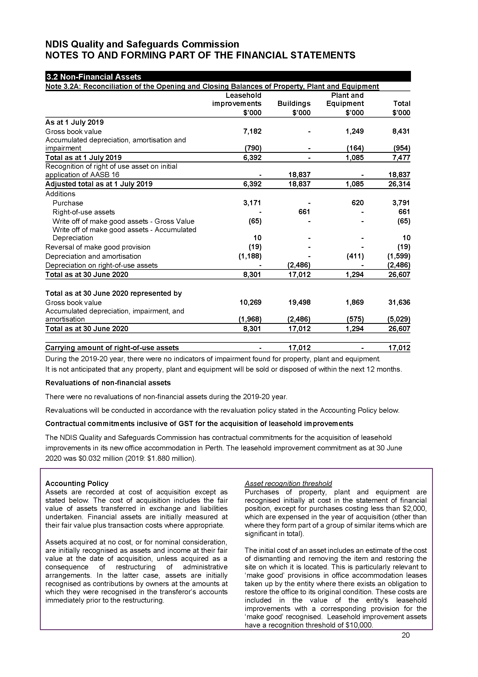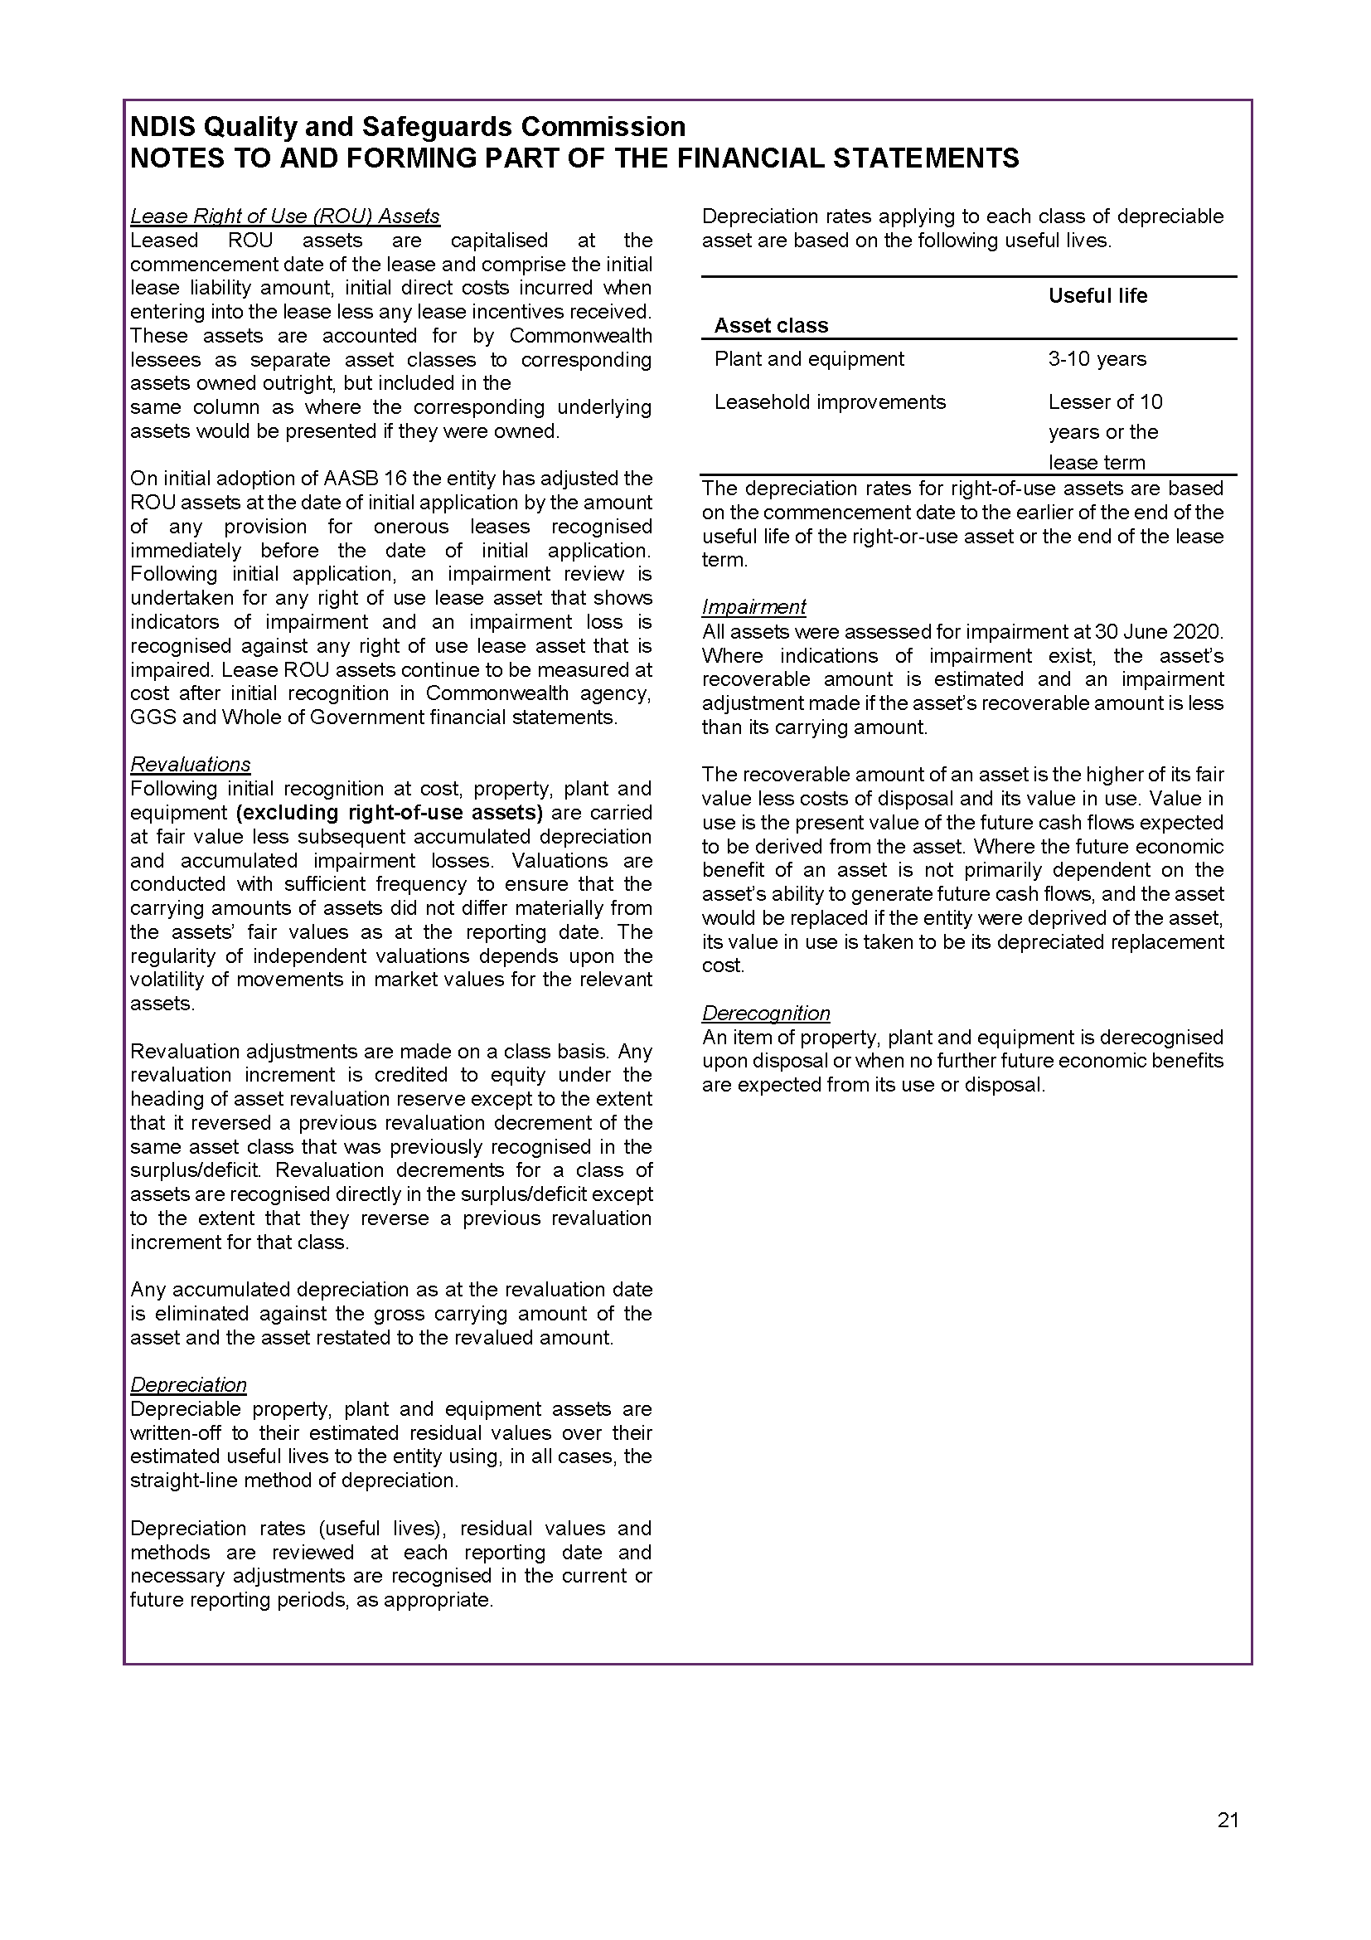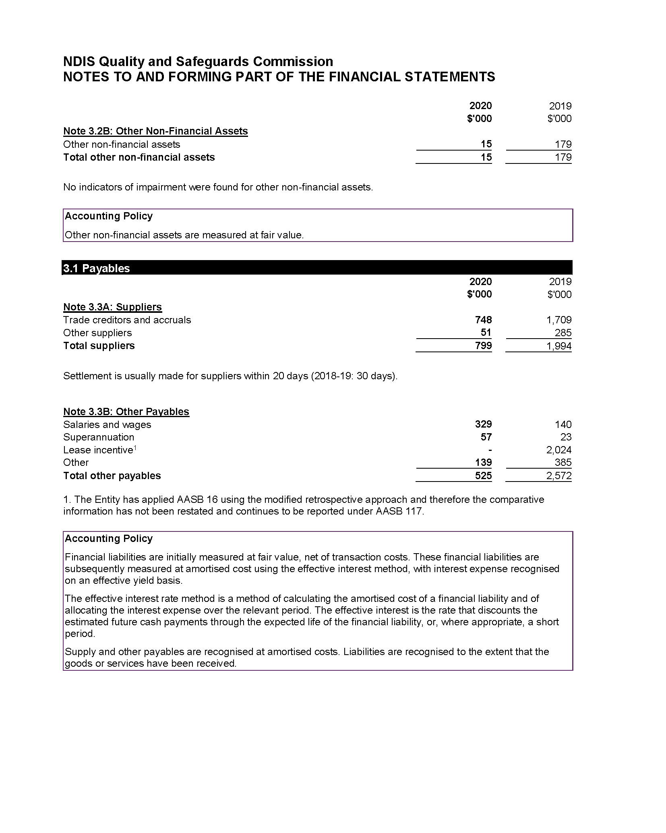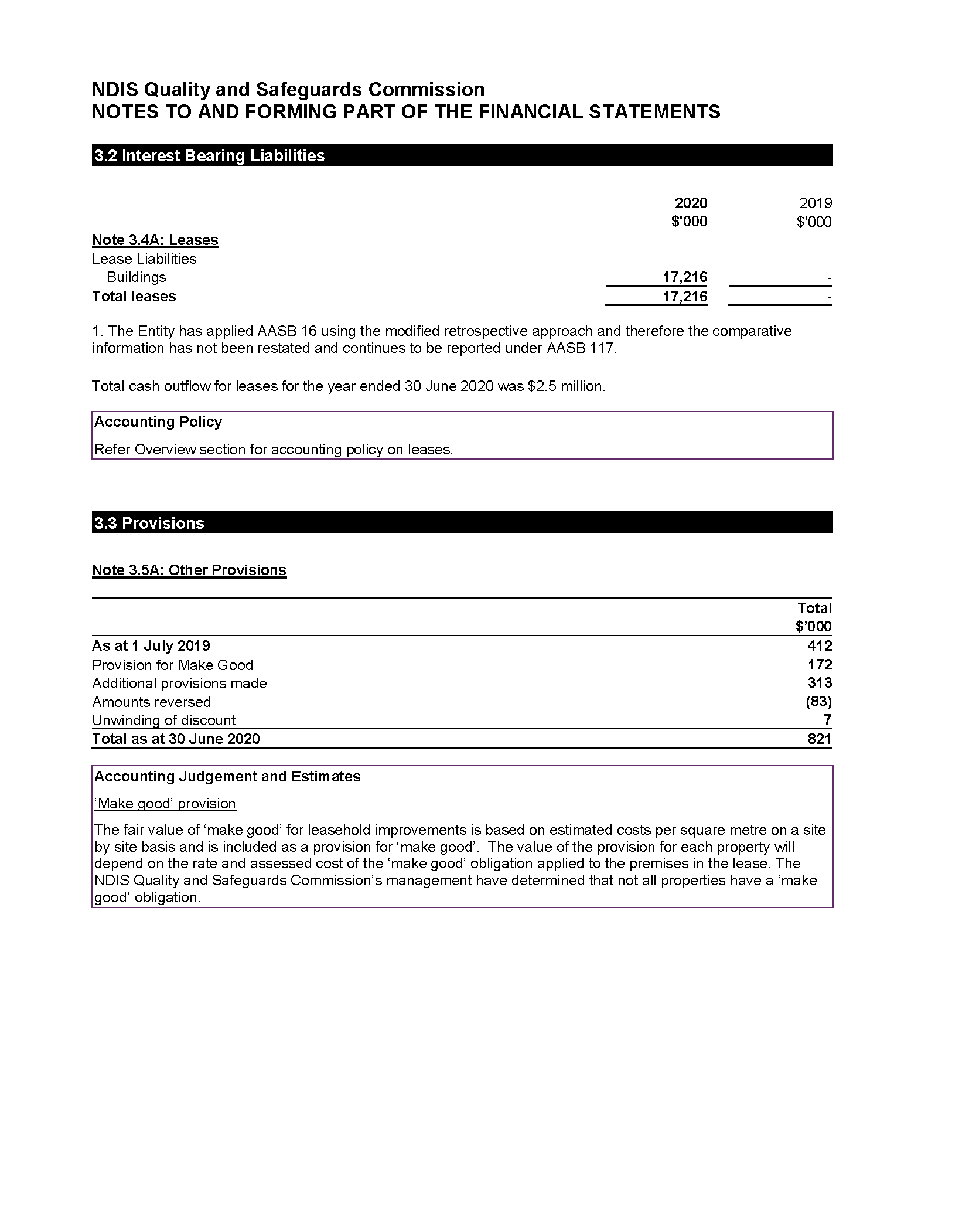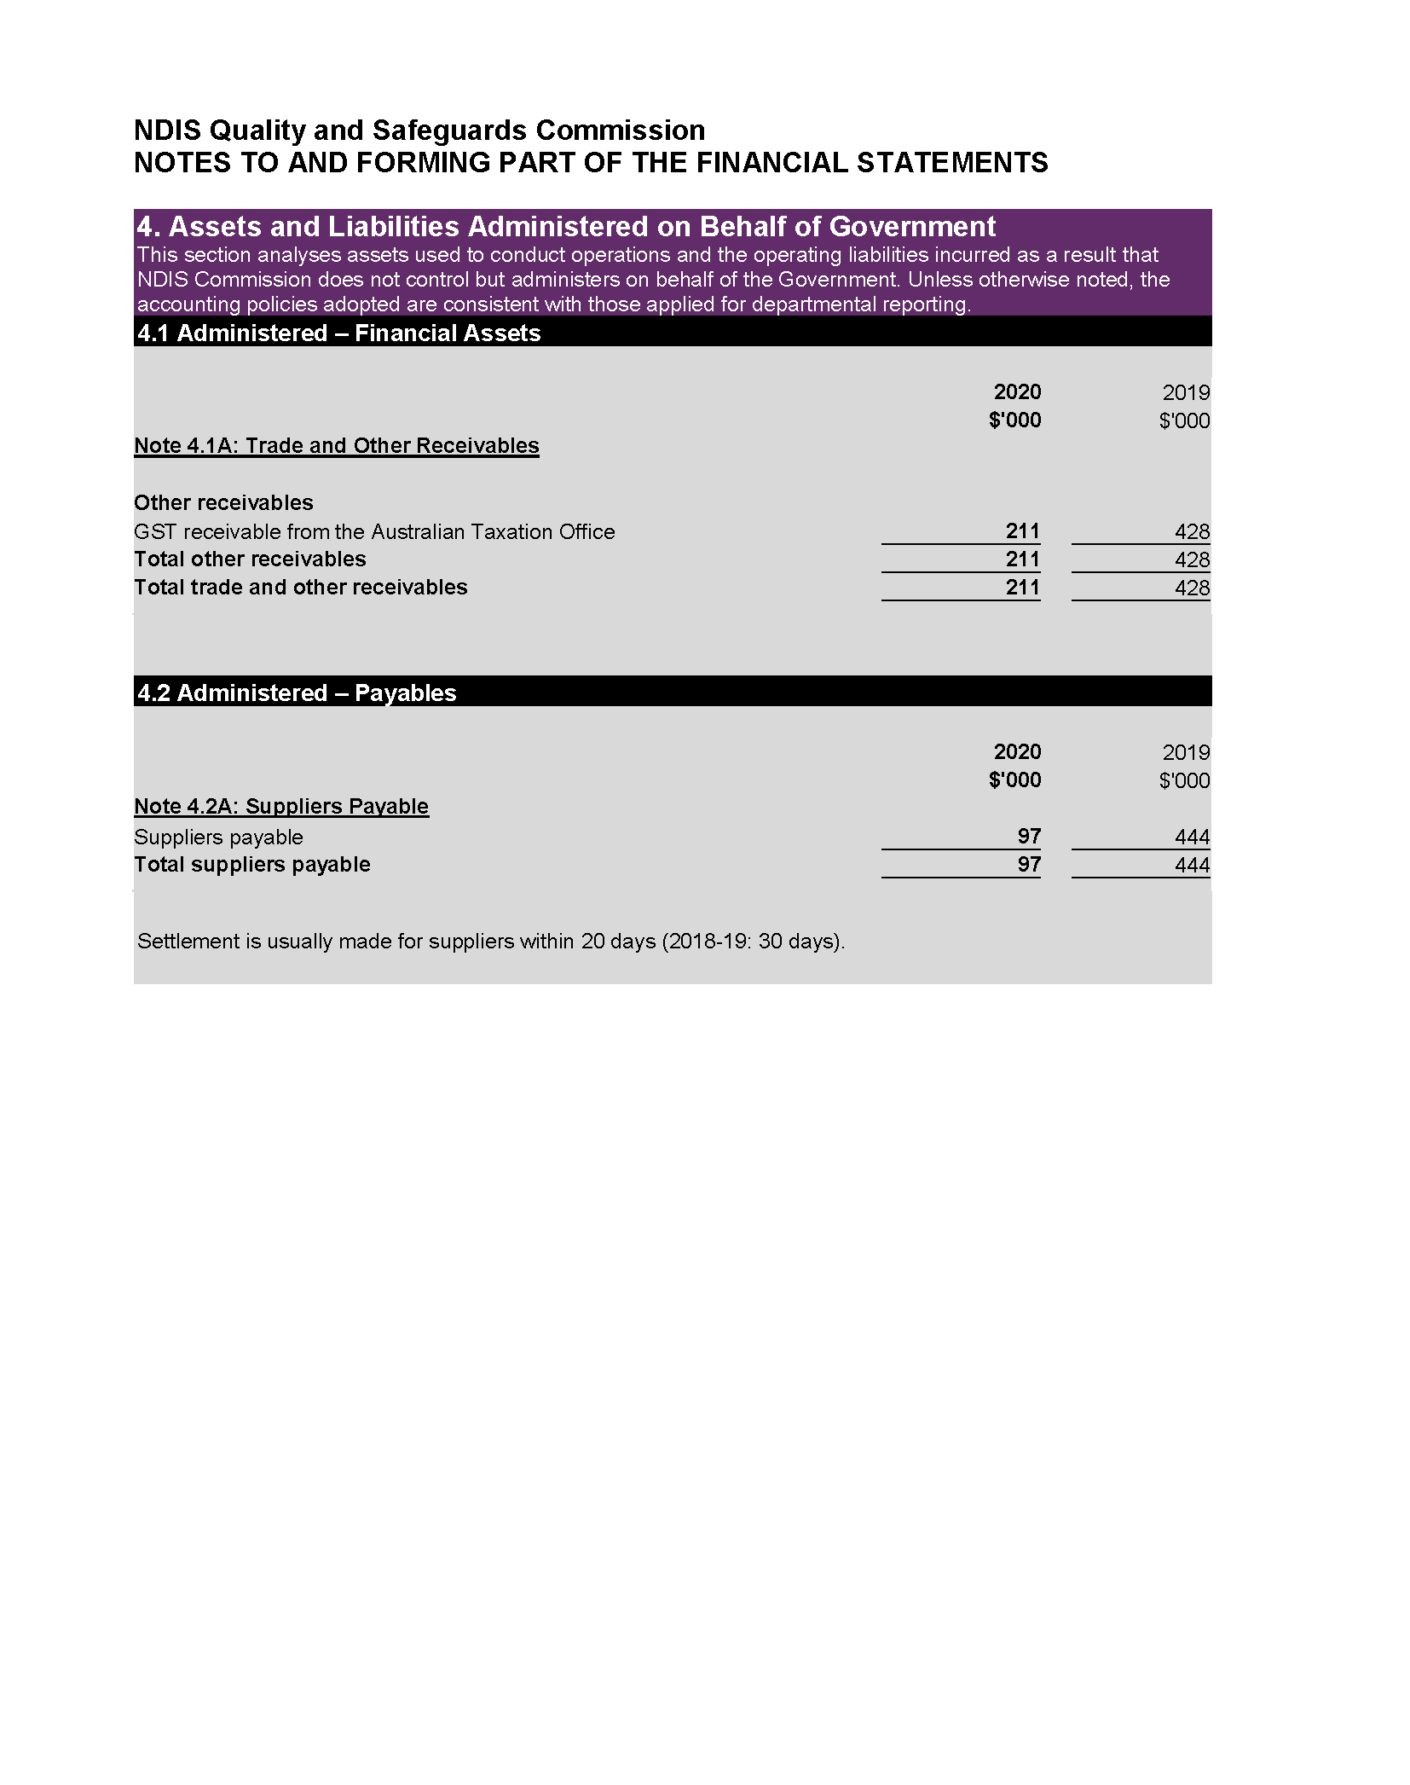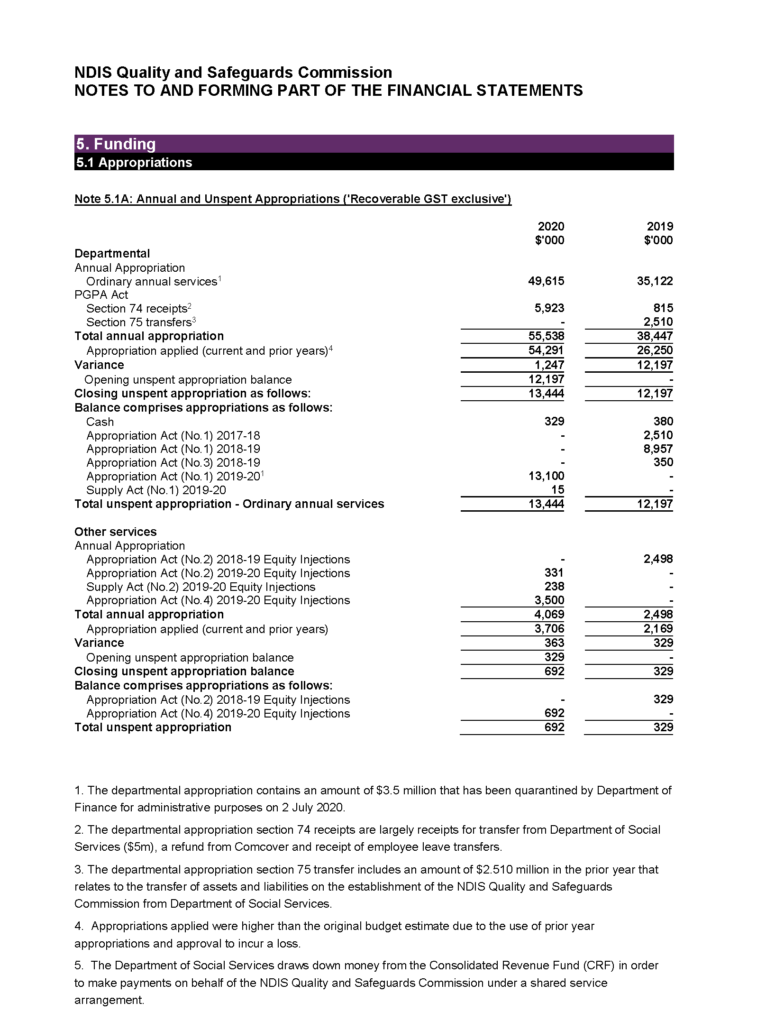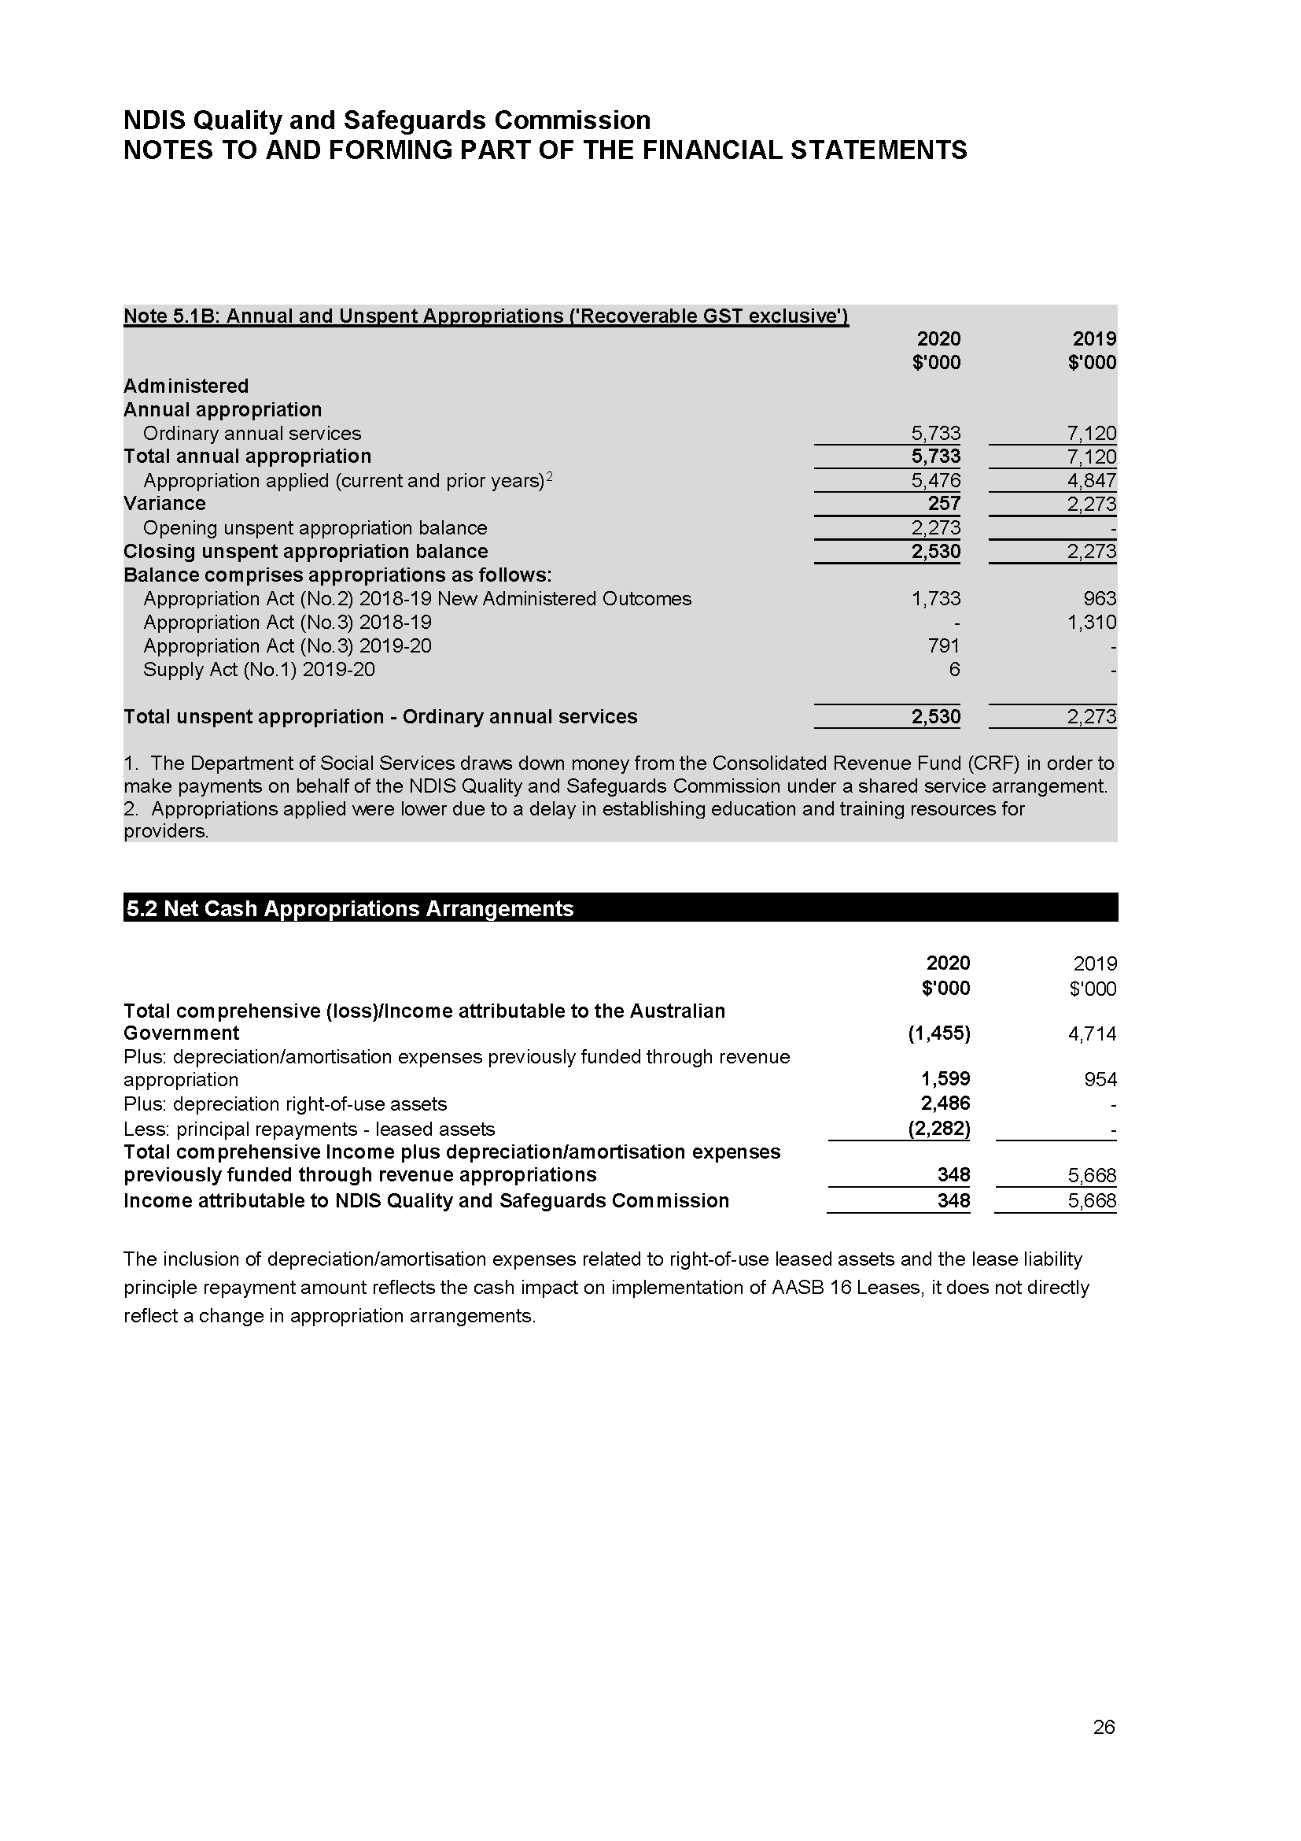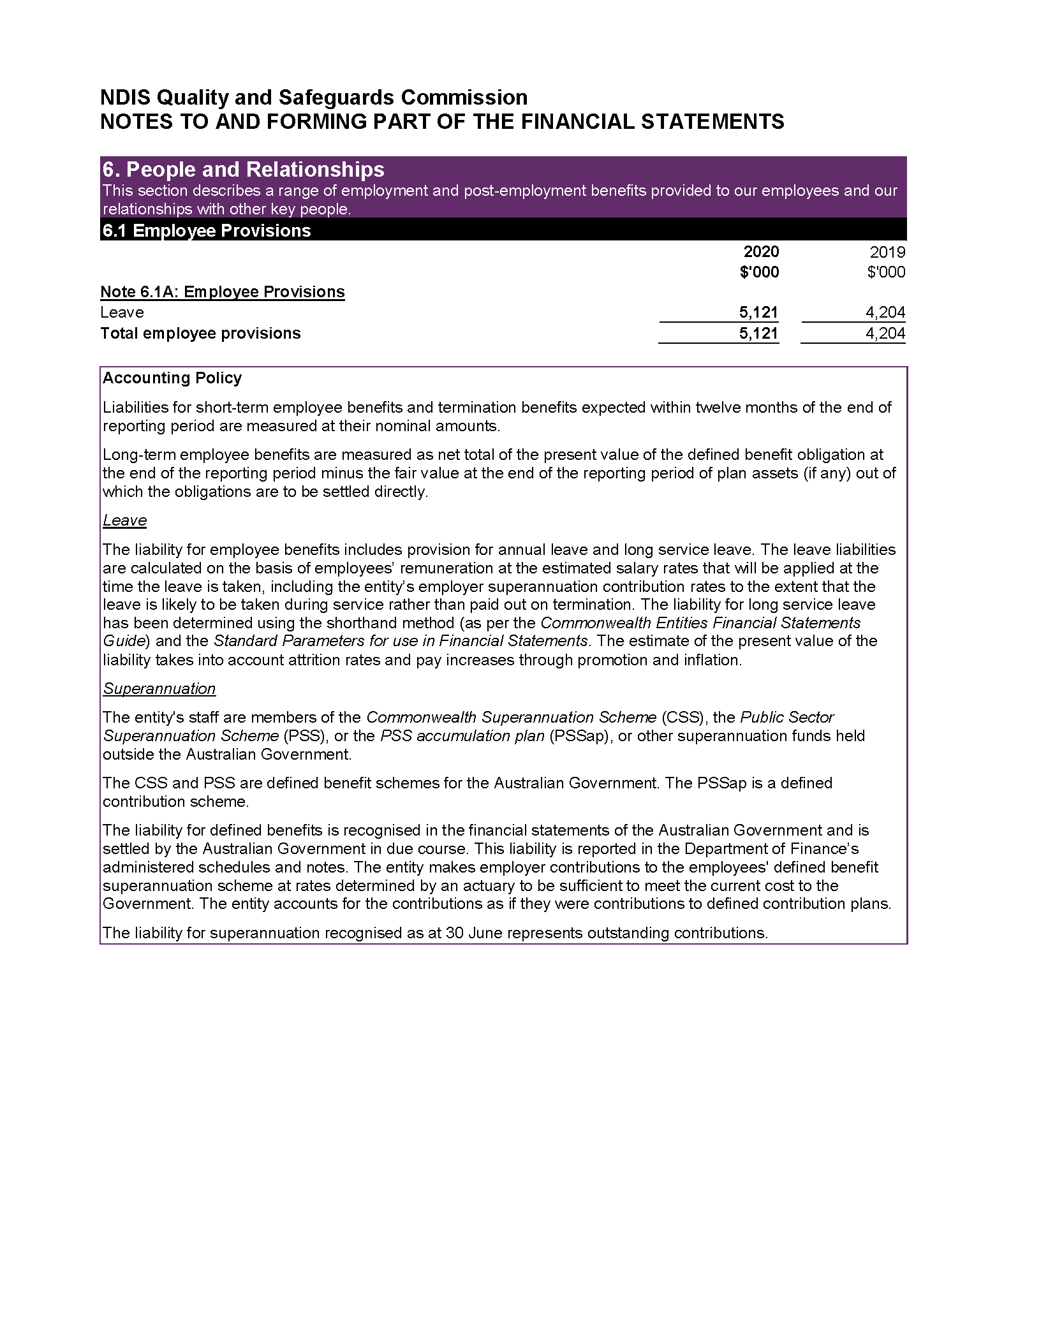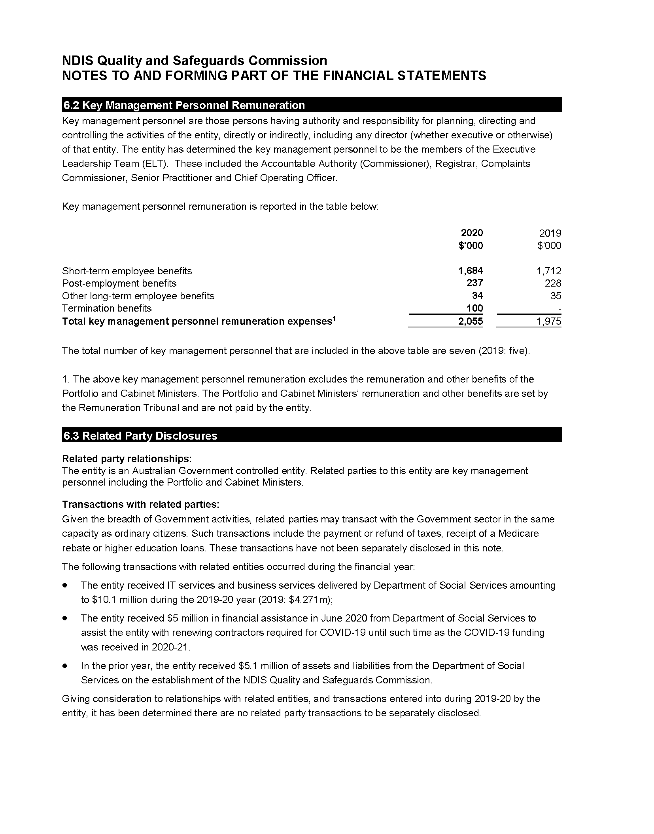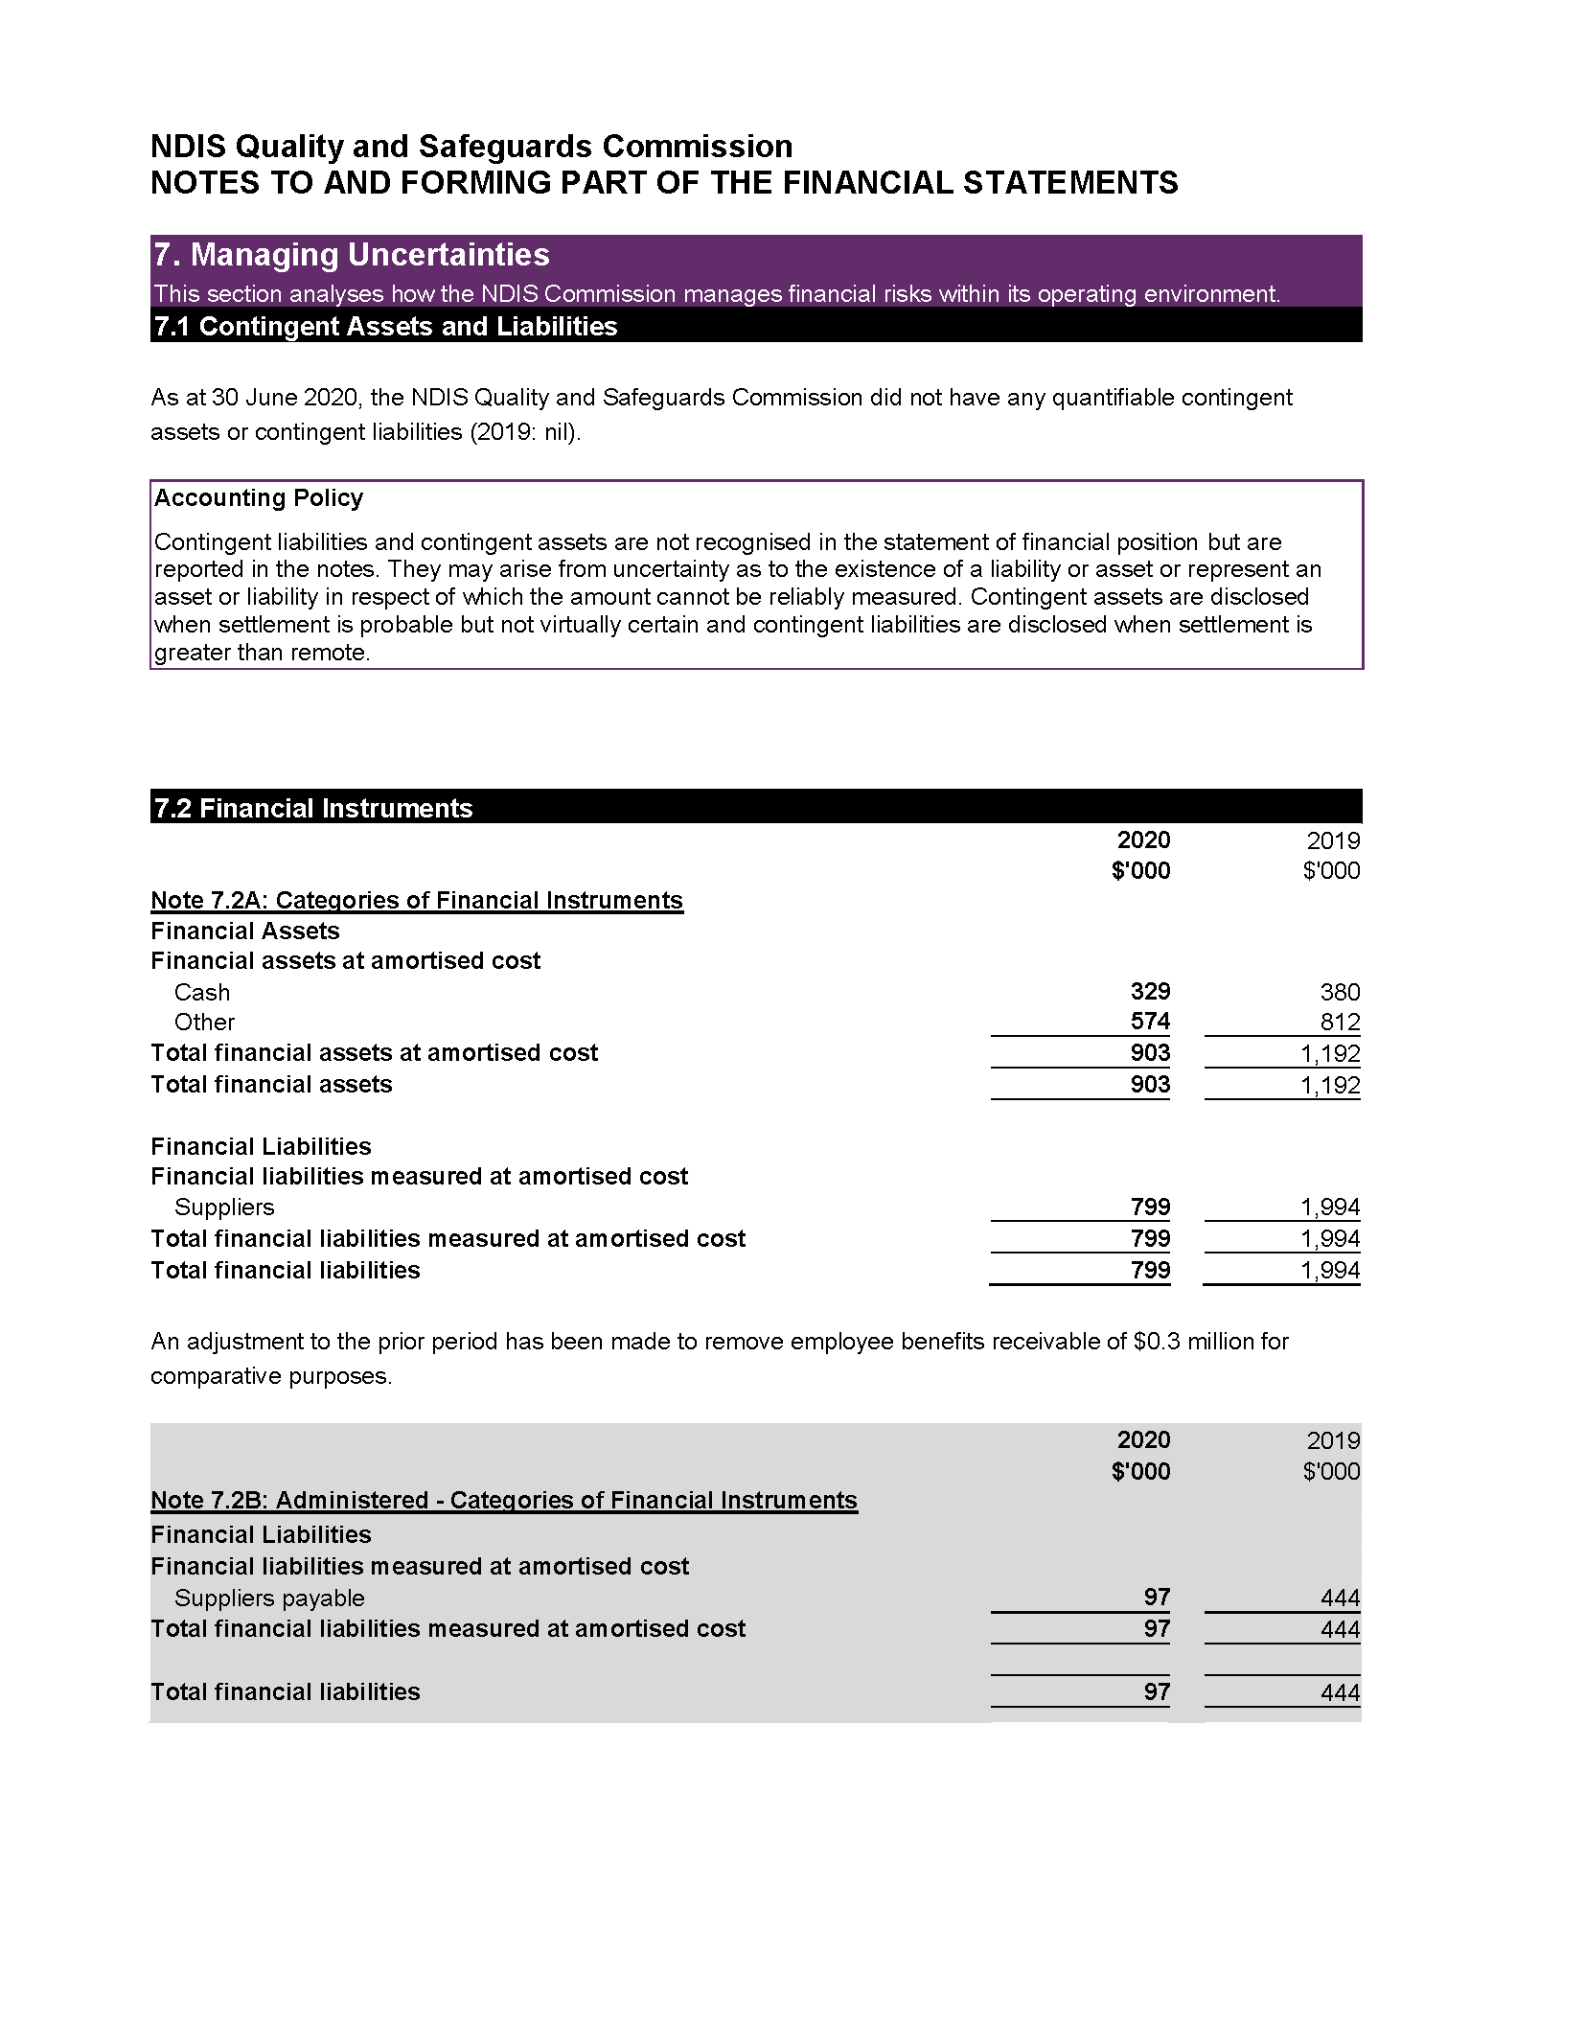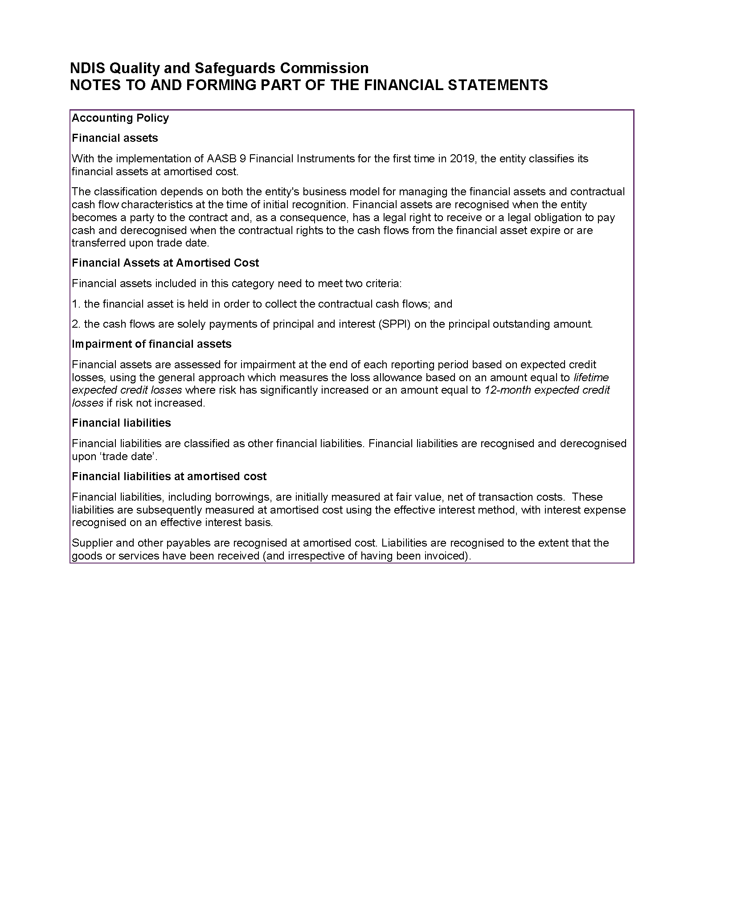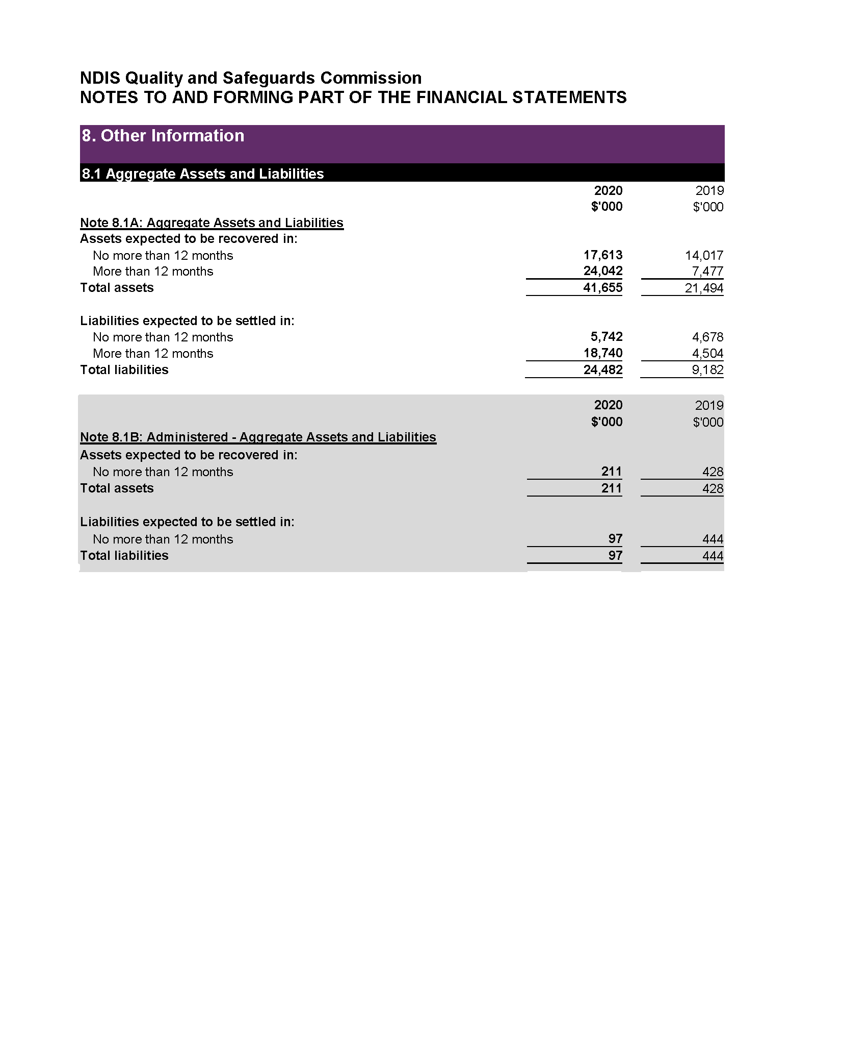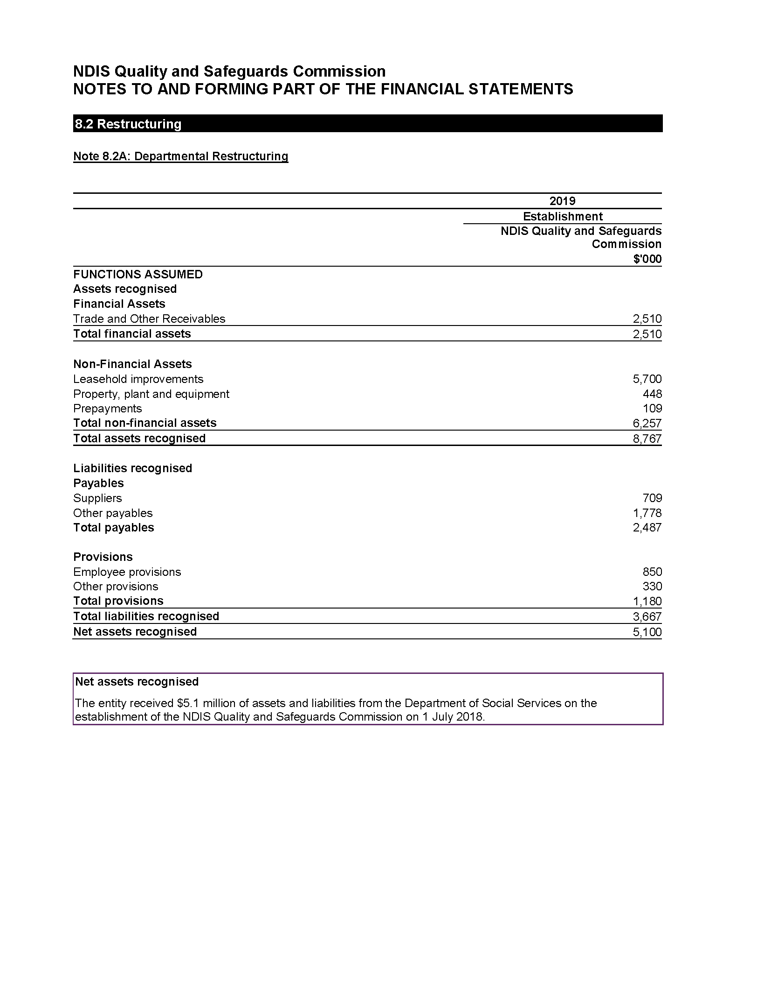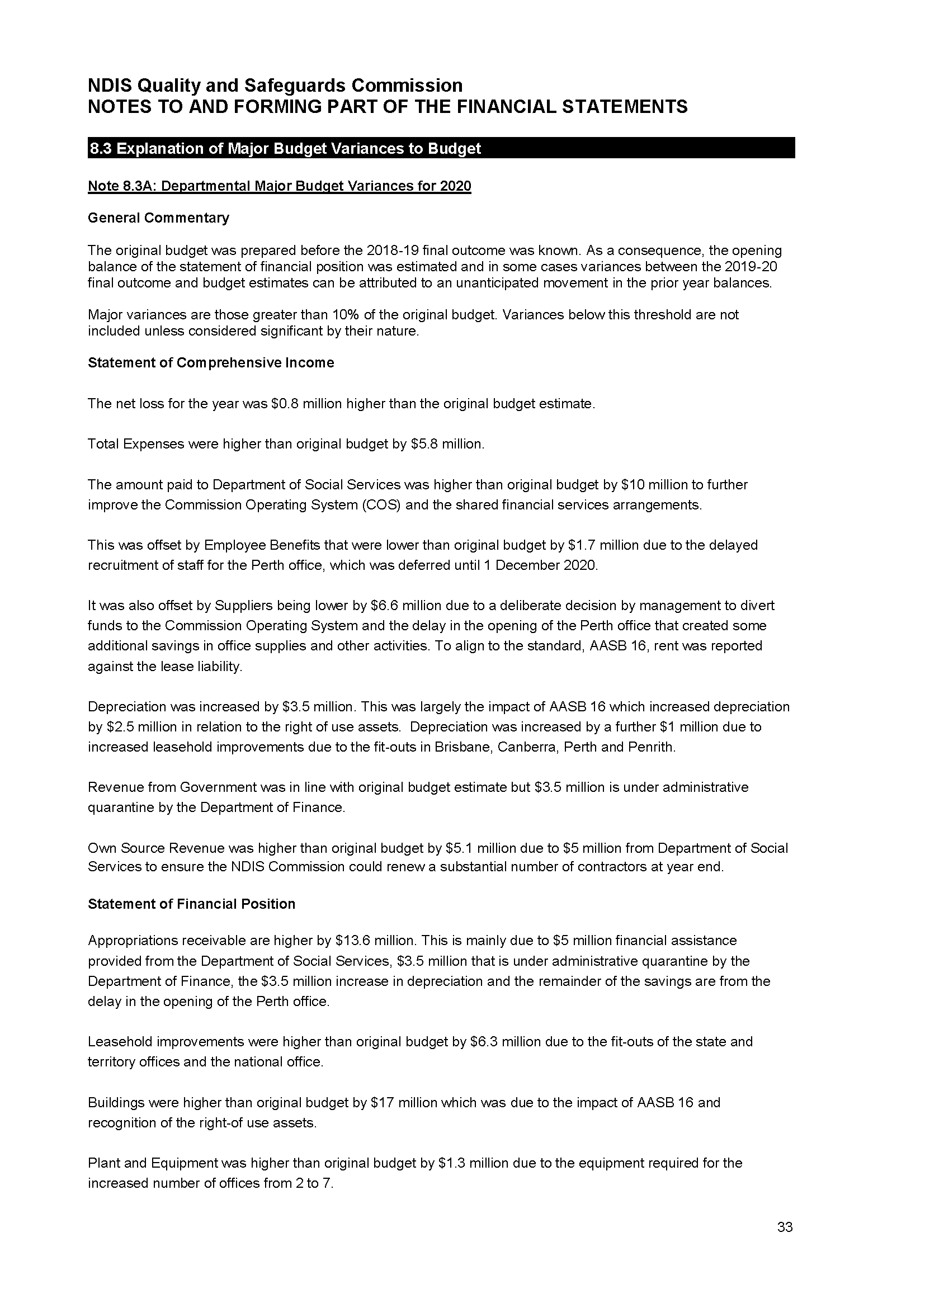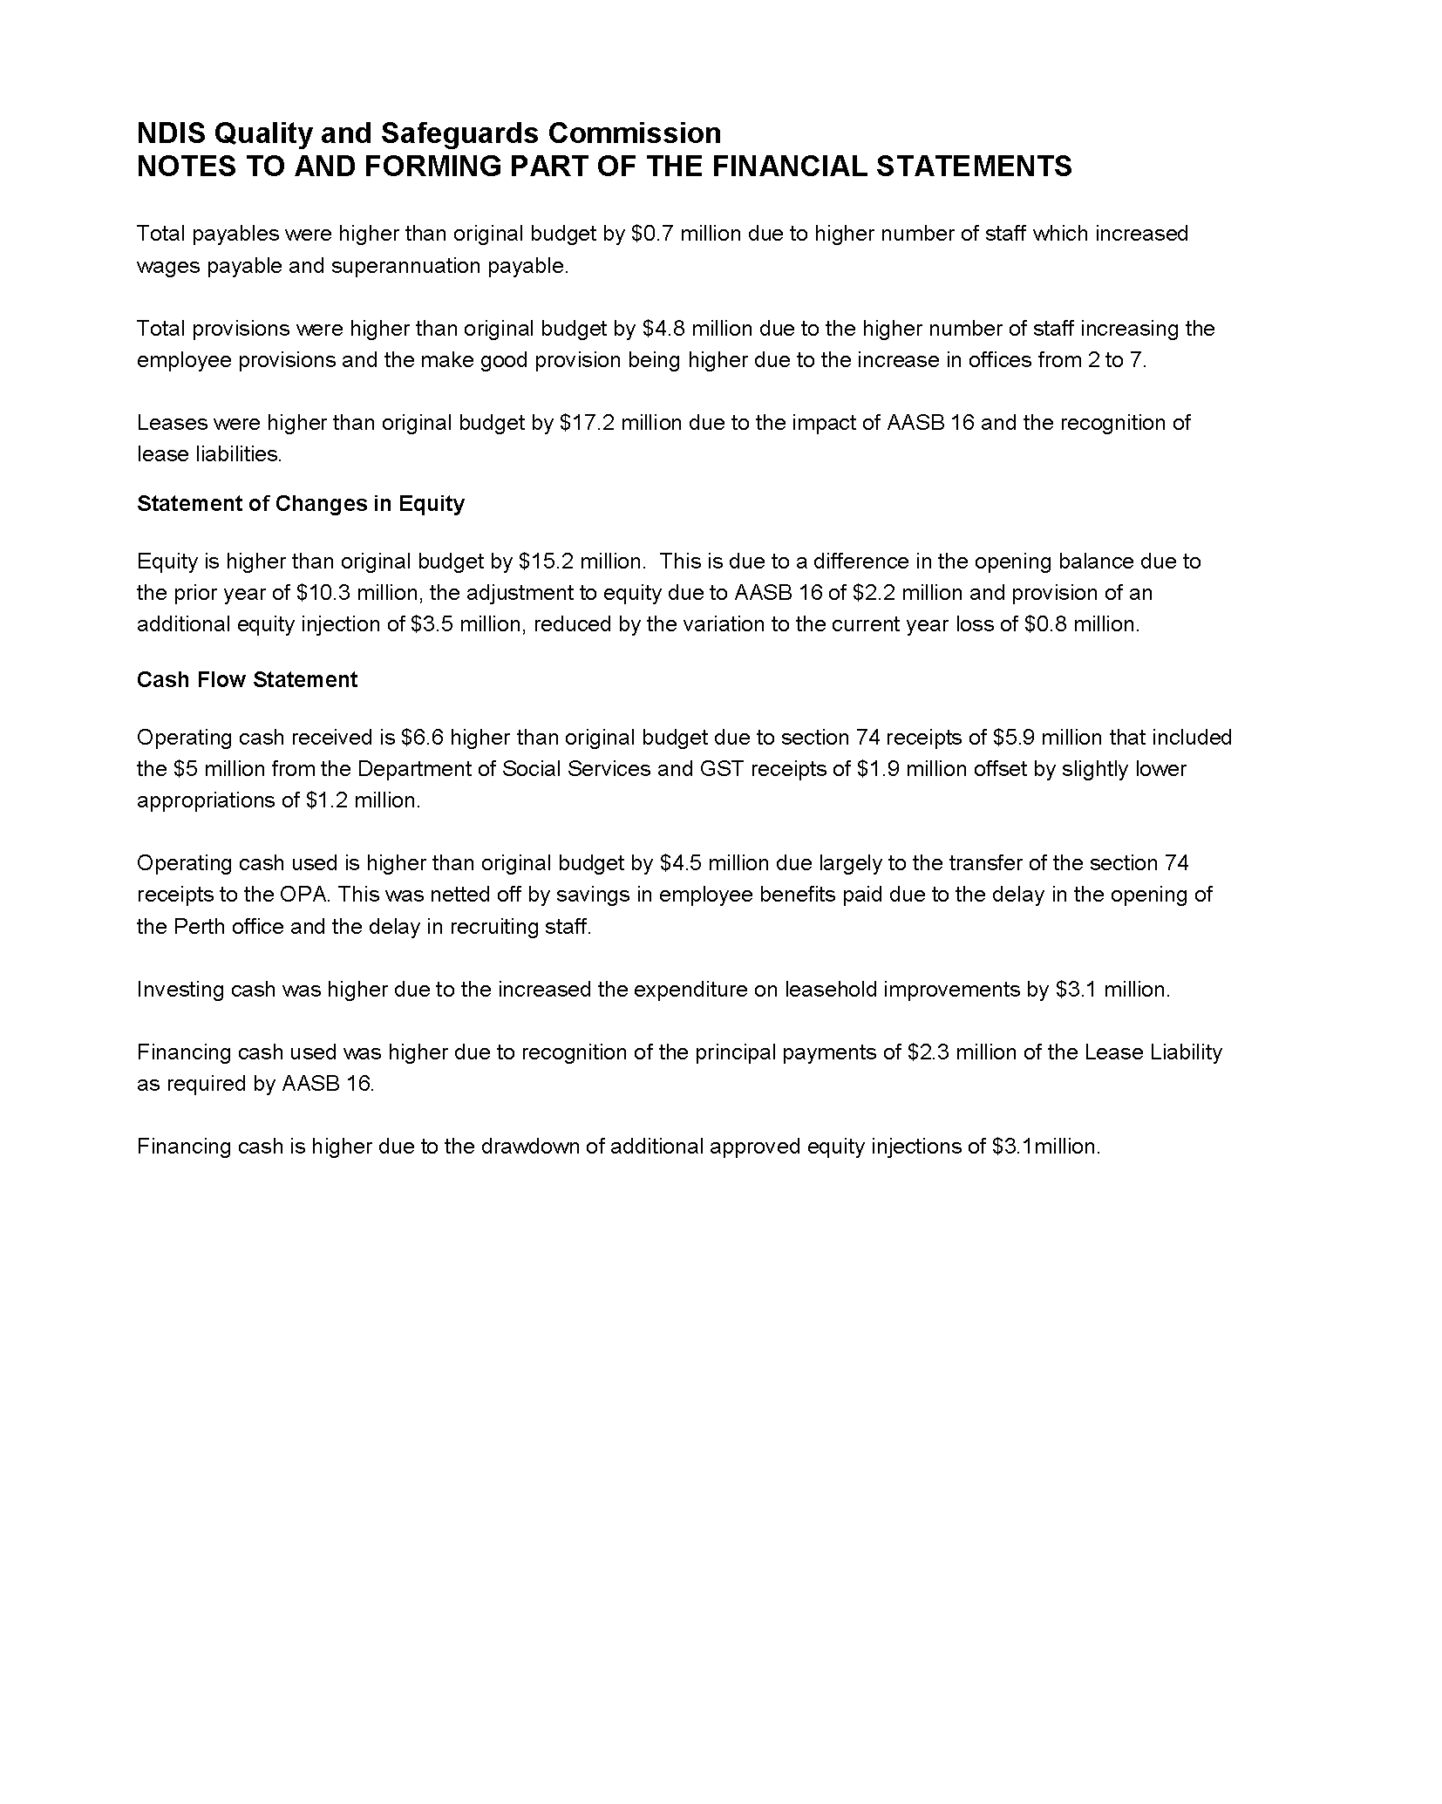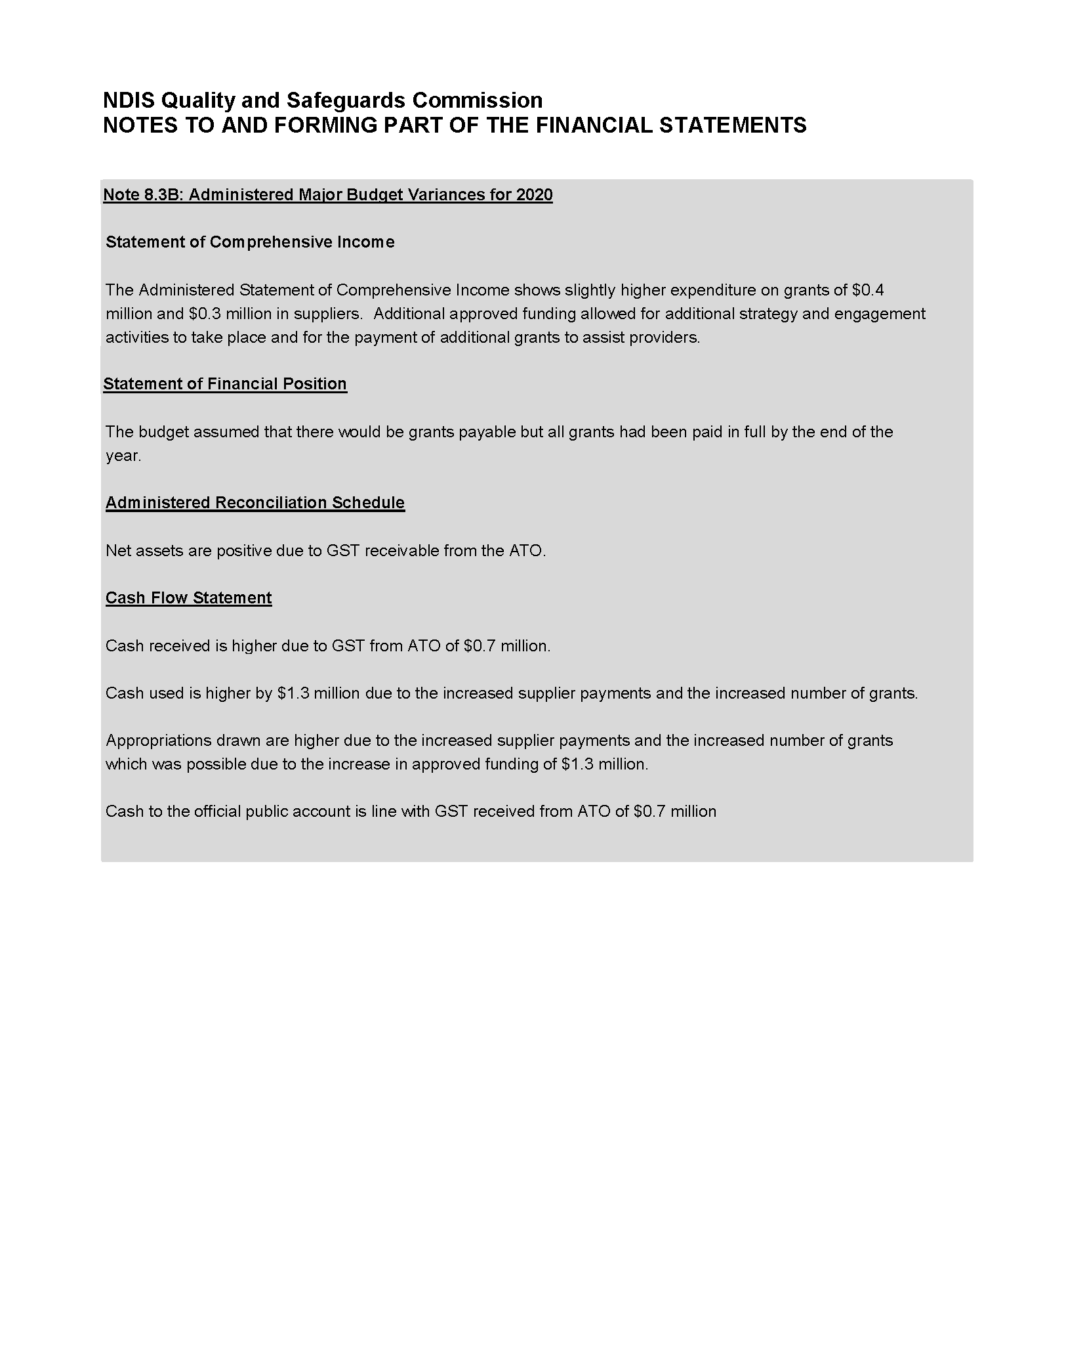

PART 5. APPENDICES

Appendix 1: Annual report list of requirements
PGPA Rule Reference | Part of Report | Description | Requirement
17AD(g) |  | Letter of transmittal
17AI | Page 7 | A copy of the letter of transmittal signed and dated by accountable authority on date final text approved, with statement that the report has been prepared in accordance with section 46 of the PGPA Act and any enabling legislation that specifies additional requirements in relation to the annual report. | Mandatory
17 AD(h) |  | Aids to access
17AJ(a) | Page 6 | Table of contents. | Mandatory
17AJ(b) | Pages 115-117 | Alphabetical index. | Mandatory
17AJ(c) | Pages 110-111 | Glossary of abbreviations and acronyms. | Mandatory
17AJ(d) | Pages 97-101 | List of requirements. | Mandatory
17AJ(e) | Page 118 | Details of contact officer. | Mandatory
17AJ(f) | Page 118 | Entity’s website address. | Mandatory
17AJ(g) | Page 118 | Electronic address of report. | Mandatory
17AD(a) |  | Review by accountable authority
17AD(a) | Pages 4-5 | A review by the accountable authority of the entity. | Mandatory
17AD(b) |  | Overview of the entity
17AE(1)(a)(i) | Pages 10, 13-19 | A description of the role and functions of the entity. | Mandatory
17AE(1)(a)(ii) | Page 12 | A description of the organisational structure of the entity. | Mandatory
17AE(1)(a)(iii) | Page 8 | A description of the outcomes and programmes administered by the entity. | Mandatory
17AE(1)(a)(iv) | Page 9 | A description of the purposes of the entity as included in corporate plan. | Mandatory
17AE(1)(aa)(i) | Page 8 | Name of the accountable authority or each member of the accountable authority. | Mandatory
17AE(1)(aa)(ii) | Page 8 | Position title of the accountable authority or each member of the accountable authority. | Mandatory
17AE(1)(aa)(iii) | Page 8 | Period as the accountable authority or member of the accountable authority within the reporting period. | Mandatory
17AE(1)(b) | Not Applicable | An outline of the structure of the portfolio of the entity. | Portfolio departments - mandatory
17AE(2) | Not applicable | Where the outcomes and programs administered by the entity differ from any Portfolio Budget Statement, Portfolio Additional Estimates Statement or other portfolio estimates statement that was prepared for the entity for the period, include details of and reasons for variation. | If applicable, Mandatory

PGPA Rule Reference | Part of Report | Description | Requirement
17AD(c) |  | Report on the performance of the entity
 |  | Annual Performance Statements
17AD(c)(i); 16F | Pages 31-43 | Annual performance statements in accordance with paragraph 39(1)  (b) of the Act and section 16F of the Rule. | Mandatory
 |  | Report on financial performance
17AF(1)(a) | Pages 52, 60-96 | A discussion and analysis of the entity’s financial performance. | Mandatory
17AF(1)(b) | Page 114 | A table summarising the total resources and total payments of the entity. | Mandatory
17AF(2) | Not Applicable | If there may be significant changes in the financial results during or after the previous or current reporting period, information on those changes, including: the cause of any operating loss of the entity; how the entity has responded to the loss and the actions that have been taken in relation to the loss; and any matter or circumstances that it can reasonably be anticipated will have a significant impact on the entity’s future operation or financial results. | If applicable, Mandatory
17AD(d) |  | Management and accountability
 |  | Corporate governance
17AG(2)(a) | Page 48 | Information on compliance with section 10 (fraud systems). | Mandatory
17AG(2)(b)(i) | Page 7 | A certification by accountable authority that fraud risk assessments and fraud control plans have been prepared. | Mandatory
17AG(2)(b)(ii) | Page 7 | A certification by accountable authority that appropriate mechanisms for preventing, detecting incidents of, investigating or otherwise dealing with, and recording or reporting fraud that meet the specific needs of the entity are in place. | Mandatory
17AG(2)(b)(iii) | Page 7 | A certification by accountable authority that all reasonable measures have been taken to deal appropriately with fraud relating to the entity. | Mandatory
17AG(2)(c) | Page 45-46 | An outline of structures and processes in place for the entity to implement principles and objectives of corporate governance. | Mandatory
17AG(2)(d) - (e) | Page 52 | A statement of significant issues reported to Minister under paragraph 19(1)(e) of the PGPA Act that relates to non-compliance with Finance law, and action taken to remedy non-compliance. | If applicable, Mandatory
 |  | Audit Committee
17AG(2A)(a) | Page 46 | A direct electronic address of the charter determining the functions of the entity’s audit committee. | Mandatory
17AG(2A)(b) | Pages 46-47 | The name of each member of the entity’s audit committee. | Mandatory
17AG(2A)(c) | Pages 46-47 | The qualifications, knowledge, skills or experience of each member of the entity’s audit committee. | Mandatory
17AG(2A)(d) | Pages 46-47 | Information about the attendance of each member of the entity’s audit committee at committee meetings. | Mandatory
17AG(2A)(e) | Pages 46-47 | The remuneration of each member of the entity’s audit committee. | Mandatory

PGPA Rule Reference | Part of Report | Description | Requirement
 |  | External scrutiny
17AG(3) | Pages 48-49 | Information on the most significant developments in external scrutiny and the entity’s response to the scrutiny. | Mandatory
17AG(3)(a) | Page 49 | Information on judicial decisions, and decisions of administrative tribunals and the Australian Information Commissioner that may have a significant effect on the operations of the entity. | If applicable, Mandatory
17AG(3)(b) | Page 49 | Information on any reports on operations of the entity by the  Auditor-General (other than reports under section 43 of the PGPA Act), a Parliamentary Committee, or the Commonwealth Ombudsman. | If applicable, Mandatory
17AG(3)(c) | Page 49 | Information on any capability reviews on the entity that were released during the period. | If applicable, Mandatory
 |  | Management of human resources
17AG(4)(a) | Page 52 | An assessment of the entity’s effectiveness in managing and developing employees to achieve entity objectives. | Mandatory
17AG(4)(aa) | Pages 53-57 | Statistics on the entity’s employees on an ongoing and non-ongoing basis, in relation to the following:  - full-time employees  - part-time employees  - gender  - staff location. | Mandatory
17AG(4)(b) | Pages 53-57 | Statistics on the entity’s APS employees on an ongoing and non-ongoing basis, in relation to the following:  - each classification level of the entity  - full-time employees  - part-time employees  - gender  - staff location  - employees who identify as Indigenous. | Mandatory
17AG(4)(c) | Pages 57-59 | Information on any enterprise agreements, individual flexibility arrangements, Australian workplace agreements, common law contracts and determinations under subsection 24(1) of the Public Service Act 1999. | Mandatory
17AG(4)(c)(i) | Pages 57-59 | Information on the number of SES and non-SES employees covered by agreements etc. identified in paragraph 17AG(4)(c). | Mandatory
17AG(4)(c)(ii) | Pages 58-59 | The salary ranges available for APS employees by classification level. | Mandatory
17AG(4)(c)(iii) | Page 59 | A description of non-salary benefits provided to employees. | Mandatory
17AG(4)(d)(i) | Page 58 | Information on the number of employees at each classification level who received performance pay. | If applicable, Mandatory
17AG(4)(d)(ii) | Not Applicable | Information on aggregate amounts of performance pay at each classification level. | If applicable, Mandatory
17AG(4)(d)(iii) | Not applicable | Information on the average amount of performance payment, and range of such payments, at each classification level. | If applicable, Mandatory
17AG(4)(d)(iv) | Not applicable | Information on aggregate amount of performance payments for the entity. | If applicable, Mandatory

PGPA Rule Reference | Part of Report | Description | Requirement
 |  | Assets management
17AG(5) | Not Applicable | An assessment of effectiveness of assets management where asset management is a significant part of the entity’s activities. | If applicable, mandatory
 |  | Purchasing
17AG(6) | Page 50 | An assessment of entity performance against the Commonwealth Procurement Rules. | Mandatory
 |  | Consultants
17AG(7)(a) | Page 50 | A summary statement detailing:  - the number of new consultancy contracts entered into during the period  - total actual expenditure on all such contracts (inc. GST)  - the number of ongoing consultancy contracts entered into in a previous reporting period  - total actual expenditure on those ongoing contracts (inc. GST). | Mandatory
17AG(7)(b) | Page 50 | A statement that “During [reporting period], [specified number] new consultancy contracts were entered into involving total actual expenditure of $[specified million]. In addition, [specified number]  ongoing consultancy contracts were active during the period, involving total actual expenditure of $[specified million]”. | Mandatory
17AG(7)(c) | Page 50 | A summary of the policies and procedures for selecting and engaging consultants and the main categories of purposes for which consultants were selected and engaged. | Mandatory
17AG(7)(d) | Page 50 | A statement that “Annual reports contain information about actual expenditure on contracts for consultancies. Information on the value of contracts and consultancies is available on the AusTender website.” | Mandatory
 |  | Australian National Audit Office access clauses
17AG(8) | Page 50 | If an entity entered into a contract with a value of more than  $100,000 (inc. GST) and the contract did not provide the  Auditor-General with access to the contractor’s premises, the report must include the name of the contractor, purpose and value of the contract, and the reason why a clause allowing access was not included in the contract. | If applicable, Mandatory
 |  | Exempt contracts
17AG(9) | Page 50 | If an entity entered into a contract or there is a standing offer with a value greater than $10,000 (inc. GST) which has been exempted from being published in AusTender because it would disclose exempt matters under the FOI Act, the annual report must include a statement that the contract or standing offer has been exempted, and the value of the contract or standing offer, to the extent that doing so does not disclose the exempt matters. | If applicable, Mandatory

PGPA Rule Reference | Part of Report | Description | Requirement
 |  | Procurement initiatives to support small business
17AG(10)(a) | Page 50 | A statement that “[Name of entity] supports small business participation in the Commonwealth Government procurement market. Small and Medium Enterprises (SME) and Small Enterprise participation statistics are available on the Department of Finance’s website.” | Mandatory
17AG(10)(b) | Page 50 | An outline of the ways in which the procurement practices of the entity support small and medium enterprises. | Mandatory
17AG(10)(c) | Not Applicable | If the entity is considered by the Department administered by the Finance Minister as material in nature—a statement that “[Name of entity] recognises the importance of ensuring that small businesses are paid on time. The results of the Survey of Australian Government Payments to Small Business are available on the Treasury’s website.” | If applicable, Mandatory
17AD(e) |  | Financial Statements
17AD(e) | Pages 60-96 | Inclusion of the annual financial statements in accordance with subsection 43(4) of the PGPA Act. | Mandatory
17AD(da) |  | Executive remuneration
17AD(da) | Pages 112-113 | Information about executive remuneration in  accordance with Subdivision C of Division 3A of Part 2-3 of the Rule. | Mandatory
17AD(f) |  | Other mandatory information
17AH(1)(a)(i) | Not Applicable | If the entity conducted advertising campaigns, a statement that “During [reporting period], the [name of entity] conducted the following advertising campaigns: [name of advertising campaigns undertaken].  Further information on those advertising campaigns is available at [address of entity’s website] and in the reports on Australian  Government advertising prepared by the Department of Finance. Those reports are available on the Department of Finance’s website.” | If applicable, Mandatory
17AH(1)(a)(ii) | Page 51 | If the entity did not conduct advertising campaigns, a statement to that effect. | If applicable, Mandatory
17AH(1)(b) | Page 51 | A statement that “Information on grants awarded by [name of entity] during [reporting period] is available at [address of entity’s website].” | If applicable, Mandatory
17AH(1)(c) | Page 45 | Outline of mechanisms of disability reporting, including reference to website for further information. | Mandatory
17AH(1)(d) | Page 45 | Website reference to where the entity’s Information Publication Scheme statement pursuant to Part II of FOI Act can be found. | Mandatory
17AH(1)(e) | Not Applicable | Correction of material errors in previous annual report. | If applicable, mandatory
17AH(2) | Page 51 | Information required by other legislation. | Mandatory

Appendix 2: Work health and safety
We are committed to the health and safety of all staff. Our work health and safety policy and resources support the health and safety of our staff and provide our leaders with tools to assist them in promoting safe work practices. Examples of work health and safety initiatives include:
- annual flu vaccinations provided to staff free of charge
- appointment of Health and Safety Representatives, First Aid Officers and Emergency Wardens
- free counselling available to all staff from the Employee Assistance Provider including critical incident support
- establishment of a Health and Safety Committee that meets on a quarterly basis
- additional procedures implemented for COVID-19 including encouraging staff to
- practice good hygiene as well as implementing additional cleaning, and social distancing protocols
- establishment of a work health and safety portal on the intranet
- providing work health and safety eLearning via our learning management system (Learnhub) and also via links available on the intranet to the Comcare learning management system.
The Comcare premium and associated regulatory charges for 2019–20 came to $179,755 (including GST).
There were no notifiable incidents in 2019–20.

Appendix 3: Engagement activities, major events and resources
This appendix details engagement activities, including major events, online and social media presence, and resources. In addition, state managers in NSW/ACT, NT, VIC, QLD, SA and TAS routinely engaged with stakeholders throughout 2019–20. Engagement focused on consolidating education and information about the NDIS Commission and its functions, including registration and reportable incidents, complaints, restrictive practice, and behaviour support.

Major Events
11 November 2019 | Conformity Assessment Body Forum: NDIS Approved Quality Auditor Scheme – hosted by JAS-ANZ and NDIS Commission | NSW
7 November 2019 | Webinar: Tips on using the NDIS Commission Portal | NSW
19 November 2019 | NDIS Commission Disability Sector Consultative Committee | VIC
26 November 2019 | NDIS Commission Industry Consultative Committee | VIC
10 March 2020 | NDIS Commission Disability Sector Consultative Committee | VIC
11 March 2020 | NDIS Commission Industry Consultative Committee | VIC
25 March 2020 | NDIS Commission WA Transition Webinar  The five in-person roadshows that were scheduled in WA were cancelled, due to COVID-19, and replaced with this livestreamed webinar. | NSW/ live webinar stream
30 June 2020 | NDIS Commission Disability Sector Consultative Committee This event was held virtually due to COVID-19. | Virtually via Webex
FY 2019–20 | The NDIS Commission's national office presented at 56 engagement activities. Approximately 10,000 stakeholders attended. | Activities between April – June included teleconferences and virtual meetings

State Engagement
NSW and ACT state office | The NDIS Commission's NSW and ACT state office presented at 84 engagement activities. Approximately 2,800 stakeholders attended. | Activities between April – June included teleconferences and virtual meetings
QLD state office | The NDIS Commission's QLD state office presented at 148 engagement activities. Approximately 4,050 stakeholders attended. | Activities between April – June included teleconferences and virtual meetings
VIC state office | The NDIS Commission's VIC state office presented at 40 engagement activities. Approximately 2,600 stakeholders attended. | Activities between April – June included teleconferences and virtual meetings
SA state office | The NDIS Commission's SA state office presented at 47 engagement activities. Approximately 1,500 stakeholders attended. | Activities between April – June included teleconferences and virtual meetings
TAS state office | The NDIS Commission's TAS state office presented at 46 engagement activities. Approximately 4,900 stakeholders attended. | Activities between April – June included teleconferences and virtual meetings
NT state office | The NDIS Commission's NT state office presented at 35 engagement activities. Approximately 800 stakeholders attended. | Activities between April – June included teleconferences and virtual meetings

Website and social media presence
NDIS Commission Website | In 2019–20, there were 894,600 visits to the NDIS Commission webpage.
Culturally and linguistically diverse (CALD) webpages | In 2019–20, there were 1,653 page views (891 unique views) of the CALD resources available on the NDIS Commission website. These pages consist of participant resources translated into 11 community languages. We currently translate some of our participant resources into. These translated resources are available on the NDIS Commission website.  - Arabic: 369 page views (189 unique)  - Chinese traditional: 255 page views (132 unique)  - Chinese simplified: 218 page views (135 unique)  - Vietnamese: 184 page views (102 unique)  - Hindi: 151 page views (79 unique)  - Italian: 115 page views (66 unique)  - French: 85 page views (47 unique)  - Greek: 76 page views (38 unique)  - Filipino: 68 page views (38 unique)  - Macedonian: 66 page views (31 unique)  - Samoan: 66 page views (34 unique).
Facebook | The NDIS Commission's Facebook page had 2,003 followers as at 30 June 2020
LinkedIn | The NDIS Commission's LinkedIn page had 12,005 followers as at 30 June 2020

Provider Newsletters and Provider Alerts
Provider Newsletters
July 2019 | Provider Newsletter
September 2019 | Provider Newsletter
October 2019 | Behaviour Support Provider Newsletter
December 2019 | Provider Newsletter
December 2019 | Behaviour Support Provider Newsletter
February 2020 | Provider Newsletter
April 2020 | Provider Newsletter (focussing on COVID-19)
June 2020 | Provider Newsletter
Provider Alerts - General
December 2019 | NDIS provider information for the Disability Royal Commission (12 December 2019)
December 2019 | Providing a safe environment for NDIS Participants (18 December 2019)
February 2020 | Providing a safe environment for NDIS Participants – update (10 February 2020)
Provider Alerts - COVID-19 specific
February 2020 | Information about the novel coronavirus outbreak (7 February 2020)
March 2020 | Provider obligations and COVID-19 health information (9 March 2020)
March 2020 | Online training module for support workers (17 March 2020)
March 2020 | Business continuity planning (19 March 2020)

Provider Newsletters and Provider Alerts
March 2020 | Information for support workers and access to PPE (24 March 2020)
March 2020 | Assistance for organisations (26 March 2020)
March 2020 | Supporting providers to respond (31 March 2020)
April 2020 | Practice Alert: Influenza (flu) vaccine from mid-April 2020 (2 April 2020)
April 2020 | Adjusting supports and reducing infection risk (3 April 2020)
April 2020 | Further assistance for organisations, people and households (9 April 2020)
April 2020 | Management and Operational Plan for People with Disability (20 April 2020)
April 2020 | FAQs for all stakeholders and information for NDIS participants (28 April 2020)
April 2020 | Changes to student visa work conditions for workers of registered NDIS providers (30 April 2020)
May 2020 | Advice for people with disability (7 May 2020)
May 2020 | Guidance on preventing, preparing for, and dealing with a COVID-19 outbreak (13 May 2020)
May 2020 | Guidance from the Australian Government Department of Health (27 May 2020)

Resources - General
July 2019 | Provider Information Sessions 2019  We uploaded resources created for, and as a result of, the NDIS provider sessions held by the NDIS Commission between March and June 2019. The sessions were for the states and  territories that transitioned from 1 July (ACT, NT, QLD, TAS and VIC), and resources comprised presentation slides, a link to the webinar and a compendium containing the sessions’ most common questions and answers.
July 2019 | Speak Up campaign resources  A series of resources developed to empower people with disability to ‘speak up’ if they need to about the quality and safety of their NDIS funded supports and services:  - ‘Speak Up’ videos and posters  - ‘Talk Up’ flyer – version for Aboriginal and Torres Strait Islander people  - ‘Speak Up’ bookmark  - ‘If you need to speak up, speak to us’ Easy Read poster  - ‘If you need to speak up, speak to us’ Easy Read brochure  - ‘How to make a complaint’ fact sheet  Resources were also available in Auslan, Braille, and CALD formats.
July 2019 | Behaviour Support videos  We developed two videos – one for behaviour support practitioners, and one for NDIS providers – about behaviour support in the NDIS Commission.
July 2019 | NDIS Commission Participant letter  An introductory letter from the NDIS Commissioner Designate outlining key information about the new NDIS Commission and what it will do for people with disability who receive NDIS funded services in the ACT, NT, QLD, TAS and VIC.  Also available in Auslan, Easy Read, and CALD formats.
July 2019 | NDIS Commission Code of Conduct poster  This poster can be printed in A3 or A4 size and is a useful resource to pin up in work areas.

Resources - General
July 2019 | Reportable Incidents resources  Quick reference guide – five-day notification form Quick reference guide – immediate notification form  Quick reference guide – Managing my reportable incidents form My reportable incidents – FAQs
August 2019 | Incident Management and reportable incidents fact sheets Incident management and reporting for registered NDIS providers When to notify the NDIS Commission about a reportable incident Information requirements for reportable incident notification  What happens when a provider reports an incident? (Fact sheet for participants)
August 2019 | Young people in residential aged care – information for NDIS participants  This fact sheet explains the role and responsibility of the NDIS Commission, the rights of NDIS participants, and the requirements and obligations of providers.
August 2019 | Young people in residential aged care – information for NDIS providers  Residential aged care providers have the same responsibilities towards NDIS participants as they do to other residents who receive services and supports under the Aged Care Act 1997. This fact sheet explains the role and responsibility of the NDIS Commission, the rights of NDIS participants, and the requirements and obligations of providers.
August 2019 | NDIS Commission Corporate Plan 2019–20
September 2019 | Provider Information Sessions 2019: Behaviour Support Q&A Compendium  In June 2019, the NDIS Commission held a series of information sessions for NDIS providers in the five states and territories that transitioned from 1 July – the ACT, NT, QLD, TAS and VIC. This document is a compendium containing the most common questions and answers from these sessions, in relation to behaviour support.
September 2019 | Complaints Management and Resolution Guidance  Information about how the NDIS Commission manages and resolves complaints we receive about the provision of NDIS supports and services.
September 2019 | Easy Read format of Effective Complaint Handling Guidelines for NDIS Providers This guidance provides more information about effective complaint handling for NDIS providers.
October 2019 | NDIS Quality and Safeguards Commission Annual Report 2018–19  Also available in standard format and in Easy Read format.
November 2019 | NDIS Commission: 12-month activity report (July 2018–June 2019)
November 2019 | Behaviour Support webinars  - Tips on using the NDIS Commission Portal: Tips for ensuring successful lodgement of behaviour support plans using the NDIS Commission Portal.  - Reporting on Restrictive Practices in the NDIS Commission Portal: Covers topics to help implementing providers navigate the reporting process successfully.
January 2020 | Provider fact sheets:  - NDIS Commission – What does this mean for providers?  The NDIS Commission works with providers to improve the quality and safety of NDIS services and supports. This fact sheet summarises what it means for providers.  - Our powers to investigate  This fact sheet explains the types of matters we investigate, how we gather information to assist with investigations, as well as how and why we can compel the provision of information.

Resources - General
February 2020 | Commission Collateral Videos  Developed three videos to help providers, participants and other stakeholders understand what the NDIS Commission does. The videos, which are aimed at providers and participants, focus on three key themes:  Listening: Making it better Educating: Confidence in choice Regulating: Feeling safe  The social media campaign launched on Facebook on Monday 10 February 2020 and on LinkedIn on Wednesday 12 February 2020. Due to COVID-19, the campaign was temporarily suspended so that our messaging could focus on important COVID-19-related messages to NDIS providers and participants. The social media campaign recommenced in June 2020. Videos also available in Auslan and an audio described version.
February 2020 | NDIS Commission 6-month activity report: July - December 2019  A report on the NDIS Commission’s activities during the period 1 July 2019 to 31 December 2019 in all states and territories except Western Australia. (The NDIS Commission will commence in WA from 1 December 2020.)
February 2020 | Research on the causes and contributors to deaths of people with disability in Australia A report on an Australia-wide perspective on the prevalence of, and factors contributing to, the deaths of people with disability.  Available in standard format and in Easy Read format.
April 2020 | About the Positive Behaviour Support Capability Framework  This resource explains what positive behaviour support is, what the framework does, and who can provide behaviour support.  Available in Plain English and in Easy Read format.
May 2020 | CALD resources:  Developed in 11 languages – Arabic, Chinese – Simplified, Chinese – Traditional, Filipino, French, Greek, Hindi, Italian, Macedonian, Samoan, & Vietnamese:  - About the NDIS Quality and Safeguards Commission  - The NDIS Code of Conduct  - How to make a complaint brochure  - How to make a complaint poster
May 2020 | Provider fact sheet: Then and now for providers in WA  This fact sheet summarises several changes for WA providers, after the NDIS Commission will commence operating in WA on 1 December 2020.
June 2020 | Provider fact sheet: NDIS Hearing equipment and services  This fact sheet explains the changes to the way hearing services will be made available to NDIS participants from 1 July 2020.  Also available in Auslan.
June 2020 | Worker Orientation Module - Screen reader compatible version  Screen reader compatible version of Worker Orientation Module ‘Quality, Safety and You’ – an interactive online course that explain the obligations of workers under the NDIS Code of Conduct, from the perspective of NDIS participants.  As at the end of June 2020, 245,813 people have completed the module – including 2,213 completions of the Auslan version.

Resources - COVID-19 specific
March 2020 | COVID-19 information webpage for providers  Provides latest COVID-19 information and updates for providers from the NDIS Commission.  - 65,565 page views as at 30 June 2020
March 2020 | COVID-19 information webpage for people with disability  This page contains links to COVID-19 updates and resources for NDIS participants.  - 7,338 page views as at 30 June 2020
March 2020 | COVID-19 Provider letters and fact sheets:  - Letter to registered providers  The NDIS Quality and Safeguards Commissioner wrote to providers on 10 March 2020 drawing providers’ attention to the COVID-19 Provider Alert and pointing out that it is essential that providers remain subscribed to all NDIS Commission communications.  - Notification of changes letter to providers  We wrote to registered providers on 24 March about the new form they must use to notify us of any change or event specified in section 13 or 13A of the NDIS (Provider Registration and Practice Standards) Rules 2018 that relate to the impact of COVID-19.  - Fact sheet – What the NDIS Commission is doing  This fact sheet provides information to registered NDIS providers to support them in understanding 1) their obligations to safely and competently provide supports and services to people with disability during the COVID-19 pandemic 2) how to reduce exposure and transmission of COVID-19.  - How to maintain NDIS supports and services  Fact sheet – Behaviour support and restrictive practices  This fact sheet provides information to assist NDIS providers to better understand behaviour support and restrictive practices due to COVID-19.  Fact sheet – Information on the use of Personal Protective Equipment (PPE)  This fact sheet explains when PPE should be used, how requests for PPE are prioritised, and provides an update on the current availability of PPE in Australia.
March 2020 | COVID-19 Participant fact sheets:  NDIS participant information  This factsheet explains what participants can expect from NDIS providers; their rights, how to make a complaint about a provider; what resources are available from the NDIA and where to find more information and resources about COVID-19.  What NDIS participants can expect from their providers and support workers  This factsheet includes some changes providers might see in the way they deliver supports and services during this pandemic.  Available in Auslan, Braille, and CALD formats.
April 2020 | Webpage: Training for NDIS workers during COVID-19  Provides information about training available to new and existing NDIS workers.  - 9,423 page views as at 30 June 2020
April 2020 | COVID-19 Provider information:  Fact sheet – Relaxation of student visa work  This letter to NDIS providers from the Department of Home Affairs explains the temporary changes to student visa work conditions during the COVID-19 pandemic.
May 2020 | COVID-19 Provider fact sheet:  COVID-19 outbreak preparedness, prevention, and management  This fact sheet supports registered NDIS providers to prepare for, respond to, and manage an outbreak of COVID-19.

Resources - COVID-19 specific
June 2020 | COVID-19 Provider information:  Fact sheet – Case studies of the NDIS Commission’s compliance approach  This fact sheet uses case studies to explain some key considerations to bear in mind during the COVID-19 pandemic.
June 2020 | COVID-19 information pack for NDIS providers and workers  This pack consolidates the guidance and advice we issued during the COVID-19 pandemic to inform, educate, and remind NDIS providers of the support available to help you meet your obligations to NDIS participants.
June 2020 | COVID-19 Information pack for NDIS participants  This information pack brings together the guidance issued to help inform and support people with disability during the COVID-19 pandemic.  Available in Auslan, Braille, and CALD formats.

Resource Distributions
Provider Information Pack | In 2019–20, the NDIS Commission printed and distributed 9,029 Provider Information Packs.
Participant Welcome Pack | In 2019–20, the NDIS Commission printed and distributed 33,985 Participant Welcome Packs. (16,454 in standard format; 15,382 in Easy Read format; 2,149 in Braille)
Code of Conduct postcard | In 2019–20, the NDIS Commission printed and distributed 15,882 Code of Conduct postcards.

Appendix 4: Glossary

Definitions
Word | Definition
Commissioner | The NDIS Quality and Safeguards Commissioner
FOI Act | The Freedom of Information Act 1982 (Cwth)
NDIS Act | The National Disability Insurance Scheme Act 2013 (Cwth)
NDIS Commission or Commission | The NDIS Quality and Safeguards Commission
NDIS Provider Register | The register maintained under section 73ZS of the NDIS Act
Participant or NDIS Participant | A person who is a participant in the NDIS as defined in the NDIS Act, sections 28-30
PGPA Act | The Public Governance, Performance and Accountability Act 2013 (Cwth)
Provider or NDIS Provider | A person or legal entity who is an NDIS provider as defined in section 9 of the NDIS Act
Registered provider | A provider that has been registered with the NDIS Quality and Safeguards Commission
Reportable incident | An incident or allegation involving the injury, abuse, neglect, or death of a participant connected with their receiving of services or supports from a registered provider
Restrictive Practice | Anything that restricts the rights or freedom of movement of a person with disability
Supports, or Supports and Services | A range of products and services which may include education, employment, social participation, independence, living arrangements, and health and wellbeing
Worker or NDIS Worker | A person employed or engaged by an NDIS provider

Acronyms
- AASB – Australian Accounting Standards Board
- AHPA – Allied Health Professions Australia
- ANAO – Australian National Audit Office
- AO – Order of Australia, Officer in the General Division
- APS – Australian Public Service
- ASL – average staffing level
- ATO – Australian Taxation Office
- CALD – culturally and linguistically diverse
- CEO – Chief Executive Officer
- COAG – Council of Australian Governments
- COS – Commission Operating System
- CSS – Commonwealth Superannuation Scheme
- DSS – Department of Social Services
- ELT – Executive Leadership Team
- EVA – executive vehicle allowance
- FBT – fringe benefits tax
- FOI - freedom of information
- FRR – Public Governance, Performance and Accountability (Financial Reporting) Rule 2015
- FTE – full time equivalent
- GST – goods and services tax
- ICT – information, communications and technology
- IPS – Information Publication Scheme
- LSL – long service leave
- NDIA – National Disability Insurance Agency
- NDIS – National Disability Insurance Scheme
- NDIS Act – National Disability Insurance Scheme Act 2013
- NDIS Commission – NDIS Quality and Safeguards Commission
- PBS – Portfolio Budget Statements
- PGPA Act – Public Governance, Performance and Accountability Act 2013
- PGPA Rule – Public Governance, Performance and Accountability Rule 2014
- PSM – Public Service Medal
- PSS – Public Sector Superannuation Scheme
- PSSap – PSS Accumulation Plan
- RL – recreation leave
- SES – Senior Executive Service
- SME – Small and Medium Enterprises
- WOM – Worker Orientation Module

Appendix 5: Information about remuneration for key management personnel, senior executives, and other highly paid staff

Information about remuneration for Key Management Personnel (KMP)
Short‑term benefits |  |  |  |  | Post employment benefits | Other long-term benefits |  | Termination benefits | Total remuneration
Name | Position Title | Base Salary | Bonuses | Other  Benefits and Allowances | Superannuation Contributions | Long Service Leave | Other Long Term Benefits | Termination benefits | Total
Graeme HEAD | Commissioner | 463,020 | - | 35,519 | 72,223 | 11,417 | - | - | 582,179
Samantha Jane TAYLOR | Registrar | 307,824 | - | 50,528 | 47,450 | 7,590 | - | - | 413,391
Jason Gary STOTT | Chief Operating Officer | 244,600 | - | 45,239 | 41,723 | 6,031 | - | - | 337,593
Jeffrey Beng-  Choon CHAN | Senior Practitioner | 249,751 | - | 46,073 | 38,499 | 6,158 | - | - | 340,481
Robert William GRIEW | Complaints Commissioner | 50,128 | - | 811 | 8,917 | 261 | - | - | 60,117
Miranda Lynn BRUYNIKS | Complaints Commissioner | 127,893 | - | 21,411 | 20,970 | 1,806 | - | 100,380 | 272,489
Joseph Andrew HANNA | Acting Chief Operating Officer | 40,442 | - | 833 | 7,264 | 268 | - | - | 48,806
TOTAL |  | 1,483,658 | - | 200,443 | 237,045 | 33,531 | - | 100,380 | 2,055,057

Information about remuneration for senior executives (SES)

 |  | Short‑term benefits |  |  | Post employment benefits | Other long-term benefits |  | Termination benefits | Total remuneration
Name | Number of Executive | Base Salary | Bonuses | Other Benefits and Allowances | Superannuation Contributions | Long Service Leave | Other Long Term Benefits | Termination benefits | Total
$220,000 - $245,000 | 1 | 169,508 | - | 37,947 | 32,100 | 4,111 | - | - | 243,666
$270,001 - $295,000 | 2 | 199,388 | - | 41,213 | 34,090 | 4,916 | - | - | 279,607
$295,001 - $320,000 | 1 | 210,927 | - | 42,298 | 39,441 | 5,201 | - | - | 297,867
Information about remuneration for other highly paid staff
There were no staff other than SES officers with a total remuneration above $220,000

Appendix 6: Entity Resource Statement
The below entity resource statement supplements the financial statements in the Annual Report by providing an integrated table summarising the total resources of, and payments made by, the NDIS Commission.
 | Current year | Payments Made | Balance Remaining
 | $’000 | $’000 | $’000
Departmental
Annual appropriations - ordinary annual services1 | 49,615 | 42,094 | 7,521
Carry forward - ordinary annual services | 12,197 | 12,197 | -
Section 74 Retained Receipts | 5,923 | - | 5,923
Annual appropriations - other services - non-operating | 4,069 | 3,377 | 692
Carry forward - other services | 329 | 329 | -
Total departmental annual appropriations | 72,133 | 57,997 | 14,136
Total departmental resourcing | 72,133 | 57,997 | 14,136
Administered
Annual appropriations - ordinary annual services | 5,733 | 4,936 | 797
Annual appropriations - other services - non-operating | - | - | -
Carry forward - other services - non-operating | 2,273 | 540 | 1,733
Annual appropriations - other services - specific payments to States, ACT, NT and local government | - | - | -
Annual appropriations - other services – new administered expenses | - | - | -
Total administered annual appropriations | 8,006 | 5,476 | 2,530
Total administered resourcing | 8,006 | 5,476 | 2,530
Total resourcing and payments for NDIS Commission | 80,139 | 63,473 | 16,666
1. Note that $3.5 million of this funding is quarantined by the Department of Finance.

ALPHABETICAL INDEX

A
Aboriginal 3, 28, 56, 105
accountabilities 8, 45-59, 98-101
Accountable Authority 8, 31, 40, 45-46, 48, 49, 50, 63, 66, 97-98
achievements 19-22
Aged Care Royal Commission 20, 49
Annual Performance Statements 7, 9, 31-43, 98
assets management 100
audit 9, 13, 15, 21, 31, 37-38, 40, 42, 46, 47, 49, 50, 51, 52, 98, 99, 100, 103
Audit Committee 40, 46-47, 51, 98
Australian Human Rights Award 28
Australian Information Commissioner 49, 99
Australian National Audit Office 47, 50, 52, 63-64, 100
B
behaviour support 10, 13-16, 18-19, 36-37, 38, 39, 44, 103-109
Branch Head Operations 28-29
budget 9, 31, 43, 54, 65-72, 89, 97
C
Carer Recognition Act 2010 51
carers 15, 30, 44, 51
Chief Operating Officer 27, 89, 112
Comcare 102
Commonwealth Fraud Control Framework 48
Commonwealth Ombudsman 33, 49, 99
Commonwealth Procurement Rules 49, 50, 100
Commonwealth Superannuation Scheme 88
communication 13, 18-19, 28, 30, 32, 108
complaints 5, 10, 11, 13, 14, 16, 17, 18, 19, 28, 32-35, 42, 103, 106
Complaints Commissioner 28, 89, 112
compliance and enforcement 10, 11, 16-17, 21, 33-34, 40, 46
Compliance and Enforcement Committee 34, 40, 46
consultants 50, 76, 100
Corporate Plan 9, 31-43, 98, 106
Council of Australian Governments 8, 45
COVID-19 4, 19, 40, 42-43, 49, 51, 92, 102, 103-109
D
delegates 33, 40, 45
Department of Education 29
Department of Finance 47, 50, 71, 80, 86, 94, 101, 114
Department of Health 18, 19, 28, 29, 44, 105
Department of Social Services 29, 45, 78, 86, 87, 89, 94, 95
Deputy Registrar 29
Disability Royal Commission 4, 20-21, 48-49, 104
diversity 56-57
E
education 5, 9, 10, 11, 15, 18-19, 28, 29, 31, 34, 40, 52, 103, 110
enforcement 10, 11, 13, 16-17, 21, 33-34, 40, 46, 48
Enterprise Agreement 57-58, 99
environment 27, 29, 51
events 42, 103
Executive Leadership Team 40, 46, 89
executive remuneration 57-58, 89, 101, 112-113
exempt contracts 50, 100
expenditure 50, 65-96, 100
external scrutiny 48-49, 99
F
feedback 30, 32, 40
finance law 52, 98
framework 8, 10, 15, 29, 41, 42, 45, 48, 49, 51, 107
fraud control 7, 48, 98
freedom of information 45
Freedom of Information Act 1982 45
functions 10, 17, 20, 33, 36, 43, 45, 97, 98, 103
G
General Counsel 29, 47
grants 39, 51, 52, 101
H
Health and Safety Committee 102
I
ICT Investment Committee 46
Indigenous 3, 56, 99, 105
inquiry 21, 33, 49
investigations 34-35, 44, 48, 106
J
judicial decisions 49, 99
jurisdiction 4, 5, 9, 20, 42, 52, 53
L
Letter of Transmittal 7, 97
location 41, 42, 53, 99
M
mandatory reporting 45-51
N
National Disability Insurance Scheme Act 2013 8, 9, 10, 11, 20, 21, 33, 34, 45, 49, 52
National Disability Strategy 2010–2020 45
NDIS Approved Quality Auditor Scheme 13, 103
NDIS Code of Conduct 11, 14, 16, 17, 34, 39, 107
NDIS Commission 4-5, 8-22, throughout
NDIS Commissioner 4-5, 7, 10-11, 12, 17, 20, 27, 37, 40, 45, 48, 49, 57, 59, 62, 105, 112
NDIS Practice Standards 11, 13, 14, 16, 17
NDIS Provider Register 11
NDIS providers 4, 8, 9, 10, 11, 13, 14, 15, 16, 17, 18, 19, 31, 32, 35, 37, 38, 39, 105, 106, 107-109
NDIS Quality and Safeguarding Framework 8
non-ongoing employees 55, 56
non-salary benefits 59, 99
O
offices 41, 51, 53
ongoing employees 54, 55, 57, 99, 100
P
Parliamentary Joint Standing Committee on the NDIS 49
partnering 13, 18, 51
performance criteria 32-43
performance statements 7, 9, 31-43, 98
Portfolio Budget Statements 9, 31, 32-42, 54
Positive Behaviour Support Capability Framework 15, 107
procedural fairness 11, 33
procurement 49, 50, 100, 101
providers 2, 4-5, 8, 9, 10, 11, 13, 14, 15-16, 17, 18, 19, 20-22, 31-39, 42, 48, 52, 105, 106, 107-109
Public Governance, Performance and Accountability Act 2013 7, 8, 31, 45, 48, 50, 52, 97, 98, 99, 101
Public Interest Disclosure Act 2013 45
Public Service Act 1999 8, 45, 52, 59
purchasing 49, 50, 100
Q
Quality and Safeguarding Framework 8
R
Registrar 19, 27, 112
registration 5, 9, 10, 11, 13, 14, 16, 17, 21, 24, 31, 34, 37, 38, 39, 42, 48, 52, 103, 108
regulatory oversight 17
remuneration 46, 50, 57-59, 98, 101, 112-113
reportable incidents 10, 13, 15, 17, 34, 39, 103, 106
restrictive practices 13, 14, 15, 16, 17, 28, 36, 37, 39, 44, 106
review 4-5, 13, 15, 16, 21, 22, 33, 34, 36, 37, 40, 43, 49, 50, 52, 97
risk management 22, 51
S
Senior Practitioner 28, 44, 112
Small and Medium Enterprises 50, 101
Speak Up campaign 32, 105
specialist disability accommodation 13, 14, 37
staff 10, 11, 19, 20, 22, 40, 41, 43, 44, 48, 51, 53, 54, 58, 99, 102, 112, 113
supported independent living 30,49
T
Torres Strait Islander 3, 56, 105
transition 4, 5, 20, 27, 29, 37, 41, 52, 54, 103, 105, 106
W
Worker Orientation Module 39, 107
workforce 52-59
work health and safety 102
workplace agreements 99

CONTACT US
Contact officer
Position | Director, Program Office and Corporate Support
Email address | contactcentre@ndiscommission.gov.au
Phone number | 1800 035 544
Entity website | www.ndiscommission.gov.au
Report storage location | www.ndiscommission.gov.au/about/corporate-documents

